What Would You Do If You No Longer Had to Earn Money to Survive?
Reclaiming Human Time, Purpose, and Freedom in an Age of Abundance
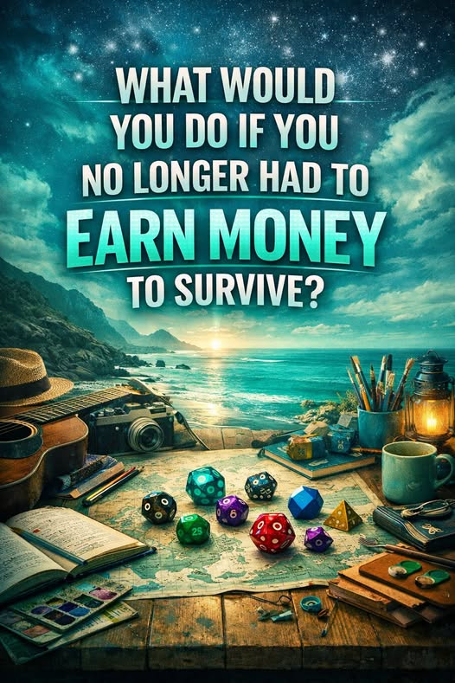

Introduction: The Question That Changes Everything
Imagine waking up tomorrow morning and discovering that your survival no longer depends on a paycheck. You have a secure home, nutritious food, dependable healthcare, access to education, and the means to participate fully in your community. These necessities are not conditional on whether an employer needs your labor this week. They are simply available.
What would you do with your life?
For some, the answer comes immediately: write a book, raise a family, travel, learn music, help a neighbor, start a garden, build a machine, explore the stars. Others might not know. After a lifetime spent working to pay the bills, the freedom to choose could feel unfamiliar.
This question lies at the heart of Terra Nova Development. It invites us to stop treating employment as the sole gateway to dignity and ask what human life could become if material security were established as a foundation rather than an endless struggle.

I. Survival Has Occupied Too Much of Human Life
For generations, people have organized their days around obtaining what they need to live. They trade time and effort for income, then trade income for food, shelter, transportation, and care. Work can bring satisfaction and meaning, but its value is often tangled with the threat of deprivation.
A parent may miss a child’s milestones to work extra shifts. A talented inventor may never have time to develop an idea. A caregiver may be forced to choose between supporting a loved one and paying rent. A person may remain in an unhealthy job because losing insurance is too risky.
We should recognize the difference between meaningful work and work demanded by fear. A society that reduces that fear does not necessarily diminish human effort. It can liberate effort for better purposes.

II. Technology Opens a New Possibility
Artificial intelligence, robotics, digital networks, and advanced manufacturing have expanded what humanity can produce. Machines can perform dangerous or repetitive tasks; software can accelerate research, logistics, and administration; renewable energy can help support new systems of production.
These technologies have not eliminated scarcity. Housing still requires land, materials, labor, and maintenance. Healthcare still requires skilled professionals. Energy systems still need infrastructure. Nor do technological gains automatically reach everyone.
But the possibility is real: as productivity grows, we can deliberately direct some of its benefits toward making essential services more dependable and affordable. The engineering challenge is not simply to produce more. It is to ensure that production translates into genuine freedom for people.

III. The Work People Might Choose
If the pressure of survival eased, human activity would not come to an end. We might see an explosion of voluntary contribution.
- Parents and grandparents could spend more time raising children and strengthening families.
- Artists, musicians, writers, and inventors could pursue ideas without immediate commercial pressure.
- Neighbors could repair homes, grow food, mentor young people, and care for older residents.
- Students could learn throughout life rather than treating education as a brief preparation for employment.
- Scientists and entrepreneurs could explore long-term projects with public benefit, even when profits are uncertain.
- People could rest, recover, play, travel, and cultivate relationships without feeling that every hour must produce income.
Some would still choose paid work. Some would build businesses. Some would take on difficult tasks for the satisfaction of helping others. Freedom does not mean everyone makes the same choice; it means more people can make a real choice.

IV. Purpose Does Not Come from a Paycheck
An employer can provide a job, but cannot give a person the full meaning of a life. Human purpose also emerges from curiosity, love, friendship, faith, service, creativity, discovery, and the simple joy of being alive.
Consider the retired teacher who continues tutoring because children matter. The mechanic who repairs a neighbor’s car without being asked. The gardener who shares vegetables. The amateur astronomer who teaches others to look at the night sky. These acts have value even when no invoice is issued.
Our economic measurements often overlook such contributions. A more humane civilization would recognize that value is not limited to transactions and that dignity does not depend on a person’s market price.

V. Freedom Must Be Designed, Not Merely Announced
The promise of abundance requires more than a declaration. It requires working institutions that deliver the basics reliably and fairly.
Terra Nova Development envisions complementary systems: universal access to healthcare, free lifelong education, efficient housing construction, affordable clean energy, and Give & Take or SALUDOS community centers where people can share usable goods and obtain practical support.
Such systems must answer ordinary engineering questions. How are resources financed? Who maintains them? How do we prevent shortages and corruption? How are decisions made? How do we protect privacy, personal freedom, and local choice? Which approaches are affordable and scalable?
The answers will vary by community. Pilot programs, transparent accounting, measured outcomes, and continual improvement can move ideas from inspiring essays to demonstrated reality. We do not have to invent perfection before beginning.

VI. A Life Beyond Compulsory Employment
Imagine someone who has always wanted to become a nurse but could not afford training. Imagine a father able to care for a newborn without losing his housing. Imagine a retired engineer teaching young people how to build practical devices. Imagine a community kitchen where preparing meals is a shared pleasure as well as a necessity.
When survival becomes more secure, people gain room to take risks, try new ideas, and contribute in ways that suit their abilities. Some may spend years studying. Others may devote themselves to conservation, caregiving, storytelling, or community service. And some may discover a sense of direction only after they finally have time to search for it.
An economy should make that exploration possible, not treat it as a luxury reserved for the wealthy.

VII. The Moral Question Beneath the Economic One
What do we believe people are here for?
Are we born primarily to generate income and consume products? Or are we here to experience creation, care for one another, develop our gifts, and leave the world better than we found it?
Terra Nova Development begins with the second possibility. Our lives cannot be reduced to wages, bank balances, job titles, or productivity statistics. Work can be a meaningful part of life, but life is greater than work.
If we gain the technological ability to reduce needless hardship, we also gain a responsibility to consider how that freedom should be shared. The measure of progress should be how many people can live with health, security, agency, and joy—not merely how many units an economy can produce.

VIII. Start by Asking People the Question
Perhaps the first step is not a massive new program. Perhaps it is a conversation in every community.
Ask a young person, a parent, a laborer, an entrepreneur, a caregiver, or a retiree: “What would you do if you no longer had to earn money to survive?”
Listen to the answers. Those answers reveal the creativity, care, learning, and generosity that are already present but often constrained by economic pressure.
Then ask a second question: “What is the smallest practical change we could make here to give people more of that freedom?”
A community tool library, a sharing center, free educational resources, better transportation, accessible childcare, and lower household energy costs are all possible starting points. Each improvement can give someone back a little time, money, and choice.

Conclusion: The Freedom to Be Human
A society rich in technology should aspire to be rich in human possibility. The purpose of automation should not be to render people unnecessary. It should be to relieve unnecessary burdens so that people have more freedom to live.
The future will still require effort, stewardship, cooperation, and hard decisions. Not every resource will be unlimited, and not every task will be pleasant. But we can build toward a world in which fewer people are forced to sacrifice their lives simply to secure the means of living.
So return to the opening question, and give it a serious answer:
What would you do if you no longer had to earn money to survive?
Whatever your answer, imagine a civilization designed to make it possible.
That is the promise Terra Nova Development seeks to explore: not a world without contribution, but a world where contribution can grow from freedom instead of fear.
There is no them. There is only us.

