**Test case 1: Simple insertion of menu items (Main/Drinks/Sides) (Junit testing)**

**Input:**

**Output:**

**Test case 2: Create new orders (Junit testing)**

**Input:**

**Output:**

**Test case 3: Entering invalid input when adding new menu items**

**Input:** Enter n instead of A/U/R.

**Output:** System checks for invalid entry and prompt the user to enter the appropriate character.

**Test case 4: Entering invalid Order number**

**Input:** Enter invalid order id

**Output:** System checks for invalid entry and prompt the user to enter the appropriate orderID.

**Test case 5: Creating new reservations without available tables**

**Input:** Creating a new reservation

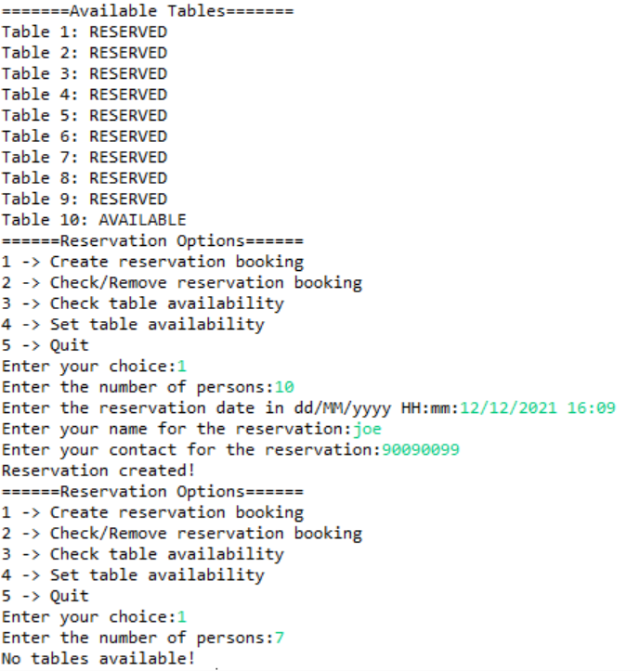

**Output:** System checks for available tables and rejects reservation if there are no tables for the specified pax.

**Test case 6: Trying to close an order without open orders and Entering invalid Order number for Invoice**

**Input:** Trying to close orders without any orders and enter invalid order id

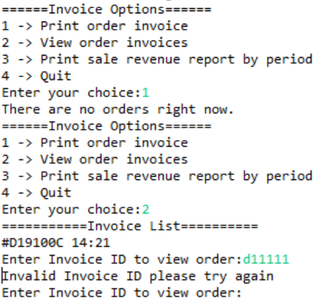

**Output:** System outputs no orders and checks for invalid entry to prompt the user to enter the appropriate orderID.

**Test case 7: Adding new item to menu (Entire flow)**

**Initial state:**

**Output:** Newly inserted item (Musan durian) is added to the menu.

**Test case 8: Create new orders (Entire flow)**

**Order created:** order created by staff with current timestamp and auto generated order ID.

**Adding items to order:**

**Output:** After adding 1 promotional set and 2 latte for table 7.

**Test case 9: Create new reservation (Entire flow)**

**Reservation created:** Reservation created by staff with current timestamp.

**Output:** After creating the reservation a table is reserved based on the number of persons in the booking.

**Test case 10: Create new invoice (Entire flow)**

**Invoice created:** Invoice created by staff with orderID, orderDate and calculations

**Output:** Invoice created and order is unable to be closed again.

**Test case 11: Print Sales revenue report (Entire flow)**

