**Introduction**

As we starting to step into the community, knowing how to read time will be a very important skill that we all must have starting from a very young age. In South Africa, learning how to tell time started as early as grade 1 to grade 3. Telling time is also the core part of the South African Mathematics curriculum during the foundation phase (Gr1-3). The learning goals for students from Gr 1-3 should be able to tell time on both analogue and digital clocks, able to use the clock to calculate elapsed time in hours and half an hour and lastly to tell the time in 12 hours and quarter hours.

The aim of this assignment is to a mobile solution that helps students from grade 1 to 3 to achieve the learning goals that was mentioned above. The app will be designed according to the South African Mathematics standards disregarding other countries goals and standards.

**Interviews**

I interviewed 7 people and each one gave answers that have similarities and differences. These are the description of their relationship with the person who’s learning to read clocks. I have: a primary school teacher, a father of a primary school kid, two mothers of a primary school kid, one mother who taught her child 30 years ago, a lady who I am uncertain who she taught and one UCT student who one taught his sister. These samples are selected from random and from different fields to prevent bias.

I have interview all of them with 6 questions with them being:

1. Tell me about your experiences teaching your children how to read a clock?

Potential follow up questions. What do they struggle the most with? Do they have homework related to this topic? Are they excited to learn?

1. Do you ever use your phone or another device as a teaching aid?

* If yes: What apps do you use? What is it like? What works and doesn’t?
* If no: Why not? Dig deeper.

1. How do you feel about the idea of a digital tool to support learning to tell time? Why?
2. What might be some good ways to approach this?
3. Are there any constraints or wishes we should think about when designing a solution?
4. What features would you want to see? Why?

Some questions are skipped, not answered due to personal, not understanding, cannot answer and therefore I did not record them.

Person 1: A lady who taught her son how to read a clock 30 years ago

1. How I taught my children is I would be using an analogue clock. I would be adjusting the hours and minutes hands and tell my son what time it is. I can’t remember if my son received any homework regarding this because he is 37 years old now.
2. I used calculators in my time to help him with counting
3. I think it is a good thing because phones are very popular today. It is one of the main sources in our everyday life to check the time.
4. We must respect time and time will respect you. I used to tell my son that he must always be at school by 8, you must always be 15 min before school opens. Everything must be on time, and this is the best solution in teaching kids understanding how to read time
5. We should teach them digital clocks first because it is easier to understand and more common today. After all, most phones and *“kids”*watches are digital today. Is better for younger generations to learn digital clocks first.
6. A small icon that animates the movement of the clocks when changing time. So, if the user enters a digital time, there will be an animation of the hands moving to their position to show the children that this is the time. *I think she is trying to say that this would make the app more enjoyable for children.*

This represents the point of view from someone who taught their children decades ago, this point of view is valuable because it shows us how the older generation method of teaching their children how to tell time. I want to interview this person because I think it is important to not only make an app that allows young parents to know how to use but also people from older generations that might have to teach their grandchild.

Person 2: A UCT student who one taught his sister

1. It is hard to add up hours and minutes. In 12-hour time, we can’t just add up hours and get to the answers straight. We could get a number that could be over 12 and we must change the number so that it fits the 12-hour time format, and we also must change the am and pm.
2. Yes, I use my phone to get many examples from the internet so that they can help me teaching them and for them to practice on their own. Repetition is key
3. I support digital tools, especially with kids. I think they learn better because it is easily accessible. It is also much entertaining because it is like playing games and kids love games.
4. I don’t know
5. The target market is an important aspect to think about because not all people in South Africa have access to electronics. So, you must design an app that does not just work with modern phones and software. You must also consider the older generation phones to allow more people to be able to use time.
6. Progress bar, the app should have a progress bar where parents can see where they are right now in studying about time. So, there can be progress in chapters, quizzes, test results so that parents can track their children progress.

This is the point of view of a UCT student who taught her sister. His point of view showed us how a teenager to young adults thinks about teaching, we are the closest generation to the children in Gr 1-3 and also received the most similar type of education when we’re in primary school. I think this candidate is very good because it gives the opinion of an adult who can relate most to young children.

Person 3: A young mother who taught her daughter how to read a clock.

1. It is a great experience to teach my daughter how to read a clock. The things that my daughter learns are not comparable to what I learn when I was her age, so we find that it is quite difficult for us to understand her school work. It is a great opportunity to learn more knowledge. My daughter struggled with math when learning about clocks. *Probably is the adding the subtracting of the hours minutes and seconds.*
2. Yes, there are things that I can’t understand myself and my daughter expect me to know. I normally use google to try to get the answer.
3. It is good, during this pandemic, schools are closed, and many have to study online. So, an app that can teach children how to tell time would be very beneficial at this time.
4. *Not answered*
5. *Not answered*
6. I think you should design the interface with more cartoons, because children love cartoon characters, and it would motivate them more in studying new things

The Point of view of this interviewee represents a young mother who walks their children home every day. I think this mother is in her late 20s, which I think is a good candidate because it shows the opinion of a young mother who had children at an age that is younger than average, which could differ from the average age or older.

Person 4: A late 20s lady who I am uncertain who she taught

1. I just taught them the minutes hours hands. I struggled the most with the minutes especially on the digital time, it was so hard that he was the child between the to or past. They get homework during school, and he is not excited about learning how to read a clock
2. Yes, sometimes I use google to research the things that I do not know
3. It would make teaching easier because it saves time, you don’t have to struggle with teaching when I can use something like YouTube to teach them how to read a clock
4. They should be taught how to read a clock in school
5. *Not answered*
6. There must be both analogue and digital clocks where the hours, minutes and seconds are running in real-time.

This point of view represents a lady who does not have children, teaching a child how to read a clock. These people should also be considered because there are many people such as babysitters who don’t have children and must teach other people’s children to read a clock. So, developing an app for them would also benefit many people like her.

Person 5: A father of a primary school kid.

1. It is pretty difficult when comes to clockwise and anti-clockwise, the sides where the hands turn and the minutes. The minutes are more difficult because of an analogue clock. We don’t have 5 then 10 then 15. It is just 1 then 2 then 3 so there is some math involved. I never saw my child do homework related to this kind of topic. They’re really excited to learn this kind of stuff because it is really interesting to them
2. I used a normal clock to teach them how to tell time, but I think teaching them how to read a digital clock is better because it is easier to understand. It is also more common
3. *Not answered*
4. The minutes must be more emphasised because it is harder.
5. Nothing
6. There must be cartoons, so for example if we say something like 10 o’clock. There should be like a cartoon hand moving to 10 o’clock. The app should also have cartoon characters that can interact with the children.

This view represents a father of a child. The fathers teaching methods should also be considered because sometimes they may differ from the mothers. So designing an app that can satisfy both fathers and mothers would be very beneficial.

Person 6: Young mother who taught her child how to read a clock

1. It was hard for them to understand the past and to, mostly the to part. When I ask them what is 12:35, they often say 35 past 12 which is not correct. They will mostly get homework at school and are very happy to learn about this kind of topic.
2. I do not use any device to teach them how to tell time, because I know all of this stuff from the back of my head therefore, I do not need anything to assist me in teaching this kind of topic
3. It would definitely help because we have to move on with technology and it is very convenient to use digital stuff as time goes.
4. Teaching at an early game and we should say time correctly when we’re teaching them and in general, because if we say it wrong, they could also get it wrong. I often say twelve thirty-five instead of twenty-five to one. Which is easier for us but wrong for children and they could be directed into the wrong path.
5. We must consider how to teach children how to read a clock easily just by looking at a clock. There are also roman numeral clocks that could confuse them. If you make that one easy for them to understand. It would be a great help
6. I would love to see the date and readable time including the seconds. There must be cartoon characters that can interact with them to make them enjoy the process more.

This is a lady that taught her child how to read the time. This is a mother who has a similar demographic to person 4. They are both mothers, this one is a bit older who both have children at similar ages. I think it is important to interview more mothers because mothers teach their children more at home than fathers.

Person 7: A teacher from a primary school

1. Generally, the kids are super excited to learn to tell the time. We find many in Gr 5 still don’t know how to tell the time though. The section we have is only 1 week long. Def, not enough time to explain time!! We generally don’t give homework on it unless they have been asked to try and read at a different time to help with understanding. They battle a lot with seeing the numbers as representing hours and minutes and which hand does what. Also, a big struggle is learning to write the time when reading off a clock and how to write 12hr and 24hr. Some kids get it, and others just battle for ages.
2. At the moment we don’t use devices other than laptops and maybe a YouTube video or PowerPoint. Other schools possibly do – if they use iPad etc.
3. I love the idea of using a digital tool!! It could be app-based that for us could be used to supplement their learning at home.
4. To think like you are a kid being taught time for the 1st time. Go back to basics. Often, we forget the basic things when teaching and assume ppl know things. The app could be progressive. Basics to more advanced concepts of time
5. Constraints would be that not all schools use technology to teach but if it could be downloaded by parents and is a fun app that kids would enjoy then it would be a winner. I would rather my kid be on an educational app than playing a game. Parents like the idea of their children learning something. Kids like to have fun thus the learning for them needs to be entertaining and almost, so they don’t realise that they are learning whilst playing.
6. I think it would need to appeal to a wide range. From beginners who are just learning – to then progress to being able to write the time or identify a time based on a clock given. If it is made into a fun game where they are keen to use the app and learning at the same time. Bright. Colourful. Funky.

This is the point of view of my favourite primary school teacher. She was my teacher in primary school, and she is a brilliant teacher. A primary school teacher view is so important because they have many years of experience. They taught hundreds if not thousands of students on the same topic. She most likely met every kind of student in primary school. Some could understand instantly, and some would take time. Having the opinion of an experienced teacher would be very beneficial to my app design.

**About the interviews:**

These are the transcript of the 7 people that I have interviewed. To prevent bias, I have interviews people like 1 teacher, 3 mothers, 1 father, 1 friend, and 1non-parents. These interviews do not represent all the opinions of their age group, job, gender, and so on. More interviews are required to identify more opinions and ideas from the general public. My assignments and prototypes will be based on my finding from these 7 interviewees.

**My answers to the questions**

I have never taught anyone how to read time, but these are my opinions on the questions.

1. Can’t answer
2. Although I never taught anyone, I would not use my phone as a teaching aid. I do not want my child to constantly look at a screen. I am not sure if there is any harm from constantly looking at a screen but for me, I wish to teach him how to read a clock not just using the standard clock as a teaching aid, but also build a natural clock by using the sunlight and a stick. This would make the learning process more fun and outdoor.
3. I support digital learning, but I do not want my children to sit in front of a screen for hours just to study. Making it more relaxing and outdoor is a great altez\rnative
4. I want to make study more fun and outdoor, like travelling, experiments, going to a clock store or collections to see different types of clocks so that my child can understand more.
5. Connectivity is the biggest constraint, not all South Africans have compatible phones and internet for apps. Therefore, not everyone can access the application. Now, as a computer scientist. I must design an app that is compatible with old phones, small in file size, free of cost and use little to no data at all.
6. I would want to see features where the clock hands can be running in real-time and the clocks in a different country.

**Affinity Sorting**

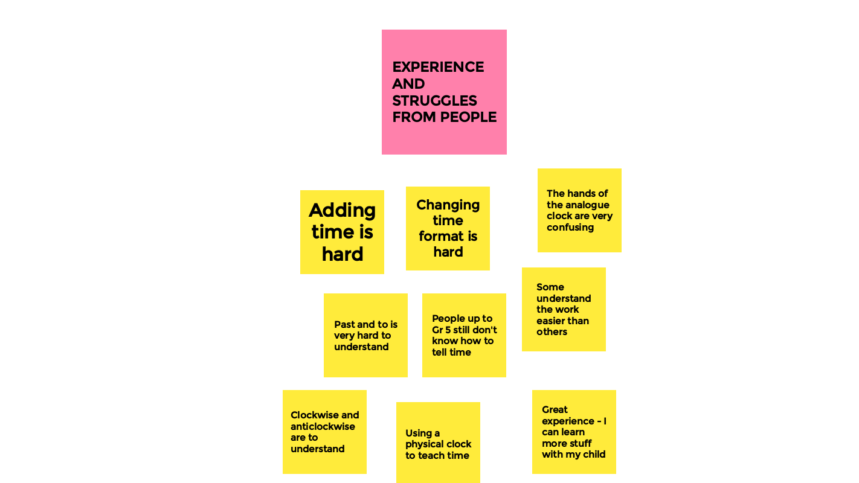

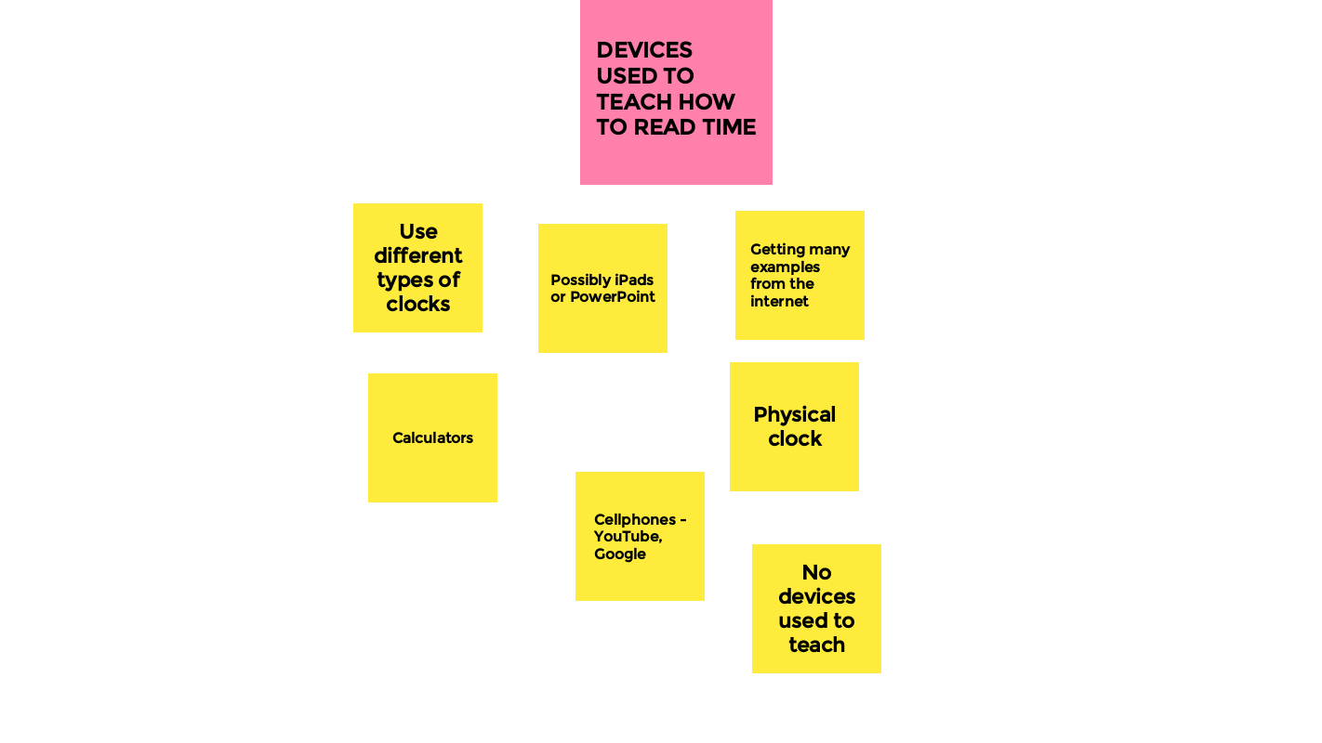 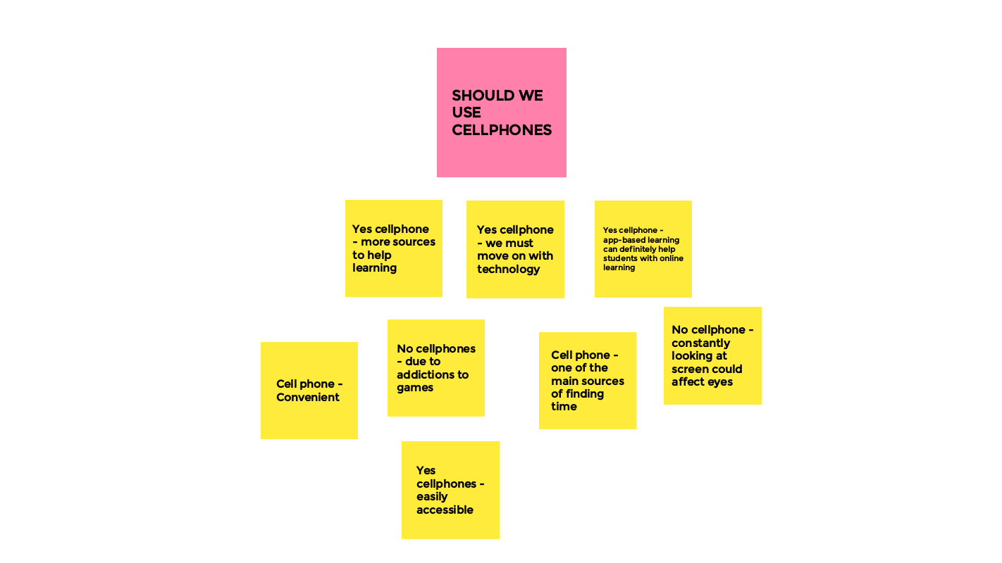

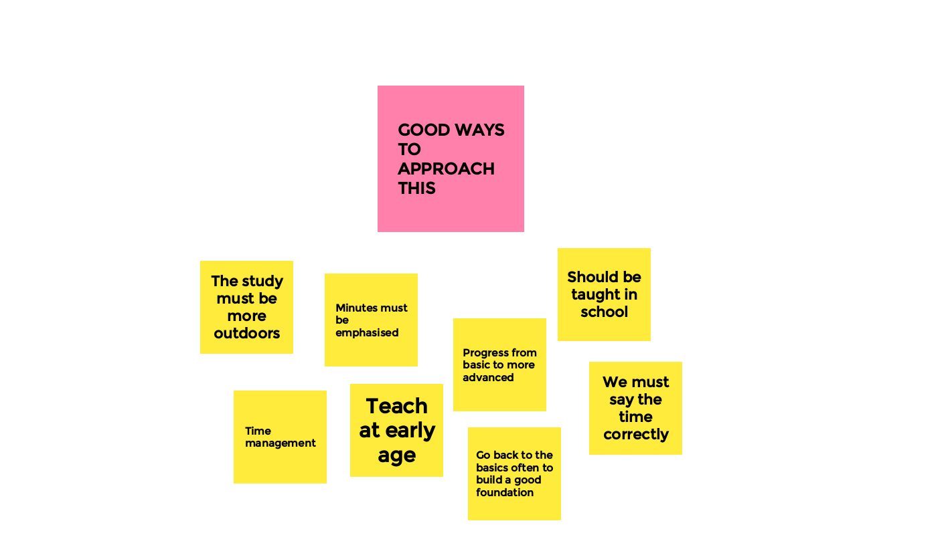

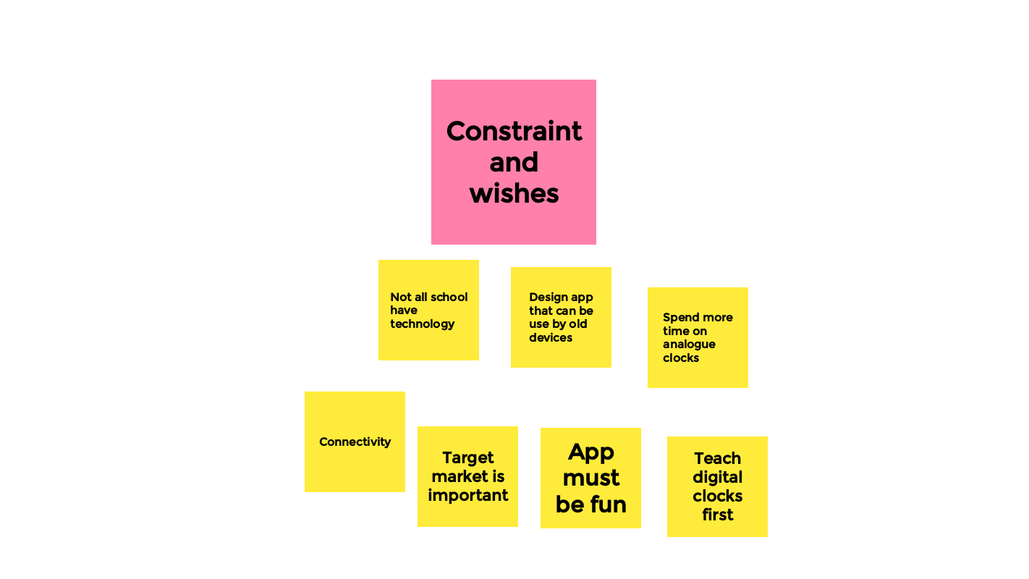

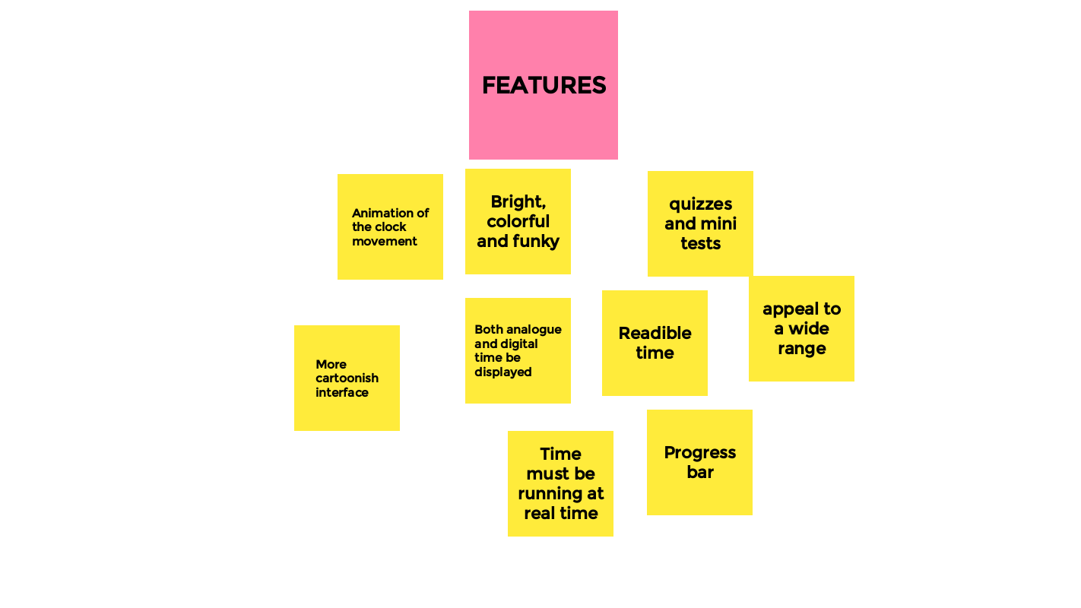

**Empathy map**

|  |  |
| --- | --- |
| **Think/Feel?**   * Really useful because it can help with online learning * Useful because keep them away from games * Useful because it is convenient * Useful because it can teach children without parents   teaching them | **Experience?**   * Teaching with a physical clock * Using internet to find answers * Using a calculator to add numbers * Difficult to understand to and past |
| **Wishes?**   * Cartoonish design * Cartoon characters feedback * Progress bar * Quizzes and mini tests * Fun to learning * Read time | **Gain?**  User   * Less effort for parents to teach * More professional teaching than home teaching * Children can enjoy teaching more * More convenient for parents |

**Ideate**

Parents/learners need a way to learn how to read time because we are currently in a pandemic right now and many times classes are taking online. So having an application that can help students with how to read time is extremely helpful. I have draw 7 different sketches to present my way of meeting user’s needs.

