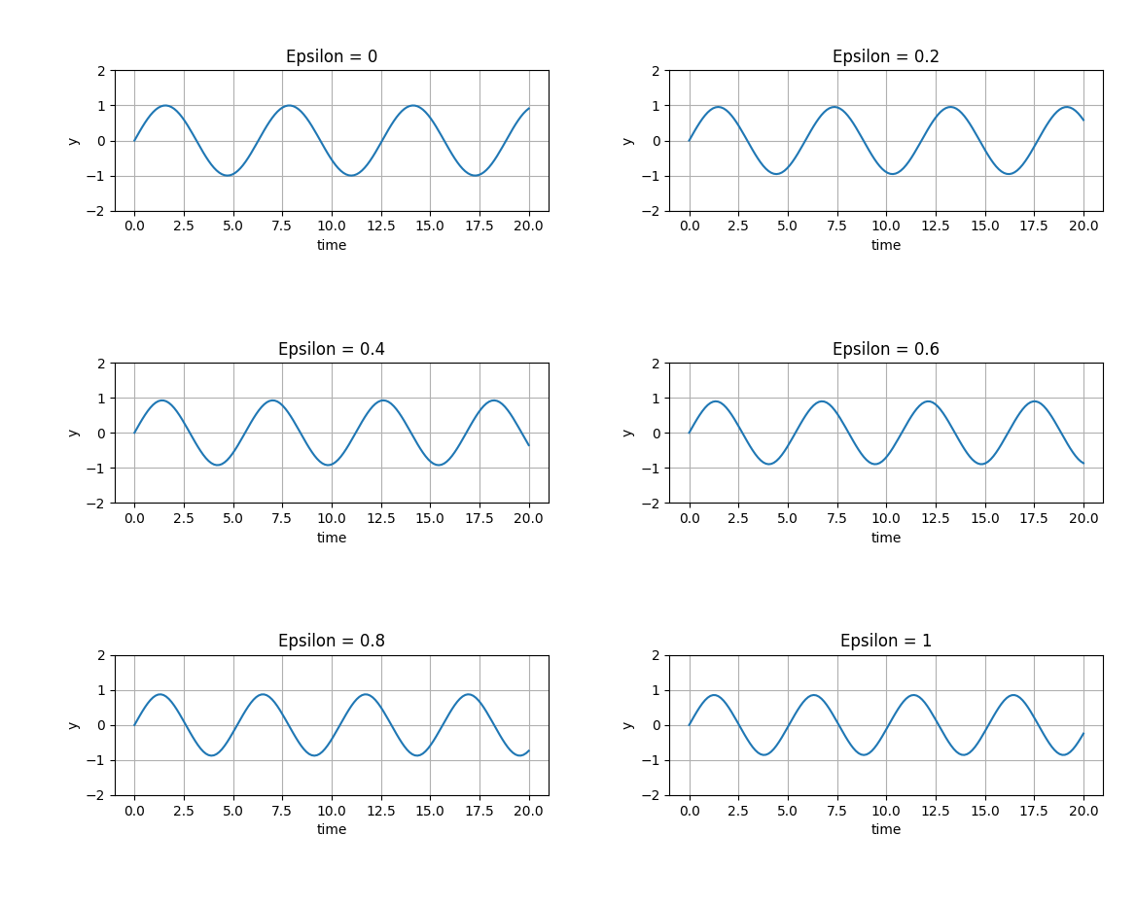
Problem 1:

The plots of u(t) with different epsilon values.

As epsilon approaches infinity, the frequency of the u(t) function gets larger and the period decreases.

As epsilon increases in value, the point where u(t) first crosses the y-axis gets closer to the origin.

Problem 2:
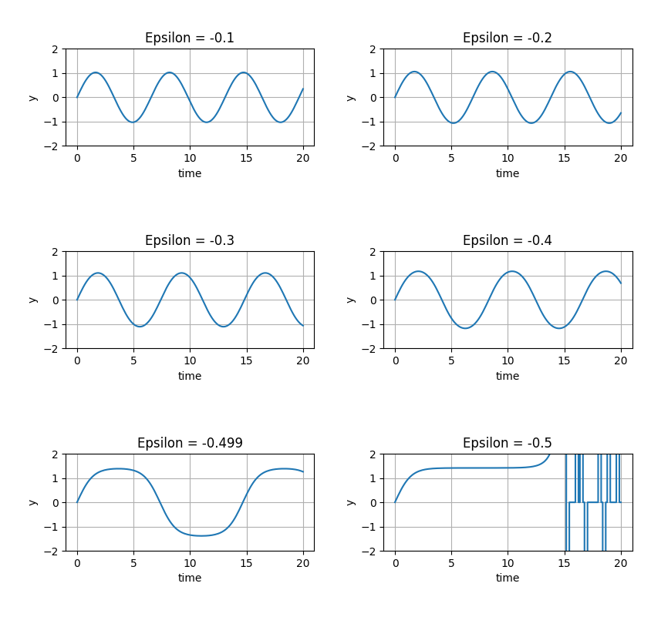
u(t) with different epsilon values
As epsilon approaches -0.5, the frequency of u(t) gets smaller and the period gets larger. After epsilon reaches -0.5 and after the function u(t) is no longer a periodic function.

As epsilon gets smaller, the point where u(t) crosses the y-axis gets further away from the origin.

Problem 3:
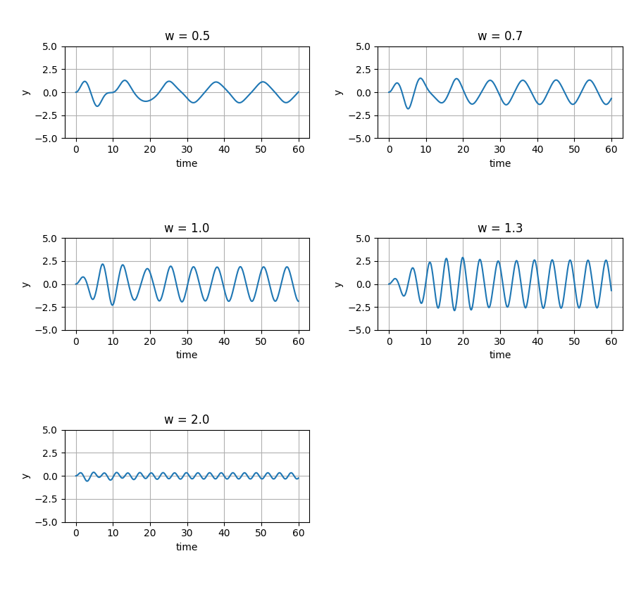
u(t) with cos frequency between 0.5 < w < 2

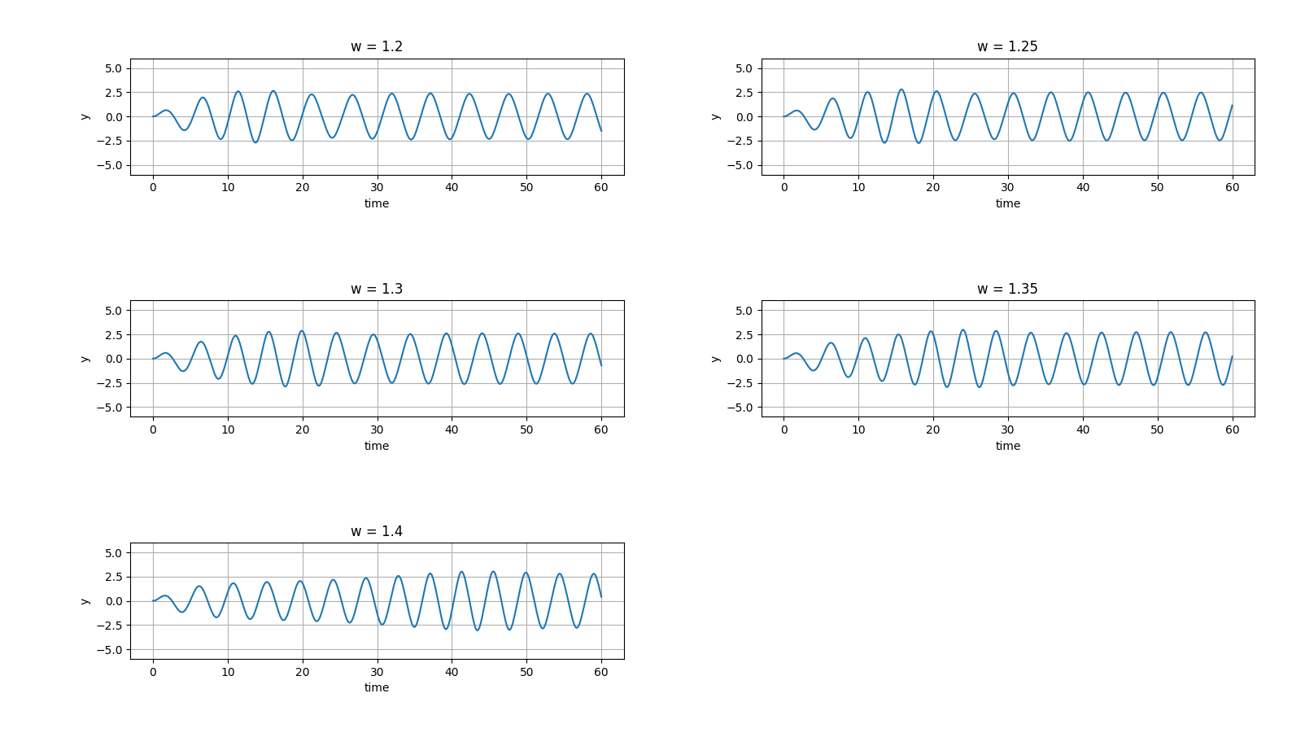
The frequency that results in the highest amplitude in 40 < t < 60 is w* = 1.4 rad/sec

