Problem 1:
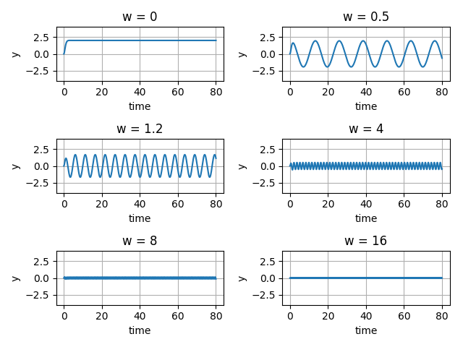
Plots of Q(t) with different frequencies for the input voltage

Problem 2:
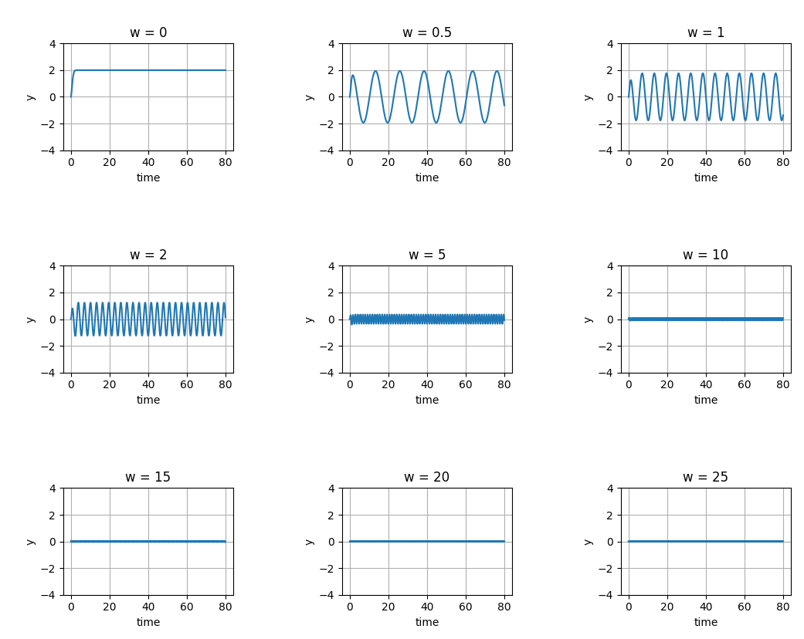
Plots of Q(t) with more frequencies for the input voltage

As seen above, A(w) gets smaller for 30 < t < 80 and stays close to and approximately zero.

