Clock constrained at 12.5 ns period (i.e. 80 MHz max clock)

**Latency :**

3 clock cycles

**Min Clock Period**

12.5 ns – 9.777 ns = 2.723 ns

**Utilization**

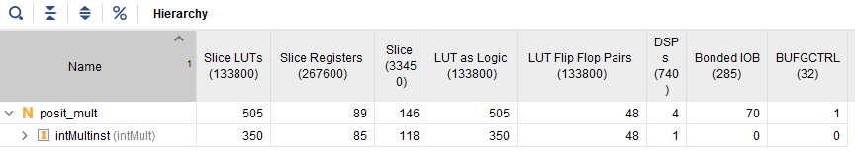

**Power**

