EZ Solutions — WordPress AI Pilot
Findings & Recommendations
Elevate MSP | July 2026

1. Executive Summary
EZ Solutions needs to produce 50+ unique location pages per client site — pages that pass Google quality checks, look premium, and remain editable in Gutenberg. Their current spin-tax approach is being flagged as mass-produced content.
Over one week, we built a proof-of-concept that generated 51 Pennsylvania city HVAC pages, each with a fundamentally different layout, all passing automated quality gates for word count, uniqueness, imagery, structure, and SEO metadata. The entire stack runs locally in Docker with zero external dependencies at runtime.
Key results:
- 51/51 pages pass all quality gates (word count, images, uniqueness, structure)
- 28 distinct section types used across corpus — no two pages look alike
- Max pairwise content similarity: 3.3% (threshold: 8%)
- Median word count: ~1,900 (min 1,013 / max 3,507)
- Zero fabricated business claims detected
- All output is native Gutenberg blocks — fully editable in WordPress

2. Scope: What We Heard
From the July 2 "WordPress QA Deepdive" call (ELVT-207) with Cindy, Marie (front-end), and Deb (back-end), we captured the following requirements:

Content & Quality
- Generate 50+ location pages per client, each with unique layout and content, in one workflow
- Target 400–1000+ words depth per page (EZ production standard)
- No mass-production sameness — client sniff-tests pages side by side
- No fabricated business claims (fictional brands = liability risk)
- Structured content: FAQ sections, CTAs, proper heading hierarchy
- No text walls — readable paragraph lengths, visual variety

Design & Platform
- Gutenberg-native — Elementor explicitly rejected
- Imagery / design layer — not walls of text
- Theme / brand layer must be professional and consistent
- Internal linking between location pages for SEO structure
- SEO meta on every page (Yoast integration)
- ACF / custom fields support for structured data

Infrastructure & Compliance
- Zero-egress inference — CA privacy constraints, data cannot leave network
- Fleet management — 300 sites, Deb runs monthly update sweeps
- MCP agent access — AI operating WordPress directly via API
- IT approval / no GitHub — self-hosted, works behind VPN, no external repos
- Client-editable output — final pages editable via WordPress or AI

The Solutions EZ Wants
In short: a production-ready pipeline that lets a non-developer generate 50+ premium, unique, SEO-ready location pages — Gutenberg-native, fully editable, running entirely on their infrastructure with no data leaving the network. Plus fleet management across their 300-site portfolio.

3. Options & Suggestions
Based on what we validated in the POC, here is our recommended tooling by capability area:
Capability | Recommended Tool | Notes
Content generation  (50+ unique pages) | Claude Code + agentic pipeline | Isolated agent per page with unique creative brief. Temperature 1.0 for maximum diversity. Quality gate enforces word count, uniqueness, structure.
Zero-egress inference  (on-prem / no data out) | Ollama + AI Engine custom env | Ollama hosts open models (gemma4, llama) locally. AI Engine Pro routes WP to localhost:11434. Validated in POC.
MCP agent access  (AI controls WP) | AI Engine Pro ($59/site) | Exposes 43 WP tools via MCP endpoint. Agents can create posts, write blocks, manage media. Bearer auth.
Fleet management  (300 sites) | MainWP (free dashboard + $228/yr extensions) | Central dashboard for plugin updates, security scans, content deployment across all child sites. API scriptable.
SEO metadata & schema | Yoast SEO (already installed) | Pipeline writes _yoast_wpseo_metadesc automatically. Future: LocalBusiness JSON-LD schema.
Imagery / media | Openverse (free, CC-licensed) | Commercial-use image pool. 14 topic categories for HVAC. Future: paid stock or client photos.
Non-dev page generation  (Marie / front-end team) | Page Generator Pro ($99/yr) | Template-based bulk generation in WP admin. No CLI needed. Good for simpler repetitive pages.
Theme / brand layer | Custom child theme of TT5 | Fraunces/Inter typography, custom palette, header/footer template parts. One-time build per client.
Design system / sections | Custom section library (25+ types) | PHP renderers produce valid Gutenberg blocks. Ken Burns heroes, hover-lift cards, accordion FAQ, colored bands.

Build vs. Buy Summary
- 80% of the pipeline is "buy" (existing tools: Claude API, AI Engine, MainWP, Yoast, Openverse)
- 20% is custom build (section library, quality gate, creative briefs, rendering pipeline)
- The custom 20% is what makes pages look fundamentally different from each other — it cannot be replicated with off-the-shelf plugins alone

4. POC (Build Option) Results
What we built and proved in one week:

Architecture
- Docker Compose stack: WordPress (8181) + MariaDB (33081) + MainWP (8282) + wp-cli
- Agentic spec generator: Python script → 51 parallel Claude API calls → JSON layout specs
- Section renderer: PHP library (25+ section types) → valid Gutenberg block markup
- Quality gate: automated checks for word count, images, headings, uniqueness, claims
- Creative briefs: 51 unique style directives (cinematic-visual, data-dashboard, minimal-zen, etc.)

Quality Gate Results
Metric | Threshold | Result
Word count | ≥ 1,000 words | 51/51 pass (median ~1,900)
Inline images | ≥ 2 per page | 51/51 pass
H2 headings | ≥ 4 per page | 51/51 pass
Paragraph length | ≤ 110 words | 51/51 pass
Meta description | Present + ≤160 chars | 51/51 pass
Shingle Jaccard | < 0.08 (all pairs) | Max 0.033 (avg <0.02)
Opening uniqueness | First 3 words unique | 51/51 unique
Banned claims | Zero matches | 0 violations

Design Quality
- 28 distinct section types used across the 51 pages
- 36% of sections have colored background bands (sand, ink, cream, dark-gradient)
- 49/51 pages include a structured service listing (feature_row, cards, or icon_list)
- All headlines ≤10 words; all CTAs ≤5 words (design taste rules enforced)
- Premium CSS: Ken Burns animation, multi-layer shadows, hover-lift, cubic-bezier transitions

Screenshots
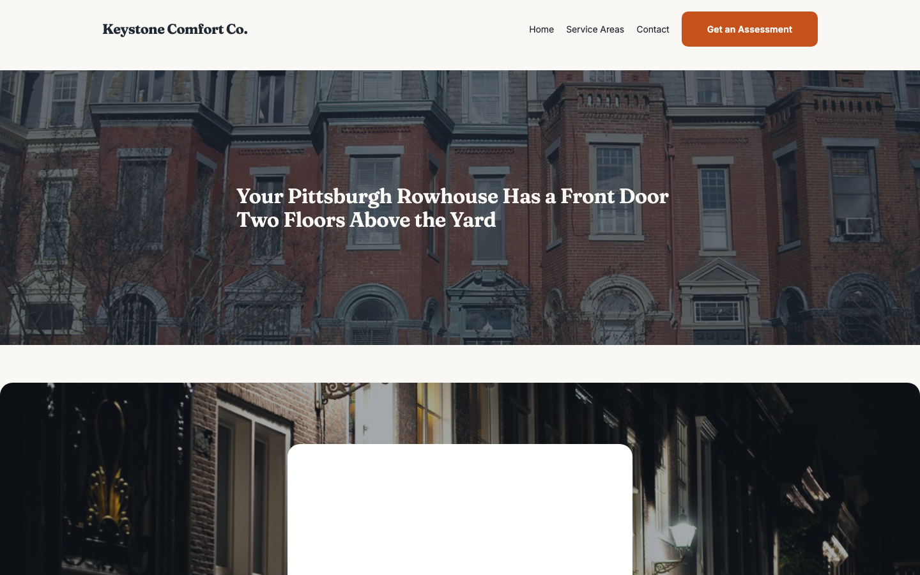
Pittsburgh — hero_cover with Ken Burns animation
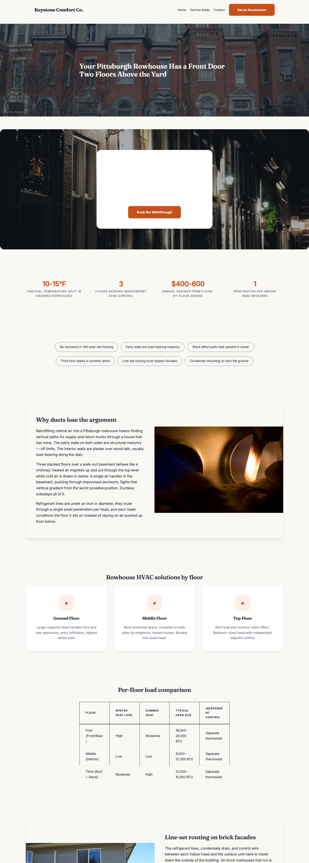
Pittsburgh — full page showing section variety
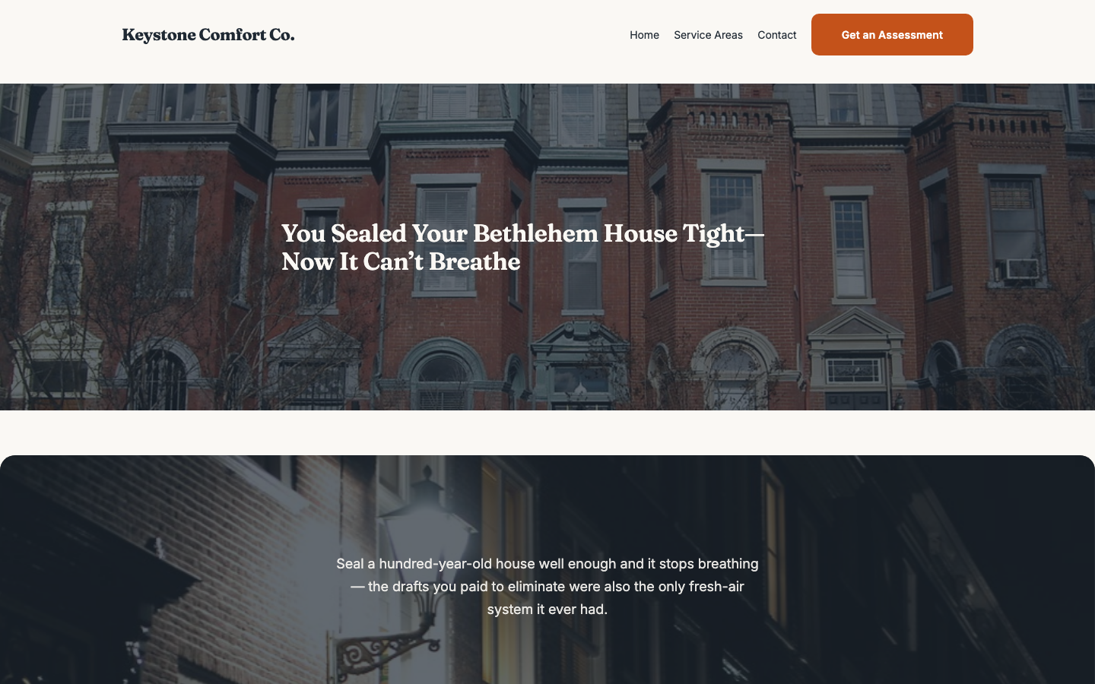
Bethlehem — hero_split with offset card design
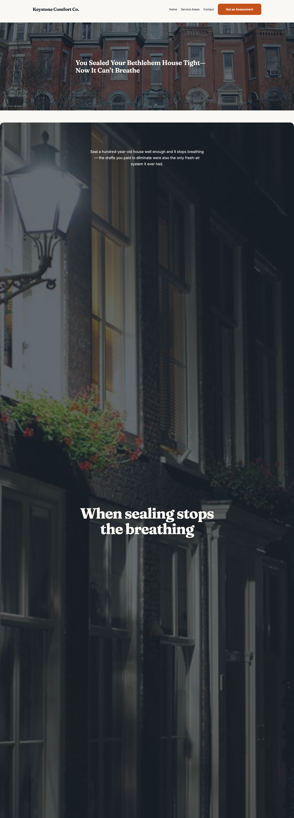
Bethlehem — colored bands, stats, feature rows
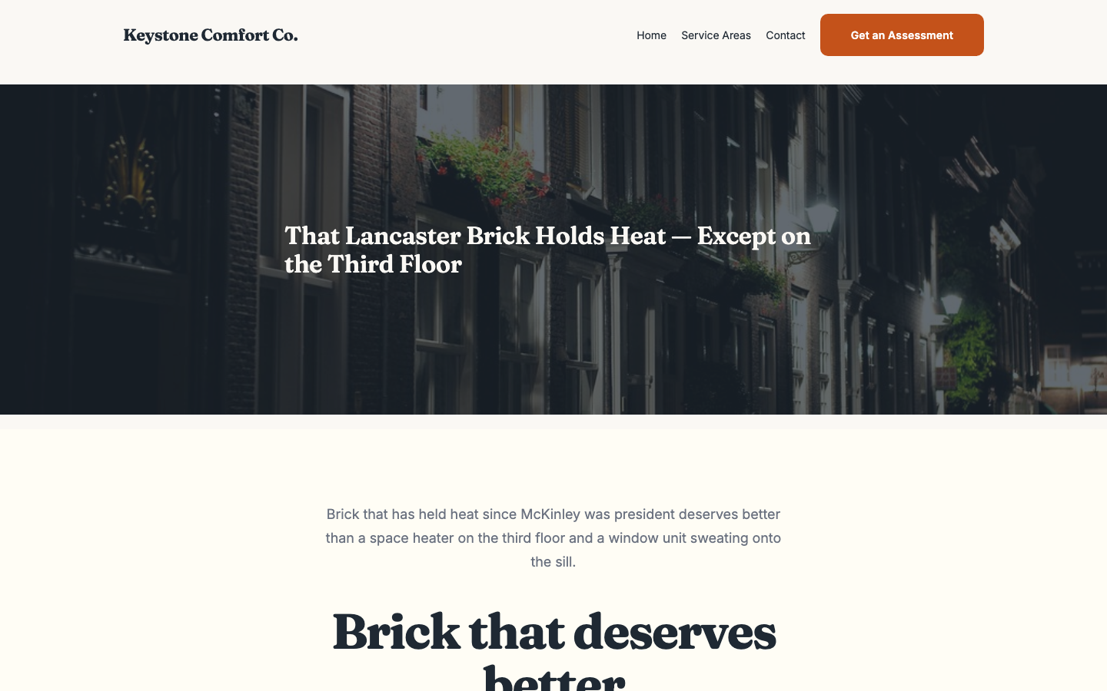
Lancaster — editorial-longform hero style
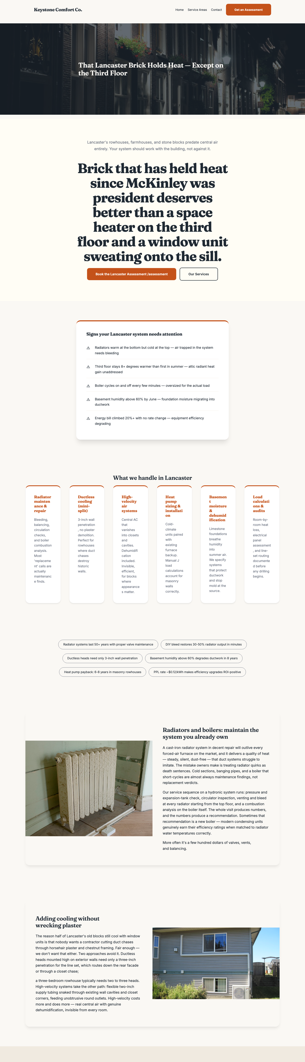
Lancaster — data cards, FAQ accordion, CTA bands
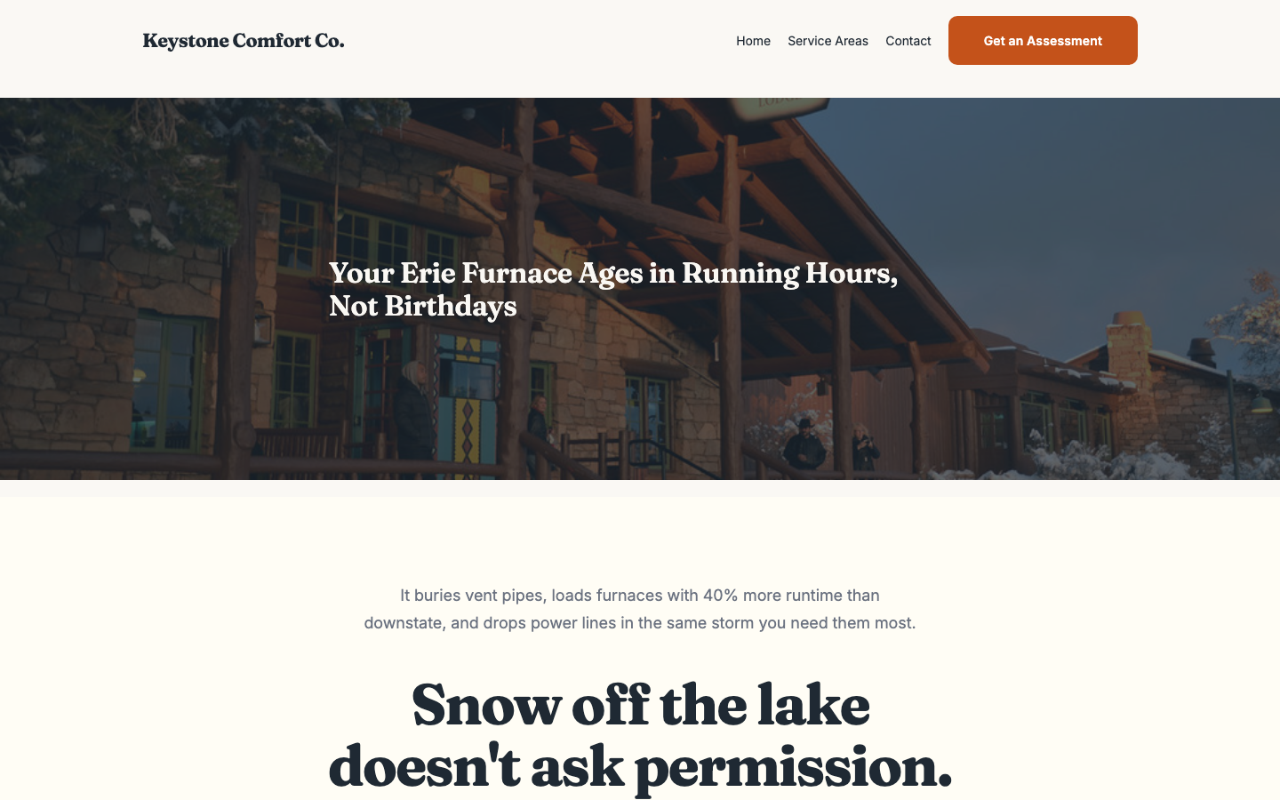
Erie — cinematic-visual hero approach
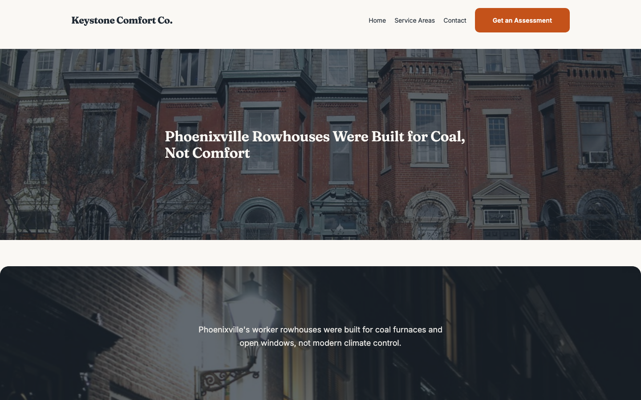
Phoenixville — minimal-zen clean design
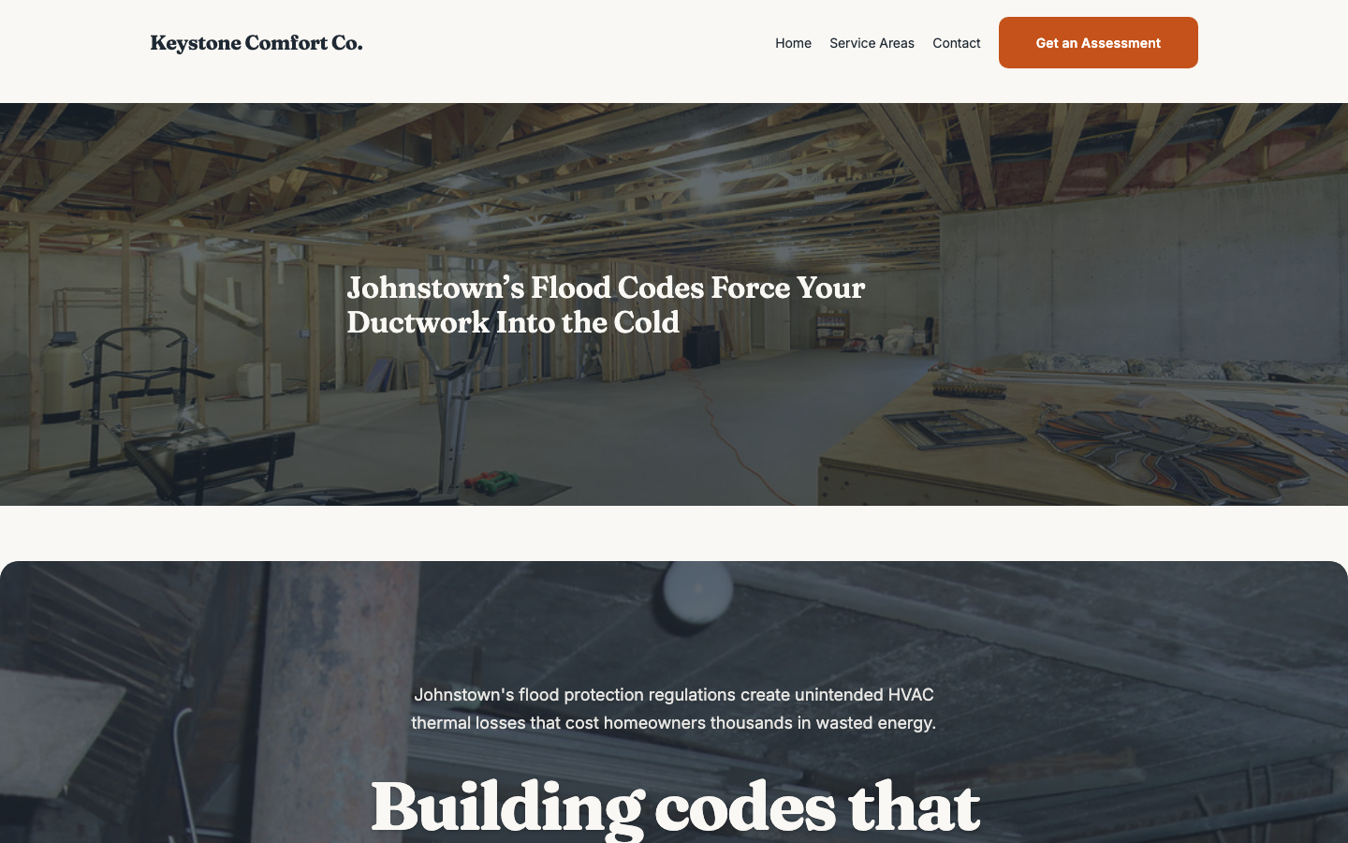
Johnstown — overlap-depth card layout

5. Recommended Next Steps

Immediate (Week 1-2)
- Approve tooling selections and budget (AI Engine Pro $59/site, Page Generator Pro $99/yr)
- Provision a persistent dev server for the Docker stack (their infrastructure, behind VPN)
- Reinstall Ollama for zero-egress inference (crashed during POC; architecture validated)
- Select first real client site for pilot deployment

Short-term (Week 3-4)
- Adapt theme layer for real client brand (replace Keystone Comfort with actual client)
- Swap Openverse images for client-specific stock or job-site photos
- Run pipeline on real client city list (not PA HVAC demo)
- Train Marie (front-end) on Page Generator Pro workflow for simpler page types
- Connect MainWP fleet dashboard to 2-3 production sites for update management

Medium-term (Month 2-3)
- Build fleet governance layer: per-site content rollout, approval workflows
- Add LocalBusiness JSON-LD schema markup to all location pages
- Implement hub-and-spoke internal linking by geo-distance
- Expand section library for other verticals (legal, dental, roofing)
- Tune word-count targets per vertical (HVAC vs. legal vs. dental)
- Set up agent guardrails for MCP access (AI Engine Pro curated tool sets)

Long-term
- Roll out pipeline across portfolio (300 sites)
- Vertical-specific creative brief libraries
- Client self-serve: non-technical staff trigger page generation from WP admin
- Automated content freshness: re-run pipeline quarterly with updated data

