Viskit is the graphical user interface (UI) that leverages Simkit, an application programmer interface (API) that supports creation and analysis of component-based DES models.

Two modes of Viskit are utilized to achieve the goal of creation and analysis of DES models, (1) component design mode, and (2) analysis mode.

In the component design mode, a non-programmer can graphically “draw” one or more event graphs, and apply appropriate parameters to those graphs. In the component construction (assembly) mode, components (event graphs) are “hooked” together to create a model. In the analysis mode, models are exercised (simulation run) where their various outputs are compared to expected results based on an experiment design.

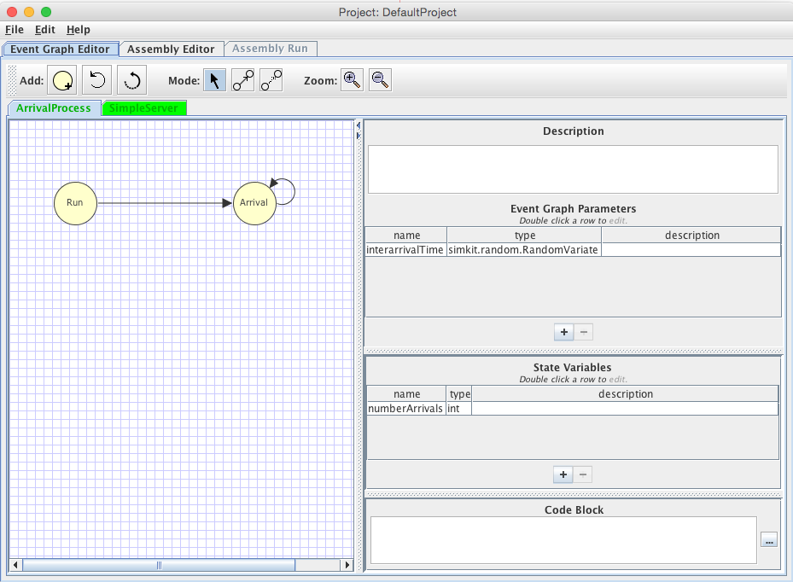

1. Arrival Process Event Graph showing parameters and state variables

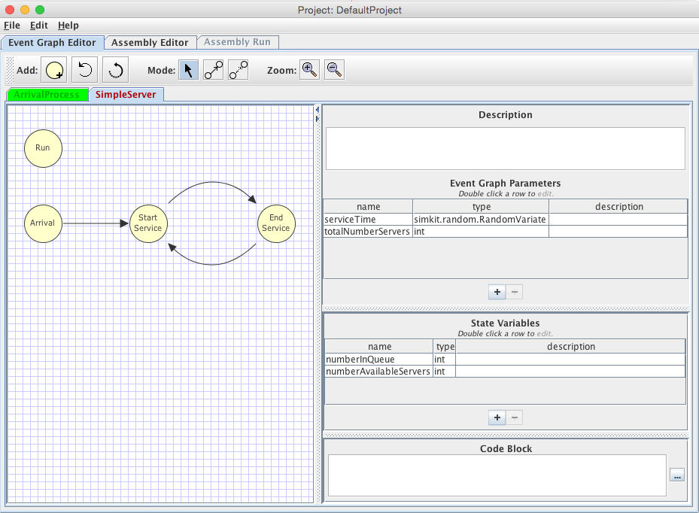

1. SimpleServer Event Graph showing status as not valid

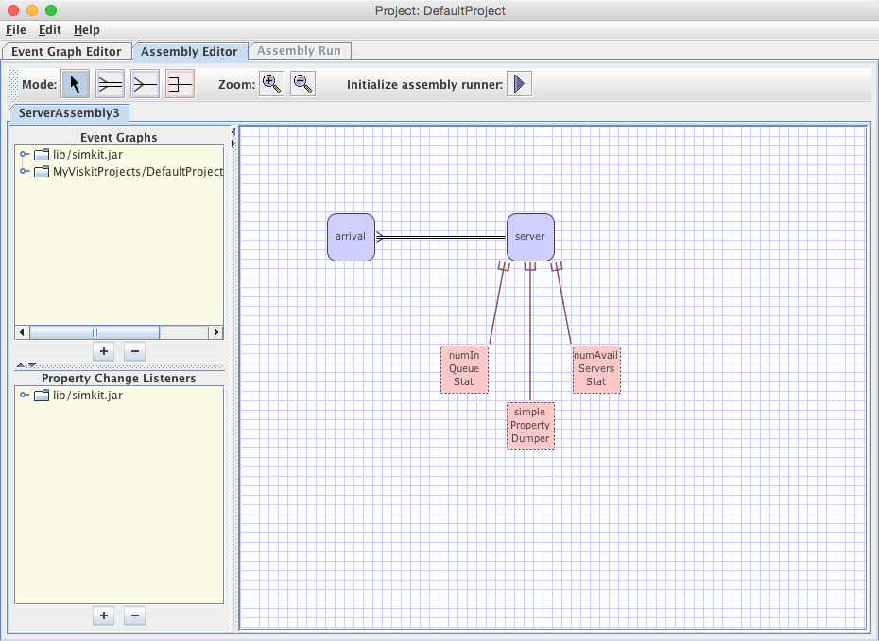

1. Component Construction (Assembly) showing Listener Event Graph Object (LEGO) connections

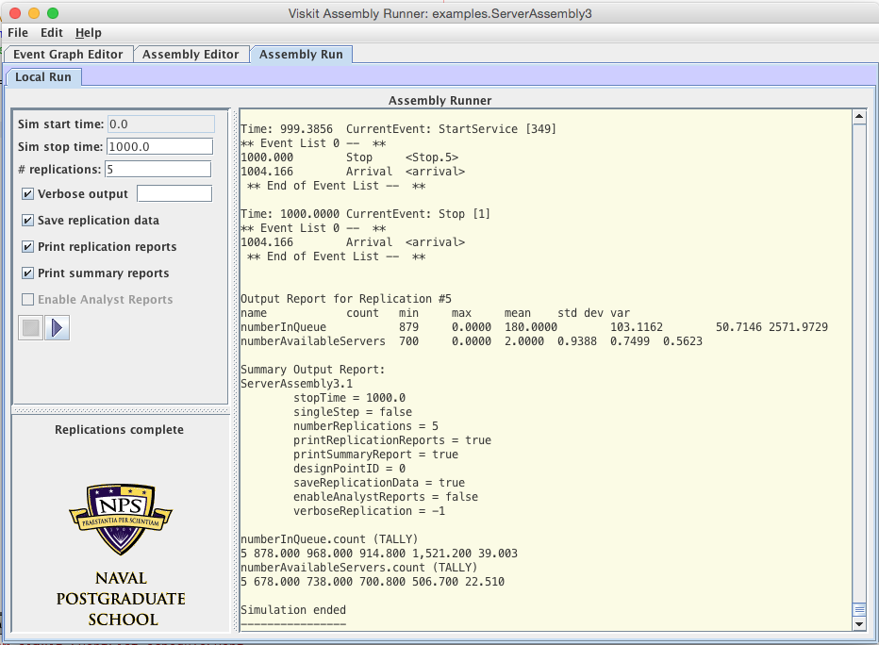

1. Assembly Run output showing individual replication and a summary reports

DES methodology is a way of modeling a situation as a series of events that take place during, or within a given situation. Two elements of DES are noteworthy. First, DES models advance time according to the Next Event rule. A list of future events (the “Event List”) hold the pending list of scheduled future events at any point in time. Rather than advancing time in discrete, uniform increments, the simulation is advanced to the next scheduled event pending on the Event List. Events can be scheduled to occur according to a sophisticated pseudo-random distribution of choice, or at fixed intervals of time. The second identifying element is that defined state variables stay constant between events, but can change instantaneously during the next scheduled event. It is the change in value of these state variables that occur during state transitions between events that can be tracked and collected over simulated time that reveal interesting insights of statistical significance.

The backbone of how Viskit operates is that once components are authored graphically, that model is saved out in Extensible Markup Language (XML) format. That XML is then parsed to generate Java source code. Once the Assembly is constructed, to include LEGO listening patterns, the Assembly is also serialized to XML and Java source code is generated. When the simulation is ready to be run for however many replication desired, the compiled Java source code is executed to produce the results seen in Figure 4.

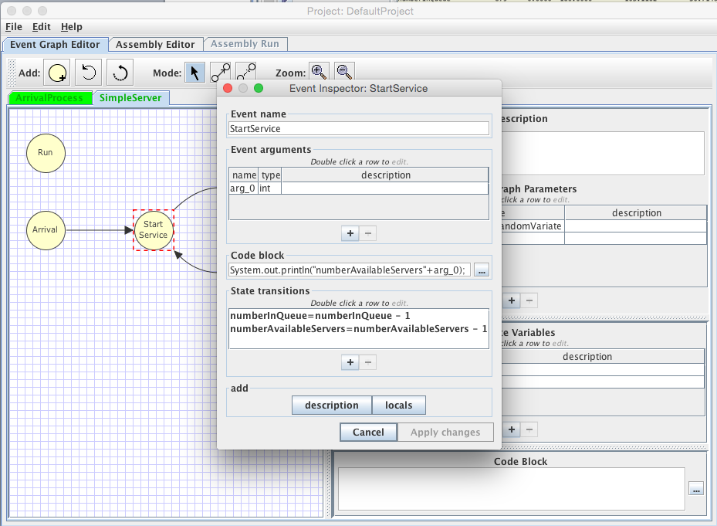

1. Event Inspector showing method argument and state transition editors

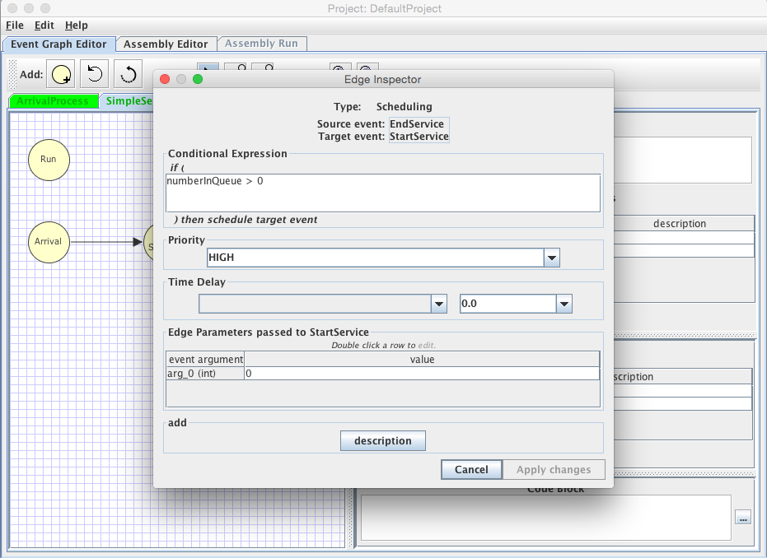

1. Scheduling Edge Inspector showing conditional, priority and time delay editors

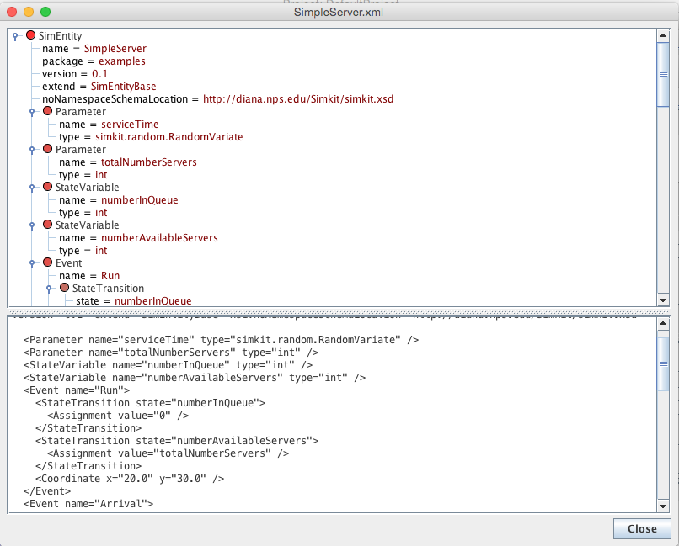

1. Event Graph serialization to XML format

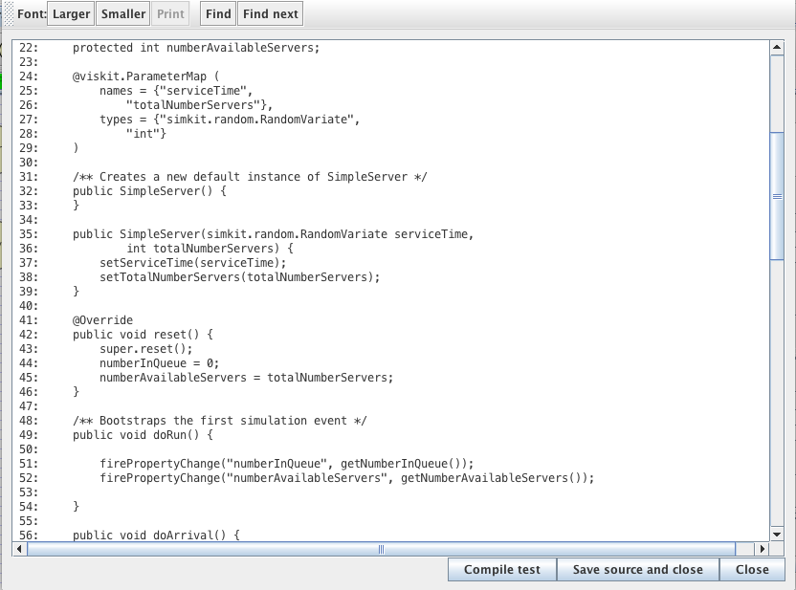

1. Generated Java source code from XML

Conclusion:

The requirement for rapid development and implementation of DES models has been present for quite some time and will continue to persist. Effective tools are required to support this effort. Simkit is one such API that supports this requirement, is open source and has proven useful as a DES tool of choice utilized to conduct experiments in numerous research programs, as a teaching aid in the classroom, and in order to complete many Masters theses at the Naval Postgraduate School (NPS).