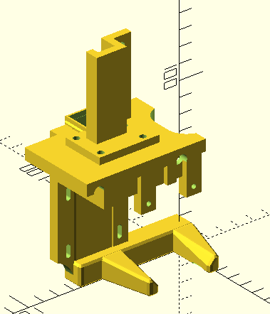
This is desiged for use by the Jubilee toolchanger with a baby bullet tool plate for mounting a Hemera. This uses the Jubilee post with a 55 mm seperation. A higher tool post base is included since the Hemera sits higher.

For parts it uses
- one 5015 fan.
- 4 o-rings, the same as standard extruder, 5x9x2mm Silicone O-Rings. (https://www.amazon.com/gp/product/B07MNMD17R).
- Bolts
  - These I needed to be this long to avoid doing damage to Hemera
    - 8 M3 x 6mm bolts
    - 6 M3 x 8mm bolts
  - These could be longer if this size is not present
    - 4 M3 x 10mm bolts
    - 4 M3 x 14mm bolts
    - 4 M4 x 12mm bolts
    - 1 M4 x 25mm bolt
- Hex Nuts
  - 8 M3 hex nuts
  - 5 M4 hex nuts
- Jubilee baby bullet tool plate – I used the plate from Lukes laboratory with capture wedge and balls.
  - https://lukeslabonline.com/collections/jubilee-parts/products/jubilee-tool-plate

Cable
Support
There are 8 parts printed without supports using the same print settings as other Jubilee parts.
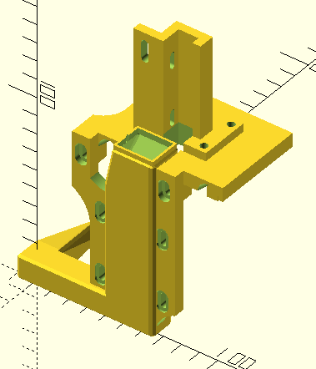
- Fan duct – export/duct.stl
- Top mount – export/top.stl
- Cable support on top of mount – export/cable-support.stl
- 4 o-ring holders – export/oring-support.stl
- Toolplate to Hemera adapter – export/adapter.stl
Duct
Top
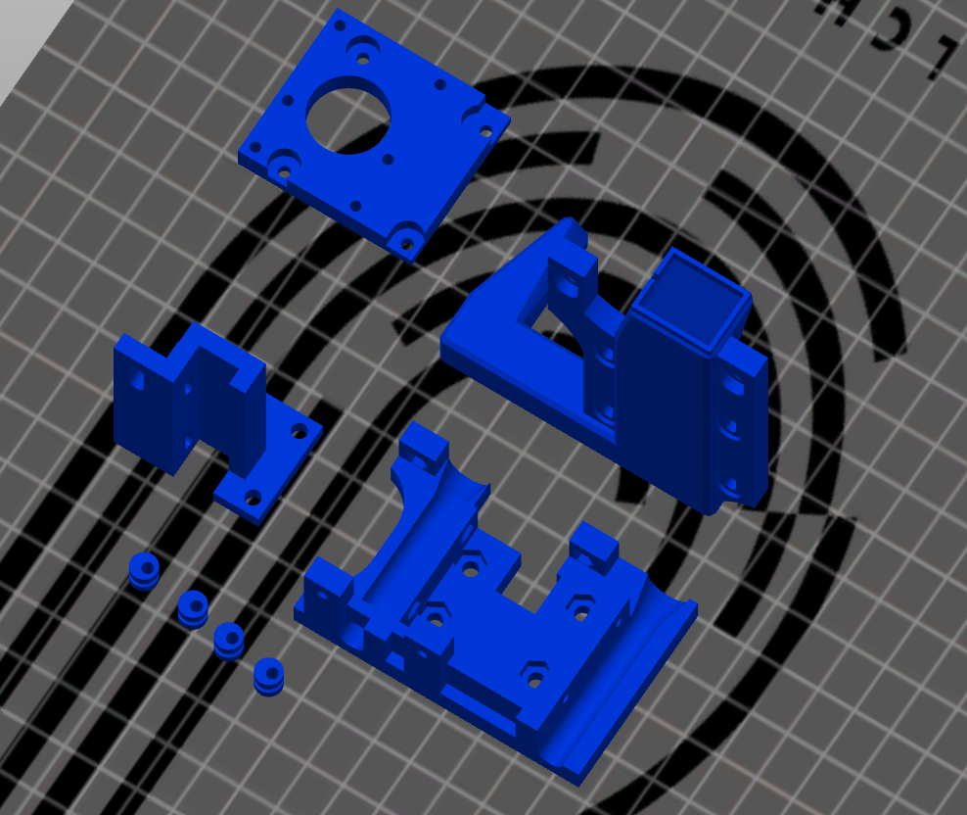
The orientation of parts when printed can be seen here. Note: the duct has long bridges. If you have any gaps in the bridge make sure the extrusion multiplier for your filament is high enough. With proper settings I did not have any issues printing this. I used Fusion Filaments HTPLA+ filament.

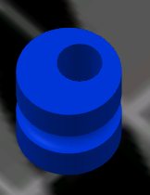
The o-ring supports are designed with an offset. These are held on by M4 x 14mm bolts, these can be slightly longer if needed. The supports can rotate to tighten the mount onto the post. In this way they can be adjusted so vibration does not move the extruder while it is parked and other tools are in use. Slippage of tools was one of the things I wanted to correct with this mount and I liked the baby bullet use of o-rings but wanted a way to adjust them.

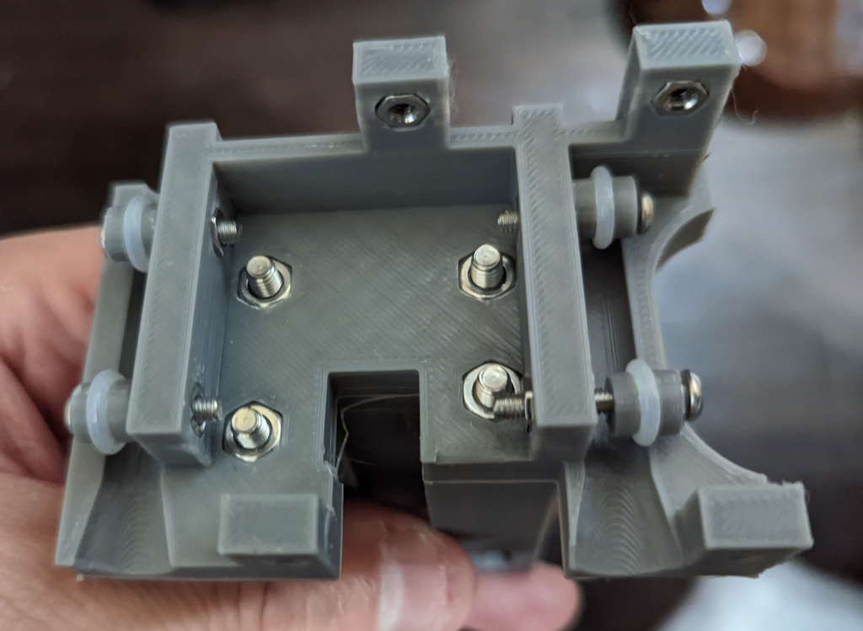
These are mounted to the underside of the top mount as shown in the picture to the left. These use 4 M3 nuts that are captured. You can also see how the cable support is mounted using 4 M4 captured nuts and M4 x 12mm bolts; these can be slightly longer if needed. There are also 2 M3 capture nuts on the back to hold the bolts for the toolplate and 2 M3 capture nuts on the front to hold the duct. The top is completed to this point before mounting. I used a big pair of pliers to squeeze these into place.

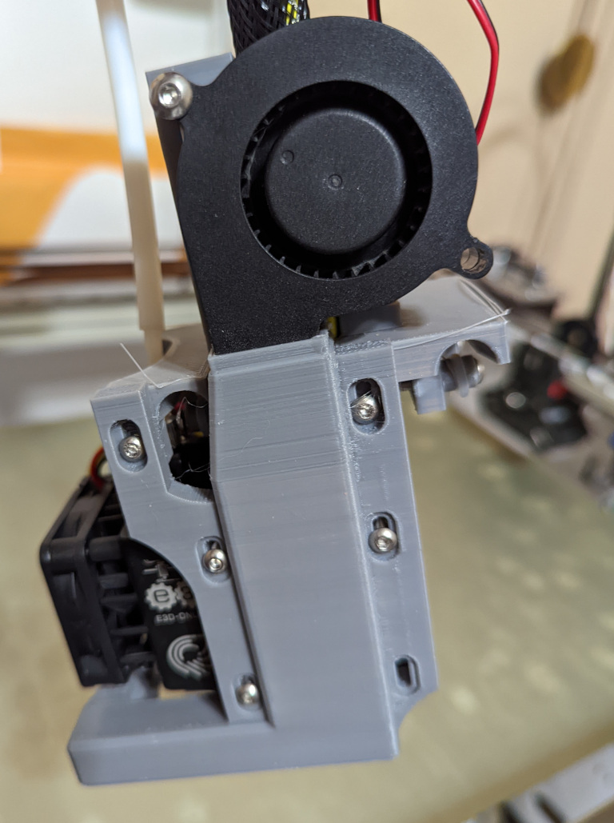
The duct is mounted to the main body of the Hemera in front to save X axis space. I used 4 M3 x 6mm bolts for this which screwed through the slots and into the square capture nuts on the Hemera. These need to be short enough not to apply pressure against the Hemera and cause damage and 6mm worked for me. With the original mount I could not get to 0 in the X axis which was another issue I wanted to solve with this mount. The holes for mounting are slotted to allow for adjustment of the duct relative to the nozzle.

Cables are positioned to enter thru the top plate and up the cable support.

After the duct is mounted, the top is bolted to the duct using 2 M3 x 10mm bolts screwed into previously installed captive nuts. These bolts can be slighly longer if 10mm bolts are not available.

The 5015 fan is mounted by attaching it using an M4 x 25mm bolt and 2 nuts in a slot contained in the cable support. If this length is not available a longer bolt can be used. I used 1 of the 2 nuts as a spacer between the fan and the cable support.

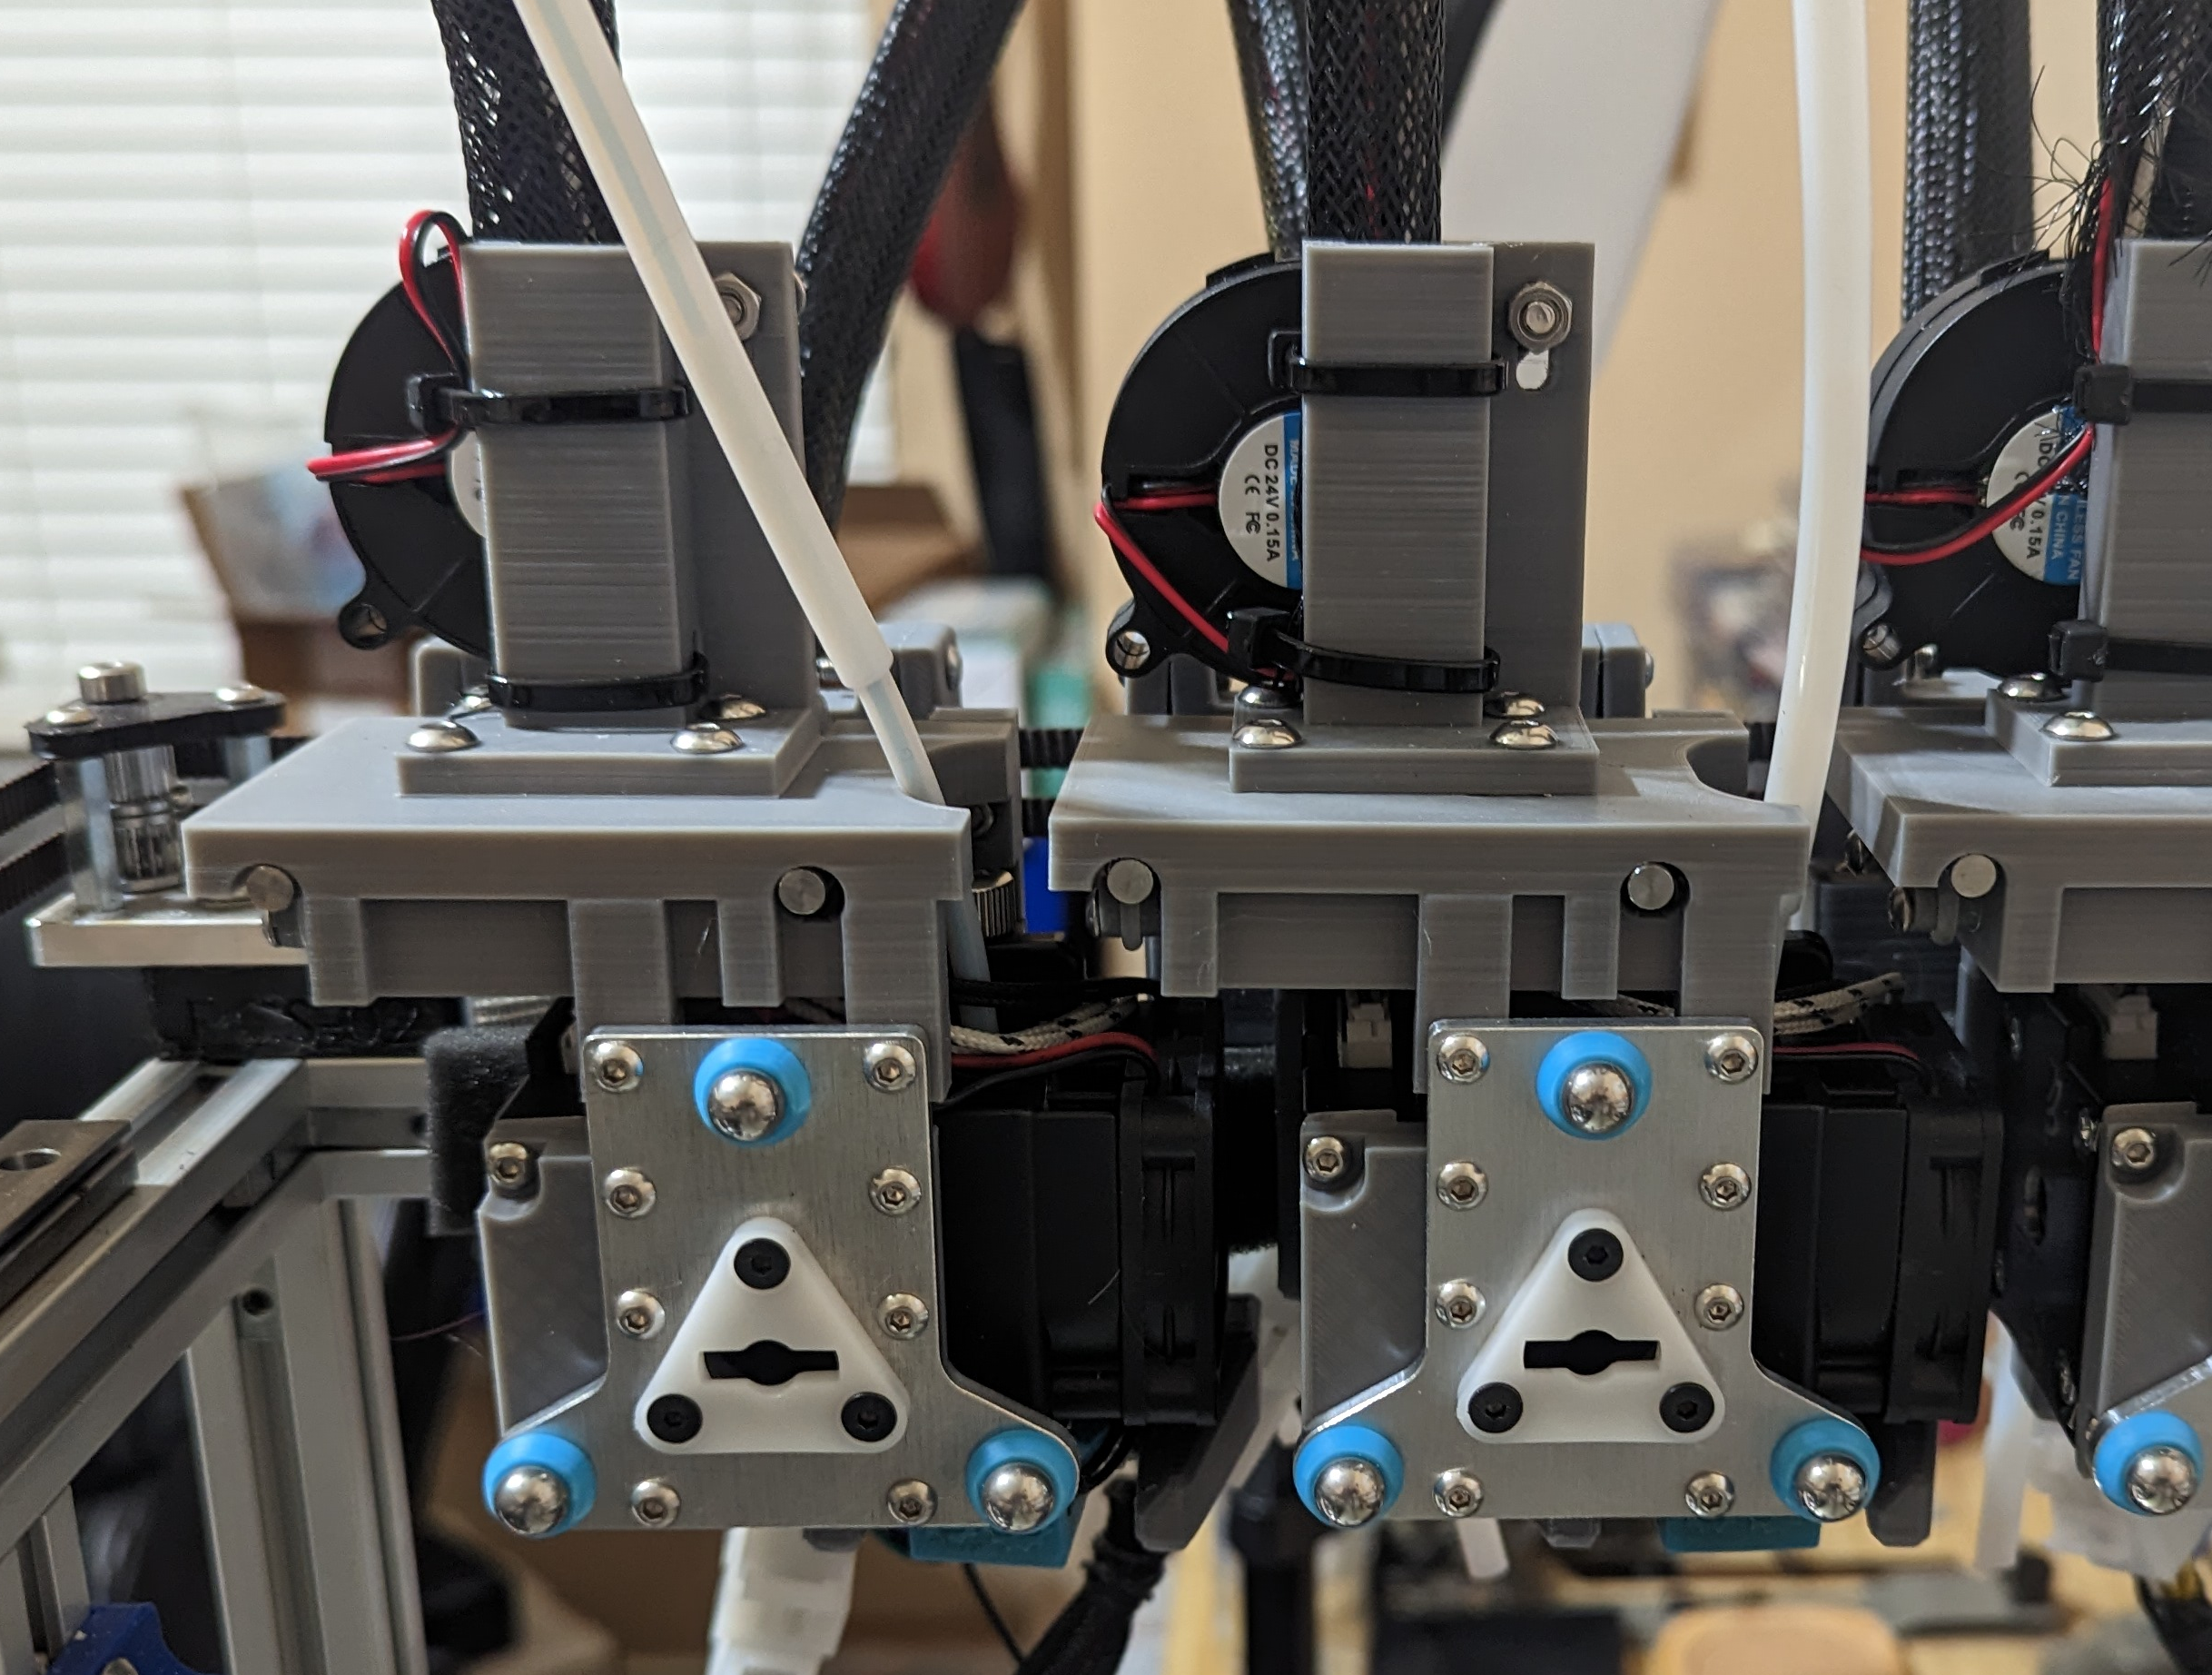
The plate adapter is added to the back of the Hemera using 4 M3 x 6mm bolts screwed thru the plate and into the square captive nuts in the Hemera. These need to be short enough to not cause damage to the Hemera when fully tightened and 6mm worked for me.

The tool plate can be seen mounted to the adapter using 6 M3 x 8mm bolts. Do not overtighten since these are only threaded into the plastic. The toolplate is mounted to the top with 2 M3 x 10mm bolts by screwing into previously inserted capture nuts.

After everything is in place, use zip ties to hold the cables in place using the slots in the cable support. If a heavy zip tie is used to provide support for the cables, this can be placed against the cable support to be held in place, behind the cables.

I built my Jubilee with extra post area so I did not worry as much about Y axis space. I expect this could be modified to use a slightly thiner adapter to save Y axis space.

I’ve included the quick openScad script, jubilee-hemera-mount.scad, I used to develop this. I’m still working on cleaning it up and making the mount more refined.

Since this mount sits higher than the baby bullet, I also needed to create a post base that was a little taller. I created a quick openScad script, hemera_parkng_post_base_55mm.scad, to modify the original stl to add this height. This stl file can be seen in the exports folder.
I also had trouble getting the posts to be inserted into the post holder straight so created a modified version that allowed the posts to be slid into a slotted hole with an M3 bolt and nut used to tighten the slot. The original holder will also work. This stl file can be seen in the exports folder.

Remember that the Hemera is deaper so longer posts are required. I used 80mm long dowels.

