GamePlay Description

How to interact

Our game is a single player. So, the interact is only with NPC. The main interact between the player and NPC is to receive the task, get the content of the task and complete the task. For example, when player receive the task NPC will say something encouraging and when player complete the task NPC will say thank you.

User Interface Design

Game menu

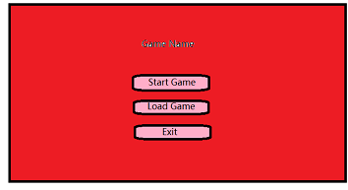

This a Game menu. Player can start game, load game and exit the game.

Normal UI

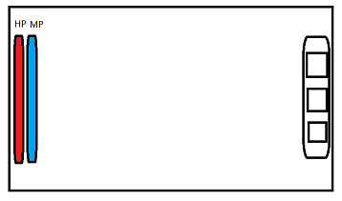

This a Player UI. Player can see Hp and Mp.

Load UI

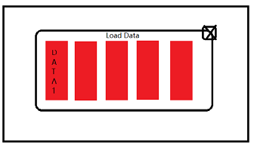

This a Load Data UI. Player can choose the data.

Mission UI

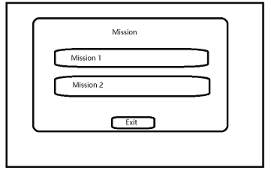

This Mission UI. Player can choose the mission.

Control

|  |  |  |
| --- | --- | --- |
| Button | Use | Function |
| Trigger |  | Player can move forword. |
| Trackpad |  | Player can change item. |
| Grip |  | Player can use item. |

Schedule：

13/12/2019-16/12/2019:

Use normal shape to complete the first level

17/12/2019-22/12/2019:

Complete the scenes, character, enemy and object for first level

Complete the main character. for example, receptionist

23/12/2019-26/12/2019:

Complete the action and sound for character and object.

27/12/2019-29/12/2019:

Complete the full version of the first level

30/12/2019-25/1/2020:

Complete level 2 and 3 the enemy, scenes, object and characters

26/1/2020-15/2/2020:

Complete level 2 and 3 the action and sound for enemy, character and object

16/2/2020-25/2/2020

Test the game and find the bug

Fix the game

26/2/2020-10/3/2020

Make the mission story

Add storage data and load data function

11/3/2020/-20/3/2020

Adjust data. For example, if the enemy attack player many damage.We will make change

21/3/2020-25/4/2020

Make difficult level

Adjust data

Complete the game

26/4/2020-12/5/2020

Test the game and find the bug

Fix the game

Milestone description

The first level (13/12/2019-29/12/2019)

The second level (30/12/2019-15/2/2020)

The third level (30/12/2019-15/2/2020)

Action plan for the prototypes

1. Story (Understand the game background and gameplay)

2. Mission (Level linking, rewards, mission database)

3. Full Narrative with Dialogue Boxes

4. The first level

5. The scenes, character, enemy and object

6. The action and sound for character and object

7. The second level

8. The third level

9. Add storage data and load data function

Work distribution:

|  |  |
| --- | --- |
| Work | Worker |
| UI design | Wu Man Kit, Lam Wang Yu,  ZHANG Yaohui, Chan Chiu Shun |
| 3D model | Wu Man Kit, |
| Document | Wu Man Kit, Lam Wang Yu |
| Story | Wu Man Kit, Chan Chiu Shun |
| Game Programming | Lam Wang Yu, ZHANG Yaohui,  Chan Chiu Shun |
| Map and build design | ZHANG Yaohui |
| Mission design | ZHANG Yaohui |

Budget estimation

Hardware:

Recommended Requirement

|  |  |
| --- | --- |
| Item | Cost |
| Input device |  |
| -keyboard | $40 |
| -mouse | $15 |
| - VR device | $4899 |
| - HTC controller | $1087 |
| PC Specification |  |
| - processor | $1050 |
| -ram | $168 |
| - graphic card | $1730 |
| total | $8980 |

Minimal Requirement

|  |  |
| --- | --- |
| Item | Cost |
| Input device |  |
| -keyboard | $40 |
| -mouse | $15 |
| - VR device | $4899 |
| - HTC controller | $1087 |
| PC Specification |  |
| - processor | $409 |
| -ram | $135 |
| - graphic card | $960 |
| total | $7545 |

Hardware Requirement

|  |  |
| --- | --- |
| Item | Cost |
| Input device |  |
| -keyboard | $40 |
| -mouse | $15 |
| - VR device | $4899 |
| - HTC controller | $1087 |
| PC Specification |  |
| - processor | $2290 |
| -ram | $255 |
| - graphic card | $1999 |
| total | $10585 |

Software:

Software Requirement

|  |  |
| --- | --- |
| Item | Cost |
| - Operation System | $1018 |
| total | $1018 |

References:

<https://www.price.com.hk/>

Level of design

The game will have three levels. At least 2 difficulty levels per level. Monsters at different levels have different properties. Players need to fight with props and weapons. When the level is more difficult. Players need to understand the game better.