**Hong Kong Institute of Vocational Education**

**Discipline of Information Technology**

**IT114107 – HD in Game Software Development**

**Final Year Project – Systems Development and Administration (ITP4913M)**

**Project Proposal**

**Project title:** < Specter City >

**Project subtitle:** <Steam VR game, terror and adventure , First Person >

**Group Members:**

|  |  |  |  |
| --- | --- | --- | --- |
|  | **Name (Student ID)** | **E-Mail** | **Phone Number** |
| 1. | Name (Student ID) | Frequently used email | Phone Number |
| 2. | ZHANG Yaohui | 180139687@stu.vtc.edu.hk | 53051152 |
| 3. | Lam Wang Yu | [terry53443445@gmail.com](mailto:terry53443445@gmail.com) | 53058008 |
| 4. | Name (Student ID) | Frequently used email | Phone Number |
| 5. | Name (Student ID) | Frequently used email | Phone Number |

* sorted by name

* Highlighted the group leader

**Introduction to our proposed game project (Statement of problem to be solved)**

About the background:   
In the City, there are a lot of ghost hidden from the human eye. Sometimes they will attack you. For protect citizen, government organize a department to antagonize them. The department we call that “ Vigil Union ”.

**Design Thinking – Empathize & Define**

<Understand the problem that you are going to solve.>

-How to create a terrifying experience by plots, background, audio

-What unique selling point do the game need to have in order to attract ppl to play?

-Provide multi-approach to solve a problem.

<Think or interview stakeholders needs, desire, experience… etc>

-Players need sense of presence to the story/ atmosphere.

-Need more interactive and intelligent ways to solve to problem.

-Keeping the player feel fresh.

<Define the pain points, challenges according to the finding above>

-Atmosphere creation

-Unique puzzle solving

-Interactive gameplay

<Define what you are going to solve>

-Multi-ways to solve problem

-Terror atmosphere

<Note that in Design Thinking, we are not focusing the problem, but the needs, desire, experience of stakeholders, which may be ignored or not considered before, i.e. human-centered>

<You may reference with the existing product here>

**Design Thinking – Ideate (draft only: explained in detail in the Initial Report)**

<Think outside the box (brainstorming) to provide creative solutions to the points found in define>

<Concentrate on idea generation (divergent thinking) – list more ideas : open-minded collaboration>

<Evaluate different proposals (convergent thinking) – Prioritize and select the best choice : do not ban difficult yet innovative proposals too soon>

<List a **few** **outline of proposed solutions** and explain what you are going to solve>

**Basic Game Design (Outline of proposed solution)**

<Basic Game Play>

-Completing quest

-~~Open World Design~~

-Solving puzzle and maze

-Fighting monster

-~~Multiplayer~~

-Play in VR

-~~Turn-based~~

<Algorithms that you may used, e.g. shortest path algorithms>

shortest path algorithms for enemy searching player

damage range algorithms for damage calculation in different range

<Basic Level Design>

-Each level completes when a session of main mission is done.

-There will be a new enemy/ playstyle being introduced in main mission.

-It is optional to complete side mission.

-Side mission will be more challenge and testing the skill that taught in

main mission.

-The reward of side mission are better than main mission which makes the

gameplay easier.

<System Architecture>

VR device (Capture motion and input)

Game Logic (Event detection)

Game client (Apply changes and update locations, data)

Database of monster/ weapon/ item/ quest.

<Data handled by the system>

Damage calculation

Monster’s Info (health, speed, base damage)

Player’s Info (health)

Player’s location (coordinates)

Status of mission (Completed?)

<other non-functional requirements>

Dynamic audio

VR device

**Main development phases (Main Stages)**

<outline your project plan by describing the system development life cycle with deadlines of tasks>

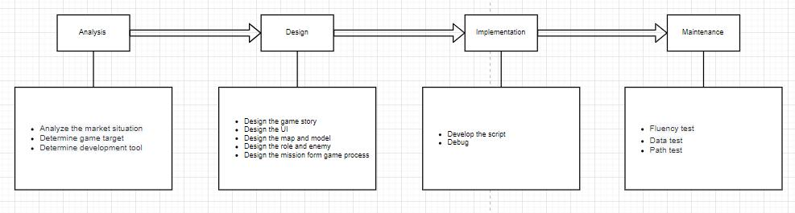

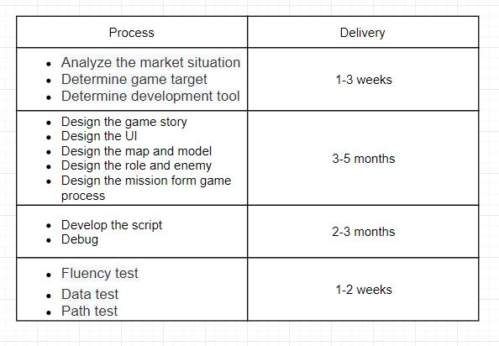

**Main deliverables**

<Describe the things that you will deliver, such as game program, source code, reports…etc>

UI Design/ Story Scripting/ Game Programming/ 3D modeling/ Documentation/ Audio

**The responsibilities of each member**

<Explain the allocation of work to individual member>

Wu Man Kit: UI design, 3D model, document

Lam Wang Yu: Game Programming, UI Design, documentation

ZHANG Yaohui: UI design , Map and build design, Game programing, Mission design

**Important Notes: After the proposal is accepted, please mail the softcopy to Project Supervisor and Project Coordinator.**