# HTML Images

[*https://www.w3schools.com/html/html_images.asp*](https://www.w3schools.com/html/html_images.asp)

# CSS Styling Images

<https://www.w3schools.com/css/css3_images.asp>

How TO - Center Images

<https://www.w3schools.com/howto/howto_css_image_center.asp>

# CSS Layout - Horizontal & Vertical Align

[*https://www.w3schools.com/css/css_align.asp*](https://www.w3schools.com/css/css_align.asp)

# *C*SS vertical-align Property

<https://www.w3schools.com/cssref/pr_pos_vertical-align.asp>

# How TO - Center Elements Vertically

<https://www.w3schools.com/howto/howto_css_center-vertical.asp>

# CSS filter Property

<https://www.w3schools.com/cssref/css3_pr_filter.asp>

# CSS Height and Width

<https://www.w3schools.com/css/css_dimension.asp>

**Width and Height, or Style?**

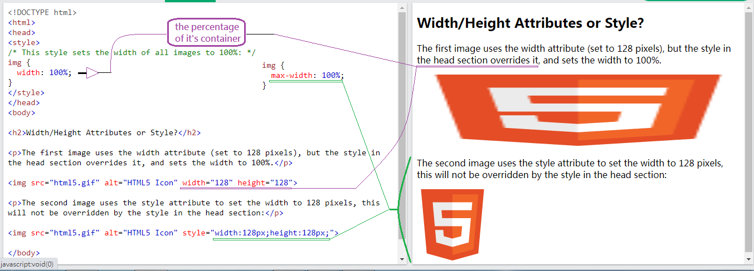

CSS Styling Images

Use the border-radius property to create circled images:

<style>

img {

border-radius: 75%;

}

Thumbnail Image as Link:

img:hover {  
  box-shadow: 0 0 2px 1px rgba(0, 140, 186, 0.5);  
}

Responsive images will automatically adjust to fit the size of the screen.

If you want an image to scale down if it has to, but never scale up to be **larger than its original size**, add the following:

img {  
  max-width: 100%;  
  height: auto;  
 }

**To center an image,** set left and right margin to **auto**and make it into a **block** element:

img {  
   display: block;  
  margin-left: auto;  
  margin-right: auto;  
  width: 50%;  
 }

max-width: 100%;

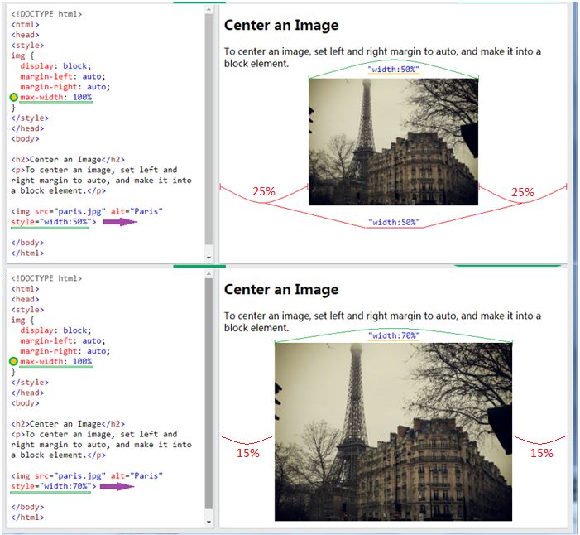

The height and width properties are used to set the **height and width** **of an element**.

The height and width properties **do not include** **padding, borders, or margins**.

It sets the height/width of the **content area** of the element.

The height and **width** properties may have the following values:

* auto - This is default. The browser calculates the height and width
* length - Defines the height/width in px, cm etc.
* % - Defines the height/width **in percent of the containing block**.

The max-width property is used to set **the maximum width of an element**.

The **max-width**can be specified in length values, like px, cm, etc., or

**in percent (%) of the containing block**, or **set to none** (**this is default**. Means that there is no maximum width).

**Note:** If you for some reason use both the width property and the max-width property **on the same element**, and the value of the width property **is larger than** the max-width property; the max-width property will be used (and the width property will be ignored).

the max-width property 大於 100% (size of **the containing block**) = => 並無義意

The min-width property defines the minimum width of an element.

If **the content is smaller than** the **minimum width**, the minimum width will **be applied**.

If the content is larger than the minimum width, the min-width property has no effect

**Note:** This prevents the value of the [width](https://www.w3schools.com/cssref/pr_dim_width.asp) property from becoming smaller than min-width.

**Use a <figure> element** to mark up **a photo** in a document, and a **<figcaption> element** to define a caption for the photo:

The <figcaption> tag defines a caption（圖書、雜誌或報紙圖片的）說明文字 for a [<figure>](https://www.w3schools.com/tags/tag_figure.asp) element.

The <figcaption> element can be placed **as the first or last child** of the <figure> element.

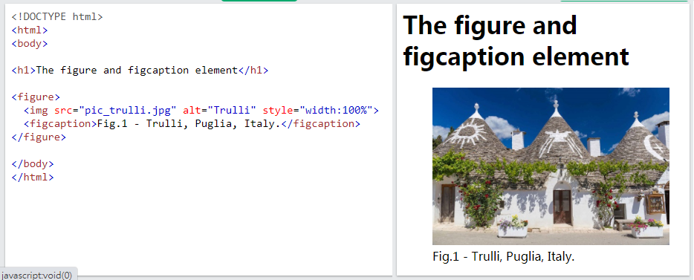

The <caption> tag defines a table caption.

The <caption> tag must be inserted **immediately after** the [<table>](https://www.w3schools.com/tags/tag_table.asp) tag.

center Align Elements

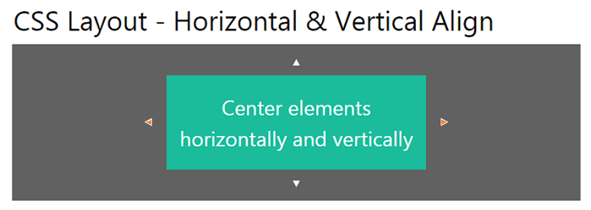

To horizontally center a **block element** (like <div>), use **margin: auto;**

**Setting the width** of the element will prevent it from stretching out to **the edges of its container.**

The element will then **take up the specified width**, and **the remaining space** will **be split equally between the two margins**:

**Left and Right Align - Using position**

One method for aligning elements is to use **position: absolute** :

**Note:** Absolute positioned elements are **removed from the normal flow**, and can **overlap** elements.

**Left and Right Align - Using float**

**the clearfix Hack**

**Note:** If an element is taller than **the element containing it**, and **it is floated**, it will overflow outside of its container. You can use the "clearfix hack" to fix this (see example below).

<https://www.w3schools.com/css/tryit.asp?filename=trycss_layout_clearfix2>

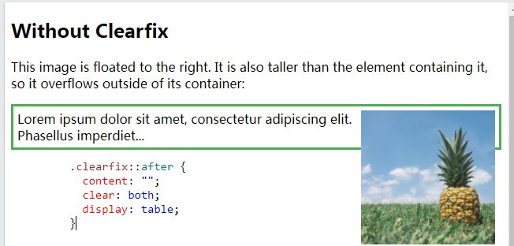

**Center vertically – using padding**

There are many ways to center an element vertically in CSS. A simple solution is to use top and bottom padding:

To center **both vertically and horizontally**, use padding and text-align: center:

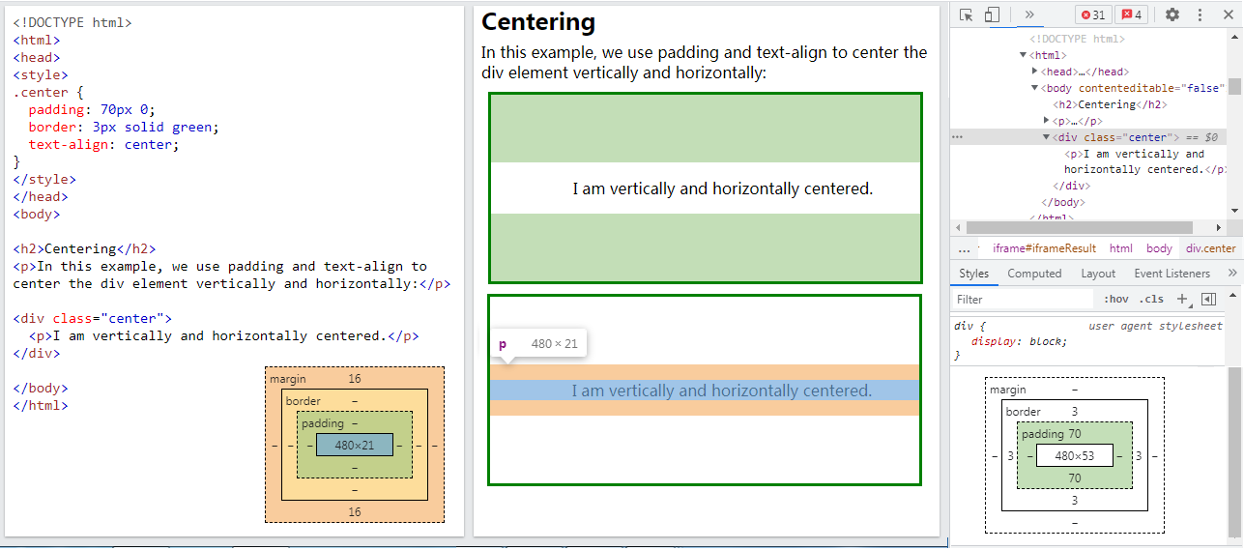

**Center Vertically - Using line-height**

Another trick is to use the line-height property with a value that is equal to the height property:

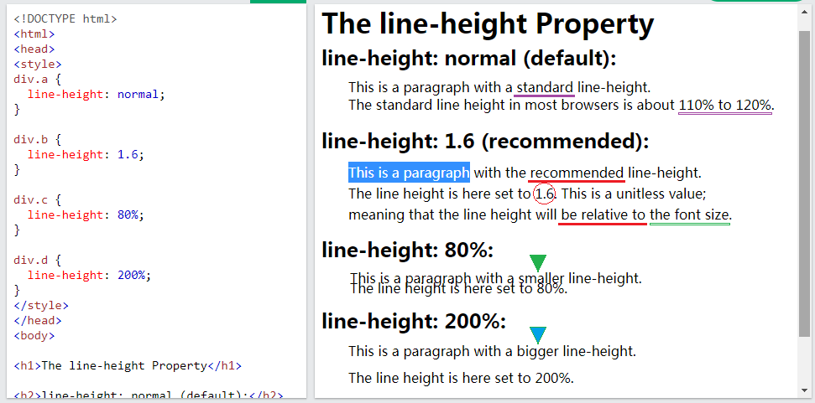

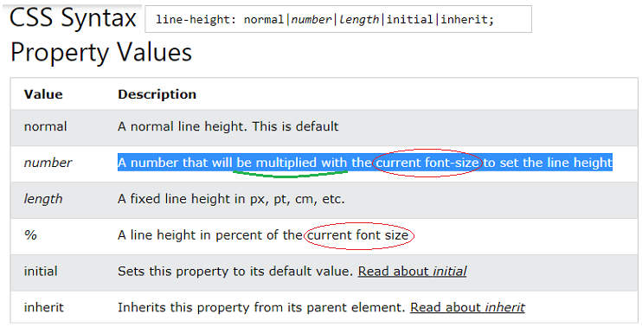

**Center Vertically - Using position & transform**

If padding and line-height **are not options**, another solution is to use **positioning** and the **transform**property:

**Center Vertically - Using Flexbox**

You can also use **flexbox to center things.** Just note that flexbox is not supported in IE10 and earlier versions:

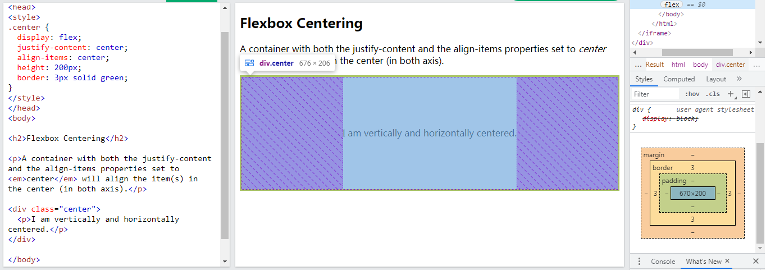

**text-align** **vertical** property: (**baseline,text-top**=>**sup ,text-bottom**=>**sub**.)

Set the vertical alignment of an image in a text :

vertical-align: baseline;

The vertical-align property sets the vertical alignment of **an element**.

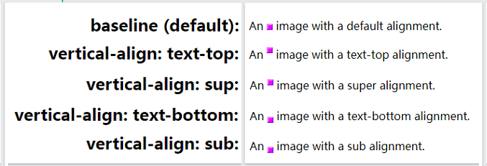

The filter property defines **visual effects** (like blur and saturation) to an element (often <img>).

**Animatable:**

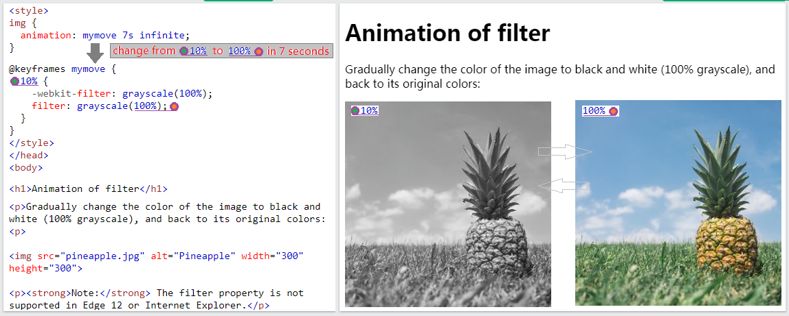

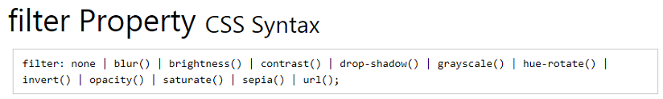

drop-shadow(**h-shadow v-shadow blur spread color**)

1. h-shadow – **Required**: Specifies a **pixel value for the horizontal shadow**. **Negative values** place the shadow to **the left of the image**.
2. v-shadow – **Required** : Specifies a **pixel value for the vertical shadow**. **Negative values** place the shadow **above the image**.
3. blur – **Optional**: This is the **third** value, and **must be in pixels**. Adds a blur effect to the shadow.

**A larger value** will create **more blur** (the shadow becomes bigger and lighter).

Negative values are not allowed. If no value is specified, 0 is used (the shadow's edge is sharp).

1. spread – **Optional**: This is the **fourth** value, and **must be in pixels**.

**Positive values** will cause the shadow to **expand and grow bigger,** and negative values will cause the shadow **to shrink**收縮. If not specified, it will be 0 (the shadow will be the same size as the element).

**Note:** Chrome, Safari and Opera, and maybe other browsers, do not support **this 4th length**; it will not render if added.

1. color - **Optional**. Adds a color to the shadow. If not specified, the color depends on the browser (often black).