<p> <**strong**>**This text is important!**<**/strong**> </p>

<p> Do not forget to buy <**mark**>milk<**/mark**> today. </p>

<p>This is normal text - <**b**>**and this is bold text**<**/b**>.</p>

**Note:** According to the HTML5 specification, the <b> tag should be used as a LAST resort when no other tag is more appropriate. The specification states that

**headings** should be denoted with the [<h1> to <h6>](https://www.w3schools.com/tags/tag_hn.asp) tags,

**emphasized** text should be denoted with the [<em>](https://www.w3schools.com/tags/tag_em.asp) tag,

**important** text should be denoted with the [<strong>](https://www.w3schools.com/tags/tag_strong.asp) tag, and

**marked/highlighted** text should be denoted with the [<mark>](https://www.w3schools.com/tags/tag_mark.asp) tag.

**Font-weight :**

**Font-size :**

**Text Color property**

**background-color**: lightgrey;

**color**: blue;

**text-align** **horizontal** property: (left or right aligned, centered, or justified.)

When the text-align property is set to **"justify"**, text-align: justify;

each line is stretched so that every line **has equal width**, and the **left and right margins** are **straight**直的(like in magazines and newspapers)

**text-align** **vertical** property: (**baseline,text-top**=>**sup ,text-bottom**=>**sub**.)

The vertical-align property sets the vertical alignment of an element.

Set the vertical alignment of an image in a text :

vertical-align: baseline;

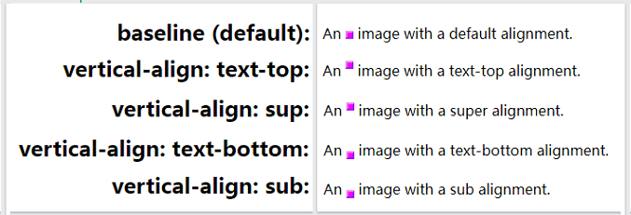

**text-decoration property**

The value text-decoration: none; is often used to remove underlines from links:

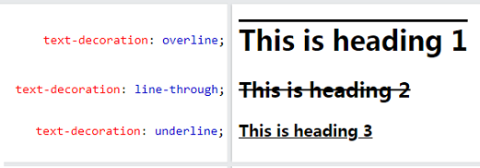

**text-transform property**

is used to specify uppercase and lowercase letters in a text. Or **capitalize** the first letter of each word:

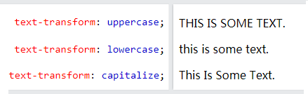

The**text-indent**property is used to specify the indentation of **the first line** of a text:

The **letter-spacing**property is used to specify the space **between the characters** in a text.

The**line-height**property is used to specify the space **between lines**:

The**word-spacing** property is used to specify the space **between the words** in a text.

The **white-space** property specifies how **white-space inside** an element is handled.

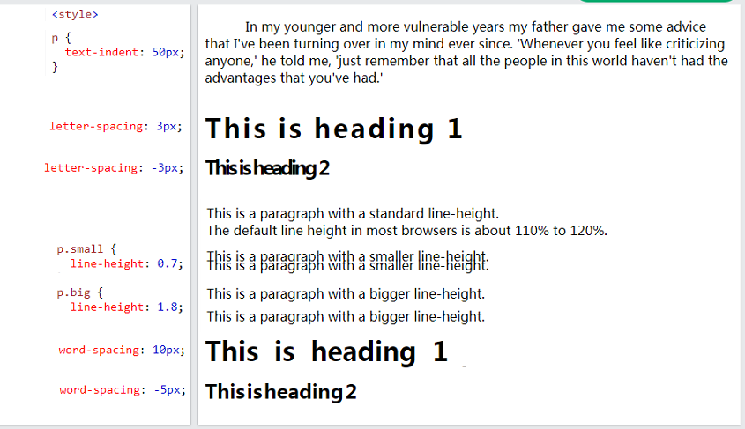

The **white-space** property specifies how **white-space inside** an element is handled.

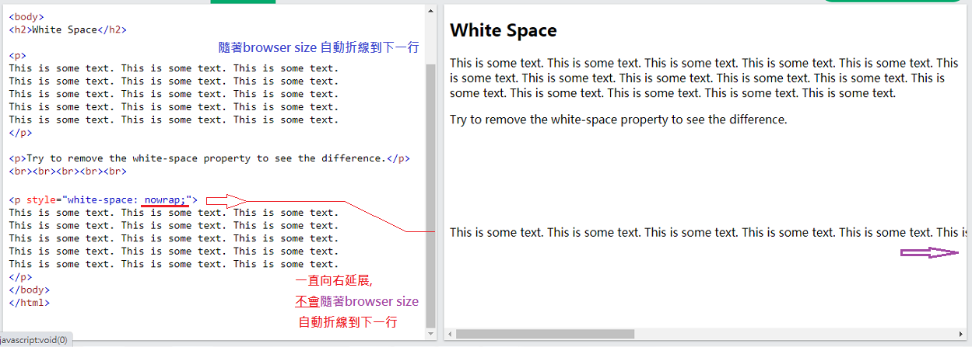

# CSS Text Effects

The CSS**text-overflow**property specifies how **overflowed content that is not displayed** should be signaled to the user.

**text-overflow**: clip|ellipsis|***string***|initial|inherit;

overflow: hidden; / **visible**

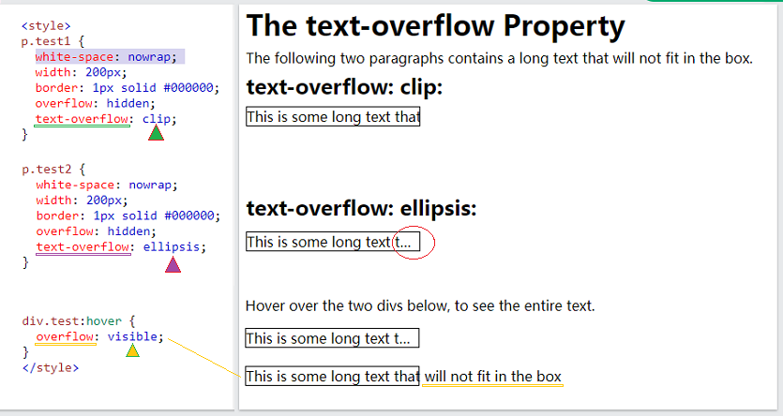

The CSS **word-wrap**property allows **long words** to be able to be broken and wrap onto **the next line**.

**Normal** value : Break words only at allowed break points

**break-word** value : Allows unbreakable words to be broken

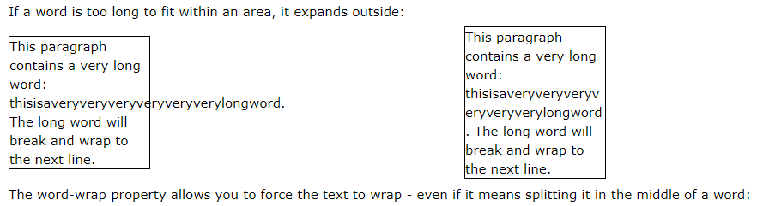

The CSS**word-break**property specifies **how words should break** when reaching the end of a line.

<https://www.w3schools.com/cssref/css3_pr_word-break.asp>

