**ES_HW02_110598040**

**陳廷豪**

**Character device driver code & C based program & Makefile**

1.Character device driver的chr_drv_ex1.c

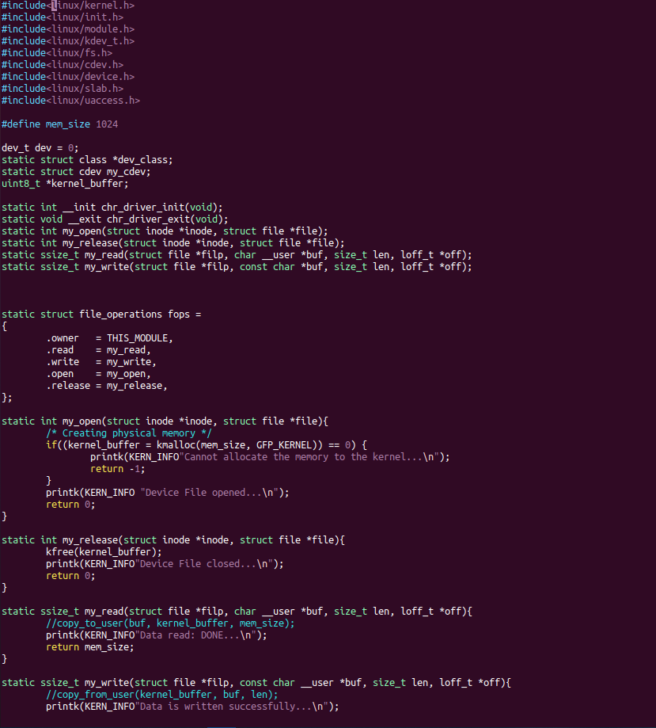

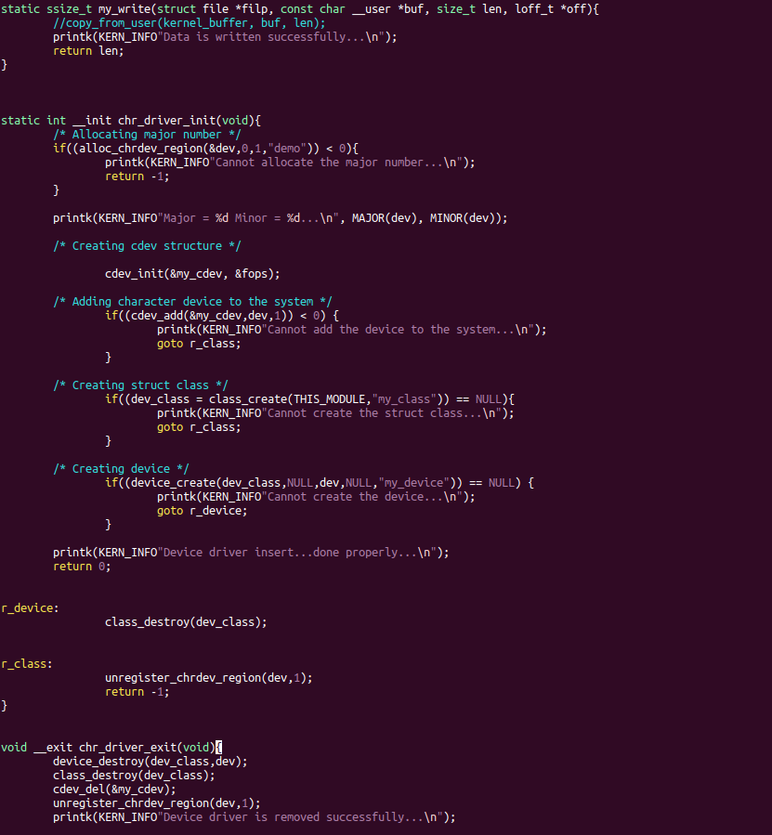

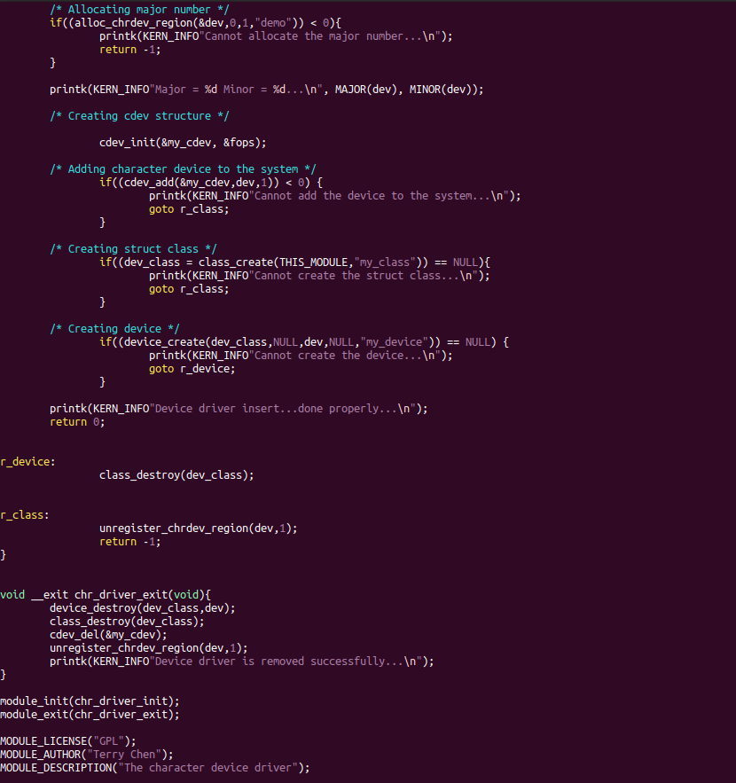

2. User Process的C based code

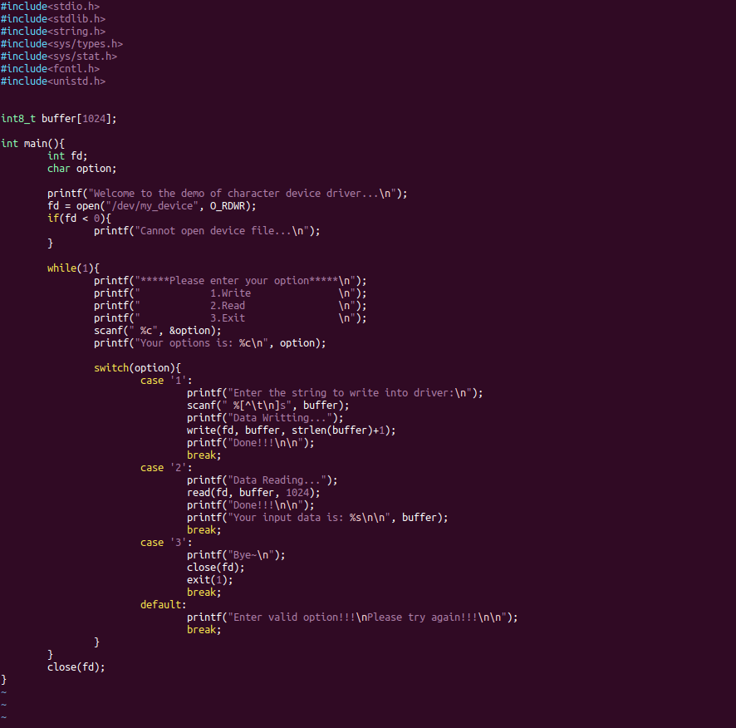

3.Makefile

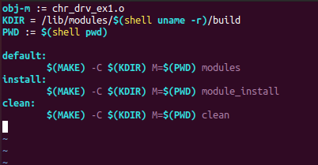

**Make successfully**

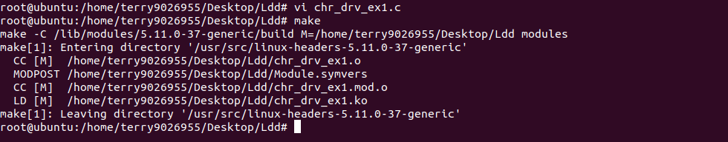

**Using lsmod to check module**

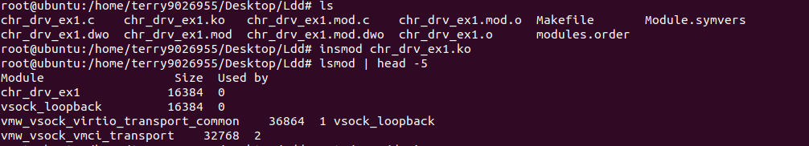

**Finding my device ”demo”**

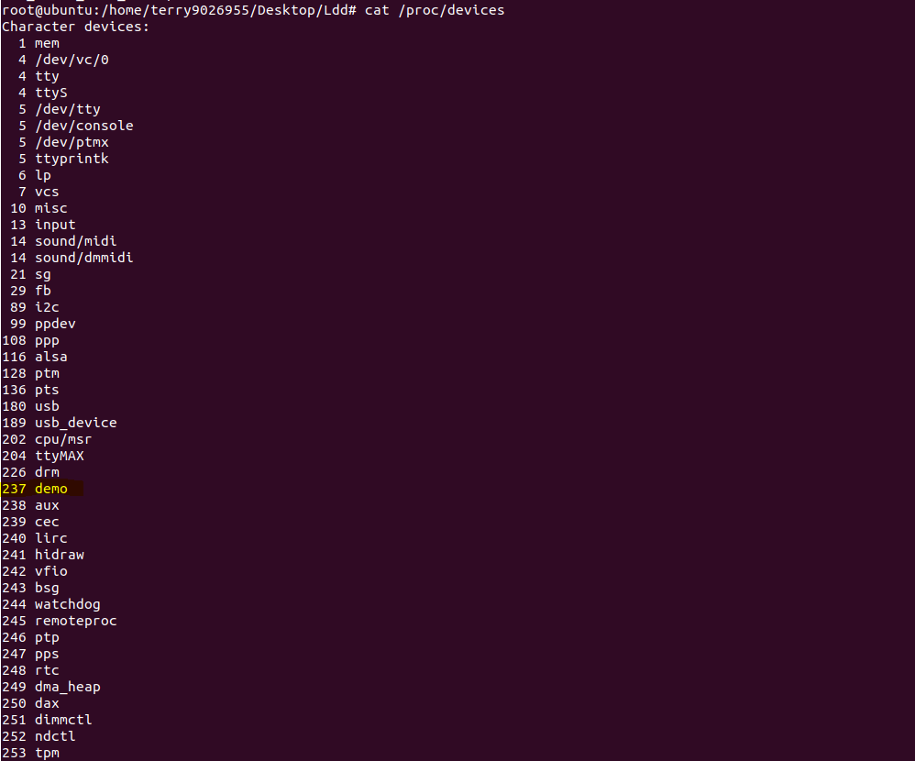

**Dmesg message “Major = 227 Minor = 0…”**

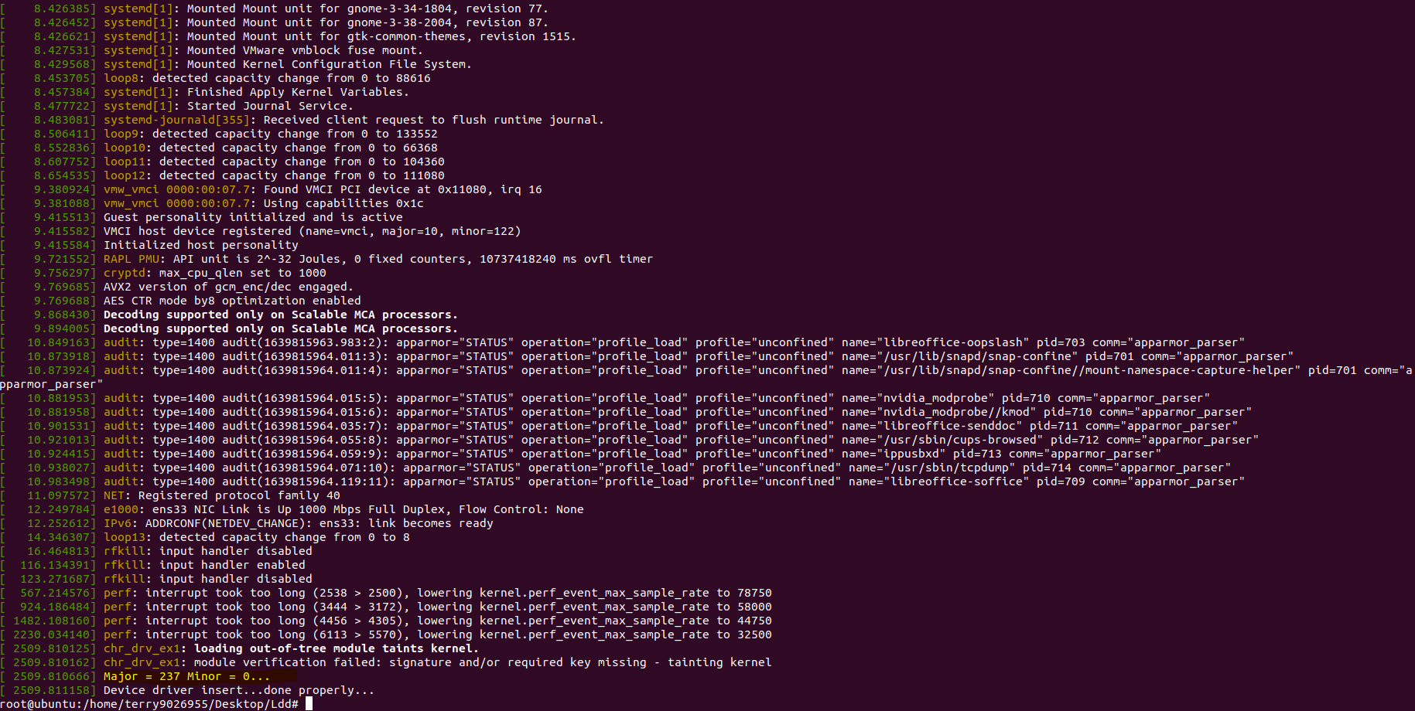

**The result of user process C program**

1. **input “1” and it starting write operation to write string into buffer**
2. **input “2” to read buffer content and show**
3. **input ”4” to check error operation**
4. **input “3” to exit**

