- Objective
This homework aims to classify social media sentences into positive, negative, or neutral sentiments. I fine-tuned some pre-trained BERT model to improve classification accuracy and achieve better performance on the given dataset.

- Implementation Details
- Data Preprocessing
To ensure fair evaluation and prevent data leakage, 10% of the provided dataset was extracted and saved as a fixed test set before training. For the remaining 90% of the data, 5-folded cross-validation was employed where the data was split in an 8:2 ratio in each fold at the beginning of each epoch. The cross-validation strategy was adopted to reduce overfitting, and stabilize performance fluctuations across each epoch, so as to make the model robust.

- Model Architecture
The backbone of this model is DeBERTa-v3-large developed by Microsoft. What make it unique are the hyperparameters used to fine-tune the model, and subtle changes about processing the token from the tokenizer.

- Training Pipeline
In all trials, the hyperparameters are required and doing well in large models, but some of them make the performance worse, such as low learning rate, weight decay and warm up steps.

- Experimental Result
- DeBERTa-v3-large (used)
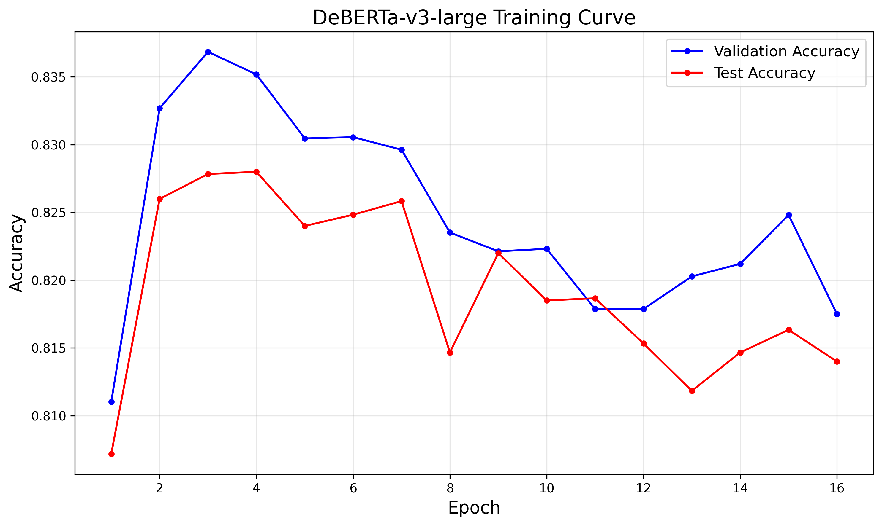
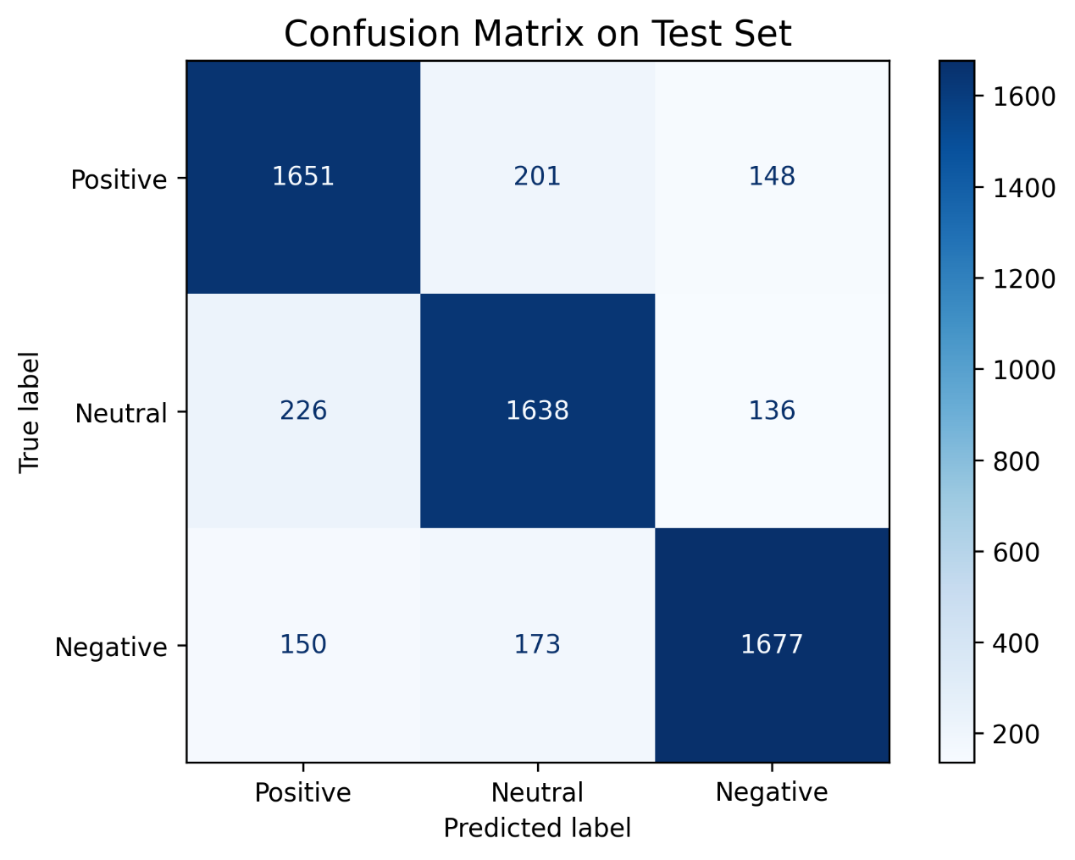

- Bert-base-uncased
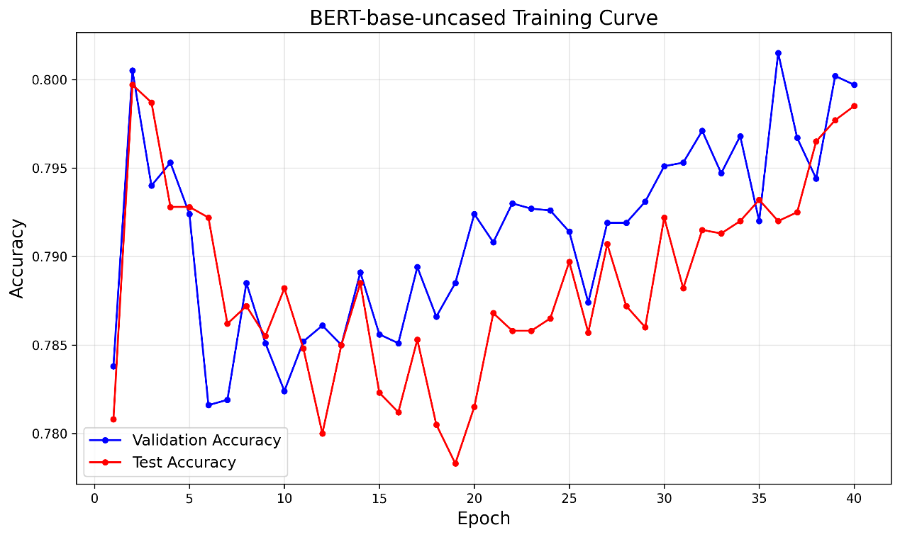

- Bert-large-uncased
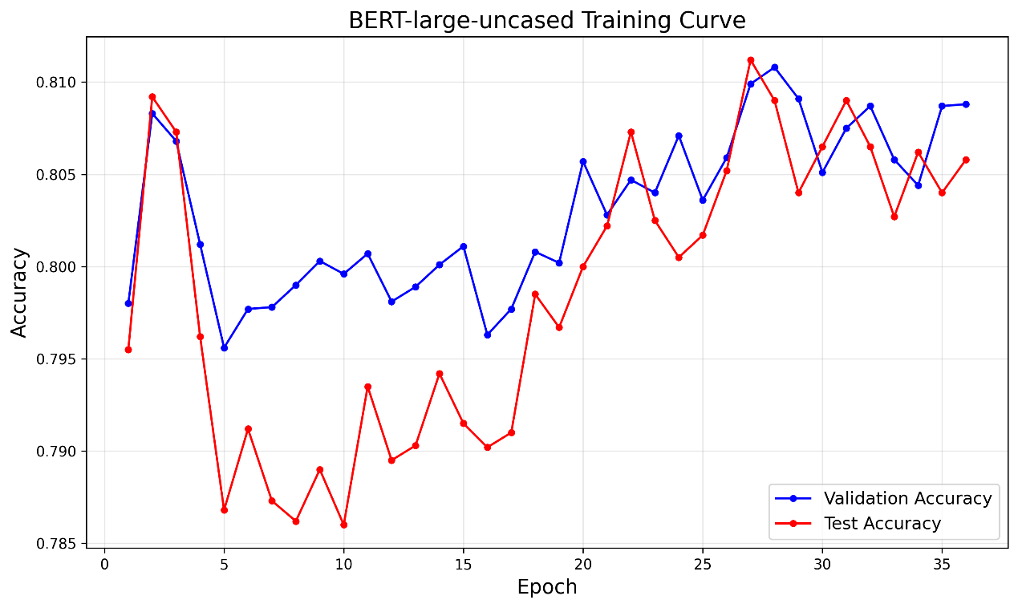

- RoBERTa-large
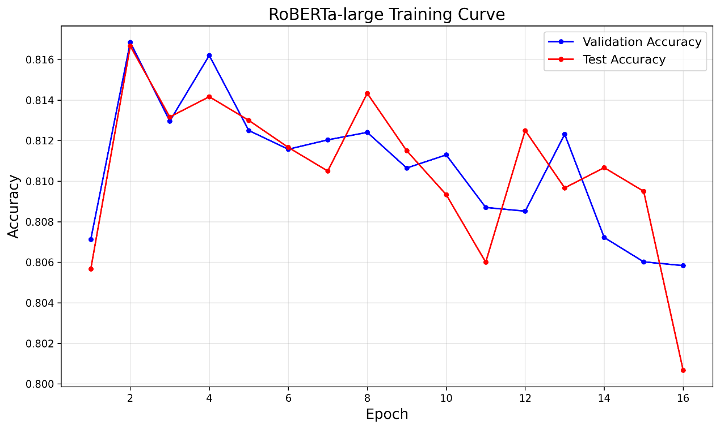

- Bertweet-base
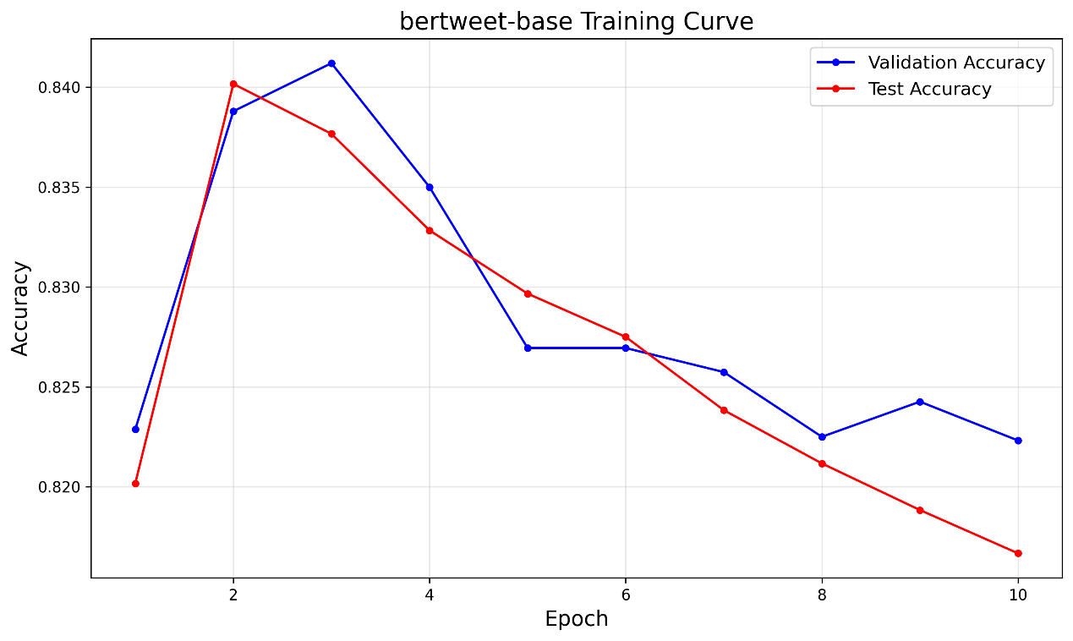

- Discussion
Regardless of the architecture of models, the highest validation accuracy was achieved around the second or the third epoch. After this point, performance began to decline, indicating the models had captured the dominant sentiment patterns within the first few epochs, which gave rise to overfitting on the training data. However, in the test of training 40 epochs, an interesting phenomenon was observed: the validation accuracy of both bert-base-uncased and bert-large-uncased slightly improved after epoch 20. This suggests that larger pretrained transformers can continue to extract finer-grained sentiment patterns from social media text even after early convergence. Bertweet-base attains the best performance among all the other models. Moreover, it have only 135M parameters, doing better than the second one, DeBERTa-v3-large, which has 435M parameters. Though bertweet-base may have a better effect on this homework, but DeBERTa has much more parameters and will have a better performance across different text domains.

