Part 1

Loss curve of DDPM with step = 300
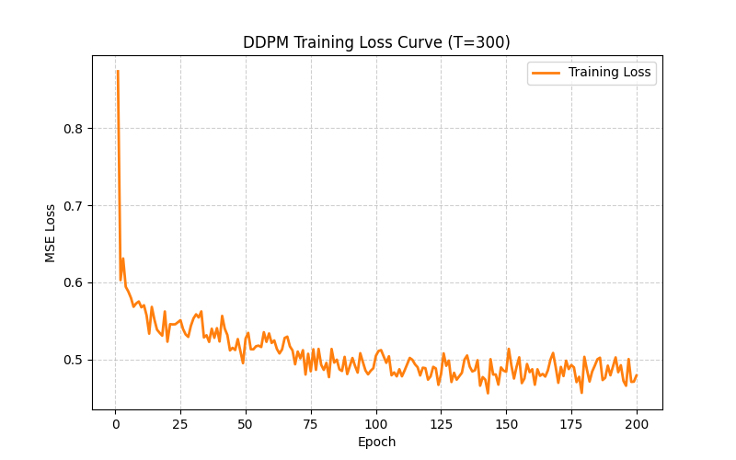

Denoising steps with 50 total steps
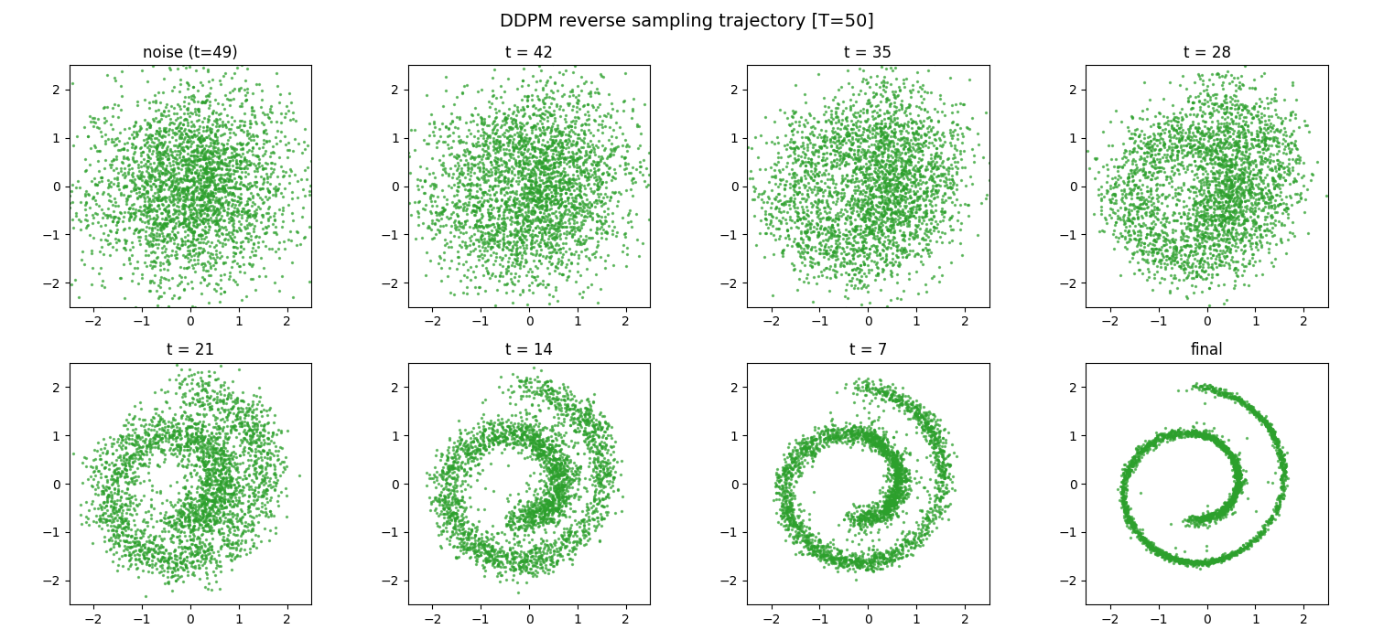

Denoising steps with 300 total steps
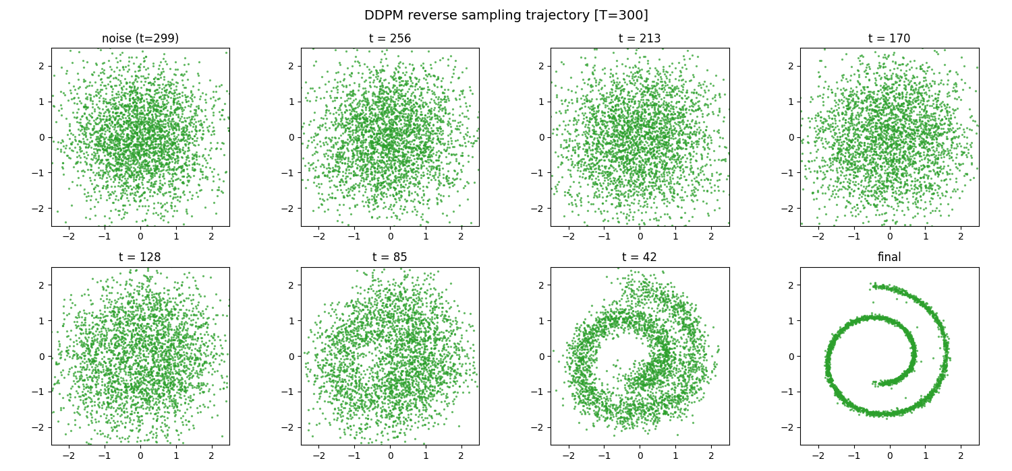

Denoising steps with 1000 total steps
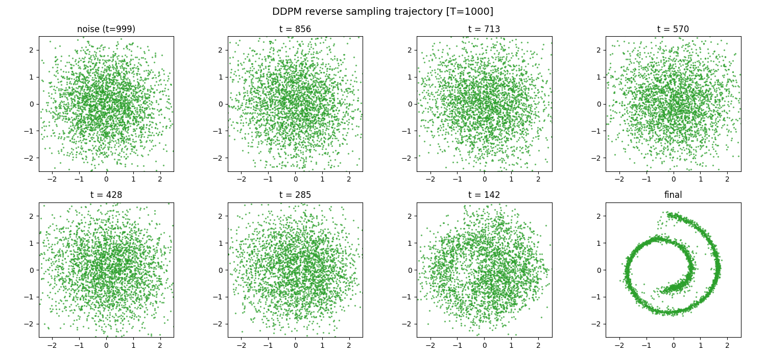

Part 2

Loss curve of basic GAN
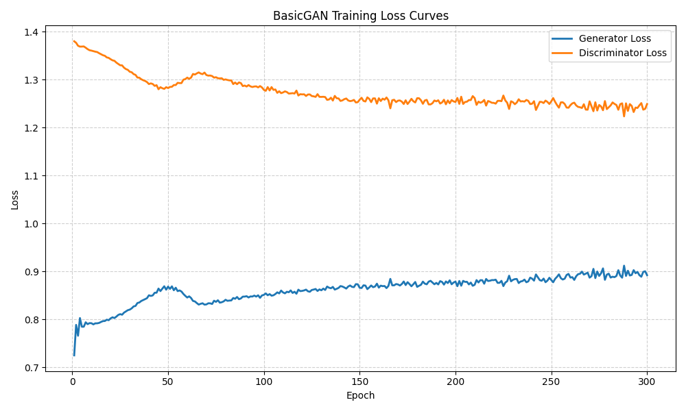

Loss curve of advanced GAN
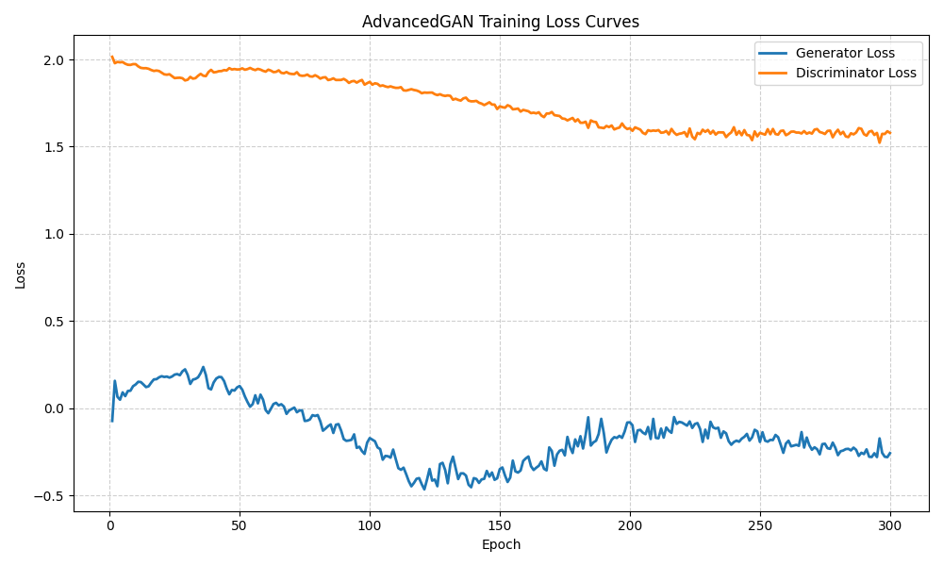

Steps by epoch (basic GAN)
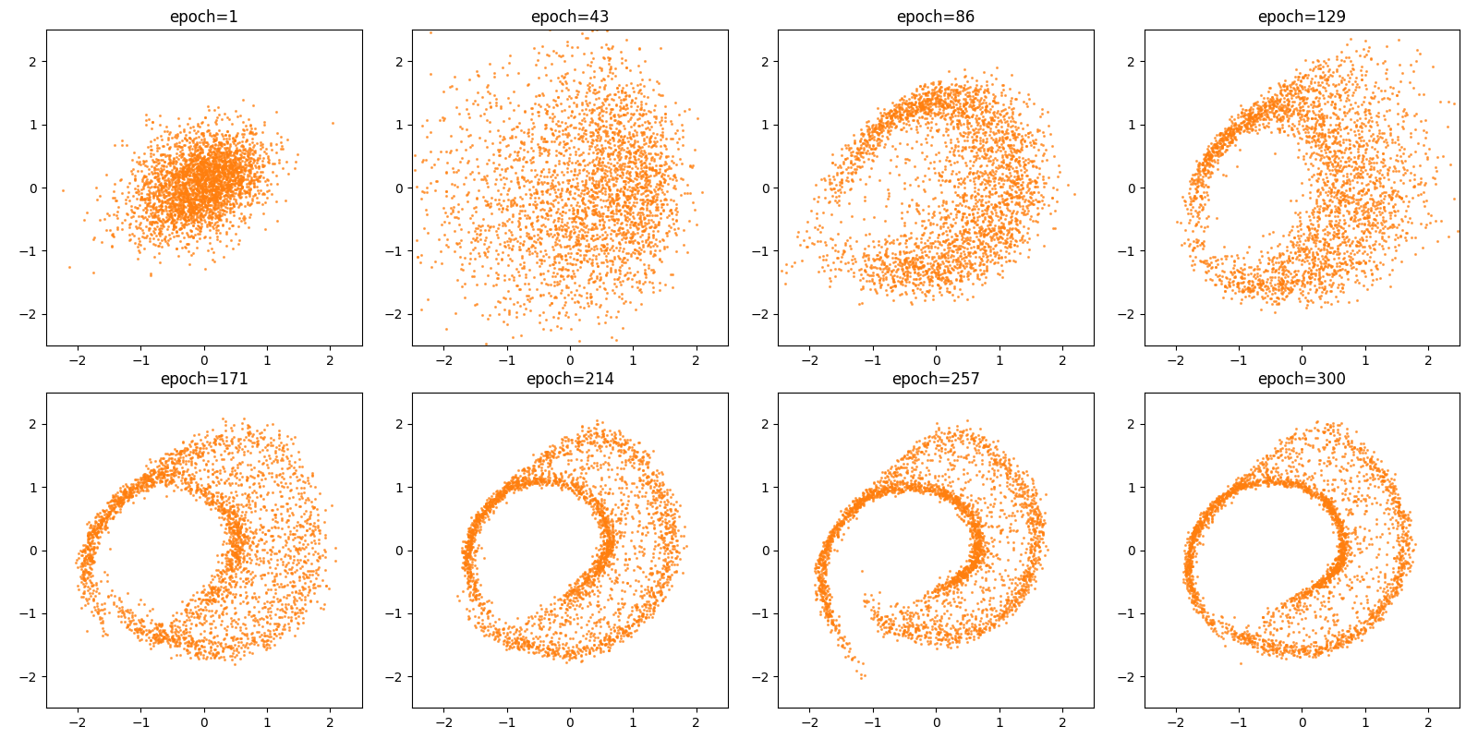

Steps by epoch (advanced GAN)
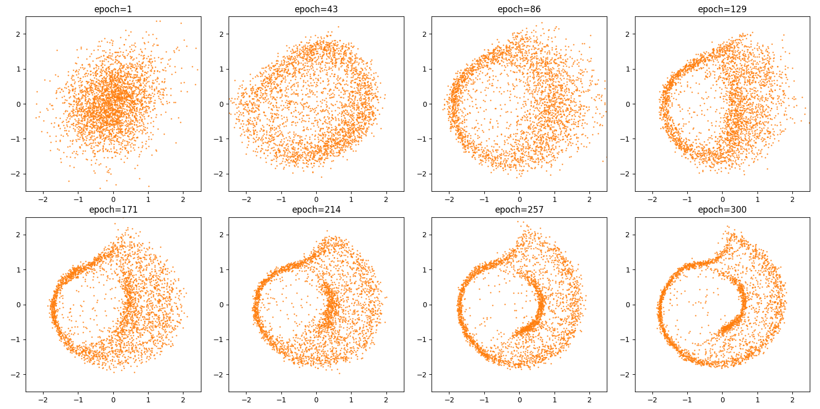

Metrics: Maximum Mean Discrepancy and Chamfer Distance
