《连连看》
#include <stdio.h>
int w,h,n;
int board[80][80]={};
int vis[80][80]={};
int next[4][2]={{-1,0},{1,0},{0,-1},{0,1}};
int dir[4]={0,0,1,1};//0:横向 1:纵向
int least=0;
bool can_go(int x, int y, int x2, int y2) {
if (x == x2 && y == y2) return 1;
if (x < 0 || x > h+1 || y < 0 || y > w+1 || vis[x][y]) return 0;
if (board[x][y]) return 0;
return 1;
}
void walk(int x2,int y2,int x,int y,int path,int direction){
if(path>10 || (least != 0 && path >= least))return ;//path不能超过10
if(x==x2 && y==y2){//到达
if(least==0){
least=path;
return ;
}
if(least>path)least=path;
}
for(int i=0;i<4;i++){
if(!can_go(x+next[i][0],y+next[i][1],x2,y2))continue;
int new_path = path;
if(direction!=-1 && direction!=dir[i]) new_path++;
vis[x+next[i][0]][y+next[i][1]]=1;
walk(x2,y2,x+next[i][0],y+next[i][1],new_path,dir[i]);
vis[x+next[i][0]][y+next[i][1]]=0;
}
return ;
}

int main (){
scanf("%d %d",&w,&h);
getchar();
for(int i=1;i<=h;i++){
for(int j=1;j<=w;j++){
char c;
scanf("%c",&c);
if(c=='X')board[i][j]=1;
}
getchar();
}
scanf("%d",&n);
for(int i=1;i<=n;i++){
int x1,y1,x2,y2;
least=0;
scanf("%d %d %d %d", &y1,&x1,&y2,&x2);
getchar();
vis[x1][y1]=1;
walk( x2, y2, x1, y1, 1, -1);
vis[x1][y1]=0;
if(least==0)printf("impossible\n");
else printf("%d\n",least);
}
return 0;
}
·最大公倍数
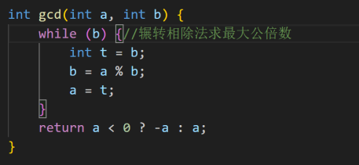

next_permutation
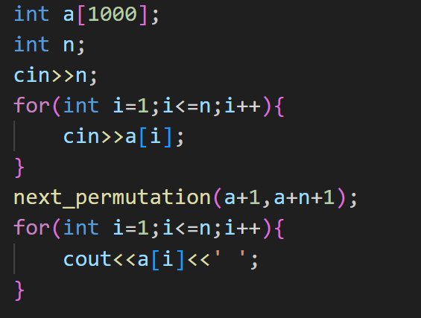
快速排序
#include <stdio.h>
#include <iostream>
using namespace std;
int partition( int ary[ ], int left, int right )
{
int judge=ary[left];
int front=left;
int end=right;
while(front<end){
while(ary[end]>=judge && front<end)end--;
ary[front]=ary[end];
while(ary[front]<=judge && front<end)front++;
ary[end]=ary[front];
}
ary[front]=judge;
return front;

}
void quicksort( int ary[ ], int left, int right )
{
if(left>=right)return ;
int m=partition(ary,left,right);
if(left<=m-1)quicksort(ary,left,m-1);
if(right>=m+1)quicksort(ary,m+1,right);

}
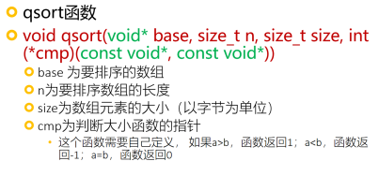
int compare_int(const void *a, const void *b) {
return *(int*)a - *(int*)b; }
int main() {
int arr[] = {9, 5, 7, 3, 1, 8, 4, 6, 2};
int n = sizeof(arr) / sizeof(arr[0]);
qsort(arr, n, sizeof(int), compare_int);
for(int i = 0; i < n; i++)
printf("%d ", arr[i]);
// 输出: 1 2 3 4 5 6 7 8 9
return 0;}
New&delete
int *pvalue = NULL, *pAry; // 初始化为 null 的指针
pvalue = new int; // 为变量请求内存
pAry = new int[10]; // 为数组的动态内存分配
(二维数组
int **array
// 数组第一维长度为 m， 第二维长度为 n
// 动态分配空间
array = new int *[m];
for( int i=0; i<m; i++ ){
array[i] = new int [n] ;
}
//释放
for( int i=0; i<m; i++ ){
delete [] arrary[i];
}
delete [] array;
