${issueDate}

|  |  |
| --- | --- |
| Re: | ${companyName}  ${companyAddress} |

Dear Sir/Madam:

Under the requirements of 33 CFR 155.4035(b)(2), this letter serves as verification and confirmation that Pre-Fire Plans for the vessels listed below have been reviewed by Donjon-SMIT marine firefighters and that each vessel’s Pre-Fire Plan is sufficient to meet our firefighting needs when responding to an incident aboard the vessel.

The following vessels are covered by this certification:

|  |  |  |  |
| --- | --- | --- | --- |
| ${c1VesselName} | ${c2VesselName} | ${c3VesselName} | ${c4VesselName} |

Pre-Fire Plans will be forwarded to and reviewed by Donjon-SMIT firefighting subcontractors and public fire departments we would utilize in a marine fire response under the terms of our contract with ${companyName}.

Pre-fire plans may be viewed online at members.donjon-smit.com. Login details are available upon request.

If there are any questions or additional information required, please contact Donjon-SMIT via telephone at 1-703-299-0081 or email at admin@donjon-smit.com.

Sincerely:

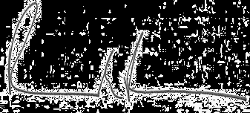

DONJON-SMIT, LLC

Richard Fredricks

Vice President

Copy to: ${QIs}