**SALVAGE, FIREFIGHTING & LIGHTERING**

**CONTRACT CERTIFICATION**

Donjon-SMIT LLC certifies that **${companyName}** (Client), as owner, operator, manager and/or agent of owner has ensured, by contract or other approved means, the availability of private salvage, firefighting and lightering personnel and equipment capable of responding to a casualty to the below listed Covered Vessel(s) in accordance with the Oil Pollution Act of 1990 (OPA-90) and Donjon-SMIT LLC separately certifies that Client has ensured, by contract or other approved means, the availability of required Vessel Emergency Services capable of responding within the required response times and in the specified Geographic Regions for the below listed Covered Vessel(s) in accordance with the California Code of Regulations Title 14.

Donjon-SMIT LLC agrees that Client has the right to name Donjon-SMIT LLC and its resources for OPA-90 and California Code of Regulations Title 14 coverage for the below listed Covered Vessel(s). Donjon-SMIT, LLC reserves the right to rescind this authorization in the event of termination of its contractual arrangements with the below listed Covered Vessel(s).

|  |  |  |  |
| --- | --- | --- | --- |
| ${c1VesselName} | ${c2VesselName} | ${c3VesselName} | ${c4VesselName} |

By:

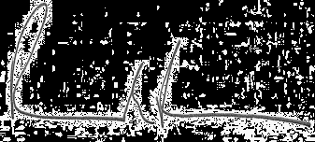

DONJON-SMIT, LLC

Richard Fredricks

Vice President Date: ${issueDate}