**Consent Agreement**

**For Vessel Response Plan**

This Agreement is entered into in accordance with 33 Code of Federal Regulations (“CFR”) Part 155, Salvage and Marine Firefighting Requirements; Nontank Vessel Response Plans; Final Rule dated September 30, 2013

DONJON-SMIT LLC hereby agrees to provide Salvage and Marine Fire Fighting services as further referenced within 33 CFR 155.4030 (a through h) and these services are capable of arriving within the response times listed in Table 155.4030(b) and consents to be listed within Vessel Response Plans issued to the below referenced company.

This agreement remains valid only for non-tank vessels carrying groups I through IV petroleum as fuel or cargo with a total capacity of less than 2,500 barrels.

This agreement remains valid for one year from the date of issue and will renew automatically for each subsequent one-year period.

This agreement may be terminated by either party by giving the other party 30 days written notice of such termination.

|  |  |
| --- | --- |
| Company: | ${companyName}  ${companyAddress} |

By: Issue Date: ${issueDate}

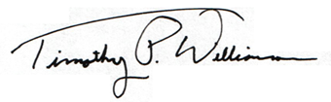

DONJON-SMIT, LLC

Timothy P. Williamson

General Manager