Soil Moisture Recommendations for Common Plants

May 22, 2023 • RainPoint

Soil moisture values are especially important for the health and vigor of flowers, plants, and vegetables, as well as for irrigation optimization. Proper watering ensures that plants receive an adequate supply of water while preventing problems such as root rot or drought stress. In this article, we will provide soil moisture recommendations for some common plants to help gardeners can adjust their irrigation schedules to the actual crop.

# What is Soil Moisture?

Soil moisture is the amount of water present in the soil and is one of the indicators of soil health. Soil moisture represents the proportion of water content in the soil relative to the maximum water-holding capacity of the soil. Soil moisture can be classified into three zones: dry, moist, or saturated.

To improve daily irrigation, gardeners can choose a soil moisture meter for monitoring the water content. Users can adjust the irrigation schedule accordingly based on changes in moisture values.

# Factors Affecting Soil Moisture

Soil moisture is influenced by factors such as climate, vegetation, and soil characteristics.

## Climate

Soil moisture is mainly limited by rainfall, such as the amount of rainfall, frequency, and intensity of rainfall. Frequent rainfall continuously replenishes the soil with water and maintains high soil moisture levels. However, prolonged or heavy rainfall may cause problems such as erosion.

## Salt Content

Salt makes the soil more compact, reducing the permeability of the soil and the rate at which water moves through the mud. This means soils with a higher salt content will have a relatively poorer ability to retain water.

## Vegetation

The roots of plants absorb water from the soil and reduce the rate of water loss from the soil. Prolonged vegetation cover prevents water evaporation and increases the water storage capacity of the soil.

## Soil Type and Properties

Different soil types and properties have different abilities to adsorb, store, transport, and release water. For example,

□Sandy soils and loamy soils have significant porosity and wider pore size. Water is less mobile in soil pores and water penetrates faster, but their water storage capacity is poor.

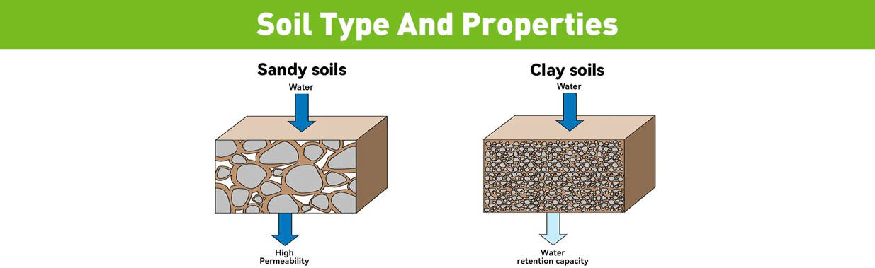□Clay soils and black soils contain higher levels of sedimentary clay particles and organic matter. These components help to form fine pores and pore channels, which have a better water retention capacity.

# Good Soil Moisture Percentage for Plants

The optimum moisture percentage for plants will vary depending on plant type, growth stage, climate, and soil type. General guidelines are as follows:

The humidity range for most flowers is between 21% and 40%.

 Agave: 20%-40%

 Aster: 40%-60%

 Bleeding Heart: 41%-60%  Butterfly Weed: 21%-40%  Cactus: 21%-40%

 Catmint: 21%-40%

 Christmas Fern: 21%-40%

 Begonia Coneflower: 21%-40%

 Daffodil: 21%-60%

 Dalia: 21%-60%

Trees and shrubs in the humidity range of 20-60%.

 Alpine Current: 21%-40%

 Bald Cypress: 21%-80%

 Barberry: 21%-40%

 Birch: 41%-60%

 Crab Apple: 21%-60%

 Elderberry: 21%-80%

 Elm: 21%-60%

 Hydragea: 41%-60%

 Potentilla: 10%-40%

 Willow: 41%-80%

The ideal humidity range for vegetables is between 41%-80%.

 Apple: 21%-60%

 Grapes: 21%-60%

 Fig: 21%-60%

 Pear: 21%-60%

 Peach: 21%-60%

 Raspberry: 21%-60%

 Strawberry: 21%-60%

 Blackberry: 21%-60%

 lueberry: 21%-60%

 Cranberry: 61%-80%

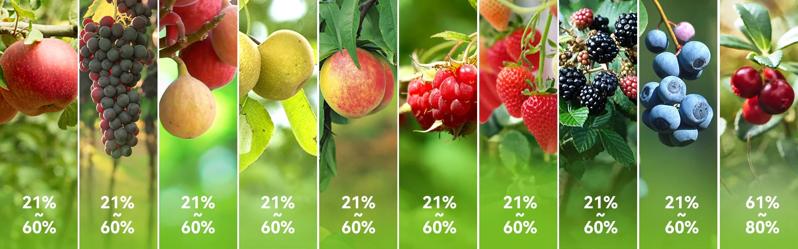

# How to Measure Soil Moisture

Soil moisture changes with soil depth. You can stick your finger into the soil and feel how dry it is. General guidelines for plants that need watering are as follows:

 Potted plants: 1-3 inches of dry soil at the surface.

 Shrubs or trees: 6-9 inches of dry soil on the surface.

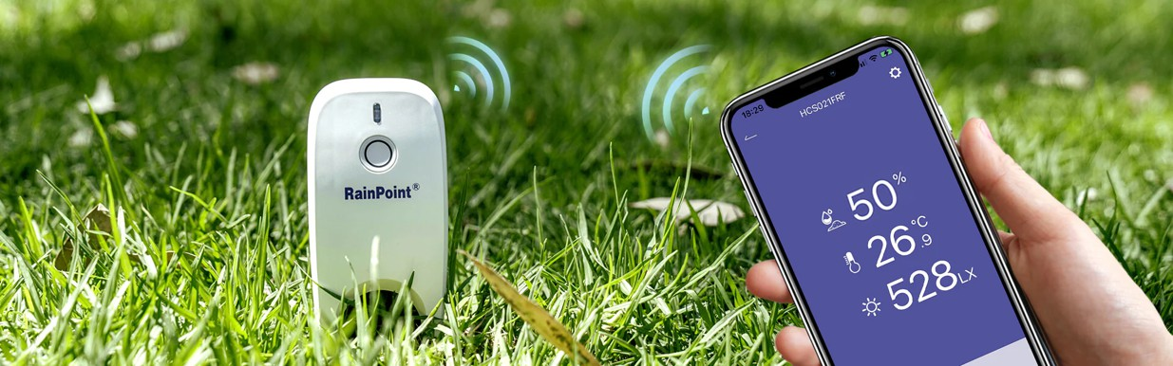Another method is to use a soil moisture meter. Moisture data closer to the roots is more informative, and the RainPoint Smart+ soil moisture sensor can measure soil moisture in deeper areas. You simply insert the moisture sensor into the area to be measured, and within the 60s the sensor will provide you with the moisture level. You can view the exact value via the HomGar APP.

By comparing the humidity range of common plants, you can see if the plant is currently in an ideal humidity space. With the data to back it up, you can enhance your irrigation or randustreamline your watering schedulemaintain soil moisture in a normal levels.

# Conclusion

Maintaining proper soil moisture levels is critical to both plant health and productivity. By knowing the optimum moisture zone for plant growth and setting moisture thresholds on a water timer, gardeners can effectively prevent over- and under-watering problems. It is important to note that the humidity recommendations provided in this article are based on general guidelines and commonly recommended practices. It is recommended that gardening experts and authorities such as Cooperative Extension be consulted for more professional advice.

Share



BA C K T O L A W N & G A R DEN

## Mowing Tips Every Home Owner Should Know The 5 Best Lawn Mowers for You

LEAVE A COMMENT

Please note, comments need to be approved before they are published.



Name



Email



Comment



PO ST CO MMEN T

This site is protected by reCAPTCHA and the Google Privacy Policy and Terms of Service apply.

 

CA T E G O R I E S

CO NT A C T US

POLI CI E S

MORE BENEFI TS

Smart+



Wi-Fi Hose Timers Bluetooth Hose Timers Digital Hose Timers Drip Irrigation System Water Meters

Garden Sensors



Customer Support Distributors

Affiliate Program About Us

Privacy Policy Refund Policy Shipping Policy Terms of Service

Enter email here

Apply for our free membership to receive exclusive deals, news, and events.

FI ND RAI NPOI NT



Ascension Island (USD $)

Get 10% Off

Send us a message

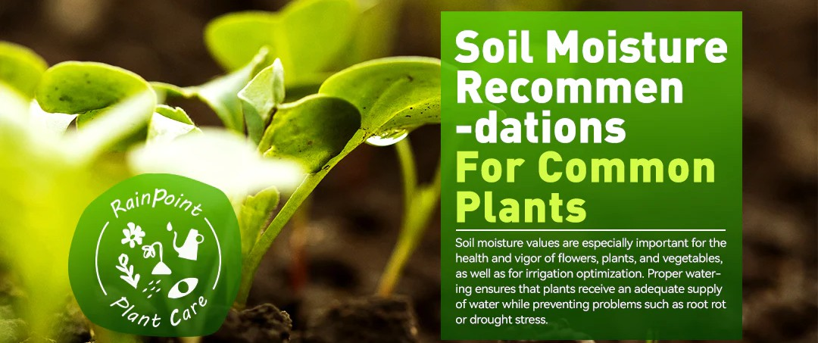

Join us and enjoy 5% commission now

SMART+ WAT E R I N G & G R O W I N G CU ST O MER C AR E GA R D E N L I F E PA R T N E R S H I P CO NTA C T U S

AC ($) English

© 2024, RainPoint Irrigation. All rights reserved.