# Roland Horology

# Tower Clock Timer Controller

# Users Manual

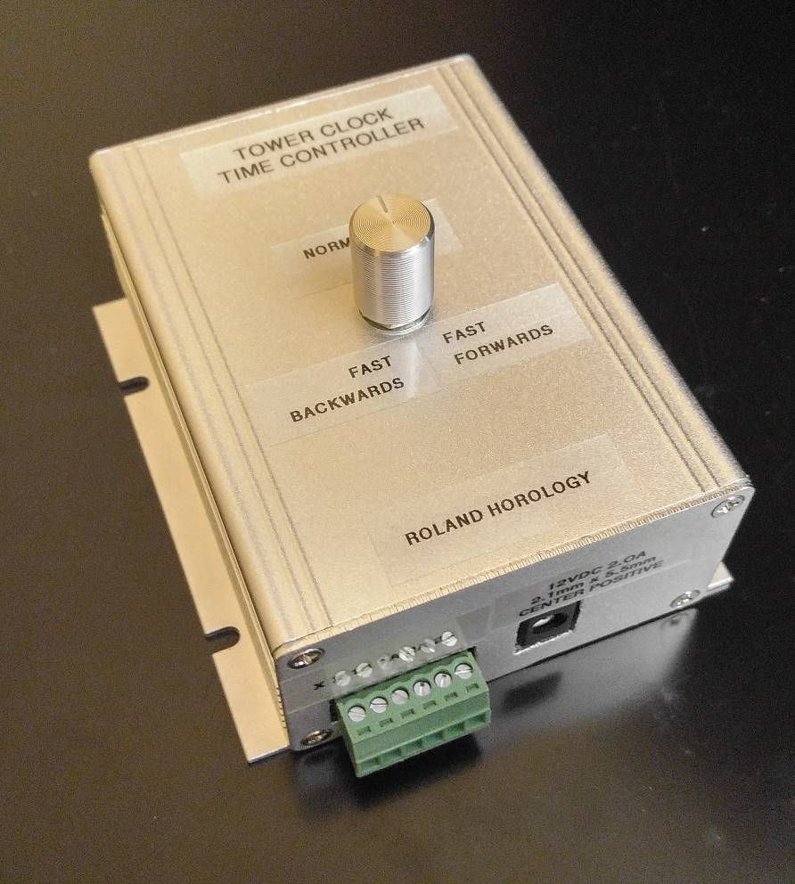

Contents

Introduction 3

Contents: 3

Safety: 3

Operating and Controlling the Tower Clock 3

Daylight Savings Time adjustment 3

Power and Wiring 4

Change Battery 5

Wi-Fi 6

HOME page 6

CONFIG>ADMIN page 7

CONFIG>GENERAL page 8

CONFIG>NETWORK 10

CONFIG>SYSTEM 10

CONFIG>TIME 11

CONFIG>uC File Editor 12

CONFIG>Update Firmware 12

Security 12

Technical Details 14

## Introduction

The Roland Horology Tower Clock Timer Controller is a custom-made purpose-built Wi-Fi enabled stepper motor driver. The controller contains the most precise electronic clock movement available and precisely controls the stepper motor in your Roland Horology Tower Clock which is providing the motion to the clock hands.

## Contents:

(1) Wall mountable Wi-Fi enabled Tower Clock Time Controller

(1) 12V 2.0A DC power supply. 2.1mm x 5.5mm, center positive

## Safety:

Power should be removed from the controller before connecting or disconnecting the wires to the stepper motor

## Operating and Controlling the Tower Clock

The controller features a single dial on the front. When the dial is in the center the clock will behave like a normal clock. When the dial is rotated clockwise or counter-clockwise, the clock will rotate accordingly. This can be used to set the time on the face of the clock.

The electronic “clock movement” is provided by an ultra-precise temperature-compenated RTC (Real Time Clock) chip: the *Maxim Integrated DS3231*. The stepper motor advances the clock appropriately each time the RTC chip advances one second. The positions of the hands on the clock face are not directly determined by the RTC, and therefore the initial time must be set. In other words, if you change the time that the RTC is reporting (through the web interface), the clock face will not automatically adjust. The clock only advances based on the RTC’s reporting that one second has passed. This and other features may be added in the future.

### Daylight Savings Time adjustment

If daylight savings time is configured (it is by default), the clock will move forward or backwards by one hour at midnight on the appropriate day. Daylight Savings time can be turned on/off via the web interface.

## Power and Wiring

The controller accepts 12VDC @ 2.0Amps maximum through a standard round DC plug with common dimensions of 2.1mm x 5.5mm. The motor will typically draw about 1A of power while moving regardless of its speed.

The motor in the Tower Clock should come pre-wires to the green terminal blocks, simply plug them into the bottom. The following is an explanation on how to wire them in case there is an issue:

The four Stepper motor wires should be wired to the removable plug using a small screw driver. The plug can be removed for ease of wiring. The stepper motors used in your clock has two pairs of two wires for a total of four wires total. Each pair are connected through each other through a small coil in the motor. One pair should be wires to terminal 1A and 1B, and the other paid should be wires to 2A and 2B. To determine which wires are each pair, use a multimeter set on Ohms mode and test two wires at a time. Each pair will register ~2.0Ohms. If the clock is moving backwards, swap the pairs, or use the webpage to configure the direction

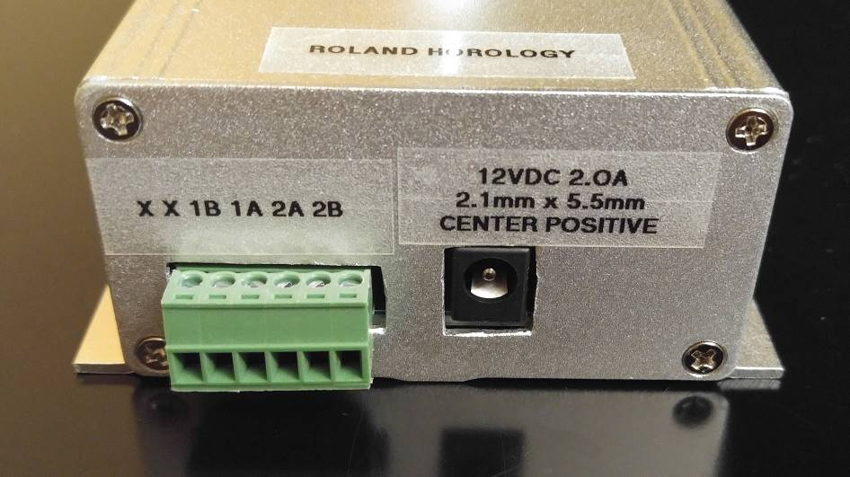

Note that the two, left most terminals are not used and no wires should be connected to them.

## Change Battery

Your Tower Clock Controller contains a standard CR2032 coin cell battery, like any electronic time piece. However, unless other electronic time pieces the power from the DC adapter is powering the clock movement. Therefore this battery is used as a backup during shipping to you or in case power is interrupted. Under normal circumstances you should only need to replace this battery every 10 years. The battery will power the clock for approximately 6 months continuously (if controller is not plugged in). If you need to change the battery, unplug the unit and unscrew one of the sides and slide the circuit board out of the housing. The CR2032 battery is simply clipped in place. Unclip it, replace it, and put everything back together

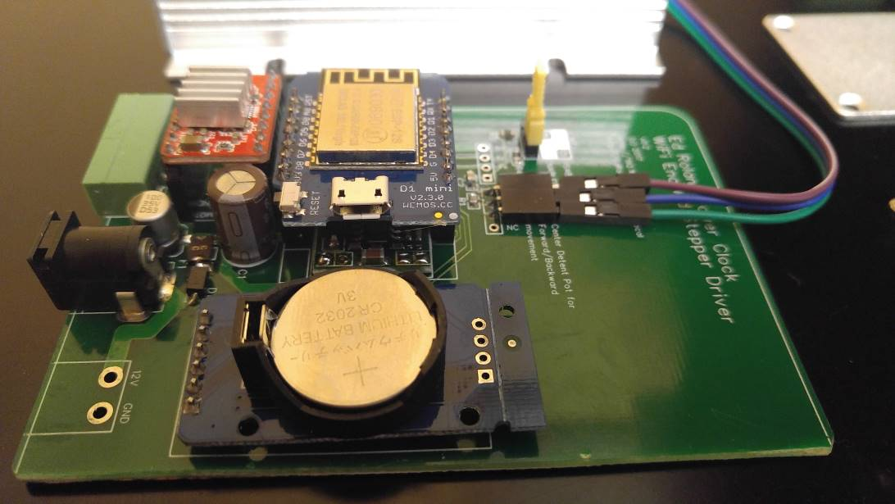

## Wi-Fi

When powered on, the controller broadcasts an open Wi-Fi name (or SSID) that you can connect to through your phone or computer: *RolandTowerClock*. Connecting to this Wi-Fi will disconnect you from your Wi-Fi and therefore the internet during the duration you are connected. Your device may alert you that this Wi-Fi has no internet connection. Of course it doesn’t, you just connected to an isolated Wi-Fi inside of a box!

After connecting, browse the following web pages:

http://192.168.4.1

http://RolandTowerClock.local

*Note that the above is only accessible from an apple product or a device with Bonjour printer services installed. On a Windows PC you can download Bonjour Printer Services, just use the googles!*

The web page will ask for authentication:

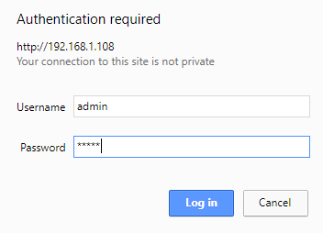

The default login is “admin”

The default password is “admin”

### HOME page

page is a slider that mimics the function of the knob on the front of the box by allow you to move the clock hands forward and backwards at various speeds.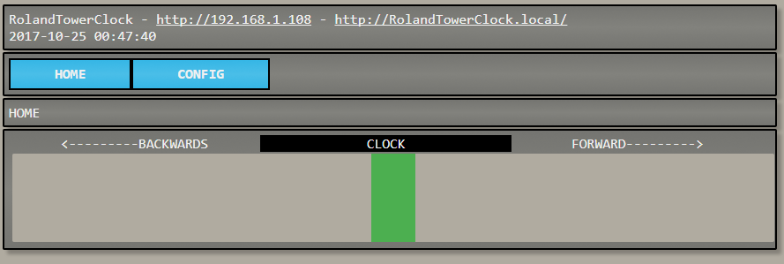

### CONFIG>ADMIN page

Allows you to change the default login/password of this web page, reset all configuration settings to default, or restart the device

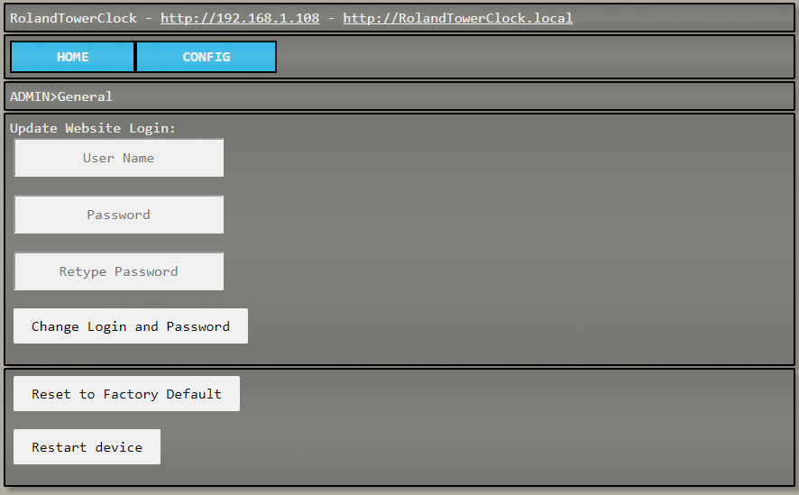

### CONFIG>GENERAL page

Allows you to change the stepper configuration, knob or potentiometer deadband, or manually control the stepper motor. The settings on this page should be changed with caution

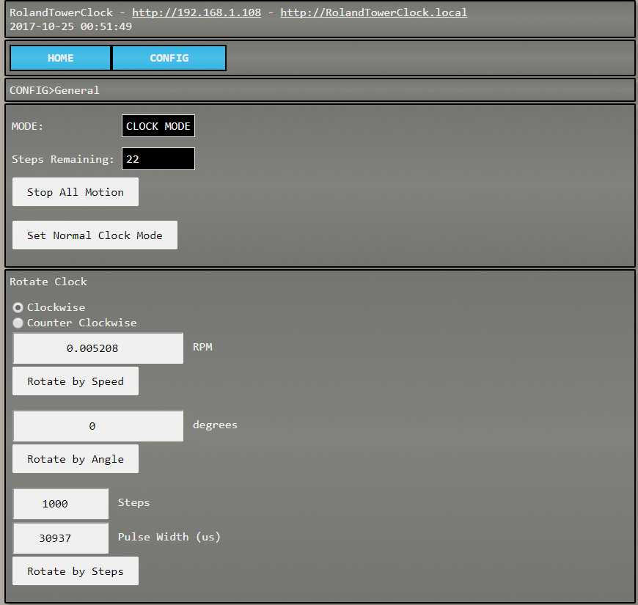

Stop All Motion – Stops all Clock Motion.

Set Normal Clock mode – Starts moving the clock normally

Manual movement section – Used for debugging mainly.

Clockwise/Counter Clockwise, set the direction of the stepper motor. All “Rotate by…” buttons obeys the Clockwise/Counter Clockwise radio buttons

RPM / Rotate by Speed – Spin final drive mechanism (typically the minute hand) at a specified RPM.

Degrees / Rotate by Angle – rotate the stepper motor by a set angle in degrees.

Steps / Pulse Width (us) / Rotate by Steps – Command the stepper driver to move the motor an exact number of steps with a specified pulse width in microseconds

#### CONFIG>GENERAL cont.

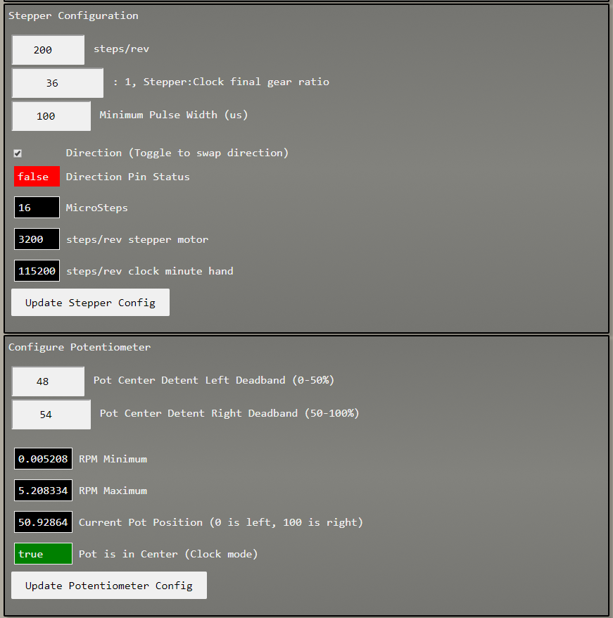

Stepper Configuration

Update the base number of steps/rev of the stepper motor used

Update the gear ratio between the stepper motor and the minute hand.

Set the minimum pulse width used to set min and max speeds by the pot, web page, etc.

Potentiometer configuration.

Update the deadband in the middle of the knob

Display Min/Max Speeds (Calculated from minimum pulse width, steps/rev, and gear ratio)

Display Current knob position

### CONFIG>NETWORK

Display WiFi information. Allows you to connect the device to your local Wi-Fi.

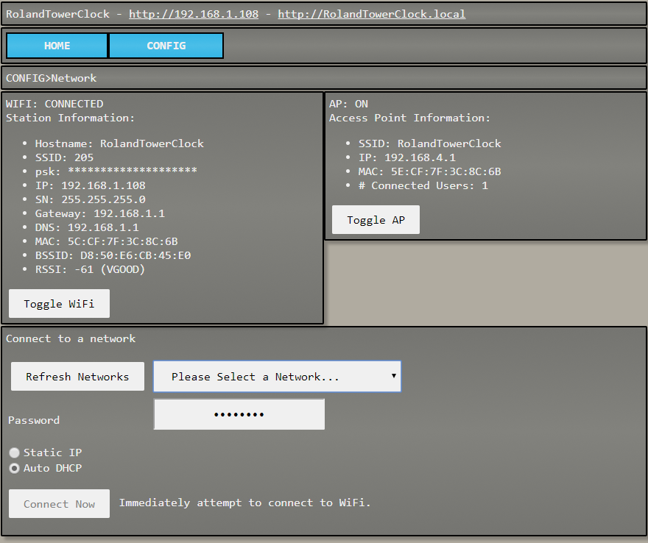

### CONFIG>SYSTEM

Displays microcontroller diagnostic information

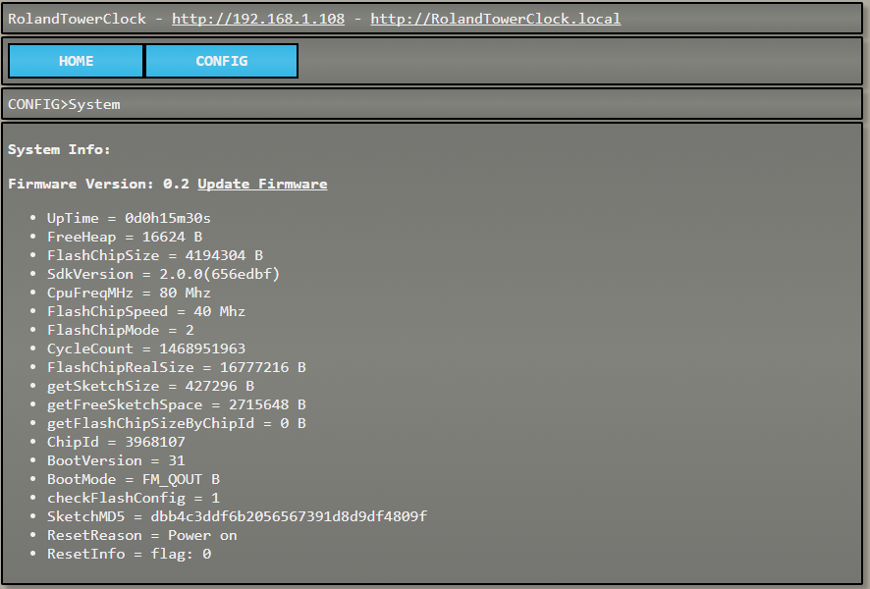

### CONFIG>TIME

Interface to the RTC

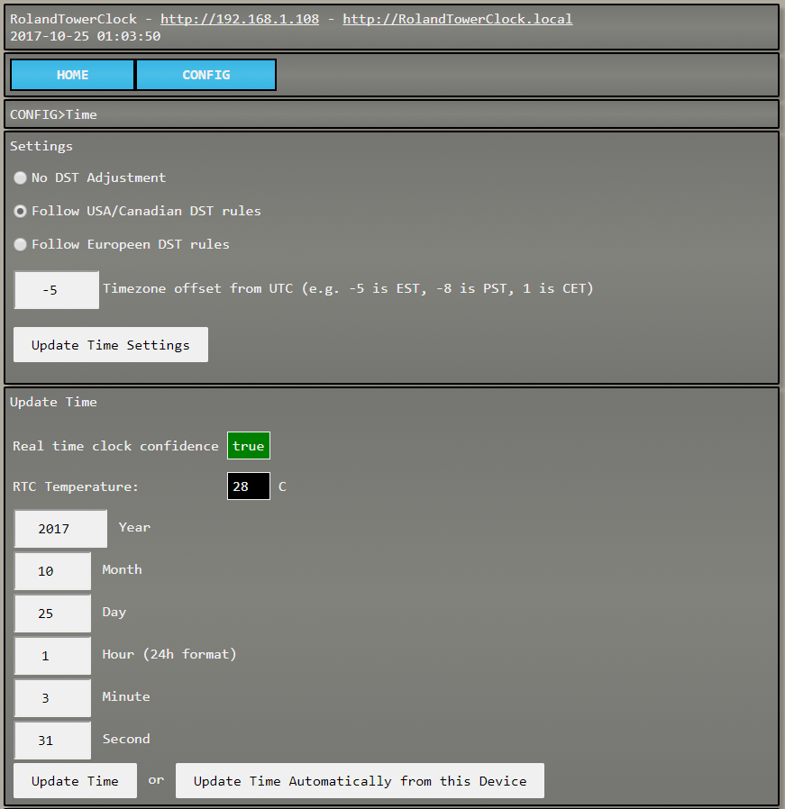

Configure daylight savings time and time zone information

Display RTC information

Manually set local time, or update the time automatically

#### CONFIG>TIME cont.

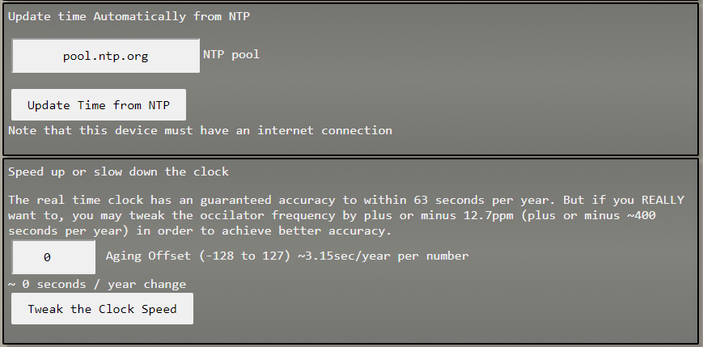

Set the RTC time to the official Internet Time

Tweak the RTC.

### CONFIG>uC File Editor

Allows direct access to the file system on the micro controller. This contains all of the webpages, JavaScript, and system configuration data. You really shouldn’t touch this…

### CONFIG>Update Firmware

Allos the programming to be updated in case future bugs are found. A file would be emailed to you and you can upload the file to update the programming using this page.

## Security

By default the controller broadcasts a Wi-Fi name or SSID that you can connect to. The controller is not connected to the internet, nor is it connected to your Wi-Fi. It is an island all to itself that you must manually connect and disconnect at will. The web interface provides a way to connect the controller to your Wi-Fi much like having your phone connect to your Wi-Fi. In this way, the web interface will be accessible on your network. When this is done, the device will now be connected to the internet through your ISP. The controller is not programmed to automatically contact anything on the internet. The only interaction the controller has with the internet is when you (the user) press the “Get NTP Time” button on the web interface, which will go out and get the official US time just your phone, computer, and any other internet connected device that has a clock. The controller was programmed by a professional US based programmer. No nefarious code exists in the controller. Source code available upon request.

To permanently disable all WiFi features a yellow jumper is provided on the circuit board. Unscrew the screws on any side and slide the circuit board out. Move the jumper as per the diagram printed on the circuit board.

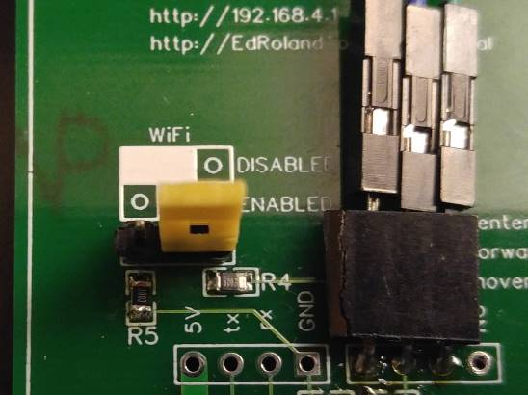

## Technical Details

Engineered, designed, and built in the USA by Terry Myers for Ed Roland of Roland Horology

<https://github.com/TerryJMyers>

Firmware revision 0.2

PCB revision: 0.2

1. Microcontroller: Wemos Mini or Wemos Mini Pro ESP8266ex dev board.
2. Stepper Controller: Pololu A4988
3. Real Time Clock: Maxim Integrated DS3231
4. 2.5A PTC fuse
5. Diode reverse polarity protection
6. Serial configuration interface via the USB port @ 115200 BAUD. (type “?” or “help” for list of commands)
7. Telnet configuration interface on port 23. Same commands as Serial