AEMOVis Walkthrough
  - Australian Energy Market Visualisation
February 2026

AEMOVis Walkthrough

Introduction
AEMOVis is a real-time visualisation dashboard for Australia’s electricity markets. It draws live data from both the National Electricity Market (NEM) — covering NSW, QLD, VIC, SA, and TAS — and the Wholesale Electricity Market (WEM) in Western Australia.
The core design principle is that markets are not first-class citizens — the type of visualisation is. Each page represents a distinct analytical lens (price trends, fuel mix, renewable penetration, etc.) rather than a single market. Where the same visualisation applies to both NEM and WEM, both data sources are available on the same page, and the Compare feature allows multiple regions to be viewed side by side. This lets analysts compare across market boundaries in a single view.

Key Features
- 15 visualisation pages covering price, demand, generation, fuel mix, renewables, outlook, reserves, and outages
- Compare mode on applicable pages — overlay XY charts or display side-by-side pie/donut charts for multiple regions simultaneously
- Live polling with 60-second refresh and stale-data guards
- Responsive layout for desktop, tablet, and mobile

Table of Contents
- Dispatch Overview
- Price and Demand
- Cumulative Price
- Fuel Mix
- Renewable Penetration
- Average Price
- 7-Day Outlook
- FCAS Prices
- Net Interchange
- WEM Outages
- WEM Energy Price
- DPV vs Demand
- WA Dispatch
- WA Reserves
- WA Gen Map

1. Dispatch Overview
The landing page provides a bird’s-eye view of all six NEM regions (NSW, QLD, VIC, SA, TAS) plus WA. Each region card shows the current spot price, demand and generation bars, and interconnector flows. This is the fastest way to assess the state of the entire Australian grid at a glance.
- Spot price displayed prominently per region
- Demand vs generation horizontal bars show supply-demand balance
- Interconnector flows table shows import/export between neighbouring regions
- WA is sourced from the WEM pulse feed; NEM regions from the AEMO dispatch API

Data Source
Aspect | NEM | WEM
Endpoint | /NEM/v1/PWS/NEMDashboard/elecSummary | pulse.csv
Base URL | dashboards.public.aemo.com.au | data.wa.aemo.com.au
Freshness | 4.5 minutes | 25 minutes
Poll interval | 60 seconds | 60 seconds
Fields | summary[] (price, demand, gen, interconnectorFlows) | TRADING_DAY_INTERVAL, ENERGY_PRICE, TOTAL_GEN_MW, TOTAL_DEMAND_MW
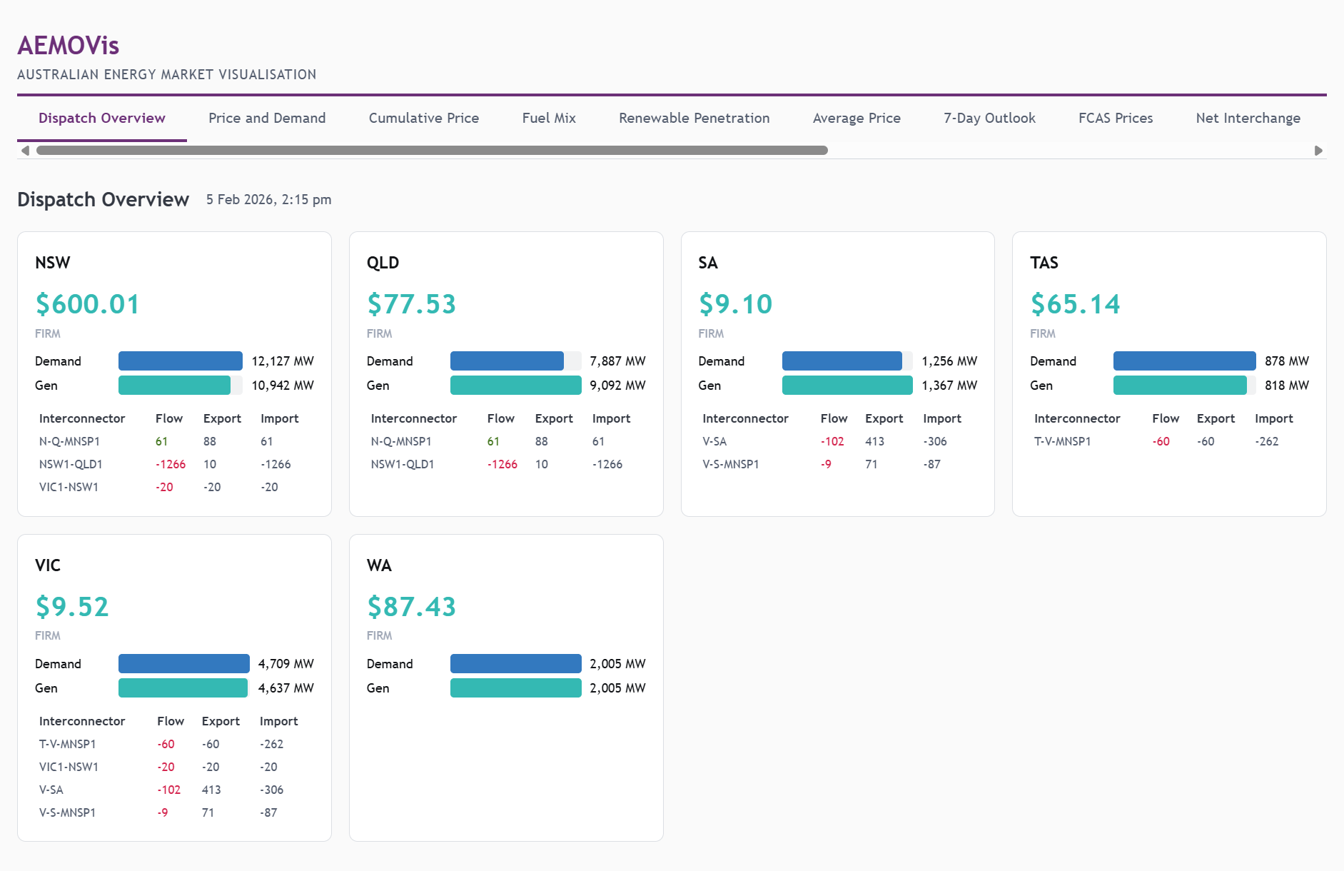
Dispatch Overview

2. Price and Demand
A dual-axis time-series chart showing spot price ($/MWh, left axis) and demand (MW, right axis) for any selected region. Supports both 5-minute and 30-minute resolution for NEM regions, while WA displays ~4 days of rolling data from the WEM pulse feed.
- Region selector — click any region button to switch
- Timescale selector — toggle between 5MIN and 30MIN (NEM only)
- Forecast overlay — dashed lines show pre-dispatch forecast where available
- APC marker — dotted line at the Administered Price Cap threshold (NEM only)
- KPI row — current price, demand, forecast values, and APC status

Compare Mode
Click Compare to overlay multiple regions on the same chart. Each region gets a distinct colour. Price lines are solid, demand lines are dashed. Forecast data appears as dotted lines. The APC marker is shown when at least one NEM region is selected.

Data Source
Aspect | NEM | WEM
Endpoint | /NEM/v1/PWS/NEMDashboard/priceAndDemand?timescale={5MIN|30MIN} | pulse.csv
Freshness | 4.5 minutes | 25 minutes
Time range | ~2 days actuals + forecast | ~4 days rolling
Fields | rrp, totalDemand, forecastedRrp, forecastedDemand | ENERGY_PRICE, TOTAL_DEMAND_MW
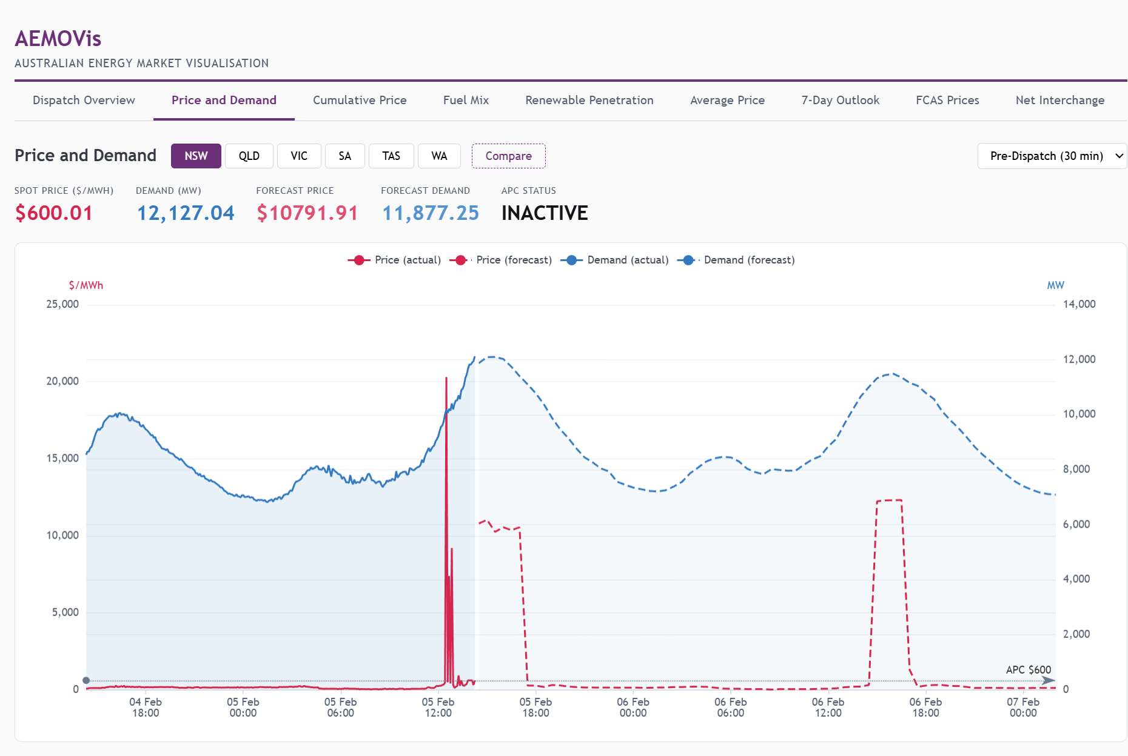
Price and Demand — Single Region
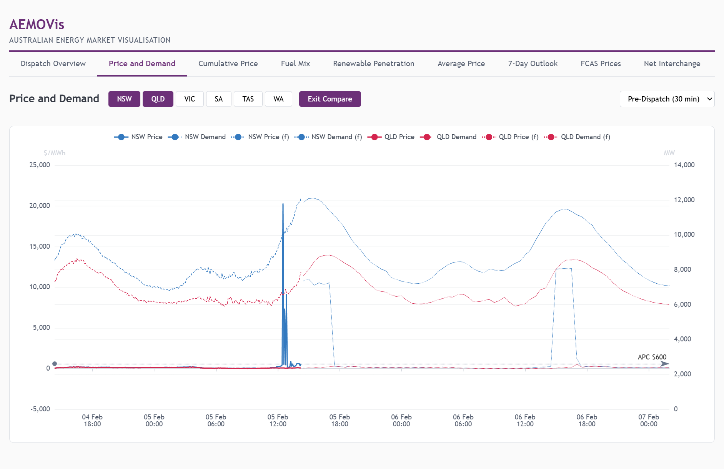
Price and Demand — Compare Mode (NSW vs QLD)

3. Cumulative Price
Tracks the running cumulative price sum across the trading day for each NEM region. This is critical for monitoring proximity to the Cumulative Price Threshold (CPT), which triggers Administered Pricing if breached. The chart shows how each region’s cumulative price evolves in real time.
- Per-region cumulative totals updated every dispatch interval
- CPT threshold line marks the trigger level
- WA is not applicable (WEM has a different pricing mechanism)

Data Source
Aspect | Value
Endpoint | /NEM/v1/PWS/NEMDashboard/cumulativePrice
Freshness | 4.5 minutes
Market | NEM only
Fields | cumulativePrice per region, cpt threshold
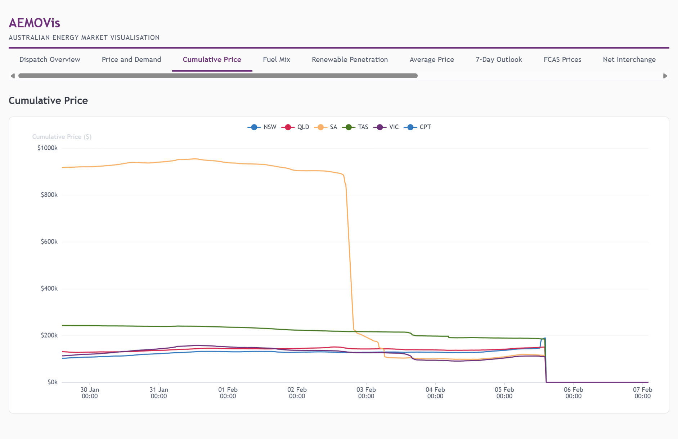
Cumulative Price

4. Fuel Mix
A donut chart breaking down current generation by fuel type for the selected region. Fuel types are colour-coded consistently (black coal = dark, wind = teal, solar = gold, gas = orange, hydro = blue, etc.) and ordered by the standard AEMO fuel hierarchy.
- Region selector — individual NEM regions, WA, or NEM aggregate
- Total MW displayed in the chart centre
- Legend with percentage breakdown
- WA fuel mix is derived by joining WEM generation data with facility metadata

Compare Mode
Click Compare to see side-by-side pie charts for multiple regions. Pies are evenly distributed across the width and auto-size — radius shrinks gracefully as more regions are added.

Data Source
Aspect | NEM | WEM
Endpoint | /NEM/v1/PWS/NEMDashboard/fuelMix?type=CURRENT | generation.csv + facility-meta-fuelmix.csv
Freshness | 4.5 minutes | 55 minutes
Fields | fuelType, generationMW | Joined via FACILITY_CODE to get PRIMARY_FUEL
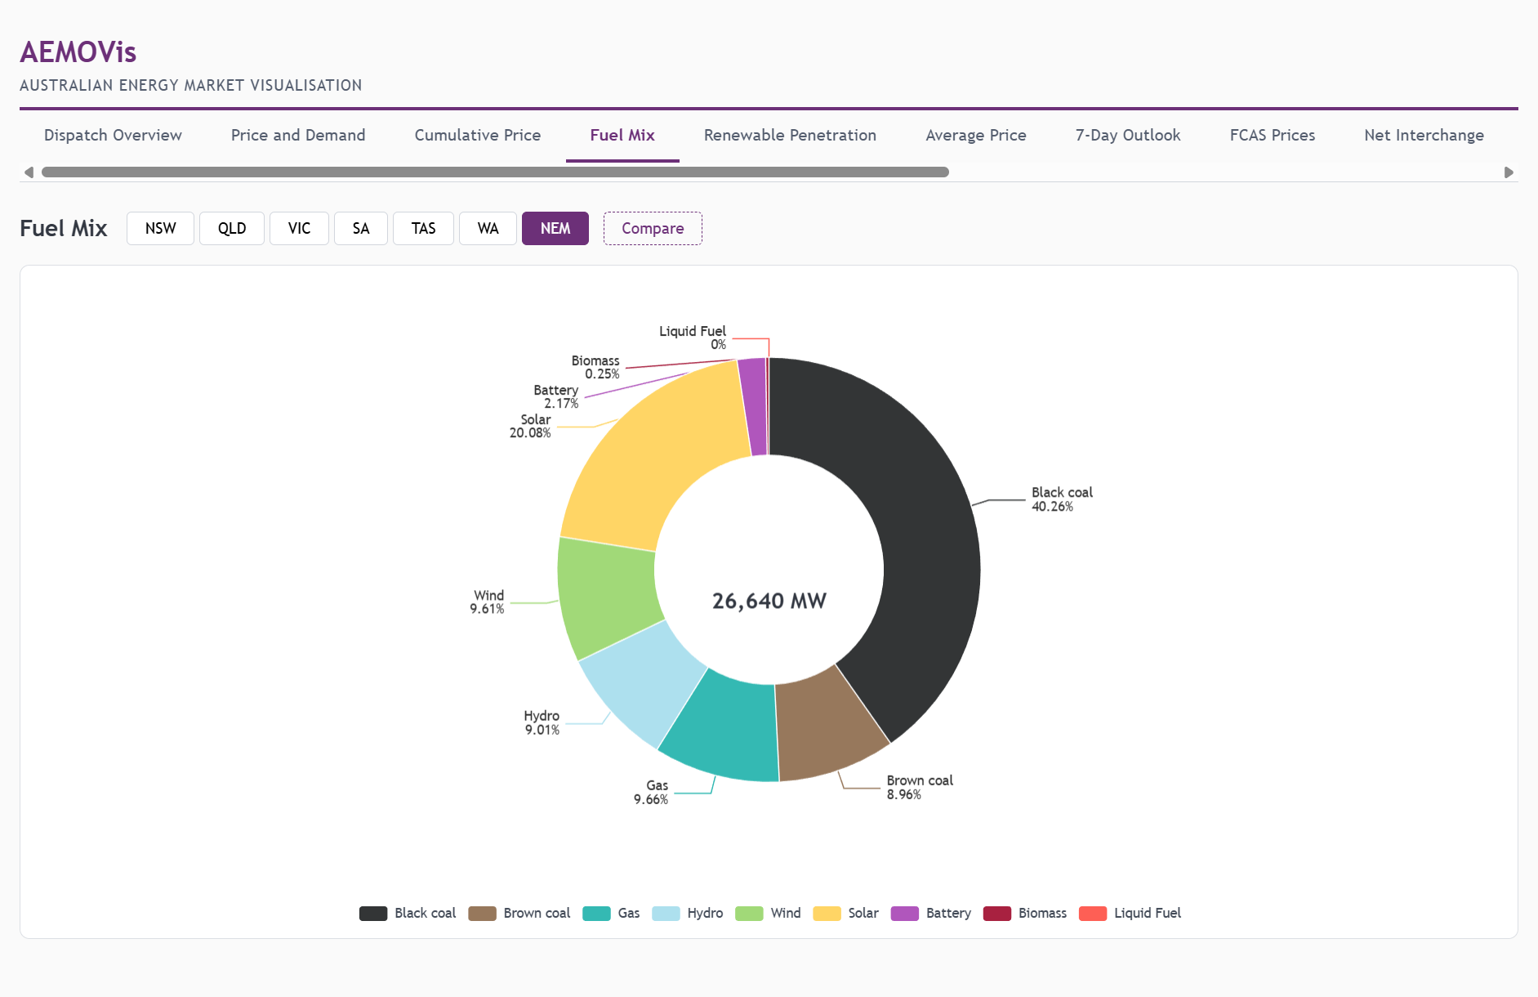
Fuel Mix — NEM Aggregate
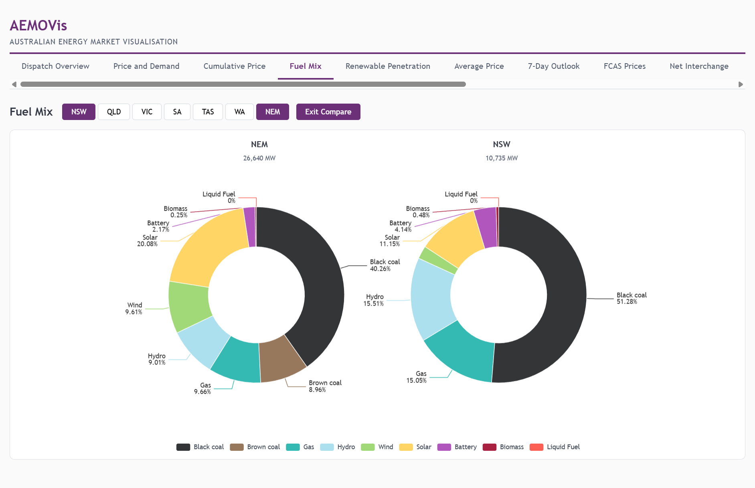
Fuel Mix — Compare Mode (NEM vs NSW)

5. Renewable Penetration
A donut chart showing the percentage of current generation from renewable sources (wind, solar, hydro, biomass, battery, rooftop PV) versus non-renewable sources. The percentage is displayed prominently in the centre.
- Region selector — individual NEM regions, WA, or NEM aggregate
- Renewable classification covers: Wind, Solar, Hydro, Biomass, Battery, Rooftop PV, Distributed PV, Utility-scale Solar
- Green/dark colour scheme for clear visual distinction

Compare Mode
Click Compare to see side-by-side donut charts showing renewable penetration for multiple regions simultaneously. Each donut displays its region label and percentage, making cross-regional comparison immediate.

Data Source
Same as Fuel Mix — derived by classifying fuel types as renewable/non-renewable.
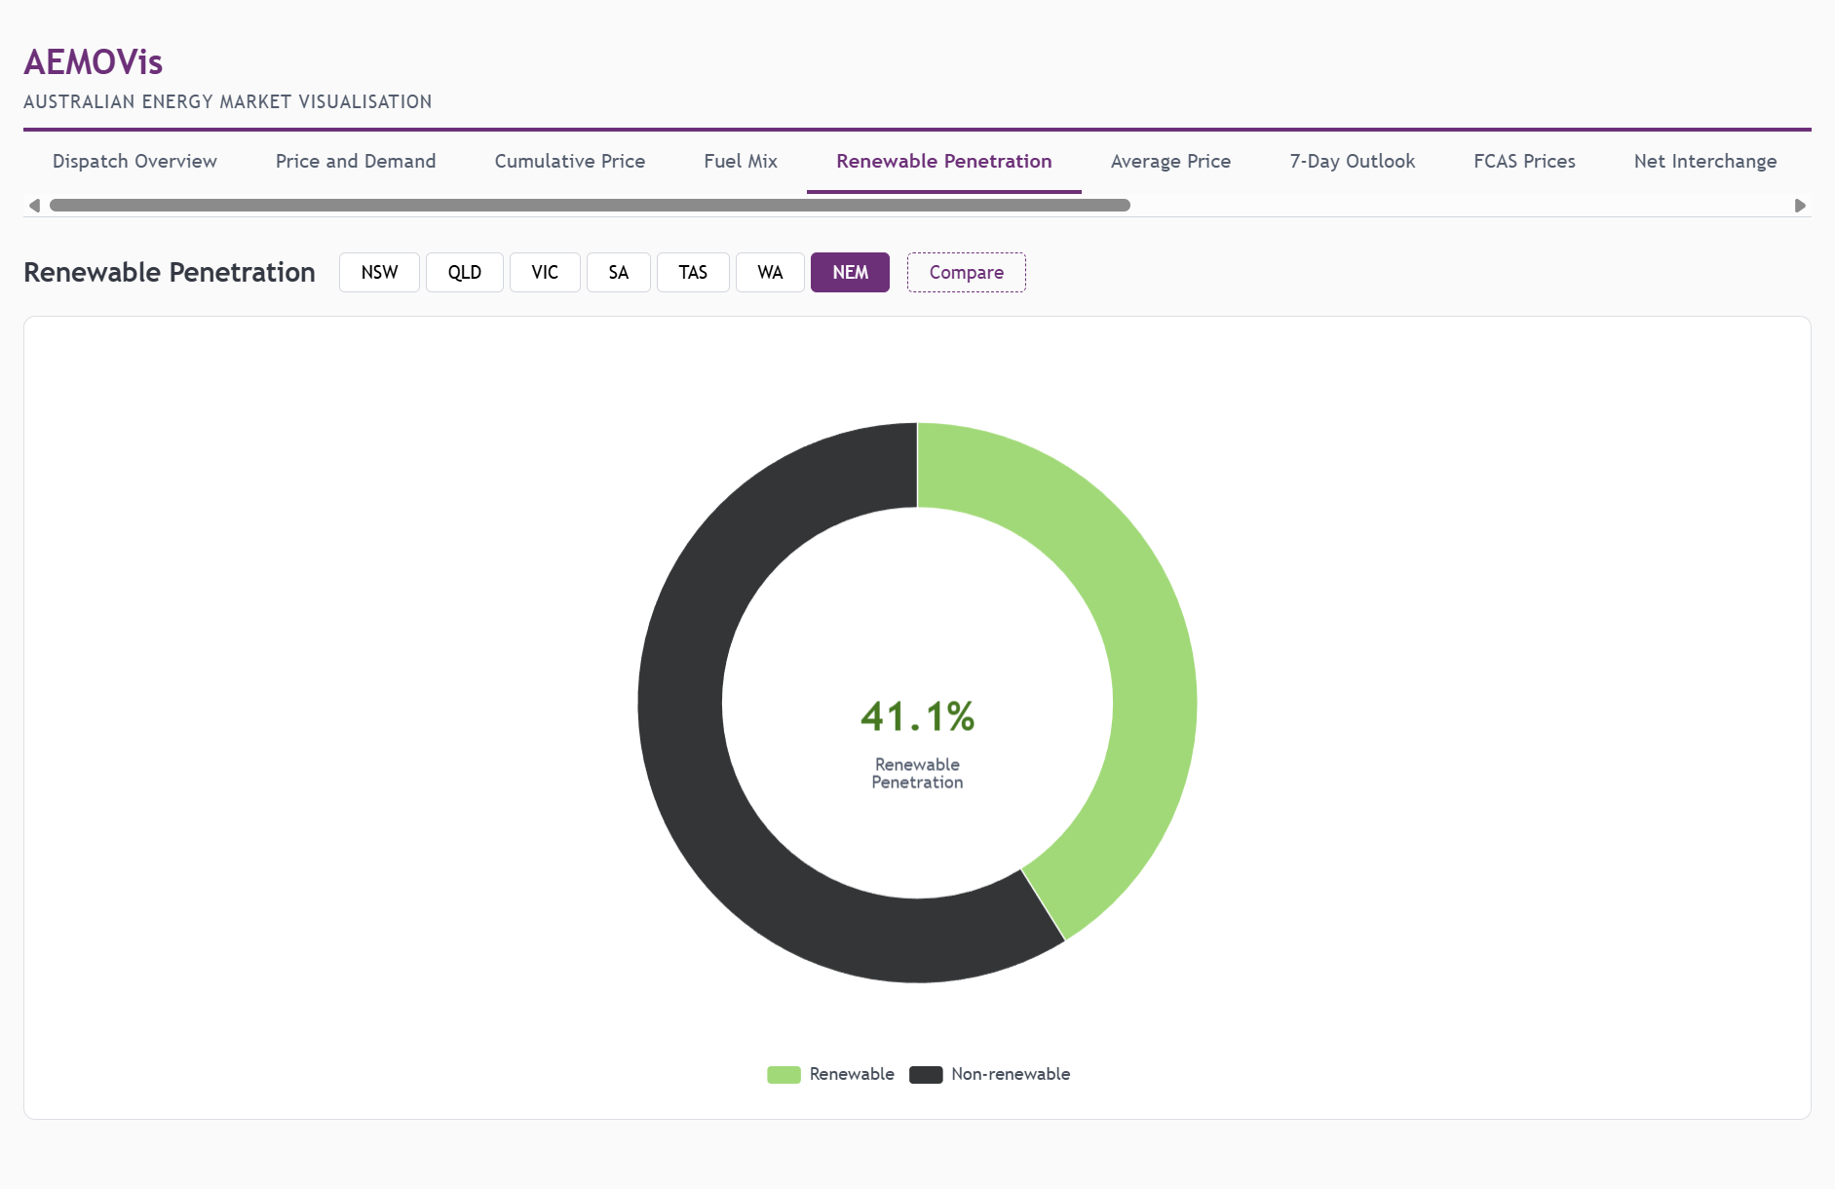
Renewable Penetration — NEM Aggregate
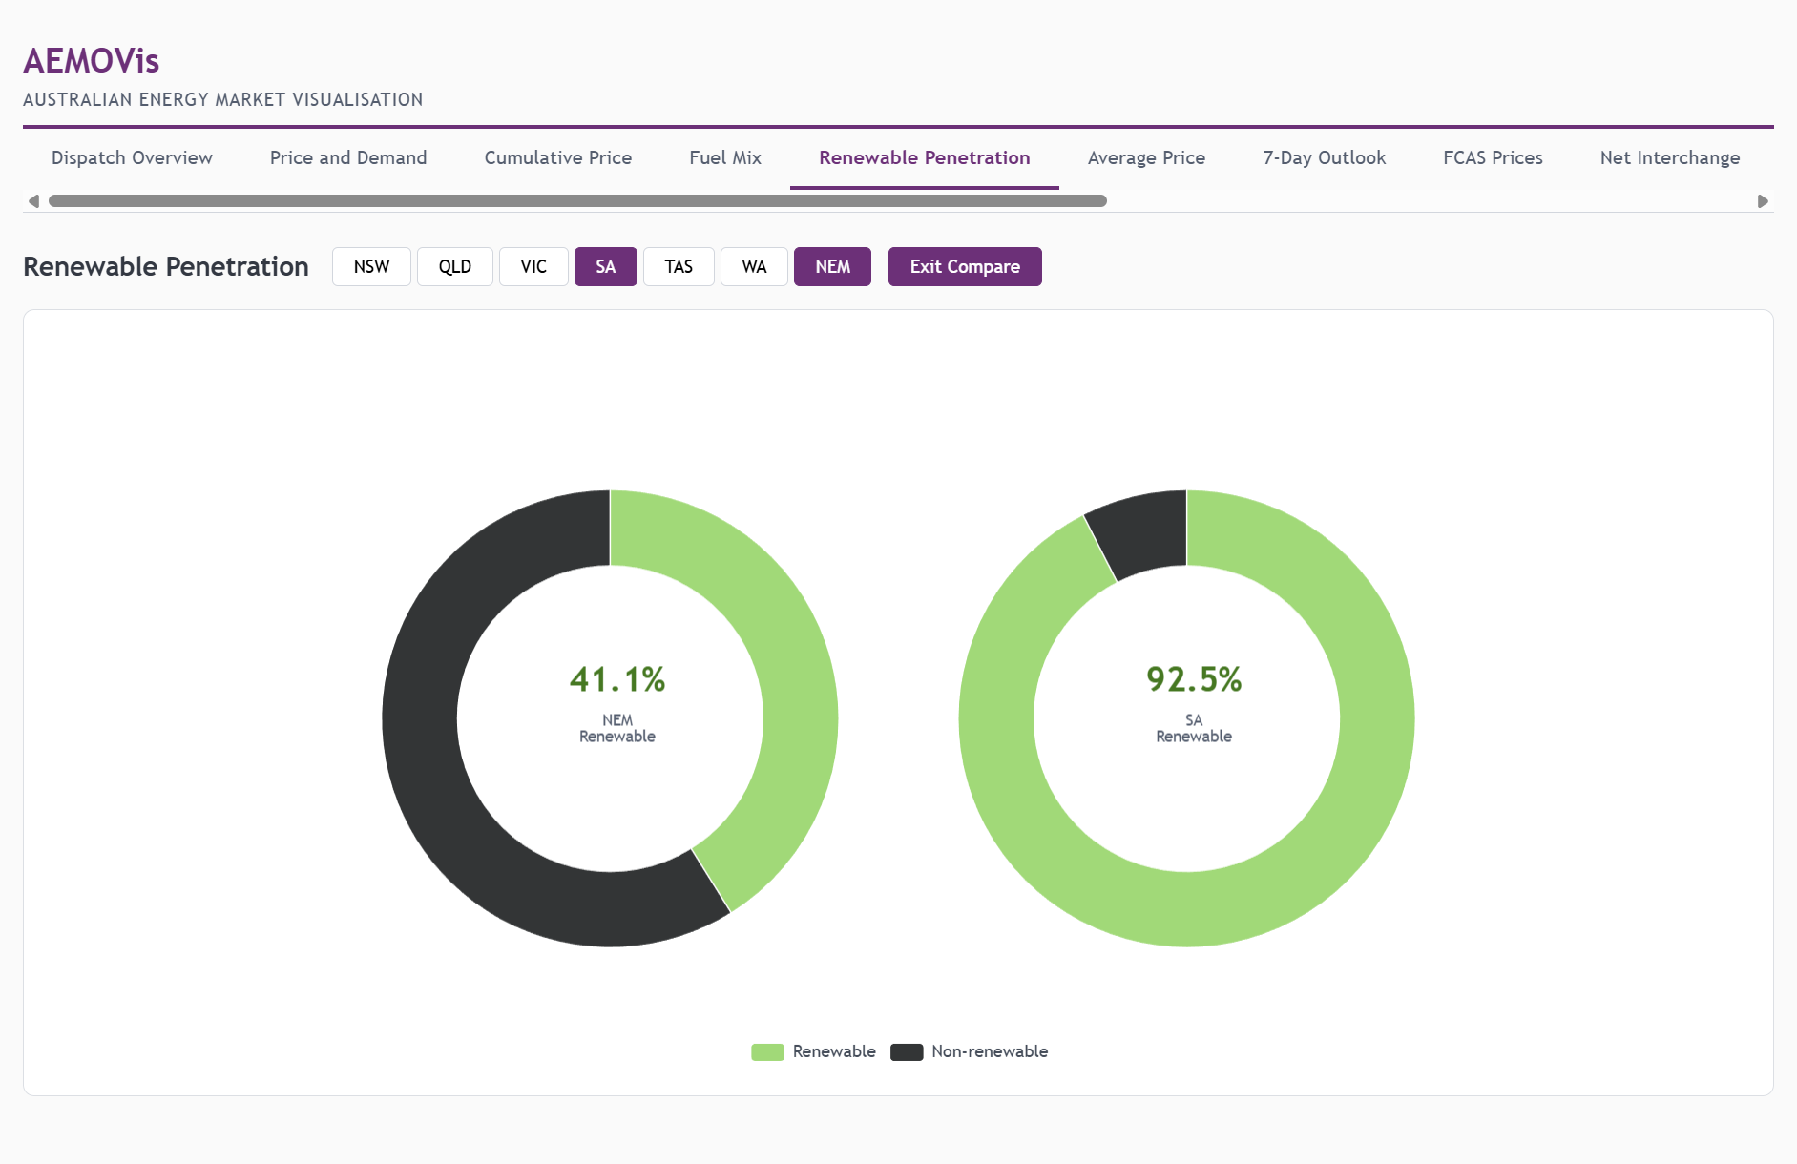
Renewable Penetration — Compare Mode (NEM vs SA)

6. Average Price
Displays the average spot price for each NEM region as a bar chart, derived from the most recent dispatch data. WA average price is included, aligned to the NEM date window (~4 days from the WEM pulse feed).
- Bar chart comparing average price across all regions
- Colour-coded by region for quick identification
- Useful for spotting sustained price divergence between states

Data Source
Aspect | NEM | WEM
Endpoint | /NEM/v1/PWS/NEMDashboard/dailyAveragePrices?year={YYYY}&month={MM} | pulse.csv
Freshness | 4.5 minutes | 25 minutes
Calculation | Pre-aggregated by AEMO | Computed from ENERGY_PRICE time series
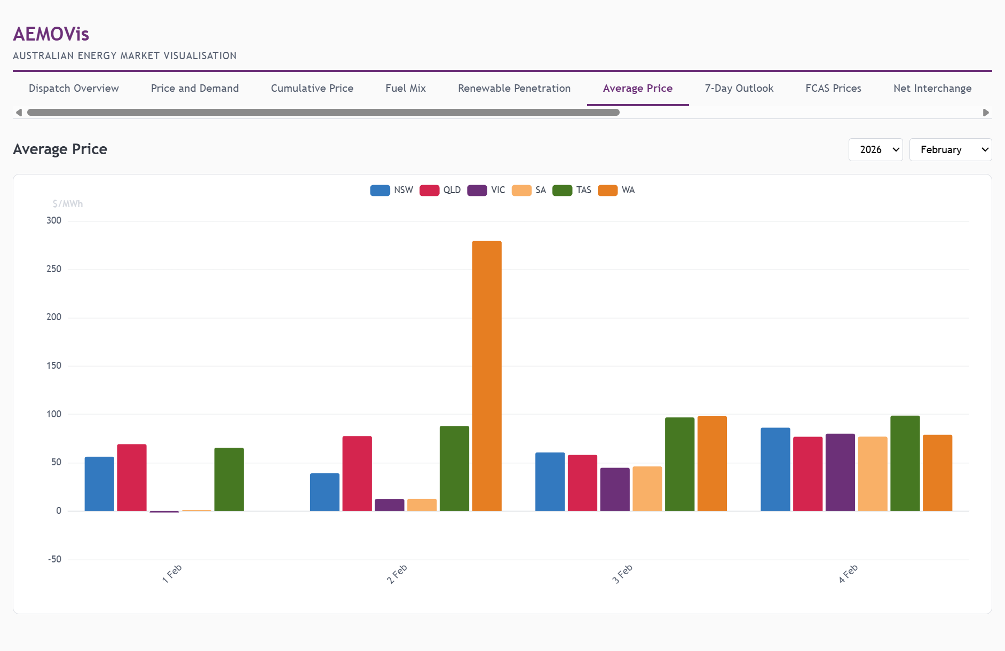
Average Price

7. 7-Day Outlook
A tabular view of AEMO’s Short Term Projected Assessment of System Adequacy (ST PASA), showing forecast demand, available capacity, and reserve margins for each NEM region over the coming seven days.
- Daily breakdown with peak demand forecasts
- Capacity and reserve columns highlight potential shortfalls
- Critical for operational planning and market participant decision-making
- NEM only — WEM outlook data is not available via the same API

Data Source
Aspect | Value
Endpoint | /NEM/v1/PWS/NEMDashboard/sevenDayOutlook
Freshness | 4.5 minutes
Market | NEM only
Fields | prettyDate, regionId, dataType, dataValue (pivoted into table)
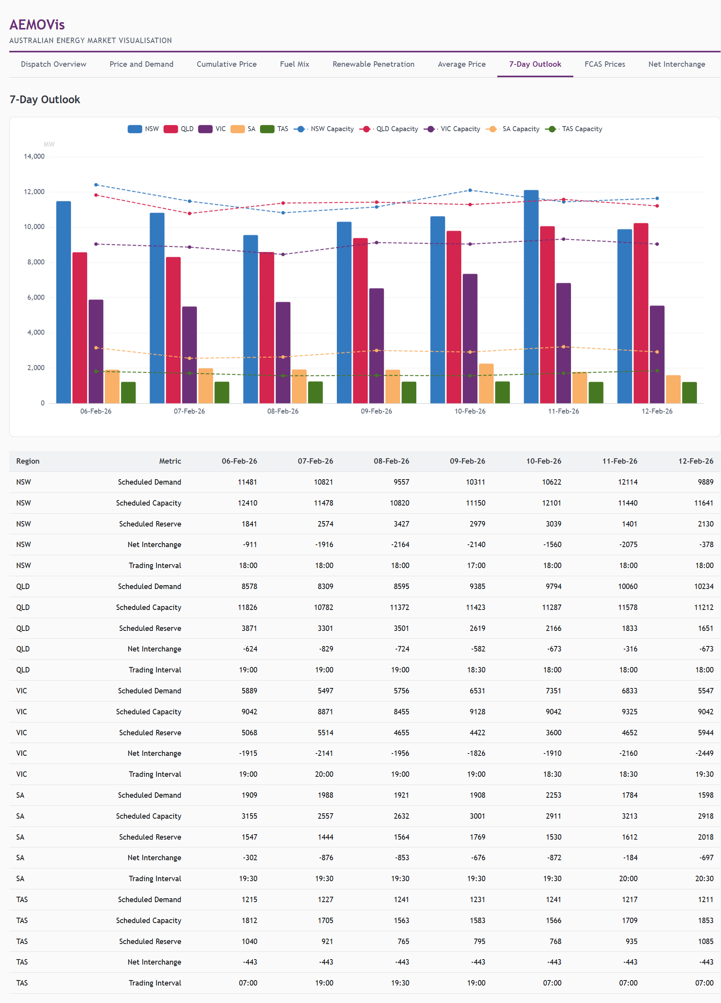
7-Day Outlook

8. FCAS Prices
A heatmap displaying Frequency Control Ancillary Services (FCAS) prices across all NEM regions. FCAS markets are essential for maintaining grid frequency stability — generators and loads are paid to provide rapid response services.
- Heatmap with regions on the Y-axis, FCAS services on the X-axis
- Colour intensity represents price (blue scale: light = low, dark = high)
- 10 FCAS services displayed: Raise/Lower for 1s, 6s, 60s, 5m, and Regulation
- KPI row shows average energy price, average FCAS price, highest FCAS price, and peak service/region

FCAS Services Explained
Service | Purpose
Raise 1s/6s/60s/5m | Increase generation/reduce load to raise frequency
Lower 1s/6s/60s/5m | Decrease generation/increase load to lower frequency
Raise/Lower Reg | Continuous regulation to maintain 50Hz

Data Source
Aspect | Value
Endpoint | /NEM/v1/PWS/NEMDashboard/elecSummary (prices array)
Freshness | 4.5 minutes
Market | NEM only
Fields | raise1SecRrp, raise6SecRrp, raise60SecRrp, raise5MinRrp, raiseRegRrp, lower1SecRrp, lower6SecRrp, lower60SecRrp, lower5MinRrp, lowerRegRrp
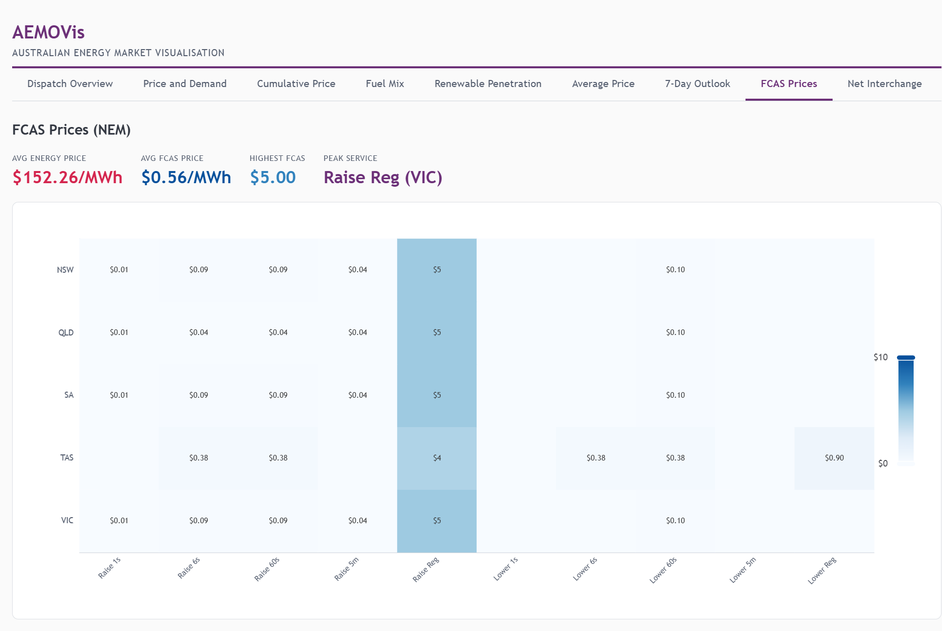
FCAS Prices

9. Net Interchange
Shows import/export flows between NEM regions over time. Positive values indicate a region is exporting power; negative values indicate importing. Also includes a Gen Breakdown toggle to view scheduled vs semi-scheduled generation.
- Bar chart showing net interchange per region over time
- Colour coding: green = exporting, red = importing
- Region toggles to filter which regions are displayed
- Gen Breakdown mode shows stacked area of scheduled (dispatchable) vs semi-scheduled (wind/solar) generation

Data Source
Aspect | Value
Endpoint | /NEM/v1/PWS/NEMDashboard/priceAndDemand?timescale=30MIN
Freshness | 4.5 minutes
Market | NEM only
Fields | netInterchange, scheduledGeneration, semiScheduledGeneration
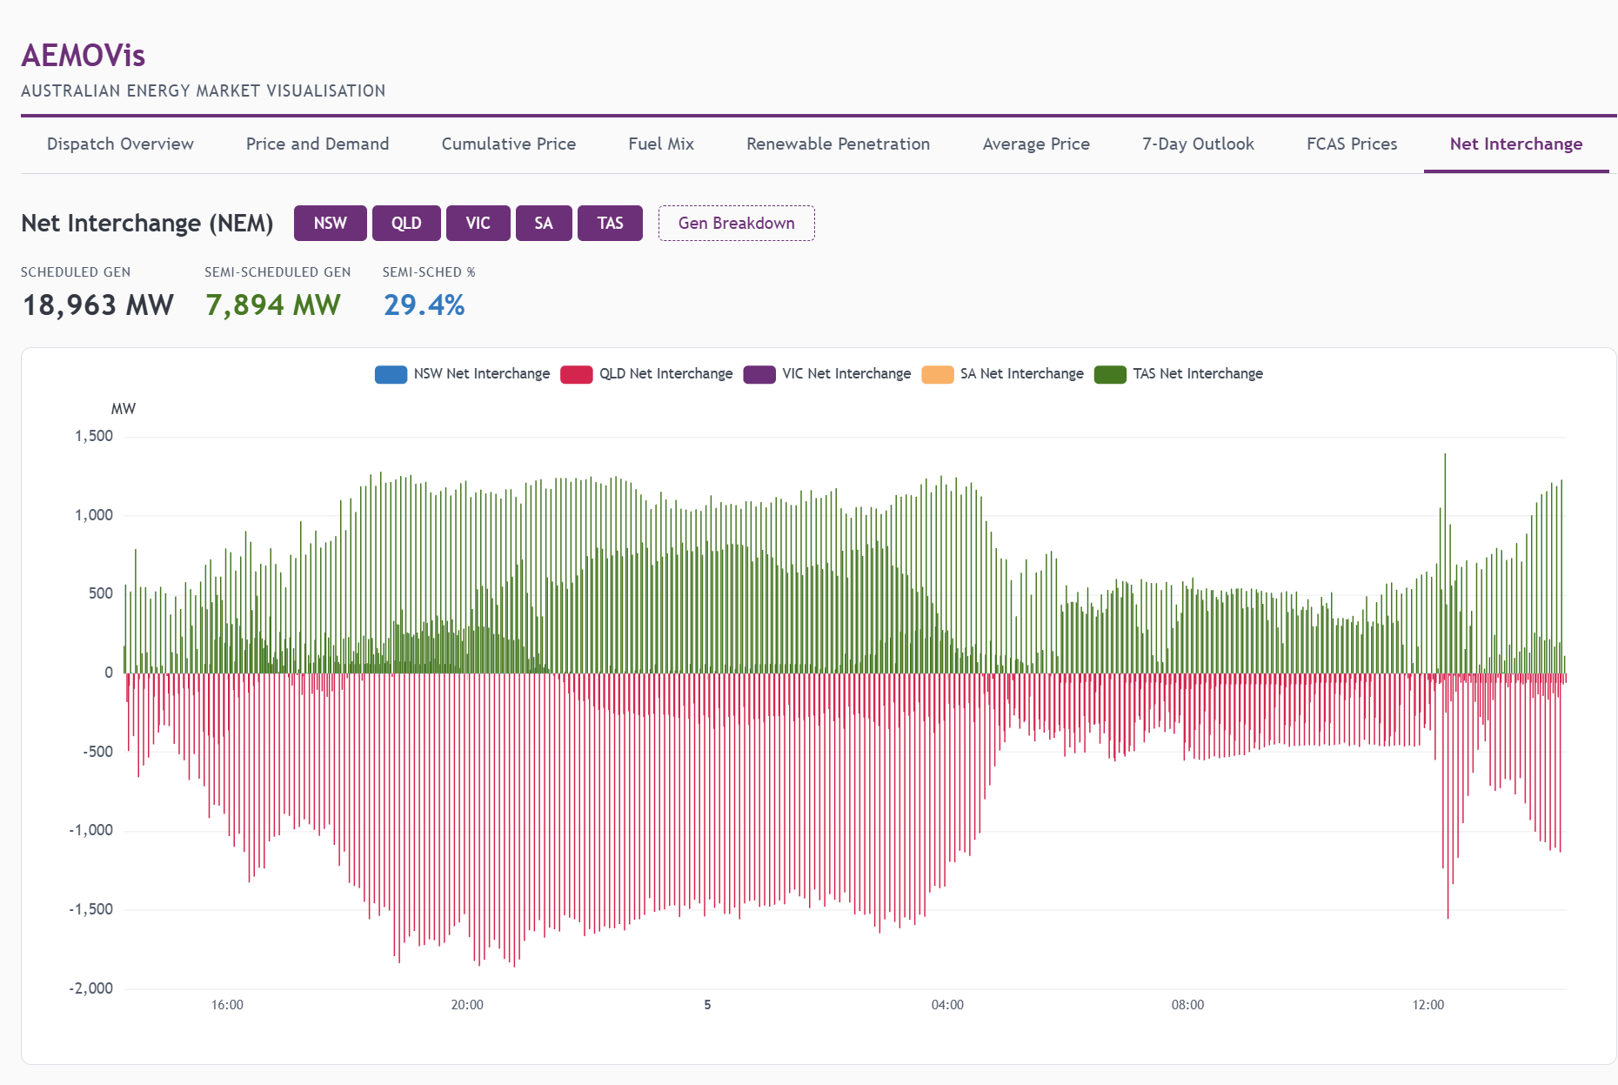
Net Interchange

10. WEM Outages
Displays currently reported generation outages in the Western Australian Wholesale Electricity Market. When outages are active, they are listed with facility name, capacity affected, and outage type. When no outages are reported, a clear status message is shown.
- Outage list with facility details and MW impact
- Total outage MW summary card
- Sourced from the WEM outage CSV feed
- WEM-only page (NEM outage data uses a different reporting mechanism)

Data Source
Aspect | Value
Endpoint | pulse.csv (outage columns)
Base URL | data.wa.aemo.com.au
Freshness | 25 minutes
Market | WEM only
Fields | OUTAGE_GEN_MW, facility outage flags
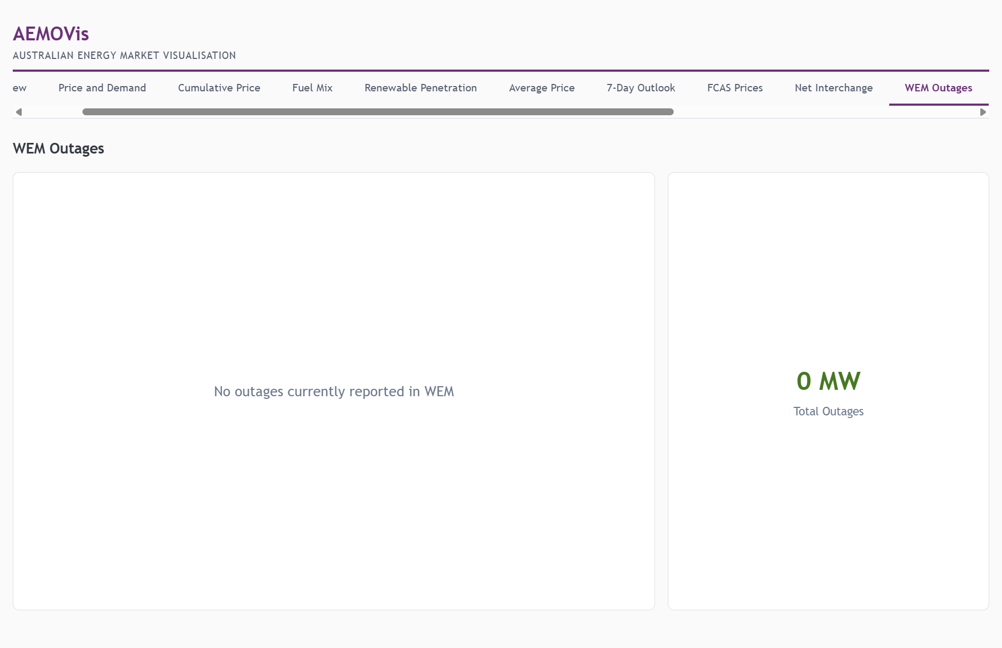
WEM Outages

11. WEM Energy Price
Note: This page overlaps with Price and Demand when WA is selected. Retained for direct WEM-focused access.
A simple time-series chart showing the WEM energy price over the rolling ~4-day window from the pulse feed. The current spot price KPI is displayed above the chart.

Data Source
Aspect | Value
Endpoint | pulse.csv
Base URL | data.wa.aemo.com.au
Freshness | 25 minutes
Market | WEM only
Fields | TRADING_DAY_INTERVAL, ENERGY_PRICE
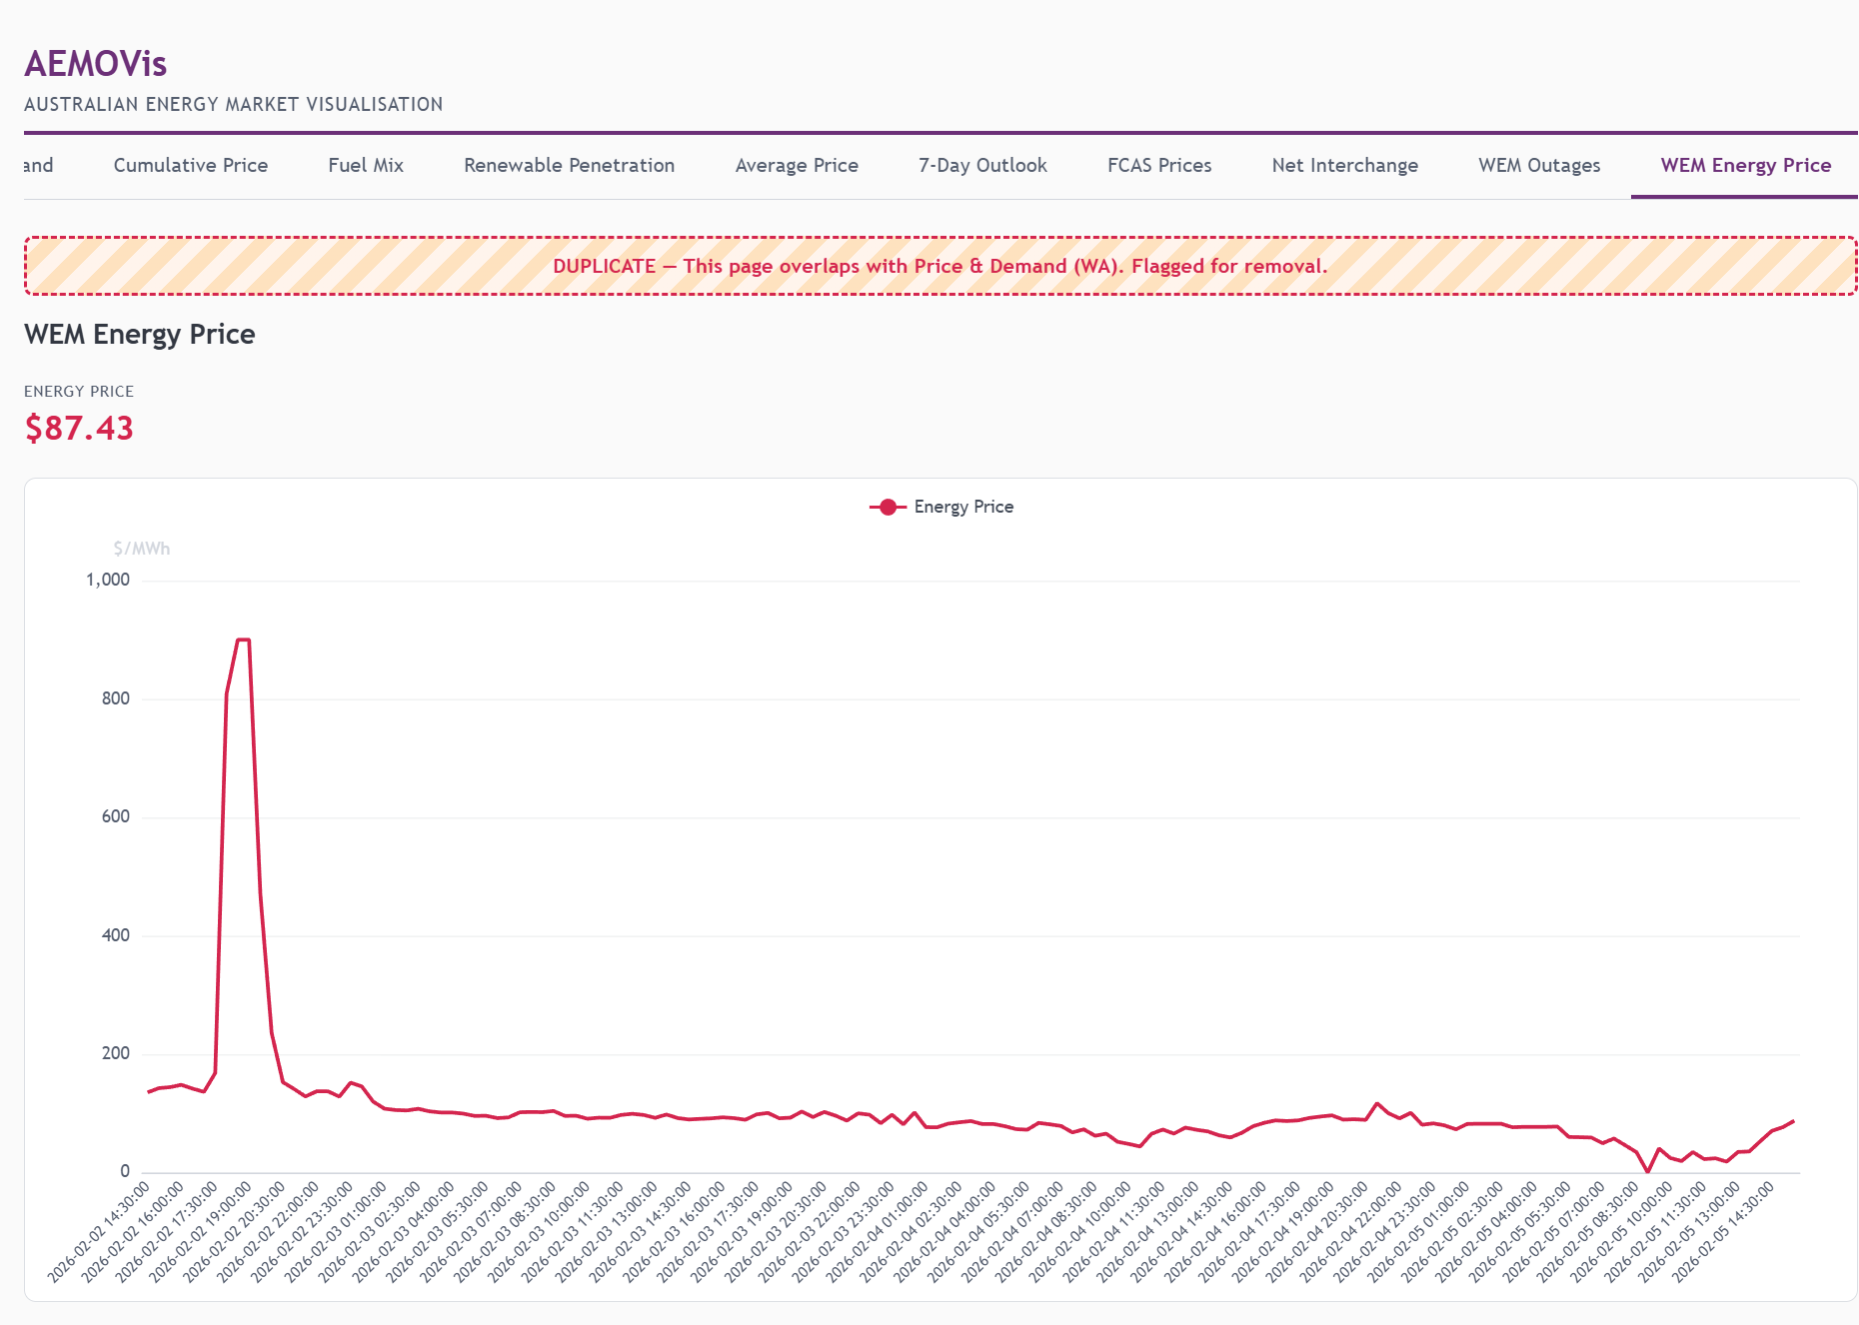
WEM Energy Price

12. DPV vs Demand
A dual-axis chart specific to Western Australia, showing the relationship between grid operational demand and distributed photovoltaic (rooftop solar) generation. This is particularly important in WA where rooftop solar penetration is among the highest in the world and significantly impacts grid operations.
- Operational Demand (MW, left axis) — total grid demand
- Distributed PV (MW, right axis) — estimated rooftop solar output
- KPI row — current demand, current DPV, peak DPV, and minimum demand
- The inverse relationship between DPV and demand is clearly visible: as solar output rises during the day, net demand drops
- WEM-only page sourced from the DPV/operational demand CSV feed

Data Source
Aspect | Value
Endpoint | distributed-pv_opdemand.csv
Base URL | data.wa.aemo.com.au/public/infographic/dpvopdemand/
Freshness | 25 minutes
Market | WEM only
Fields | TRADING_INTERVAL, OPERATIONAL_DEMAND_MW, ESTIMATED_DPV_MW
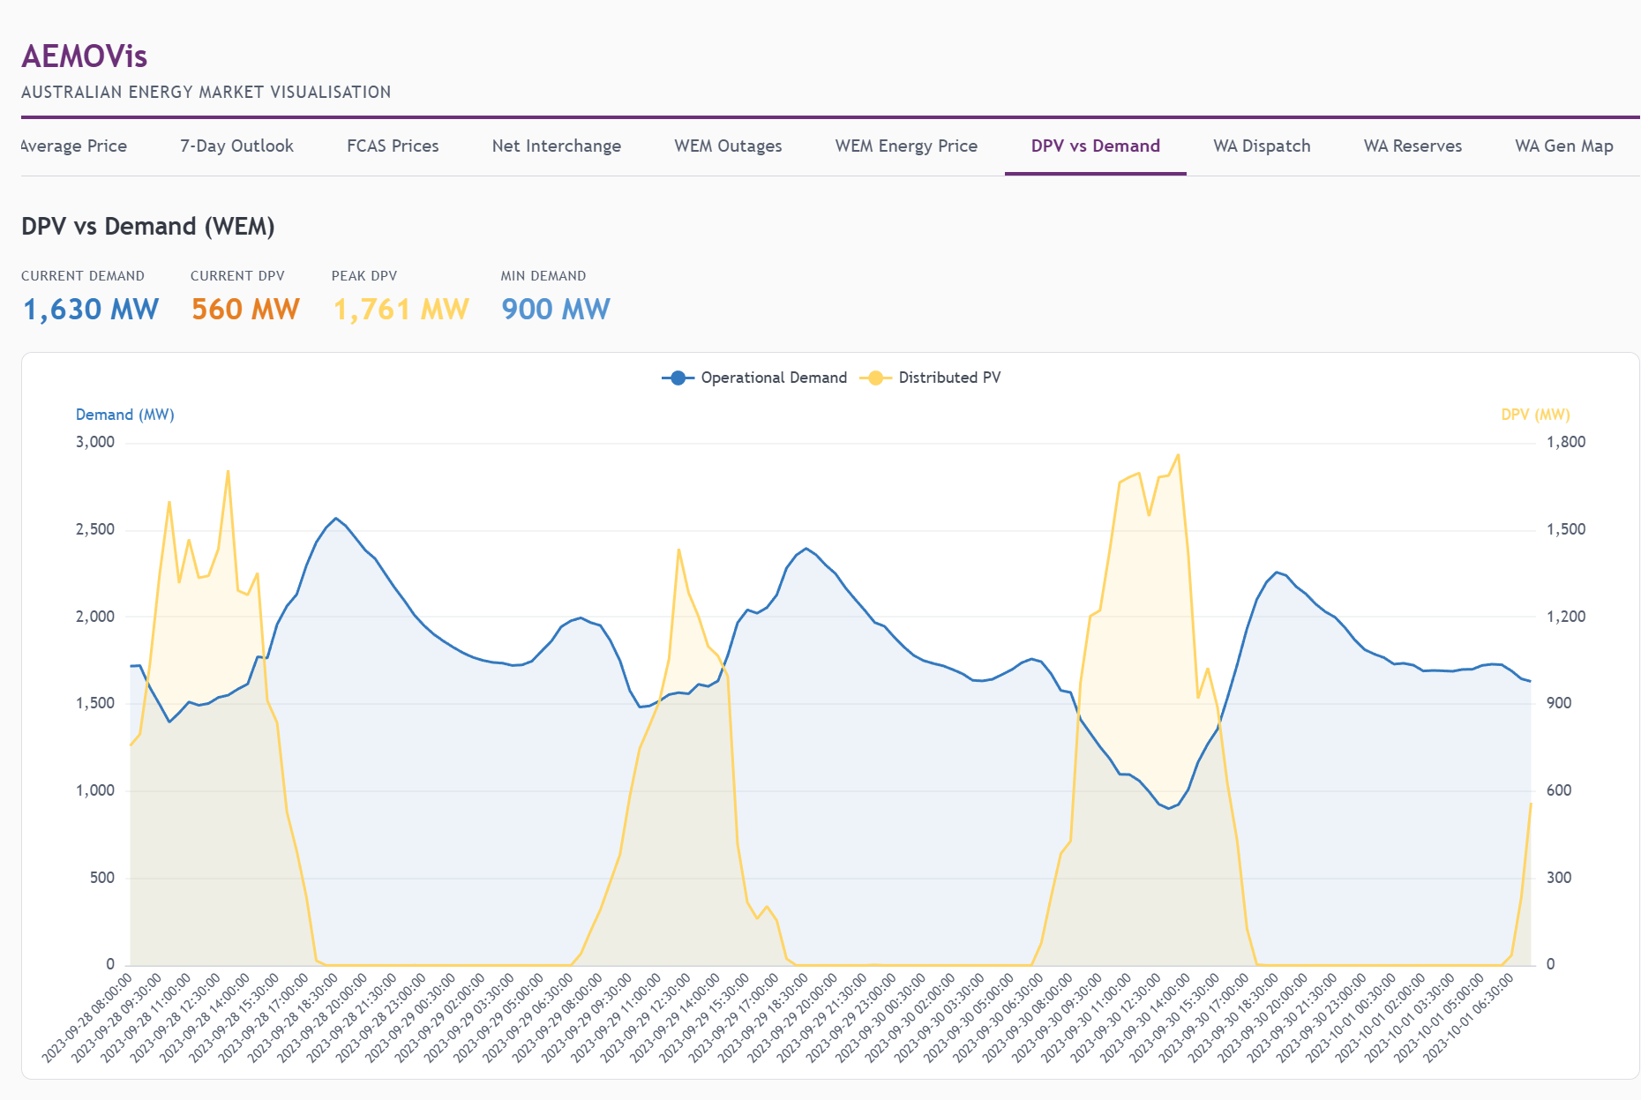
DPV vs Demand

13. WA Dispatch
A stacked area chart showing WA generation by fuel type over 2 days (96 × 30-minute intervals), with a price line overlay. This provides a detailed view of Western Australia’s generation mix and how it correlates with price movements.
- Stacked area by fuel type (Gas, Coal, Wind, Solar, Battery, etc.)
- Price overlay (red line, right axis) shows energy price trajectory
- KPI row — current generation, current price, peak generation, capacity utilization
- Fuels ordered by standard hierarchy: Coal → Gas → Hydro → Wind → Solar → Battery → Biomass

Data Source
Aspect | Value
Generation endpoint | generation.csv
Metadata endpoint | facility-meta-fuelmix.csv
Price endpoint | pulse.csv
Base URL | data.wa.aemo.com.au
Freshness | Generation: 55 min, Pulse: 25 min, Metadata: 1 hour
Market | WEM only
Fields | I01–I48 (interval generation), FACILITY_CODE, PRIMARY_FUEL, MAX_GEN_CAPACITY
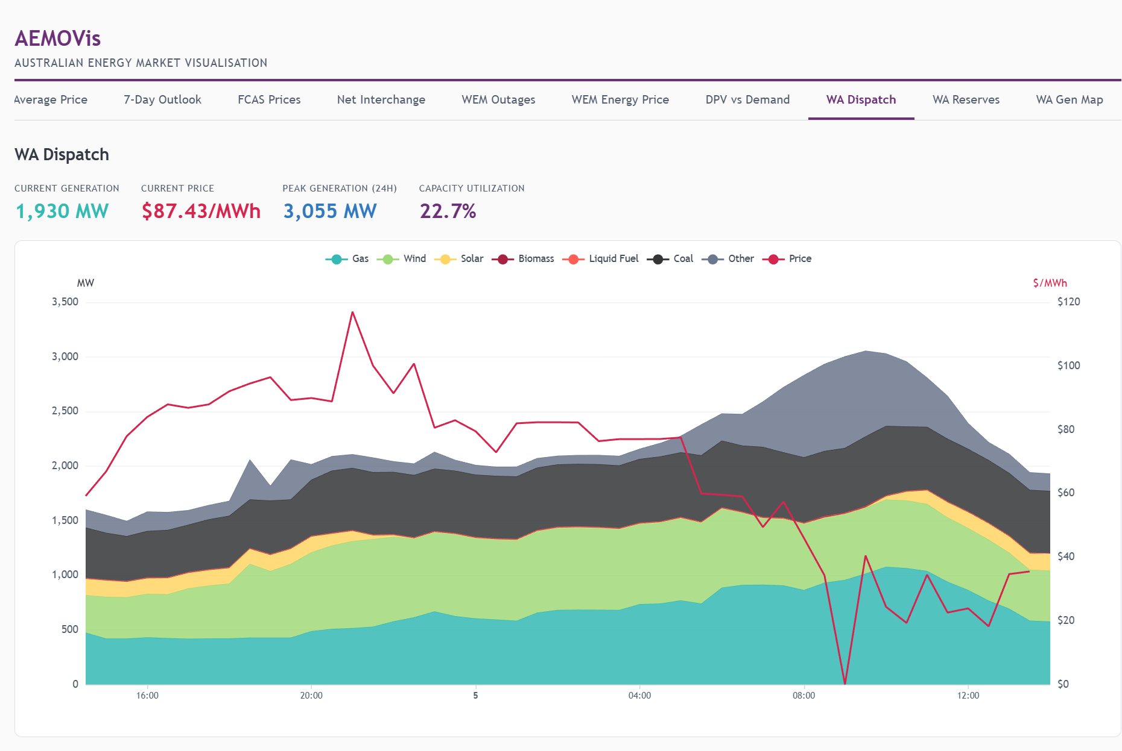
WA Dispatch

14. WA Reserves
Displays spinning reserve, LFAS (Load Following Ancillary Service) requirements, and forecast vs actual generation in the WEM. Essential for monitoring WA grid stability margins.
- Forecast Demand (dashed blue) — AEMO’s demand forecast
- Actual Generation (solid teal) — real-time total generation
- RTD Generation (green) — Real-Time Dispatch generation
- LFAS Up Requirement (purple, right axis) — load following reserve requirement
- Spinning Reserve (red, right axis) — available spinning reserve
- KPI row — LFAS requirement, spinning reserve, actual generation, forecast accuracy

Data Source
Aspect | Value
Endpoint | pulse.csv
Base URL | data.wa.aemo.com.au
Freshness | 25 minutes
Market | WEM only
Fields | RTD_TOTAL_SPINNING_RESERVE, LFAS_UP_REQUIREMENT_MW, FORECAST_EOI_MW, ACTUAL_TOTAL_GENERATION, RTD_TOTAL_GENERATION
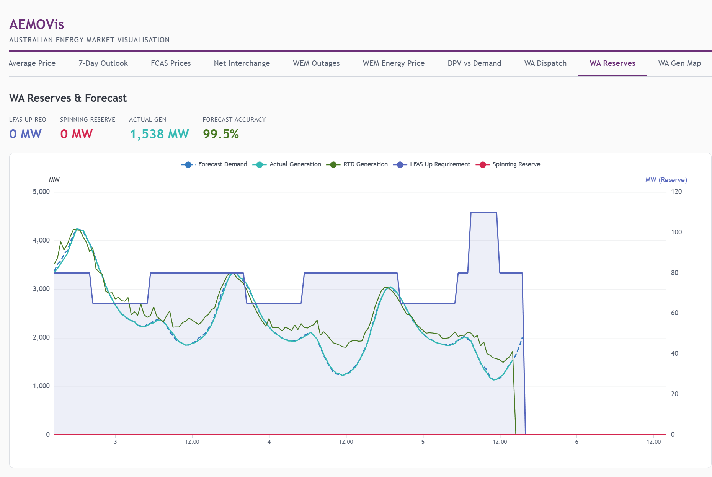
WA Reserves

15. WA Gen Map
A geographic map of Western Australia with scatter overlay showing all registered generation facilities. Each facility is positioned by latitude/longitude, sized by current output, and coloured by fuel type.
- Scatter overlay on Australia map (WA highlighted)
- Symbol size proportional to current MW output
- Colour by fuel type — consistent with other fuel mix visualisations
- Legend filtering — click fuel types to show/hide
- KPI row — data timestamp, total facilities, generating facilities, total output, installed capacity
- Pan and zoom enabled for detailed exploration

Data Source
Aspect | Value
Generation endpoint | generation.csv
Metadata endpoint | facility-meta-fuelmix.csv
Base URL | data.wa.aemo.com.au
Freshness | Generation: 55 min, Metadata: 1 hour
Market | WEM only
Fields | I01 (current output), MAX_GEN_CAPACITY, LATITUDE, LONGITUDE, PRIMARY_FUEL, DISPLAY_NAME
GeoJSON | Australia states (WA region highlighted)
Note: Some facility coordinates in AEMO metadata are incorrect (defaulting to Perth CBD). The application includes coordinate corrections for known facilities based on Global Energy Observatory, Wikipedia, and planning documents.
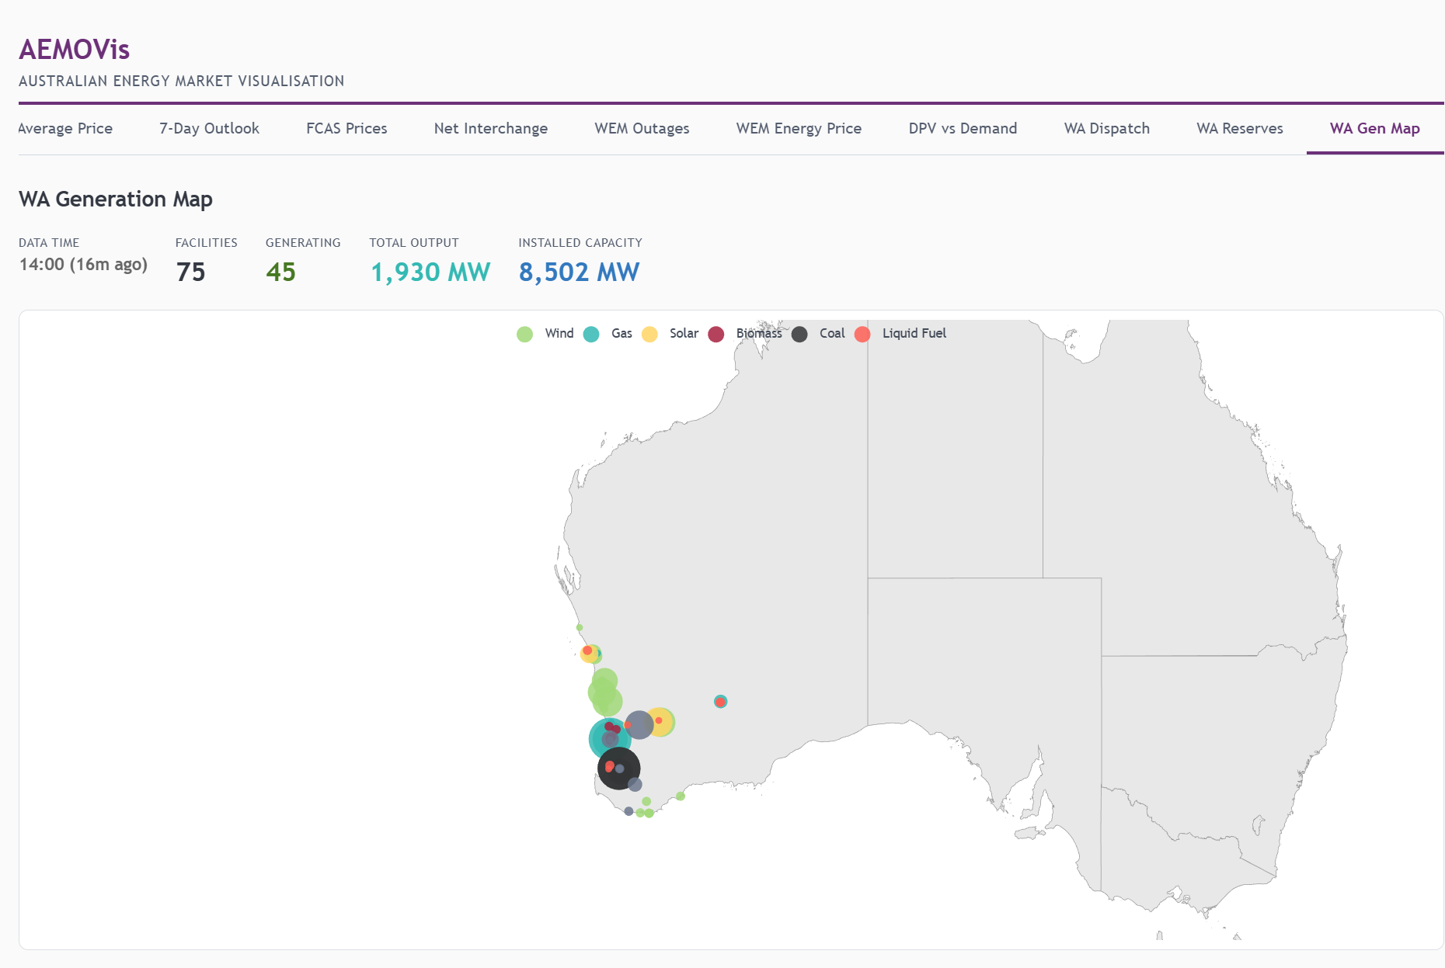
WA Gen Map

Technical Notes

Architecture
- Framework: Vanilla JavaScript SPA (no React/Vue/Angular)
- Charting: Apache ECharts 6.x for high-performance, interactive visualisations
- State: nanostores for reactive atom-based state management
- HTTP: ky for NEM REST API (with retry/timeout), native fetch for WEM CSVs
- CSV Parsing: PapaParse for WEM data files
- Mapping: ECharts geo component with Australia GeoJSON

Data Sources Summary
Market | Base URL | Format | Auth
NEM | dashboards.public.aemo.com.au | JSON REST | API key (public)
WEM | data.wa.aemo.com.au | CSV files | None (CORS open)

Polling & Freshness
The application uses a dual-layer freshness system:
- fetchIfStale() — On page mount, only fetches if data is older than freshness threshold
- Poller — Background 60-second interval checks freshness before refetch
Data Type | Freshness | Poll Interval
NEM API data | 4.5 minutes | 60 seconds
WEM pulse.csv | 25 minutes | 60 seconds
WEM generation.csv | 55 minutes | 60 seconds
WEM facility metadata | 1 hour | 60 seconds

WEM API Quirks
- Accept header required: WEM’s IIS server returns 406 unless a browser-style Accept header is sent
- CSV format: All WEM data is CSV (not JSON)
- No JSON APIs: Historical JSON endpoints (ReferenceTradingPrice, EssentialServicesPricing) return 404

Compare Mode
Available on: Price and Demand, Fuel Mix, and Renewable Penetration
- XY charts use overlaid series with region-specific colours
- Pie/donut charts use side-by-side positioning with adaptive sizing
- Radius shrinks gracefully as more regions are selected

