## Users search for, criterion for search, and format of output:

My idea, since we are dealing with a Recipe app is to let the users choose an ingredient of any Recipe through a search page /recipes/search and in return, the App will show a Panda Dataframe (as a table) with all the recipes containing the searched ingredient.

Data analysis:

Additionally, the result will also display 3 different types of charts based on user’s choice (Pie, Bar, Line) showing the difference in cooking time (x) between each resulting recipe(s) in y. Labels will be the Recipe names.

Test Scenarios:

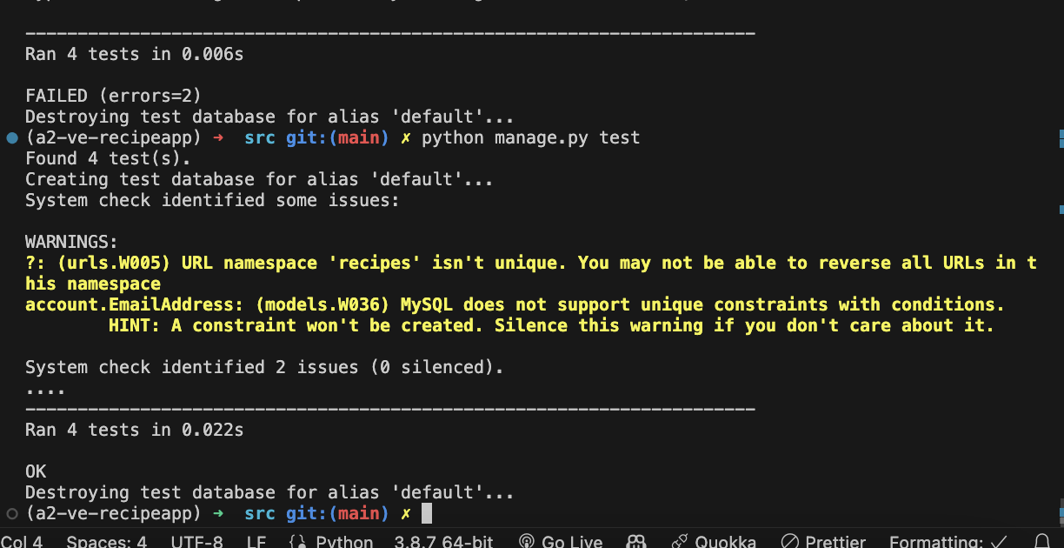

Execution Flow:

