# Ch2b. markdown tutorials, cheat sheet

### Cheat sheets

I did not find any complete cheat sheet… the best thing to do is to search for what you need… for example “**github flavored markdown italics**”.



<https://devhints.io/markdown>

<https://github.com/adam-p/markdown-here/wiki/Markdown-Cheatsheet>

<https://commonmark.org/help/>

<https://www.markdownguide.org/cheat-sheet/>

<https://daringfireball.net/projects/markdown/syntax>

<https://dev.to/soshace/markdown-cheat-sheet-definitive-guide-to-markdown-markdown-resources-n15>

### comments

<https://stackoverflow.com/questions/4823468/comments-in-markdown>

u could turn comments on/off.. I personally like this very much.

<span class="comment">this is a comment</span>

put this in style sheet

.comment { display: none; }

You can also put comments in md files like this.

[comment]: <> (this is

a comment)

[]: <> (this is

a comment)

[]: # (this is

most platform independent comment)

<!--- this is

a comment -->

### Cross refs 20200115

TERRY: this is where I found a discussion of how to do xrefs…

<https://stackoverflow.com/questions/5319754/cross-reference-named-anchor-in-markdown>

problem: those <a ….> appear in the right column.

So put the <a…> before the heading title. Example:

xxxxxxxxxxxxxxxxxxxxxxxxxxxx

1. If the authorization is successful, the postback is placed in the postback queue (see Queuing ).

…………………….

<a name="queuing"/>

## Queuing

### How to learn markdown

### 1) To learn markdown I think the best site is

<https://jonschlinkert.github.io/remarkable/demo/>

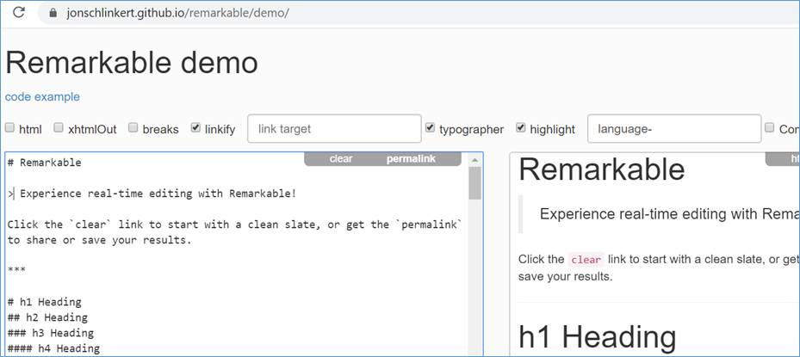

Just start modifying things and see what happens.

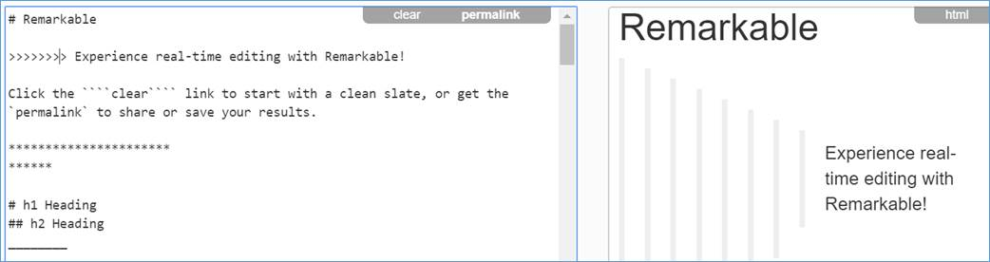

### 2) Theres a gold (very wordy) explanation here:

<https://docusaurus.io/docs/en/doc-markdown>

since the docs are based on docusaurus, I would consider this authoritative.

“Docusaurus uses [GitHub Flavored Markdown (GFM)](https://guides.github.com/features/mastering-markdown/). Find out more about Docusaurus-specific fields when writing Markdown.”

### 3) The official github short guide.

<https://guides.github.com/features/mastering-markdown/>

### 4) wiki gives some background, describes other markdown versions. Wiki:

GitHub Flavored Markdown (GFM)[[edit](https://en.wikipedia.org/w/index.php?title=Markdown&action=edit&section=4)]

In 2017, GitHub released a formal specification of their GitHub Flavored Markdown (GFM) that is based on CommonMark.[[32]](https://en.wikipedia.org/wiki/Markdown#cite_note-32) It follows the CommonMark specification exactly except for *tables, strikethrough, autolinks and task lists,* which the GitHub spec has added as extensions.[[33]](https://en.wikipedia.org/wiki/Markdown#cite_note-33) GitHub also changed the parser used on their sites accordingly, which required that some documents be changed. For instance, GFM now requires that the [hash symbol](https://en.wikipedia.org/wiki/Number_sign) that creates a heading be separated from the heading text by a space character.