xxxxx:\TerryT\__readme_first.docx

20200122

ttaylor@xxxxxxxxxxxxx.com

TOC

Location of doc deliverables (P:\TerryT) 2

1_doc_portal_demo_docusaurus.docx 3

1a_markdown_tutorial_cheat_sheets.docx 4

1b_partner_portal_demo_react_firebase.docx 4

2_doc_portal_ch4.docx 4

3_doc_portal_ch13567.docx 4

### Location of doc deliverables (xxxxxx:\TerryT)

The following is the list of docs. “R” means release version finished.

9_doc_portal contains the contents of the docs in markdown (MD) format.

xxxxxxxxxxxxxxxxxxxxxxxxxxx

### 1_doc_portal_demo_docusaurus.docx

shows all the steps I used to created a demo portal on my personal pc (no admin rights on VC pc) using docusaurus (Facebook-ReactJS-based).

First page something like this:

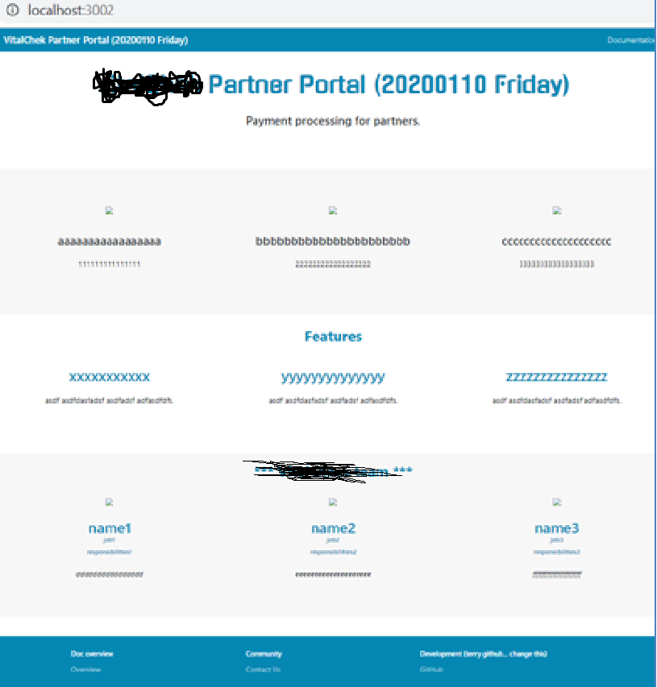

Click Documentation and then the main pages. Something like this.

xxxxxxxxxxxxxxxxxxxxxx

### 1a_markdown_tutorial_cheat_sheets.docx

Basic info about learning markdown.

### 1b_partner_portal_demo_react_firebase.docx

Chapter 1 describes how I completed a React/Firebase portal tutorial (an interesting possible tech to create the partner portal). 40 chapters, everything worked except the last chapter (deployed to firebase and problems with DB connection… not enough time to figure it out). Its impressive that a novice like myself could complete this with no assistance… shows that the tech is good.

### 2_doc_portal_ch4.docx

summarizes doc portal tools and doc deployment tools I researched. Favorite tool was docusaurus.

### 3_doc_portal_ch13567.docx

the original big doc for everything. Later I extracted ch4, 4b to create **2_doc_portal_ch4.docx**.