https://www.youtube.com/watch?v=eIQh02xuVw4
GraphQL Explained in 100 Seconds
Fireship

https://www.youtube.com/watch?v=Dr2dDWzThK8&t=0s
GraphQL Tutorial Beginner - Learn GraphQL in NodeJS / ExpressJS
PedroTech

https://www.youtube.com/watch?v=YyUWW04HwKY
GraphQL With React Tutorial - Apollo Client
PedroTech

**https://www.youtube.com/playlist?list=PLpPqplz6dKxXICtNgHY1tiCPau_AwWAJU
GraphQL Course - Beginner To Expert
PedroTech
9 ast updated on Sep 30, 2021 videos 98,321 views Last updated on Sep 30, 2021

https://welearncode.com/beginners-guide-graphql

https://www.tutorialspoint.com/graphql/graphql_environment_setup.html

OVERVIEW

https://www.apollographql.com/tutorials/lift-off-part1/01-feature-overview-and-setup

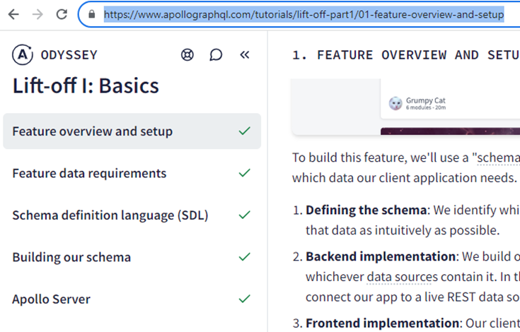

1. start Server/client (FEATURE OVERVIEW AND SETUP)

1.1 clone the app's starter repository

git clone https://github.com/apollographql/odyssey-lift-off-part1
C:\Users\terry\Downloads\graphql

PS C:\Users\terry> cd C:\Users\terry\Downloads\graphql
PS C:\Users\terry\Downloads\graphql> git clone https://github.com/apollographql/odyssey-lift-off-part1
Cloning into 'odyssey-lift-off-part1'...
remote: Enumerating objects: 842, done.
remote: Counting objects: 100% (840/840), done.
remote: Compressing objects: 100% (431/431), done.
remote: Total 842 (delta 442), reused 720 (delta 392), pack-reused 2Receiving objects: 99% (834/842), 1.98 MiB | 3.93 MiB/s
Receiving objects: 100% (842/842), 2.94 MiB | 4.42 MiB/s, done.
Resolving deltas: 100% (442/442), done.

1.2 server start (4000?)
in server/ directory install dependencies
npm install
run the app:
npm start

PS C:\Users\terry\Downloads\graphql> cd .\odyssey-lift-off-part1\
PS C:\Users\terry\Downloads\graphql\odyssey-lift-off-part1> cd server
PS C:\Users\terry\Downloads\graphql\odyssey-lift-off-part1\server> npm install
added 33 packages, and audited 34 packages in 828ms
4 packages are looking for funding
run `npm fund` for details
3 moderate severity vulnerabilities
To address all issues (including breaking changes), run:
npm audit fix --force
Run `npm audit` for details.
PS C:\Users\terry\Downloads\graphql\odyssey-lift-off-part1\server> npm start
> catstronauts-server-complete@1.0.0 start
> nodemon src/index
[nodemon] 2.0.20
[nodemon] to restart at any time, enter `rs`
[nodemon] watching path(s): *.*
[nodemon] watching extensions: js,mjs,json
[nodemon] starting `node src/index.js`
[nodemon] clean exit - waiting for changes before restart

1.3 client start 3000

client/ install dependencies and start the app:
npm install
npm start

PS C:\Users\terry> cd C:\Users\terry\Downloads\graphql\odyssey-lift-off-part1\client
PS C:\Users\terry\Downloads\graphql\odyssey-lift-off-part1\client> npm install
npm WARN deprecated source-map-url@0.4.1: See https://github.com/lydell/source-map-url#deprecated
npm WARN deprecated urix@0.1.0: Please see https://github.com/lydell/urix#deprecated
npm WARN deprecated @types/testing-library__dom@7.5.0: This is a stub types definition. testing-library__dom provides its own type definitions, so you do not need this installed.
npm WARN deprecated @types/classnames@2.3.1: This is a stub types definition. classnames provides its own type definitions, so you do not need this installed.
npm WARN deprecated source-map-resolve@0.5.3: See https://github.com/lydell/source-map-resolve#deprecated
npm WARN deprecated resolve-url@0.2.1: https://github.com/lydell/resolve-url#deprecated
npm WARN deprecated w3c-hr-time@1.0.2: Use your platform's native performance.now() and performance.timeOrigin.
added 737 packages, and audited 738 packages in 16s
122 packages are looking for funding
run `npm fund` for details
2 moderate severity vulnerabilities
To address all issues, run:
npm audit fix

Run `npm audit` for details.
PS C:\Users\terry\Downloads\graphql\odyssey-lift-off-part1\client> npm start

> catstronauts-client@1.0.0 start
> vite
VITE v4.4.4 ready in 380 ms
➜ Local: http://127.0.0.1:3000/
➜ press h to show help

running app at http://127.0.0.1:3000/, or localhost:3000.

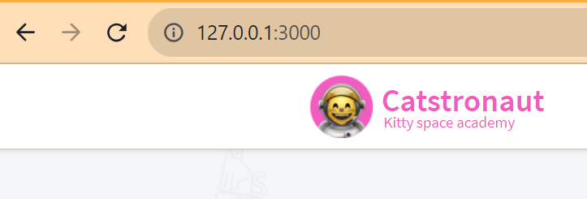

x2. (text only) FEATURE DATA REQUIREMENT

xxx

x3. (text only) SCHEMA DEFINITION LANGUAGE (SDL)

xxxx

4. @apollo/server / create server schema.js (BUILDING OUR SCHEMA)

4.1 open in IDE
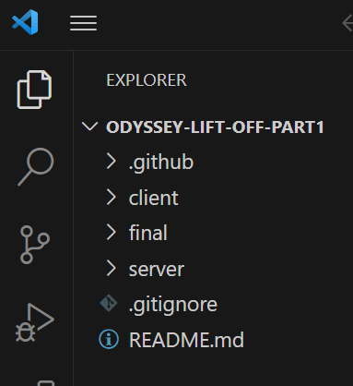

4.2 npm install @apollo/server graphql graphql-tag

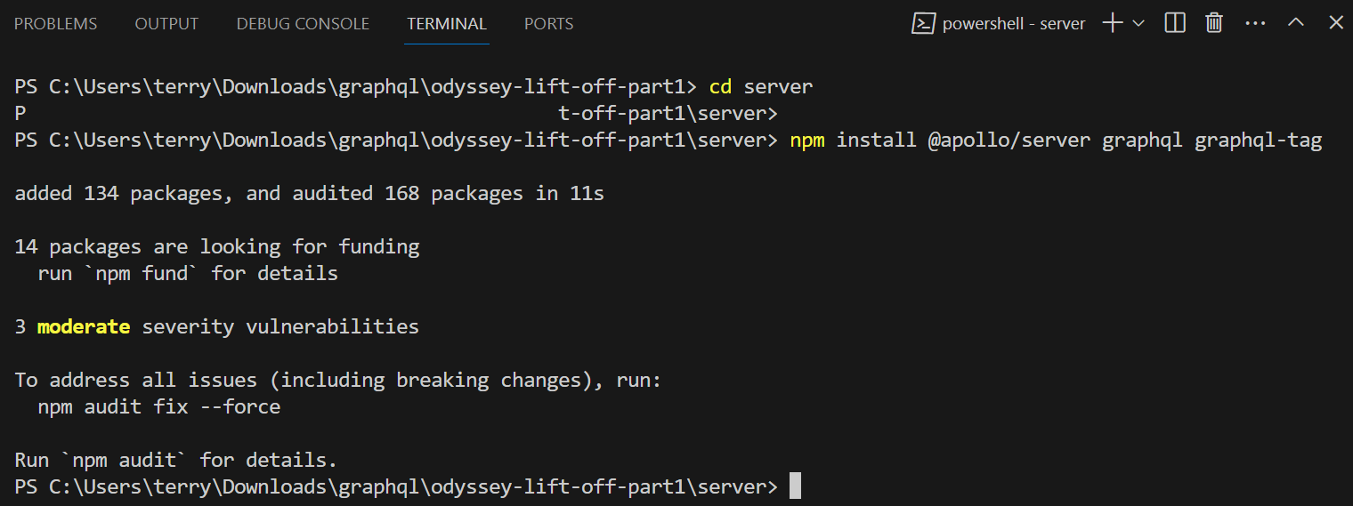

4.3 copy schema.js

TERRY: just copy

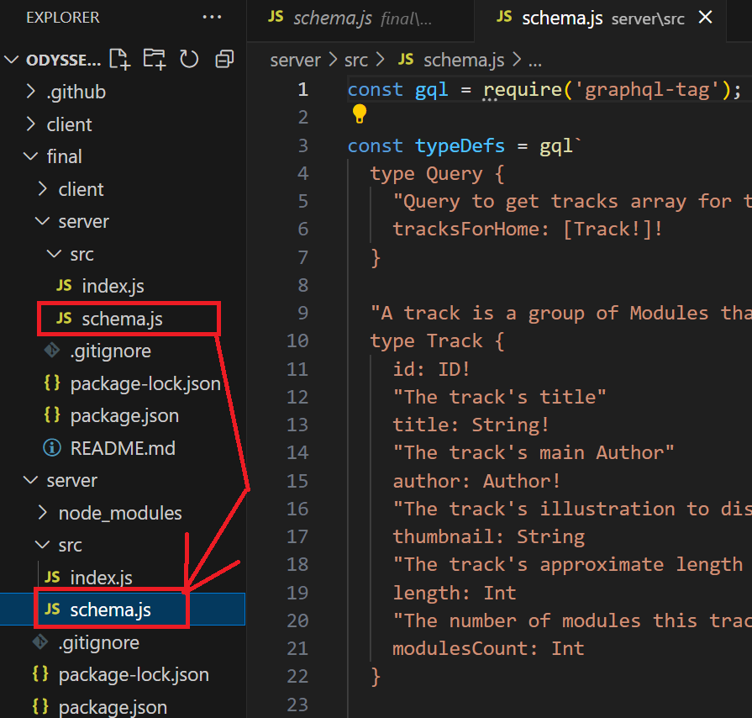
schema.js should be this
const gql = require("graphql-tag");

const typeDefs = gql`
type Query {
"Get tracks array for homepage grid"
tracksForHome: [Track!]!
}

"A track is a group of Modules that teaches about a specific topic"
type Track {
id: ID!
"The track's title"
title: String!
"The track's main author"
author: Author!
"The track's main illustration to display in track card or track page detail"
thumbnail: String
"The track's approximate length to complete, in minutes"
length: Int
"The number of modules this track contains"
modulesCount: Int
}

"Author of a complete Track"
type Author {
id: ID!
"Author's first and last name"
name: String!
"Author's profile picture url"
photo: String
}
`;

module.exports = typeDefs;

5. setup mock (APOLLO SERVER)

5.1 VSC terminal install mock/schema

PS C:\Users\terry\Downloads\graphql\odyssey-lift-off-part1\server> npm install @graphql-tools/mock @graphql-tools/schema

added 6 packages, changed 3 packages, and audited 174 packages in 4s

14 packages are looking for funding
run `npm fund` for details

3 moderate severity vulnerabilities

To address all issues (including breaking changes), run:
npm audit fix --force

Run `npm audit` for details.
PS C:\Users\terry\Downloads\graphql\odyssey-lift-off-part1\server>

5.2 copy mock code

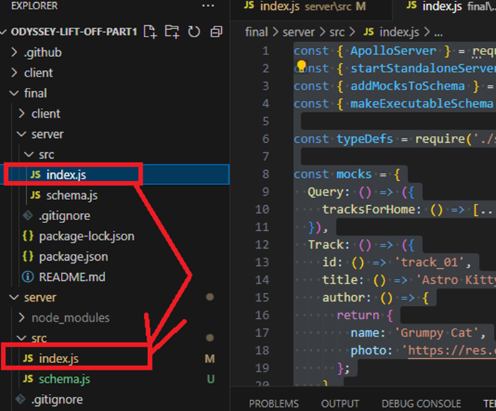

5.3 refresh localhost:4000 (explorer)

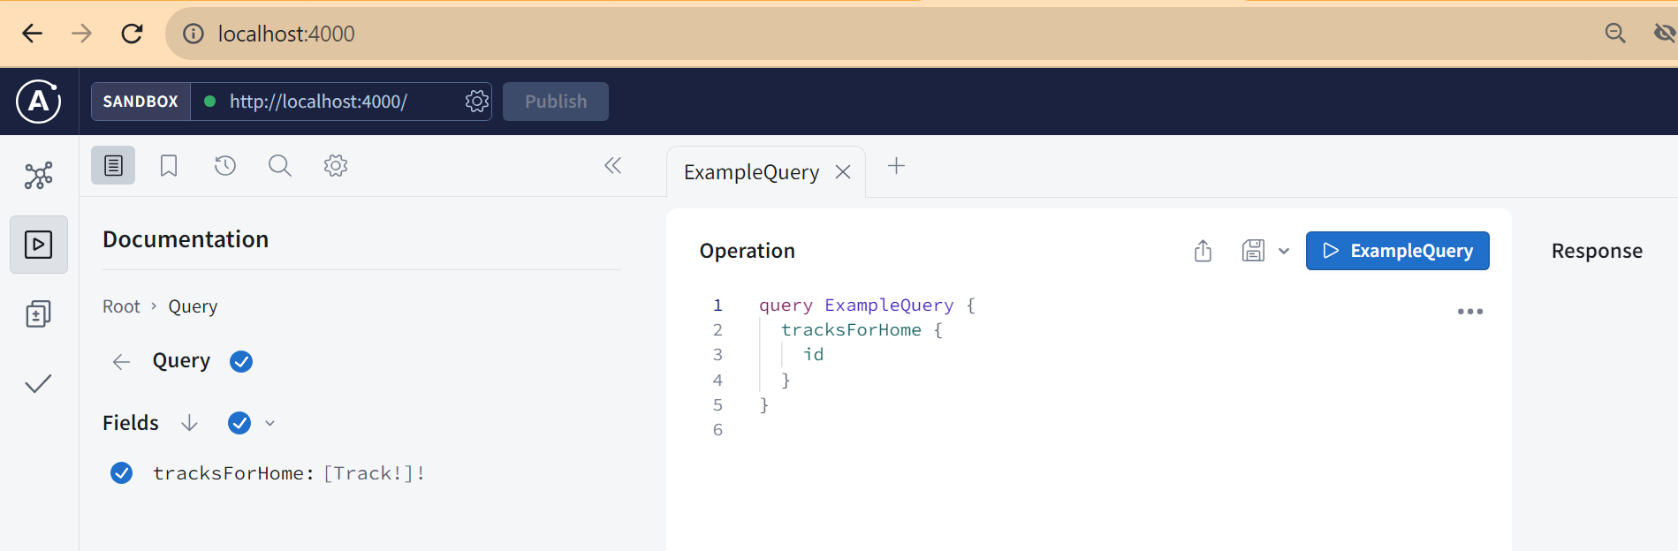

6. using explorer (APOLLO EXPLORER)

6.1 example query

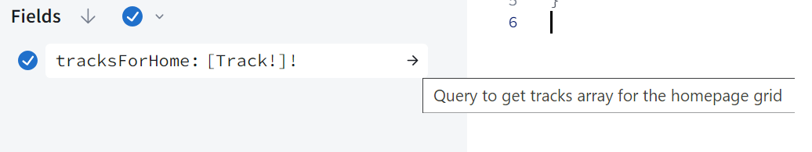
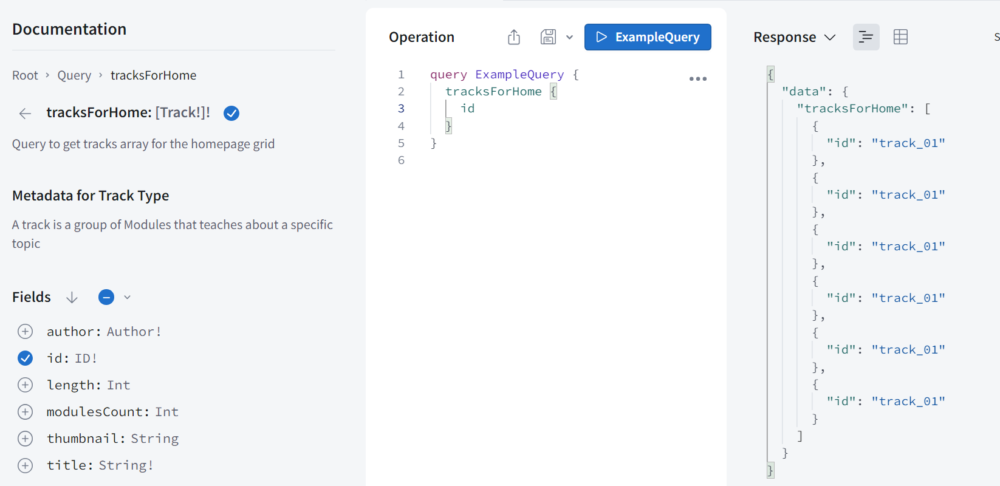

6.2 Add title field to query

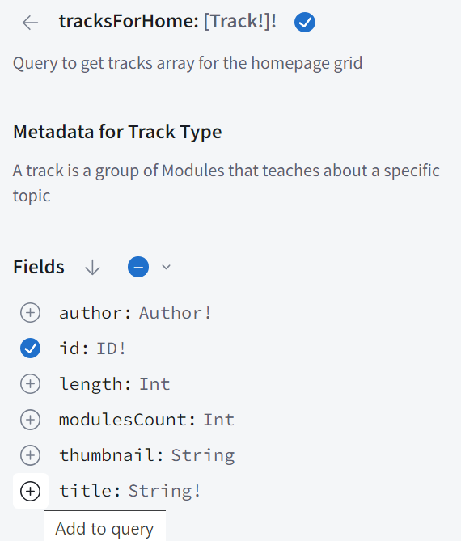

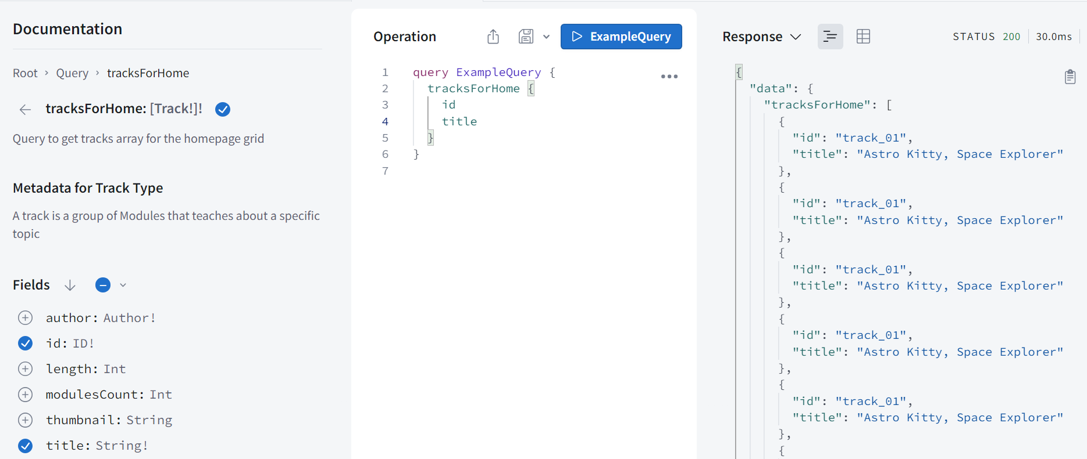

6.3 select all scalar fields

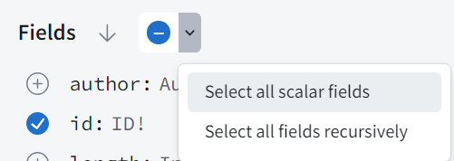

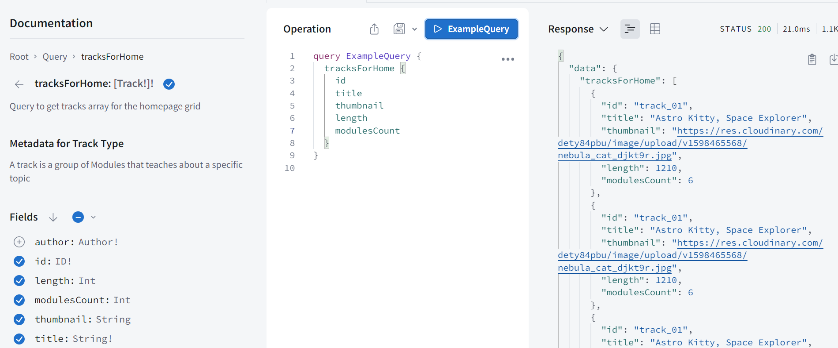

6.4 select all fields recursively

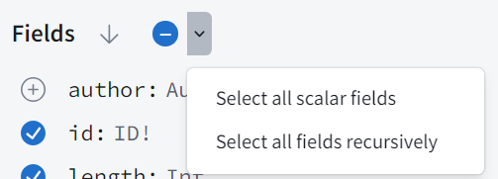

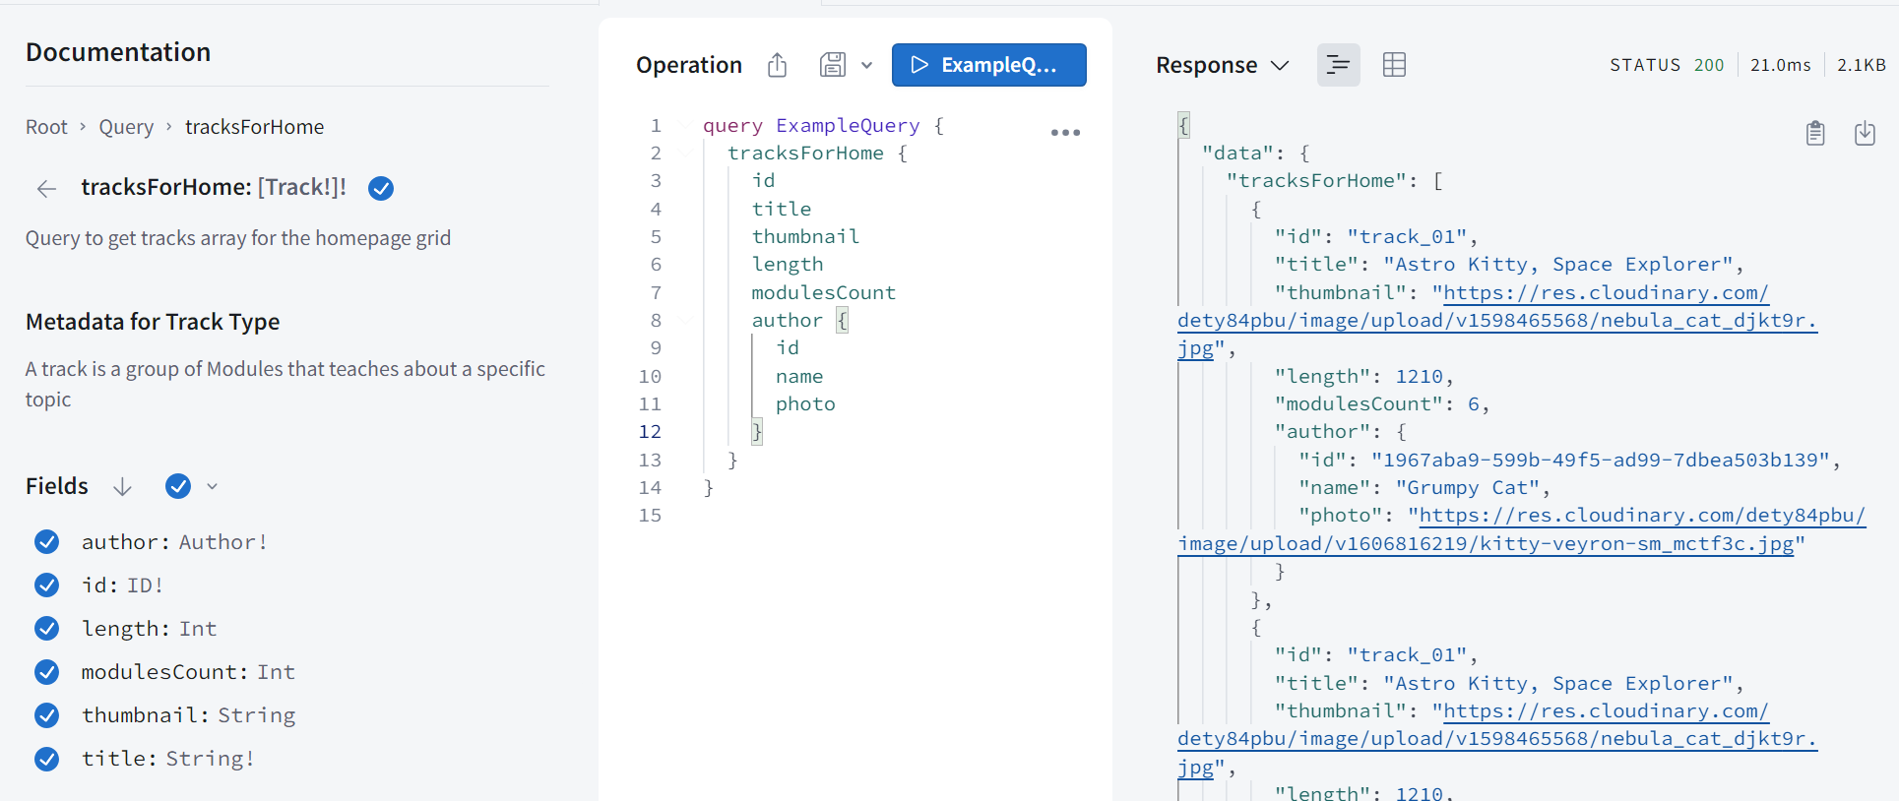

6.5 rename (select and change)

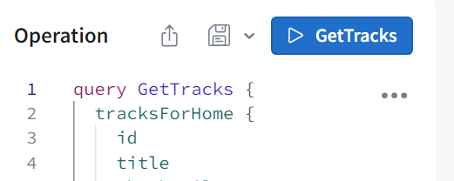

6.6 Save operation

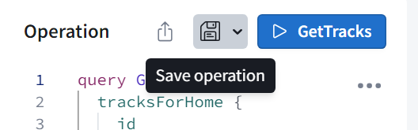

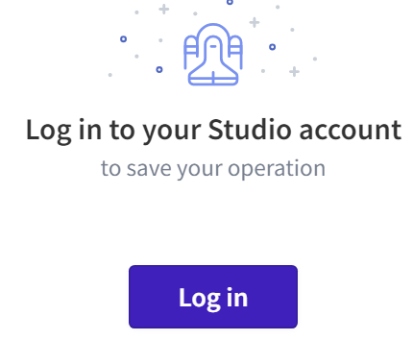

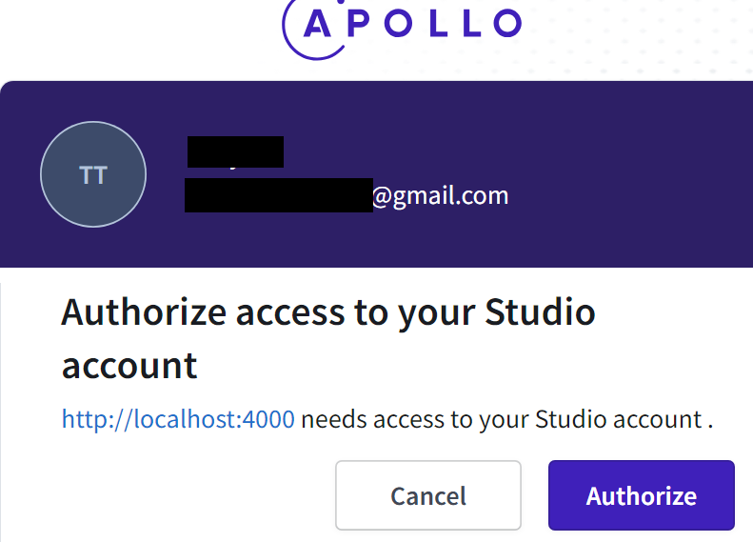

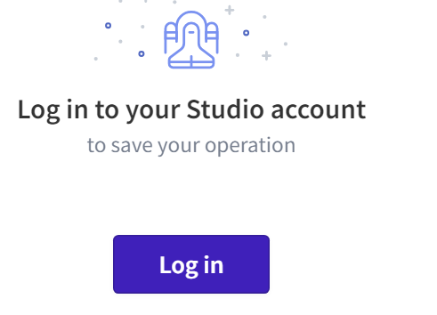

Error here... you have to always go to login page when clicking save button

I never see this dialog
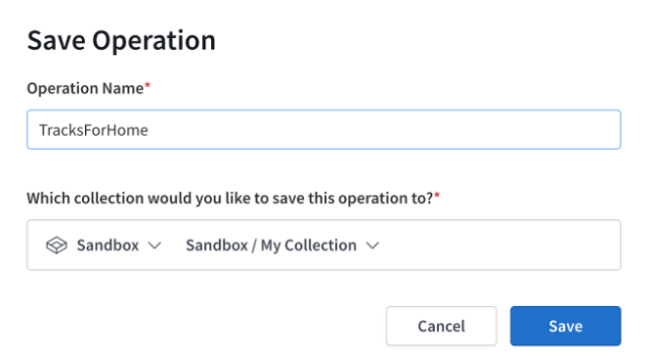

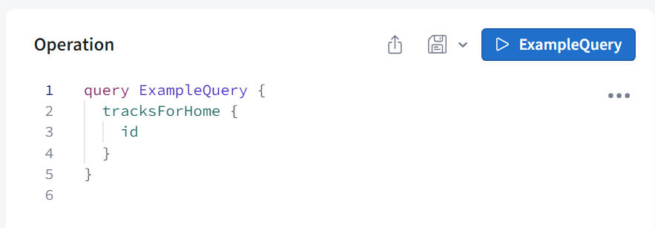

x7. Frontend first steps

TERRY: this was already started.

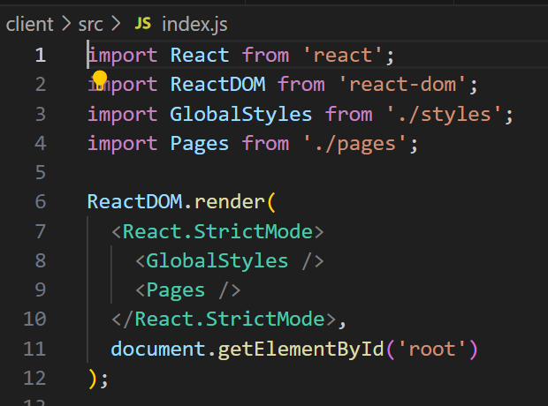

8. Apollo Client 3

From the client/ directory, run the following command:
npm install graphql @apollo/client

PS C:\Users\terry\Downloads\graphql\odyssey-lift-off-part1\client> npm install graphql @apollo/client

added 13 packages, and audited 751 packages in 7s

122 packages are looking for funding
run `npm fund` for details

2 moderate severity vulnerabilities

To address all issues, run:
npm audit fix

Run `npm audit` for details.
PS C:\Users\terry\Downloads\graphql\odyssey-lift-off-part1\client>

change index.js to this

import React from "react";
import ReactDOM from "react-dom";
import GlobalStyles from "./styles";
import Pages from "./pages";
import { ApolloProvider, ApolloClient, InMemoryCache } from "@apollo/client";

const client = new ApolloClient({
uri: "http://localhost:4000",
cache: new InMemoryCache()
});

ReactDOM.render(
<ApolloProvider client={client}>
<GlobalStyles />
<Pages />
</ApolloProvider>,
document.getElementById("root")
);

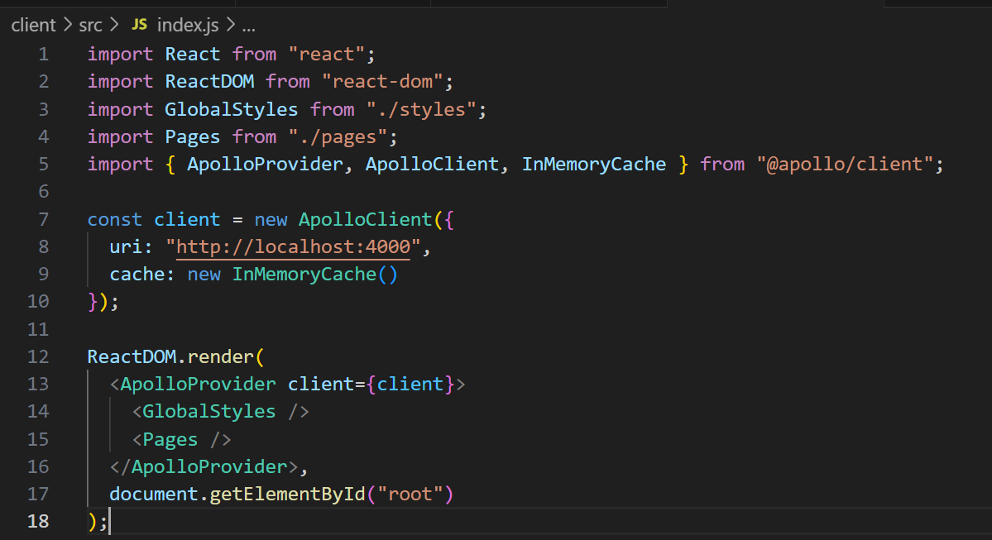

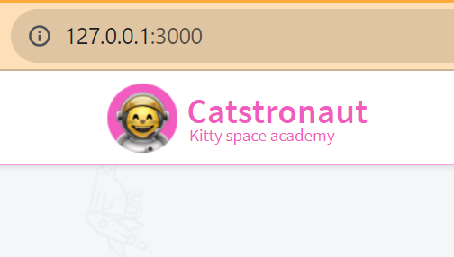

9. defining a query

9.1 tracks.js

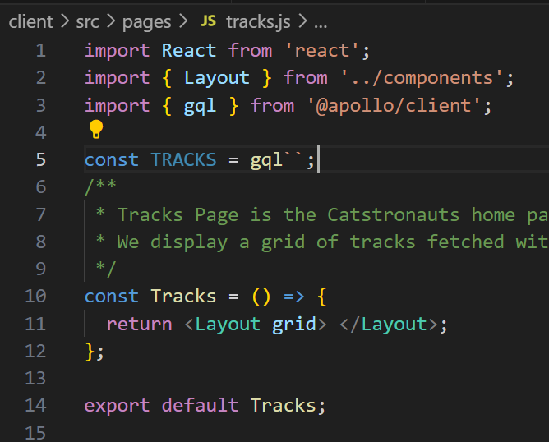

9.2 i cant view operation collections

always asks me to login
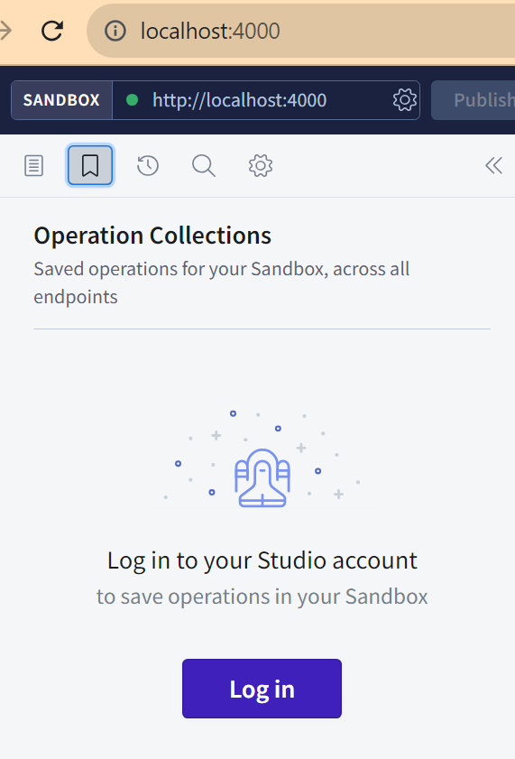

10. useQuery hook
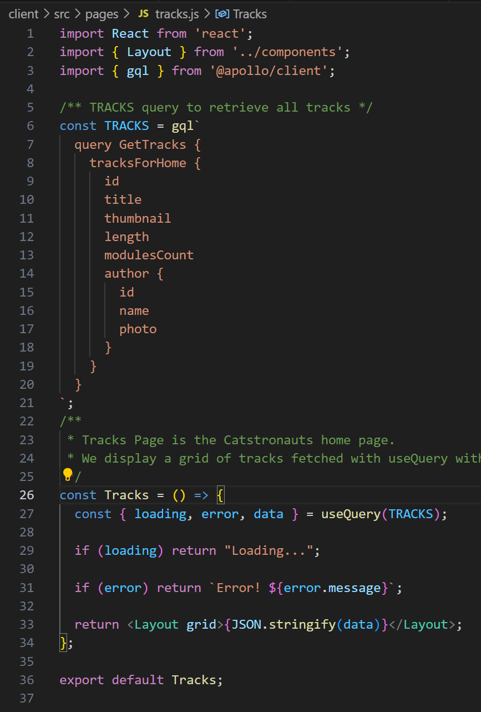

save autorestart... nothing

npm start in vscode .... nothing

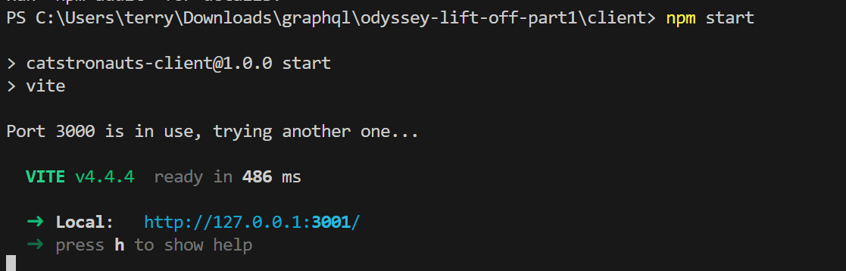

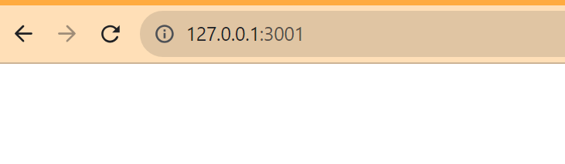

npm start command line .... nothing

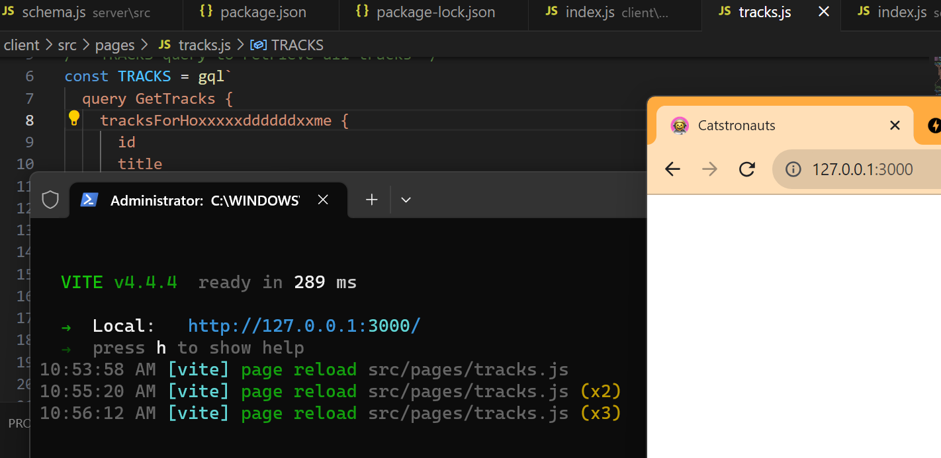

final file version
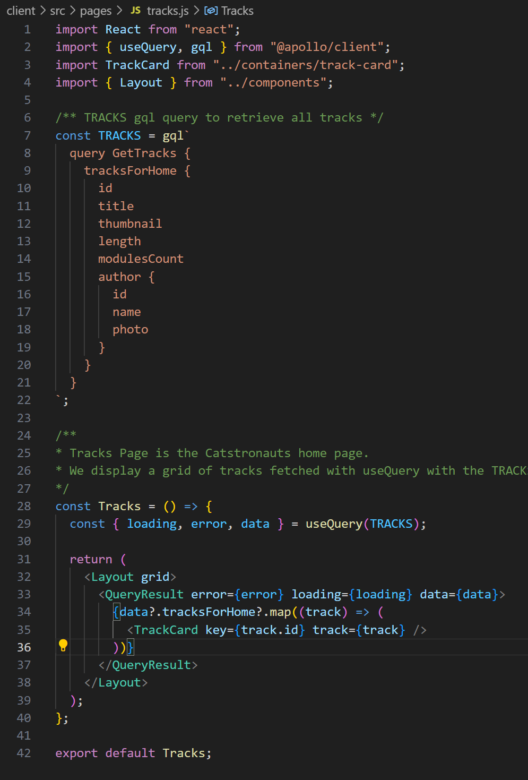

restart everything... still same error ... have something to do with login error?
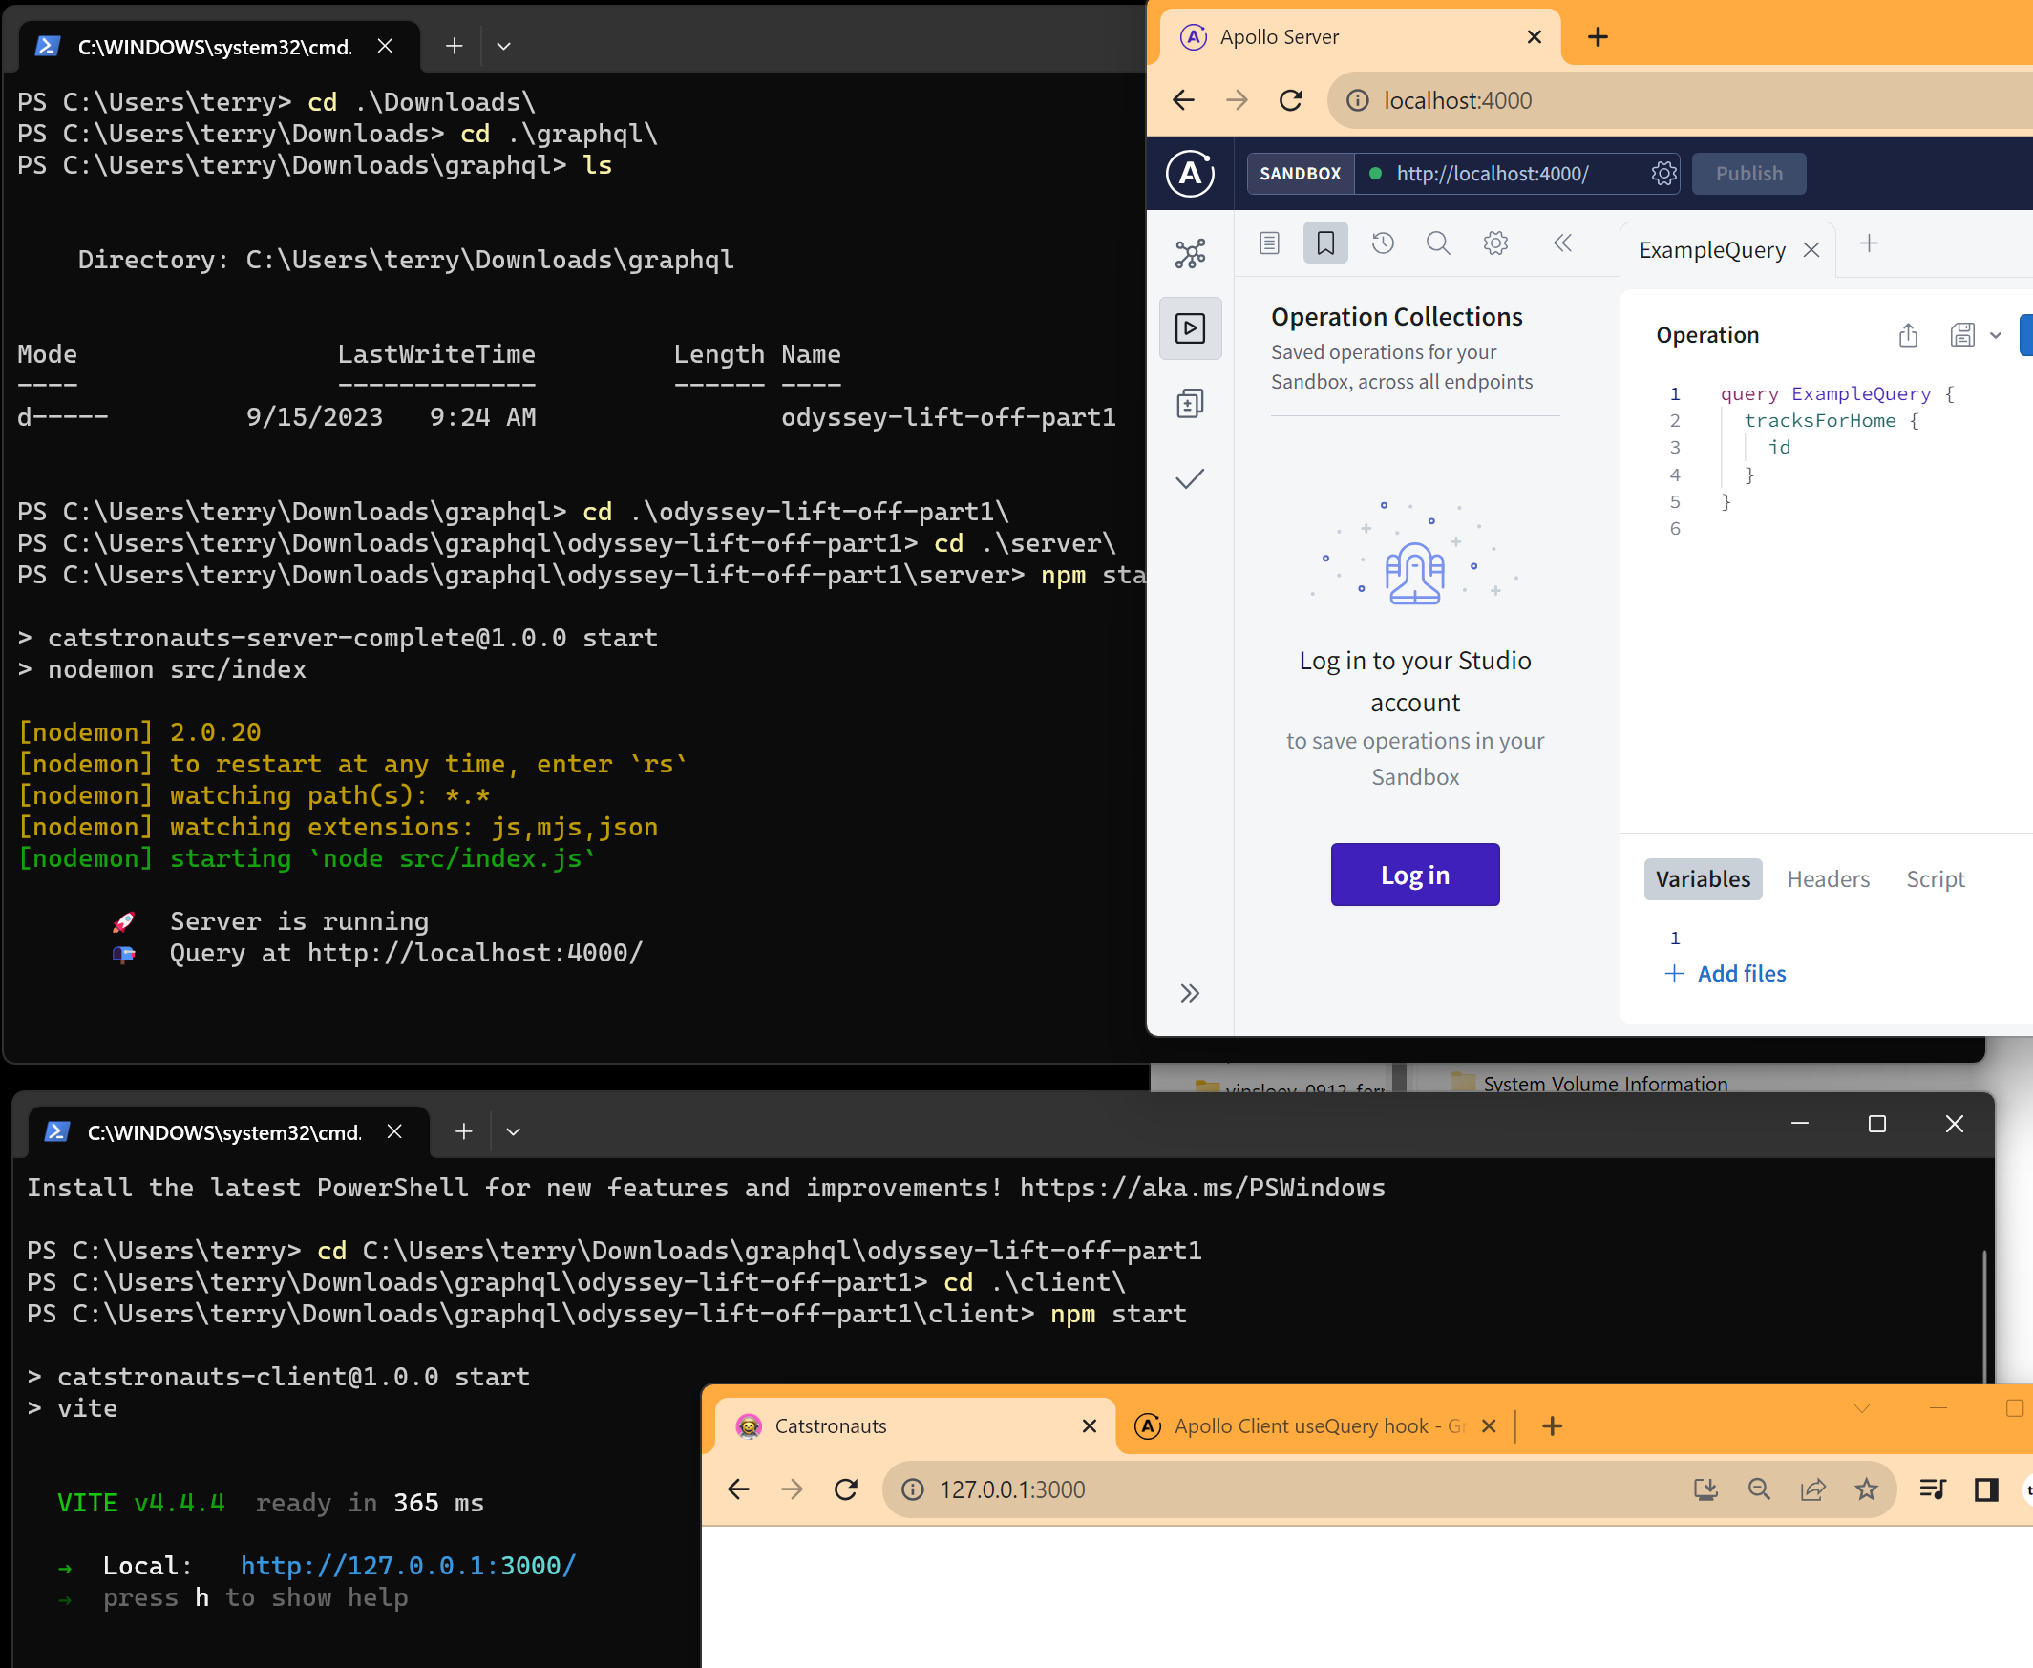

11 restart pc

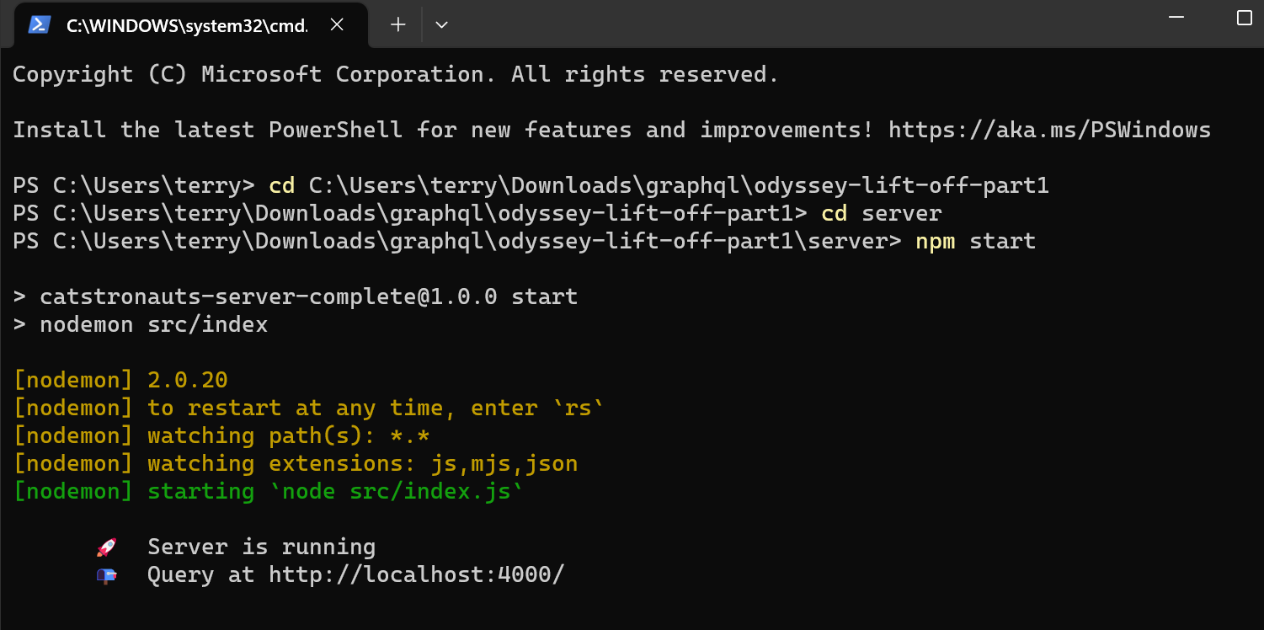
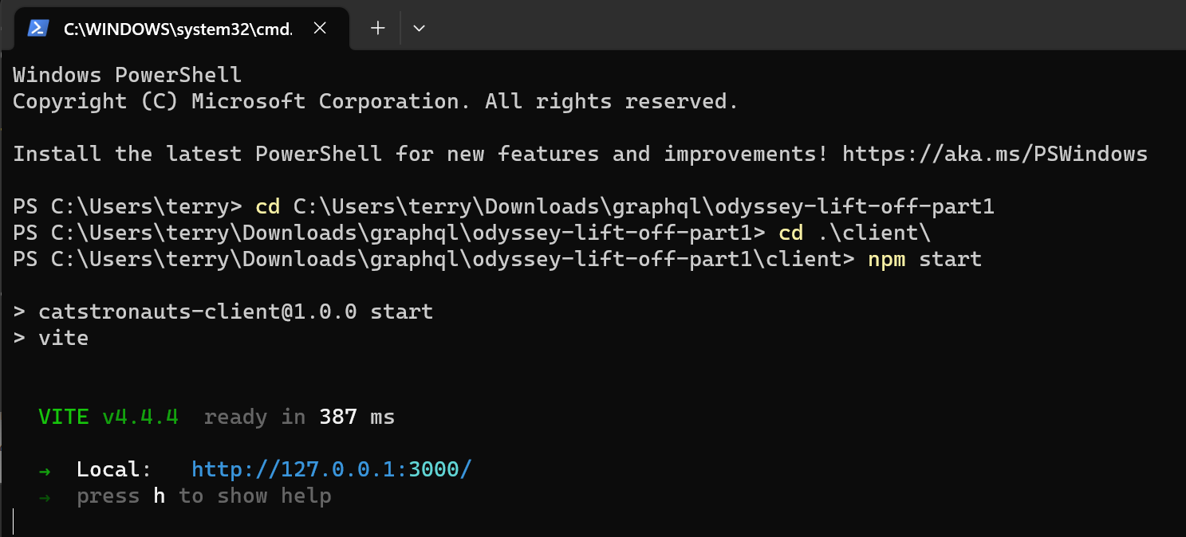
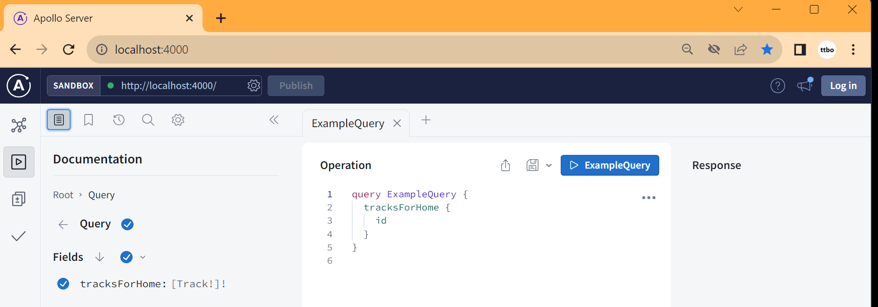
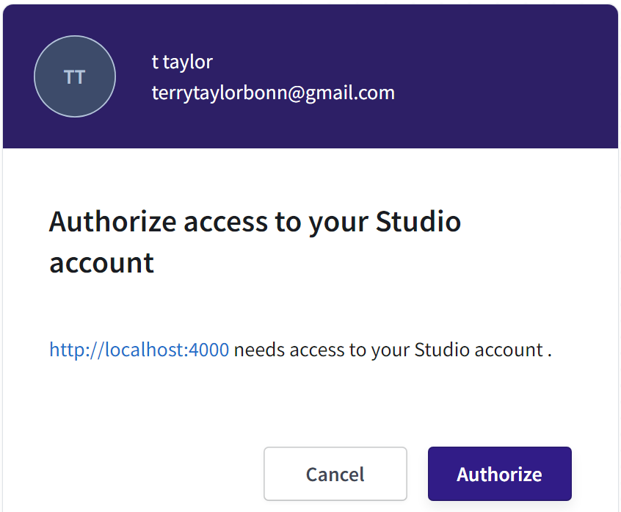
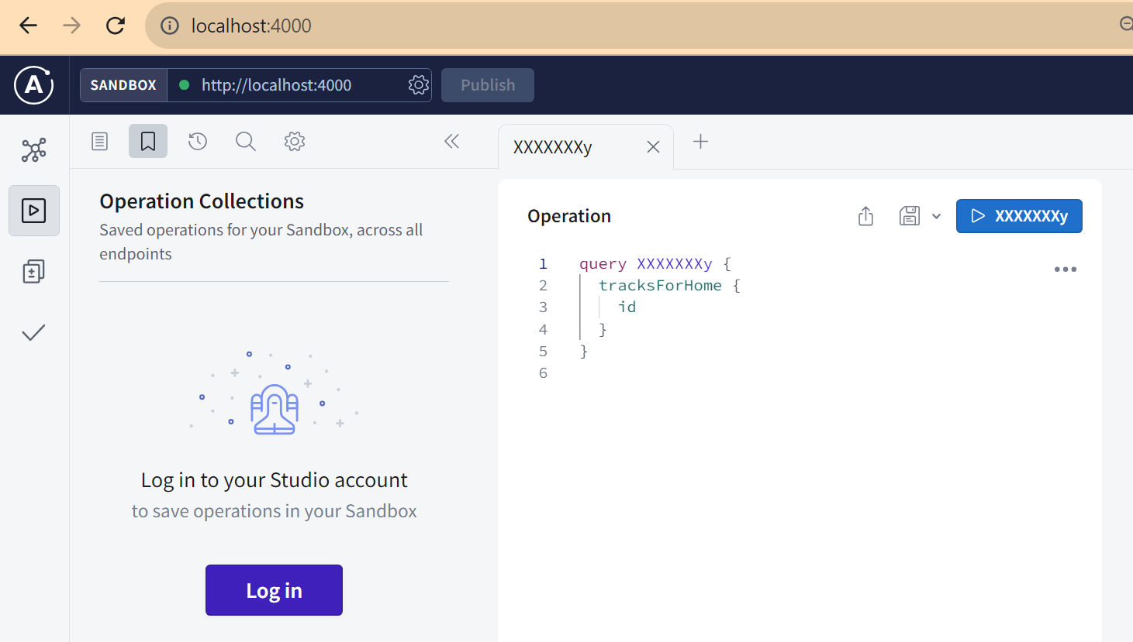
The login error still there... i cant change the name of the operation.

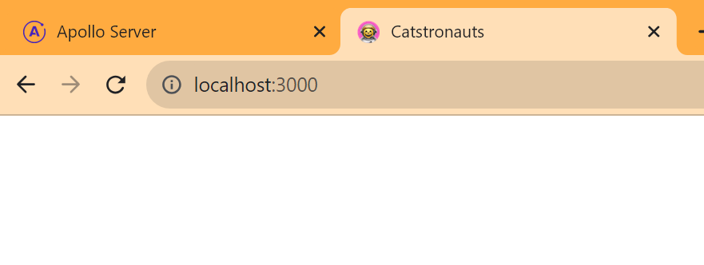
this not work either
