terry.taylor@xxxx 2023.0901
@ https://drive.google.com/drive/folders/xxxxxxxxxxxxxxxxxx
Contents
About this document 1
Overview of Gdrive “terry docs” (23 docx + 1 Swagger yaml + 1 Postman json) 1
1 Doc planning docs 1
2 End user docs (deliverables) 2
3 Endpoint/parameter descriptions / interviews 3
4 Endpoint tests 3
5 Recipe docs 3

About this document
This document describes the ~25 documents I created that are on the Terry Mythical Gdrive. Many of these docs are quite large and technically detailed (with diagrams, code tests, and examples). Total size of all files = ~150 MB (lots of screenshots).
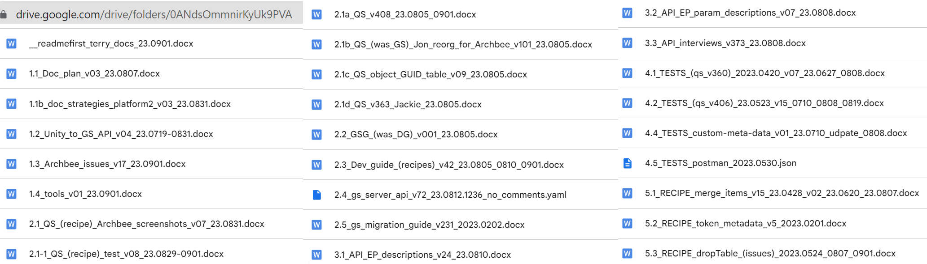

Overview of Gdrive “terry docs” (23 docx + 1 Swagger yaml + 1 Postman json)

1 Doc planning docs

 | File name | Description
1 | 1.1_Doc_plan_  v03_23.0807.docx | March 2023 (no doc plan doc after that).
2 | 1.1b_Doc_strategies_platform2_  v03_23.0831.docx | Describes the strategy used to get info required for docs (from the code).
3 | 1.2_Unity_to_GS_API_  v04_23.0719-0831.docx | July 2023. Describes the architecture and command flow in NFL rivals and where the API fits in.
4 | 1.3_Archbee_issues_  v17_23.0901.docx | Archbee issues.
5 | 1.4_tools_  v01_23.0901.docx | Various notes about different tools.

2 End user docs (deliverables)

The general idea (~late 2022, early 2023) for a documentation set was the following 4 docs (+ doc 2.5 from Jon in July 2023):
2.1 QS (hands-on for core endpoints)
2.2 GSG (details usage of all endpoints, how they interact, etc)
2.3 DG (how-to/recipes for game dev using GS API)
2.4 API REF (swagger with tech details of API usage)
2.5 MIGRATION GUIDE (good idea from Jon)

The following lists the corresponding docs I created. Sometimes there are multiple docs because of various changing requirements. Often a doc was developed based on a plan that was later changed.
 | File name | Description
6 | 2.1_QS_(recipe)_Archbee_screenshots_  v07_23.0831.docx | At one point I had a close to “releaseable” quality QuickStart (QS). But after it was decided to release only a small fraction of the content, I started using it as a test document, filling it full of examples. Then around Aug 2023 was decided to create this doc, a “recipe”, which is basically the QS I had always been planning to do.
7 | 2.1-1_QS_(recipe)_test_  v08_23.0829-0901.docx | Ran throught all of the endpoints in the QS recipe as a test.
8 | 2.1a_QS_  v408_23.0805_0901.docx | At one point this document was close to “releaseable” quality QuickStart (QS). But after it was decided to release only a small fraction of the content, I started using it as a test document, filling it full of examples. Then around start of 2023 August I took v406 and deleted as much junk as possible.
9 | 2.1b_QS_(was_GS)_  Jon_reorg_for_Archbee_  v101_23.0805.docx | This document was reorg’d around 0511 based on structure from Jon. Very logical structure, could have been a useful doc, but was not used. I named the file QS, because to me its more like a quick start. Also includes input from 2 recorded conversations (80 mins) with Eric.
10 | 2.1c_QS_object_GUID_table_  v09_23.0805.docx | This doc was created as a “notebook” for the reader to jot down GUID’s when going thru the API QS (such a doc is needed in particular because almost all endpoints that create an object with a GUID name that parameter “id”, which makes making mistakes very easy; this doc helps to deal with this complexity). I myself needed such a doc when I started with the API. This doc content will not be included in any release docs.
11 | 2.1d_QS_v363_Jackie_  23.0805.docx | I took qs_v363 (full version with tests) and created “quick start” for Jackie.
12 | 2.2_GSG_(was_DG)_  v001_23.0805.docx | This started as a skeleton for a dev guide in 2022 November (only 2 months after I started on this project). But later I thought it would better to publish this content as a GSG (getting started guide; I use “GSG” instead of “GS” to avoid confusion with “Game Services”). The goal is to demo how to use endpoints back-to-back in the most common workflows. Not the detail of the QS, but more broad.
13 | 2.3_Dev_guide_(recipes)_  v42_23.0805_0810_0901.docx | The first 2 doc sets (2.1x, 2.2x above) were for a QuickStart (step-by-step intro to API) and Getting Started Guide (GSG, showing how to use all endpoints in workflows).  The 3rd doc was to be a developer guide, focusing on how to implement with the API the most common game developers workflows (for example: how to use dropTables to support drops).  PART1: DEV GUIDE CHAPTERS. Chapters 4b,4c,4d,4a,5 were to be recipes for different game sites (inventory, shop, marketplace, checkout, game server, mobile). For example, what a drop looked like on the website, and how it could be implemented with GS API. I was not sure about what this should look like. So this doc is mainly my notes and research. This doc was never used. NOTE: See ch5 of this doc for more recipe docs.  PART2: SITE ANALYSIS of Rivals / NN websites. Self study, trying to figure things out.  PART3: ENDPOINT TESTS.  PART4: RESEARCH. Self study, tutorials, examples for graphql, apollo, swashbuckle, archbee, fusionauth.
14 | 2.4_gs_server_api_  v72_23.0812.1236_no_comments.yaml | Swagger file. ~65 endpoints.  1 The source for this file was generated from code (using a “homebrew” method). Accurate content, but difficult to maintain and organize (I could not edit in the code).  2 I decided to manually edit the auto-generated swagger (result is reorganized, with endpoints in logical order).
15 | 2.5_gs_migration_guide_  v231_2023.0202.docx | Basic idea: Show how to migrate NN to platform 3? Lots of feedback, but only questions (that I could not answer). I think this doc was abandoned because the topic was too complex and NN would not be migrating.

3 Endpoint/parameter descriptions / interviews

 | File name | Description
16 | 3.1_API_EP_descriptions_  v24_23.0810.docx | This doc is a “staging area” (before putting into the yaml file (2.4)) for endpoint (not parameter) descriptions.  There are ~120 endpoints, but only 59 core (“common”) endpoints are documented.  Ch A,B Endpoint descriptions (59 total) based on interviews.  Ch 5,4,3,2,1 Transcripts of interviews.
17 | 3.2_API_EP_param_descriptions_  v07_23.0808.docx | This doc (a reformatted/distilled version of the swagger file) is also a “staging area”, but for parameters.  I did it this way to minimize duplicate entries (parameters showing up multiple times). Swagger also lists the same parameters multiple times, but with components this occurs far less often that if you just take the list from the swagger UI). Lists ~500 endpoints (# of endpoints in swagger). ~375 are numbered as unique (still some repeats, probably about ~300 are unique).
18 | 3.3_API_interviews_  v373_23.0808.docx | Interviews with xxxx and xxxx.  - I started these interviews when I was still planning to write a GSG doc (how to use endpoints). So the interviews were about general usage, not focusing only on endpoint/param description text.  - I did not have the 65 endpoint endpoint list when I did this interview (and there was no authoritative list of all the endpoints/params), so much of the content of this doc is not needed now).

4 Endpoint tests

Swagger and postman tests.

 | File name | Description
19 | 4.1_TESTS_(qs_v360)_  2023.0420_v07_23.0627_0808.docx | Originally planned as QuickStart. this became a testing doc.  28 MB QS version, lots of tests (swagger, postman), repeats (good source of historical test data).
20 | 4.2_TESTS_(qs_v406)_  23.0523_v15_0710_0808_0819.docx | 13 MB “distilled” version of 4.1.
21 | 4.4_TESTS_custom-metat-data_  v01_23.0710_udpate_0808.docx | Has customData tests from 0710, 0630 (run-through of CD, MD, CMD endpoints)
22 | 4.5_TESTS_postman_  2023.0530.json | Collection of all Postman tests.

5 Recipe docs

The original plan was to combine all recipes into a developer guide (the API as seen by the game developer).

 | File name | Description
23 | 5.1_RECIPE_merge_items_  v15_23.0428_v02_23.0620_23.0807.docx | Abandoned because there is no GET itemClass endpoint. There are many versions of this doc.
24 | 5.2_RECIPE_token_metadata_  v5_2023.0201.docx | Describes a token metadata+attributes test I ran on 2023.0131-0201. I wanted to understand the details of how the API works. The content would be a chapter in the GS “Token recipes”.
25 | 5.3_RECIPE_dropTables_(issues)_  2023.0524_0807_0901.docx | Summarizes dropTable problems. I spent a great deal of time trying to get dropTables to work because I did not know that they only worked when used in a limited way. Updated this doc 0901 significantly after dev meeting previous day that was about dropTables.

