Result:

1： generate the SSD with cluster number range from 1 to 10

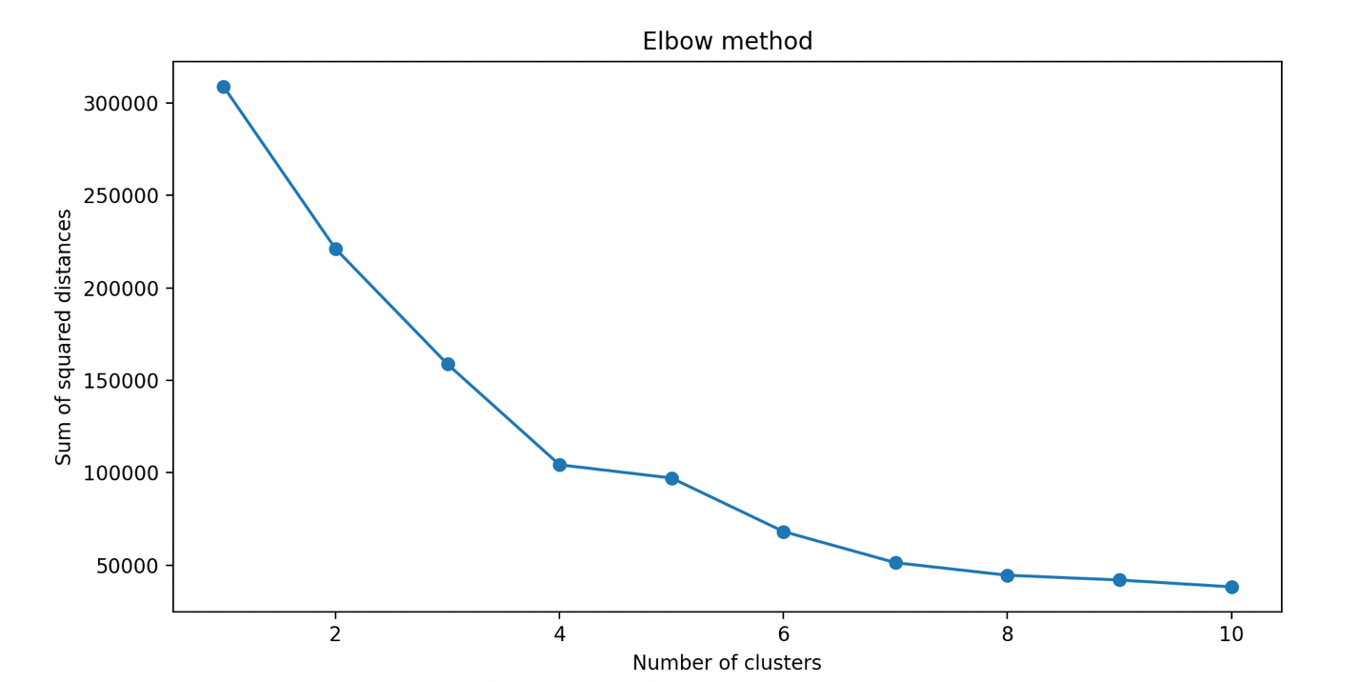

So we choose 4 as the cluster number.

2: Visualize the relations between income and spending 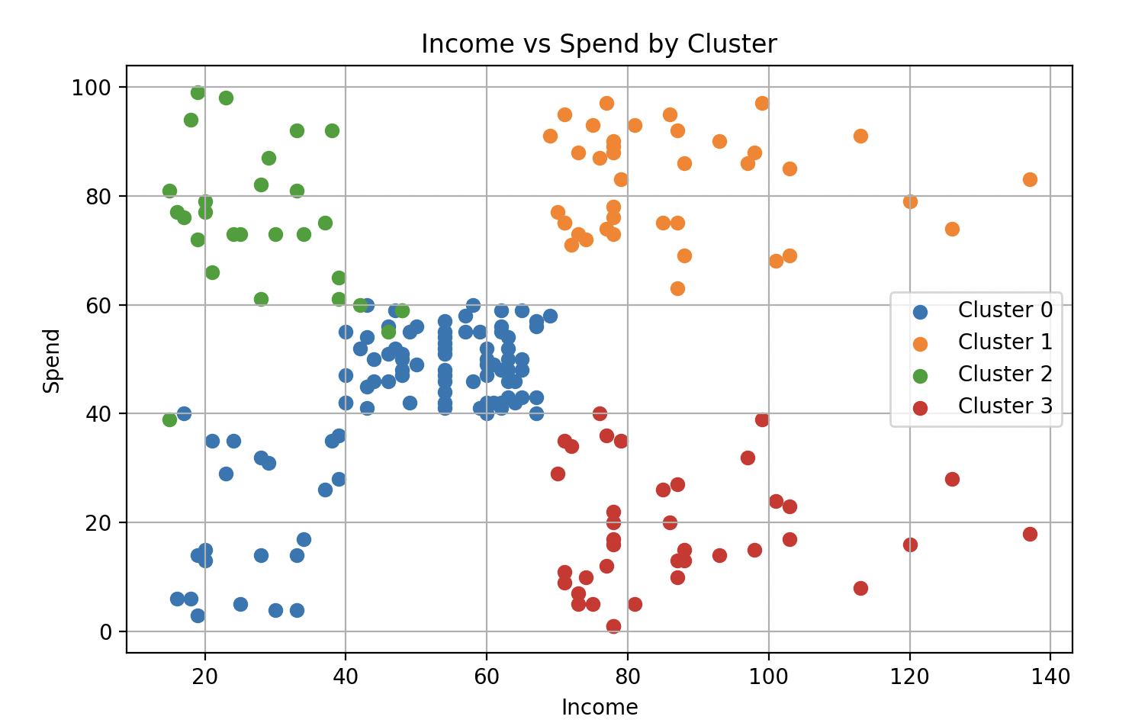

3:visualize the relation between income and age

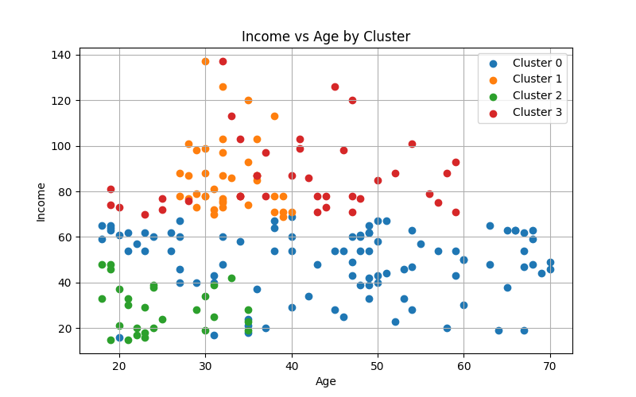

4: Try to find names for different clusters based on these visualizations.

* C0(Blue): across all age: Income-Spending Balance: Strive to make ends meet
* C1(Orange): Middle age, High Income, High Spending: Social Elite but the victim of consumerism
* C2(Green): Young Age, Low Income, High Spending: Rich second generation
* C3(Red): across all age, High Income, Low Spending: Social Elite with good Financial habit