1. Ware argues that human perception involves 2.5 dimensions. Given this assertion, when might a 3D visualization be useful and why?

Ware’s argument entails that ‘depth’ is a dimension that is inferred from other sources of information in the other dimensions (and thereby cannot be counted as a whole dimension); e.g. *shadows*, *relative size*, or the way that objects seem to move in front of each other when the viewer him/herself changes position, i.e. *motion parallax*. This depth-dimension however does provide the viewer with a sense of space, which is vital in areas like architecture and astronomy (side note: most of the things we know about this area are actually indirectly inferred, e.g. what stars are made of by using the absorption of light by specific particles).

1. In Chapter 6, Ware presents some implications of pattern recognition and visual working memory on design. Provide an example that harnesses some of these principles (perhaps an advertisement, visualization, or interface) and discuss how the design takes these principles into account. Please include a screenshot, photo, or website URL.

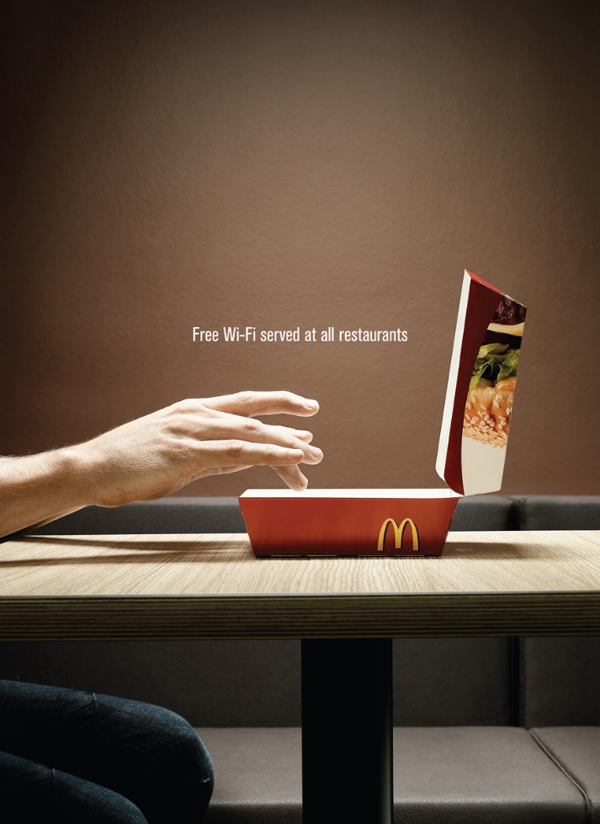I’ve chosen an advertisement by McDonalds Corporation that particularly shows a lot of symbolism.

According to Ware, symbols can be described as visual shapes that have become cognitively bound to a particular non-visual cluster of concepts.

Ware states that looking at symbols: “causes an automatic and rapid activation of these concepts”. He continues that this temporary activation of visual objects is *visual working memory* and that people in general can only hold a limited amount of objects in this working memory. This also depends on the complexity of these objects as more complex objects take up more of your visual working memory.

In this case quite simple symbols are used: the food box in the picture immediately activates related concepts like the brand of McDonalds, the food, the restaurants, etc. However, the shape of the box looks much like a laptop and together with the position of the hands activate concepts related to working on a laptop and using wireless internet. The entire setting in this advertisement only enhances these concepts as the amount of symbols is low and therefore it is easy for our cognitive systems to process the information (not much pattern recognition or visual working memory is needed). This allows for an instant recognition of the brand and their message.

1. According to Bostock et. al., what are the primary advantages of D3? Based on your reading of the article, please provide an example of a type of visualization that would be easier and better implemented in D3 as opposed to HTML5, JSON, and Javascript. Please list the pros and cons of choosing D3 over pure HTML5, JSON and Javascript.

The visualisation benchmarking described in the article by Bostock et al. (2011) shows that D3 is generally faster than Flash or Protovis when it comes to page loads (i.e. initialisation times) and shows an improved scalability. According to the authors another advantage is the transparancy of the D3 approach as it enables direct and clear-cut manipulation of the document object model to generate and modify content. Furthermore, D3 seems to offer methods beyond the scope of Protovis as the researchers state: “We (and our users) have solved diverse visualization tasks using D3 that would be difficult or impossible with Protovis. Examples include pure HTML displays (§5.1), multi-stage animations [15], and interactive visualizations of complex structures”. This is to be somewhat expected as D3 is a follow-up of Protovis.

The advantage of using the D3 library compared to just using HTML, CSS and JavaScript is the same as using any library: it contains helper functions that enable users to interact with their creation in a more efficient way. According to Bostock et al., data toolkits generally encapsulate the DOM, making it easier to create visualisations. However, this abstraction simultaneously decreases the accessibility to the DOM and thereby the design opportunities (Bostock et al., 2011). Due to the direct manipulation of the DOM with D3, these problems are less hefty for D3 compared to the other options, but still there is some amount of separation between the developer and the implementation of visualisations.

1. Of the visualization figures presented in Heer et. al., which do you find the most difficult to comprehend? Does the complexity of the figure interfere with the goal of visualization as described in the article? Include a screenshot of the figure you have chosen in your response and use principles that you have learned so far (i.e., from design, perception, and cognition) to justify your choice.

We’ve already discussed this in class, but hereby I’ll shortly describe some of the arguments. I’ve picked figure 4f. of the article by Heer et al. entitled: “A Tour Through the Visualisation Zoo”. In this article the authors state that the aims of the visualisations in section 4 are to show the hierarchy of the Flare package and the size of the packages it consists of. These visualisations are probably intended for the developers that work with Flare, e.g. to be able to import certain data packages on the lowest level possible and reduce the amount of code.

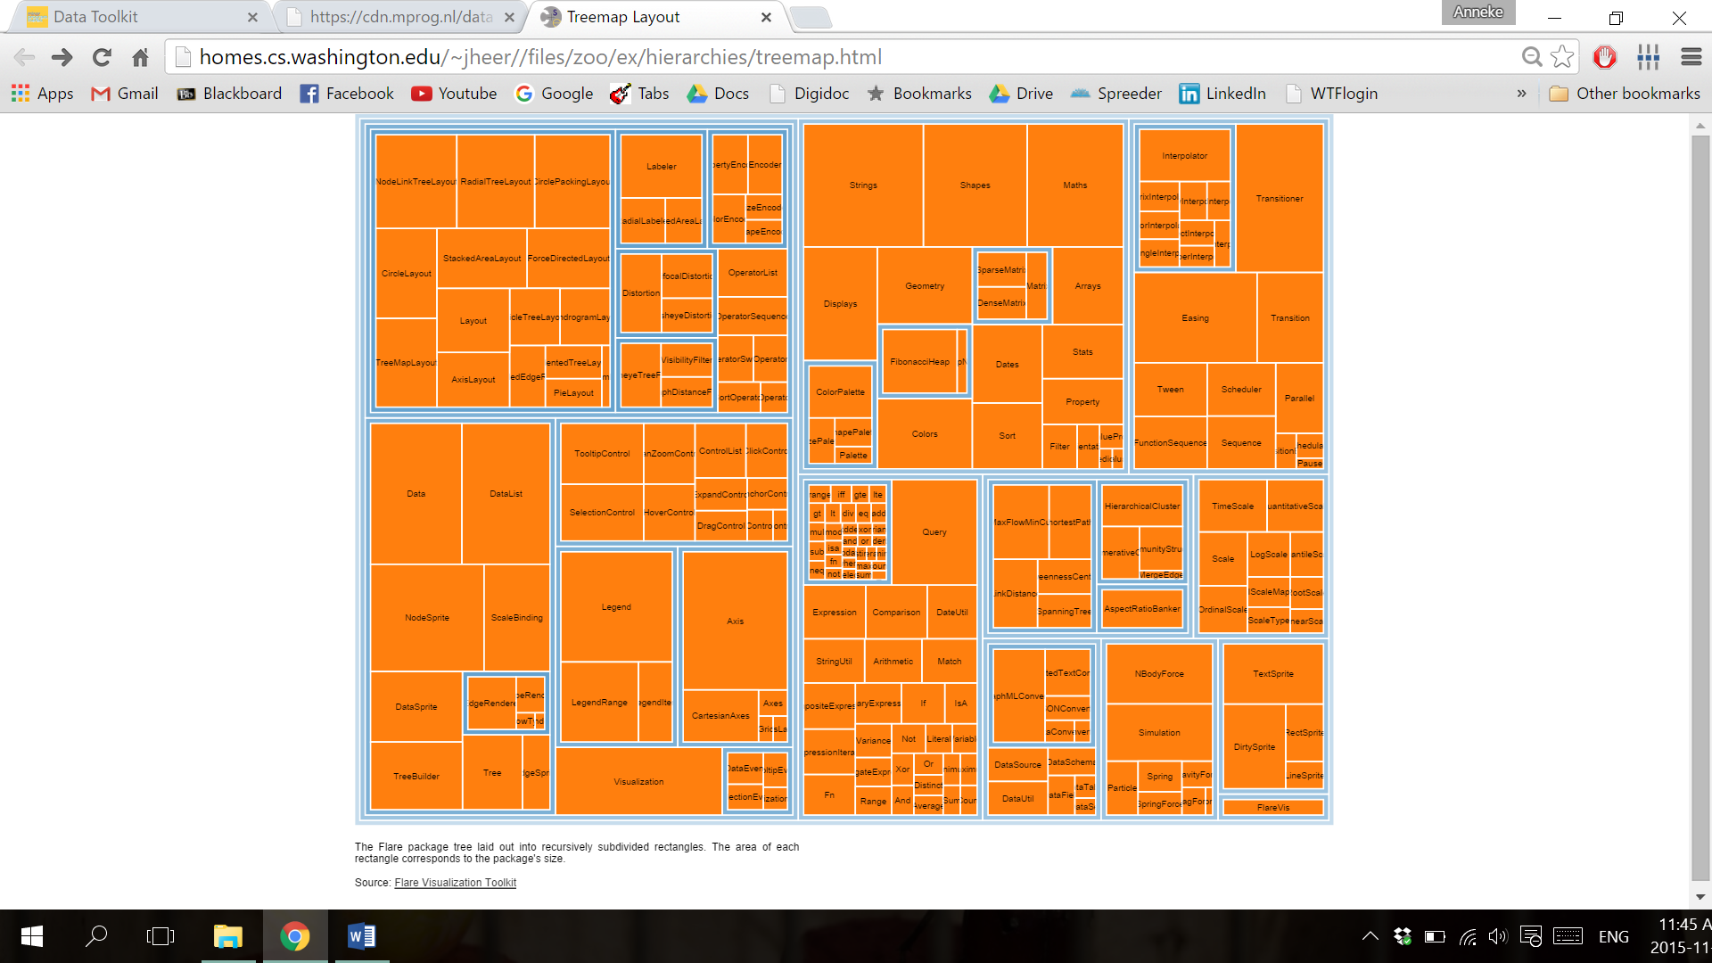In this particular visualisation it seems that the two major aims are not really met. The hierarchy is difficult to see as the overarching categories are unclearly coloured and not indicated with labels. The names of the categories can only be seen by hovering over the tiny lines around the orange blocks. Speaking of those, the colour is very fierce and that combined with the amount of text – that doesn’t fit – is overpowering and too much for our working memory. According to Waren this can hold only three objects at the same time also the pattern recognition and finding a way that is described in his book are made very difficult. Looking for a specific package entails overcoming the vivid orange and searching for the name of the package through all of the rectangles.

Some positives: the grouping of the packages is clear due to the use of relative closeness that indicates a relationship or category, as described by Waren. Also the size of the packages can be easily deduced from the areas of the rectangles. A better choice of colours could easily enhance the grouping effect and may even help to show a hierarchy. This could also be aided by the use of thicker ‘envelopes’ for the folders.

1. Play around with the interactive graphs included in the Heer article. You need to open this page in a browser that runs Java. Focus on Figure 1A. To what extent do interactivity and transitions, elements that D3 optimizes, add to the clarity and message of the visualization? With the element of interactivity in mind, redesign and sketch the contents of figure 1A with one of the other visualization types described in the Heer article. Include a picture of a sketch of your idea, and describe how it supports comprehension and data exploration.

The interactivity allows you to see how much a stock value changed given a specific date of purchase for instance. The transitions are really fast, probably due to the fast page loads as described by Bostock et al. (2011). It is a very nice feature that the relative difference are set to zero and the y-axis is immediately adjusted when your mouse hovers over the x-axis; although this also makes the visualisation a bit busy when you move fast and it can be confusing that the null-point also shifts. One thing that is pity of this graph is that it only shows relative gain or loss without the actual value of the stocks at a given time. The only way to do that is make a different line graph with the absolute values instead of the relative ones. Maybe the best way to achieve a full view of the data is to combine figure 1a with a something like figure 1c and show where your cursor is on the x-axis on all graphs at the same time. This allows comparisons of all stocks at the same time using the relative changes and the absolute values.