Supporting Information for:

***eDNA metabarcoding reveals dietary niche overlap among herbivores in an Indian wildlife sanctuary***

**Table of Contents:**

|  |  |
| --- | --- |
| S1. Herbivore primers | Page 1 |
| S2. Plant DNA reference libraries | Page 2 |
| S3. Dataprocessing steps in  OBITools and R | Page 5 |
| S4. Identity and abundance of  MOTUs | Sup-0002, sheet 2 |
| S5. Taxonomic assignment of  MOTUs | Sup-0002, sheet 3 |
| S6. MOTU read counts per sample | Sup-0002, sheet 4 |
| S7. Relative read abundances of  MOTUS per herbivore | Sup-0002, sheet 5 |
| S8. Niche width based  on presence/absence data | Page 6 |
| S9. NMDS of Bray-Curtis distances  based on presence/absence data | Page 7 |
| S10. Bray-Curtis dissimilarity and  Pianka’s niche overlap values  based on presence/absence data | Page 8 |
| S11. Dietary difference among  species (adonis) | Page 9 |
| S12. Pianka’s niche overlap models | Page 10 |

## S1. Herbivore primers

In order to confirm the identity of the herbivore faecal samples, we designed primers for the different target species (table S1) using Geneious 6.1.8 (https://www.geneious.com).

Table S1. The herbivore specific primers designed for this study. GenBank identities refer to the sequences used for the primer design.

|  |  |  |  |  |  |  |
| --- | --- | --- | --- | --- | --- | --- |
| **Target species** | **Target gene** | **Primer name** | **Primer sequence** | **Primer size(bp)** | **Product size(bp)** | **Tm (°C)** |
| *Macaca radiata* | 12S | macacF | TGGAAGGTGCGCTTGGATAA | 20 | 150 | 55 |
| GenBank: AY224262.1 | | macacR | ATGGTTTAGTGTGCGTTGGC | 20 |  |  |
| *Elephas maximus* | Cytb | elmaF | TCTAGCTTTCCTACCAATTGCAG | 23 | 150 | 53 |
| GenBank: AY589512.2 | | elmaR | TTGATAGCGAGGTAAGTGGACC | 22 |  |  |
| *Hystrix indica* | 16S | hyinF | TGCCCAGTGACAAACCAGTT | 20 | 150 | 53 |
| GenBank: JN714145.1 | | hyinR | CACGGGAAGGTCAATTTCACTG | 22 |  |  |
| *Bos bubalus,*  *Bos taurus indicus,*  *Bos gaurus* | CO1 | bosbubF | GTAACCGCACACGCATTTGT | 20 | 149 | 52 |
| GenBank: KF808255.1, MF667930.1, JQ735454.1 | | bosbubR | GGAGGGAGRAGTCAGAAGCT | 20 |  |  |
| *Rusa unicolor,*  *Axis axis, Muntiacus muntjak* | CO1 | rusaxismF | YGTAACCGCACATGCATTCG | 20 | 150 | 52 |
| GenBank: KT372090.1, KT372098.1, KT372093.1 | | rusaxismR | GGWGGRAGRAGYCAAAAGCTT | 21 |  |  |
| *Tetracerus quadricornis, Capra hircus* | CO1 | tqcaF | AACAGAYCGAAACCTAAACACAACC | 25 | 150 | 51 |
| GenBank: EF536355.1, JN245994.1 | | tqcaR | TAGGTTACGATGTGAGARATTATTCC | 26 |  |  |
| *Melursus ursinus* | Cytb | slothbF | ATCAGACACAACCACAGCCT | 20 | 150 | 54 |
| GenBank: EF196662.1 | | slothbR | GAGCCATAGTACAGACCCCG | 20 |  |  |
| *Lepus spp*. | Cytb | lepusF | TGGCTCCAATAACCCATCAGG | 21 | 180 | 48 |
| GenBank: JQ219662.1, NC_025316.1, KU250092.1, HQ596461.1 | | lepusR | TTGAGGGGATTGGCAGGGG | 19 |  |  |
| *Sus scrofa* | Cytb | susF | CGCTACCTACATGCAAACGGA | 21 | 180 | 50 |
| GenBank: JN242241.1, AB015083.1 | | susR | TGATATTTGTCCTCAGGGCAGG | 22 |  |  |

## S2. Plant DNA Reference libraries

Two plant DNA reference libraries were prepared for the taxonomic identification of the plant DNA sequences: a global reference library and a local reference library. Both reference libraries were created by performing an in-silico PCR with the *ecoPCR* software (Ficetola et al., 2010) using taxonomic information from the NCBI Taxonomy database (https://www.ncbi.nlm.nih.gov/taxonomy). We ran ecoPCR with the *trnL g* and *h* primers, setting the product size to 10 - 150 bp and allowing a maximum of 3 errors per primer, but no errors on the last base of the 3’ end.

The resulting global reference library is a primer-specific reference database based on the global EMBL database (release 137) and contains 111146 sequences of 18101 plant taxa. The local reference library is more specific and only contains DNA sequences of plant taxa known to occur in MM Hills and the surrounding area based on monitoring data (ATREE) and published species lists (appendix 1 from Harisha, 2015). The local reference library contains a total 555 sequences of 134 plant taxa and is constructed of sequences obtained from the EMBL database (release 137) plus an additional 34 species of locally occurring *poaceae* that were sequenced for this study (table S2).

Fresh leaves were collected from Male Mahadeshwara Hills Wildlife Sanctuary (MM Hills) and stored at -20 °C until DNA extraction. Total genomic DNA was extracted from leaf material using a cetyltrimethylammonium bromide (CTAB) method (Sambrook et al., 1989). DNA of the plant samples with high contents of various pigments were purified by Qiagen-DNeasy Plant Mini Kit following the manufacturer’s protocols. Plant DNA metabarcoding was done using the trnL *c* and *d* primers from Taberlet et al. (1991). Plant DNA amplifications were carried out in a final volume of 50 µL containing 50–100 ng of template DNA and 0.2 μM of each primer. The amplification mixture further contained 1 U of Taq DNA Polymerase with 1X Buffer (Bangalore Genei, Bangalore, India) and 0.25 mM of each dNTP. The mixture was denatured at 95 °C for 5 min, followed by 35 cycles of 30 s at 95 °C, and 30 s at 54 °C, 30 s at 72 °C and a 10 min final elongation at 72 °C. PCR products were cleaned with a MinElute PCR Purification Kit (Qiagen, CA). Cycle sequencing reactions were performed in 10 μl reactions using 1 μl of BigDyeH Terminator cycle sequencing chemistry (v3.1; ABI; Warrington, Cheshire, UK) and run on ABI 3730XL sequencer (Applied Biosystems, USA). The qualities of generated sequences were estimated by assembling the original forward and reverse sequences using CodonCode Aligner 3.0 (CodonCode Co., USA).

Table S2. The poaceae species sequenced for this study and their GenBank accession numbers.

|  |  |  |  |
| --- | --- | --- | --- |
| **Genus** | **Species name** | ***trn*L c,d**  **sequence length** | **GenBank accession** |
| *Apluda* | *Apluda mutica* L. | 714 | MT263035 |
| *Aristida* | *Aristida funiculata* Trin. & Rupr. | 801 | MT263049 |
|  | *Aristida setacea* Retz. | 811 | MT263050 |
|  | *Aristida adscensionis* L. | 808 | MT263053 |
| *Bothriochloa* | *Bothriochloa pertusa* (L.) A.Camus | 707 | MT263046 |
|  | *Bothriochloa insculpta* (Hochst. ex A.Rich.) A.Camus | 742 | MT263047 |
| *Cymbopogon* | *Cymbopogon flexuosus* (Nees ex Steud.) W.Watson | 670 | MT263037 |
|  | *Cymbopogon citratus* (DC.) Stapf | 645 | MT263060 |
|  | *Cymbopogon nardus* (L.) Rendle | 668 | MT263061 |
|  | *Cymbopogon commutatus* (Steud.) Stapf | 383 | MT263062 |
|  | *Cymbopogon goeringii* (Steud.) A.Camus | 654 | MT263063 |
| *Cynodon* | *Cynodon dactylon* (L.) Pers. | 736 | MT263039 |
|  | *Cynodon nlemfuensis* Vanderyst | 446 | MT263064 |
| *Dactyloctenium* | *Dactyloctenium aegyptium* (L.) Willd. | 760 | MT263036 |
|  | *Dactyloctenium radulans* (R.Br.) P.Beauv. | 605 | MT263059 |
| *Dichanthium* | *Dichanthium annulatum* (Forssk.) Stapf | 712 | MT263038 |
| *Digitaria* | *Digitaria bicornis* (Lam.) Roem. & Schult. | 793 | MT263041 |
|  | *Digitaria sanguinalis* (L.) Scop. | 788 | MT263051 |
|  | *Digitaria ischaemum* (Schreb.) Muhl. | 769 | MT263052 |
| *Eleusine* | *Eleusine indica* (L.) Gaertn. | 816 | MT263040 |
|  | *Eleusine coracana* (L.) Gaertn. | 444 | MT263065 |
| *Hackelochloa* | *Hackelochloa granularis* (L.) Kuntze | 771 | MT263054 |
| *Heteropogon* | *Heteropogon contortus* (L.) P.Beauv. ex Roem. & Schult. | 700 | MT263034 |
| *Megathyrsus* | *Megathyrsus maximus* (Jacq.) B.K.Simon & S.W.L.Jacobs | 818 | MT263057 |
| *Melinis* | *Melinis repens* (Willd.) Zizka | 704 | MT263048 |
| *Panicum* | *Panicum virgatum* L. | 737 | MT263043 |
|  | *Panicum maximum* Jacq. | 583 | MT263056 |
|  | *Panicum bulbosum* Kunth | 539 | MT263058 |
| *Setaria* | *Setaria pumila* (Poir.) Roem. & Schult. | 754 | MT263042 |
| *Sorghum* | *Sorghum bicolor* (L.) Moench | 768 | MT263055 |
| *Sporobolus* | *Sporobolus diandrus* (Retz.) P.Beauv. | 512 | MT263066 |
|  | *Sporobolus blakei* B.K.Simon | 513 | MT263067 |
| *Themeda* | *Themeda triandra* Forssk. | 716 | MT263044 |
|  | *Themeda arundinacea* (Roxb.) A.Camus | 701 | MT263045 |

### References

Ficetola, G., Coissac, E., Zundel, S., Riaz, T., Shehzad, W., Bessière, J., … Pompanon, F. (2010). An In silico approach for the evaluation of DNA barcodes. *BMC Genomics*, *11*(1), 434. https://doi.org/10.1186/1471-2164-11-434

Harisha, R. P., Padmavathy, S., & Nagaraja, B. C. (2015). Traditional Ecological Knowledge (TEK) and its Importance in South India: Perspecive from Local Communities. *Applied Ecology and Environmental Research*, *14*(1), 311–326. https://doi.org/10.15666/aeer/1401_311326

Sambrook, J., E. F. Fritsch, and T. Maniatis. 1989. *Molecular cloning: A laboratory manual.* Cold Spring Harbor Laboratory Press, Cold Spring Harbor, New York, USA.

Taberlet,P., Gielly,L., Pautou,G. and Bouvet,J. (1991) Universal primers for amplification of three non-coding regions of chloroplast DNA. *Plant Mol. Biol., 17*, 1105–1109.

## S3. Data processing steps in OBITools and R

Raw read data are available at the European Nucleotide Archive (ENA) under study accession number PRJEB41139: http://www.ebi.ac.uk/ena/data/view/PRJEB41139

A public GitHub repository with code and supporting files used to process the raw data is available here: https://github.com/terschure/dataprocessing_MMH

Table S3. Number of sequence reads and unique sequences remaining after each filtering step.

|  |  |  |  |
| --- | --- | --- | --- |
| **Filtering steps** | **Program/command** | **Total reads** | **Unique sequences** |
| Raw reads |  | 168 357 706 |  |
| Pairwise alignment | *illuminapairedend* | 84 178 853 |  |
| Assignment to samples | *ngsfilter* | 69 623 377 |  |
| Merged identical reads | *obiuniq* & *obiannotate* |  | 968 157 |
| Removal of reads with count =1 & < 8 bp length | *obigrep* | 61 537 259 | 130 021 |
| Identification & removal of PCR/sequencing errors | *obiclean* & R | 55 868 956 | 22 164 |
| Reduction of read counts of each sequence per sample (each cell in the MOTU table) by 0.001% | R | 55 778 708 | 16 856 |
| Removal of sequences with maximum abundance in negative controls & sequences with ≤ 95% match | R | 52 375 610 | 3 801 |
| Removal of unreliable PCR replicates (Euclidian distances between replicates ≥ non-replicates) & samples represented by < 2 replicates | R | 48 428 300 | 3 725 |
| Removal of samples only present once (Asian palm civet, sloth bear) & merging replicates (mean) | R | 13 702 072 | 3 725 |
| Removal of sequences that make up ≤ 1 % of the sample & taxa that are not in the region | R | 12 509 596 | 134 |

## S8. Niche width (Shannon) based on presence/absence data

Table S8.1. Overview of niche width described by average MOTU count and Shannon diversity index per herbivore species with standard errors for both measures. Feeding guild assignments are based on Nowak and Walker (1999), Ahrestani et al. (2012), Ahrestani and Sankaran (2016), and IUCN (2020).

|  |  |  |  |  |  |
| --- | --- | --- | --- | --- | --- |
| **Herbivore species** | **Latin name** | **MOTUs** | (**±** **SE)** | **Shannon** | (**±** **SE)** |
| Cattle | *Bos taurus indicus* | 6.22 | (± 0.69) | 1.67 | (± 0.12) |
| Domestic goat | *Capra hircus* | 11.75 | (± 1.53) | 2.41 | (± 0.12) |
| Water buffalo | *Bubalus bubalis* | 13.33 | (± 2.73) | 2.54 | (± 0.23) |
| Asian elephant | *Elephas maximus* | 8.40 | (± 2.84) | 1.83 | (± 0.41) |
| Barking deer | *Muntiacus muntjak* | 7.50 | (± 2.50) | 1.96 | (± 0.35) |
| Bonnet macaque | *Macaca radiata* | 4.83 | (± 0.91) | 1.49 | (± 0.19) |
| Indian hare | *Lepus nigricollis* | 7.67 | (± 1.76) | 1.98 | (± 0.23) |
| Indian porcupine | *Hystrix indica* | 8.75 | (± 1.97) | 2.05 | (± 0.32) |
| Sambar deer | *Rusa unicolor* | 12.40 | (± 0.93) | 2.51 | (± 0.07) |
| Wild boar | *Sus scrofa* | 9.33 | (± 1.20) | 2.22 | (± 0.14) |

Table S8.2. Kruskal-Wallis rank sum test of differences in Shannon diversity for the presence/absence data (chi-squared = 23.044, df = 9, p-value = 0.006098). No significant differences are found when looking at pairwise comparisons using the Holm adjustment of p-values. The upper number for each comparison is Dunn’s pairwise z test statistic, the bottom number is the adjusted p-value. alpha = 0.05 Reject Ho if p <= alpha/2.

|  |  |  |  |  |  |  |  |  |  |
| --- | --- | --- | --- | --- | --- | --- | --- | --- | --- |
|  | **Asian_el** | **Barking_** | **Bonnet_m** | **Cattle** | **Domestic** | **Indian_h** | **Indian_p** | **Sambar_d** | **Water_bu** |
| **Barking_** | 0.163074 |  |  |  |  |  |  |  |  |
|  | 1.0000 |  |  |  |  |  |  |  |  |
| **Bonnet_m** | 1.236957 | 0.750250 |  |  |  |  |  |  |  |
|  | 1.0000 | 1.0000 |  |  |  |  |  |  |  |
| **Cattle** | 0.856750 | 0.388374 | -0.711720 |  |  |  |  |  |  |
|  | 1.0000 | 1.0000 | 1.0000 |  |  |  |  |  |  |
| **Domestic** | -1.39689 | -1.17989 | -2.861461 | -2.97007 |  |  |  |  |  |
|  | 1.0000 | 1.0000 | 0.0886 | 0.0640 |  |  |  |  |  |
| **Indian_h** | 0.053378 | -0.10675 | -1.00413 | -0.62518 | 1.233868 |  |  |  |  |
|  | 0.4787 | 1.0000 | 1.0000 | 1.0000 | 1.0000 |  |  |  |  |
| **Indian_p** | -0.35696 | -0.43405 | -1.531342 | -1.22238 | 0.909395 | -0.3645 |  |  |  |
|  | 1.0000 | 1.0000 | 1.0000 | 1.0000 | 1.0000 | 1.0000 |  |  |  |
| **Sambar_d** | -1.78745 | -1.51426 | -3.103889 | -3.14779 | -0.58610 | -1.6013 | -1.3282 |  |  |
|  | 1.0000 | 1.0000 | 0.0420 | 0.0370 | 1.0000 | 1.0000 | 1.0000 |  |  |
| **Water_bu** | -1.48443 | -1.33700 | -2.592382 | -2.45471 | -0.42499 | -1.3754 | -1.1058 | 0.063545 |  |
|  | 1.0000 | 1.0000 | 0.1954 | 0.2820 | 1.0000 | 1.0000 | 1.0000 | 0.9493 |  |
| **Wild_boa** | -0.51853 | -0.56428 | -1.594807 | -1.30558 | 0.616934 | -0.5115 | -0.1822 | 1.029443 | 0.863925 |
|  | 1.0000 | 1.0000 | 1.0000 | 1.0000 | 1.0000 | 1.0000 | 1.0000 | 1.0000 | 1.0000 |

## S9. NMDS of Bray-Curtis dissimilarities based on presence/absence data

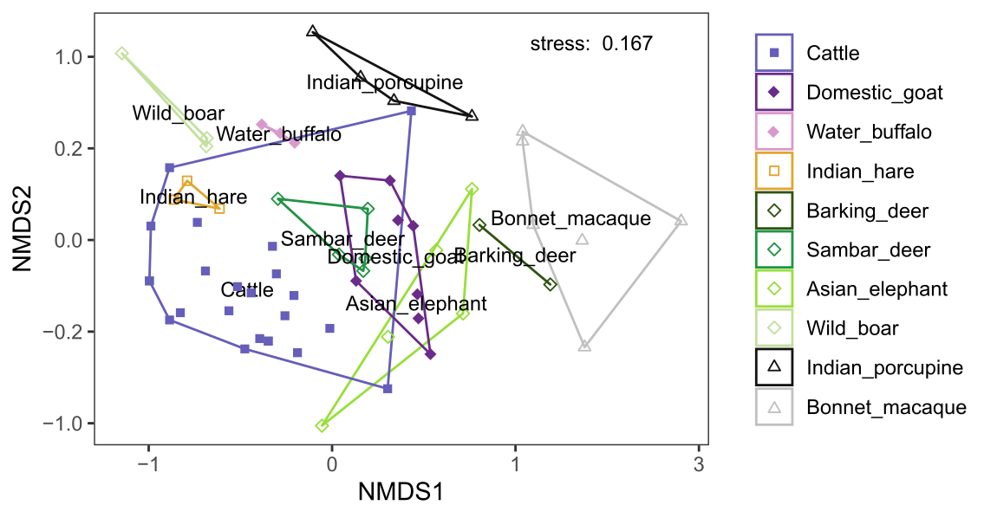

Figure S9: NMDS plot based on the presence/absence data per faecal sample using Bray-Curtis dissimilarity (adonis F9,52 = 4.31, R2 = 0.42, P ≤ 0.001). The positioning of the species label indicates the mean for that species. Samples from domestic herbivore species are indicated with filled symbols and the shapes of the symbols refer to the different feeding guilds: grazer (square), mixed feeder (diamond), and frugivore (triangle).

## S10. Bray-Curtis dissimilarity and Pianka’s niche overlap values based on presence/absence data

Table S10. Bray-Curtis dissimilarity (bottom left; 0:similar 1:dissimilar) and Pianka’s overlap index (top right; 0:no overlap 1:full overlap) based on presence/absence data. Asterisks indicate statistically significant niche overlap (i.e., greater than expected by chance based on comparison with 1000 null models, α = 0.05).

|  |  |  |  |  |  |  |  |  |  |  |
| --- | --- | --- | --- | --- | --- | --- | --- | --- | --- | --- |
|  | **Cattle** | **Domestic goat** | **Water buffalo** | **Asian elephant** | **Barking deer** | **Bonnet macaque** | **Indian hare** | **Indian porcupine** | **Sambar deer** | **Wild boar** |
| **Cattle** |  | 0.34* | 0.42* | 0.27* | 0.09 | 0.06 | 0.53* | 0.12 | 0.52* | 0.28* |
| **Domestic goat** | 0.78 |  | 0.23* | 0.47* | 0.30* | 0.28* | 0.23* | 0.30* | 0.64* | 0.03 |
| **Water buffalo** | 0.78 | 0.82 |  | 0.16 | 0.02 | 0.15 | 0.27* | 0.13 | 0.26* | 0.41* |
| **Asian elephant** | 0.81 | 0.67 | 0.90 |  | 0.32* | 0.27* | 0.09 | 0.24* | 0.31* | 0.00 |
| **Barking deer** | 0.94 | 0.75 | 0.97 | 0.76 |  | 0.41* | 0.00 | 0.20 | 0.23* | 0.00 |
| **Bonnet macaque** | 0.93 | 0.78 | 0.93 | 0.79 | 0.73 |  | 0.00 | 0.12 | 0.26* | 0.06 |
| **Indian hare** | 0.70 | 0.84 | 0.81 | 0.89 | 1.00 | 1.00 |  | 0.15 | 0.36* | 0.48* |
| **Indian porcupine** | 0.87 | 0.74 | 0.90 | 0.79 | 0.78 | 0.90 | 0.91 |  | 0.25* | 0.05 |
| **Sambar deer** | 0.72 | 0.54 | 0.79 | 0.73 | 0.80 | 0.88 | 0.73 | 0.76 |  | 0.22* |
| **Wild boar** | 0.85 | 0.98 | 0.65 | 1.00 | 1.00 | 0.95 | 0.65 | 0.97 | 0.85 |  |

## S11. Dietary difference among species (adonis)

Table S11. Results of pairwise adonis tests based on Bray-Curtis dissimilarities for the RRA and the presence/absence data with and without Bonferroni adjusted p-values.

|  |  |  |  |  |  |  |  |  |
| --- | --- | --- | --- | --- | --- | --- | --- | --- |
|  | **Relative read abundance data** | | | | **Presence/absence data** | | | |
| **pairs** | **F Model** | **R2** | **p-value** | **p-adj** | **F**  **Model** | **R2** | **p-value** | **p-adj** |
| Cattle vs Indian_hare | 2.12 | 0.0812 | 0.058 | 1.000 | 2.50 | 0.0945 | 0.005 | 0.225 |
| Cattle vs Sambar_deer | 3.02 | 0.1040 | 0.007 | 0.315 | 3.97 | 0.1326 | 0.001 | 0.045* |
| Cattle vs Bonnet_macaque | 7.78 | 0.2238 | 0.001 | 0.045* | 7.59 | 0.2195 | 0.001 | 0.045* |
| Cattle vs Domestic_goat | 6.82 | 0.1904 | 0.001 | 0.045* | 6.73 | 0.1884 | 0.001 | 0.045* |
| Cattle vs Barking_deer | 3.37 | 0.1277 | 0.010 | 0.450 | 4.20 | 0.1545 | 0.003 | 0.135 |
| Cattle vs Water_buffalo | 3.24 | 0.1188 | 0.003 | 0.135 | 3.11 | 0.1146 | 0.006 | 0.270 |
| Cattle vs Indian_porcupine | 4.20 | 0.1439 | 0.002 | 0.090 | 4.78 | 0.1605 | 0.001 | 0.045* |
| Cattle vs Asian_elephant | 3.77 | 0.1267 | 0.005 | 0.225 | 5.15 | 0.1654 | 0.001 | 0.045* |
| Cattle vs Wild_boar | 5.54 | 0.1877 | 0.001 | 0.045* | 4.70 | 0.1638 | 0.001 | 0.045* |
| Indian_hare vs Sambar_deer | 2.24 | 0.2718 | 0.041 | 1.000 | 4.60 | 0.4341 | 0.015 | 0.675 |
| Indian_hare vs Bonnet_macaque | 4.28 | 0.3797 | 0.012 | 0.540 | 4.79 | 0.4062 | 0.012 | 0.540 |
| Indian_hare vs Domestic_goat | 4.04 | 0.3098 | 0.007 | 0.315 | 4.36 | 0.3262 | 0.008 | 0.360 |
| Indian_hare vs Barking_deer | 2.91 | 0.4924 | 0.100 | 1.000 | 7.14 | 0.7042 | 0.100 | 1.000 |
| Indian_hare vs Water_buffalo | 2.69 | 0.4020 | 0.100 | 1.000 | 4.01 | 0.5007 | 0.100 | 1.000 |
| Indian_hare vs Indian_porcupine | 2.04 | 0.2893 | 0.035 | 1.000 | 3.10 | 0.3828 | 0.034 | 1.000 |
| Indian_hare vs Asian_elephant | 4.13 | 0.4078 | 0.051 | 1.000 | 5.42 | 0.4747 | 0.018 | 0.810 |
| Indian_hare vs Wild_boar | 3.54 | 0.4698 | 0.100 | 1.000 | 3.45 | 0.4632 | 0.100 | 1.000 |
| Sambar_deer vs Bonnet_macaque | 4.40 | 0.3284 | 0.006 | 0.270 | 4.64 | 0.3404 | 0.003 | 0.135 |
| Sambar_deer vs Domestic_goat | 2.36 | 0.1769 | 0.012 | 0.540 | 1.94 | 0.1500 | 0.033 | 1.000 |
| Sambar_deer vs Barking_deer | 2.72 | 0.3525 | 0.046 | 1.000 | 5.38 | 0.5183 | 0.047 | 1.000 |
| Sambar_deer vs Water_buffalo | 2.47 | 0.2914 | 0.018 | 0.810 | 4.72 | 0.4403 | 0.015 | 0.675 |
| Sambar_deer vs Indian_porcupine | 2.45 | 0.2590 | 0.006 | 0.270 | 3.46 | 0.3307 | 0.006 | 0.270 |
| Sambar_deer vs Asian_elephant | 3.98 | 0.3321 | 0.004 | 0.180 | 4.90 | 0.3799 | 0.012 | 0.540 |
| Sambar_deer vs Wild_boar | 4.86 | 0.4474 | 0.019 | 0.855 | 7.25 | 0.5471 | 0.026 | 1.000 |
| Bonnet_macaque vs Domestic_goat | 5.06 | 0.2965 | 0.001 | 0.045* | 3.94 | 0.2473 | 0.002 | 0.090 |
| Bonnet_macaque vs Barking_deer | 2.05 | 0.2548 | 0.068 | 1.000 | 1.64 | 0.2149 | 0.214 | 1.000 |
| Bonnet_macaque vs Water_buffalo | 3.44 | 0.3298 | 0.011 | 0.495 | 3.63 | 0.3416 | 0.007 | 0.315 |
| Bonnet_macaque vs Indian_porcupine | 2.60 | 0.2451 | 0.021 | 0.945 | 2.85 | 0.2630 | 0.005 | 0.225 |
| Bonnet_macaque vs Asian_elephant | 4.32 | 0.3243 | 0.011 | 0.495 | 3.61 | 0.2862 | 0.005 | 0.225 |
| Bonnet_macaque vs Wild_boar | 5.00 | 0.4165 | 0.009 | 0.405 | 5.02 | 0.4176 | 0.011 | 0.495 |
| Domestic_goat vs Barking_deer | 2.54 | 0.2410 | 0.022 | 0.990 | 3.13 | 0.2814 | 0.030 | 1.000 |
| Domestic_goat vs Water_buffalo | 3.40 | 0.2742 | 0.005 | 0.225 | 3.90 | 0.3022 | 0.007 | 0.315 |
| Domestic_goat vs Indian_porcupine | 2.62 | 0.2078 | 0.002 | 0.090 | 2.68 | 0.2116 | 0.002 | 0.090 |
| Domestic_goat vs Asian_elephant | 2.95 | 0.2115 | 0.016 | 0.720 | 2.86 | 0.2063 | 0.004 | 0.180 |
| Domestic_goat vs Wild_boar | 5.24 | 0.3680 | 0.007 | 0.315 | 6.42 | 0.4164 | 0.007 | 0.315 |
| Barking_deer vs Water_buffalo | 2.28 | 0.4318 | 0.100 | 1.000 | 5.56 | 0.6497 | 0.100 | 1.000 |
| Barking_deer vs Indian_porcupine | 1.05 | 0.2077 | 0.467 | 1.000 | 2.08 | 0.3422 | 0.067 | 1.000 |
| Barking_deer vs Asian_elephant | 2.35 | 0.3195 | 0.051 | 1.000 | 3.06 | 0.3796 | 0.047 | 1.000 |
| Barking_deer vs Wild_boar | 3.93 | 0.5670 | 0.100 | 1.000 | 10.35 | 0.7753 | 0.100 | 1.000 |
| Water_buffalo vs Indian_porcupine | 1.88 | 0.2728 | 0.074 | 1.000 | 2.72 | 0.3519 | 0.067 | 1.000 |
| Water_buffalo vs Asian_elephant | 2.92 | 0.3271 | 0.033 | 1.000 | 4.49 | 0.4280 | 0.015 | 0.675 |
| Water_buffalo vs Wild_boar | 3.47 | 0.4643 | 0.100 | 1.000 | 3.80 | 0.4871 | 0.100 | 1.000 |
| Indian_porcupine vs Asian_elephant | 2.38 | 0.2533 | 0.063 | 1.000 | 2.67 | 0.2762 | 0.020 | 0.900 |
| Indian_porcupine vs Wild_boar | 2.92 | 0.3690 | 0.028 | 1.000 | 4.09 | 0.4499 | 0.037 | 1.000 |
| Asian_elephant vs Wild_boar | 5.17 | 0.4627 | 0.014 | 0.630 | 7.05 | 0.5402 | 0.020 | 0.900 |

## S12. Pianka’s niche overlap models

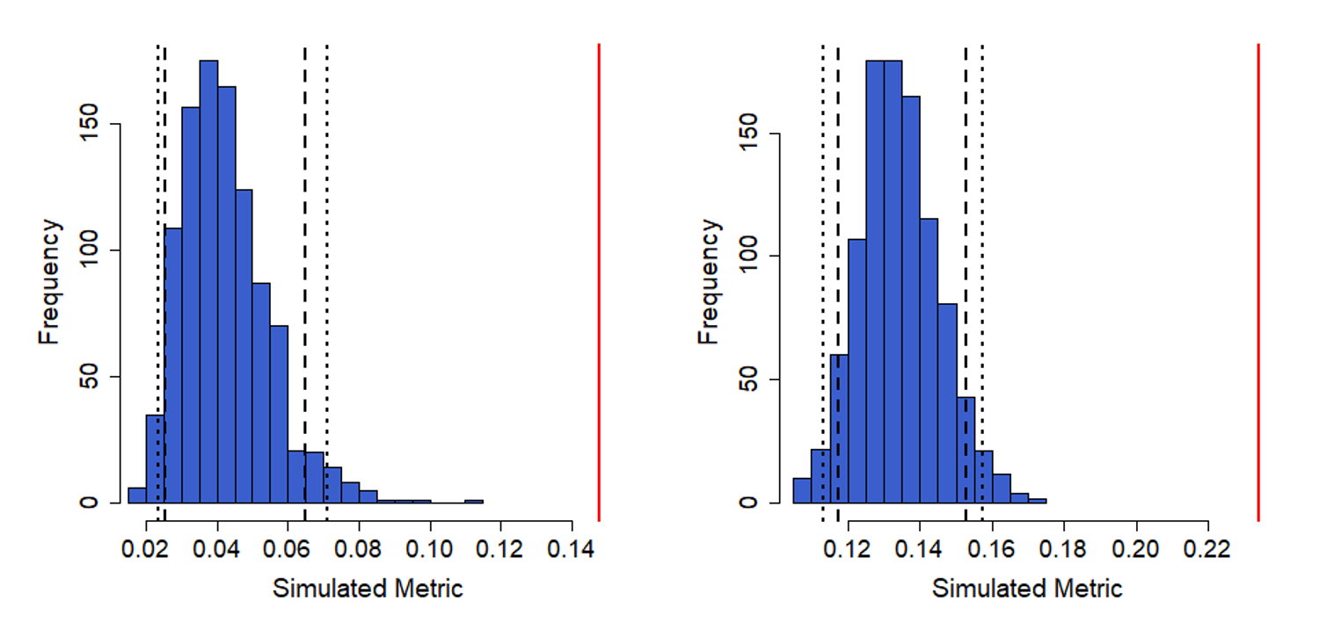

Figure S12.1: Histogram of simulated Pianka values based on all RRA data (left; 95% CI [0.024, 0.073]) and all presence/absence data (right; 95% CI [0.115, 0.157]). The blue bars are the results from the null model created with the ra3 algorithm and 1000 replications (EcoSimR) while the red line indicates the observed Pianka value for all herbivores species combined.

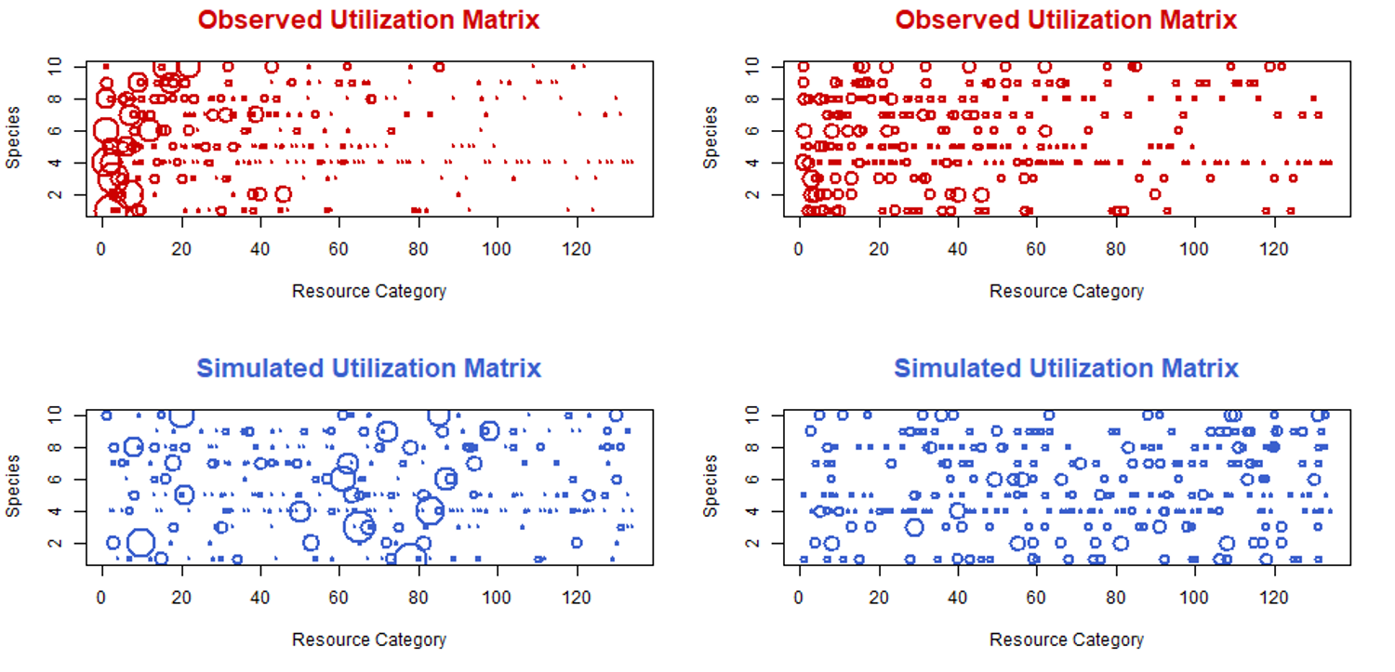

Figure S12.2: Utilization matrices based on RRA data (left) and the occurrence data (right) of observed (red) and simulated (blue) values from a null model created with the ra3 algorithm and 1000 replications (EcoSimR). The area of each circle depicted is proportional to the utilization of a resource category by a species. If no circle is shown, the utilization was 0.