Supplementary information for:

# *Sed*aDNA metabarcoding as a tool for assessing prehistoric plant use at Upper Palaeolithic cave site Aghitu-3, Armenia

Anneke T.M. ter Schure1, Angela A. Bruch2, Andrew W. Kandel3, Boris Gasparyan4, Rainer W. Bussmann5, Anne K. Brysting1, Hugo J. de Boer6, Sanne Boessenkool1

1 Centre for Ecological and Evolutionary Synthesis, University of Oslo, Oslo, Norway.

2 The Role of Culture in Early Expansions of Humans, Heidelberg Academy of Sciences and Humanities, Senckenberg Research Institute, Frankfurt, Germany.

3 The Role of Culture in Early Expansions of Humans, Heidelberg Academy of Sciences and Humanities, University of Tübingen, Tübingen, Germany.

4 Institute of Archaeology and Ethnography, National Academy of Sciences of the Republic of Armenia, Yerevan, Armenia.

5 Department of Ethnobotany, Institute of Botany, Ilia State University, Tbilisi, Georgia.

6 Natural History Museum, University of Oslo, Oslo, Norway.

Contents

A.1. DNA filtering steps 1

A.2. Correction of read counts 2

A.3. Plant stratigraphic plots 4

A.4. Statistical differences in plant richness between Archaeological Horizons 6

# A.1. DNA filtering steps

**Table A.1.** Overview of the DNA sequence read counts and number of unique sequences per filtering step.

|  |  |  |  |
| --- | --- | --- | --- |
| **Filtering step** | **Program** | **Total reads** | **Unique sequences** |
| Raw reads |  | 168 787 958 |  |
| Pairwise alignment | *illuminapairedend* | 168 787 958 |  |
| Assignment to samples | *ngsfilter* | 137 558 235 |  |
| Removal of reads with count = 1 and < 8 bp length & merging identical reads | *obigrep & obiuniq* | 130 010 462 | 338 885 |
| Matching the reference database | *ecotag & obigrep* | 130 000 975 | 338 182 |
| Identification & removal of PCR/sequencing errors | *obiclean* | 125 211 062 | 174 208 |
| Removal of sequences also present in negative controls | R | 68 191 867 | 151 204 |
| Removal of sequences with < 97.5% ID match | R | 41 461 019 | 1010 |
| Removal of sequence read counts < 10 reads per PCR repeat | R | 41 456 965 | 250 |
| Removal of sequences occurring in < 2 PCR repeats over the entire dataset | R | 36 828 760 | 135 |
| Removal of sequences with < 98% ID match, without family annotation, or deemed unlikely by a taxonomic expert | R | 33 259 880 | 129 |
| Setting read counts to 0 for samples with < 2 positive replicates | R | 33 069 116 | 129 |
| Repeated removal of sequences occurring in < 2 PCR repeats over the entire dataset | R | 33 022 936 | 128 |
| Merging PCR replicates while averaging the read counts per sample | R | 9 346 840 | 128 |

# A.2. Correction of read counts

**Table A.2.** Calculation of the correction ratio for calculating the read counts per extracted mg of sediment. Correction ratio = mg extracted sediment * fraction in PCR * fraction in cleanup *(fraction in pool / dilution factor).

|  |  |  |  |  |  |  |  |  |
| --- | --- | --- | --- | --- | --- | --- | --- | --- |
| **sample_s_replicate** | **depth** | **mg extracted** | **fraction in PCR** | **fraction in cleanup** | **dilution factor for pool** | **volume for pool** | **fraction in pool** | **correction ratio** |
| AGH03E1_s_1 | -1.66 | 110 | 0.05 | 0.034 | 1 | 8.54 | 0.097 | 0.018416 |
| AGH03E1_s_4 | -1.66 | 110 | 0.05 | 0.042 | 1 | 5.78 | 0.066 | 0.015072 |
| AGH03E1_s_5 | -1.66 | 110 | 0.05 | 0.042 | 1 | 5.78 | 0.066 | 0.015072 |
| AGH05E1_s_3 | -1.46 | 120 | 0.05 | 0.033 | 1 | 12.00 | 0.136 | 0.027291 |
| AGH05E1_s_4 | -1.46 | 120 | 0.05 | 0.043 | 10 | 10.27 | 0.117 | 0.003045 |
| AGH05E1_s_6 | -1.46 | 120 | 0.05 | 0.043 | 10 | 10.27 | 0.117 | 0.003045 |
| AGH07E1_s_4 | -1.27 | 90 | 0.05 | 0.100 | 10 | 6.59 | 0.075 | 0.003372 |
| AGH07E1_s_5 | -1.27 | 90 | 0.05 | 0.042 | 1 | 5.78 | 0.066 | 0.012331 |
| AGH08E1_s_2 | -1.15 | 160 | 0.05 | 0.033 | 1 | 12.00 | 0.136 | 0.036388 |
| AGH08E1_s_3 | -1.15 | 160 | 0.05 | 0.033 | 1 | 12.00 | 0.136 | 0.036388 |
| AGH08E1_s_4 | -1.15 | 160 | 0.05 | 0.043 | 10 | 10.27 | 0.117 | 0.004061 |
| AGH08E1_s_5 | -1.15 | 160 | 0.05 | 0.043 | 10 | 10.27 | 0.117 | 0.004061 |
| AGH08E1_s_6 | -1.15 | 160 | 0.05 | 0.042 | 1 | 6.47 | 0.074 | 0.024542 |
| AGH09E1_s_2 | -5.55 | 100 | 0.05 | 0.033 | 1 | 12.00 | 0.136 | 0.022743 |
| AGH10E1_s_3 | -5.45 | 130 | 0.05 | 0.077 | 10 | 24.32 | 0.277 | 0.013825 |
| AGH10E1_s_4 | -5.45 | 130 | 0.05 | 0.042 | 1 | 5.78 | 0.066 | 0.017812 |
| AGH10E1_s_6 | -5.45 | 130 | 0.05 | 0.125 | 10 | 3.17 | 0.036 | 0.002933 |
| AGH12E1_s_1 | -5.06 | 110 | 0.05 | 0.077 | 1 | 1.59 | 0.018 | 0.007629 |
| AGH12E1_s_2 | -5.06 | 110 | 0.05 | 0.033 | 1 | 12.00 | 0.136 | 0.025017 |
| AGH12E1_s_3 | -5.06 | 110 | 0.05 | 0.091 | 10 | 5.95 | 0.068 | 0.003384 |
| AGH12E1_s_4 | -5.06 | 110 | 0.05 | 0.043 | 10 | 10.27 | 0.117 | 0.002792 |
| AGH12E1_s_5 | -5.06 | 110 | 0.05 | 0.043 | 10 | 10.27 | 0.117 | 0.002792 |
| AGH12E1_s_6 | -5.06 | 110 | 0.05 | 0.042 | 1 | 6.47 | 0.074 | 0.016873 |
| AGH14E1_s_2 | -4.79 | 100 | 0.05 | 0.077 | 10 | 24.32 | 0.277 | 0.010635 |
| AGH14E1_s_3 | -4.79 | 100 | 0.05 | 0.077 | 10 | 24.32 | 0.277 | 0.010635 |
| AGH14E1_s_4 | -4.79 | 100 | 0.05 | 0.125 | 10 | 3.17 | 0.036 | 0.002256 |
| AGH14E1_s_5 | -4.79 | 100 | 0.05 | 0.125 | 10 | 3.17 | 0.036 | 0.002256 |
| AGH14E1_s_6 | -4.79 | 100 | 0.05 | 0.100 | 10 | 6.59 | 0.075 | 0.003747 |
| AGH17E1_s_2 | -4.7 | 90 | 0.05 | 0.077 | 10 | 24.32 | 0.277 | 0.009571 |
| AGH17E1_s_3 | -4.7 | 90 | 0.05 | 0.077 | 10 | 24.32 | 0.277 | 0.009571 |
| AGH17E1_s_4 | -4.7 | 90 | 0.05 | 0.042 | 1 | 5.78 | 0.066 | 0.012331 |
| AGH17E1_s_5 | -4.7 | 90 | 0.05 | 0.100 | 10 | 6.59 | 0.075 | 0.003372 |
| AGH17E1_s_6 | -4.7 | 90 | 0.05 | 0.042 | 1 | 5.78 | 0.066 | 0.012331 |
| AGH19E1_s_1 | -4.57 | 110 | 0.05 | 0.091 | 10 | 5.95 | 0.068 | 0.003384 |
| AGH19E1_s_2 | -4.57 | 110 | 0.05 | 0.033 | 1 | 12.00 | 0.136 | 0.025017 |
| AGH19E1_s_3 | -4.57 | 110 | 0.05 | 0.091 | 10 | 5.95 | 0.068 | 0.003384 |
| AGH19E1_s_4 | -4.57 | 110 | 0.05 | 0.043 | 10 | 10.27 | 0.117 | 0.002792 |
| AGH19E1_s_5 | -4.57 | 110 | 0.05 | 0.143 | 10 | 3.26 | 0.037 | 0.002911 |
| AGH19E1_s_6 | -4.57 | 110 | 0.05 | 0.043 | 10 | 10.27 | 0.117 | 0.002792 |
| AGH21E1_s_1 | -4.45 | 150 | 0.05 | 0.091 | 10 | 5.95 | 0.068 | 0.004614 |
| AGH21E1_s_2 | -4.45 | 150 | 0.05 | 0.033 | 1 | 12.00 | 0.136 | 0.034114 |
| AGH21E1_s_3 | -4.45 | 150 | 0.05 | 0.091 | 10 | 5.95 | 0.068 | 0.004614 |
| AGH21E1_s_4 | -4.45 | 150 | 0.05 | 0.043 | 10 | 10.27 | 0.117 | 0.003807 |
| AGH21E1_s_5 | -4.45 | 150 | 0.05 | 0.043 | 10 | 10.27 | 0.117 | 0.003807 |
| AGH21E1_s_6 | -4.45 | 150 | 0.05 | 0.043 | 10 | 10.27 | 0.117 | 0.003807 |
| AGH23E1_s_2 | -4.26 | 110 | 0.05 | 0.077 | 10 | 24.32 | 0.277 | 0.011698 |
| AGH23E1_s_3 | -4.26 | 110 | 0.05 | 0.034 | 1 | 8.54 | 0.097 | 0.018416 |
| AGH23E1_s_4 | -4.26 | 110 | 0.05 | 0.100 | 10 | 6.59 | 0.075 | 0.004122 |
| AGH23E1_s_5 | -4.26 | 110 | 0.05 | 0.100 | 10 | 6.59 | 0.075 | 0.004122 |
| AGH23E1_s_6 | -4.26 | 110 | 0.05 | 0.042 | 1 | 5.78 | 0.066 | 0.015072 |
| AGH25E1_s_1 | -4.01 | 130 | 0.05 | 0.077 | 1 | 1.59 | 0.018 | 0.009017 |
| AGH25E1_s_2 | -4.01 | 130 | 0.05 | 0.077 | 1 | 1.59 | 0.018 | 0.009017 |
| AGH25E1_s_3 | -4.01 | 130 | 0.05 | 0.077 | 1 | 1.59 | 0.018 | 0.009017 |
| AGH25E1_s_4 | -4.01 | 130 | 0.05 | 0.143 | 10 | 3.26 | 0.037 | 0.003440 |
| AGH25E1_s_5 | -4.01 | 130 | 0.05 | 0.043 | 10 | 10.27 | 0.117 | 0.003299 |
| AGH25E1_s_6 | -4.01 | 130 | 0.05 | 0.043 | 10 | 10.27 | 0.117 | 0.003299 |
| AGH27E1_s_2 | -3.76 | 130 | 0.05 | 0.077 | 10 | 24.32 | 0.277 | 0.013825 |
| AGH27E1_s_3 | -3.76 | 130 | 0.05 | 0.077 | 10 | 24.32 | 0.277 | 0.013825 |
| AGH27E1_s_4 | -3.76 | 130 | 0.05 | 0.042 | 1 | 5.78 | 0.066 | 0.017812 |
| AGH27E1_s_5 | -3.76 | 130 | 0.05 | 0.100 | 10 | 6.59 | 0.075 | 0.004871 |
| AGH27E1_s_6 | -3.76 | 130 | 0.05 | 0.042 | 1 | 5.78 | 0.066 | 0.017812 |
| AGH28E1_s_2 | -3.63 | 190 | 0.05 | 0.077 | 1 | 1.59 | 0.018 | 0.013178 |
| AGH28E1_s_3 | -3.63 | 190 | 0.05 | 0.077 | 1 | 1.59 | 0.018 | 0.013178 |
| AGH28E1_s_4 | -3.63 | 190 | 0.05 | 0.042 | 1 | 6.47 | 0.074 | 0.029144 |
| AGH28E1_s_5 | -3.63 | 190 | 0.05 | 0.043 | 10 | 10.27 | 0.117 | 0.004822 |
| AGH30E1_s_1 | -3.42 | 130 | 0.05 | 0.033 | 1 | 12.00 | 0.136 | 0.029566 |
| AGH30E1_s_2 | -3.42 | 130 | 0.05 | 0.091 | 10 | 5.95 | 0.068 | 0.003999 |
| AGH30E1_s_3 | -3.42 | 130 | 0.05 | 0.077 | 1 | 1.59 | 0.018 | 0.009017 |
| AGH30E1_s_4 | -3.42 | 130 | 0.05 | 0.043 | 10 | 10.27 | 0.117 | 0.003299 |
| AGH30E1_s_5 | -3.42 | 130 | 0.05 | 0.143 | 10 | 3.26 | 0.037 | 0.003440 |
| AGH30E1_s_6 | -3.42 | 130 | 0.05 | 0.143 | 10 | 3.26 | 0.037 | 0.003440 |
| AGH32E1_s_2 | -3.25 | 180 | 0.05 | 0.034 | 1 | 8.54 | 0.097 | 0.030135 |
| AGH32E1_s_3 | -3.25 | 180 | 0.05 | 0.077 | 10 | 24.32 | 0.277 | 0.019143 |
| AGH32E1_s_5 | -3.25 | 180 | 0.05 | 0.125 | 10 | 3.17 | 0.036 | 0.004061 |
| AGH34E1_s_1 | -3.05 | 100 | 0.05 | 0.091 | 10 | 5.95 | 0.068 | 0.003076 |
| AGH34E1_s_2 | -3.05 | 100 | 0.05 | 0.077 | 1 | 1.59 | 0.018 | 0.006936 |
| AGH34E1_s_3 | -3.05 | 100 | 0.05 | 0.077 | 1 | 1.59 | 0.018 | 0.006936 |
| AGH34E1_s_4 | -3.05 | 100 | 0.05 | 0.143 | 10 | 3.26 | 0.037 | 0.002646 |
| AGH34E1_s_6 | -3.05 | 100 | 0.05 | 0.042 | 1 | 6.47 | 0.074 | 0.015339 |
| AGH36E1_s_2 | -2.91 | 90 | 0.05 | 0.034 | 1 | 8.54 | 0.097 | 0.015068 |
| AGH36E1_s_3 | -2.91 | 90 | 0.05 | 0.034 | 1 | 8.54 | 0.097 | 0.015068 |
| AGH36E1_s_4 | -2.91 | 90 | 0.05 | 0.125 | 10 | 3.17 | 0.036 | 0.002030 |
| AGH36E1_s_5 | -2.91 | 90 | 0.05 | 0.125 | 10 | 3.17 | 0.036 | 0.002030 |
| AGH38E1_s_1 | -2.76 | 100 | 0.05 | 0.091 | 10 | 5.95 | 0.068 | 0.003076 |
| AGH38E1_s_2 | -2.76 | 100 | 0.05 | 0.033 | 1 | 12.00 | 0.136 | 0.022743 |
| AGH38E1_s_3 | -2.76 | 100 | 0.05 | 0.033 | 1 | 12.00 | 0.136 | 0.022743 |
| AGH38E1_s_4 | -2.76 | 100 | 0.05 | 0.042 | 1 | 6.47 | 0.074 | 0.015339 |
| AGH38E1_s_5 | -2.76 | 100 | 0.05 | 0.042 | 1 | 6.47 | 0.074 | 0.015339 |
| AGH38E1_s_6 | -2.76 | 100 | 0.05 | 0.043 | 10 | 10.27 | 0.117 | 0.002538 |
| AGH40E1_s_4 | -2.5 | 110 | 0.05 | 0.100 | 10 | 6.59 | 0.075 | 0.004122 |
| AGH40E1_s_5 | -2.5 | 110 | 0.05 | 0.125 | 10 | 3.17 | 0.036 | 0.002481 |
| AGH40E1_s_6 | -2.5 | 110 | 0.05 | 0.042 | 1 | 5.78 | 0.066 | 0.015072 |
| AGH41E1_s_1 | -2.39 | 140 | 0.05 | 0.091 | 10 | 5.95 | 0.068 | 0.004307 |
| AGH41E1_s_2 | -2.39 | 140 | 0.05 | 0.077 | 1 | 1.59 | 0.018 | 0.009710 |
| AGH41E1_s_3 | -2.39 | 140 | 0.05 | 0.077 | 1 | 1.59 | 0.018 | 0.009710 |
| AGH41E1_s_4 | -2.39 | 140 | 0.05 | 0.043 | 10 | 10.27 | 0.117 | 0.003553 |
| AGH41E1_s_5 | -2.39 | 140 | 0.05 | 0.143 | 10 | 3.26 | 0.037 | 0.003705 |
| AGH41E1_s_6 | -2.39 | 140 | 0.05 | 0.043 | 10 | 10.27 | 0.117 | 0.003553 |
| AGH43E1_s_1 | -2.13 | 130 | 0.05 | 0.033 | 1 | 12.00 | 0.136 | 0.029566 |
| AGH43E1_s_6 | -2.13 | 130 | 0.05 | 0.143 | 10 | 3.26 | 0.037 | 0.003440 |
| AGH44E1_s_4 | -2.05 | 90 | 0.05 | 0.100 | 10 | 6.59 | 0.075 | 0.003372 |

# A.3. Plant stratigraphic plots

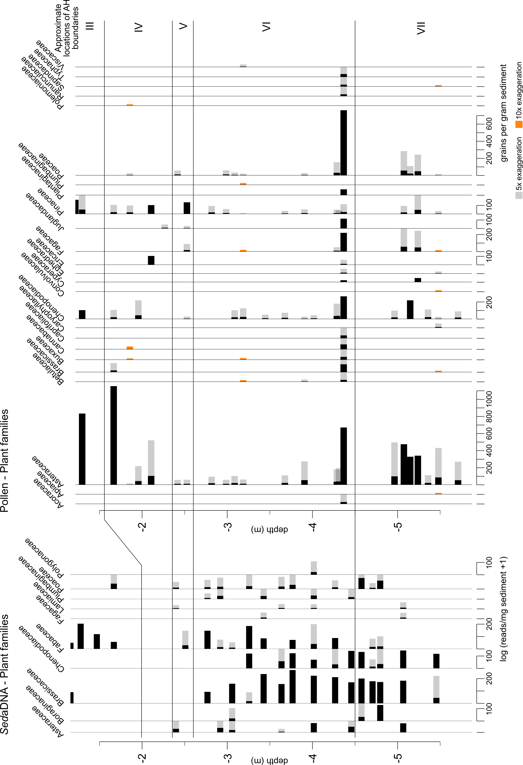

**Figure A.3.1.** *Sed*aDNA concentrations (left; in log (reads per mg sediment +1)) and pollen concentrations (right; in grains per gram sediment) per plant family.

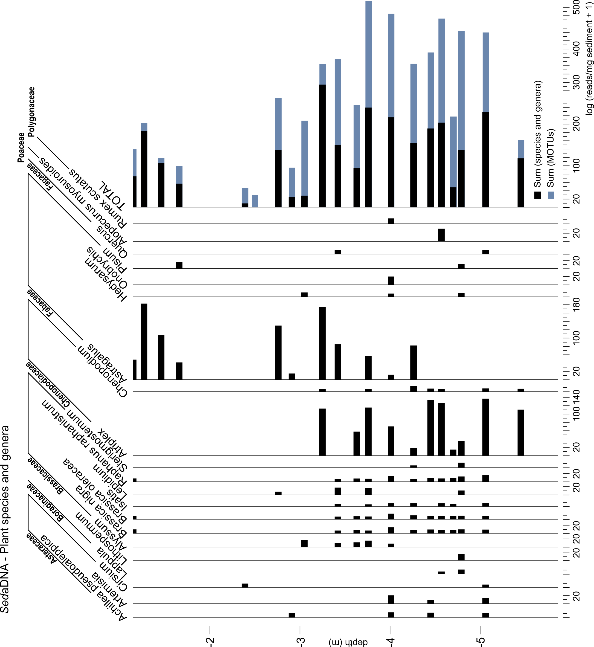

**Figure A.3.2.** S*ed*aDNA concentrations (log (reads per mg sediment +1)) per useful plant species or genus.

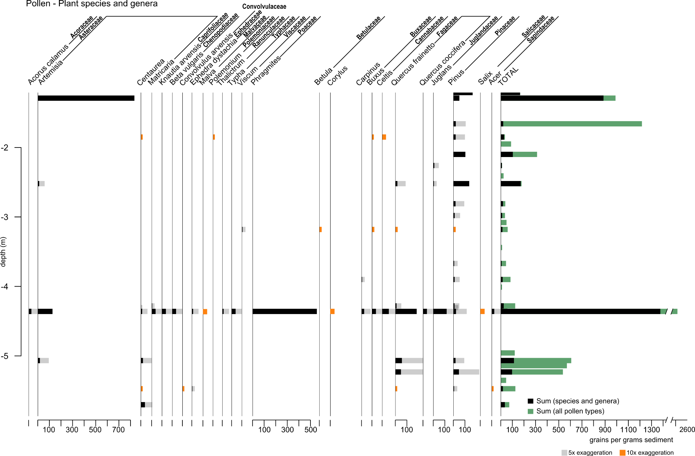

**Figure A.3.3.** Pollen concentrations (grains per gram sediment) per useful plant species or genus.

# A.4. Statistical differences in plant richness between Archaeological Horizons

**Table A.4.** Results from the non-parametric Mann-Whitney-Wilcoxon test to identify differences in plant richness (*sed*aDNA MOTUs or pollen taxa) among archaeological horizons (AH VII, VI, V, IV, III). *P-*values are adjusted using the Holm-method.

|  |  |  |  |  |  |  |  |  |  |
| --- | --- | --- | --- | --- | --- | --- | --- | --- | --- |
| proxy | group1 | group2 | n1 | n2 | statistic | p | p.signif | p.adj | p.adj.signif |
| DNA | III | IV | 5 | 2 | 9 | 0.16 | ns | 0.8 | ns |
| DNA | III | V | 5 | 2 | 8 | 0.381 | ns | 0.884 | ns |
| DNA | III | VI | 5 | 10 | 3 | 0.008 | ** | 0.084 | ns |
| DNA | III | VII | 5 | 6 | 4.5 | 0.067 | ns | 0.471 | ns |
| DNA | IV | V | 2 | 2 | 0 | 0.221 | ns | 0.884 | ns |
| DNA | IV | VI | 2 | 10 | 0 | 0.041 | * | 0.365 | ns |
| DNA | IV | VII | 2 | 6 | 1 | 0.124 | ns | 0.744 | ns |
| DNA | V | VI | 2 | 10 | 0 | 0.041 | * | 0.365 | ns |
| DNA | V | VII | 2 | 6 | 2 | 0.286 | ns | 0.884 | ns |
| DNA | VI | VII | 10 | 6 | 34.5 | 0.664 | ns | 0.884 | ns |
| DNA | III | IV-V | 5 | 4 | 17 | 0.105 | ns | 0.105 | ns |
| DNA | III | VI-VII | 5 | 16 | 7.5 | 0.008 | ** | 0.021 | * |
| DNA | IV-V | VI-VII | 4 | 16 | 3 | 0.007 | ** | 0.021 | * |
| pollen | III | IV | 4 | 8 | 12 | 0.536 | ns | 1 | ns |
| pollen | III | V | 4 | 3 | 4 | 0.582 | ns | 1 | ns |
| pollen | III | VI | 4 | 13 | 11 | 0.097 | ns | 0.969 | ns |
| pollen | III | VII | 4 | 10 | 11 | 0.217 | ns | 1 | ns |
| pollen | IV | V | 8 | 3 | 11 | 0.917 | ns | 1 | ns |
| pollen | IV | VI | 8 | 13 | 34.5 | 0.214 | ns | 1 | ns |
| pollen | IV | VII | 8 | 10 | 31 | 0.44 | ns | 1 | ns |
| pollen | V | VI | 3 | 13 | 14 | 0.499 | ns | 1 | ns |
| pollen | V | VII | 3 | 10 | 12 | 0.667 | ns | 1 | ns |
| pollen | VI | VII | 13 | 10 | 71 | 0.731 | ns | 1 | ns |
| pollen | III | IV-V | 4 | 11 | 16 | 0.457 | ns | 0.457 | ns |
| pollen | III | VI-VII | 4 | 23 | 22 | 0.104 | ns | 0.312 | ns |
| pollen | IV-V | VI-VII | 11 | 23 | 91.5 | 0.198 | ns | 0.396 | ns |