
Tertiary Infotech Academy Pte Ltd
UEN: 201200696W
LESSON PLAN
For
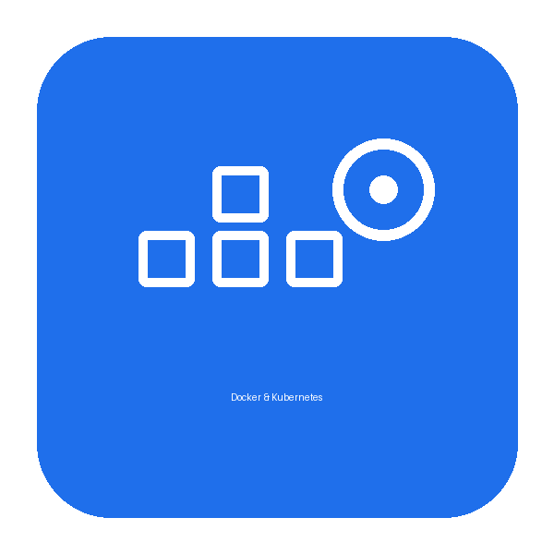
Docker Fundamentals for Beginners
Course Code: C1285
Conducted by
Tertiary Infotech Academy Pte Ltd
UEN: 201200696W
Version 1.0

DOCUMENT VERSION CONTROL RECORD
Version Number | Effective Date of Release | Summary of Included Changes | Author
1.0 | 3 October 2026 | First version — one-day lesson plan (Docker + Kubernetes), 7.5 instructional hours. | Tertiary Infotech Academy Pte Ltd

TABLE OF CONTENTS
Right-click and choose “Update Field”, or press F9, to build the table of contents.

Course Title | Docker Fundamentals for Beginners
Course Code | C1285
Duration | 1 Day (7.5 instructional hours)
Daily Schedule | 9:30 AM – 5:30 PM (7.5 instructional hours, excluding lunch)
Lunch Break | 12:55 PM – 1:25 PM (30 minutes)
Delivery Mode | Instructor-led, hands-on labs in KillerCoda browser terminals
Prerequisites | Basic command-line familiarity; no prior Docker or Kubernetes experience required
Tools | Docker, Docker Compose, kubectl, KillerCoda, a Docker Hub account

Course Overview
This one-day hands-on course teaches participants to containerise, run and orchestrate real applications with Docker and Kubernetes. Throughout the course learners build and deploy a single sample web application — TaskBoard (a Flask task tracker backed by Redis and PostgreSQL) — progressing from a single container to a multi-service Docker Compose stack and finally a scalable Kubernetes deployment. The morning covers Docker: commands, building images with a Dockerfile, CMD vs ENTRYPOINT, volumes, networking, configuration and Docker Hub. The afternoon covers Docker Compose and Kubernetes: Pods, Namespaces, Deployments, rolling updates and rollbacks, Services, storage, and Jobs/CronJobs.

Learning Outcomes
By the end of this course, participants will be able to:
- Explain containerisation and the Docker architecture, and manage containers with the Docker CLI.
- Build custom images with a Dockerfile, applying layer caching and .dockerignore best practices.
- Distinguish CMD from ENTRYPOINT and package command-line tools correctly.
- Persist and share data using named volumes and bind mounts.
- Connect containers over a custom network using DNS, and publish services with port mapping.
- Configure containers at runtime with environment variables and publish images to Docker Hub.
- Define and run multi-service applications (web + cache + database) with Docker Compose.
- Explain Kubernetes architecture and deploy applications as Pods, Deployments and Services.
- Scale and self-heal workloads and perform zero-downtime rolling updates and rollbacks.
- Persist data with PersistentVolumes/Claims and run batch work with Jobs and CronJobs.

Day 1 · 9:30am – 5:30pm
Docker & Kubernetes — Build, Compose, Deploy & Scale
Morning Session · 9:30 AM – 12:55 PM
Time | Topic / Activity | Duration
9:30 – 9:40 | Welcome, course objectives & overview | 10 min
9:40 – 10:00 | Topic 1: Containers, Docker architecture & core concepts | 20 min
10:00 – 10:15 | Lab 1: Docker Commands — Run & Manage Containers | 15 min
10:15 – 10:30 | Lab 2: Images & Inspecting Containers — pull, cp, inspect | 15 min
10:30 – 10:40 | Topic 2: Building images — Dockerfile, layers & build cache | 10 min
10:40 – 11:00 | Lab 3: Build the TaskBoard Image with a Dockerfile | 20 min
11:00 – 11:15 | Lab 4: Dockerfile Best Practices — .dockerignore & layer caching | 15 min
11:15 – 11:35 | Lab 5: CMD vs ENTRYPOINT — the taskboard-cli tool | 20 min
11:35 – 11:45 | Topic 3: Docker storage — volumes & bind mounts | 10 min
11:45 – 12:05 | Lab 6: Docker Storage — Named Volumes & Bind Mounts | 20 min
12:05 – 12:15 | Topic 4: Docker networking — bridges, DNS & ports | 10 min
12:15 – 12:35 | Lab 7: Docker Networking — Custom Bridge, DNS & Port Mapping | 20 min
12:35 – 12:45 | Lab 8: Configuration with Environment Variables | 10 min
12:45 – 12:55 | Lab 9: Sharing Images — Push to Docker Hub | 10 min
Time | Topic / Activity | Duration
12:55 – 1:25 | Lunch Break | 30 min
Afternoon Session · 1:25 PM – 5:30 PM
Time | Topic / Activity | Duration
1:25 – 1:35 | Topic 5: Docker Compose — multi-service apps | 10 min
1:35 – 1:45 | Lab 10: Docker Compose — Single Service | 10 min
1:45 – 1:55 | Lab 11: Docker Compose — Multi-Service (Web + Redis) | 10 min
1:55 – 2:10 | Lab 12: Docker Compose — Full-Stack (Web + PostgreSQL + Redis) | 15 min
2:10 – 2:35 | Topic 6: Kubernetes architecture & kubectl | 25 min
2:35 – 2:55 | Lab 13: Kubernetes Pods — Imperative & Declarative | 20 min
2:55 – 3:10 | Lab 14: Kubernetes Namespaces — Environment Isolation | 15 min
3:10 – 3:20 | Topic 7: Deployments, ReplicaSets & self-healing | 10 min
3:20 – 3:45 | Lab 15: Deployments — Scaling & Self-Healing | 25 min
3:45 – 4:05 | Lab 16: Rolling Updates & Rollbacks | 20 min
4:05 – 4:15 | Topic 8: Services & networking in Kubernetes | 10 min
4:15 – 4:35 | Lab 17: Services — ClusterIP & NodePort | 20 min
4:35 – 4:45 | Topic 9: Storage, Jobs & CronJobs | 10 min
4:45 – 5:00 | Lab 18: Kubernetes Storage — emptyDir, PV & PVC | 15 min
5:00 – 5:15 | Lab 19: Jobs & CronJobs — Batch and Scheduled Tasks | 15 min
5:15 – 5:30 | Course review, learner feedback & closing | 15 min

Labs Covered
All 19 hands-on labs are delivered in KillerCoda browser terminals and mirror the slide deck and Learner Guide exactly:
Lab | Topic | Title
1 | Docker commands | Docker Commands — Run & Manage Containers
2 | Docker commands | Images & Inspecting Containers — pull, cp, inspect
3 | Docker Build / Dockerfile | Build the TaskBoard Image with a Dockerfile
4 | Dockerfile best practices | Dockerfile Best Practices — .dockerignore & layer caching
5 | CMD vs ENTRYPOINT | CMD vs ENTRYPOINT — the taskboard-cli tool
6 | Volumes | Docker Storage — Named Volumes & Bind Mounts
7 | Networking | Docker Networking — Custom Bridge, DNS & Port Mapping
8 | Environment variables | Configuration with Environment Variables
9 | Docker Hub | Sharing Images — Push to Docker Hub
10 | Docker Compose | Docker Compose — Single Service
11 | Docker Compose | Docker Compose — Multi-Service (Web + Redis)
12 | Docker Compose | Docker Compose — Full-Stack (Web + PostgreSQL + Redis)
13 | Pods | Kubernetes Pods — Imperative & Declarative
14 | Namespaces | Kubernetes Namespaces — Environment Isolation
15 | Deployments | Deployments — Scaling & Self-Healing
16 | Rolling updates & rollbacks | Rolling Updates & Rollbacks
17 | Services | Services — ClusterIP & NodePort
18 | Storage | Kubernetes Storage — emptyDir, PV & PVC
19 | Jobs & CronJobs | Jobs & CronJobs — Batch and Scheduled Tasks

