

AI Transformation with Microsoft Copilot
Learner Guide | C776 | v1.0 | 1 October 2026
Conducted by Tertiary Infotech Academy Pte Ltd · UEN 201200696W

Document Version Control Record
Version | Effective date | Material changes | Author
v1.0 | 1 October 2026 | Initial release: Microsoft 365 Copilot, no-code Workflows, Agent Builder and business outcomes. | Tertiary Infotech Academy

Table of contents

Topic 1: Use Microsoft 365 Copilot for everyday business work ........................................ 3
Topic 2: Design safe Copilot Workflows and human controls ........................................ 10
Topic 3: Create and test bounded Copilot agents ........................................ 14
Topic 4: Lead adoption, measure value and scale outcomes ........................................ 19
Lab walkthroughs ........................................ 25

Course learning outcomes
- LO1. Develop technology implementation plans and business processes for Microsoft Copilot.
- LO2. Develop control procedures for Microsoft Copilot to manage security.
- LO3. Evaluate the integration of Microsoft Copilot to ensure alignment with business objectives.
- LO4. Develop optimization plans for Microsoft Copilot to improve business operations.

Before you start
Use an approved Microsoft 365 training tenant. All Northstar Service names, customers, accounts and figures in this guide are synthetic. Do not enter live personal or confidential information in exercises.
Use Microsoft 365 Copilot in an approved work or school account when licensed. If a feature is unavailable, use the supplied synthetic source pack and label the artifact as an offline exercise. Review every consequential Copilot statement against its source.
Reference basis: Microsoft AB-730 informs Copilot work in Microsoft 365 apps; AB-731 informs transformation leadership. The MicrosoftLearning AB-730 labs inform the hands-on pattern. This course is not Microsoft exam preparation. Copilot Workflows availability depends on the tenant and Frontier access; complete a labelled offline design and test when unavailable.

Topic 1: Use Microsoft 365 Copilot for everyday business work
Learning outcome: LO1. Official reference: https://learn.microsoft.com/en-us/credentials/certifications/ai-business-professional/

01. Choose a service outcome
Work scenario. Northstar Service starts with service response baseline and customer feedback. Use Microsoft 365 Copilot Chat to identify a bounded opportunity. The output is pilot opportunity statement.
Copilot practice. 1. Open Microsoft 365 Copilot Chat and Pages in the approved Microsoft 365 work environment, or open the synthetic case pack. 2. State the executive decision, audience, source and constraints. 3. Ask Copilot for the named output and request assumptions and uncertainties. 4. Compare material claims and figures with the supplied source. 5. Edit and save a human-owned decision artifact. The matching Lab 01 gives a copy-ready prompt and detailed steps.
Human check. Sponsor confirms outcome and owner. Challenge the result if ai use is mistaken for customer benefit. Record the decision owner and a corrective action.
Outcome measure. Comparable response time. State the baseline, cohort and period. Separate observed results from estimates before presenting value to a sponsor.
Practice in Lab 01. Evidence: Pilot opportunity statement; expected acceptance: Sponsor confirms outcome and owner.

02. Ask a useful question
Work scenario. Northstar Service starts with a vague request to improve service. Add audience, task, source, constraints and output to a Copilot prompt. The output is reusable work prompt.
Copilot practice. 1. Open Microsoft 365 Copilot Chat and Pages in the approved Microsoft 365 work environment, or open the synthetic case pack. 2. State the executive decision, audience, source and constraints. 3. Ask Copilot for the named output and request assumptions and uncertainties. 4. Compare material claims and figures with the supplied source. 5. Edit and save a human-owned decision artifact. The matching Lab 01 gives a copy-ready prompt and detailed steps.
Human check. Manager confirms the prompt answers the real question. Challenge the result if polished response has no decision value. Record the decision owner and a corrective action.
Outcome measure. Relevant answers per review. State the baseline, cohort and period. Separate observed results from estimates before presenting value to a sponsor.
Practice in Lab 01. Evidence: Reusable work prompt; expected acceptance: Manager confirms the prompt answers the real question.

03. Ground a chat answer
Work scenario. Northstar Service starts with current service policy and two case notes. Ask Copilot Chat to answer from the supplied source. The output is sourced response summary.
Copilot practice. 1. Open Microsoft 365 Copilot Chat and Pages in the approved Microsoft 365 work environment, or open the synthetic case pack. 2. State the executive decision, audience, source and constraints. 3. Ask Copilot for the named output and request assumptions and uncertainties. 4. Compare material claims and figures with the supplied source. 5. Edit and save a human-owned decision artifact. The matching Lab 01 gives a copy-ready prompt and detailed steps.
Human check. Check every material statement against the source. Challenge the result if an unsupported claim is repeated. Record the decision owner and a corrective action.
Outcome measure. Verified claims per sample. State the baseline, cohort and period. Separate observed results from estimates before presenting value to a sponsor.
Practice in Lab 01. Evidence: Sourced response summary; expected acceptance: Check every material statement against the source.

04. Compare options in Chat
Work scenario. Northstar Service starts with three possible pilot processes. Ask Copilot for benefits, trade-offs and missing evidence. The output is option comparison.
Copilot practice. 1. Open Microsoft 365 Copilot Chat and Pages in the approved Microsoft 365 work environment, or open the synthetic case pack. 2. State the executive decision, audience, source and constraints. 3. Ask Copilot for the named output and request assumptions and uncertainties. 4. Compare material claims and figures with the supplied source. 5. Edit and save a human-owned decision artifact. The matching Lab 01 gives a copy-ready prompt and detailed steps.
Human check. Use the same criteria for all options. Challenge the result if the preferred option receives easier criteria. Record the decision owner and a corrective action.
Outcome measure. Options with complete evidence. State the baseline, cohort and period. Separate observed results from estimates before presenting value to a sponsor.
Practice in Lab 01. Evidence: Option comparison; expected acceptance: Use the same criteria for all options.

05. Share a Copilot Page
Work scenario. Northstar Service starts with a reviewed team decision summary. Move approved ideas into a Copilot Page or offline shared brief. The output is shared planning page.
Copilot practice. 1. Open Microsoft 365 Copilot Chat and Pages in the approved Microsoft 365 work environment, or open the synthetic case pack. 2. State the executive decision, audience, source and constraints. 3. Ask Copilot for the named output and request assumptions and uncertainties. 4. Compare material claims and figures with the supplied source. 5. Edit and save a human-owned decision artifact. The matching Lab 01 gives a copy-ready prompt and detailed steps.
Human check. Owner checks content and access before sharing. Challenge the result if draft assumptions are shown as decisions. Record the decision owner and a corrective action.
Outcome measure. Open questions assigned. State the baseline, cohort and period. Separate observed results from estimates before presenting value to a sponsor.
Practice in Lab 01. Evidence: Shared planning page; expected acceptance: Owner checks content and access before sharing.

06. Draft a Word brief
Work scenario. Northstar Service starts with approved pilot notes and service baseline. Use Copilot in Word to draft a two-page decision brief. The output is reviewed word brief.
Copilot practice. 1. Open Copilot in Word PowerPoint and Outlook in the approved Microsoft 365 work environment, or open the synthetic case pack. 2. State the executive decision, audience, source and constraints. 3. Ask Copilot for the named output and request assumptions and uncertainties. 4. Compare material claims and figures with the supplied source. 5. Edit and save a human-owned decision artifact. The matching Lab 02 gives a copy-ready prompt and detailed steps.
Human check. Sponsor checks numbers and recommendation. Challenge the result if copilot invents a benefit estimate. Record the decision owner and a corrective action.
Outcome measure. Verified material claims. State the baseline, cohort and period. Separate observed results from estimates before presenting value to a sponsor.
Practice in Lab 02. Evidence: Reviewed Word brief; expected acceptance: Sponsor checks numbers and recommendation.

07. Refine executive tone
Work scenario. Northstar Service starts with a rough draft for a leadership audience. Ask Copilot in Word to shorten and clarify the recommendation. The output is concise executive summary.
Copilot practice. 1. Open Copilot in Word PowerPoint and Outlook in the approved Microsoft 365 work environment, or open the synthetic case pack. 2. State the executive decision, audience, source and constraints. 3. Ask Copilot for the named output and request assumptions and uncertainties. 4. Compare material claims and figures with the supplied source. 5. Edit and save a human-owned decision artifact. The matching Lab 02 gives a copy-ready prompt and detailed steps.
Human check. Human owner signs the final message. Challenge the result if important caveat disappears. Record the decision owner and a corrective action.
Outcome measure. Decisions understood in review. State the baseline, cohort and period. Separate observed results from estimates before presenting value to a sponsor.
Practice in Lab 02. Evidence: Concise executive summary; expected acceptance: Human owner signs the final message.

08. Create board slides
Work scenario. Northstar Service starts with approved word brief and baseline chart. Use Copilot in PowerPoint to create a five-slide decision story. The output is board presentation.
Copilot practice. 1. Open Copilot in Word PowerPoint and Outlook in the approved Microsoft 365 work environment, or open the synthetic case pack. 2. State the executive decision, audience, source and constraints. 3. Ask Copilot for the named output and request assumptions and uncertainties. 4. Compare material claims and figures with the supplied source. 5. Edit and save a human-owned decision artifact. The matching Lab 02 gives a copy-ready prompt and detailed steps.
Human check. Trace every chart to approved values. Challenge the result if slide claim exceeds the source. Record the decision owner and a corrective action.
Outcome measure. Figures checked before review. State the baseline, cohort and period. Separate observed results from estimates before presenting value to a sponsor.
Practice in Lab 02. Evidence: Board presentation; expected acceptance: Trace every chart to approved values.

09. Draft Outlook update
Work scenario. Northstar Service starts with approved pilot decision and open actions. Use Copilot in Outlook to prepare a status message. The output is unsent status draft.
Copilot practice. 1. Open Copilot in Word PowerPoint and Outlook in the approved Microsoft 365 work environment, or open the synthetic case pack. 2. State the executive decision, audience, source and constraints. 3. Ask Copilot for the named output and request assumptions and uncertainties. 4. Compare material claims and figures with the supplied source. 5. Edit and save a human-owned decision artifact. The matching Lab 02 gives a copy-ready prompt and detailed steps.
Human check. Sponsor approves recipients and commitments. Challenge the result if an unapproved promise is sent. Record the decision owner and a corrective action.
Outcome measure. Messages approved before sending. State the baseline, cohort and period. Separate observed results from estimates before presenting value to a sponsor.
Practice in Lab 02. Evidence: Unsent status draft; expected acceptance: Sponsor approves recipients and commitments.

10. Use Researcher carefully
Work scenario. Northstar Service starts with synthetic policy and market question. Use Researcher if available to gather sources, or compare supplied documents. The output is source and uncertainty list.
Copilot practice. 1. Open Copilot in Word PowerPoint and Outlook in the approved Microsoft 365 work environment, or open the synthetic case pack. 2. State the executive decision, audience, source and constraints. 3. Ask Copilot for the named output and request assumptions and uncertainties. 4. Compare material claims and figures with the supplied source. 5. Edit and save a human-owned decision artifact. The matching Lab 02 gives a copy-ready prompt and detailed steps.
Human check. Validate dates, claims and relevance. Challenge the result if research summary treats weak source as fact. Record the decision owner and a corrective action.
Outcome measure. Sources verified. State the baseline, cohort and period. Separate observed results from estimates before presenting value to a sponsor.
Practice in Lab 02. Evidence: Source and uncertainty list; expected acceptance: Validate dates, claims and relevance.

11. Explore Excel data
Work scenario. Northstar Service starts with synthetic monthly service-volume workbook. Ask Copilot in Excel to surface patterns and outliers. The output is trend summary.
Copilot practice. 1. Open Copilot in Excel and Teams in the approved Microsoft 365 work environment, or open the synthetic case pack. 2. State the executive decision, audience, source and constraints. 3. Ask Copilot for the named output and request assumptions and uncertainties. 4. Compare material claims and figures with the supplied source. 5. Edit and save a human-owned decision artifact. The matching Lab 03 gives a copy-ready prompt and detailed steps.
Human check. Check chart and denominator against workbook. Challenge the result if an outlier is presented as a trend. Record the decision owner and a corrective action.
Outcome measure. Patterns confirmed. State the baseline, cohort and period. Separate observed results from estimates before presenting value to a sponsor.
Practice in Lab 03. Evidence: Trend summary; expected acceptance: Check chart and denominator against workbook.

12. Build a simple chart
Work scenario. Northstar Service starts with synthetic before-and-after service table. Use Copilot in Excel to propose a clear chart. The output is annotated comparison chart.
Copilot practice. 1. Open Copilot in Excel and Teams in the approved Microsoft 365 work environment, or open the synthetic case pack. 2. State the executive decision, audience, source and constraints. 3. Ask Copilot for the named output and request assumptions and uncertainties. 4. Compare material claims and figures with the supplied source. 5. Edit and save a human-owned decision artifact. The matching Lab 03 gives a copy-ready prompt and detailed steps.
Human check. Use comparable periods and units. Challenge the result if axis hides change or variation. Record the decision owner and a corrective action.
Outcome measure. Correctly labelled charts. State the baseline, cohort and period. Separate observed results from estimates before presenting value to a sponsor.
Practice in Lab 03. Evidence: Annotated comparison chart; expected acceptance: Use comparable periods and units.

13. Prepare a Teams meeting
Work scenario. Northstar Service starts with pilot objective, questions and decision owner. Use Copilot to prepare a concise meeting agenda. The output is decision agenda.
Copilot practice. 1. Open Copilot in Excel and Teams in the approved Microsoft 365 work environment, or open the synthetic case pack. 2. State the executive decision, audience, source and constraints. 3. Ask Copilot for the named output and request assumptions and uncertainties. 4. Compare material claims and figures with the supplied source. 5. Edit and save a human-owned decision artifact. The matching Lab 03 gives a copy-ready prompt and detailed steps.
Human check. Chair confirms questions and owner. Challenge the result if meeting has no decision to make. Record the decision owner and a corrective action.
Outcome measure. Decisions reached. State the baseline, cohort and period. Separate observed results from estimates before presenting value to a sponsor.
Practice in Lab 03. Evidence: Decision agenda; expected acceptance: Chair confirms questions and owner.

14. Review meeting recap
Work scenario. Northstar Service starts with synthetic teams transcript and dissent note. Use Copilot in Teams to summarize decisions and actions. The output is validated action log.
Copilot practice. 1. Open Copilot in Excel and Teams in the approved Microsoft 365 work environment, or open the synthetic case pack. 2. State the executive decision, audience, source and constraints. 3. Ask Copilot for the named output and request assumptions and uncertainties. 4. Compare material claims and figures with the supplied source. 5. Edit and save a human-owned decision artifact. The matching Lab 03 gives a copy-ready prompt and detailed steps.
Human check. Chair checks speakers, owners and dates. Challenge the result if action is attributed to wrong person. Record the decision owner and a corrective action.
Outcome measure. Actions confirmed. State the baseline, cohort and period. Separate observed results from estimates before presenting value to a sponsor.
Practice in Lab 03. Evidence: Validated action log; expected acceptance: Chair checks speakers, owners and dates.

15. Follow up after meeting
Work scenario. Northstar Service starts with validated action log and unresolved questions. Use Copilot Chat or Outlook to draft an unsent follow-up. The output is reviewed follow-up message.
Copilot practice. 1. Open Copilot in Excel and Teams in the approved Microsoft 365 work environment, or open the synthetic case pack. 2. State the executive decision, audience, source and constraints. 3. Ask Copilot for the named output and request assumptions and uncertainties. 4. Compare material claims and figures with the supplied source. 5. Edit and save a human-owned decision artifact. The matching Lab 03 gives a copy-ready prompt and detailed steps.
Human check. Owner approves external distribution. Challenge the result if dissent or hold condition is omitted. Record the decision owner and a corrective action.
Outcome measure. Actions closed on time. State the baseline, cohort and period. Separate observed results from estimates before presenting value to a sponsor.
Practice in Lab 03. Evidence: Reviewed follow-up message; expected acceptance: Owner approves external distribution.

Topic 2: Design safe Copilot Workflows and human controls
Learning outcome: LO2. Official reference: https://support.microsoft.com/en-us/microsoft-365-copilot/get-started-with-workflows-in-microsoft-365-copilot

16. Spot a repeatable handoff
Work scenario. Northstar Service starts with synthetic email requests and missed deadlines. Describe a Microsoft 365 Copilot Workflows opportunity in plain language. The output is workflow opportunity card.
Copilot practice. 1. Open Copilot Workflows agent in the approved Microsoft 365 work environment, or open the synthetic case pack. 2. State the executive decision, audience, source and constraints. 3. Ask Copilot for the named output and request assumptions and uncertainties. 4. Compare material claims and figures with the supplied source. 5. Edit and save a human-owned decision artifact. The matching Lab 04 gives a copy-ready prompt and detailed steps.
Human check. Process owner confirms a repeatable trigger. Challenge the result if one-off judgment is automated. Record the decision owner and a corrective action.
Outcome measure. Handoff time. State the baseline, cohort and period. Separate observed results from estimates before presenting value to a sponsor.
Practice in Lab 04. Evidence: Workflow opportunity card; expected acceptance: Process owner confirms a repeatable trigger.

17. Define trigger and result
Work scenario. Northstar Service starts with service request email with fictional fields. Ask Workflows to draft trigger, steps and intended output. The output is trigger-to-result map.
Copilot practice. 1. Open Copilot Workflows agent in the approved Microsoft 365 work environment, or open the synthetic case pack. 2. State the executive decision, audience, source and constraints. 3. Ask Copilot for the named output and request assumptions and uncertainties. 4. Compare material claims and figures with the supplied source. 5. Edit and save a human-owned decision artifact. The matching Lab 04 gives a copy-ready prompt and detailed steps.
Human check. Owner verifies trigger is precise. Challenge the result if wrong message starts workflow. Record the decision owner and a corrective action.
Outcome measure. Correctly triggered cases. State the baseline, cohort and period. Separate observed results from estimates before presenting value to a sponsor.
Practice in Lab 04. Evidence: Trigger-to-result map; expected acceptance: Owner verifies trigger is precise.

18. Add review step
Work scenario. Northstar Service starts with draft acknowledgement and case summary. Ask Workflows to route draft for human approval. The output is human review gate.
Copilot practice. 1. Open Copilot Workflows agent in the approved Microsoft 365 work environment, or open the synthetic case pack. 2. State the executive decision, audience, source and constraints. 3. Ask Copilot for the named output and request assumptions and uncertainties. 4. Compare material claims and figures with the supplied source. 5. Edit and save a human-owned decision artifact. The matching Lab 04 gives a copy-ready prompt and detailed steps.
Human check. No external commitment before approval. Challenge the result if message sends without review. Record the decision owner and a corrective action.
Outcome measure. Unapproved sends. State the baseline, cohort and period. Separate observed results from estimates before presenting value to a sponsor.
Practice in Lab 04. Evidence: Human review gate; expected acceptance: No external commitment before approval.

19. Test exceptions
Work scenario. Northstar Service starts with missing case owner and contradictory priority. Test workflow with normal and exception examples. The output is test and exception log.
Copilot practice. 1. Open Copilot Workflows agent in the approved Microsoft 365 work environment, or open the synthetic case pack. 2. State the executive decision, audience, source and constraints. 3. Ask Copilot for the named output and request assumptions and uncertainties. 4. Compare material claims and figures with the supplied source. 5. Edit and save a human-owned decision artifact. The matching Lab 04 gives a copy-ready prompt and detailed steps.
Human check. Hold unknown owner or conflicting input. Challenge the result if exception is silently routed. Record the decision owner and a corrective action.
Outcome measure. Exceptions detected. State the baseline, cohort and period. Separate observed results from estimates before presenting value to a sponsor.
Practice in Lab 04. Evidence: Test and exception log; expected acceptance: Hold unknown owner or conflicting input.

20. Decide to activate
Work scenario. Northstar Service starts with workflow test record and accountable owner. Review Workflows draft, permissions and run history before enabling. The output is go or hold record.
Copilot practice. 1. Open Copilot Workflows agent in the approved Microsoft 365 work environment, or open the synthetic case pack. 2. State the executive decision, audience, source and constraints. 3. Ask Copilot for the named output and request assumptions and uncertainties. 4. Compare material claims and figures with the supplied source. 5. Edit and save a human-owned decision artifact. The matching Lab 04 gives a copy-ready prompt and detailed steps.
Human check. Owner approves live activation in authorised tenant. Challenge the result if simulation is described as deployed. Record the decision owner and a corrective action.
Outcome measure. Approved runs. State the baseline, cohort and period. Separate observed results from estimates before presenting value to a sponsor.
Practice in Lab 04. Evidence: Go or hold record; expected acceptance: Owner approves live activation in authorised tenant.

21. Check data access
Work scenario. Northstar Service starts with two synthetic role-based document sets. Review what a workflow can read and where output goes. The output is data boundary map.
Copilot practice. 1. Open Copilot Workflows agent in the approved Microsoft 365 work environment, or open the synthetic case pack. 2. State the executive decision, audience, source and constraints. 3. Ask Copilot for the named output and request assumptions and uncertainties. 4. Compare material claims and figures with the supplied source. 5. Edit and save a human-owned decision artifact. The matching Lab 05 gives a copy-ready prompt and detailed steps.
Human check. Data owner approves sources and recipients. Challenge the result if restricted content reaches a broad channel. Record the decision owner and a corrective action.
Outcome measure. Unexpected access findings. State the baseline, cohort and period. Separate observed results from estimates before presenting value to a sponsor.
Practice in Lab 05. Evidence: Data boundary map; expected acceptance: Data owner approves sources and recipients.

22. Verify source freshness
Work scenario. Northstar Service starts with current and retired service rules. Test the draft workflow against both versions. The output is source test record.
Copilot practice. 1. Open Copilot Workflows agent in the approved Microsoft 365 work environment, or open the synthetic case pack. 2. State the executive decision, audience, source and constraints. 3. Ask Copilot for the named output and request assumptions and uncertainties. 4. Compare material claims and figures with the supplied source. 5. Edit and save a human-owned decision artifact. The matching Lab 05 gives a copy-ready prompt and detailed steps.
Human check. Current rule governs action. Challenge the result if retired rule triggers an action. Record the decision owner and a corrective action.
Outcome measure. Current-source rate. State the baseline, cohort and period. Separate observed results from estimates before presenting value to a sponsor.
Practice in Lab 05. Evidence: Source test record; expected acceptance: Current rule governs action.

23. Set approval responsibility
Work scenario. Northstar Service starts with service, risk and it roles. Assign who reviews, pauses and restores a workflow. The output is plain-language responsibility card.
Copilot practice. 1. Open Copilot Workflows agent in the approved Microsoft 365 work environment, or open the synthetic case pack. 2. State the executive decision, audience, source and constraints. 3. Ask Copilot for the named output and request assumptions and uncertainties. 4. Compare material claims and figures with the supplied source. 5. Edit and save a human-owned decision artifact. The matching Lab 05 gives a copy-ready prompt and detailed steps.
Human check. Each consequential action has an owner. Challenge the result if everyone assumes another team approves. Record the decision owner and a corrective action.
Outcome measure. Controls with named owners. State the baseline, cohort and period. Separate observed results from estimates before presenting value to a sponsor.
Practice in Lab 05. Evidence: Plain-language responsibility card; expected acceptance: Each consequential action has an owner.

24. Plan incident response
Work scenario. Northstar Service starts with synthetic misrouted notification. Write a pause, contain, notify and retest path. The output is incident response card.
Copilot practice. 1. Open Copilot Workflows agent in the approved Microsoft 365 work environment, or open the synthetic case pack. 2. State the executive decision, audience, source and constraints. 3. Ask Copilot for the named output and request assumptions and uncertainties. 4. Compare material claims and figures with the supplied source. 5. Edit and save a human-owned decision artifact. The matching Lab 05 gives a copy-ready prompt and detailed steps.
Human check. Risk owner decides restart. Challenge the result if workflow continues after a failure. Record the decision owner and a corrective action.
Outcome measure. Time to pause. State the baseline, cohort and period. Separate observed results from estimates before presenting value to a sponsor.
Practice in Lab 05. Evidence: Incident response card; expected acceptance: Risk owner decides restart.

25. Review workflow value
Work scenario. Northstar Service starts with five sample requests and review minutes. Compare manual and assisted handoff times. The output is workflow pilot scorecard.
Copilot practice. 1. Open Copilot Workflows agent in the approved Microsoft 365 work environment, or open the synthetic case pack. 2. State the executive decision, audience, source and constraints. 3. Ask Copilot for the named output and request assumptions and uncertainties. 4. Compare material claims and figures with the supplied source. 5. Edit and save a human-owned decision artifact. The matching Lab 05 gives a copy-ready prompt and detailed steps.
Human check. Include human review and error effort. Challenge the result if gross time saved is called net value. Record the decision owner and a corrective action.
Outcome measure. Net minutes per case. State the baseline, cohort and period. Separate observed results from estimates before presenting value to a sponsor.
Practice in Lab 05. Evidence: Workflow pilot scorecard; expected acceptance: Include human review and error effort.

Topic 3: Create and test bounded Copilot agents
Learning outcome: LO3. Official reference: https://support.microsoft.com/en-us/microsoft-365-copilot/build-your-own-agent-with-microsoft-365-copilot

26. Choose agent purpose
Work scenario. Northstar Service starts with recurring employee policy questions. Define one bounded use for Copilot Agent Builder. The output is agent purpose statement.
Copilot practice. 1. Open Microsoft 365 Copilot Agent Builder in the approved Microsoft 365 work environment, or open the synthetic case pack. 2. State the executive decision, audience, source and constraints. 3. Ask Copilot for the named output and request assumptions and uncertainties. 4. Compare material claims and figures with the supplied source. 5. Edit and save a human-owned decision artifact. The matching Lab 06 gives a copy-ready prompt and detailed steps.
Human check. Owner excludes high-impact decisions. Challenge the result if agent has no clear scope. Record the decision owner and a corrective action.
Outcome measure. In-scope answer rate. State the baseline, cohort and period. Separate observed results from estimates before presenting value to a sponsor.
Practice in Lab 06. Evidence: Agent purpose statement; expected acceptance: Owner excludes high-impact decisions.

27. Write instructions
Work scenario. Northstar Service starts with approved policy excerpts and role statement. Describe audience, task, boundaries and escalation in Agent Builder. The output is agent instructions draft.
Copilot practice. 1. Open Microsoft 365 Copilot Agent Builder in the approved Microsoft 365 work environment, or open the synthetic case pack. 2. State the executive decision, audience, source and constraints. 3. Ask Copilot for the named output and request assumptions and uncertainties. 4. Compare material claims and figures with the supplied source. 5. Edit and save a human-owned decision artifact. The matching Lab 06 gives a copy-ready prompt and detailed steps.
Human check. Owner checks failure and escalation wording. Challenge the result if agent implies it can approve policy. Record the decision owner and a corrective action.
Outcome measure. Escalations handled. State the baseline, cohort and period. Separate observed results from estimates before presenting value to a sponsor.
Practice in Lab 06. Evidence: Agent instructions draft; expected acceptance: Owner checks failure and escalation wording.

28. Add knowledge
Work scenario. Northstar Service starts with current synthetic policy files. Attach approved knowledge sources in Agent Builder. The output is knowledge-source register.
Copilot practice. 1. Open Microsoft 365 Copilot Agent Builder in the approved Microsoft 365 work environment, or open the synthetic case pack. 2. State the executive decision, audience, source and constraints. 3. Ask Copilot for the named output and request assumptions and uncertainties. 4. Compare material claims and figures with the supplied source. 5. Edit and save a human-owned decision artifact. The matching Lab 06 gives a copy-ready prompt and detailed steps.
Human check. Data owner validates permissions and versions. Challenge the result if retired file remains attached. Record the decision owner and a corrective action.
Outcome measure. Approved sources used. State the baseline, cohort and period. Separate observed results from estimates before presenting value to a sponsor.
Practice in Lab 06. Evidence: Knowledge-source register; expected acceptance: Data owner validates permissions and versions.

29. Create starter prompts
Work scenario. Northstar Service starts with three common user questions. Write clear starter prompts for the agent. The output is starter prompt set.
Copilot practice. 1. Open Microsoft 365 Copilot Agent Builder in the approved Microsoft 365 work environment, or open the synthetic case pack. 2. State the executive decision, audience, source and constraints. 3. Ask Copilot for the named output and request assumptions and uncertainties. 4. Compare material claims and figures with the supplied source. 5. Edit and save a human-owned decision artifact. The matching Lab 06 gives a copy-ready prompt and detailed steps.
Human check. Business user can understand each prompt. Challenge the result if prompts ask for unsupported decisions. Record the decision owner and a corrective action.
Outcome measure. Prompt completion rate. State the baseline, cohort and period. Separate observed results from estimates before presenting value to a sponsor.
Practice in Lab 06. Evidence: Starter prompt set; expected acceptance: Business user can understand each prompt.

30. Preview a response
Work scenario. Northstar Service starts with typical policy question with source answer. Test the agent preview and compare to source. The output is agent response review.
Copilot practice. 1. Open Microsoft 365 Copilot Agent Builder in the approved Microsoft 365 work environment, or open the synthetic case pack. 2. State the executive decision, audience, source and constraints. 3. Ask Copilot for the named output and request assumptions and uncertainties. 4. Compare material claims and figures with the supplied source. 5. Edit and save a human-owned decision artifact. The matching Lab 06 gives a copy-ready prompt and detailed steps.
Human check. Owner verifies accuracy and citation. Challenge the result if confident answer is unsupported. Record the decision owner and a corrective action.
Outcome measure. Correct answers per test. State the baseline, cohort and period. Separate observed results from estimates before presenting value to a sponsor.
Practice in Lab 06. Evidence: Agent response review; expected acceptance: Owner verifies accuracy and citation.

31. Test a normal question
Work scenario. Northstar Service starts with approved leave-policy example. Ask the agent for a bounded answer. The output is normal-case test record.
Copilot practice. 1. Open Microsoft 365 Copilot Agent Builder in the approved Microsoft 365 work environment, or open the synthetic case pack. 2. State the executive decision, audience, source and constraints. 3. Ask Copilot for the named output and request assumptions and uncertainties. 4. Compare material claims and figures with the supplied source. 5. Edit and save a human-owned decision artifact. The matching Lab 07 gives a copy-ready prompt and detailed steps.
Human check. Answer matches current source. Challenge the result if agent omits a condition. Record the decision owner and a corrective action.
Outcome measure. Correct normal answers. State the baseline, cohort and period. Separate observed results from estimates before presenting value to a sponsor.
Practice in Lab 07. Evidence: Normal-case test record; expected acceptance: Answer matches current source.

32. Test missing knowledge
Work scenario. Northstar Service starts with question outside approved policy set. Ask the agent to state uncertainty and escalation. The output is out-of-scope test record.
Copilot practice. 1. Open Microsoft 365 Copilot Agent Builder in the approved Microsoft 365 work environment, or open the synthetic case pack. 2. State the executive decision, audience, source and constraints. 3. Ask Copilot for the named output and request assumptions and uncertainties. 4. Compare material claims and figures with the supplied source. 5. Edit and save a human-owned decision artifact. The matching Lab 07 gives a copy-ready prompt and detailed steps.
Human check. Agent hands off unknown answer. Challenge the result if agent invents a policy. Record the decision owner and a corrective action.
Outcome measure. Correct escalations. State the baseline, cohort and period. Separate observed results from estimates before presenting value to a sponsor.
Practice in Lab 07. Evidence: Out-of-scope test record; expected acceptance: Agent hands off unknown answer.

33. Test conflicting sources
Work scenario. Northstar Service starts with current and retired synthetic policies. Challenge the agent with contradictory evidence. The output is conflict test record.
Copilot practice. 1. Open Microsoft 365 Copilot Agent Builder in the approved Microsoft 365 work environment, or open the synthetic case pack. 2. State the executive decision, audience, source and constraints. 3. Ask Copilot for the named output and request assumptions and uncertainties. 4. Compare material claims and figures with the supplied source. 5. Edit and save a human-owned decision artifact. The matching Lab 07 gives a copy-ready prompt and detailed steps.
Human check. Owner chooses authoritative source. Challenge the result if agent cites retired policy. Record the decision owner and a corrective action.
Outcome measure. Conflicts surfaced. State the baseline, cohort and period. Separate observed results from estimates before presenting value to a sponsor.
Practice in Lab 07. Evidence: Conflict test record; expected acceptance: Owner chooses authoritative source.

34. Pilot with users
Work scenario. Northstar Service starts with three synthetic role personas. Run a small acceptance review before sharing. The output is pilot feedback log.
Copilot practice. 1. Open Microsoft 365 Copilot Agent Builder in the approved Microsoft 365 work environment, or open the synthetic case pack. 2. State the executive decision, audience, source and constraints. 3. Ask Copilot for the named output and request assumptions and uncertainties. 4. Compare material claims and figures with the supplied source. 5. Edit and save a human-owned decision artifact. The matching Lab 07 gives a copy-ready prompt and detailed steps.
Human check. Address material failures before release. Challenge the result if first demo is treated as sign-off. Record the decision owner and a corrective action.
Outcome measure. Critical failures closed. State the baseline, cohort and period. Separate observed results from estimates before presenting value to a sponsor.
Practice in Lab 07. Evidence: Pilot feedback log; expected acceptance: Address material failures before release.

35. Share and monitor
Work scenario. Northstar Service starts with approved agent and audience list. Review Agent Builder sharing and ongoing feedback plan. The output is agent release and review card.
Copilot practice. 1. Open Microsoft 365 Copilot Agent Builder in the approved Microsoft 365 work environment, or open the synthetic case pack. 2. State the executive decision, audience, source and constraints. 3. Ask Copilot for the named output and request assumptions and uncertainties. 4. Compare material claims and figures with the supplied source. 5. Edit and save a human-owned decision artifact. The matching Lab 07 gives a copy-ready prompt and detailed steps.
Human check. Owner checks audience and knowledge access. Challenge the result if agent is shared too broadly. Record the decision owner and a corrective action.
Outcome measure. Reviewed usage and feedback. State the baseline, cohort and period. Separate observed results from estimates before presenting value to a sponsor.
Practice in Lab 07. Evidence: Agent release and review card; expected acceptance: Owner checks audience and knowledge access.

Topic 4: Lead adoption, measure value and scale outcomes
Learning outcome: LO4. Official reference: https://learn.microsoft.com/en-us/credentials/certifications/ai-transformation-leader/

36. Map a work journey
Work scenario. Northstar Service starts with chat, workflow and agent opportunities. Show where each Copilot mode helps in one service journey. The output is future-state journey map.
Copilot practice. 1. Open Copilot Chat and Word in the approved Microsoft 365 work environment, or open the synthetic case pack. 2. State the executive decision, audience, source and constraints. 3. Ask Copilot for the named output and request assumptions and uncertainties. 4. Compare material claims and figures with the supplied source. 5. Edit and save a human-owned decision artifact. The matching Lab 08 gives a copy-ready prompt and detailed steps.
Human check. Keep human decisions visible. Challenge the result if the same task is duplicated. Record the decision owner and a corrective action.
Outcome measure. Time to completion. State the baseline, cohort and period. Separate observed results from estimates before presenting value to a sponsor.
Practice in Lab 08. Evidence: Future-state journey map; expected acceptance: Keep human decisions visible.

37. Choose a first cohort
Work scenario. Northstar Service starts with thirty synthetic seats across three teams. Prioritize roles with useful work and manager support. The output is pilot cohort plan.
Copilot practice. 1. Open Copilot Chat and Word in the approved Microsoft 365 work environment, or open the synthetic case pack. 2. State the executive decision, audience, source and constraints. 3. Ask Copilot for the named output and request assumptions and uncertainties. 4. Compare material claims and figures with the supplied source. 5. Edit and save a human-owned decision artifact. The matching Lab 08 gives a copy-ready prompt and detailed steps.
Human check. Sponsor signs selection criteria. Challenge the result if licence count replaces opportunity. Record the decision owner and a corrective action.
Outcome measure. Productive pilot users. State the baseline, cohort and period. Separate observed results from estimates before presenting value to a sponsor.
Practice in Lab 08. Evidence: Pilot cohort plan; expected acceptance: Sponsor signs selection criteria.

38. Prepare managers
Work scenario. Northstar Service starts with role questions and practice needs. Draft a manager briefing with Copilot in Word. The output is manager enablement brief.
Copilot practice. 1. Open Copilot Chat and Word in the approved Microsoft 365 work environment, or open the synthetic case pack. 2. State the executive decision, audience, source and constraints. 3. Ask Copilot for the named output and request assumptions and uncertainties. 4. Compare material claims and figures with the supplied source. 5. Edit and save a human-owned decision artifact. The matching Lab 08 gives a copy-ready prompt and detailed steps.
Human check. Managers can explain limits and outcomes. Challenge the result if training only shows features. Record the decision owner and a corrective action.
Outcome measure. Practice completion. State the baseline, cohort and period. Separate observed results from estimates before presenting value to a sponsor.
Practice in Lab 08. Evidence: Manager enablement brief; expected acceptance: Managers can explain limits and outcomes.

39. Collect user feedback
Work scenario. Northstar Service starts with synthetic comments from first two weeks. Use Copilot Chat to group friction and successes. The output is improvement backlog.
Copilot practice. 1. Open Copilot Chat and Word in the approved Microsoft 365 work environment, or open the synthetic case pack. 2. State the executive decision, audience, source and constraints. 3. Ask Copilot for the named output and request assumptions and uncertainties. 4. Compare material claims and figures with the supplied source. 5. Edit and save a human-owned decision artifact. The matching Lab 08 gives a copy-ready prompt and detailed steps.
Human check. Assign an owner and due date. Challenge the result if complaints about bad sources are called prompt errors. Record the decision owner and a corrective action.
Outcome measure. Issues closed. State the baseline, cohort and period. Separate observed results from estimates before presenting value to a sponsor.
Practice in Lab 08. Evidence: Improvement backlog; expected acceptance: Assign an owner and due date.

40. Set scale gate
Work scenario. Northstar Service starts with adoption, quality and risk observations. Define go, hold and stop conditions. The output is scale decision checklist.
Copilot practice. 1. Open Copilot Chat and Word in the approved Microsoft 365 work environment, or open the synthetic case pack. 2. State the executive decision, audience, source and constraints. 3. Ask Copilot for the named output and request assumptions and uncertainties. 4. Compare material claims and figures with the supplied source. 5. Edit and save a human-owned decision artifact. The matching Lab 08 gives a copy-ready prompt and detailed steps.
Human check. Critical failure blocks scale. Challenge the result if average score hides severe error. Record the decision owner and a corrective action.
Outcome measure. Required gates passed. State the baseline, cohort and period. Separate observed results from estimates before presenting value to a sponsor.
Practice in Lab 08. Evidence: Scale decision checklist; expected acceptance: Critical failure blocks scale.

41. Measure time honestly
Work scenario. Northstar Service starts with baseline, assisted and review minutes. Use Copilot in Excel to explain net minutes saved. The output is net-time table.
Copilot practice. 1. Open Copilot in Excel and Word in the approved Microsoft 365 work environment, or open the synthetic case pack. 2. State the executive decision, audience, source and constraints. 3. Ask Copilot for the named output and request assumptions and uncertainties. 4. Compare material claims and figures with the supplied source. 5. Edit and save a human-owned decision artifact. The matching Lab 09 gives a copy-ready prompt and detailed steps.
Human check. Check formulas and comparable work. Challenge the result if review time is omitted. Record the decision owner and a corrective action.
Outcome measure. Net minutes per task. State the baseline, cohort and period. Separate observed results from estimates before presenting value to a sponsor.
Practice in Lab 09. Evidence: Net-time table; expected acceptance: Check formulas and comparable work.

42. Measure quality
Work scenario. Northstar Service starts with sample drafts and correction log. Use Copilot to summarize error types. The output is quality scorecard.
Copilot practice. 1. Open Copilot in Excel and Word in the approved Microsoft 365 work environment, or open the synthetic case pack. 2. State the executive decision, audience, source and constraints. 3. Ask Copilot for the named output and request assumptions and uncertainties. 4. Compare material claims and figures with the supplied source. 5. Edit and save a human-owned decision artifact. The matching Lab 09 gives a copy-ready prompt and detailed steps.
Human check. Critical error is reported separately. Challenge the result if average quality hides material failure. Record the decision owner and a corrective action.
Outcome measure. Critical errors per sample. State the baseline, cohort and period. Separate observed results from estimates before presenting value to a sponsor.
Practice in Lab 09. Evidence: Quality scorecard; expected acceptance: Critical error is reported separately.

43. Measure adoption
Work scenario. Northstar Service starts with seat assignments and actual useful sessions. Compare licence, activity and productive use. The output is adoption chart.
Copilot practice. 1. Open Copilot in Excel and Word in the approved Microsoft 365 work environment, or open the synthetic case pack. 2. State the executive decision, audience, source and constraints. 3. Ask Copilot for the named output and request assumptions and uncertainties. 4. Compare material claims and figures with the supplied source. 5. Edit and save a human-owned decision artifact. The matching Lab 09 gives a copy-ready prompt and detailed steps.
Human check. Define productive use per role. Challenge the result if seats are presented as adoption. Record the decision owner and a corrective action.
Outcome measure. Productive users per cohort. State the baseline, cohort and period. Separate observed results from estimates before presenting value to a sponsor.
Practice in Lab 09. Evidence: Adoption chart; expected acceptance: Define productive use per role.

44. Estimate total cost
Work scenario. Northstar Service starts with synthetic licensing, training and review costs. Compare costs and benefits with Excel. The output is scenario table.
Copilot practice. 1. Open Copilot in Excel and Word in the approved Microsoft 365 work environment, or open the synthetic case pack. 2. State the executive decision, audience, source and constraints. 3. Ask Copilot for the named output and request assumptions and uncertainties. 4. Compare material claims and figures with the supplied source. 5. Edit and save a human-owned decision artifact. The matching Lab 09 gives a copy-ready prompt and detailed steps.
Human check. Label assumptions and sensitivity. Challenge the result if licence is the only cost. Record the decision owner and a corrective action.
Outcome measure. Cost per verified outcome. State the baseline, cohort and period. Separate observed results from estimates before presenting value to a sponsor.
Practice in Lab 09. Evidence: Scenario table; expected acceptance: Label assumptions and sensitivity.

45. Decide investment
Work scenario. Northstar Service starts with value, quality and risk records. Draft a fund, hold or stop note in Word. The output is investment decision memo.
Copilot practice. 1. Open Copilot in Excel and Word in the approved Microsoft 365 work environment, or open the synthetic case pack. 2. State the executive decision, audience, source and constraints. 3. Ask Copilot for the named output and request assumptions and uncertainties. 4. Compare material claims and figures with the supplied source. 5. Edit and save a human-owned decision artifact. The matching Lab 09 gives a copy-ready prompt and detailed steps.
Human check. Sponsor signs conditions. Challenge the result if optimistic forecast is described as measured. Record the decision owner and a corrective action.
Outcome measure. Conditions met. State the baseline, cohort and period. Separate observed results from estimates before presenting value to a sponsor.
Practice in Lab 09. Evidence: Investment decision memo; expected acceptance: Sponsor signs conditions.

46. Prioritize use cases
Work scenario. Northstar Service starts with five candidate copilot opportunities. Rank outcome, readiness, risk and owner. The output is opportunity portfolio.
Copilot practice. 1. Open Copilot in PowerPoint and Chat in the approved Microsoft 365 work environment, or open the synthetic case pack. 2. State the executive decision, audience, source and constraints. 3. Ask Copilot for the named output and request assumptions and uncertainties. 4. Compare material claims and figures with the supplied source. 5. Edit and save a human-owned decision artifact. The matching Lab 10 gives a copy-ready prompt and detailed steps.
Human check. Reject ownerless opportunity. Challenge the result if highest volume is treated as highest value. Record the decision owner and a corrective action.
Outcome measure. Validated value per case. State the baseline, cohort and period. Separate observed results from estimates before presenting value to a sponsor.
Practice in Lab 10. Evidence: Opportunity portfolio; expected acceptance: Reject ownerless opportunity.

47. Design ninety days
Work scenario. Northstar Service starts with pilot observations and manager capacity. Sequence chat, workflow and agent waves. The output is ninety-day roadmap.
Copilot practice. 1. Open Copilot in PowerPoint and Chat in the approved Microsoft 365 work environment, or open the synthetic case pack. 2. State the executive decision, audience, source and constraints. 3. Ask Copilot for the named output and request assumptions and uncertainties. 4. Compare material claims and figures with the supplied source. 5. Edit and save a human-owned decision artifact. The matching Lab 10 gives a copy-ready prompt and detailed steps.
Human check. Each wave has owner and gate. Challenge the result if rollout outruns support. Record the decision owner and a corrective action.
Outcome measure. Wave gates met. State the baseline, cohort and period. Separate observed results from estimates before presenting value to a sponsor.
Practice in Lab 10. Evidence: Ninety-day roadmap; expected acceptance: Each wave has owner and gate.

48. Tell the board
Work scenario. Northstar Service starts with verified pilot outcome and open risks. Use Copilot in PowerPoint to draft a board update. The output is board scorecard.
Copilot practice. 1. Open Copilot in PowerPoint and Chat in the approved Microsoft 365 work environment, or open the synthetic case pack. 2. State the executive decision, audience, source and constraints. 3. Ask Copilot for the named output and request assumptions and uncertainties. 4. Compare material claims and figures with the supplied source. 5. Edit and save a human-owned decision artifact. The matching Lab 10 gives a copy-ready prompt and detailed steps.
Human check. Every claim has source and date. Challenge the result if risk disappears from narrative. Record the decision owner and a corrective action.
Outcome measure. Claims traceable. State the baseline, cohort and period. Separate observed results from estimates before presenting value to a sponsor.
Practice in Lab 10. Evidence: Board scorecard; expected acceptance: Every claim has source and date.

49. Challenge the case
Work scenario. Northstar Service starts with a confident recommendation and downside scenario. Ask Copilot Chat for counterarguments. The output is decision challenge log.
Copilot practice. 1. Open Copilot in PowerPoint and Chat in the approved Microsoft 365 work environment, or open the synthetic case pack. 2. State the executive decision, audience, source and constraints. 3. Ask Copilot for the named output and request assumptions and uncertainties. 4. Compare material claims and figures with the supplied source. 5. Edit and save a human-owned decision artifact. The matching Lab 10 gives a copy-ready prompt and detailed steps.
Human check. Executive answers strongest objection. Challenge the result if polished demo substitutes for evidence. Record the decision owner and a corrective action.
Outcome measure. Objections resolved. State the baseline, cohort and period. Separate observed results from estimates before presenting value to a sponsor.
Practice in Lab 10. Evidence: Decision challenge log; expected acceptance: Executive answers strongest objection.

50. Make the call
Work scenario. Northstar Service starts with portfolio, roadmap and scorecard. Record the sponsor go, hold or stop decision. The output is signed transformation decision.
Copilot practice. 1. Open Copilot in PowerPoint and Chat in the approved Microsoft 365 work environment, or open the synthetic case pack. 2. State the executive decision, audience, source and constraints. 3. Ask Copilot for the named output and request assumptions and uncertainties. 4. Compare material claims and figures with the supplied source. 5. Edit and save a human-owned decision artifact. The matching Lab 10 gives a copy-ready prompt and detailed steps.
Human check. Owner names next review date. Challenge the result if decision has no accountable owner. Record the decision owner and a corrective action.
Outcome measure. Conditions met on time. State the baseline, cohort and period. Separate observed results from estimates before presenting value to a sponsor.
Practice in Lab 10. Evidence: Signed transformation decision; expected acceptance: Owner names next review date.

Lab walkthroughs

Lab 01 walkthrough
Business outcome: Copilot Chat and shared planning. Use Microsoft 365 Copilot Chat and Pages with five synthetic tasks. Save a reviewed, source-backed artifact and a human go/hold decision for each task.
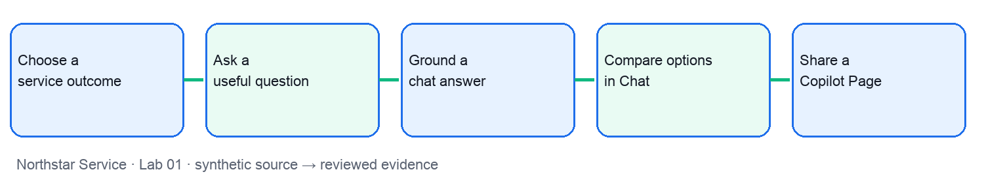
Microsoft workflow reference: official Microsoft Support screenshot for orientation. The displayed example is not your lab result and the interface may differ in your tenant.
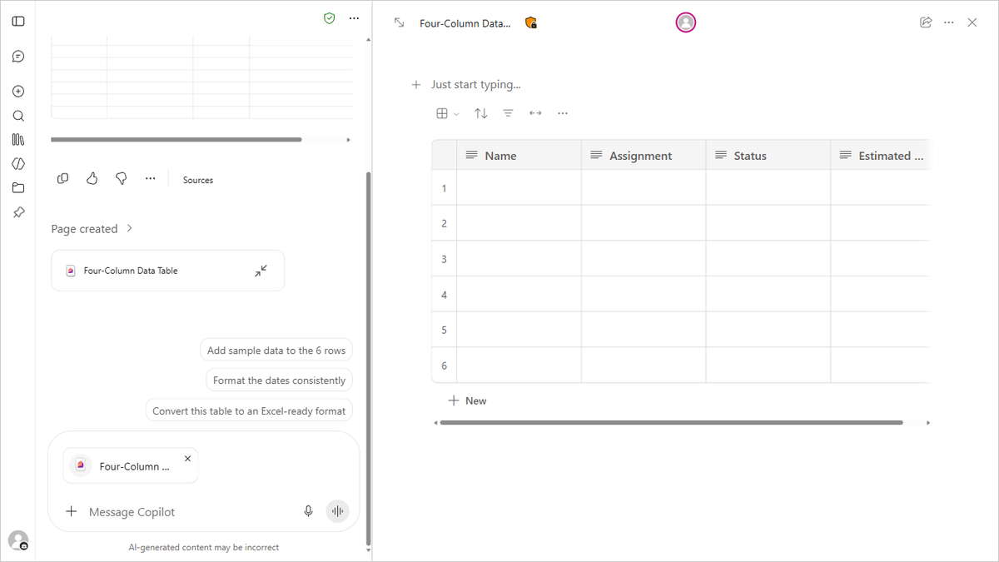
Screenshot source: https://support.microsoft.com/en-us/microsoft-365-copilot/draft-content-with-microsoft-365-copilot-chat-and-copilot-pages
Preparation: open lab-01/README.md, source-pack.md, scenario.csv, prompt-cards.md and value-model.csv. Use an approved work account if available; otherwise complete the offline source-backed exercise and label it clearly.
- Step 1 — Choose a service outcome: locate NS-01 in scenario.csv and read the matching source-pack section. In Microsoft 365 Copilot Chat and Pages, use prompt-cards.md to ask for the decision artifact. Use Microsoft 365 Copilot Chat to identify a bounded opportunity. Save pilot opportunity statement. Check: Sponsor confirms outcome and owner. Challenge: AI use is mistaken for customer benefit. Report comparable response time, source, assumptions, reviewer and date.
- Step 2 — Ask a useful question: locate NS-02 in scenario.csv and read the matching source-pack section. In Microsoft 365 Copilot Chat and Pages, use prompt-cards.md to ask for the decision artifact. Add audience, task, source, constraints and output to a Copilot prompt. Save reusable work prompt. Check: Manager confirms the prompt answers the real question. Challenge: Polished response has no decision value. Report relevant answers per review, source, assumptions, reviewer and date.
- Step 3 — Ground a chat answer: locate NS-03 in scenario.csv and read the matching source-pack section. In Microsoft 365 Copilot Chat and Pages, use prompt-cards.md to ask for the decision artifact. Ask Copilot Chat to answer from the supplied source. Save sourced response summary. Check: Check every material statement against the source. Challenge: An unsupported claim is repeated. Report verified claims per sample, source, assumptions, reviewer and date.
- Step 4 — Compare options in Chat: locate NS-04 in scenario.csv and read the matching source-pack section. In Microsoft 365 Copilot Chat and Pages, use prompt-cards.md to ask for the decision artifact. Ask Copilot for benefits, trade-offs and missing evidence. Save option comparison. Check: Use the same criteria for all options. Challenge: The preferred option receives easier criteria. Report options with complete evidence, source, assumptions, reviewer and date.
- Step 5 — Share a Copilot Page: locate NS-05 in scenario.csv and read the matching source-pack section. In Microsoft 365 Copilot Chat and Pages, use prompt-cards.md to ask for the decision artifact. Move approved ideas into a Copilot Page or offline shared brief. Save shared planning page. Check: Owner checks content and access before sharing. Challenge: Draft assumptions are shown as decisions. Report open questions assigned, source, assumptions, reviewer and date.
Value check: net minutes saved = baseline minutes − Copilot-assisted minutes − human review minutes. Multiply by comparable task volume only after checking quality. Treat hourly value and licence cost in value-model.csv as synthetic assumptions; show low, base and high cases.
Test it: Sponsor confirms outcome and owner. Manager confirms the prompt answers the real question. Check every material statement against the source. Use the same criteria for all options. Owner checks content and access before sharing. Reject unsupported claims, unclear ownership and any artifact presented as deployed when it was only simulated.

Lab 02 walkthrough
Business outcome: Word PowerPoint and Outlook content. Use Copilot in Word PowerPoint and Outlook with five synthetic tasks. Save a reviewed, source-backed artifact and a human go/hold decision for each task.
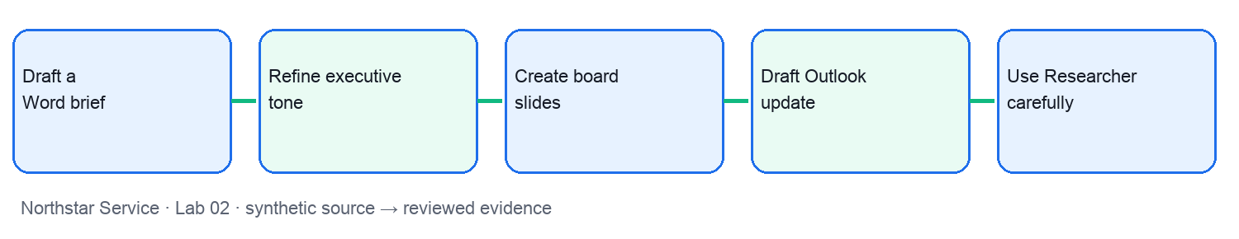
Microsoft workflow reference: official Microsoft Support screenshot for orientation. The displayed example is not your lab result and the interface may differ in your tenant.
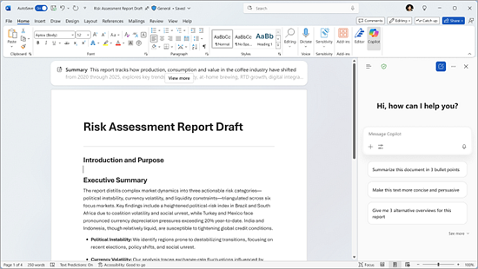
Screenshot source: https://support.microsoft.com/en-us/microsoft-365-copilot/how-copilot-chat-works-in-microsoft-365-apps
Preparation: open lab-02/README.md, source-pack.md, scenario.csv, prompt-cards.md and value-model.csv. Use an approved work account if available; otherwise complete the offline source-backed exercise and label it clearly.
- Step 1 — Draft a Word brief: locate NS-06 in scenario.csv and read the matching source-pack section. In Copilot in Word PowerPoint and Outlook, use prompt-cards.md to ask for the decision artifact. Use Copilot in Word to draft a two-page decision brief. Save reviewed word brief. Check: Sponsor checks numbers and recommendation. Challenge: Copilot invents a benefit estimate. Report verified material claims, source, assumptions, reviewer and date.
- Step 2 — Refine executive tone: locate NS-07 in scenario.csv and read the matching source-pack section. In Copilot in Word PowerPoint and Outlook, use prompt-cards.md to ask for the decision artifact. Ask Copilot in Word to shorten and clarify the recommendation. Save concise executive summary. Check: Human owner signs the final message. Challenge: Important caveat disappears. Report decisions understood in review, source, assumptions, reviewer and date.
- Step 3 — Create board slides: locate NS-08 in scenario.csv and read the matching source-pack section. In Copilot in Word PowerPoint and Outlook, use prompt-cards.md to ask for the decision artifact. Use Copilot in PowerPoint to create a five-slide decision story. Save board presentation. Check: Trace every chart to approved values. Challenge: Slide claim exceeds the source. Report figures checked before review, source, assumptions, reviewer and date.
- Step 4 — Draft Outlook update: locate NS-09 in scenario.csv and read the matching source-pack section. In Copilot in Word PowerPoint and Outlook, use prompt-cards.md to ask for the decision artifact. Use Copilot in Outlook to prepare a status message. Save unsent status draft. Check: Sponsor approves recipients and commitments. Challenge: An unapproved promise is sent. Report messages approved before sending, source, assumptions, reviewer and date.
- Step 5 — Use Researcher carefully: locate NS-10 in scenario.csv and read the matching source-pack section. In Copilot in Word PowerPoint and Outlook, use prompt-cards.md to ask for the decision artifact. Use Researcher if available to gather sources, or compare supplied documents. Save source and uncertainty list. Check: Validate dates, claims and relevance. Challenge: Research summary treats weak source as fact. Report sources verified, source, assumptions, reviewer and date.
Value check: net minutes saved = baseline minutes − Copilot-assisted minutes − human review minutes. Multiply by comparable task volume only after checking quality. Treat hourly value and licence cost in value-model.csv as synthetic assumptions; show low, base and high cases.
Test it: Sponsor checks numbers and recommendation. Human owner signs the final message. Trace every chart to approved values. Sponsor approves recipients and commitments. Validate dates, claims and relevance. Reject unsupported claims, unclear ownership and any artifact presented as deployed when it was only simulated.

Lab 03 walkthrough
Business outcome: Excel analysis and Teams decisions. Use Copilot in Excel and Teams with five synthetic tasks. Save a reviewed, source-backed artifact and a human go/hold decision for each task.
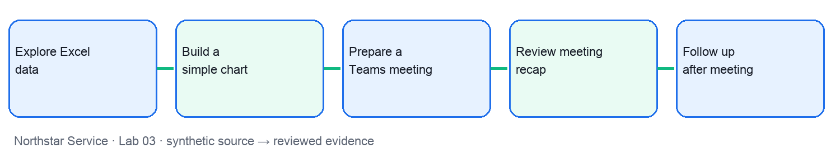
Microsoft workflow reference: official Microsoft Support screenshot for orientation. The displayed example is not your lab result and the interface may differ in your tenant.
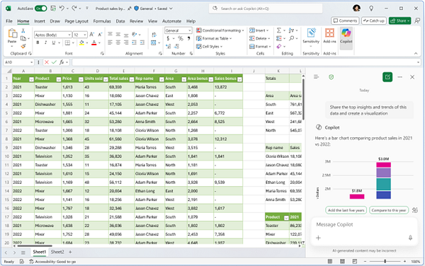
Screenshot source: https://support.microsoft.com/en-us/microsoft-365-copilot/how-copilot-chat-works-in-microsoft-365-apps
Preparation: open lab-03/README.md, source-pack.md, scenario.csv, prompt-cards.md and value-model.csv. Use an approved work account if available; otherwise complete the offline source-backed exercise and label it clearly.
- Step 1 — Explore Excel data: locate NS-11 in scenario.csv and read the matching source-pack section. In Copilot in Excel and Teams, use prompt-cards.md to ask for the decision artifact. Ask Copilot in Excel to surface patterns and outliers. Save trend summary. Check: Check chart and denominator against workbook. Challenge: An outlier is presented as a trend. Report patterns confirmed, source, assumptions, reviewer and date.
- Step 2 — Build a simple chart: locate NS-12 in scenario.csv and read the matching source-pack section. In Copilot in Excel and Teams, use prompt-cards.md to ask for the decision artifact. Use Copilot in Excel to propose a clear chart. Save annotated comparison chart. Check: Use comparable periods and units. Challenge: Axis hides change or variation. Report correctly labelled charts, source, assumptions, reviewer and date.
- Step 3 — Prepare a Teams meeting: locate NS-13 in scenario.csv and read the matching source-pack section. In Copilot in Excel and Teams, use prompt-cards.md to ask for the decision artifact. Use Copilot to prepare a concise meeting agenda. Save decision agenda. Check: Chair confirms questions and owner. Challenge: Meeting has no decision to make. Report decisions reached, source, assumptions, reviewer and date.
- Step 4 — Review meeting recap: locate NS-14 in scenario.csv and read the matching source-pack section. In Copilot in Excel and Teams, use prompt-cards.md to ask for the decision artifact. Use Copilot in Teams to summarize decisions and actions. Save validated action log. Check: Chair checks speakers, owners and dates. Challenge: Action is attributed to wrong person. Report actions confirmed, source, assumptions, reviewer and date.
- Step 5 — Follow up after meeting: locate NS-15 in scenario.csv and read the matching source-pack section. In Copilot in Excel and Teams, use prompt-cards.md to ask for the decision artifact. Use Copilot Chat or Outlook to draft an unsent follow-up. Save reviewed follow-up message. Check: Owner approves external distribution. Challenge: Dissent or hold condition is omitted. Report actions closed on time, source, assumptions, reviewer and date.
Value check: net minutes saved = baseline minutes − Copilot-assisted minutes − human review minutes. Multiply by comparable task volume only after checking quality. Treat hourly value and licence cost in value-model.csv as synthetic assumptions; show low, base and high cases.
Test it: Check chart and denominator against workbook. Use comparable periods and units. Chair confirms questions and owner. Chair checks speakers, owners and dates. Owner approves external distribution. Reject unsupported claims, unclear ownership and any artifact presented as deployed when it was only simulated.

Lab 04 walkthrough
Business outcome: Design a Copilot Workflow. Use Copilot Workflows agent with five synthetic tasks. Save a reviewed, source-backed artifact and a human go/hold decision for each task.
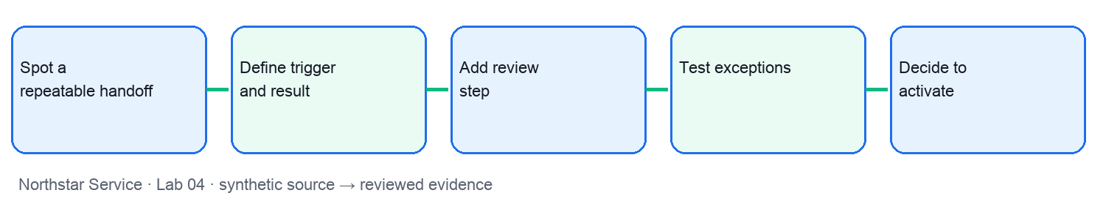
Microsoft workflow reference: official Microsoft Support screenshot for orientation. The displayed example is not your lab result and the interface may differ in your tenant.
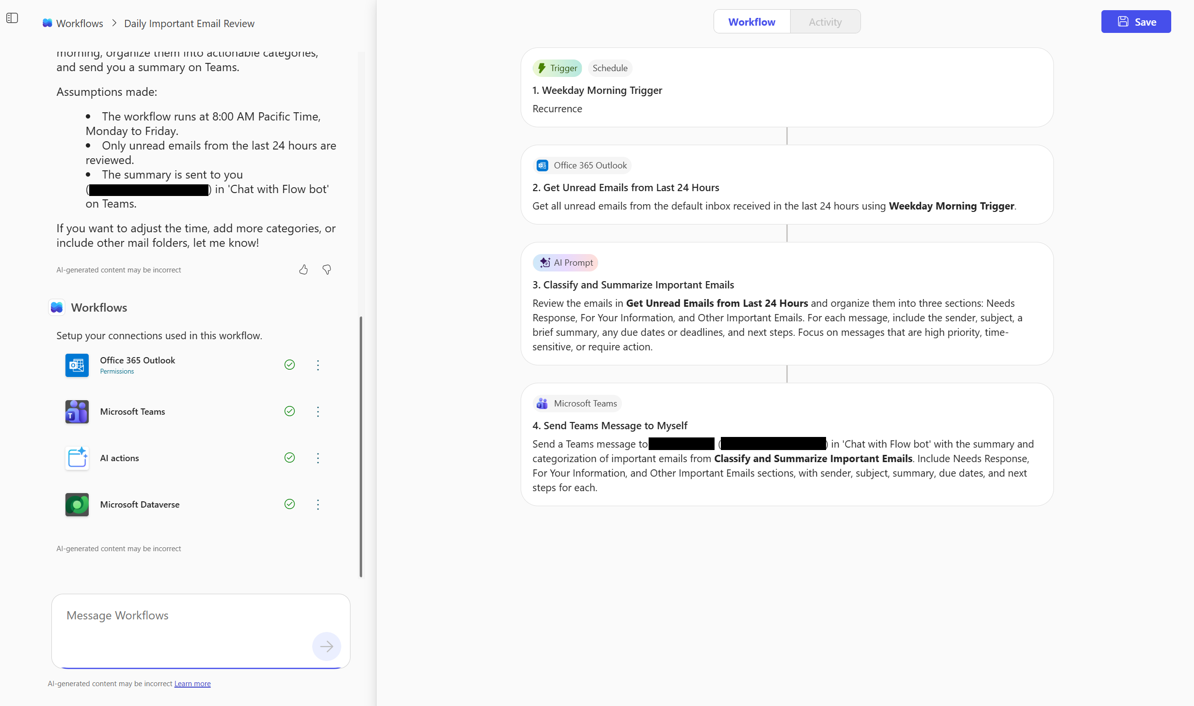
Screenshot source: https://support.microsoft.com/en-us/microsoft-365-copilot/get-started-with-workflows-in-microsoft-365-copilot (image: https://support.microsoft.com/en-us/microsoft-365-copilot/media/workflow-agent.png)
Preparation: open lab-04/README.md, source-pack.md, scenario.csv, prompt-cards.md and value-model.csv. Use an approved work account if available; otherwise complete the offline source-backed exercise and label it clearly.
- Step 1 — Spot a repeatable handoff: locate NS-16 in scenario.csv and read the matching source-pack section. In Copilot Workflows agent, use prompt-cards.md to ask for the decision artifact. Describe a Microsoft 365 Copilot Workflows opportunity in plain language. Save workflow opportunity card. Check: Process owner confirms a repeatable trigger. Challenge: One-off judgment is automated. Report handoff time, source, assumptions, reviewer and date.
- Step 2 — Define trigger and result: locate NS-17 in scenario.csv and read the matching source-pack section. In Copilot Workflows agent, use prompt-cards.md to ask for the decision artifact. Ask Workflows to draft trigger, steps and intended output. Save trigger-to-result map. Check: Owner verifies trigger is precise. Challenge: Wrong message starts workflow. Report correctly triggered cases, source, assumptions, reviewer and date.
- Step 3 — Add review step: locate NS-18 in scenario.csv and read the matching source-pack section. In Copilot Workflows agent, use prompt-cards.md to ask for the decision artifact. Ask Workflows to route draft for human approval. Save human review gate. Check: No external commitment before approval. Challenge: Message sends without review. Report unapproved sends, source, assumptions, reviewer and date.
- Step 4 — Test exceptions: locate NS-19 in scenario.csv and read the matching source-pack section. In Copilot Workflows agent, use prompt-cards.md to ask for the decision artifact. Test workflow with normal and exception examples. Save test and exception log. Check: Hold unknown owner or conflicting input. Challenge: Exception is silently routed. Report exceptions detected, source, assumptions, reviewer and date.
- Step 5 — Decide to activate: locate NS-20 in scenario.csv and read the matching source-pack section. In Copilot Workflows agent, use prompt-cards.md to ask for the decision artifact. Review Workflows draft, permissions and run history before enabling. Save go or hold record. Check: Owner approves live activation in authorised tenant. Challenge: Simulation is described as deployed. Report approved runs, source, assumptions, reviewer and date.
Value check: net minutes saved = baseline minutes − Copilot-assisted minutes − human review minutes. Multiply by comparable task volume only after checking quality. Treat hourly value and licence cost in value-model.csv as synthetic assumptions; show low, base and high cases.
Test it: Process owner confirms a repeatable trigger. Owner verifies trigger is precise. No external commitment before approval. Hold unknown owner or conflicting input. Owner approves live activation in authorised tenant. Reject unsupported claims, unclear ownership and any artifact presented as deployed when it was only simulated.

Lab 05 walkthrough
Business outcome: Control and review a workflow. Use Copilot Workflows agent with five synthetic tasks. Save a reviewed, source-backed artifact and a human go/hold decision for each task.
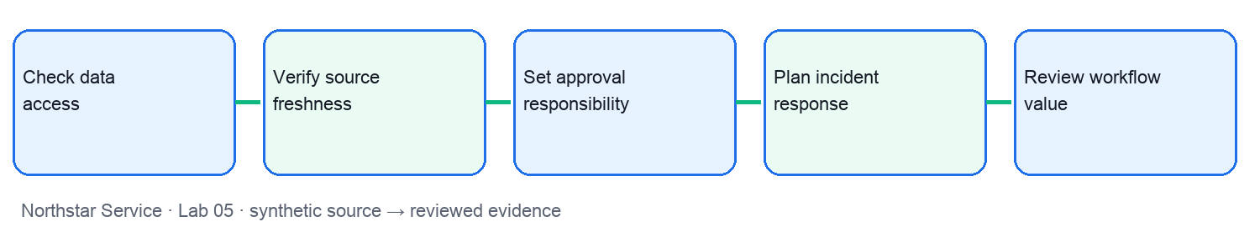
Microsoft workflow reference: official Microsoft Support screenshot for orientation. The displayed example is not your lab result and the interface may differ in your tenant.
Screenshot source: https://support.microsoft.com/en-us/microsoft-365-copilot/get-started-with-workflows-in-microsoft-365-copilot (image: https://support.microsoft.com/en-us/microsoft-365-copilot/media/workflow-agent.png)
Preparation: open lab-05/README.md, source-pack.md, scenario.csv, prompt-cards.md and value-model.csv. Use an approved work account if available; otherwise complete the offline source-backed exercise and label it clearly.
- Step 1 — Check data access: locate NS-21 in scenario.csv and read the matching source-pack section. In Copilot Workflows agent, use prompt-cards.md to ask for the decision artifact. Review what a workflow can read and where output goes. Save data boundary map. Check: Data owner approves sources and recipients. Challenge: Restricted content reaches a broad channel. Report unexpected access findings, source, assumptions, reviewer and date.
- Step 2 — Verify source freshness: locate NS-22 in scenario.csv and read the matching source-pack section. In Copilot Workflows agent, use prompt-cards.md to ask for the decision artifact. Test the draft workflow against both versions. Save source test record. Check: Current rule governs action. Challenge: Retired rule triggers an action. Report current-source rate, source, assumptions, reviewer and date.
- Step 3 — Set approval responsibility: locate NS-23 in scenario.csv and read the matching source-pack section. In Copilot Workflows agent, use prompt-cards.md to ask for the decision artifact. Assign who reviews, pauses and restores a workflow. Save plain-language responsibility card. Check: Each consequential action has an owner. Challenge: Everyone assumes another team approves. Report controls with named owners, source, assumptions, reviewer and date.
- Step 4 — Plan incident response: locate NS-24 in scenario.csv and read the matching source-pack section. In Copilot Workflows agent, use prompt-cards.md to ask for the decision artifact. Write a pause, contain, notify and retest path. Save incident response card. Check: Risk owner decides restart. Challenge: Workflow continues after a failure. Report time to pause, source, assumptions, reviewer and date.
- Step 5 — Review workflow value: locate NS-25 in scenario.csv and read the matching source-pack section. In Copilot Workflows agent, use prompt-cards.md to ask for the decision artifact. Compare manual and assisted handoff times. Save workflow pilot scorecard. Check: Include human review and error effort. Challenge: Gross time saved is called net value. Report net minutes per case, source, assumptions, reviewer and date.
Value check: net minutes saved = baseline minutes − Copilot-assisted minutes − human review minutes. Multiply by comparable task volume only after checking quality. Treat hourly value and licence cost in value-model.csv as synthetic assumptions; show low, base and high cases.
Test it: Data owner approves sources and recipients. Current rule governs action. Each consequential action has an owner. Risk owner decides restart. Include human review and error effort. Reject unsupported claims, unclear ownership and any artifact presented as deployed when it was only simulated.

Lab 06 walkthrough
Business outcome: Build a focused Copilot agent. Use Microsoft 365 Copilot Agent Builder with five synthetic tasks. Save a reviewed, source-backed artifact and a human go/hold decision for each task.
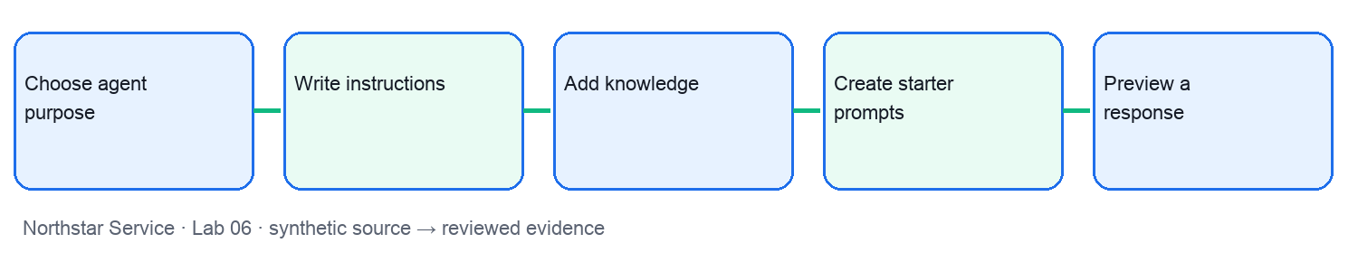
Microsoft workflow reference: official Microsoft Support screenshot for orientation. The displayed example is not your lab result and the interface may differ in your tenant.
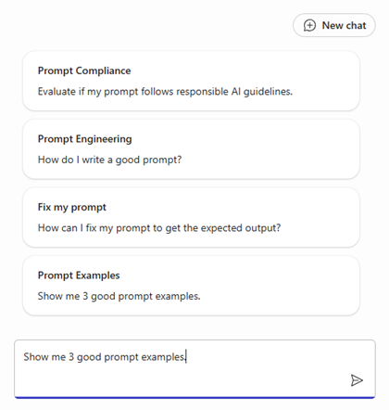
Screenshot source: https://support.microsoft.com/en-us/microsoft-365-copilot/build-your-own-agent-with-microsoft-365-copilot (image: https://support.microsoft.com/en-us/microsoft-365-copilot/media/starter-prompts-for-agent.png)
Preparation: open lab-06/README.md, source-pack.md, scenario.csv, prompt-cards.md and value-model.csv. Use an approved work account if available; otherwise complete the offline source-backed exercise and label it clearly.
- Step 1 — Choose agent purpose: locate NS-26 in scenario.csv and read the matching source-pack section. In Microsoft 365 Copilot Agent Builder, use prompt-cards.md to ask for the decision artifact. Define one bounded use for Copilot Agent Builder. Save agent purpose statement. Check: Owner excludes high-impact decisions. Challenge: Agent has no clear scope. Report in-scope answer rate, source, assumptions, reviewer and date.
- Step 2 — Write instructions: locate NS-27 in scenario.csv and read the matching source-pack section. In Microsoft 365 Copilot Agent Builder, use prompt-cards.md to ask for the decision artifact. Describe audience, task, boundaries and escalation in Agent Builder. Save agent instructions draft. Check: Owner checks failure and escalation wording. Challenge: Agent implies it can approve policy. Report escalations handled, source, assumptions, reviewer and date.
- Step 3 — Add knowledge: locate NS-28 in scenario.csv and read the matching source-pack section. In Microsoft 365 Copilot Agent Builder, use prompt-cards.md to ask for the decision artifact. Attach approved knowledge sources in Agent Builder. Save knowledge-source register. Check: Data owner validates permissions and versions. Challenge: Retired file remains attached. Report approved sources used, source, assumptions, reviewer and date.
- Step 4 — Create starter prompts: locate NS-29 in scenario.csv and read the matching source-pack section. In Microsoft 365 Copilot Agent Builder, use prompt-cards.md to ask for the decision artifact. Write clear starter prompts for the agent. Save starter prompt set. Check: Business user can understand each prompt. Challenge: Prompts ask for unsupported decisions. Report prompt completion rate, source, assumptions, reviewer and date.
- Step 5 — Preview a response: locate NS-30 in scenario.csv and read the matching source-pack section. In Microsoft 365 Copilot Agent Builder, use prompt-cards.md to ask for the decision artifact. Test the agent preview and compare to source. Save agent response review. Check: Owner verifies accuracy and citation. Challenge: Confident answer is unsupported. Report correct answers per test, source, assumptions, reviewer and date.
Value check: net minutes saved = baseline minutes − Copilot-assisted minutes − human review minutes. Multiply by comparable task volume only after checking quality. Treat hourly value and licence cost in value-model.csv as synthetic assumptions; show low, base and high cases.
Test it: Owner excludes high-impact decisions. Owner checks failure and escalation wording. Data owner validates permissions and versions. Business user can understand each prompt. Owner verifies accuracy and citation. Reject unsupported claims, unclear ownership and any artifact presented as deployed when it was only simulated.

Lab 07 walkthrough
Business outcome: Test share and monitor an agent. Use Microsoft 365 Copilot Agent Builder with five synthetic tasks. Save a reviewed, source-backed artifact and a human go/hold decision for each task.
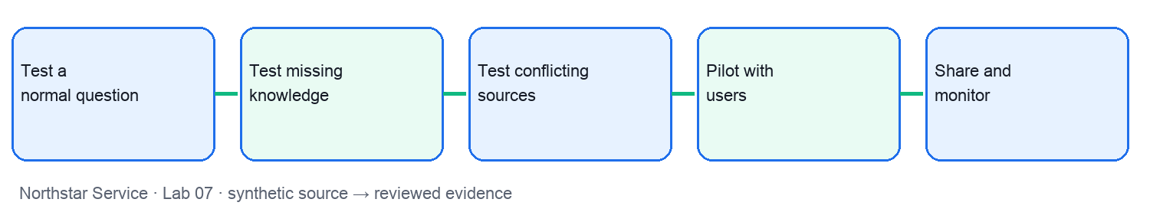
Microsoft workflow reference: official Microsoft Support screenshot for orientation. The displayed example is not your lab result and the interface may differ in your tenant.
Screenshot source: https://support.microsoft.com/en-us/microsoft-365-copilot/build-your-own-agent-with-microsoft-365-copilot (image: https://support.microsoft.com/en-us/microsoft-365-copilot/media/starter-prompts-for-agent.png)
Preparation: open lab-07/README.md, source-pack.md, scenario.csv, prompt-cards.md and value-model.csv. Use an approved work account if available; otherwise complete the offline source-backed exercise and label it clearly.
- Step 1 — Test a normal question: locate NS-31 in scenario.csv and read the matching source-pack section. In Microsoft 365 Copilot Agent Builder, use prompt-cards.md to ask for the decision artifact. Ask the agent for a bounded answer. Save normal-case test record. Check: Answer matches current source. Challenge: Agent omits a condition. Report correct normal answers, source, assumptions, reviewer and date.
- Step 2 — Test missing knowledge: locate NS-32 in scenario.csv and read the matching source-pack section. In Microsoft 365 Copilot Agent Builder, use prompt-cards.md to ask for the decision artifact. Ask the agent to state uncertainty and escalation. Save out-of-scope test record. Check: Agent hands off unknown answer. Challenge: Agent invents a policy. Report correct escalations, source, assumptions, reviewer and date.
- Step 3 — Test conflicting sources: locate NS-33 in scenario.csv and read the matching source-pack section. In Microsoft 365 Copilot Agent Builder, use prompt-cards.md to ask for the decision artifact. Challenge the agent with contradictory evidence. Save conflict test record. Check: Owner chooses authoritative source. Challenge: Agent cites retired policy. Report conflicts surfaced, source, assumptions, reviewer and date.
- Step 4 — Pilot with users: locate NS-34 in scenario.csv and read the matching source-pack section. In Microsoft 365 Copilot Agent Builder, use prompt-cards.md to ask for the decision artifact. Run a small acceptance review before sharing. Save pilot feedback log. Check: Address material failures before release. Challenge: First demo is treated as sign-off. Report critical failures closed, source, assumptions, reviewer and date.
- Step 5 — Share and monitor: locate NS-35 in scenario.csv and read the matching source-pack section. In Microsoft 365 Copilot Agent Builder, use prompt-cards.md to ask for the decision artifact. Review Agent Builder sharing and ongoing feedback plan. Save agent release and review card. Check: Owner checks audience and knowledge access. Challenge: Agent is shared too broadly. Report reviewed usage and feedback, source, assumptions, reviewer and date.
Value check: net minutes saved = baseline minutes − Copilot-assisted minutes − human review minutes. Multiply by comparable task volume only after checking quality. Treat hourly value and licence cost in value-model.csv as synthetic assumptions; show low, base and high cases.
Test it: Answer matches current source. Agent hands off unknown answer. Owner chooses authoritative source. Address material failures before release. Owner checks audience and knowledge access. Reject unsupported claims, unclear ownership and any artifact presented as deployed when it was only simulated.

Lab 08 walkthrough
Business outcome: Pilot adoption and work redesign. Use Copilot Chat and Word with five synthetic tasks. Save a reviewed, source-backed artifact and a human go/hold decision for each task.
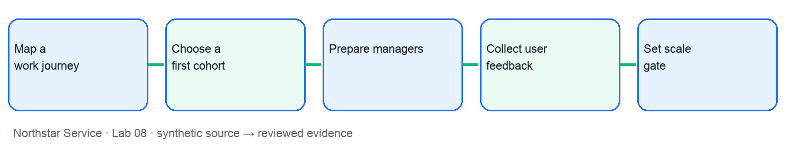
Microsoft workflow reference: official Microsoft Support screenshot for orientation. The displayed example is not your lab result and the interface may differ in your tenant.
Screenshot source: https://support.microsoft.com/en-us/microsoft-365-copilot/how-copilot-chat-works-in-microsoft-365-apps
Preparation: open lab-08/README.md, source-pack.md, scenario.csv, prompt-cards.md and value-model.csv. Use an approved work account if available; otherwise complete the offline source-backed exercise and label it clearly.
- Step 1 — Map a work journey: locate NS-36 in scenario.csv and read the matching source-pack section. In Copilot Chat and Word, use prompt-cards.md to ask for the decision artifact. Show where each Copilot mode helps in one service journey. Save future-state journey map. Check: Keep human decisions visible. Challenge: The same task is duplicated. Report time to completion, source, assumptions, reviewer and date.
- Step 2 — Choose a first cohort: locate NS-37 in scenario.csv and read the matching source-pack section. In Copilot Chat and Word, use prompt-cards.md to ask for the decision artifact. Prioritize roles with useful work and manager support. Save pilot cohort plan. Check: Sponsor signs selection criteria. Challenge: Licence count replaces opportunity. Report productive pilot users, source, assumptions, reviewer and date.
- Step 3 — Prepare managers: locate NS-38 in scenario.csv and read the matching source-pack section. In Copilot Chat and Word, use prompt-cards.md to ask for the decision artifact. Draft a manager briefing with Copilot in Word. Save manager enablement brief. Check: Managers can explain limits and outcomes. Challenge: Training only shows features. Report practice completion, source, assumptions, reviewer and date.
- Step 4 — Collect user feedback: locate NS-39 in scenario.csv and read the matching source-pack section. In Copilot Chat and Word, use prompt-cards.md to ask for the decision artifact. Use Copilot Chat to group friction and successes. Save improvement backlog. Check: Assign an owner and due date. Challenge: Complaints about bad sources are called prompt errors. Report issues closed, source, assumptions, reviewer and date.
- Step 5 — Set scale gate: locate NS-40 in scenario.csv and read the matching source-pack section. In Copilot Chat and Word, use prompt-cards.md to ask for the decision artifact. Define go, hold and stop conditions. Save scale decision checklist. Check: Critical failure blocks scale. Challenge: Average score hides severe error. Report required gates passed, source, assumptions, reviewer and date.
Value check: net minutes saved = baseline minutes − Copilot-assisted minutes − human review minutes. Multiply by comparable task volume only after checking quality. Treat hourly value and licence cost in value-model.csv as synthetic assumptions; show low, base and high cases.
Test it: Keep human decisions visible. Sponsor signs selection criteria. Managers can explain limits and outcomes. Assign an owner and due date. Critical failure blocks scale. Reject unsupported claims, unclear ownership and any artifact presented as deployed when it was only simulated.

Lab 09 walkthrough
Business outcome: Measure value and make an investment case. Use Copilot in Excel and Word with five synthetic tasks. Save a reviewed, source-backed artifact and a human go/hold decision for each task.
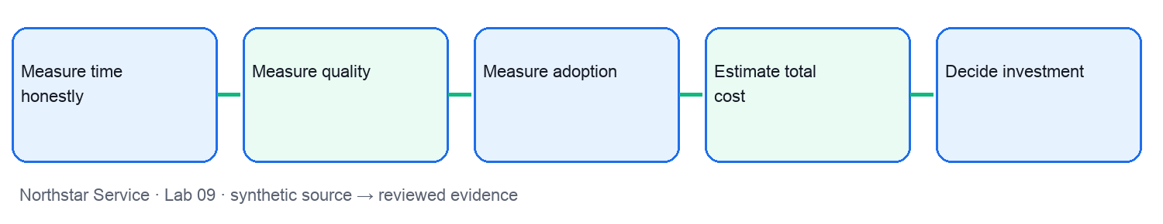
Microsoft workflow reference: official Microsoft Support screenshot for orientation. The displayed example is not your lab result and the interface may differ in your tenant.
Screenshot source: https://support.microsoft.com/en-us/microsoft-365-copilot/how-copilot-chat-works-in-microsoft-365-apps
Preparation: open lab-09/README.md, source-pack.md, scenario.csv, prompt-cards.md and value-model.csv. Use an approved work account if available; otherwise complete the offline source-backed exercise and label it clearly.
- Step 1 — Measure time honestly: locate NS-41 in scenario.csv and read the matching source-pack section. In Copilot in Excel and Word, use prompt-cards.md to ask for the decision artifact. Use Copilot in Excel to explain net minutes saved. Save net-time table. Check: Check formulas and comparable work. Challenge: Review time is omitted. Report net minutes per task, source, assumptions, reviewer and date.
- Step 2 — Measure quality: locate NS-42 in scenario.csv and read the matching source-pack section. In Copilot in Excel and Word, use prompt-cards.md to ask for the decision artifact. Use Copilot to summarize error types. Save quality scorecard. Check: Critical error is reported separately. Challenge: Average quality hides material failure. Report critical errors per sample, source, assumptions, reviewer and date.
- Step 3 — Measure adoption: locate NS-43 in scenario.csv and read the matching source-pack section. In Copilot in Excel and Word, use prompt-cards.md to ask for the decision artifact. Compare licence, activity and productive use. Save adoption chart. Check: Define productive use per role. Challenge: Seats are presented as adoption. Report productive users per cohort, source, assumptions, reviewer and date.
- Step 4 — Estimate total cost: locate NS-44 in scenario.csv and read the matching source-pack section. In Copilot in Excel and Word, use prompt-cards.md to ask for the decision artifact. Compare costs and benefits with Excel. Save scenario table. Check: Label assumptions and sensitivity. Challenge: Licence is the only cost. Report cost per verified outcome, source, assumptions, reviewer and date.
- Step 5 — Decide investment: locate NS-45 in scenario.csv and read the matching source-pack section. In Copilot in Excel and Word, use prompt-cards.md to ask for the decision artifact. Draft a fund, hold or stop note in Word. Save investment decision memo. Check: Sponsor signs conditions. Challenge: Optimistic forecast is described as measured. Report conditions met, source, assumptions, reviewer and date.
Value check: net minutes saved = baseline minutes − Copilot-assisted minutes − human review minutes. Multiply by comparable task volume only after checking quality. Treat hourly value and licence cost in value-model.csv as synthetic assumptions; show low, base and high cases.
Test it: Check formulas and comparable work. Critical error is reported separately. Define productive use per role. Label assumptions and sensitivity. Sponsor signs conditions. Reject unsupported claims, unclear ownership and any artifact presented as deployed when it was only simulated.

Lab 10 walkthrough
Business outcome: Lead the transformation decision. Use Copilot in PowerPoint and Chat with five synthetic tasks. Save a reviewed, source-backed artifact and a human go/hold decision for each task.
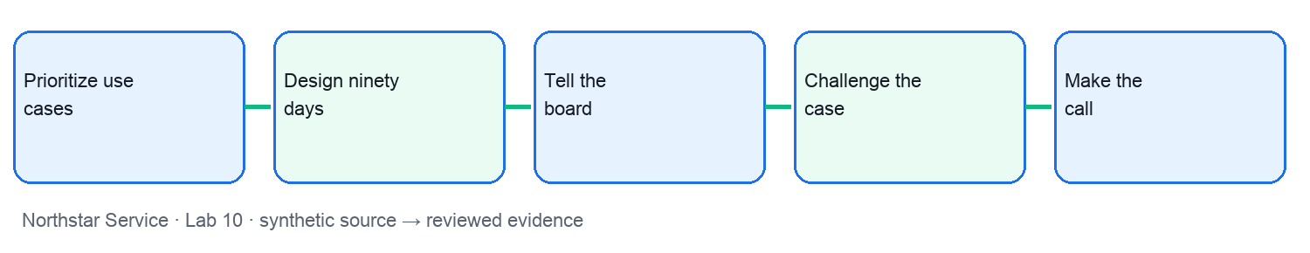
Microsoft workflow reference: official Microsoft Support screenshot for orientation. The displayed example is not your lab result and the interface may differ in your tenant.
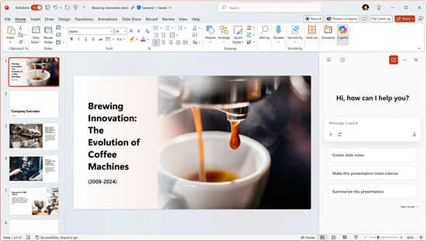
Screenshot source: https://support.microsoft.com/en-us/microsoft-365-copilot/how-copilot-chat-works-in-microsoft-365-apps
Preparation: open lab-10/README.md, source-pack.md, scenario.csv, prompt-cards.md and value-model.csv. Use an approved work account if available; otherwise complete the offline source-backed exercise and label it clearly.
- Step 1 — Prioritize use cases: locate NS-46 in scenario.csv and read the matching source-pack section. In Copilot in PowerPoint and Chat, use prompt-cards.md to ask for the decision artifact. Rank outcome, readiness, risk and owner. Save opportunity portfolio. Check: Reject ownerless opportunity. Challenge: Highest volume is treated as highest value. Report validated value per case, source, assumptions, reviewer and date.
- Step 2 — Design ninety days: locate NS-47 in scenario.csv and read the matching source-pack section. In Copilot in PowerPoint and Chat, use prompt-cards.md to ask for the decision artifact. Sequence chat, workflow and agent waves. Save ninety-day roadmap. Check: Each wave has owner and gate. Challenge: Rollout outruns support. Report wave gates met, source, assumptions, reviewer and date.
- Step 3 — Tell the board: locate NS-48 in scenario.csv and read the matching source-pack section. In Copilot in PowerPoint and Chat, use prompt-cards.md to ask for the decision artifact. Use Copilot in PowerPoint to draft a board update. Save board scorecard. Check: Every claim has source and date. Challenge: Risk disappears from narrative. Report claims traceable, source, assumptions, reviewer and date.
- Step 4 — Challenge the case: locate NS-49 in scenario.csv and read the matching source-pack section. In Copilot in PowerPoint and Chat, use prompt-cards.md to ask for the decision artifact. Ask Copilot Chat for counterarguments. Save decision challenge log. Check: Executive answers strongest objection. Challenge: Polished demo substitutes for evidence. Report objections resolved, source, assumptions, reviewer and date.
- Step 5 — Make the call: locate NS-50 in scenario.csv and read the matching source-pack section. In Copilot in PowerPoint and Chat, use prompt-cards.md to ask for the decision artifact. Record the sponsor go, hold or stop decision. Save signed transformation decision. Check: Owner names next review date. Challenge: Decision has no accountable owner. Report conditions met on time, source, assumptions, reviewer and date.
Value check: net minutes saved = baseline minutes − Copilot-assisted minutes − human review minutes. Multiply by comparable task volume only after checking quality. Treat hourly value and licence cost in value-model.csv as synthetic assumptions; show low, base and high cases.
Test it: Reject ownerless opportunity. Each wave has owner and gate. Every claim has source and date. Executive answers strongest objection. Owner names next review date. Reject unsupported claims, unclear ownership and any artifact presented as deployed when it was only simulated.

