
Tertiary Infotech Academy Pte Ltd
UEN: 201200696W
LEARNER GUIDE
For
Generative AI (GenAI) Visuals in Photoshop and Firefly
TGS Ref No: TGS-2024045220
Conducted by
Tertiary Infotech Academy Pte Ltd
UEN: 201200696W
Version 8

DOCUMENT VERSION CONTROL RECORD
Version Number | Effective Date of Release | Summary of Included Changes | Author
6.0 | Legacy release | Original trainer slides and lab-reference set. | Tertiary Infotech Academy
8 | 13 October 2026 | Expanded visual rebuild with 32 retained concepts and ten self-contained Photoshop/Firefly labs. | Dr Alfred Ang

TABLE OF CONTENTS
Current verified contents are listed below. Update this editable TOC field in Word to refresh page references.
Section | Page
Purpose and Use | 4
Learning Outcomes and TSC Alignment | 4
Topic 1 — GenAI for Visual Communication | 5
Topic 2 — Firefly Storyboards and Reference Control | 10
Topic 3 — Photoshop Generative Editing and Critique | 15
Topic 4 — Colour Strategy, Enhancement and Delivery | 23
Intellectual Property, Responsible AI and Sources | 28

Purpose and Use
This Learner Guide carries the detailed procedures intentionally omitted from the visual course slides. Work from the supplied PSD/JPEG files, preserve originals, keep the layered master, and verify every export.

Learning Outcomes
- LO1: Initiate visual communication through generative AI in Photoshop and Firefly.
- LO2: Create storyboards in Firefly for visual narratives and task flows.
- LO3: Propose enhancements through aesthetic analysis and advanced critique in Photoshop.
- LO4: Formulate generative-AI colour strategies in Photoshop.

TSC Alignment
Code | Knowledge / Ability
K1 | Elements of typography, logos, visual communication design and information design.
K2 | Best practices for visual communication.
K3 | Uses of relevant visual-design software packages.
K4 | Colour fundamentals and forms.
K5 | Techniques for analysing aesthetics.
A1 | Initiate visual communication ideas through exploration.
A2 | Develop outputs by integrating media, materials, processes and environments.
A3 | Create storyboards and task flows to communicate intentions.
A4 | Evaluate design work with stakeholders.
A5 | Propose suggestions to enhance visual formats.
A6 | Critique own and others' work using explicit criteria.
A7 | Develop strategies that strengthen the appeal of visual outputs.

Core Professional Workflow
1. Clarify purpose, audience, output channel and constraints.
2. Verify source quality, ownership, licence, consent and permitted use.
3. Set pixel dimensions, colour mode, bit depth and profile for the deliverable.
4. Build with named layers, groups, masks, adjustment layers and Smart Objects.
5. Experiment by changing one factor at a time and retaining a baseline.
6. Evaluate at Fit and 100% views using composition, edge, tone, output and rights criteria.
7. Export, reopen and verify the delivery file; retain the editable master and evidence.

Topic 1 — GenAI for Visual Communication
Turn an audience need into an intentional, rights-aware visual direction.
Alignment: LO1 · K1 · K2 · A1 · A2

Human-led GenAI Creative Loop
A human defines the brief, directs generation, selects evidence and remains accountable for publication.
Best used for: Fast exploration where intent and judgement matter more than raw variation count.
Key controls: Brief · prompt · variation · critique · edit · verify
Watch for: Automating the decision as well as the production.
Quality evidence: A decision log connects the selected visual to audience, purpose and acceptance criteria.

GenAI Image Use Cases and Boundaries
Generation, insertion, removal, expansion and translation solve different visual problems and carry different risks.
Best used for: Choosing an appropriate AI feature before opening a tool.
Key controls: Task type · rights · sensitivity · required control · delivery channel
Watch for: Using generation where faithful documentation is required.
Quality evidence: The chosen feature and boundary are justified against the brief.

Prompt Anatomy
A useful prompt combines subject, action, setting, visual treatment, composition and constraints.
Best used for: Creating a clear starting direction without over-prescribing every pixel.
Key controls: Subject · action · setting · medium · lighting · camera · exclusions
Watch for: Contradictory adjectives, vague subjects and accidental text instructions.
Quality evidence: Prompt components can be traced to visible properties of the result.

Prompt Iteration and Variation
Changing one prompt factor at a time makes cause and effect observable.
Best used for: Converging from a broad direction to a defensible final candidate.
Key controls: Baseline · single-variable change · seed/variation · comparison notes
Watch for: Changing model, prompt, style and composition simultaneously.
Quality evidence: A contact sheet shows at least three labelled iterations and the selection reason.

Visual Hierarchy and Emphasis
Scale, contrast, position, isolation and detail establish what viewers notice first.
Best used for: Campaign visuals that need a clear focal point and reading order.
Key controls: Primary focal point · secondary cue · supporting detail · CTA space
Watch for: Competing focal points or an empty area that cannot hold useful copy.
Quality evidence: A squint test and thumbnail view preserve the intended reading order.

Scale, Balance and Alignment
Relative size signals importance; visual mass and common edges stabilise the composition.
Best used for: Combining generated imagery with typography or brand elements.
Key controls: Scale ratio · visual weight · grid · edge alignment · safe area
Watch for: Centred-by-default layouts or tangencies that feel accidental.
Quality evidence: Guides and a reduced-size review confirm balance across the frame.

Contrast, Repetition and Negative Space
Contrast separates roles, repetition creates coherence and negative space gives the message room to breathe.
Best used for: Social tiles, posters and storyboard frames that must scan quickly.
Key controls: Value contrast · colour contrast · repeated motif · breathing room
Watch for: Decorative repetition that overwhelms the subject.
Quality evidence: Grayscale and thumbnail checks confirm separation and rhythm.

Audience, Story and Responsible Provenance
A visual is credible when its message fits the audience and its source, prompts and edits remain explainable.
Best used for: Commercial, organisational and public-facing visual communication.
Key controls: Audience need · claim risk · asset rights · prompt log · Content Credentials
Watch for: Misleading realism, unlicensed references or unsupported claims.
Quality evidence: A provenance note accompanies the editable master and export.

Lab 01 — Prompt-to-Image Visual Brief
Scenario: A reading campaign needs an imaginative hero image with clear copy space for a social tile.
Goal: Translate an audience brief into a controlled Firefly prompt set and selected visual direction.

Workflow Evidence Preview
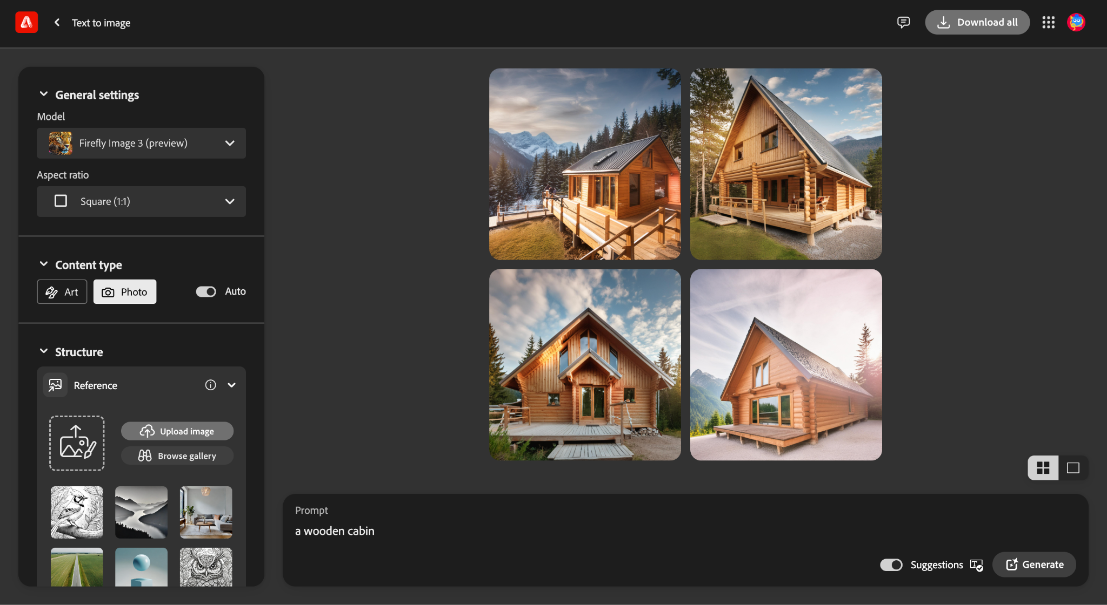
Authentic workflow screenshot from the supplied v6 trainer reference. Interface labels and positions may differ in the current Adobe release. The workflow-state schematic below is an editable evidence model.
Input asset | Named control state | Editable proof | Verification
Firefly_a dog reading a book while sitting at a desk by candle light, while wearing glasses, 120801.jpg | Draft a baseline prompt using subject, action, setting, visual treatment, composition and lighting. | Three prompt/result records, selected JPEG and decision log identifying A1 exploration and A2 integration decisions | The log records model, prompt, selection reason and provenance consideration.

Detailed Procedure
1. Create a folder named `working` and preserve the supplied JPEGs unchanged.
2. Write a one-sentence brief naming audience, message, channel, aspect ratio and required copy space.
3. Draft a baseline prompt using subject, action, setting, visual treatment, composition and lighting.
4. Generate a first set in Firefly and record the model and content type used.
5. Change only one prompt factor for iteration two; label the changed factor.
6. Change a different single factor for iteration three; retain all three prompt/result records.
7. Compare the candidates for hierarchy, copy space, artefacts, audience fit and rights/provenance.
8. Export the selected candidate as `lab01-selected.jpg` and save `lab01-decision-log.txt`.

Evidence to Retain
Three prompt/result records, selected JPEG and decision log identifying A1 exploration and A2 integration decisions.

Test It
PASS when:
• At least three controlled prompt iterations are retained.
• The selected JPEG has a clear focal point and intentional copy space.
• The log records model, prompt, selection reason and provenance consideration.
Lab folder: labs/lab-01-prompt-to-image-visual-brief/

Lab 02 — Design Principles and Prompt Refinement
Scenario: A creative studio wants a poster-ready yarn-art visual with one strong headline zone.
Goal: Use Photoshop layout evidence to refine a generated visual against hierarchy, balance and contrast criteria.

Workflow Evidence Preview
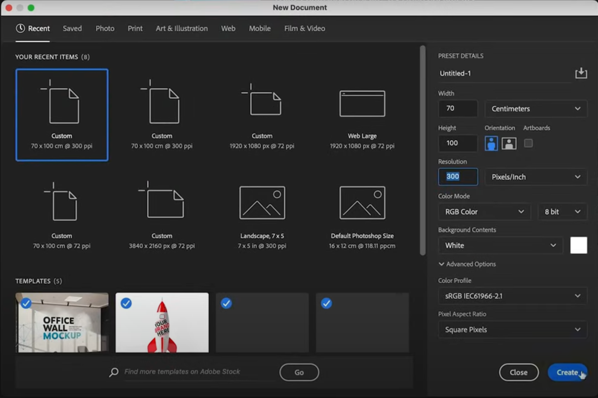
Authentic workflow screenshot from the supplied v6 trainer reference. Interface labels and positions may differ in the current Adobe release. The workflow-state schematic below is an editable evidence model.
Input asset | Named control state | Editable proof | Verification
reference.jpg | Create guides for a primary focal area, headline zone and safe margins. | Layered PSD, exported JPEG and a short comparison note covering K1/K2 design principles | Comparison note cites at least three explicit design criteria.

Detailed Procedure
1. Open `structure-reference.psd` and immediately save `lab02-working.psd`.
2. Inspect layer names, canvas ratio, dominant lines and negative-space zones.
3. Create guides for a primary focal area, headline zone and safe margins.
4. Write a Firefly prompt that preserves the structural intent while changing subject or material.
5. Generate at least two candidates and place them as separate Smart Object layers.
6. Add editable placeholder type to test hierarchy; do not embed essential copy in generated pixels.
7. Compare scale, alignment, value contrast and breathing room at Fit and thumbnail views.
8. Retain the stronger candidate, name all layers and export `lab02-poster.jpg`.

Evidence to Retain
Layered PSD, exported JPEG and a short comparison note covering K1/K2 design principles.

Test It
PASS when:
• PSD contains guides, editable type and separate candidate layers.
• The final hierarchy remains clear at thumbnail size.
• Comparison note cites at least three explicit design criteria.
Lab folder: labs/lab-02-design-principles-prompt-refinement/

Topic 2 — Firefly Storyboards and Reference Control
Control composition and style, then organise variations into a communicable flow.
Alignment: LO2 · K3 · A3

Choosing a Firefly Image Model
Firefly models offer different balances of speed, realism, prompt interpretation and control.
Best used for: Matching generation quality and latency to the storyboard purpose.
Key controls: Current model · output intent · speed · detail · available controls
Watch for: Assuming the newest model behaves identically to an older one.
Quality evidence: The selected model is recorded with a visible comparison or reason.

Content Type and Visual Intensity
Content type steers photo/illustration behaviour while visual intensity adjusts how strongly styling affects the result.
Best used for: Moving between documentary-looking and illustrative storyboard frames.
Key controls: Photo/art · auto mode · visual intensity · effects
Watch for: Treating intensity as a substitute for a clear prompt.
Quality evidence: Two controlled variants demonstrate the effect of the setting.

Colour, Lighting and Camera Controls
Secondary controls guide palette, lighting direction, field of view and depth cues.
Best used for: Keeping a sequence visually coherent without copying every frame.
Key controls: Colour/tone · lighting · camera angle · lens/depth cues
Watch for: A lighting instruction that conflicts with the reference composition.
Quality evidence: Frames share a documented palette and plausible light direction.

Composition Reference
A composition reference transfers spatial arrangement and structural relationships without duplicating the source pixels.
Best used for: Maintaining camera position, pose or layout across storyboard alternatives.
Key controls: Reference strength · crop · silhouette · dominant lines · prompt
Watch for: Using a reference without rights or expecting identity fidelity.
Quality evidence: Overlay or side-by-side evidence confirms structural similarity.

Style Reference
A style reference guides colour, texture, lighting and rendering character while the prompt controls subject matter.
Best used for: Unifying multiple scenes under one art direction.
Key controls: Reference strength · visual intensity · effects · prompt specificity
Watch for: Combining style and composition changes without a baseline.
Quality evidence: A contact sheet shows consistent treatment across different subjects.

Storyboard Architecture
A storyboard converts a narrative into beats with a purpose, frame, transition and evidence for each beat.
Best used for: Explaining an experience, campaign sequence or task journey.
Key controls: Opening · context · action · transformation · outcome · CTA
Watch for: A gallery of attractive images with no causal sequence.
Quality evidence: Every frame has a caption, purpose and transition note.

Task Flow for Team Collaboration
A task flow assigns inputs, decisions, hand-offs and review gates so visual work can be repeated by a team.
Best used for: Moving from ideation to approved, editable and channel-ready output.
Key controls: Owner · input · action · decision · output · reviewer
Watch for: Unowned approval steps or ambiguous version names.
Quality evidence: A flow diagram identifies ownership and acceptance at each gate.

Generated Texture with Editable Photoshop Type
Generate a rights-aware texture as imagery. Keep editable type as the base layer, place the generated texture immediately above it, and clip the texture to the type so the letterforms control visibility without rasterising the text.
Best used for: Creating expressive display typography while keeping wording, font, colour and fit editable.
Key controls: Texture prompt · live type base layer · texture layer above · clipping mask · scale/position · colour overlay · tracking · legibility
Watch for: Reversing the clipping stack, treating generated pixels as editable copy, using obsolete Text Effects interfaces, or losing contrast at delivery size.
Quality evidence: The PSD retains a live type base layer, clipped texture layer immediately above it and named colour/fit controls; the reopened export passes a thumbnail legibility check.

Lab 03 — Composition and Style References
Scenario: A wellness campaign needs varied subjects that retain one composition and art direction.
Goal: Create a controlled Firefly comparison using composition and style references independently and together.

Workflow Evidence Preview
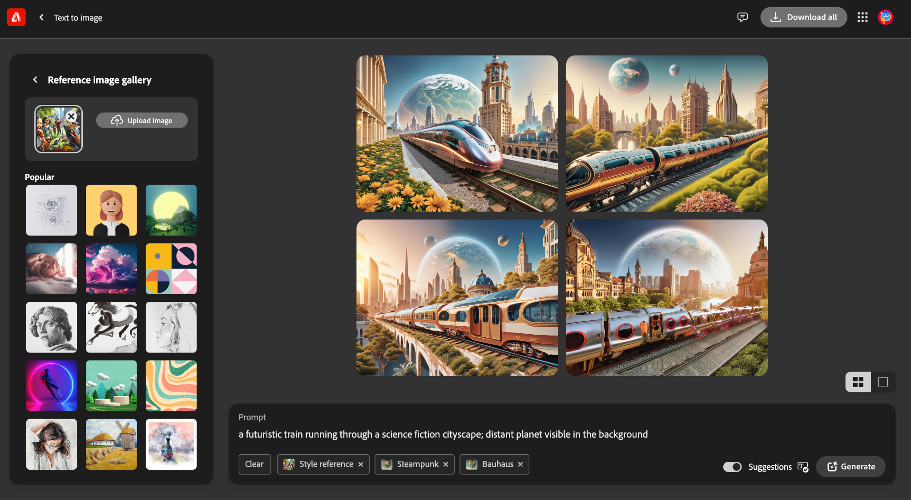
Authentic workflow screenshot from the supplied v6 trainer reference. Interface labels and positions may differ in the current Adobe release. The workflow-state schematic below is an editable evidence model.
Input asset | Named control state | Editable proof | Verification
hummingbird.jpg | Add `composition-reference.jpg`, select a moderate strength and generate a second set. | Four labelled JPEG conditions, comparison PSD and a reference-control decision note | Decision note distinguishes structural and stylistic influence.

Detailed Procedure
1. Confirm the supplied references are used only for this authorised learning activity.
2. Write one subject prompt and generate a baseline without references.
3. Add `composition-reference.jpg`, select a moderate strength and generate a second set.
4. Remove the composition reference, add `style-reference.jpg` and generate a third set.
5. Apply both references and generate a fourth set without changing the core subject prompt.
6. Export one candidate from each condition using descriptive filenames.
7. Create a four-up comparison canvas in Photoshop with editable labels.
8. Record which setting best controlled structure, treatment and campaign consistency.

Evidence to Retain
Four labelled JPEG conditions, comparison PSD and a reference-control decision note.

Test It
PASS when:
• Baseline, composition-only, style-only and combined results are present.
• Only the intended reference condition changes between comparisons.
• Decision note distinguishes structural and stylistic influence.
Lab folder: labs/lab-03-composition-and-style-references/

Lab 04 — Storyboard and Task Flow
Scenario: A fictional Wellness Week Singapore 2026 campaign needs a short visual journey from stress to restorative action.
Goal: Build a five-frame Firefly storyboard and a team task flow that communicates intent and ownership.

Workflow Evidence Preview
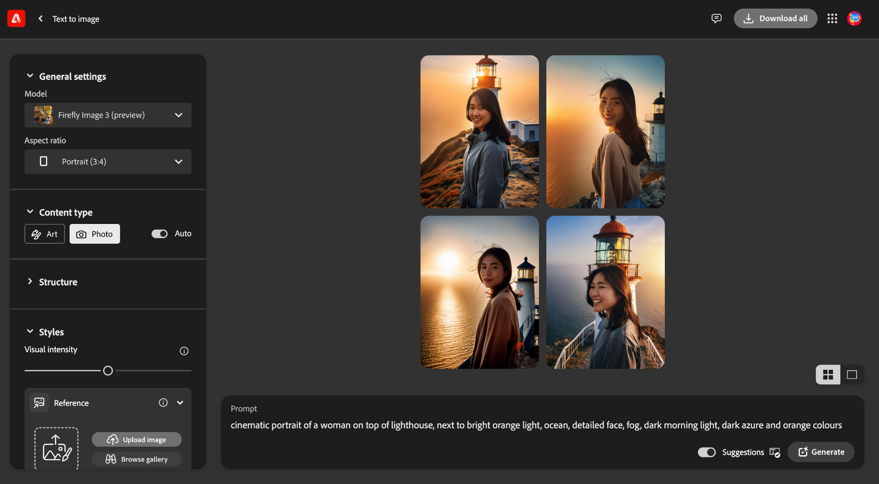
Authentic workflow screenshot from the supplied v6 trainer reference. Interface labels and positions may differ in the current Adobe release. The workflow-state schematic below is an editable evidence model.
Input asset | Named control state | Editable proof | Verification
adventure.jpg | Define a shared palette, lighting direction, aspect ratio and style reference for the sequence. | Five-frame layered storyboard PSD, exported JPEG, task-flow panel and peer-review note | At least one revision is traceable to stakeholder or peer feedback.

Detailed Procedure
1. Save the PSD as `lab04-storyboard.psd` and inspect its editable frame structure.
2. Write five beats: opening, context, action, transformation and outcome/CTA.
3. Define a shared palette, lighting direction, aspect ratio and style reference for the sequence.
4. Generate one candidate for each beat, keeping the documented shared controls constant.
5. Place each candidate in its own Smart Object frame and add editable captions.
6. Create a task-flow panel naming owner, input, action, review gate and output for generation, Photoshop edit and approval.
7. Review continuity of subject, palette, lighting and causal sequence with a peer.
8. Revise one frame, record the reason and export `lab04-storyboard.jpg`.

Evidence to Retain
Five-frame layered storyboard PSD, exported JPEG, task-flow panel and peer-review note.

Test It
PASS when:
• Every frame has a purpose and transition caption.
• Task flow includes ownership and an approval gate.
• At least one revision is traceable to stakeholder or peer feedback.
Lab folder: labs/lab-04-storyboard-and-task-flow/

Topic 3 — Photoshop Generative Editing and Critique
Use selections and generative features to build, evaluate and improve editable composites.
Alignment: LO3 · K3 · K5 · A4 · A5 · A6

Photoshop Generative AI Feature Map
Photoshop connects Generative Fill, Expand, Background, Harmonize and reference-based generation to selections and layers.
Best used for: Selecting the smallest feature that solves the editing problem.
Key controls: Selection · prompt/reference · model · variations · generated layer
Watch for: Flattening before review or confusing destructive and generated edits.
Quality evidence: The Layers panel shows the generated content and editable source structure.

Selection as a Generative Instruction
Selection geometry defines where change may occur and gives the model contextual pixels at its boundary.
Best used for: Precise insertion, replacement and local repair.
Key controls: Selection edge · feather · context margin · mask · target layer
Watch for: Selections that clip shadows or include protected details.
Quality evidence: Selection/mask evidence and a 100% edge inspection are retained.

Generative Fill
Generative Fill creates non-destructive variations on a new generated layer inside the selected region.
Best used for: Adding, replacing or removing local content with contextual blending.
Key controls: Prompt or blank prompt · model · variation · generated layer
Watch for: Anatomy errors, repeated textures and lighting mismatch.
Quality evidence: Before/after, selected variation and layered PSD prove the decision.

Generative Expand
Generative Expand extends the canvas and synthesises contextual pixels beyond the original frame.
Best used for: Reframing a master visual for landscape, portrait and square channels.
Key controls: Crop ratio · anchor · prompt/blank · safe area · variation
Watch for: Extending low-quality edges or moving the focal point unintentionally.
Quality evidence: Three channel crops preserve subject integrity and useful copy space.

Generate Background and Harmonize
Background generation replaces the environment; Harmonize adjusts a placed subject to the surrounding tone, colour and light.
Best used for: Fast composites that still require realistic integration.
Key controls: Subject isolation · background prompt · scale · contact shadow · Harmonize
Watch for: Floating subjects, incorrect perspective or inconsistent light direction.
Quality evidence: Layered before/after and zoomed edge/shadow evidence pass review.

Reference Image in Generative Fill
A reference image provides additional visual guidance while the prompt and selection define the requested change.
Best used for: Improving consistency of an object, material or visual direction.
Key controls: Reference asset · rights · prompt · selection · variation
Watch for: Expecting an exact copy or using a reference without permission.
Quality evidence: The reference, selected output and rights record are stored together.

Inpainting and Outpainting
Inpainting changes content inside a boundary; outpainting synthesises beyond an existing boundary.
Best used for: Choosing between local repair and frame extension.
Key controls: Protected area · context overlap · seam location · content continuity
Watch for: Visible seams, repeated objects or altered protected content.
Quality evidence: A difference review confirms only the intended region changed.

Aesthetic Critique and Golden-ratio Heuristics
Critique separates description, interpretation, evaluation and recommendation; compositional heuristics are prompts for judgement, not guarantees.
Best used for: Explaining why a visual works and proposing an actionable revision.
Key controls: Hierarchy · balance · rhythm · focal placement · audience fit · technical finish
Watch for: Treating a grid or ratio as proof of quality.
Quality evidence: A criterion-based critique identifies evidence, impact and one testable change.

Lab 05 — Generative Fill: Directed Inpainting
Scenario: An editorial wildlife visual needs a plausible environmental detail without damaging the original subject.
Goal: Use a controlled selection and Generative Fill to add, replace and remove content non-destructively.

Workflow Evidence Preview
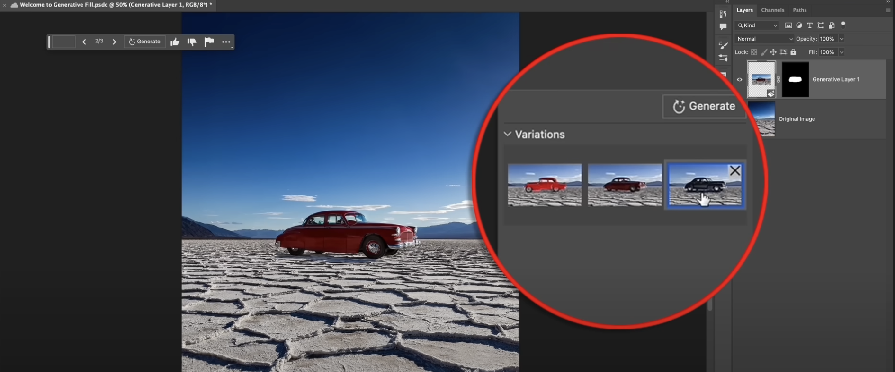
Authentic workflow screenshot from the supplied v6 trainer reference. Interface labels and positions may differ in the current Adobe release. The workflow-state schematic below is an editable evidence model.
Input asset | Named control state | Editable proof | Verification
Firefly_a robot dancing at a party 830052.jpg | Draw a selection with enough surrounding context for one added environmental detail. | Layered PSD, selected variations, final JPEG and zoomed edge/Layers-panel evidence | Edges, lighting and scale pass 100% inspection.

Detailed Procedure
1. Open `elephant-start.psd` and save `lab05-generative-fill.psd`.
2. Duplicate the source group and identify protected subject edges.
3. Draw a selection with enough surrounding context for one added environmental detail.
4. Run Generative Fill with a concise prompt and retain at least three variations.
5. Select the strongest variation by edge, light, scale and narrative fit.
6. Create a second selection and use a blank prompt for a controlled removal.
7. Inspect both edits at Fit and 100%, refining masks without flattening.
8. Export `lab05-final.jpg` and capture the Layers panel as evidence.

Evidence to Retain
Layered PSD, selected variations, final JPEG and zoomed edge/Layers-panel evidence.

Test It
PASS when:
• Original pixels remain protected.
• Generated edits are on named generated layers with editable masks.
• Edges, lighting and scale pass 100% inspection.
Lab folder: labs/lab-05-generative-fill/

Lab 06 — Background Replacement and Harmonize
Scenario: A portrait must be adapted into an outdoor campaign visual while remaining editable.
Goal: Generate a new background, integrate a placed element and evaluate lighting, perspective and contact.

Workflow Evidence Preview
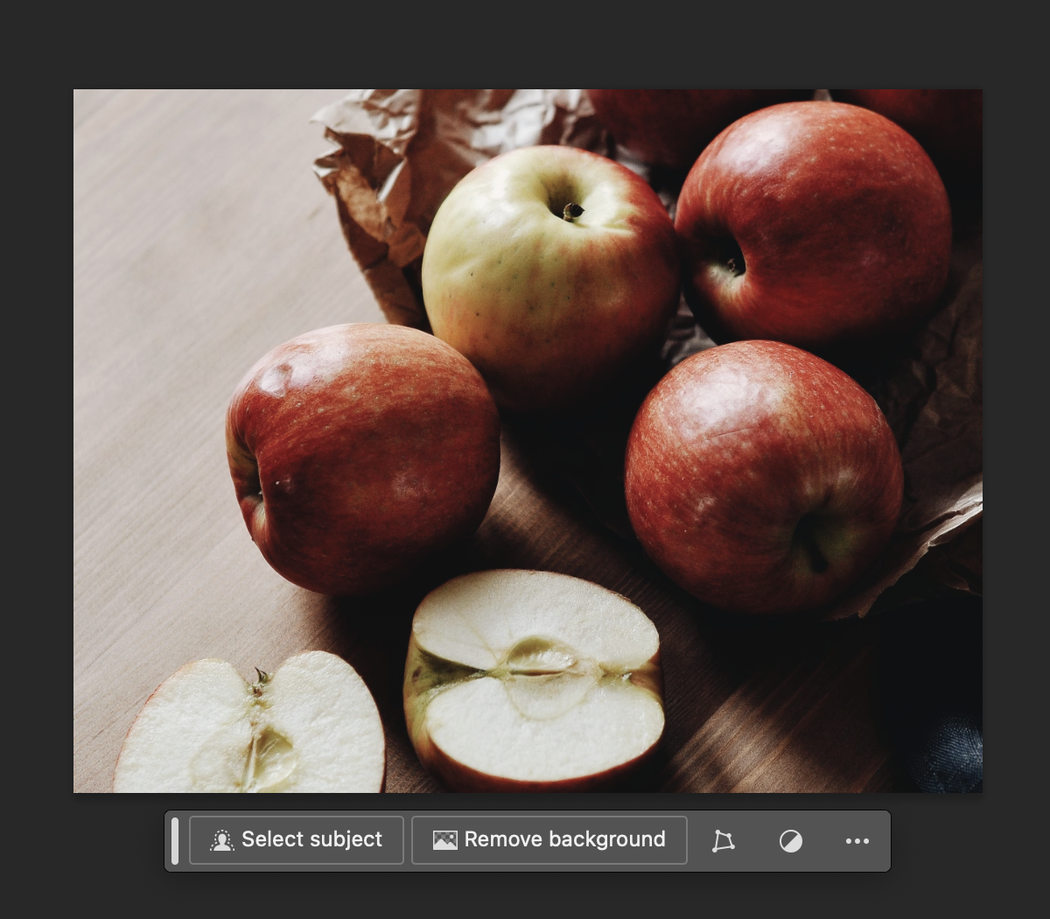
Authentic workflow screenshot from the supplied v6 trainer reference. Interface labels and positions may differ in the current Adobe release. The workflow-state schematic below is an editable evidence model.
Input asset | Named control state | Editable proof | Verification
park bench.jpg | Generate a background that provides compatible camera height, light direction and copy space. | Layered PSD, final JPEG, before/after comparison and criterion-based integration note | The note evaluates at least four explicit aesthetic/technical criteria.

Detailed Procedure
1. Open the starter PSD and save `lab06-harmonize.psd`.
2. Inspect subject isolation and refine the mask around hair, clothing and contact edges.
3. Generate a background that provides compatible camera height, light direction and copy space.
4. Place `park-bench.jpg` as a Smart Object and remove its original background non-destructively.
5. Scale and position the bench using perspective and believable subject relationship.
6. Use Harmonize where available, outputting to an editable layer; otherwise use clipped adjustment layers.
7. Add or refine contact shadow and compare before/after at Fit and 100%.
8. Export `lab06-final.jpg` and record the critique criteria used.

Evidence to Retain
Layered PSD, final JPEG, before/after comparison and criterion-based integration note.

Test It
PASS when:
• Subject and placed element masks remain editable.
• Light, perspective and contact shadow are visually coherent.
• The note evaluates at least four explicit aesthetic/technical criteria.
Lab folder: labs/lab-06-background-and-harmonize/

Lab 07 — Generative Expand for Channel Ratios
Scenario: A campaign hero must work across social, presentation and mobile-story channels.
Goal: Extend one master visual into square, landscape and portrait variants without losing hierarchy.

Workflow Evidence Preview
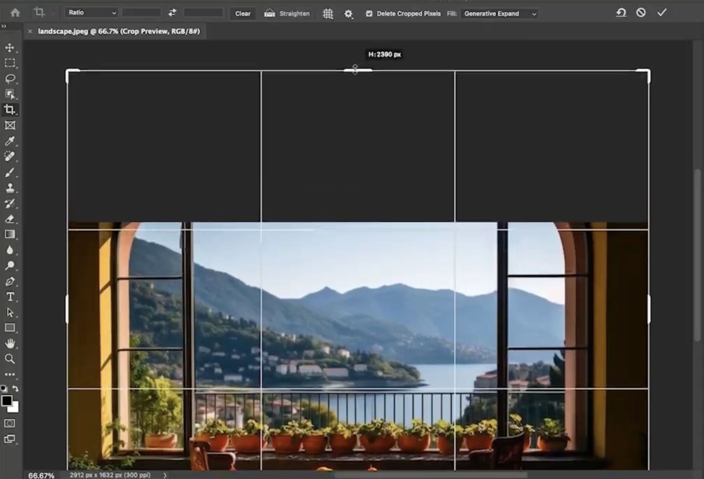
Authentic workflow screenshot from the supplied v6 trainer reference. Interface labels and positions may differ in the current Adobe release. The workflow-state schematic below is an editable evidence model.
Input asset | Named control state | Editable proof | Verification
landscape-start.jpeg | Create a 16:9 landscape variant, adjusting the anchor to protect the focal point. | Master PSD plus three channel JPEGs and a ratio-by-ratio verification checklist | No visible seams or repeated artefacts remain at 100%.

Detailed Procedure
1. Open `koala-start.psd`, save `lab07-master.psd` and identify protected subject pixels.
2. Create a square 1:1 variant with Generative Expand and intentional copy space.
3. Create a 16:9 landscape variant, adjusting the anchor to protect the focal point.
4. Create a 9:16 portrait variant with adequate top and bottom safe areas.
5. Retain at least two variations for any ratio with repeated objects or seams.
6. Inspect edges, repeated textures and subject anatomy at 100%.
7. Add non-destructive cleanup layers only where required.
8. Export `lab07-square.jpg`, `lab07-landscape.jpg` and `lab07-portrait.jpg`.

Evidence to Retain
Master PSD plus three channel JPEGs and a ratio-by-ratio verification checklist.

Test It
PASS when:
• All three aspect ratios are delivered.
• Focal hierarchy and protected subject details remain intact.
• No visible seams or repeated artefacts remain at 100%.
Lab folder: labs/lab-07-generative-expand-channel-ratios/

Lab 08 — Reference Image and Multi-Prompt Composition
Scenario: A fashion visual requires an altered garment treatment that follows a supplied material reference.
Goal: Use a permitted reference image and staged selections to construct a coherent multi-element composition.

Workflow Evidence Preview
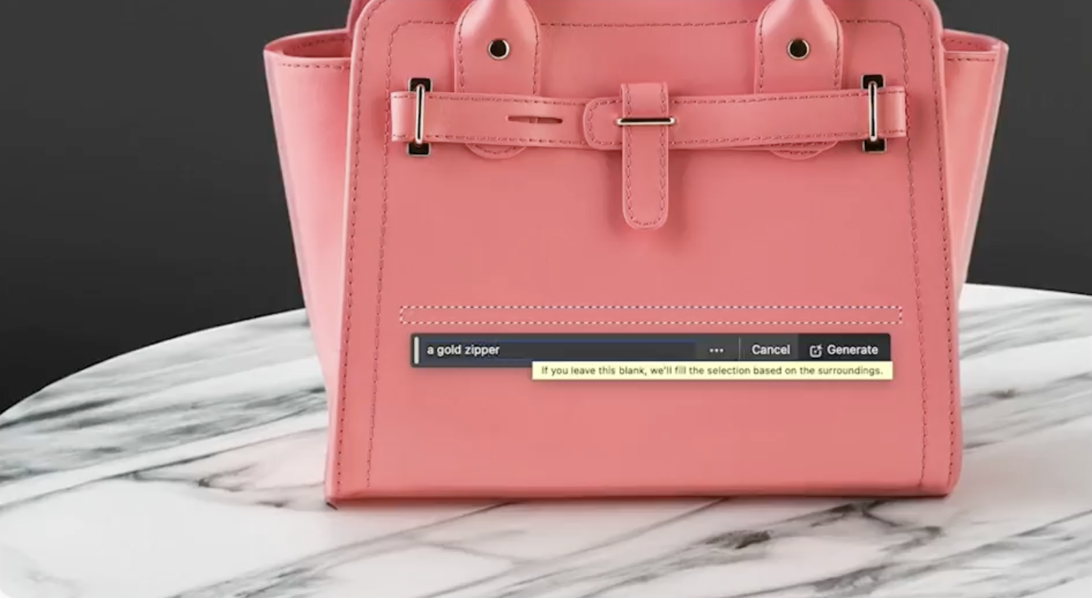
Authentic workflow screenshot from the supplied v6 trainer reference. Interface labels and positions may differ in the current Adobe release. The workflow-state schematic below is an editable evidence model.
Input asset | Named control state | Editable proof | Verification
reference.jpeg | Select only the garment region, preserving face, hands and background. | Layered reference-guided PSD, final JPEG, rights note and four-part critique with revision | The critique leads to one visible, traceable improvement.

Detailed Procedure
1. Open `coat-start.psd`, save `lab08-reference-image.psd` and inspect existing masks.
2. Record the supplied reference filename and authorised learning-use context.
3. Select only the garment region, preserving face, hands and background.
4. Invoke Generative Fill with `garment-reference.jpeg` as the reference and a concise material/colour prompt.
5. Review variations for garment boundary, folds, lighting and identity preservation.
6. Create a second isolated selection for one supporting accessory or background detail.
7. Critique the result using description, interpretation, evaluation and recommendation; make one traceable revision.
8. Export `lab08-final.jpg` and save the critique as `lab08-critique.txt`.

Evidence to Retain
Layered reference-guided PSD, final JPEG, rights note and four-part critique with revision.

Test It
PASS when:
• Protected identity and background regions remain unchanged.
• Reference asset and selected variation are retained with the PSD.
• The critique leads to one visible, traceable improvement.
Lab folder: labs/lab-08-reference-image-composition/

Topic 4 — Colour Strategy, Enhancement and Delivery
Build a coherent palette, preserve editability and verify the delivered visual.
Alignment: LO4 · K4 · K5 · A7

Hue, Saturation, Brightness and Value
Hue identifies colour family, saturation its intensity, and value/brightness its light-dark position.
Best used for: Diagnosing palette and separation before choosing an adjustment.
Key controls: Hue relationship · saturation range · value contrast · skin/brand constraints
Watch for: Increasing saturation when the problem is value separation.
Quality evidence: A palette swatch and grayscale review support the colour decision.

Adjustment Layers and Masks
Adjustment layers store tonal or colour changes separately; masks control where each adjustment applies.
Best used for: Reversible campaign colour work and local corrections.
Key controls: Adjustment type · layer order · mask density · blend mode · opacity
Watch for: Painting directly on the only copy or leaving masks unnamed.
Quality evidence: Named adjustment layers and masks remain editable in the PSD.

Histogram and Levels
The histogram displays tonal distribution; Levels remaps black point, white point and midtones.
Best used for: Correcting global tonal range and identifying clipping.
Key controls: Channel · black point · gamma · white point · output levels
Watch for: Forcing every image to fill the histogram or clipping detail.
Quality evidence: Before/after histograms and highlight/shadow checks show controlled range.

Curves
Curves remaps input to output values with points that target overall tone or individual colour channels.
Best used for: Fine contrast shaping and colour-balance correction.
Key controls: Anchor points · slope · channel · mask · clipping preview
Watch for: Too many points, banding or unwanted colour casts.
Quality evidence: A labelled Curves layer and before/after comparison show the intended change.

Colour Balance and Hue/Saturation
Colour Balance shifts tonal ranges toward complementary colours; Hue/Saturation targets hue families and intensity.
Best used for: Harmonising composite elements and establishing a campaign palette.
Key controls: Shadows/midtones/highlights · target colour range · saturation · mask
Watch for: Global shifts that damage skin tones, neutrals or brand colours.
Quality evidence: Sampled swatches and targeted masks demonstrate controlled application.

Neural Filters and Restoration
Neural Filters provide AI-assisted transformations that can output to a new layer for further review.
Best used for: Restoration, colourisation and portrait enhancement where source evidence is incomplete.
Key controls: Filter model · strength · output method · local cleanup · review
Watch for: Invented detail, identity changes or treating an AI result as historical fact.
Quality evidence: Original, AI output and manual corrections remain separately reviewable.

Campaign Colour Consistency
A campaign palette combines role-based colours, contrast targets and adjustment recipes across assets.
Best used for: Keeping storyboard, social and poster outputs recognisably related.
Key controls: Primary/secondary/accent roles · value range · accessibility · export profile
Watch for: Matching hex values while ignoring surrounding colour and output profile.
Quality evidence: A palette sheet and three channel exports show consistent roles.

Output Verification and Content Credentials
Professional delivery includes export settings, reopen checks, provenance and a retained editable master.
Best used for: Hand-off to stakeholders, publication and audit-ready delivery.
Key controls: Format · dimensions · profile · compression · metadata · Content Credentials
Watch for: Assuming an exported file is correct without reopening it.
Quality evidence: PSD, verified JPEG and provenance/read-me record form one evidence package.

Lab 09 — Restoration, Critique and Colour Strategy
Scenario: An archive image will support a heritage-wellness story but must not imply certainty where AI reconstructs missing detail.
Goal: Restore a damaged image, evaluate invented detail and develop a reversible colour treatment.

Workflow Evidence Preview
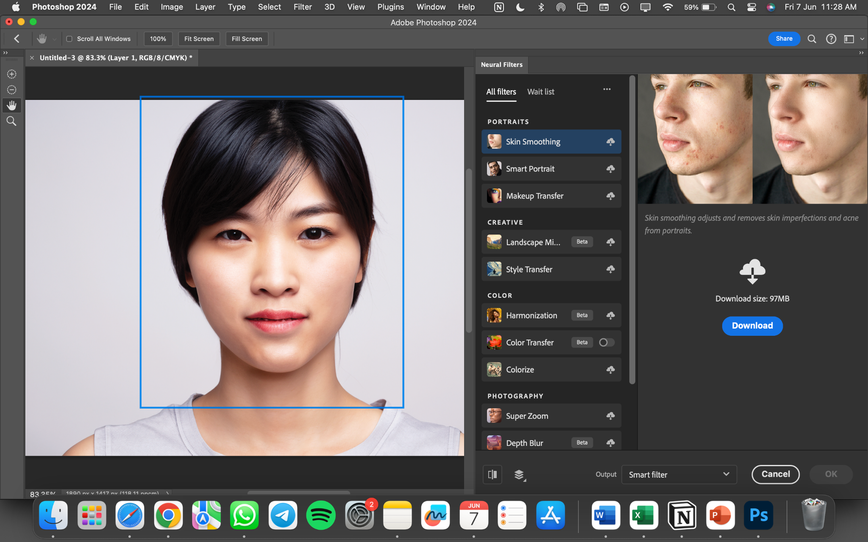
Authentic workflow screenshot from the supplied v6 trainer reference. Interface labels and positions may differ in the current Adobe release. The workflow-state schematic below is an editable evidence model.
Input asset | Named control state | Editable proof | Verification
model.jpeg | Inspect faces, hands, edges and repeating texture; mask or retouch unsupported artefacts. | Layered restoration PSD, verified JPEG, palette swatches and critique of AI-inferred detail | The critique discloses uncertainty and proposes a defensible enhancement.

Detailed Procedure
1. Open the damaged PSD and save `lab09-restoration.psd` without altering the original layer.
2. Use a Neural Filter or restoration workflow with output set to a new layer.
3. Inspect faces, hands, edges and repeating texture; mask or retouch unsupported artefacts.
4. Create a Levels or Curves adjustment layer to establish usable tonal range without clipping.
5. Develop a restrained palette using Colour Balance or Hue/Saturation adjustment layers and masks.
6. Compare the original, AI-only and corrected states at Fit and 100%.
7. Write a critique distinguishing observed source detail from AI-inferred detail.
8. Export `lab09-final.jpg` and retain a palette swatch layer in the PSD.

Evidence to Retain
Layered restoration PSD, verified JPEG, palette swatches and critique of AI-inferred detail.

Test It
PASS when:
• Original, AI output and manual corrections remain separately reviewable.
• Tonal range avoids unintended highlight/shadow clipping.
• The critique discloses uncertainty and proposes a defensible enhancement.
Lab folder: labs/lab-09-restoration-critique-colour/

Lab 10 — Wellness Campaign Capstone
Scenario: Fictional Wellness Week Singapore 2026 needs a coherent hero visual and three channel exports for a positive, inclusive message.
Goal: Integrate A1–A7 into an editable campaign visual, storyboard summary, critique and colour-delivery package.

Workflow Evidence Preview
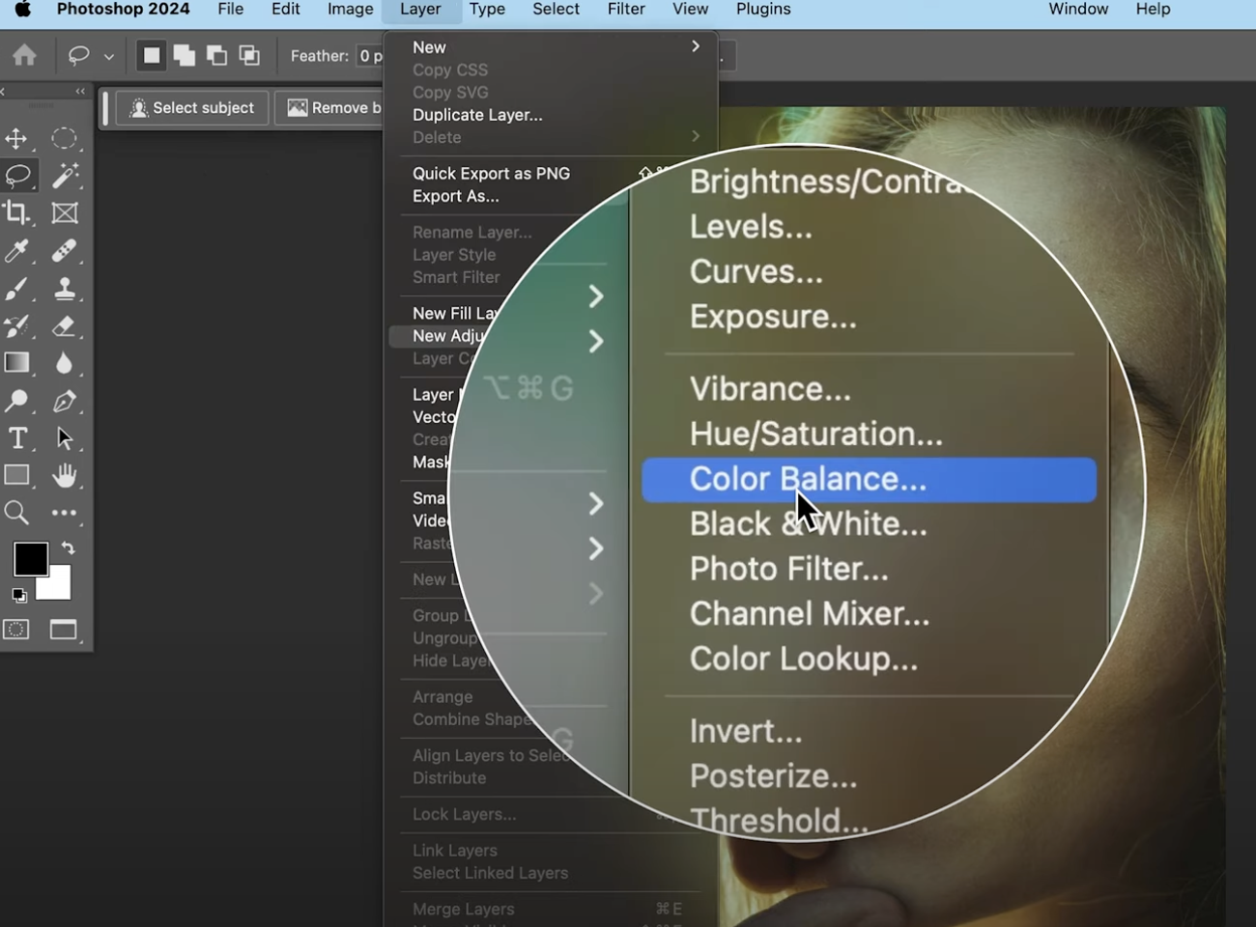
Authentic workflow screenshot from the supplied v6 trainer reference. Interface labels and positions may differ in the current Adobe release. The workflow-state schematic below is an editable evidence model.
Input asset | Named control state | Editable proof | Verification
PP - Generative AI (GenAI).jpg | Integrate the selected result with the supplied PSD using named layers, masks and generated layers. | Layered master PSD, prompt log, storyboard strip, peer critique, enhancement record, palette and three verified JPEGs | Provenance and asset-permission notes accompany delivery.

Detailed Procedure
1. Open the starter PSD, save `lab10-capstone.psd` and write a brief naming audience, message and channels.
2. Explore at least two Firefly directions; record prompt, model, references and selection rationale.
3. Integrate the selected result with the supplied PSD using named layers, masks and generated layers.
4. Create a three-frame storyboard strip showing problem, restorative action and outcome/CTA.
5. Ask a peer to evaluate hierarchy, inclusivity, aesthetics, technical finish and message fit; record the feedback.
6. Propose and implement at least two traceable enhancements based on the critique.
7. Create a role-based colour strategy with primary, secondary and accent swatches plus reversible adjustment layers.
8. Export square, landscape and portrait JPEGs; reopen each and record dimensions, colour profile and visual verification.

Evidence to Retain
Layered master PSD, prompt log, storyboard strip, peer critique, enhancement record, palette and three verified JPEGs.

Test It
PASS when:
• The package visibly demonstrates A1–A7.
• All adjustments and generated elements remain editable and named.
• Three exports are reopened and pass dimension, colour and visual checks.
• Provenance and asset-permission notes accompany delivery.
Lab folder: labs/lab-10-wellness-campaign-capstone/

Intellectual Property and Responsible AI
Use only assets you created or are permitted to use. Record the source, owner, licence or consent, date, allowed modifications, commercial or redistribution scope and attribution requirement. Public visibility does not itself grant reuse permission. Review current Adobe generative-AI terms before commercial work, respect third-party rights in prompts and reference images, and retain provenance information where appropriate. This guide is educational information, not legal advice.

Source Register
Authority | Location
Official course page | https://www.tertiarycourses.com.sg/wsq-generative-ai-genai-visuals-in-photoshop-and-firefly.html
Legacy trainer slides v6 | reference/WSQ - Master Trainer Slides - Generative AI (GenAI) Visuals in Photoshop and Firefly - v6.pptx
Original practical lab references | reference/lab reference 1; reference/lab reference 2; reference/lab reference 3
Live LMS-TMS assessment papers | reference/tms/original-WA.docx; reference/tms/original-PP.docx
Adobe Firefly Text to Image | https://helpx.adobe.com/firefly/web/work-with-images/generate-images/generate-images-from-text-descriptions.html
Adobe Firefly Style Reference | https://helpx.adobe.com/firefly/web/work-with-images/generate-images/reference-images-for-styling.html
Adobe Firefly Composition Reference | https://helpx.adobe.com/firefly/web/work-with-images/generate-images/match-image-composition-to-reference-image.html
Adobe Photoshop Generative AI Overview | https://helpx.adobe.com/photoshop/desktop/generative-ai/generative-ai-features-overview.html
Adobe Photoshop Reference Image | https://helpx.adobe.com/photoshop/desktop/create-open-import-images/create-images/use-reference-images-for-consistent-results.html
Adobe Photoshop Generative Model Control | https://helpx.adobe.com/photoshop/desktop/generative-ai/select-an-ai-model-for-generative-control.html
Adobe Neural Filters | https://helpx.adobe.com/photoshop/desktop/effects-filters/neural-filters/use-neural-filters-to-enhance-images.html
Adobe Adjustment Layers | https://helpx.adobe.com/photoshop/desktop/create-manage-layers/color-adjustment-fill-layers/adjustment-layers-options.html
Adobe Curves Help | https://helpx.adobe.com/photoshop/using/curves-adjustment.html
Adobe Content Credentials | https://helpx.adobe.com/au/firefly/web/get-started/learn-the-basics/content-credentials-overview.html
Adobe Firefly Product Terms | https://helpx.adobe.com/legal/product-descriptions/adobe-firefly.html

