
Tertiary Infotech Academy Pte Ltd
UEN: 201200696W
LESSON PLAN
For
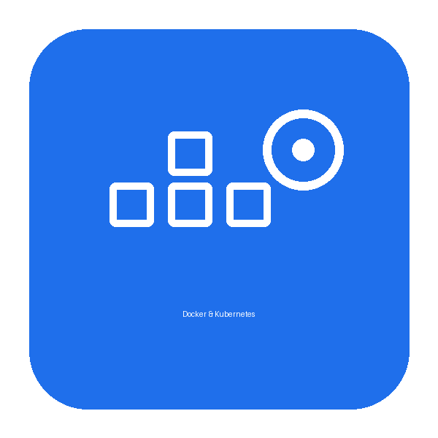
Application Integration with Docker and Kubernetes
TGS Ref No: TGS-2021010366
Conducted by
Tertiary Infotech Academy Pte Ltd
UEN: 201200696W
Version 1.0

DOCUMENT VERSION CONTROL RECORD
Version Number | Effective Date of Release | Summary of Included Changes | Author
1.0 | 30 June 2026 | First version — 2-day lesson plan (Docker + Kubernetes) aligned to the slide deck and the 19 hands-on labs; 9:00 AM-6:00 PM, 8 training hours/day | Tertiary Infotech Academy Pte Ltd

TABLE OF CONTENTS
Right-click and choose “Update Field”, or press F9, to build the table of contents.

Course Title | Application Integration with Docker and Kubernetes
Course Code | TGS-2021010366
Duration | 2 Days (16 training hours)
Daily Schedule | 9:00 AM – 6:00 PM (8 training hours/day, excluding lunch)
Lunch Break | 1:00 PM – 2:00 PM (1 hour)
Breaks | Short tea breaks are scheduled within each day's training hours
Delivery Mode | Instructor-led, hands-on labs in KillerCoda browser terminals
Prerequisites | Basic command-line familiarity; no prior Docker or Kubernetes experience required
Tools | Docker, Docker Compose, kubectl, KillerCoda, a Docker Hub account

Course Overview
This 2-day hands-on course teaches participants to containerise, run and orchestrate real applications with Docker and Kubernetes. Throughout the course learners build and deploy a single sample web application — TaskBoard (a Flask task tracker backed by Redis and PostgreSQL) — progressing from a single container to a multi-service Docker Compose stack and finally a scalable Kubernetes deployment. Day 1 covers Docker: commands, building images with a Dockerfile, CMD vs ENTRYPOINT, volumes, networking, configuration, Docker Hub and Docker Compose. Day 2 covers Kubernetes: Pods, Namespaces, Deployments, rolling updates and rollbacks, Services, storage, and Jobs/CronJobs.

Learning Outcomes
By the end of this course, participants will be able to:
- Explain containerisation and the Docker architecture, and manage containers with the Docker CLI.
- Build custom images with a Dockerfile, applying layer caching and .dockerignore best practices.
- Distinguish CMD from ENTRYPOINT and package command-line tools correctly.
- Persist and share data using named volumes and bind mounts.
- Connect containers over a custom network using DNS, and publish services with port mapping.
- Configure containers at runtime with environment variables and publish images to Docker Hub.
- Define and run multi-service applications (web + cache + database) with Docker Compose.
- Explain Kubernetes architecture and deploy applications as Pods, Deployments and Services.
- Scale and self-heal workloads and perform zero-downtime rolling updates and rollbacks.
- Persist data with PersistentVolumes/Claims and run batch work with Jobs and CronJobs.

Day 1
Docker — Images, Storage, Networking & Compose
Morning Session · 9:00 AM – 1:00 PM
Time | Topic / Activity | Duration
9:00 – 9:15 | Welcome, course objectives & overview (TGS-2021010366) | 15 min
9:15 – 9:45 | Topic 1: Containers, Docker architecture & core concepts | 30 min
9:45 – 10:10 | Lab 1: Docker Commands — Run & Manage Containers | 25 min
10:10 – 10:35 | Lab 2: Images & Inspecting Containers — pull, cp, inspect | 25 min
10:35 – 10:50 | Tea Break | 15 min
10:50 – 11:10 | Topic 2: Building images — Dockerfile, layers & build cache | 20 min
11:10 – 11:45 | Lab 3: Build the TaskBoard Image with a Dockerfile | 35 min
11:45 – 12:10 | Lab 4: Dockerfile Best Practices — .dockerignore & layer caching | 25 min
12:10 – 12:45 | Lab 5: CMD vs ENTRYPOINT — the taskboard-cli tool | 35 min
12:45 – 1:00 | Morning Q&A | 15 min
Time | Topic / Activity | Duration
1:00 – 2:00 | Lunch Break | 60 min
Afternoon Session · 2:00 PM – 6:00 PM
Time | Topic / Activity | Duration
2:00 – 2:20 | Topic 3: Docker storage — volumes & bind mounts | 20 min
2:20 – 2:50 | Lab 6: Docker Storage — Named Volumes & Bind Mounts | 30 min
2:50 – 3:10 | Topic 4: Docker networking — bridges, DNS & ports | 20 min
3:10 – 3:40 | Lab 7: Docker Networking — Custom Bridge, DNS & Port Mapping | 30 min
3:40 – 3:55 | Tea Break | 15 min
3:55 – 4:15 | Lab 8: Configuration with Environment Variables | 20 min
4:15 – 4:35 | Lab 9: Sharing Images — Push to Docker Hub | 20 min
4:35 – 4:50 | Topic 5: Docker Compose — multi-service apps | 15 min
4:50 – 5:10 | Lab 10: Docker Compose — Single Service | 20 min
5:10 – 5:30 | Lab 11: Docker Compose — Multi-Service (Web + Redis) | 20 min
5:30 – 5:55 | Lab 12: Docker Compose — Full-Stack (Web + PostgreSQL + Redis) | 25 min
5:55 – 6:00 | Day 1 recap & wrap-up | 5 min

Day 2
Kubernetes — Deploy, Scale, Update & Persist
Morning Session · 9:00 AM – 1:00 PM
Time | Topic / Activity | Duration
9:00 – 9:15 | Day 1 recap & Day 2 objectives | 15 min
9:15 – 9:55 | Topic 6: Kubernetes architecture & kubectl | 40 min
9:55 – 10:30 | Lab 13: Kubernetes Pods — Imperative & Declarative | 35 min
10:30 – 10:55 | Lab 14: Kubernetes Namespaces — Environment Isolation | 25 min
10:55 – 11:10 | Tea Break | 15 min
11:10 – 11:30 | Topic 7: Deployments, ReplicaSets & self-healing | 20 min
11:30 – 12:10 | Lab 15: Deployments — Scaling & Self-Healing | 40 min
12:10 – 12:45 | Lab 16: Rolling Updates & Rollbacks | 35 min
12:45 – 1:00 | Morning Q&A | 15 min
Time | Topic / Activity | Duration
1:00 – 2:00 | Lunch Break | 60 min
Afternoon Session · 2:00 PM – 6:00 PM
Time | Topic / Activity | Duration
2:00 – 2:20 | Topic 8: Services & networking in Kubernetes | 20 min
2:20 – 2:55 | Lab 17: Services — ClusterIP & NodePort | 35 min
2:55 – 3:10 | Topic 9: Storage, Jobs & CronJobs | 15 min
3:10 – 3:35 | Lab 18: Kubernetes Storage — emptyDir, PV & PVC | 25 min
3:35 – 4:00 | Lab 19: Jobs & CronJobs — Batch and Scheduled Tasks | 25 min
4:00 – 5:15 | Final Assessment — written / MCQ on the LMS (lms.tertiaryinfotech.com) | 75 min
5:15 – 5:30 | Tea Break | 15 min
5:30 – 6:00 | Course review, learner feedback (TRAQOM) & closing | 30 min

Labs Covered
All 19 hands-on labs are delivered in KillerCoda browser terminals and mirror the slide deck and Learner Guide exactly:
Lab | Topic | Title
1 | Docker commands | Docker Commands — Run & Manage Containers
2 | Docker commands | Images & Inspecting Containers — pull, cp, inspect
3 | Docker Build / Dockerfile | Build the TaskBoard Image with a Dockerfile
4 | Dockerfile best practices | Dockerfile Best Practices — .dockerignore & layer caching
5 | CMD vs ENTRYPOINT | CMD vs ENTRYPOINT — the taskboard-cli tool
6 | Volumes | Docker Storage — Named Volumes & Bind Mounts
7 | Networking | Docker Networking — Custom Bridge, DNS & Port Mapping
8 | Environment variables | Configuration with Environment Variables
9 | Docker Hub | Sharing Images — Push to Docker Hub
10 | Docker Compose | Docker Compose — Single Service
11 | Docker Compose | Docker Compose — Multi-Service (Web + Redis)
12 | Docker Compose | Docker Compose — Full-Stack (Web + PostgreSQL + Redis)
13 | Pods | Kubernetes Pods — Imperative & Declarative
14 | Namespaces | Kubernetes Namespaces — Environment Isolation
15 | Deployments | Deployments — Scaling & Self-Healing
16 | Rolling updates & rollbacks | Rolling Updates & Rollbacks
17 | Services | Services — ClusterIP & NodePort
18 | Storage | Kubernetes Storage — emptyDir, PV & PVC
19 | Jobs & CronJobs | Jobs & CronJobs — Batch and Scheduled Tasks

Assessment
Participants are assessed through their hands-on lab work across both days and a final written / MCQ assessment on Day 2 (starting at 4:00 PM) delivered on the LMS. A minimum of 75% attendance across all sessions is required for SSG funding.

