
Tertiary Infotech Academy Pte Ltd
UEN: 201200696W
LEARNER GUIDE
For
Autodesk Certified Professional (ACP) - AutoCAD Design and Drafting
TGS Ref No: TGS-2023036004
Conducted by
Tertiary Infotech Academy Pte Ltd
UEN: 201200696W
Version 8.0

DOCUMENT VERSION CONTROL RECORD
Version Number | Effective Date of Release | Summary of Included Changes | Author
1.0 | 2 February 2023 | First version | Tertiary Infotech Academy
2.0 | 17 October 2025 | Updated company name | Tertiary Infotech Academy
8.0 | 22 August 2026 | Rebuilt as a detailed 32-hour guide aligned to five current Autodesk ACP domains, ten self-contained AutoCAD labs, recovered PP source files and revised WA/PP instruments. | Tertiary Infotech Academy

TABLE OF CONTENTS
How to Use This Guide 4
Standards, Art Direction and Drawing Trust 4
The AutoCAD Precision System 4
Drawing Management and Revision 4
Annotation and Stakeholder Story 5
Authoring and Reuse 5
Layouts, Output and Collaboration 5
Learning Outcomes and TSC Mapping 5
Knowledge 6
Abilities 6
Detailed Labs 6
Lab 01 - Drawing Standards and Project Setup 7
Lab 02 - Layers, Object Management and Revision Control 9
Lab 03 - Annotation Standards and Stakeholder Story 11
Lab 04 - Dimensions, Multileaders and Data Tables 13
Lab 05 - Advanced Geometry and Precision Editing 15
Lab 06 - Blocks, Attributes and Data Extraction 17
Lab 07 - Layouts, Viewports and Page Setups 19
Lab 08 - Publish, Plot and eTransmit 21
Lab 09 - Xrefs, Underlays and Drawing Comparison 23
Lab 10 - Integrated Sink Documentation Capstone 25
Assessment Preparation 26
References 26

How to Use This Guide
The slide deck is concept-led. This Learner Guide and the individual lab folders carry the detailed procedures, evidence requirements and acceptance criteria.
Work through Labs 1-10 in sequence. Always edit a working copy, preserve the recovered original DWG, and use the JPEG brief in each lab folder as a visual checking reference.
AutoCAD commands can be launched from the ribbon, palettes, shortcut menu or command line. The guide names the command so learners can work across interface arrangements.

Standards, Art Direction and Drawing Trust
Art direction becomes operational when the drawing declares units, origin, scale, layer naming, lineweight hierarchy, annotation system, sheet convention and revision status.
A standard is a testable agreement. Record what must remain consistent, who owns the source, how exceptions are approved and what evidence proves the rule was applied.
For every source or Xref, distinguish visual context from editable ownership. Referencing preserves accountability; copying geometry can hide source changes and create conflicting truth.

The AutoCAD Precision System
Accuracy comes from a system: drawing units, UCS, object snaps, polar/object-snap tracking, dynamic input, typed coordinates or distances, fit-for-purpose object types, and explicit measurement.
Model scale, insertion scale, viewport scale and plot scale are separate controls. A wrong model should not be corrected by manipulating paper output.
Use ID, DIST, LIST, Properties and plot preview as independent checks. Visual appearance alone is not evidence of dimensional accuracy.

Drawing Management and Revision
Layers organise by function or purpose. Off hides temporarily; Freeze suppresses regeneration and can improve performance; Lock protects objects while preserving context.
Property filters and group filters help navigate complex drawings. Layer states restore named review/plot conditions, while viewport overrides control sheet-specific presentation.
Use Audit and Purge deliberately. Investigate warnings, remove only confirmed unused definitions, preserve a revision before cleanup and verify references after the operation.

Annotation and Stakeholder Story
A stakeholder should be able to orient, read the primary dimensions, follow callouts to decisions, check schedules and identify the current revision without searching the sheet.
Named text, dimension, multileader and table styles are organisational assets. Annotative properties help one object remain readable across required viewport scales.
Revision clouds, delta notes and drawing comparison make change visible. Wipeouts can improve legibility but must never conceal required geometry or evidence.

Authoring and Reuse
Polylines are connected, measurable paths; splines model controlled smooth curves; regions support area properties and Boolean operations; xlines and rays are construction references.
Use the least destructive modification that communicates design intent. Associative arrays preserve relationships; multifunctional grips expose object-specific edits.
Blocks are reusable definitions; groups are temporary selection relationships. Attributes attach instance data to blocks, and Data Extraction turns that data into schedules.

Layouts, Output and Collaboration
Model space contains full-size design geometry. Paper space composes controlled sheets through title blocks, viewports, scales, layer overrides and page setups.
Publish only current layouts, inspect every output page at full size, and use eTransmit to package dependencies with documented path handling.
Attach and Overlay have different nesting behaviour. Relative paths are usually portable inside a disciplined project tree; every package must be open-tested from its final location.

Learning Outcomes and TSC Mapping
- LO1: Define the application of emerging design visualization standards in AutoCAD art direction and sketching.
- LO2: Develop the organisation's drawing and sketching capabilities using methods for revising 2D and 3D technical drawings.
- LO3: Develop organisation-specific drawing standards that use storytelling and annotation to engage stakeholders.
- LO4: Lead the integration of emerging drawing technologies and suitable methods in alignment with organisational growth.
- LO5: Inspire stakeholders to explore traditional and contemporary approaches to drawing and sketching.

Knowledge
- K1: Emerging design visualization standards
- K2: Methods to revise two-dimensional and three-dimensional technical drawings
- K3: Elements of storytelling and stakeholder engagement through drawings
- K4: Key emerging technologies for drawing and sketching

Abilities
- A1: Define the art direction and sketching style for the organisation
- A2: Define and guide the development of drawing and sketching capabilities
- A3: Develop standards for organisational drawing and sketching
- A4: Lead selection of suitable drawing technology and methods aligned with growth
- A5: Inspire exploration of traditional and contemporary drawing approaches

Detailed Labs
Each lab has its own folder with a detailed guide, printable PDF mirror, evidence checklist, JPEG brief and the relevant recovered AutoCAD working files.

Lab 01 - Drawing Standards and Project Setup
Mapping: LO1 · K1 · A1
Translate a design brief into a documented AutoCAD setup covering units, visual style, naming, layers and evidence standards.
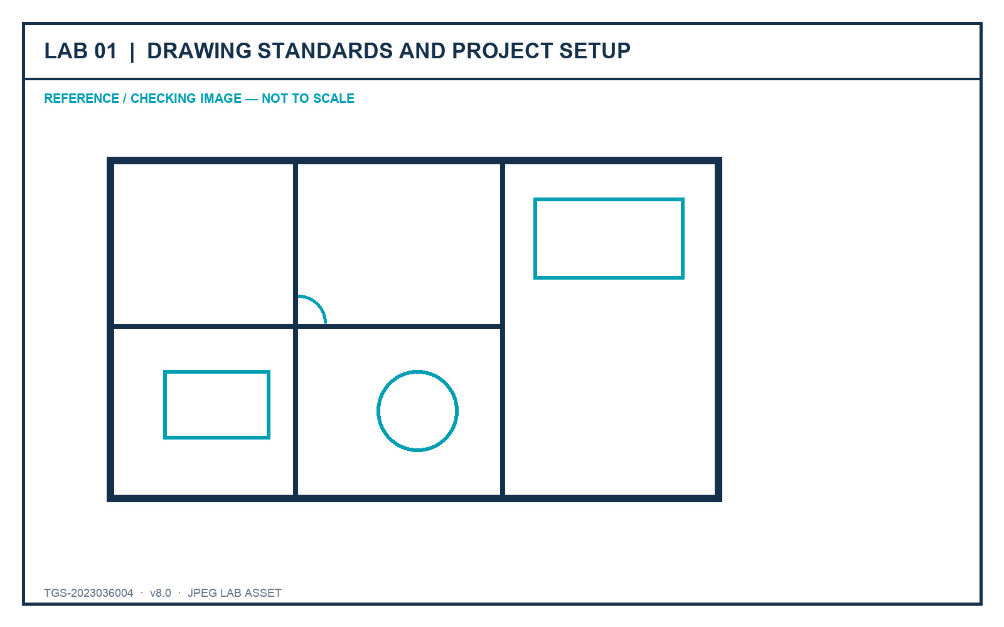
Figure: Lab JPEG visual brief/checking image

Outcome and supplied files
A standards-ready furniture plan with a completed drawing-standard record and verified setup evidence.
- lab-reference.jpg - JPEG brief and checking image
- Furniture_Floor_Plan.dwg - recovered AutoCAD source file

Detailed procedure
Step 1 - Open the supplied Furniture_Floor_Plan.dwg and save a working copy named lab01-<initials>.dwg.
Command / tool: SAVEAS
Step 2 - Read the project brief and record the intended discipline, audience, drawing purpose and required deliverables.
Command / tool: Lab brief
Step 3 - Open Drawing Units; confirm the length type, precision, insertion scale and angle convention required by the brief.
Command / tool: UNITS
Step 4 - Inspect extents and measure two known elements to confirm the drawing scale is credible before editing.
Command / tool: ZOOM Extents · DIST
Step 5 - Create a named UCS for the principal drawing orientation and restore World UCS for comparison.
Command / tool: UCS · Named
Step 6 - Define the layer naming, colour, linetype, lineweight and plot expectations in the standards record.
Command / tool: LAYER
Step 7 - Check object properties for representative walls, fixtures and annotations; record any exceptions.
Command / tool: PROPERTIES
Step 8 - Set a visual review style that makes lineweight and object hierarchy easy to inspect.
Command / tool: LWDISPLAY
Step 9 - Purge only confirmed unused definitions, then audit the file and save a new revision.
Command / tool: PURGE · AUDIT
Step 10 - Capture the Units, Layer Properties, UCS and measured-dimension evidence required by the checklist.
Command / tool: Evidence screenshots

Verification and acceptance
Units, scale, UCS, naming and layer rules are documented; the drawing opens without errors and passes the lab checklist.
- Save the final DWG using learner initials and a revision identifier.
- Capture the relevant setting and visible result in the same evidence sequence.
- Complete the lab evidence checklist before submission.

Lab 02 - Layers, Object Management and Revision Control
Mapping: LO2 · K2 · A2
Organise and revise a drawing using selection methods, layer filters, layer states, overrides and controlled cleanup.
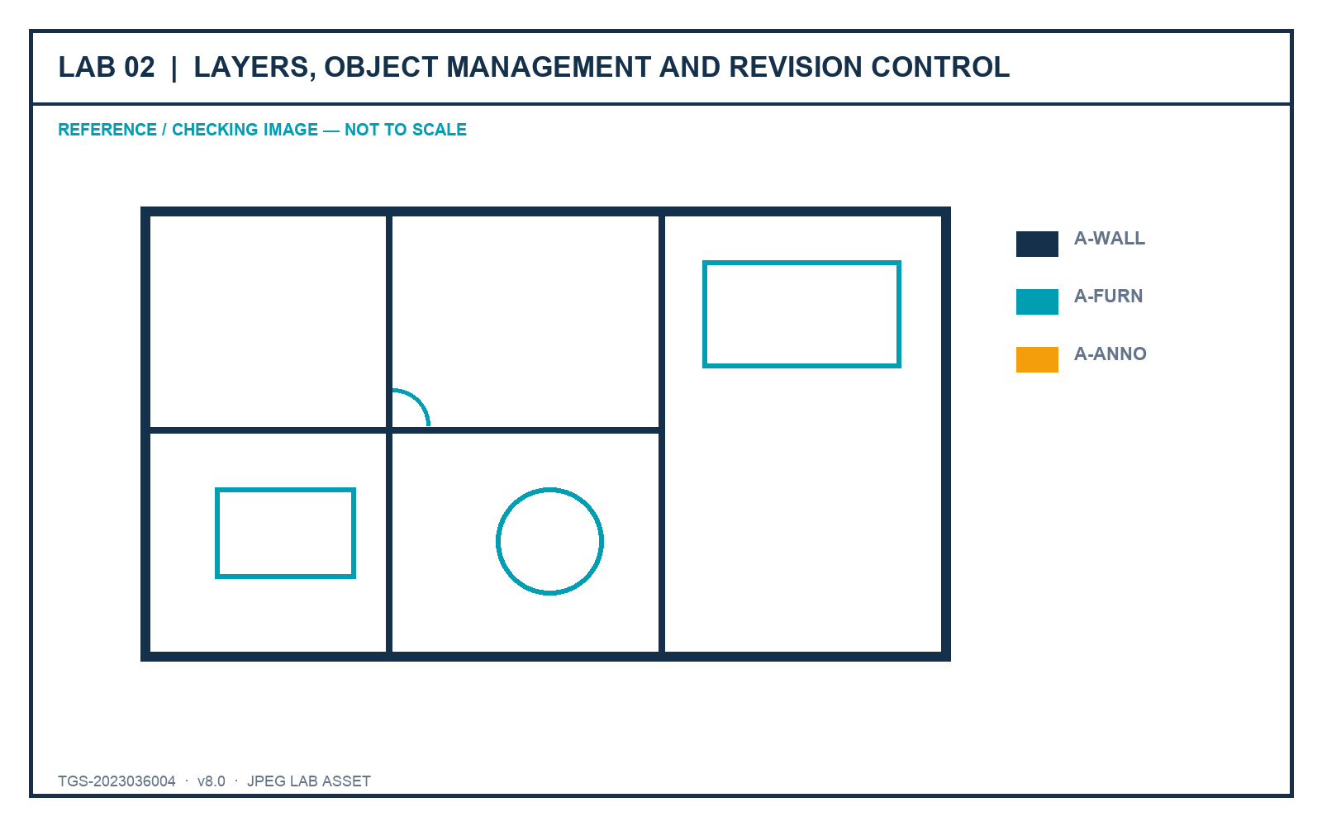
Figure: Lab JPEG visual brief/checking image

Outcome and supplied files
A revised furniture plan with reusable layer states, filters and a change log.
- lab-reference.jpg - JPEG brief and checking image
- Furniture_Floor_Plan.dwg - recovered AutoCAD source file

Detailed procedure
Step 1 - Open the Lab 2 source copy and create a new revision before making organisational changes.
Command / tool: SAVEAS
Step 2 - Use Quick Select to find objects by layer, colour and object type; compare with Select Similar.
Command / tool: QSELECT · SELECTSIMILAR
Step 3 - Create discipline-based property filters and a temporary group filter for the current revision task.
Command / tool: LAYER FILTER
Step 4 - Save a Presentation layer state and a Coordination layer state with different visibility and plot settings.
Command / tool: LAYERSTATE
Step 5 - Apply viewport-ready layer-property overrides to highlight the coordination scope without changing global properties.
Command / tool: Layer overrides
Step 6 - Lock reference layers, freeze layers not needed for the task and explain the difference from turning a layer off.
Command / tool: LOCK · FREEZE · OFF
Step 7 - Use Hide/Isolate for a short review, then end isolation and prove no objects remain accidentally hidden.
Command / tool: ISOLATEOBJECTS · UNISOLATEOBJECTS
Step 8 - Merge only the two duplicate layers named in the brief and confirm the destination layer.
Command / tool: LAYMRG
Step 9 - Record before/after layer counts and describe how the changes support team revision capability.
Command / tool: Layer Properties evidence
Step 10 - Audit and save the final revision with the completed change log.
Command / tool: AUDIT · SAVE

Verification and acceptance
Required filters and states restore correctly; no object is lost; the merged layers and revision evidence match the brief.
- Save the final DWG using learner initials and a revision identifier.
- Capture the relevant setting and visible result in the same evidence sequence.
- Complete the lab evidence checklist before submission.

Lab 03 - Annotation Standards and Stakeholder Story
Mapping: LO3 · K3 · A3
Create an annotation system that leads a stakeholder from overview to decision-critical detail.
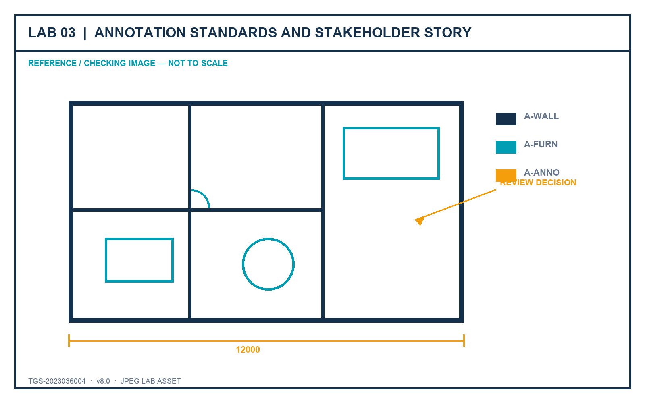
Figure: Lab JPEG visual brief/checking image

Outcome and supplied files
An annotated plan with text, dimensions, multileaders, hatches and revision communication governed by named styles.
- lab-reference.jpg - JPEG brief and checking image
- Furniture_Floor_Plan.dwg - recovered AutoCAD source file

Detailed procedure
Step 1 - Open the source drawing and identify the three messages the stakeholder must understand first.
Command / tool: Stakeholder brief
Step 2 - Create or verify a text style with the required font, height rule and width factor.
Command / tool: STYLE
Step 3 - Create a dimension style for the project units, precision, arrowheads, text placement and tolerances.
Command / tool: DIMSTYLE
Step 4 - Create a multileader style with a consistent landing, arrowhead and content hierarchy.
Command / tool: MLEADERSTYLE
Step 5 - Apply concise callouts that state the decision, not merely the object name.
Command / tool: MLEADER
Step 6 - Use hatches with controlled scale and origin to distinguish material or scope without obscuring geometry.
Command / tool: HATCH · HATCHEDIT
Step 7 - Add a revision cloud and delta note to make one documented change visible.
Command / tool: REVCLOUD
Step 8 - Use a wipeout only where it improves readability and confirm frame/display settings do not hide required geometry.
Command / tool: WIPEOUT
Step 9 - Run an annotation-scale review at two intended viewport scales.
Command / tool: CANNOSCALE
Step 10 - Capture the styles, annotation hierarchy and stakeholder reading order in the evidence sheet.
Command / tool: Evidence screenshots

Verification and acceptance
Annotations are legible at the required scales, styles are reusable, and the drawing tells a clear review story.
- Save the final DWG using learner initials and a revision identifier.
- Capture the relevant setting and visible result in the same evidence sequence.
- Complete the lab evidence checklist before submission.

Lab 04 - Dimensions, Multileaders and Data Tables
Mapping: LO3 · K3 · A3
Build a coordinated detailing layer that combines efficient dimensions, callouts and a component schedule.
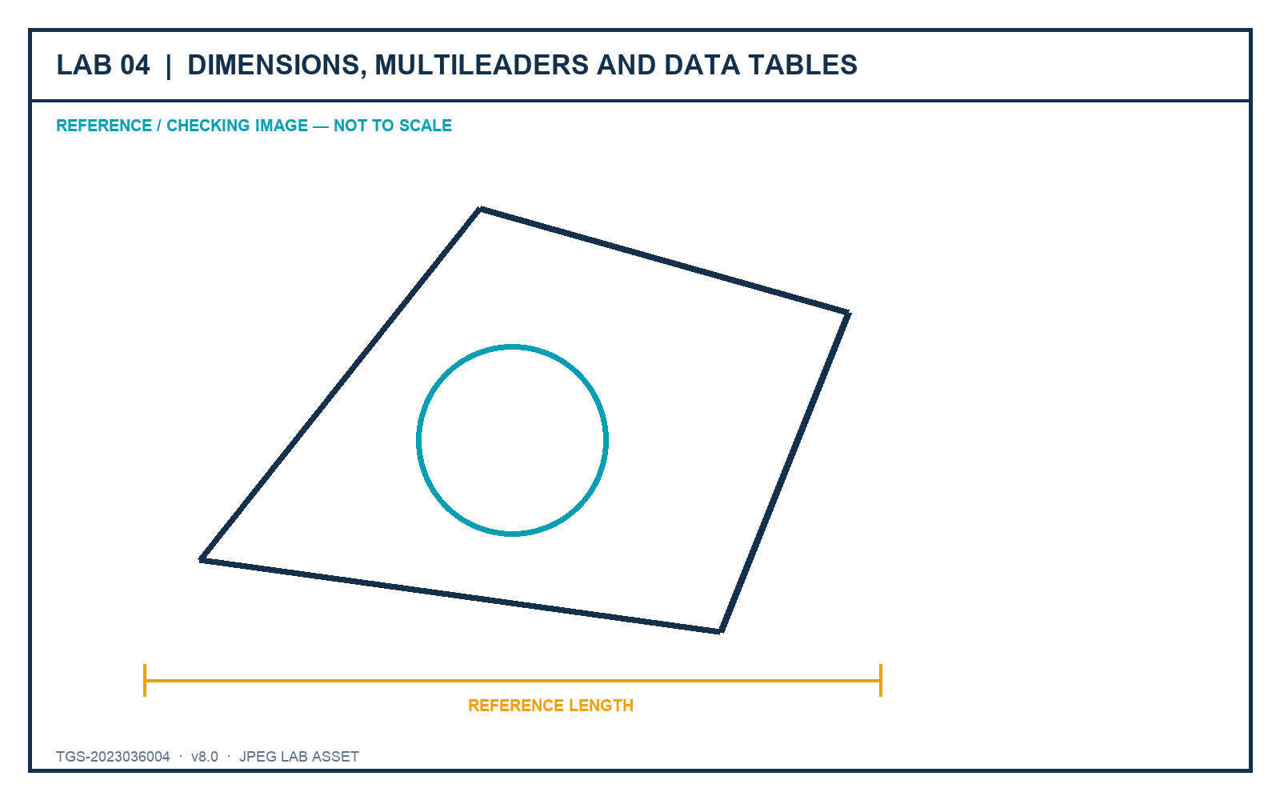
Figure: Lab JPEG visual brief/checking image

Outcome and supplied files
A review sheet with validated dimensions, labels and a structured furniture/component table.
- lab-reference.jpg - JPEG brief and checking image
- Furniture_Floor_Plan.dwg - recovered AutoCAD source file

Detailed procedure
Step 1 - Create linear, aligned, angular and radial dimensions only where each type communicates the geometry correctly.
Command / tool: DIM
Step 2 - Use Quick Dimension for a repeated chain, then inspect and correct crowded or ambiguous results.
Command / tool: QDIM
Step 3 - Edit dimension text only when necessary and preserve the measured value through fields or associative dimensions.
Command / tool: DIMREASSOCIATE
Step 4 - Add keynotes with multileaders and align them into a readable callout column.
Command / tool: MLEADERALIGN
Step 5 - Create a table style with a clear title, header and data-row hierarchy.
Command / tool: TABLESTYLE
Step 6 - Insert a component schedule with item, description, material, size and manufacturer columns.
Command / tool: TABLE
Step 7 - Use a field for one drawing property and update it to prove the link is live.
Command / tool: FIELD · UPDATEFIELD
Step 8 - Check spelling, unit consistency, overlaps and duplicated information.
Command / tool: SPELL · visual check
Step 9 - Plot-preview the sheet at the intended scale and correct any annotation that becomes unreadable.
Command / tool: PLOT Preview
Step 10 - Save the final sheet and complete the acceptance checklist.
Command / tool: SAVE

Verification and acceptance
Dimensions remain associative, leaders are aligned, the table is complete and the plotted sheet is readable.
- Save the final DWG using learner initials and a revision identifier.
- Capture the relevant setting and visible result in the same evidence sequence.
- Complete the lab evidence checklist before submission.

Lab 05 - Advanced Geometry and Precision Editing
Mapping: LO1–LO2 · K1, K2 · A1, A2
Author and revise technical geometry with polylines, arcs, polygons, splines, regions, construction geometry and precision tools.
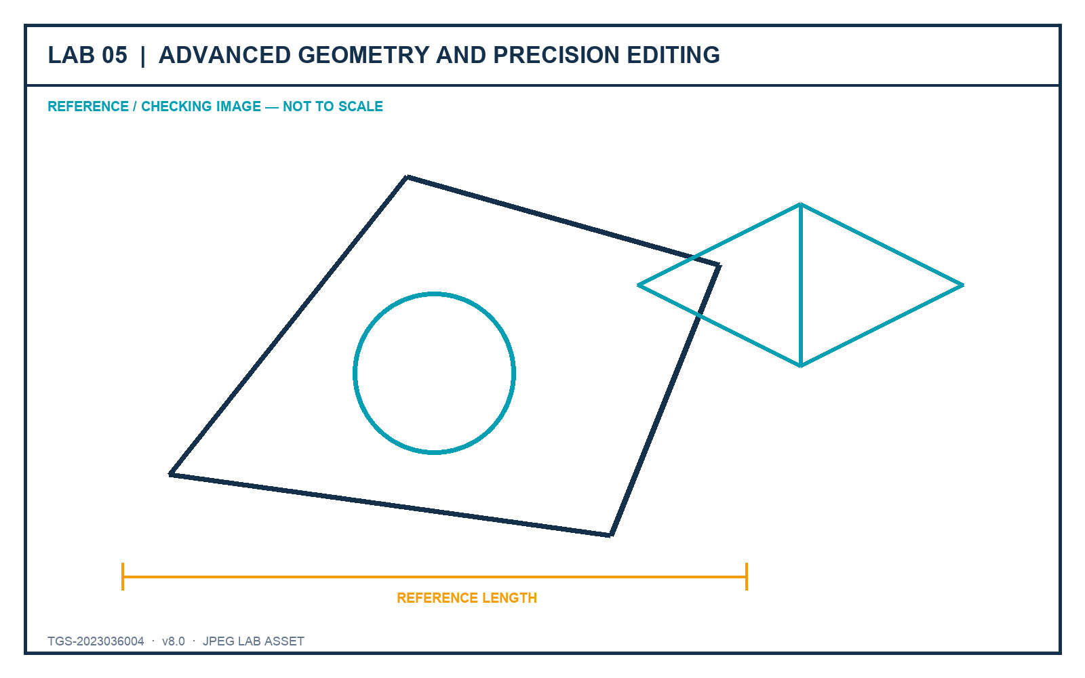
Figure: Lab JPEG visual brief/checking image

Outcome and supplied files
A precise 2D component study plus an isometric view using fit-for-purpose object types.
- lab-reference.jpg - JPEG brief and checking image
- Furniture_Floor_Plan.dwg - recovered AutoCAD source file

Detailed procedure
Step 1 - Set object snaps, polar tracking and dynamic input for the supplied geometry brief.
Command / tool: OSNAP · POLAR · DYNMODE
Step 2 - Create a closed polyline outline with one straight and one arc segment; verify closure and area.
Command / tool: PLINE · LIST
Step 3 - Create a polygon by centre/radius and another by edge; compare control and revision behaviour.
Command / tool: POLYGON
Step 4 - Create a spline using fit points, then edit its control vertices to refine the silhouette.
Command / tool: SPLINE · SPLINEDIT
Step 5 - Use xlines and rays as non-plotting construction references on a dedicated layer.
Command / tool: XLINE · RAY
Step 6 - Convert the closed outlines into regions and demonstrate Union and Subtract on copies.
Command / tool: REGION · UNION · SUBTRACT
Step 7 - Use grips, multifunctional grips, Move, Rotate, Offset, Mirror, Stretch, Trim and Extend on measured edits.
Command / tool: GRIPS · MODIFY tools
Step 8 - Create a rectangular or polar associative array and edit its parameters after placement.
Command / tool: ARRAYRECT · ARRAYPOLAR
Step 9 - Switch to isometric drafting, cycle isoplanes and add an isocircle for the component study.
Command / tool: ISODRAFT · F5 · ELLIPSE Isocircle
Step 10 - Verify coordinates and dimensions, then save the finished component sheet.
Command / tool: ID · DIST · SAVE

Verification and acceptance
Objects use suitable types, edits remain accurate, construction geometry is separated and the isometric view is coherent.
- Save the final DWG using learner initials and a revision identifier.
- Capture the relevant setting and visible result in the same evidence sequence.
- Complete the lab evidence checklist before submission.

Lab 06 - Blocks, Attributes and Data Extraction
Mapping: LO4 · K4 · A4
Develop reusable content that carries organisational data and supports consistent schedules.
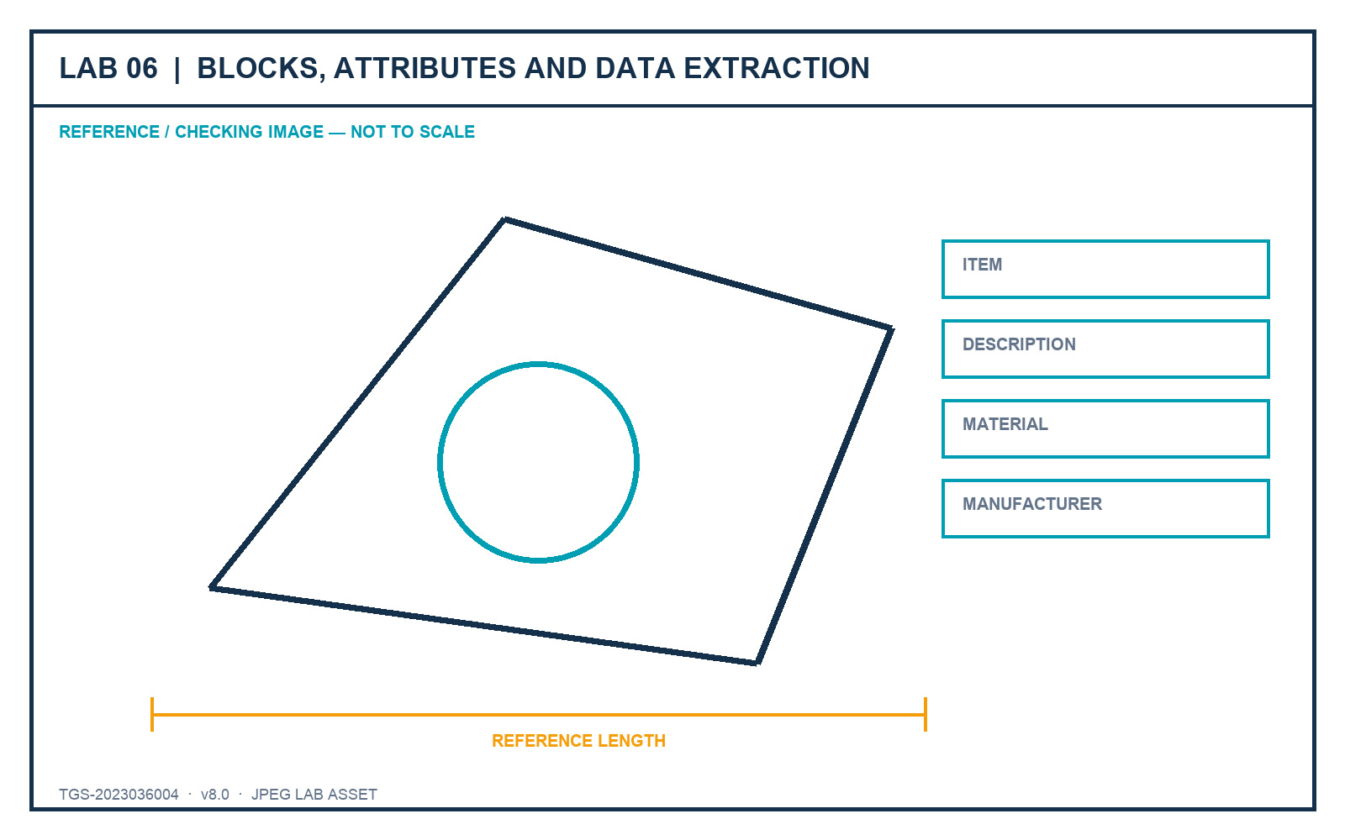
Figure: Lab JPEG visual brief/checking image

Outcome and supplied files
A small furniture block library with attributes and an extracted component schedule.
- lab-reference.jpg - JPEG brief and checking image
- Furniture_Block_Attributes.dwg - recovered AutoCAD source file

Detailed procedure
Step 1 - Open the source file and inventory the furniture objects that should become reusable definitions.
Command / tool: BEDIT / source review
Step 2 - Choose logical base points and create named blocks using the project naming rule.
Command / tool: BLOCK
Step 3 - Write one approved block to an external DWG for controlled reuse.
Command / tool: WBLOCK
Step 4 - Define ITEM, DESCRIPTION, MATERIAL and MANUFACTURER attributes with suitable prompts and defaults.
Command / tool: ATTDEF
Step 5 - Insert several block instances and enter distinct attribute values.
Command / tool: INSERT
Step 6 - Edit one block definition and confirm all instances update without losing attribute values.
Command / tool: BEDIT · BSAVE
Step 7 - Synchronise attribute definitions and repair any out-of-date instances.
Command / tool: ATTSYNC
Step 8 - Extract block and attribute data into an AutoCAD table.
Command / tool: DATAEXTRACTION
Step 9 - Group a temporary review set and explain why a group is not a reusable block definition.
Command / tool: GROUP
Step 10 - Save the library, schedule and evidence of the data relationship.
Command / tool: SAVE

Verification and acceptance
Blocks reuse cleanly, attributes persist through edits and the extracted schedule matches the inserted instances.
- Save the final DWG using learner initials and a revision identifier.
- Capture the relevant setting and visible result in the same evidence sequence.
- Complete the lab evidence checklist before submission.

Lab 07 - Layouts, Viewports and Page Setups
Mapping: LO3 · K3 · A1, A2, A3
Build ISO A1, A2 and A3 layouts with correct page setups, title blocks, viewport views and locked scales.
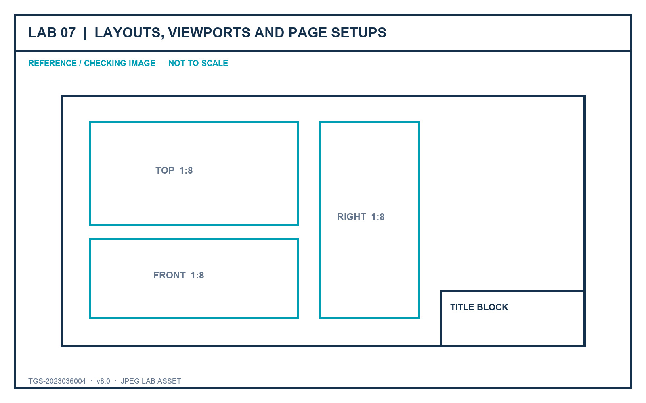
Figure: Lab JPEG visual brief/checking image

Outcome and supplied files
A coordinated three-sheet sink drawing set that mirrors the original practical-assessment workflow.
- lab-reference.jpg - JPEG brief and checking image
- Sink_Layouts.dwg - recovered AutoCAD source file
- ISO A1 title block.dwg - recovered AutoCAD source file
- ISO A2 title block.dwg - recovered AutoCAD source file
- ISO A3 title block.dwg - recovered AutoCAD source file

Detailed procedure
Step 1 - Open Sink_Layouts.dwg and save a working copy in the Lab 7 folder.
Command / tool: SAVEAS
Step 2 - Inspect model-space extents, saved views and the current ISO A2 layout.
Command / tool: ZOOM Extents · VIEW
Step 3 - Create a named page setup for each required ISO expanded sheet size and verify plot units and orientation.
Command / tool: PAGESETUP
Step 4 - Copy the ISO A2 layout twice and rename the copies ISO A1 and ISO A3.
Command / tool: LAYOUT Copy · Rename
Step 5 - Assign the correct page setup to ISO A1, ISO A2 and ISO A3.
Command / tool: PAGESETUP
Step 6 - Insert each supplied title-block drawing at 0,0 on the Border layer in paper space.
Command / tool: -INSERT 0,0
Step 7 - Create three equal viewports on ISO A2 and place them on the Viewports layer.
Command / tool: MVIEW
Step 8 - Set Top, Front and Right views, apply 1:8 scale, Hidden visual style and lock the viewports.
Command / tool: VIEW · ZOOM 1/8xp · LOCK
Step 9 - Create one SE Isometric viewport on ISO A3 at 1:5 using Shaded or Realistic style and lock it.
Command / tool: MVIEW · SE Isometric · 1/5xp
Step 10 - Preview all sheets, verify title blocks and save the coordinated drawing set.
Command / tool: PLOT Preview · SAVE

Verification and acceptance
All three layouts use the correct sheet, border and viewport settings; scales and view locks match the brief.
- Save the final DWG using learner initials and a revision identifier.
- Capture the relevant setting and visible result in the same evidence sequence.
- Complete the lab evidence checklist before submission.

Lab 08 - Publish, Plot and eTransmit
Mapping: LO3–LO4 · K3, K4 · A3, A4
Configure repeatable output and package the drawing set with all required dependencies.
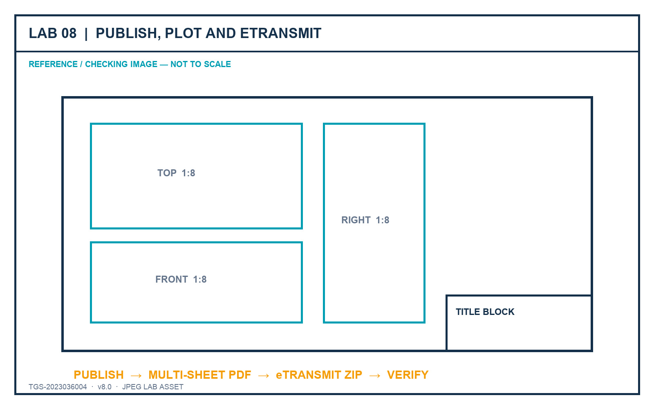
Figure: Lab JPEG visual brief/checking image

Outcome and supplied files
A published PDF sheet set and a verified eTransmit package with a transmittal report.
- lab-reference.jpg - JPEG brief and checking image
- Sink_Layouts.dwg - recovered AutoCAD source file
- ISO A1 title block.dwg - recovered AutoCAD source file
- ISO A2 title block.dwg - recovered AutoCAD source file
- ISO A3 title block.dwg - recovered AutoCAD source file

Detailed procedure
Step 1 - Open the completed layout drawing and run a dependency check before publishing.
Command / tool: XREF · FONTALT awareness
Step 2 - Import or create the approved page setups and apply them consistently to the sheet set.
Command / tool: PAGESETUP Import
Step 3 - Open Publish, order the sheets and remove any model-space sheet not required by the brief.
Command / tool: PUBLISH
Step 4 - Set the PDF output options, plot stamp rule and layer-information requirement.
Command / tool: Publish Options
Step 5 - Preview each sheet and correct clipping, lineweight, colour and scale defects before output.
Command / tool: Preview
Step 6 - Publish the multi-sheet PDF and inspect every page at full size.
Command / tool: PUBLISH
Step 7 - Open eTransmit and review all referenced files, fonts, plot styles and support paths.
Command / tool: ETRANSMIT
Step 8 - Choose a package structure that keeps the drawing portable and records path handling.
Command / tool: Transmittal Setup
Step 9 - Create the ZIP package and verify it contains the current DWG, title blocks and transmittal report.
Command / tool: Create Transmittal
Step 10 - Record hashes/file sizes and save the final evidence checklist.
Command / tool: Finder / checksum evidence

Verification and acceptance
The PDF contains all required sheets and the eTransmit package opens as a complete, current drawing set.
- Save the final DWG using learner initials and a revision identifier.
- Capture the relevant setting and visible result in the same evidence sequence.
- Complete the lab evidence checklist before submission.

Lab 09 - Xrefs, Underlays and Drawing Comparison
Mapping: LO4 · K4 · A4
Coordinate external drawings and review changes while preserving clear ownership and portable references.
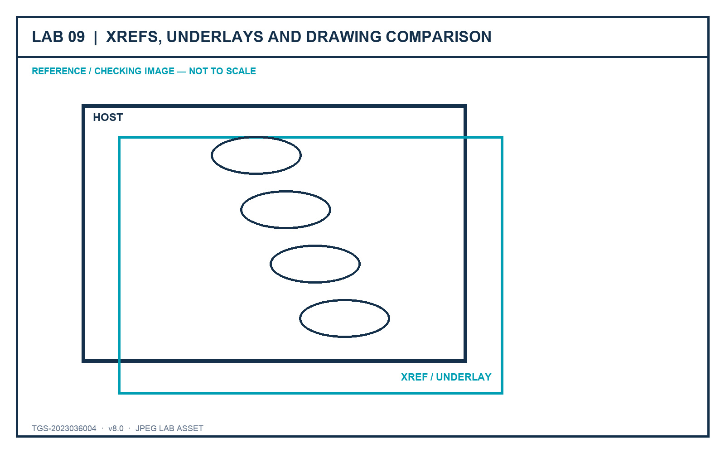
Figure: Lab JPEG visual brief/checking image

Outcome and supplied files
A host coordination drawing with controlled Xrefs/underlays and a documented comparison review.
- lab-reference.jpg - JPEG brief and checking image
- Furniture_Floor_Plan.dwg - recovered AutoCAD source file
- Sink_Layouts.dwg - recovered AutoCAD source file

Detailed procedure
Step 1 - Create a new host drawing and save it in the Lab 9 folder before attaching references.
Command / tool: NEW · SAVEAS
Step 2 - Attach Furniture_Floor_Plan.dwg as an Xref using a relative path, insertion 0,0,0, scale 1 and rotation 0.
Command / tool: XREF Attach
Step 3 - Overlay Sink_Layouts.dwg and explain why Overlay avoids nested-reference propagation.
Command / tool: XREF Overlay
Step 4 - Inspect Xref layer prefixes and apply a host-only layer override for review visibility.
Command / tool: LAYER
Step 5 - Unload and reload one reference; then repath it to a relative location without losing placement.
Command / tool: XREF Unload · Reload · Change Path
Step 6 - Attach the supplied JPEG reference as a raster underlay on a dedicated non-plotting layer.
Command / tool: IMAGEATTACH
Step 7 - Clip or fade the underlay only enough to support review without hiding host geometry.
Command / tool: IMAGECLIP · IMAGEADJUST
Step 8 - Create a controlled revision copy, change three items and run Drawing Compare.
Command / tool: DWGCOMPARE
Step 9 - Classify changes as added, removed or modified and record the required stakeholder response.
Command / tool: Compare review
Step 10 - Package the host and references and verify all relative links resolve from the package folder.
Command / tool: ETRANSMIT

Verification and acceptance
References resolve using controlled paths, ownership remains clear and the compare record accurately identifies changes.
- Save the final DWG using learner initials and a revision identifier.
- Capture the relevant setting and visible result in the same evidence sequence.
- Complete the lab evidence checklist before submission.

Lab 10 - Integrated Sink Documentation Capstone
Mapping: LO1–LO5 · K1–K4 · A1–A5
Complete the recovered sink-layout dataset as a professional drawing package and lead a short stakeholder review.
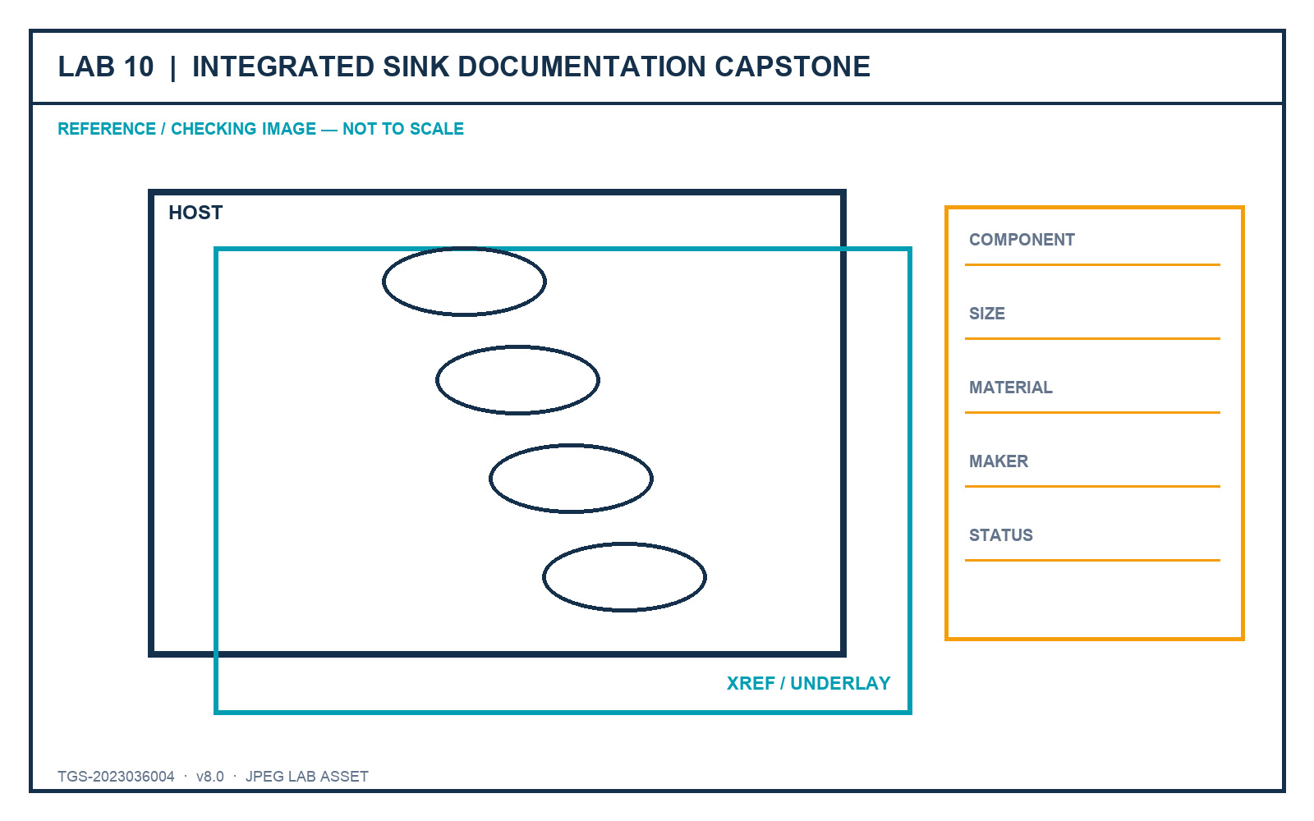
Figure: Lab JPEG visual brief/checking image

Outcome and supplied files
A standards-based sink drawing set with layouts, title blocks, viewports, component table, publish package and review evidence.
- lab-reference.jpg - JPEG brief and checking image
- Sink_Layouts.dwg - recovered AutoCAD source file
- Furniture_Block_Attributes.dwg - recovered AutoCAD source file
- ISO A1 title block.dwg - recovered AutoCAD source file
- ISO A2 title block.dwg - recovered AutoCAD source file
- ISO A3 title block.dwg - recovered AutoCAD source file

Detailed procedure
Step 1 - Review the capstone brief and define the intended visual hierarchy, sheet standards and stakeholder questions.
Command / tool: Capstone brief
Step 2 - Create ISO A1, A2 and A3 layouts with the correct page setups and title blocks at 0,0.
Command / tool: LAYOUT · PAGESETUP · INSERT
Step 3 - Create and lock the required Top, Front, Right and SE Isometric viewports at the specified scales.
Command / tool: MVIEW · 1:8 · 1:5
Step 4 - Apply the organisational layer and annotation standards developed in earlier labs.
Command / tool: Layer states · styles
Step 5 - Create a component schedule listing visible sink components, dimensions, materials and manufacturer details.
Command / tool: TABLE · attributes/data extraction
Step 6 - Use revision communication to identify one design decision that needs stakeholder confirmation.
Command / tool: REVCLOUD · MLEADER
Step 7 - Run drawing-health, missing-reference, scale and plot-preview checks.
Command / tool: AUDIT · XREF · PLOT Preview
Step 8 - Publish a multi-sheet PDF and create an eTransmit ZIP of the current package.
Command / tool: PUBLISH · ETRANSMIT
Step 9 - Present the drawing story in three minutes: overview, decision-critical details and requested approval.
Command / tool: Stakeholder review
Step 10 - Submit the DWG, published PDF, package inventory and completed evidence checklist.
Command / tool: Submission

Verification and acceptance
The drawing set meets the capstone acceptance criteria and the learner can justify each standard, technology and communication decision.
- Save the final DWG using learner initials and a revision identifier.
- Capture the relevant setting and visible result in the same evidence sequence.
- Complete the lab evidence checklist before submission.

Assessment Preparation
- Written Assessment (WA-SAQ) — 4 open-ended questions covering K1–K4, 60 minutes, open book.
- Practical Performance (PP) — 5 hands-on tasks covering A1–A5, 120 minutes, open book.
The WA retains four open-ended questions mapped to K1-K4. The PP retains five tasks mapped to A1-A5 and uses the recovered Sink_Layouts and ISO title-block dataset.
For the PP, rehearse the complete Lab 7 and Lab 10 workflow while explaining why each page setup, viewport, scale, title block and component-table decision is appropriate.

References
- Autodesk Certified Professional in AutoCAD for Design and Drafting certification page.
- Autodesk AutoCAD certification-preparation course, updated December 2025.
- Autodesk AutoCAD 2026 Help.
- Tertiary course page and published learning outcomes for TGS-2023036004.
- Legacy trainer slides v7, Learner Guide v2, Drive WA/PP v1, and recovered original PP dataset.

