
Tertiary Infotech Academy Pte Ltd
UEN: 201200696W
LESSON PLAN
For
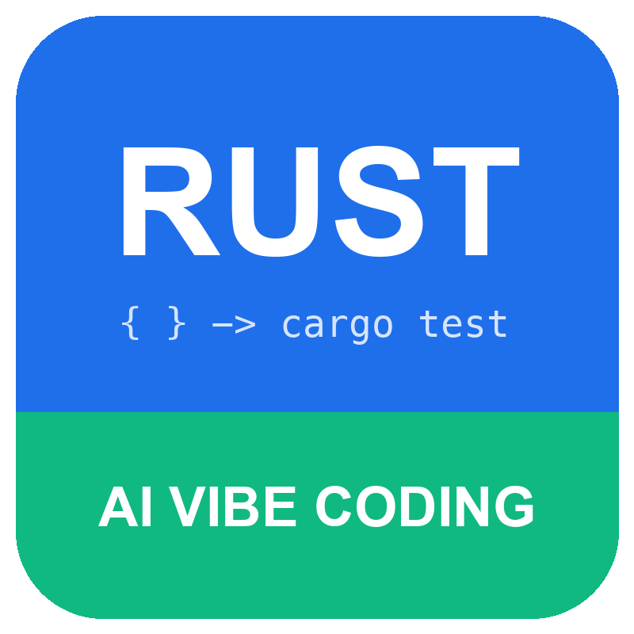
AI Vibe Coding with Rust
TGS Ref No: TGS-2023039924
Conducted by
Tertiary Infotech Academy Pte Ltd
UEN: 201200696W
Version 3.1

DOCUMENT VERSION CONTROL RECORD
Version Number | Effective Date of Release | Summary of Included Changes | Author
1.0 | Not recorded | Initial release (Methodologies in C Programming) | Tertiary Infotech Academy
2.0 | 13 September 2026 | Rebuilt as AI-Assisted C Programming for Arduino with 14 activities | Dr Alfred Ang
3.0 | 27 September 2026 | Course retitled AI Vibe Coding with Rust: all topics, slides, Learner Guide, Lesson Plan, 14 verified Rust activity crates and assessments rewritten | Dr Alfred Ang
3.1 | 27 September 2026 | Added the Learn Rust layer: 28 verified sample scripts, Learn Rust prompts in every Prompt PDF, a learn-it-first slide per activity and curated learning resources | Dr Alfred Ang

TABLE OF CONTENTS
Course Overview 4
Learning Outcomes 4
Daily Schedule 4
Topic-by-topic Breakdown 5
Topic 1: Rust Programming Fundamentals and Software Components (Slides 17-59) 5
Activity 1: Turn a specification into a Rust function (Slides 42-47) 5
Activity 2: Validate a product code with strings (Slides 48-53) 5
Activity 3: Share inventory records with ownership and borrowing (Slides 54-59) 6
Topic 2: AI Vibe Coding for Rust Application Development (Slides 60-102) 6
Activity 4: Vibe-code a command parser (Slides 85-90) 6
Activity 5: Organise a crate into modules (Slides 91-96) 6
Activity 6: Load inventory JSON with Cargo dependencies (Slides 97-102) 6
Topic 3: Rust Programming Controls, Functions and Features (Slides 103-146) 7
Activity 7: Apply stock movements with enums and match (Slides 128-133) 7
Activity 8: Track stock in a HashMap (Slides 134-139) 7
Activity 9: Price mixed order lines with traits and iterators (Slides 140-145) 7
Topic 4: Testing, Debugging and Integrating Rust Components (Slides 147-187) 7
Activity 10: Parse CSV records with Result and custom errors (Slides 169-174) 8
Activity 11: Debug a failing integration with tests (Slides 175-180) 8
Activity 12: Integrate components into a tested command-line tool (Slides 181-186) 8
Topic 5: AI-Assisted Rust Software Design and Documentation (Slides 188-222) 8
Activity 13: Document an API with rustdoc and doctests (Slides 210-215) 9
Activity 14: Design and document a reorder feature with AI (Slides 216-221) 9
Resources Required 9
Assessment 9
Evidence and Source Notes 9

Course Overview
AI Vibe Coding with Rust (TGS-2023039924) is a two-day WSQ course mapped to TSC Software Design ICT-DES-3005-1.1. Learners build Rust components for the StockPilot stock service with an AI coding assistant, using the compiler, tests, clippy and rustfmt as the acceptance gate. Delivery: 9:30 AM to 6:30 PM; 14 training hours and 2 assessment hours. Courseware version 3.1.

Learning Outcomes
LO1: Determine basic software components using programming methodologies to meet functional specifications (K1/A1).
LO2: Apply programming methodologies and tools for software creation (K2/A2).
LO3: Select essential programming controls and features to meet software design requirements (K3/A3).
LO4: Examine the interoperability and functionality of programming components (K4/A4).
LO5: Generate programming design documentation aligned with user specifications (K5/A5).

Daily Schedule
Time | Minutes | Topic / Activity | Content and method | Slides
Day 1 9:30-11:30 | 120 | Topic 1 / Activities 1-3 | Admin (Slides 1-16) then Rust toolchain, types, functions, strings, ownership | Slides 17-59
Day 1 11:30-12:30 | 60 | Topic 2 / Activity 4 | Vibe-coding loop, bounded prompts, compiler as reviewer | Slides 60-102
Day 1 12:30-1:30 | 60 | Lunch | Break / excluded | -
Day 1 1:30-3:30 | 120 | Topic 2 / Activities 5-6 | Modules, Cargo dependencies, fmt and clippy | Slides 60-102
Day 1 3:30-6:30 | 180 | Topic 3 / Activities 7-9 | match, collections, traits, generics and iterators | Slides 103-146
Day 2 9:30-12:30 | 180 | Topic 4 / Activities 10-12 | Errors, debugging, integration tests and CLI | Slides 147-187
Day 2 12:30-1:30 | 60 | Lunch | Break / excluded | -
Day 2 1:30-4:30 | 180 | Topic 5 / Activities 13-14 + briefing | rustdoc, doctests, traceability and design record | Slides 188-222
Day 2 4:30-5:30 | 60 | Written Assessment / K1-K5 | Individual, open book | -
Day 2 5:30-6:30 | 60 | Practical Performance / A1-A5 | Individual, hands-on | -
Training contact: Topic 1 120 min, Topic 2 180 min, Topic 3 180 min, Topic 4 180 min, Topic 5 180 min = 840 min (14 h). Day 1: 480 training minutes. Day 2: 360 training minutes + 120 assessment minutes. Two 60-minute lunches are excluded. Activity minutes are hands-on practice inside each block; the remaining time covers concept teaching, demonstrations, AI-review discussion and feedback. Short breaks are taken within blocks as needed.

Topic-by-topic Breakdown

Topic 1: Rust Programming Fundamentals and Software Components (Slides 17-59)
K1/A1. Method: interactive lecture with worked Rust examples (divider Slide 17), live vibe-coding demonstration, then independent hands-on activities with trainer review.
Concept | Slides
A specification becomes a component contract | 18-20
The Rust toolchain: rustup, cargo and rustc | 21-23
Anatomy of a Cargo package | 24-26
Variables are immutable by default | 27-29
Choose integer types deliberately | 30-32
Functions: the signature is the contract | 33-35
String and &str: owned text and borrowed text | 36-38
Ownership moves; borrowing lends | 39-41

Activity 1: Turn a specification into a Rust function (Slides 42-47)
StockPilot must price an order line. The specification limits quantity to 1..10,000 and forbids a silently wrapped total. You create the Cargo package, write the function and prove it with tests. Mapping: K1/A1; 25 minutes; folder labs/activity-01-line-total.
Acceptance: cargo test reports 5 passed; cargo run prints "4 x 250 cents = 1000 cents". Trainer checks: signatures unchanged, boundary tests predicted from the specification, clippy and fmt clean, and a review record showing at least one AI proposal accepted, edited or rejected with a reason.

Activity 2: Validate a product code with strings (Slides 48-53)
Product codes arrive from scanners and spreadsheets with stray spaces and lower-case letters. StockPilot accepts only the SKU format AAA-9999 and normalises valid input to upper case. Mapping: K1/A1; 25 minutes; folder labs/activity-02-sku-validation.
Acceptance: cargo test reports 6 passed, including the non-ASCII and whitespace cases. Trainer checks: signatures unchanged, boundary tests predicted from the specification, clippy and fmt clean, and a review record showing at least one AI proposal accepted, edited or rejected with a reason.

Activity 3: Share inventory records with ownership and borrowing (Slides 54-59)
Three StockPilot functions handle the same item list differently: one only reads it, one changes one item and one consumes the list. You choose the parameter types that express those intentions. Mapping: K1/A1 K3/A3; 25 minutes; folder labs/activity-03-ownership-borrowing.
Acceptance: cargo test reports 5 passed; the overflow test proves the item is unchanged. Trainer checks: signatures unchanged, boundary tests predicted from the specification, clippy and fmt clean, and a review record showing at least one AI proposal accepted, edited or rejected with a reason.

Topic 2: AI Vibe Coding for Rust Application Development (Slides 60-102)
K2/A2. Method: interactive lecture with worked Rust examples (divider Slide 60), live vibe-coding demonstration, then independent hands-on activities with trainer review.
Concept | Slides
The vibe-coding loop for Rust | 61-63
Write a bounded prompt | 64-66
The compiler is your first reviewer | 67-69
Review AI-generated Rust before accepting it | 70-72
Modules and visibility organise a crate | 73-75
Cargo dependencies and Cargo.lock | 76-78
fmt and clippy encode team practice | 79-81
Set up VS Code for Rust vibe coding | 82-84

Activity 4: Vibe-code a command parser (Slides 85-90)
Store staff will type commands such as "add ABC-0001 5". You describe the command language to an AI assistant, review the generated parser, and keep only code that passes the acceptance tests. Mapping: K2/A2; 25 minutes; folder labs/activity-04-cli-commands.
Acceptance: cargo test reports 5 passed; cargo run -- add ABC-0001 5 prints Add { sku: "ABC-0001", qty: 5 }. Trainer checks: signatures unchanged, boundary tests predicted from the specification, clippy and fmt clean, and a review record showing at least one AI proposal accepted, edited or rejected with a reason.

Activity 5: Organise a crate into modules (Slides 91-96)
The reporting code has grown. You split StockPilot formatting into a money module and a report module, expose only what callers need, and keep the behaviour identical under test. Mapping: K2/A2; 25 minutes; folder labs/activity-05-modules-visibility.
Acceptance: cargo test reports 4 passed; tests import activity05::money and activity05::report. Trainer checks: signatures unchanged, boundary tests predicted from the specification, clippy and fmt clean, and a review record showing at least one AI proposal accepted, edited or rejected with a reason.

Activity 6: Load inventory JSON with Cargo dependencies (Slides 97-102)
The purchasing team exports inventory as JSON. You add serde and serde_json with Cargo, derive the data contract, and let the type system reject malformed records at the boundary. Mapping: K2/A2 K4/A4; 25 minutes; folder labs/activity-06-cargo-serde-json.
Acceptance: cargo test reports 6 passed; stock value of data/inventory.json is 65,948 cents. Trainer checks: signatures unchanged, boundary tests predicted from the specification, clippy and fmt clean, and a review record showing at least one AI proposal accepted, edited or rejected with a reason.

Topic 3: Rust Programming Controls, Functions and Features (Slides 103-146)
K3/A3. Method: interactive lecture with worked Rust examples (divider Slide 103), live vibe-coding demonstration, then independent hands-on activities with trainer review.
Concept | Slides
if and match are expressions | 104-106
enum + match model every case | 107-109
Loops: for, while and loop | 110-112
Structs and impl blocks | 113-115
Collections: Vec and HashMap | 116-118
Traits and generics share behaviour | 119-121
Closures and iterator chains | 122-124
Option and Result are control features | 125-127

Activity 7: Apply stock movements with enums and match (Slides 128-133)
Stock changes through receipts, shipments and manual adjustments. An enum names every movement and match forces each one to be handled, including the failure cases. Mapping: K3/A3; 30 minutes; folder labs/activity-07-match-control-flow.
Acceptance: cargo test reports 6 passed, covering every variant and every error. Trainer checks: signatures unchanged, boundary tests predicted from the specification, clippy and fmt clean, and a review record showing at least one AI proposal accepted, edited or rejected with a reason.

Activity 8: Track stock in a HashMap (Slides 134-139)
StockPilot needs fast lookup by SKU. You wrap a HashMap in an Inventory type so every change goes through methods that enforce the stock rules. Mapping: K3/A3; 30 minutes; folder labs/activity-08-hashmap-inventory.
Acceptance: cargo test reports 6 passed; low_stock(5) returns AAA-0001 and BBB-0002 only. Trainer checks: signatures unchanged, boundary tests predicted from the specification, clippy and fmt clean, and a review record showing at least one AI proposal accepted, edited or rejected with a reason.

Activity 9: Price mixed order lines with traits and iterators (Slides 140-145)
Orders can contain products and services (for example, device set-up hours). A Priced trait gives both one pricing contract, and iterator chains total and filter them without manual index loops. Mapping: K3/A3; 30 minutes; folder labs/activity-09-traits-iterators.
Acceptance: cargo test reports 5 passed; the mixed order totals 14,297 cents. Trainer checks: signatures unchanged, boundary tests predicted from the specification, clippy and fmt clean, and a review record showing at least one AI proposal accepted, edited or rejected with a reason.

Topic 4: Testing, Debugging and Integrating Rust Components (Slides 147-187)
K4/A4. Method: interactive lecture with worked Rust examples (divider Slide 147), live vibe-coding demonstration, then independent hands-on activities with trainer review.
Concept | Slides
Unit tests live beside the code | 148-150
Integration tests check components together | 151-153
Custom errors and the ? operator | 154-156
Read a failing test like a detective | 157-159
Debug with dbg!, focused tests and AI | 160-162
Interoperability: arguments, files, exit codes | 163-165
Serde: typed data at the boundary | 166-168

Activity 10: Parse CSV records with Result and custom errors (Slides 169-174)
Stock files arrive with typos. Instead of crashing, StockPilot must report exactly which line is wrong and why, while still importing every valid line. Mapping: K4/A4; 30 minutes; folder labs/activity-10-error-handling.
Acceptance: cargo test reports 5 passed; data/stock.csv yields 2 records and errors on lines 3, 4 and 6. Trainer checks: signatures unchanged, boundary tests predicted from the specification, clippy and fmt clean, and a review record showing at least one AI proposal accepted, edited or rejected with a reason.

Activity 11: Debug a failing integration with tests (Slides 175-180)
The nightly stock summary is wrong: the total is too low and a correctly stocked item is flagged. The starter crate contains two real defects. You reproduce them with tests, diagnose them with the help of an AI assistant, fix them and keep regression tests. Mapping: K4/A4; 35 minutes; folder labs/activity-11-debug-integration.
Acceptance: Starter: 4 of 6 tests fail. After both fixes cargo test reports 6 passed. Trainer checks: signatures unchanged, boundary tests predicted from the specification, clippy and fmt clean, and a review record showing at least one AI proposal accepted, edited or rejected with a reason.

Activity 12: Integrate components into a tested command-line tool (Slides 181-186)
Operations staff will run StockPilot from a terminal and from scheduled scripts. You connect the library to a binary that reads a file, prints a report and returns exit codes that other programs can rely on. Mapping: K4/A4; 30 minutes; folder labs/activity-12-cli-integration.
Acceptance: cargo test reports 7 passed; cargo run -- ../data/stock.csv prints ITEMS 4, TOTAL $526.55, LOW STOCK ABC-0003. Trainer checks: signatures unchanged, boundary tests predicted from the specification, clippy and fmt clean, and a review record showing at least one AI proposal accepted, edited or rejected with a reason.

Topic 5: AI-Assisted Rust Software Design and Documentation (Slides 188-222)
K5/A5. Method: interactive lecture with worked Rust examples (divider Slide 188), live vibe-coding demonstration, then independent hands-on activities with trainer review.
Concept | Slides
Doc comments become documentation | 189-191
Doctests keep examples honest | 192-194
Trace requirements to code and tests | 195-197
Architecture and module maps | 198-200
Record design decisions | 201-203
AI-assisted documentation, human-verified | 204-206
Hand over: README and maintenance notes | 207-209

Activity 13: Document an API with rustdoc and doctests (Slides 210-215)
The maintenance team will own the reorder calculation. The starter code works but has no documentation. You write rustdoc comments whose examples are compiled and run as tests, and trace them to requirements. Mapping: K5/A5; 30 minutes; folder labs/activity-13-rustdoc-doctests.
Acceptance: cargo test runs 3 tests and 3 doctests; cargo doc --no-deps builds; clippy -D warnings is clean. Trainer checks: signatures unchanged, boundary tests predicted from the specification, clippy and fmt clean, and a review record showing at least one AI proposal accepted, edited or rejected with a reason.

Activity 14: Design and document a reorder feature with AI (Slides 216-221)
Capstone: purchasing wants weekly reorder suggestions. You agree requirements R1-R4, implement the feature with an AI assistant, and hand over a design record that traces every requirement to code and tests. Mapping: K5/A5 K4/A4; 30 minutes; folder labs/activity-14-design-capstone.
Acceptance: cargo test reports 6 passed and 1 doctest; docs/design.md traces R1-R4 to named tests. Trainer checks: signatures unchanged, boundary tests predicted from the specification, clippy and fmt clean, and a review record showing at least one AI proposal accepted, edited or rejected with a reason.

Resources Required
Current slide deck (AI-Vibe-Coding-with-Rust-v3.1), Learner Guide, and the course repository with 14 activity folders (each with starter/solution crates, samples/ scripts and a Prompt PDF). Per learner: Windows or Mac laptop, Rust stable via rustup (with clippy and rustfmt), Visual Studio Code with rust-analyzer, an AI coding assistant, and internet access (Activity 6 downloads the serde crates). Trainer: projector, the same toolchain, and the restricted assessment answer keys (not distributed to learners).

Assessment
Day 2, 4:30-5:30 PM: Written Assessment (SAQ), 60 minutes, 5 open-ended questions covering K1-K5. 5:30-6:30 PM: Practical Performance (PP), 60 minutes, 5 hands-on tasks covering A1-A5 using the class Rust crates. Both are open book and individual. Learners download papers and upload answers on the LMS (https://lms-tms.tertiaryinfotech.com/). Outcome: Competent (C) or Not Yet Competent (NYC); re-assessment and appeal follow the ATO procedure.

Evidence and Source Notes
All slide references in this plan are read from the built slide_map.json of the current deck. The 14 activity crates were verified with rustc 1.93.1 (01f6ddf75 2026-02-11) (build/qa/labs-verification.json). Sources are listed in the Learner Guide.

