Lumina launch readiness report
SW-2026 | Synthetic training example | DRAFT FOR REVIEW | 7 September 2026
Decision requested: retain the planned SGD 18,000 budget and close nine staff-training gaps before the 25 September release review. Launch remains planned for 1 October; the target is 120 qualified enquiries.
Jan–Jun revenue is SGD 933,290.00; cost is SGD 521,097.41; margin is SGD 412,192.59. Events contributes the highest margin: SGD 121,247.22. Margin is revenue minus supplied costs, not net profit. This history does not establish an October forecast or prove that reallocating spend will reproduce the result.
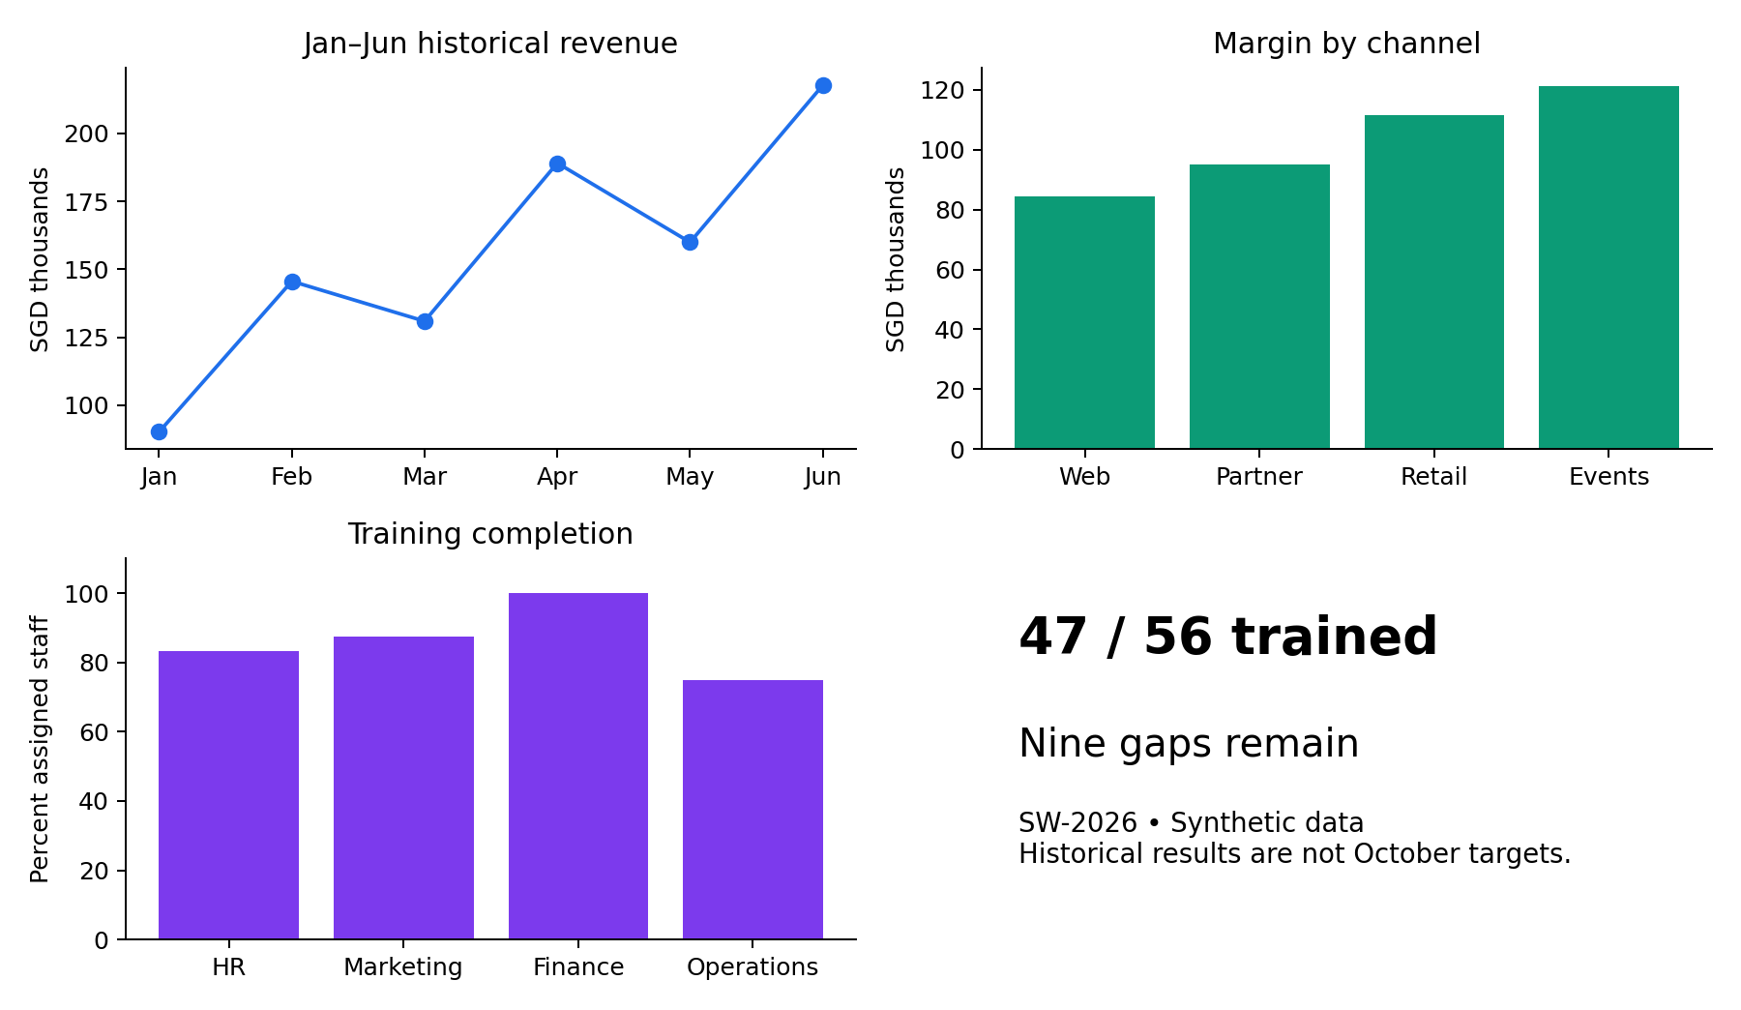
Sources: Lumina-Business-Data.xlsx — Campaign_Data!I2:J97; Monthly!A1:D7; Channels!A1:D5; HR_Readiness!A1:E6. Readiness is a simulated 7 September snapshot: 47/56 trained (83.9%). CAM-2026-Q4 supplies the planned budget, target and launch date.
Actions: A01 Aisha — train remaining staff by 24 September. A02 Daniel — review copy by 23 September. A03 Mei — verify numbers by 25 September. A04 Harish — service readiness by 25 September. Record evidence and review status in the same Loop action register. Carbon-neutral claims are not supported. This draft has not been approved, sent or posted.

