 | TERTIARY INFOTECH ACADEMY  Practical technology training for the work you do

WSQ COURSE / WSQ AI and Microsoft Copilot
AI Transformation with Microsoft Copilot
Plan, secure, integrate and measure Copilot at work
TGS-2024044051
3 days  DURATION | 24 hours including 2 hours of  TRAINING | Beginner  LEVEL | 12 Woodlands Square #07-85/86/  VENUE
Why this matters now
Turn Microsoft Copilot from isolated prompts into a controlled business improvement programme. Build an implementation plan, test security gates, design an agent workflow, and measure pilot value using evidence your stakeholders can review.
Fee at a glance
BEFORE GST  $1,500  Published course fee | AFTER GST  $1,635  GST included | MCES / SME 70% FUNDED  $585  Subject to eligibility
Funding support and benefits
MAKE TRAINING MORE AFFORDABLE
Verified support options for this course
✓ SkillsFuture Credit  Use available credit, subject to eligibility | ✓ PSEA  Eligible learners may use PSEA | ✓ SFEC  Employer support, subject to eligibility
✓ Absentee Payroll  Employer support, subject to eligibility | ✓ MCES  Enhanced funding, subject to eligibility

Explore dates and register  Scan the QR code or use the link to view current dates and register.  www.tertiarycourses.com.sg/wsq-ai-transformation-with-microsoft-copilot.html | 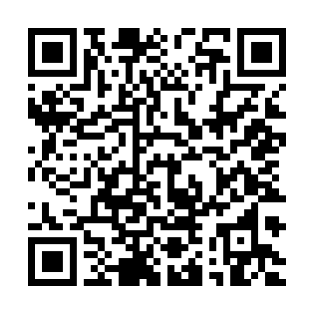  SCAN TO REGISTER

Course description
AI Transformation with Microsoft Copilot equips participants to plan, design, implement and evaluate AI-powered solutions using Microsoft 365 Copilot, Copilot Studio, Microsoft Foundry, Power Platform and connected business workflows. Learners work with organisational data, files and application context while preserving privacy and security. They design custom agents, prompts and integrations; test output quality, prompt injection and sensitive-data exposure; and use telemetry and ROI measures to decide whether to scale. Synthetic cases and structured labs keep practical evidence separate from live customer data.
Course topics
01 | Topic 1: Microsoft 365 Copilot Implementation and Business Process Transformation  Tenant readiness • License allocation • Graph permission scope • Business-process mapping • Opportunity scoring • Prompt context window • Grounded retrieval • Word proposal draft • Excel service analysis • PowerPoint executive story • Outlook response workflow • Teams meeting synthesis • Adoption rollout

02 | Topic 2: Microsoft Copilot Administration, Security and Responsible AI  Identity and MFA • Sensitivity labels • DLP boundaries • SharePoint oversharing • Retention and records • Audit event trail • Prompt-injection boundary • Fabrication review • Tool permission design • Environment policy • Incident response • Human decision gate

03 | Topic 3: Copilot Integration, AI Agents and Cross-Platform Workflows  Agent purpose contract • Knowledge-source curation • Citation evaluation • Copilot Studio topic routing • Connector action • Approval action • Power Automate flow • Dynamics 365 context • Foundry model choice • MCP tool registration • A2A handoff • Multi-agent orchestration • Cross-platform error handling

04 | Topic 4: AI Optimization, Performance Monitoring and Business Value Assessment  Usage telemetry • Agent quality rubric • Golden test set • Time-saved estimate • ROI model • License optimization • Latency budget • Error budget • Feedback triage • Experiment design • Rollout wave gate • Retirement control

Learning outcomes
LO1 Develop technology implementation plans and business processes for Microsoft Copilot.
LO2 Develop control procedures for Microsoft Copilot to manage security.
LO3 Evaluate the integration of Microsoft Copilot to ensure alignment with business objectives.
LO4 Develop optimization plans for Microsoft Copilot to improve business operations.

Fees and course details
Published fee: $1,500 before GST. GST: $135. Total: $1,635 after GST.
Scenario | Funding | Before GST | After GST
Baseline 50% funded | $750 | $750 | $885
MCES / SME 70% funded | $1,050 | $450 | $585
Funding and final payable amounts are subject to eligibility and official approval. GST is shown separately from the course fee.
Funding validity: 5 Apr 2024 to 4 Apr 2028
Eligible support and course benefits
SkillsFuture Credit
PSEA
SFEC
Absentee Payroll
MCES
Plan your attendance
Duration | 3 days
Training and assessment | 24 hours including 2 hours of assessment
Mode | Physical classroom or synchronised Zoom; corporate training available
Venue | 12 Woodlands Square #07-85/86/87, Woods Square Tower 1, Singapore 737715
Schedule | 9:30am–6:30pm on scheduled training days
Assessment | Written assessment and practical performance assessment, one hour each, individual open book
Who should attend | Business transformation, operations, IT, security and process owners who need evidence-led Copilot adoption and control decisions.
Certification | Certificate of Achievement from Tertiary Infotech Academy and, on meeting WSQ assessment and attendance requirements, SkillsFuture Singapore Statement of Attainment via OpenCerts.

Ready to build your next capability?  Scan the QR code or use the link to view current dates and register.  www.tertiarycourses.com.sg/wsq-ai-transformation-with-microsoft-copilot.html | SCAN TO REGISTER
enquiry@tertiaryinfotech.com · +65 6100 0613

