


AI Transformation with Microsoft Copilot
Learner Guide | TGS-2024044051 | v1.0 | 27 September 2026
Conducted by Tertiary Infotech Academy Pte Ltd · UEN 201200696W

Document Version Control Record
Version | Effective date | Material changes | Author
v1.0 | 27 September 2026 | Complete replacement of legacy MS-700 content with Copilot implementation, security, agents and value assessment. | Tertiary Infotech Academy

Table of contents
Topic 1: Microsoft 365 Copilot Implementation and Business Process Transformation ........................................ 3
Topic 2: Microsoft Copilot Administration, Security and Responsible AI ........................................ 9
Topic 3: Copilot Integration, AI Agents and Cross-Platform Workflows ........................................ 14
Topic 4: AI Optimization, Performance Monitoring and Business Value Assessment ........................................ 20
Lab walkthroughs ........................................ 26
Assessment preparation ........................................ 46

Course learning outcomes
- LO1. Develop technology implementation plans and business processes for Microsoft Copilot.
- LO2. Develop control procedures for Microsoft Copilot to manage security.
- LO3. Evaluate the integration of Microsoft Copilot to ensure alignment with business objectives.
- LO4. Develop optimization plans for Microsoft Copilot to improve business operations.

Before you start
Use an approved Microsoft 365 training tenant. All Northstar Service names, customers, accounts and figures in this guide are synthetic. Do not enter live personal or confidential information in exercises.
Some tenant features require licences or administrator policy. Use the provided synthetic evidence and decision templates when a feature is unavailable; record the limitation rather than claiming a live configuration.

Topic 1: Microsoft 365 Copilot Implementation and Business Process Transformation
Learning outcome: LO1. Official reference: https://learn.microsoft.com/en-us/copilot/microsoft-365/microsoft-365-copilot-architecture

01. Tenant readiness
Operational situation. Northstar Service starts with microsoft 365 tenant inventory. The intended transformation is to check identities, data estate and licensed workload availability and produce readiness register with owner and gap.
Procedure. 1. Open the relevant approved Microsoft 365 or Copilot Studio workspace, or the synthetic case record supplied in the lab. 2. Record the input and its owner. 3. Apply the transformation to a copy. 4. Compare the output with the source. 5. Log the reviewer, decision and date. Never claim a simulated configuration is a tenant deployment.
Control. Admin signs off app and data prerequisites. Diagnose a failure when licensed user lacks a supported app or data source. Preserve an input/output evidence trace and rerun the same test after correction.
Measure. Eligible users divided by target users. Define numerator, denominator, time window and cohort before comparing a baseline with a pilot. Do not infer business value from activity counts alone.
Practice in Lab 01. Evidence: Readiness register with owner and gap; expected acceptance: Admin signs off app and data prerequisites.

02. License allocation
Operational situation. Northstar Service starts with 30 pilot seats and role list. The intended transformation is to match entitlement to high-frequency document tasks and produce license assignment and cohort list.
Procedure. 1. Open the relevant approved Microsoft 365 or Copilot Studio workspace, or the synthetic case record supplied in the lab. 2. Record the input and its owner. 3. Apply the transformation to a copy. 4. Compare the output with the source. 5. Log the reviewer, decision and date. Never claim a simulated configuration is a tenant deployment.
Control. Approve seats against role and cost center. Diagnose a failure when seat assigned but service plan disabled. Preserve an input/output evidence trace and rerun the same test after correction.
Measure. Active pilot users divided by assigned seats. Define numerator, denominator, time window and cohort before comparing a baseline with a pilot. Do not infer business value from activity counts alone.
Practice in Lab 01. Evidence: License assignment and cohort list; expected acceptance: Approve seats against role and cost center.

03. Graph permission scope
Operational situation. Northstar Service starts with sharepoint file acl and test identities. The intended transformation is to compare search results under user a and user b and produce access matrix with allowed files.
Procedure. 1. Open the relevant approved Microsoft 365 or Copilot Studio workspace, or the synthetic case record supplied in the lab. 2. Record the input and its owner. 3. Apply the transformation to a copy. 4. Compare the output with the source. 5. Log the reviewer, decision and date. Never claim a simulated configuration is a tenant deployment.
Control. Least privilege and owner review. Diagnose a failure when overshared file appears in both result sets. Preserve an input/output evidence trace and rerun the same test after correction.
Measure. Unexpected accessible files count. Define numerator, denominator, time window and cohort before comparing a baseline with a pilot. Do not infer business value from activity counts alone.
Practice in Lab 01. Evidence: Access matrix with allowed files; expected acceptance: Least privilege and owner review.

04. Business-process mapping
Operational situation. Northstar Service starts with service request intake with six handoffs. The intended transformation is to mark drafting, lookup and approval steps and produce current-to-future swimlane.
Procedure. 1. Open the relevant approved Microsoft 365 or Copilot Studio workspace, or the synthetic case record supplied in the lab. 2. Record the input and its owner. 3. Apply the transformation to a copy. 4. Compare the output with the source. 5. Log the reviewer, decision and date. Never claim a simulated configuration is a tenant deployment.
Control. Keep human approval on customer-facing send. Diagnose a failure when automation bypasses approval. Preserve an input/output evidence trace and rerun the same test after correction.
Measure. Median handoff time in minutes. Define numerator, denominator, time window and cohort before comparing a baseline with a pilot. Do not infer business value from activity counts alone.
Practice in Lab 01. Evidence: Current-to-future swimlane; expected acceptance: Keep human approval on customer-facing send.

05. Opportunity scoring
Operational situation. Northstar Service starts with ten candidate workflows. The intended transformation is to score volume, time, data quality and risk and produce ranked use-case backlog.
Procedure. 1. Open the relevant approved Microsoft 365 or Copilot Studio workspace, or the synthetic case record supplied in the lab. 2. Record the input and its owner. 3. Apply the transformation to a copy. 4. Compare the output with the source. 5. Log the reviewer, decision and date. Never claim a simulated configuration is a tenant deployment.
Control. Reject use case with ungoverned sensitive data. Diagnose a failure when high score hides missing data owner. Preserve an input/output evidence trace and rerun the same test after correction.
Measure. Weighted score per use case. Define numerator, denominator, time window and cohort before comparing a baseline with a pilot. Do not infer business value from activity counts alone.
Practice in Lab 01. Evidence: Ranked use-case backlog; expected acceptance: Reject use case with ungoverned sensitive data.

06. Prompt context window
Operational situation. Northstar Service starts with customer email and policy excerpts. The intended transformation is to separate task, context, constraints and format and produce reusable prompt card.
Procedure. 1. Open the relevant approved Microsoft 365 or Copilot Studio workspace, or the synthetic case record supplied in the lab. 2. Record the input and its owner. 3. Apply the transformation to a copy. 4. Compare the output with the source. 5. Log the reviewer, decision and date. Never claim a simulated configuration is a tenant deployment.
Control. Never paste personal data into unmanaged chat. Diagnose a failure when answer omits policy exception. Preserve an input/output evidence trace and rerun the same test after correction.
Measure. Grounded claims divided by claims. Define numerator, denominator, time window and cohort before comparing a baseline with a pilot. Do not infer business value from activity counts alone.
Practice in Lab 02. Evidence: Reusable prompt card; expected acceptance: Never paste personal data into unmanaged chat.

07. Grounded retrieval
Operational situation. Northstar Service starts with approved policy file and user query. The intended transformation is to retrieve accessible passages before generation and produce answer with source citations.
Procedure. 1. Open the relevant approved Microsoft 365 or Copilot Studio workspace, or the synthetic case record supplied in the lab. 2. Record the input and its owner. 3. Apply the transformation to a copy. 4. Compare the output with the source. 5. Log the reviewer, decision and date. Never claim a simulated configuration is a tenant deployment.
Control. Verify source version and user permission. Diagnose a failure when citation points to superseded policy. Preserve an input/output evidence trace and rerun the same test after correction.
Measure. Supported answer statements divided by total. Define numerator, denominator, time window and cohort before comparing a baseline with a pilot. Do not infer business value from activity counts alone.
Practice in Lab 02. Evidence: Answer with source citations; expected acceptance: Verify source version and user permission.

08. Word proposal draft
Operational situation. Northstar Service starts with synthetic service improvement brief. The intended transformation is to generate structure then compare to source register and produce draft proposal with evidence comments.
Procedure. 1. Open the relevant approved Microsoft 365 or Copilot Studio workspace, or the synthetic case record supplied in the lab. 2. Record the input and its owner. 3. Apply the transformation to a copy. 4. Compare the output with the source. 5. Log the reviewer, decision and date. Never claim a simulated configuration is a tenant deployment.
Control. Human owns final facts and approval. Diagnose a failure when unsupported cost claim enters draft. Preserve an input/output evidence trace and rerun the same test after correction.
Measure. Verified claims divided by total claims. Define numerator, denominator, time window and cohort before comparing a baseline with a pilot. Do not infer business value from activity counts alone.
Practice in Lab 02. Evidence: Draft proposal with evidence comments; expected acceptance: Human owns final facts and approval.

09. Excel service analysis
Operational situation. Northstar Service starts with synthetic ticket table: 120 rows. The intended transformation is to aggregate cycle time by issue category and produce pivot table and chart.
Procedure. 1. Open the relevant approved Microsoft 365 or Copilot Studio workspace, or the synthetic case record supplied in the lab. 2. Record the input and its owner. 3. Apply the transformation to a copy. 4. Compare the output with the source. 5. Log the reviewer, decision and date. Never claim a simulated configuration is a tenant deployment.
Control. Check formula range and outliers. Diagnose a failure when blank dates skew mean. Preserve an input/output evidence trace and rerun the same test after correction.
Measure. Median cycle time by category. Define numerator, denominator, time window and cohort before comparing a baseline with a pilot. Do not infer business value from activity counts alone.
Practice in Lab 02. Evidence: Pivot table and chart; expected acceptance: Check formula range and outliers.

10. PowerPoint executive story
Operational situation. Northstar Service starts with approved word findings and excel chart. The intended transformation is to create a three-message decision deck and produce five-slide review deck.
Procedure. 1. Open the relevant approved Microsoft 365 or Copilot Studio workspace, or the synthetic case record supplied in the lab. 2. Record the input and its owner. 3. Apply the transformation to a copy. 4. Compare the output with the source. 5. Log the reviewer, decision and date. Never claim a simulated configuration is a tenant deployment.
Control. Presenter validates every number. Diagnose a failure when chart title and source mismatch. Preserve an input/output evidence trace and rerun the same test after correction.
Measure. Correct figures divided by checked figures. Define numerator, denominator, time window and cohort before comparing a baseline with a pilot. Do not infer business value from activity counts alone.
Practice in Lab 02. Evidence: Five-slide review deck; expected acceptance: Presenter validates every number.

11. Outlook response workflow
Operational situation. Northstar Service starts with synthetic customer escalation email. The intended transformation is to draft acknowledgement and response options and produce reviewed reply with owner and deadline.
Procedure. 1. Open the relevant approved Microsoft 365 or Copilot Studio workspace, or the synthetic case record supplied in the lab. 2. Record the input and its owner. 3. Apply the transformation to a copy. 4. Compare the output with the source. 5. Log the reviewer, decision and date. Never claim a simulated configuration is a tenant deployment.
Control. Send remains a human action. Diagnose a failure when tone implies an unapproved commitment. Preserve an input/output evidence trace and rerun the same test after correction.
Measure. Replies with explicit next owner. Define numerator, denominator, time window and cohort before comparing a baseline with a pilot. Do not infer business value from activity counts alone.
Practice in Lab 03. Evidence: Reviewed reply with owner and deadline; expected acceptance: Send remains a human action.

12. Teams meeting synthesis
Operational situation. Northstar Service starts with synthetic transcript with actions. The intended transformation is to extract decisions, dissent and open questions and produce action register with timestamps.
Procedure. 1. Open the relevant approved Microsoft 365 or Copilot Studio workspace, or the synthetic case record supplied in the lab. 2. Record the input and its owner. 3. Apply the transformation to a copy. 4. Compare the output with the source. 5. Log the reviewer, decision and date. Never claim a simulated configuration is a tenant deployment.
Control. Meeting owner confirms transcript accuracy. Diagnose a failure when speaker attribution is wrong. Preserve an input/output evidence trace and rerun the same test after correction.
Measure. Confirmed actions divided by extracted actions. Define numerator, denominator, time window and cohort before comparing a baseline with a pilot. Do not infer business value from activity counts alone.
Practice in Lab 03. Evidence: Action register with timestamps; expected acceptance: Meeting owner confirms transcript accuracy.

13. Adoption rollout
Operational situation. Northstar Service starts with three departments and pilot feedback. The intended transformation is to sequence champions, learning and support and produce 30-60-90 day rollout plan.
Procedure. 1. Open the relevant approved Microsoft 365 or Copilot Studio workspace, or the synthetic case record supplied in the lab. 2. Record the input and its owner. 3. Apply the transformation to a copy. 4. Compare the output with the source. 5. Log the reviewer, decision and date. Never claim a simulated configuration is a tenant deployment.
Control. Gate wave two on measured quality. Diagnose a failure when low adoption despite licenses. Preserve an input/output evidence trace and rerun the same test after correction.
Measure. Weekly active usage by cohort. Define numerator, denominator, time window and cohort before comparing a baseline with a pilot. Do not infer business value from activity counts alone.
Practice in Lab 03. Evidence: 30-60-90 day rollout plan; expected acceptance: Gate wave two on measured quality.

Topic 2: Microsoft Copilot Administration, Security and Responsible AI
Learning outcome: LO2. Official reference: https://learn.microsoft.com/en-us/microsoft-copilot-studio/security-faq

14. Identity and MFA
Operational situation. Northstar Service starts with user roles and sign-in policy. The intended transformation is to require appropriate identity assurance and produce conditional-access decision log.
Procedure. 1. Open the relevant approved Microsoft 365 or Copilot Studio workspace, or the synthetic case record supplied in the lab. 2. Record the input and its owner. 3. Apply the transformation to a copy. 4. Compare the output with the source. 5. Log the reviewer, decision and date. Never claim a simulated configuration is a tenant deployment.
Control. Security team owns exception process. Diagnose a failure when shared account bypasses attribution. Preserve an input/output evidence trace and rerun the same test after correction.
Measure. Protected sign-ins divided by sign-ins. Define numerator, denominator, time window and cohort before comparing a baseline with a pilot. Do not infer business value from activity counts alone.
Practice in Lab 03. Evidence: Conditional-access decision log; expected acceptance: Security team owns exception process.

15. Sensitivity labels
Operational situation. Northstar Service starts with public, internal and confidential files. The intended transformation is to map labels to sharing and copilot exposure and produce label policy matrix.
Procedure. 1. Open the relevant approved Microsoft 365 or Copilot Studio workspace, or the synthetic case record supplied in the lab. 2. Record the input and its owner. 3. Apply the transformation to a copy. 4. Compare the output with the source. 5. Log the reviewer, decision and date. Never claim a simulated configuration is a tenant deployment.
Control. Data owner reviews label changes. Diagnose a failure when confidential file labelled public. Preserve an input/output evidence trace and rerun the same test after correction.
Measure. Mislabelled sampled files count. Define numerator, denominator, time window and cohort before comparing a baseline with a pilot. Do not infer business value from activity counts alone.
Practice in Lab 03. Evidence: Label policy matrix; expected acceptance: Data owner reviews label changes.

16. DLP boundaries
Operational situation. Northstar Service starts with prompt containing synthetic account number. The intended transformation is to block or warn for restricted data movement and produce dlp test evidence.
Procedure. 1. Open the relevant approved Microsoft 365 or Copilot Studio workspace, or the synthetic case record supplied in the lab. 2. Record the input and its owner. 3. Apply the transformation to a copy. 4. Compare the output with the source. 5. Log the reviewer, decision and date. Never claim a simulated configuration is a tenant deployment.
Control. Policy owner approves exceptions. Diagnose a failure when sensitive output leaves approved boundary. Preserve an input/output evidence trace and rerun the same test after correction.
Measure. Blocked risky attempts per test set. Define numerator, denominator, time window and cohort before comparing a baseline with a pilot. Do not infer business value from activity counts alone.
Practice in Lab 04. Evidence: DLP test evidence; expected acceptance: Policy owner approves exceptions.

17. SharePoint oversharing
Operational situation. Northstar Service starts with site members, visitors and anonymous links. The intended transformation is to review inherited access and link types and produce remediation ticket list.
Procedure. 1. Open the relevant approved Microsoft 365 or Copilot Studio workspace, or the synthetic case record supplied in the lab. 2. Record the input and its owner. 3. Apply the transformation to a copy. 4. Compare the output with the source. 5. Log the reviewer, decision and date. Never claim a simulated configuration is a tenant deployment.
Control. Owner removes broad access before pilot. Diagnose a failure when copilot surfaces a broadly shared secret. Preserve an input/output evidence trace and rerun the same test after correction.
Measure. High-risk links remediated. Define numerator, denominator, time window and cohort before comparing a baseline with a pilot. Do not infer business value from activity counts alone.
Practice in Lab 04. Evidence: Remediation ticket list; expected acceptance: Owner removes broad access before pilot.

18. Retention and records
Operational situation. Northstar Service starts with contract lifecycle and retention schedule. The intended transformation is to apply record class to source documents and produce retention decision table.
Procedure. 1. Open the relevant approved Microsoft 365 or Copilot Studio workspace, or the synthetic case record supplied in the lab. 2. Record the input and its owner. 3. Apply the transformation to a copy. 4. Compare the output with the source. 5. Log the reviewer, decision and date. Never claim a simulated configuration is a tenant deployment.
Control. Records officer approves disposal. Diagnose a failure when old draft retrieved as current policy. Preserve an input/output evidence trace and rerun the same test after correction.
Measure. Current-version retrieval rate. Define numerator, denominator, time window and cohort before comparing a baseline with a pilot. Do not infer business value from activity counts alone.
Practice in Lab 04. Evidence: Retention decision table; expected acceptance: Records officer approves disposal.

19. Audit event trail
Operational situation. Northstar Service starts with agent action and user identity. The intended transformation is to capture time, actor, source and action and produce traceable audit record.
Procedure. 1. Open the relevant approved Microsoft 365 or Copilot Studio workspace, or the synthetic case record supplied in the lab. 2. Record the input and its owner. 3. Apply the transformation to a copy. 4. Compare the output with the source. 5. Log the reviewer, decision and date. Never claim a simulated configuration is a tenant deployment.
Control. Admin preserves logs per policy. Diagnose a failure when action cannot be attributed to a user. Preserve an input/output evidence trace and rerun the same test after correction.
Measure. Trace-complete actions divided by actions. Define numerator, denominator, time window and cohort before comparing a baseline with a pilot. Do not infer business value from activity counts alone.
Practice in Lab 04. Evidence: Traceable audit record; expected acceptance: Admin preserves logs per policy.

20. Prompt-injection boundary
Operational situation. Northstar Service starts with document with an embedded hostile instruction. The intended transformation is to treat retrieved text as data, not instruction and produce injection test and refusal trace.
Procedure. 1. Open the relevant approved Microsoft 365 or Copilot Studio workspace, or the synthetic case record supplied in the lab. 2. Record the input and its owner. 3. Apply the transformation to a copy. 4. Compare the output with the source. 5. Log the reviewer, decision and date. Never claim a simulated configuration is a tenant deployment.
Control. Tool action requires explicit authorization. Diagnose a failure when agent follows source text as a command. Preserve an input/output evidence trace and rerun the same test after correction.
Measure. Injected commands ignored per test set. Define numerator, denominator, time window and cohort before comparing a baseline with a pilot. Do not infer business value from activity counts alone.
Practice in Lab 04. Evidence: Injection test and refusal trace; expected acceptance: Tool action requires explicit authorization.

21. Fabrication review
Operational situation. Northstar Service starts with answer with five factual claims. The intended transformation is to check each claim against current citations and produce claim-verification worksheet.
Procedure. 1. Open the relevant approved Microsoft 365 or Copilot Studio workspace, or the synthetic case record supplied in the lab. 2. Record the input and its owner. 3. Apply the transformation to a copy. 4. Compare the output with the source. 5. Log the reviewer, decision and date. Never claim a simulated configuration is a tenant deployment.
Control. Human reviewer signs high-impact output. Diagnose a failure when plausible unsupported number survives. Preserve an input/output evidence trace and rerun the same test after correction.
Measure. Supported claims divided by claims. Define numerator, denominator, time window and cohort before comparing a baseline with a pilot. Do not infer business value from activity counts alone.
Practice in Lab 05. Evidence: Claim-verification worksheet; expected acceptance: Human reviewer signs high-impact output.

22. Tool permission design
Operational situation. Northstar Service starts with read and write connector scopes. The intended transformation is to separate read-only pilot from write actions and produce permission grant register.
Procedure. 1. Open the relevant approved Microsoft 365 or Copilot Studio workspace, or the synthetic case record supplied in the lab. 2. Record the input and its owner. 3. Apply the transformation to a copy. 4. Compare the output with the source. 5. Log the reviewer, decision and date. Never claim a simulated configuration is a tenant deployment.
Control. Entra admin consents only minimum scope. Diagnose a failure when write tool used in a read workflow. Preserve an input/output evidence trace and rerun the same test after correction.
Measure. Unused privileged grants count. Define numerator, denominator, time window and cohort before comparing a baseline with a pilot. Do not infer business value from activity counts alone.
Practice in Lab 05. Evidence: Permission grant register; expected acceptance: Entra admin consents only minimum scope.

23. Environment policy
Operational situation. Northstar Service starts with dev, test and production environments. The intended transformation is to apply connector and publishing policy and produce environment control matrix.
Procedure. 1. Open the relevant approved Microsoft 365 or Copilot Studio workspace, or the synthetic case record supplied in the lab. 2. Record the input and its owner. 3. Apply the transformation to a copy. 4. Compare the output with the source. 5. Log the reviewer, decision and date. Never claim a simulated configuration is a tenant deployment.
Control. Promote only after test evidence. Diagnose a failure when maker publishes from unrestricted default. Preserve an input/output evidence trace and rerun the same test after correction.
Measure. Policy violations by environment. Define numerator, denominator, time window and cohort before comparing a baseline with a pilot. Do not infer business value from activity counts alone.
Practice in Lab 05. Evidence: Environment control matrix; expected acceptance: Promote only after test evidence.

24. Incident response
Operational situation. Northstar Service starts with synthetic disclosure report. The intended transformation is to contain, preserve evidence, notify owner and produce incident timeline and action log.
Procedure. 1. Open the relevant approved Microsoft 365 or Copilot Studio workspace, or the synthetic case record supplied in the lab. 2. Record the input and its owner. 3. Apply the transformation to a copy. 4. Compare the output with the source. 5. Log the reviewer, decision and date. Never claim a simulated configuration is a tenant deployment.
Control. Security owner determines escalation. Diagnose a failure when evidence lost during agent disable. Preserve an input/output evidence trace and rerun the same test after correction.
Measure. Time to containment in minutes. Define numerator, denominator, time window and cohort before comparing a baseline with a pilot. Do not infer business value from activity counts alone.
Practice in Lab 05. Evidence: Incident timeline and action log; expected acceptance: Security owner determines escalation.

25. Human decision gate
Operational situation. Northstar Service starts with draft customer refund recommendation. The intended transformation is to require reviewer before irreversible action and produce approval record with rationale.
Procedure. 1. Open the relevant approved Microsoft 365 or Copilot Studio workspace, or the synthetic case record supplied in the lab. 2. Record the input and its owner. 3. Apply the transformation to a copy. 4. Compare the output with the source. 5. Log the reviewer, decision and date. Never claim a simulated configuration is a tenant deployment.
Control. Named business owner signs release. Diagnose a failure when workflow auto-issues refund. Preserve an input/output evidence trace and rerun the same test after correction.
Measure. Unapproved actions count. Define numerator, denominator, time window and cohort before comparing a baseline with a pilot. Do not infer business value from activity counts alone.
Practice in Lab 05. Evidence: Approval record with rationale; expected acceptance: Named business owner signs release.

Topic 3: Copilot Integration, AI Agents and Cross-Platform Workflows
Learning outcome: LO3. Official reference: https://learn.microsoft.com/en-us/microsoft-copilot-studio/knowledge-improve

26. Agent purpose contract
Operational situation. Northstar Service starts with helpdesk scope and user intents. The intended transformation is to define allowed requests and refusals and produce agent instruction card.
Procedure. 1. Open the relevant approved Microsoft 365 or Copilot Studio workspace, or the synthetic case record supplied in the lab. 2. Record the input and its owner. 3. Apply the transformation to a copy. 4. Compare the output with the source. 5. Log the reviewer, decision and date. Never claim a simulated configuration is a tenant deployment.
Control. Scope owner approves boundary. Diagnose a failure when agent answers outside approved domain. Preserve an input/output evidence trace and rerun the same test after correction.
Measure. In-scope resolution rate. Define numerator, denominator, time window and cohort before comparing a baseline with a pilot. Do not infer business value from activity counts alone.
Practice in Lab 06. Evidence: Agent instruction card; expected acceptance: Scope owner approves boundary.

27. Knowledge-source curation
Operational situation. Northstar Service starts with policy pdfs and sharepoint site. The intended transformation is to choose authoritative files with metadata and produce source register and index plan.
Procedure. 1. Open the relevant approved Microsoft 365 or Copilot Studio workspace, or the synthetic case record supplied in the lab. 2. Record the input and its owner. 3. Apply the transformation to a copy. 4. Compare the output with the source. 5. Log the reviewer, decision and date. Never claim a simulated configuration is a tenant deployment.
Control. Remove stale or duplicate files. Diagnose a failure when agent cites archived policy. Preserve an input/output evidence trace and rerun the same test after correction.
Measure. Current-source citation rate. Define numerator, denominator, time window and cohort before comparing a baseline with a pilot. Do not infer business value from activity counts alone.
Practice in Lab 06. Evidence: Source register and index plan; expected acceptance: Remove stale or duplicate files.

28. Citation evaluation
Operational situation. Northstar Service starts with twenty grounded test questions. The intended transformation is to compare answers to source passages and produce evaluation scorecard.
Procedure. 1. Open the relevant approved Microsoft 365 or Copilot Studio workspace, or the synthetic case record supplied in the lab. 2. Record the input and its owner. 3. Apply the transformation to a copy. 4. Compare the output with the source. 5. Log the reviewer, decision and date. Never claim a simulated configuration is a tenant deployment.
Control. Fail release below evidence threshold. Diagnose a failure when citation exists but does not support claim. Preserve an input/output evidence trace and rerun the same test after correction.
Measure. Supported citations divided by citations. Define numerator, denominator, time window and cohort before comparing a baseline with a pilot. Do not infer business value from activity counts alone.
Practice in Lab 06. Evidence: Evaluation scorecard; expected acceptance: Fail release below evidence threshold.

29. Copilot Studio topic routing
Operational situation. Northstar Service starts with password reset and leave-query intents. The intended transformation is to route to topic or generative answer and produce topic decision flow.
Procedure. 1. Open the relevant approved Microsoft 365 or Copilot Studio workspace, or the synthetic case record supplied in the lab. 2. Record the input and its owner. 3. Apply the transformation to a copy. 4. Compare the output with the source. 5. Log the reviewer, decision and date. Never claim a simulated configuration is a tenant deployment.
Control. Escalate unsupported requests. Diagnose a failure when wrong topic triggers a tool. Preserve an input/output evidence trace and rerun the same test after correction.
Measure. Correct route per test case. Define numerator, denominator, time window and cohort before comparing a baseline with a pilot. Do not infer business value from activity counts alone.
Practice in Lab 06. Evidence: Topic decision flow; expected acceptance: Escalate unsupported requests.

30. Connector action
Operational situation. Northstar Service starts with case-create api schema. The intended transformation is to map validated input to action parameters and produce action contract and sample payload.
Procedure. 1. Open the relevant approved Microsoft 365 or Copilot Studio workspace, or the synthetic case record supplied in the lab. 2. Record the input and its owner. 3. Apply the transformation to a copy. 4. Compare the output with the source. 5. Log the reviewer, decision and date. Never claim a simulated configuration is a tenant deployment.
Control. Validate inputs and consent. Diagnose a failure when missing case owner causes bad write. Preserve an input/output evidence trace and rerun the same test after correction.
Measure. Successful validated actions. Define numerator, denominator, time window and cohort before comparing a baseline with a pilot. Do not infer business value from activity counts alone.
Practice in Lab 06. Evidence: Action contract and sample payload; expected acceptance: Validate inputs and consent.

31. Approval action
Operational situation. Northstar Service starts with low and high value requests. The intended transformation is to branch at amount threshold and produce approval path with actor and timestamp.
Procedure. 1. Open the relevant approved Microsoft 365 or Copilot Studio workspace, or the synthetic case record supplied in the lab. 2. Record the input and its owner. 3. Apply the transformation to a copy. 4. Compare the output with the source. 5. Log the reviewer, decision and date. Never claim a simulated configuration is a tenant deployment.
Control. No silent auto-approval. Diagnose a failure when high-value request takes fast path. Preserve an input/output evidence trace and rerun the same test after correction.
Measure. Threshold breaches count. Define numerator, denominator, time window and cohort before comparing a baseline with a pilot. Do not infer business value from activity counts alone.
Practice in Lab 07. Evidence: Approval path with actor and timestamp; expected acceptance: No silent auto-approval.

32. Power Automate flow
Operational situation. Northstar Service starts with form submission and structured fields. The intended transformation is to trigger, validate, approve, write, notify and produce flow run trace.
Procedure. 1. Open the relevant approved Microsoft 365 or Copilot Studio workspace, or the synthetic case record supplied in the lab. 2. Record the input and its owner. 3. Apply the transformation to a copy. 4. Compare the output with the source. 5. Log the reviewer, decision and date. Never claim a simulated configuration is a tenant deployment.
Control. Use service identity with least privilege. Diagnose a failure when duplicate trigger creates two tickets. Preserve an input/output evidence trace and rerun the same test after correction.
Measure. Idempotent completions divided by runs. Define numerator, denominator, time window and cohort before comparing a baseline with a pilot. Do not infer business value from activity counts alone.
Practice in Lab 07. Evidence: Flow run trace; expected acceptance: Use service identity with least privilege.

33. Dynamics 365 context
Operational situation. Northstar Service starts with synthetic account and case record. The intended transformation is to ground response in permitted crm fields and produce case summary and next-step draft.
Procedure. 1. Open the relevant approved Microsoft 365 or Copilot Studio workspace, or the synthetic case record supplied in the lab. 2. Record the input and its owner. 3. Apply the transformation to a copy. 4. Compare the output with the source. 5. Log the reviewer, decision and date. Never claim a simulated configuration is a tenant deployment.
Control. Respect record-level access. Diagnose a failure when summary includes another account. Preserve an input/output evidence trace and rerun the same test after correction.
Measure. Cross-account leakage count. Define numerator, denominator, time window and cohort before comparing a baseline with a pilot. Do not infer business value from activity counts alone.
Practice in Lab 07. Evidence: Case summary and next-step draft; expected acceptance: Respect record-level access.

34. Foundry model choice
Operational situation. Northstar Service starts with latency, quality and residency constraints. The intended transformation is to compare candidate models on test set and produce model decision card.
Procedure. 1. Open the relevant approved Microsoft 365 or Copilot Studio workspace, or the synthetic case record supplied in the lab. 2. Record the input and its owner. 3. Apply the transformation to a copy. 4. Compare the output with the source. 5. Log the reviewer, decision and date. Never claim a simulated configuration is a tenant deployment.
Control. Approve budget and data region. Diagnose a failure when cheaper model fails critical test. Preserve an input/output evidence trace and rerun the same test after correction.
Measure. Quality score per cost unit. Define numerator, denominator, time window and cohort before comparing a baseline with a pilot. Do not infer business value from activity counts alone.
Practice in Lab 07. Evidence: Model decision card; expected acceptance: Approve budget and data region.

35. MCP tool registration
Operational situation. Northstar Service starts with tool schema and server identity. The intended transformation is to expose a bounded tool to an agent and produce tool catalog with scopes.
Procedure. 1. Open the relevant approved Microsoft 365 or Copilot Studio workspace, or the synthetic case record supplied in the lab. 2. Record the input and its owner. 3. Apply the transformation to a copy. 4. Compare the output with the source. 5. Log the reviewer, decision and date. Never claim a simulated configuration is a tenant deployment.
Control. Authenticate and log each invocation. Diagnose a failure when untrusted server gains broad access. Preserve an input/output evidence trace and rerun the same test after correction.
Measure. Authorized calls divided by all calls. Define numerator, denominator, time window and cohort before comparing a baseline with a pilot. Do not infer business value from activity counts alone.
Practice in Lab 07. Evidence: Tool catalog with scopes; expected acceptance: Authenticate and log each invocation.

36. A2A handoff
Operational situation. Northstar Service starts with service agent and billing agent contract. The intended transformation is to send task with identity and context limits and produce handoff trace and result.
Procedure. 1. Open the relevant approved Microsoft 365 or Copilot Studio workspace, or the synthetic case record supplied in the lab. 2. Record the input and its owner. 3. Apply the transformation to a copy. 4. Compare the output with the source. 5. Log the reviewer, decision and date. Never claim a simulated configuration is a tenant deployment.
Control. Entra authorization at endpoint. Diagnose a failure when receiving agent loses context boundary. Preserve an input/output evidence trace and rerun the same test after correction.
Measure. Successful authorized handoffs. Define numerator, denominator, time window and cohort before comparing a baseline with a pilot. Do not infer business value from activity counts alone.
Practice in Lab 08. Evidence: Handoff trace and result; expected acceptance: Entra authorization at endpoint.

37. Multi-agent orchestration
Operational situation. Northstar Service starts with research, policy and drafting subagents. The intended transformation is to sequence outputs with conflict resolution and produce orchestration map and provenance.
Procedure. 1. Open the relevant approved Microsoft 365 or Copilot Studio workspace, or the synthetic case record supplied in the lab. 2. Record the input and its owner. 3. Apply the transformation to a copy. 4. Compare the output with the source. 5. Log the reviewer, decision and date. Never claim a simulated configuration is a tenant deployment.
Control. Supervisor approves final answer. Diagnose a failure when agents amplify an unsupported claim. Preserve an input/output evidence trace and rerun the same test after correction.
Measure. Conflicts detected before release. Define numerator, denominator, time window and cohort before comparing a baseline with a pilot. Do not infer business value from activity counts alone.
Practice in Lab 08. Evidence: Orchestration map and provenance; expected acceptance: Supervisor approves final answer.

38. Cross-platform error handling
Operational situation. Northstar Service starts with crm timeout and retry policy. The intended transformation is to retry safely then queue for human and produce dead-letter record with correlation id.
Procedure. 1. Open the relevant approved Microsoft 365 or Copilot Studio workspace, or the synthetic case record supplied in the lab. 2. Record the input and its owner. 3. Apply the transformation to a copy. 4. Compare the output with the source. 5. Log the reviewer, decision and date. Never claim a simulated configuration is a tenant deployment.
Control. No duplicate write on retry. Diagnose a failure when retry creates duplicate case. Preserve an input/output evidence trace and rerun the same test after correction.
Measure. Duplicate-free retries divided by retries. Define numerator, denominator, time window and cohort before comparing a baseline with a pilot. Do not infer business value from activity counts alone.
Practice in Lab 08. Evidence: Dead-letter record with correlation ID; expected acceptance: No duplicate write on retry.

Topic 4: AI Optimization, Performance Monitoring and Business Value Assessment
Learning outcome: LO4. Official reference: https://learn.microsoft.com/en-us/microsoft-365/copilot/copilot-control-system/measurement-reporting

39. Usage telemetry
Operational situation. Northstar Service starts with weekly usage export by cohort. The intended transformation is to join license, active use and role and produce adoption dashboard.
Procedure. 1. Open the relevant approved Microsoft 365 or Copilot Studio workspace, or the synthetic case record supplied in the lab. 2. Record the input and its owner. 3. Apply the transformation to a copy. 4. Compare the output with the source. 5. Log the reviewer, decision and date. Never claim a simulated configuration is a tenant deployment.
Control. Aggregate before sharing individual trends. Diagnose a failure when metric counts sign-in as productive use. Preserve an input/output evidence trace and rerun the same test after correction.
Measure. Weekly active users divided by licensed. Define numerator, denominator, time window and cohort before comparing a baseline with a pilot. Do not infer business value from activity counts alone.
Practice in Lab 08. Evidence: Adoption dashboard; expected acceptance: Aggregate before sharing individual trends.

40. Agent quality rubric
Operational situation. Northstar Service starts with twenty task prompts with known answers. The intended transformation is to score accuracy, evidence and safety and produce evaluation matrix.
Procedure. 1. Open the relevant approved Microsoft 365 or Copilot Studio workspace, or the synthetic case record supplied in the lab. 2. Record the input and its owner. 3. Apply the transformation to a copy. 4. Compare the output with the source. 5. Log the reviewer, decision and date. Never claim a simulated configuration is a tenant deployment.
Control. Block release on critical safety failure. Diagnose a failure when high average hides one severe error. Preserve an input/output evidence trace and rerun the same test after correction.
Measure. Pass rate per risk tier. Define numerator, denominator, time window and cohort before comparing a baseline with a pilot. Do not infer business value from activity counts alone.
Practice in Lab 08. Evidence: Evaluation matrix; expected acceptance: Block release on critical safety failure.

41. Golden test set
Operational situation. Northstar Service starts with representative questions and edge cases. The intended transformation is to version expected results and sources and produce regression test dataset.
Procedure. 1. Open the relevant approved Microsoft 365 or Copilot Studio workspace, or the synthetic case record supplied in the lab. 2. Record the input and its owner. 3. Apply the transformation to a copy. 4. Compare the output with the source. 5. Log the reviewer, decision and date. Never claim a simulated configuration is a tenant deployment.
Control. Data owner approves test updates. Diagnose a failure when test set contains stale expected answer. Preserve an input/output evidence trace and rerun the same test after correction.
Measure. Changed results per release. Define numerator, denominator, time window and cohort before comparing a baseline with a pilot. Do not infer business value from activity counts alone.
Practice in Lab 09. Evidence: Regression test dataset; expected acceptance: Data owner approves test updates.

42. Time-saved estimate
Operational situation. Northstar Service starts with baseline 18 min and assisted 11 min. The intended transformation is to subtract review time and scale by volume and produce net time-saving model.
Procedure. 1. Open the relevant approved Microsoft 365 or Copilot Studio workspace, or the synthetic case record supplied in the lab. 2. Record the input and its owner. 3. Apply the transformation to a copy. 4. Compare the output with the source. 5. Log the reviewer, decision and date. Never claim a simulated configuration is a tenant deployment.
Control. Validate observed samples. Diagnose a failure when gross saving ignores review effort. Preserve an input/output evidence trace and rerun the same test after correction.
Measure. Net minutes saved per task. Define numerator, denominator, time window and cohort before comparing a baseline with a pilot. Do not infer business value from activity counts alone.
Practice in Lab 09. Evidence: Net time-saving model; expected acceptance: Validate observed samples.

43. ROI model
Operational situation. Northstar Service starts with seats, license cost, volume and wage rate. The intended transformation is to compare realized value to total costs and produce conservative roi worksheet.
Procedure. 1. Open the relevant approved Microsoft 365 or Copilot Studio workspace, or the synthetic case record supplied in the lab. 2. Record the input and its owner. 3. Apply the transformation to a copy. 4. Compare the output with the source. 5. Log the reviewer, decision and date. Never claim a simulated configuration is a tenant deployment.
Control. Separate measured from assumed inputs. Diagnose a failure when benefit double-counts the same task. Preserve an input/output evidence trace and rerun the same test after correction.
Measure. (Value minus cost) divided by cost. Define numerator, denominator, time window and cohort before comparing a baseline with a pilot. Do not infer business value from activity counts alone.
Practice in Lab 09. Evidence: Conservative ROI worksheet; expected acceptance: Separate measured from assumed inputs.

44. License optimization
Operational situation. Northstar Service starts with seat use by department and month. The intended transformation is to reclaim idle seats after review and produce reallocation recommendation.
Procedure. 1. Open the relevant approved Microsoft 365 or Copilot Studio workspace, or the synthetic case record supplied in the lab. 2. Record the input and its owner. 3. Apply the transformation to a copy. 4. Compare the output with the source. 5. Log the reviewer, decision and date. Never claim a simulated configuration is a tenant deployment.
Control. Line manager confirms exceptions. Diagnose a failure when idle seats kept while pilot waits. Preserve an input/output evidence trace and rerun the same test after correction.
Measure. Active seats divided by assigned seats. Define numerator, denominator, time window and cohort before comparing a baseline with a pilot. Do not infer business value from activity counts alone.
Practice in Lab 09. Evidence: Reallocation recommendation; expected acceptance: Line manager confirms exceptions.

45. Latency budget
Operational situation. Northstar Service starts with prompt, retrieval and tool timings. The intended transformation is to decompose p50 and p95 response time and produce latency waterfall.
Procedure. 1. Open the relevant approved Microsoft 365 or Copilot Studio workspace, or the synthetic case record supplied in the lab. 2. Record the input and its owner. 3. Apply the transformation to a copy. 4. Compare the output with the source. 5. Log the reviewer, decision and date. Never claim a simulated configuration is a tenant deployment.
Control. Do not remove safety checks for speed. Diagnose a failure when tool call dominates p95. Preserve an input/output evidence trace and rerun the same test after correction.
Measure. p95 seconds per task. Define numerator, denominator, time window and cohort before comparing a baseline with a pilot. Do not infer business value from activity counts alone.
Practice in Lab 09. Evidence: Latency waterfall; expected acceptance: Do not remove safety checks for speed.

46. Error budget
Operational situation. Northstar Service starts with failed action and unsafe answer logs. The intended transformation is to set severity-weighted threshold and produce error-budget burn chart.
Procedure. 1. Open the relevant approved Microsoft 365 or Copilot Studio workspace, or the synthetic case record supplied in the lab. 2. Record the input and its owner. 3. Apply the transformation to a copy. 4. Compare the output with the source. 5. Log the reviewer, decision and date. Never claim a simulated configuration is a tenant deployment.
Control. Pause rollout at threshold. Diagnose a failure when aggregate rate masks severe event. Preserve an input/output evidence trace and rerun the same test after correction.
Measure. Severe failures per 1000 tasks. Define numerator, denominator, time window and cohort before comparing a baseline with a pilot. Do not infer business value from activity counts alone.
Practice in Lab 10. Evidence: Error-budget burn chart; expected acceptance: Pause rollout at threshold.

47. Feedback triage
Operational situation. Northstar Service starts with user corrections and support tickets. The intended transformation is to tag source, prompt, policy or tool cause and produce prioritized defect backlog.
Procedure. 1. Open the relevant approved Microsoft 365 or Copilot Studio workspace, or the synthetic case record supplied in the lab. 2. Record the input and its owner. 3. Apply the transformation to a copy. 4. Compare the output with the source. 5. Log the reviewer, decision and date. Never claim a simulated configuration is a tenant deployment.
Control. Preserve evidence and owner. Diagnose a failure when prompt tweak hides source defect. Preserve an input/output evidence trace and rerun the same test after correction.
Measure. Median time to close defect. Define numerator, denominator, time window and cohort before comparing a baseline with a pilot. Do not infer business value from activity counts alone.
Practice in Lab 10. Evidence: Prioritized defect backlog; expected acceptance: Preserve evidence and owner.

48. Experiment design
Operational situation. Northstar Service starts with pilot and comparison cohorts. The intended transformation is to hold task and measurement constant and produce evaluation protocol.
Procedure. 1. Open the relevant approved Microsoft 365 or Copilot Studio workspace, or the synthetic case record supplied in the lab. 2. Record the input and its owner. 3. Apply the transformation to a copy. 4. Compare the output with the source. 5. Log the reviewer, decision and date. Never claim a simulated configuration is a tenant deployment.
Control. Avoid claiming causality from correlation. Diagnose a failure when different work mix biases result. Preserve an input/output evidence trace and rerun the same test after correction.
Measure. Adjusted change in cycle time. Define numerator, denominator, time window and cohort before comparing a baseline with a pilot. Do not infer business value from activity counts alone.
Practice in Lab 10. Evidence: Evaluation protocol; expected acceptance: Avoid claiming causality from correlation.

49. Rollout wave gate
Operational situation. Northstar Service starts with pilot qa, security and adoption data. The intended transformation is to evaluate go or hold criteria and produce wave decision record.
Procedure. 1. Open the relevant approved Microsoft 365 or Copilot Studio workspace, or the synthetic case record supplied in the lab. 2. Record the input and its owner. 3. Apply the transformation to a copy. 4. Compare the output with the source. 5. Log the reviewer, decision and date. Never claim a simulated configuration is a tenant deployment.
Control. Named sponsor owns release. Diagnose a failure when wave launches without risk sign-off. Preserve an input/output evidence trace and rerun the same test after correction.
Measure. Criteria passed divided by required. Define numerator, denominator, time window and cohort before comparing a baseline with a pilot. Do not infer business value from activity counts alone.
Practice in Lab 10. Evidence: Wave decision record; expected acceptance: Named sponsor owns release.

50. Retirement control
Operational situation. Northstar Service starts with unused agent and knowledge sources. The intended transformation is to disable access and retain required records and produce decommission checklist.
Procedure. 1. Open the relevant approved Microsoft 365 or Copilot Studio workspace, or the synthetic case record supplied in the lab. 2. Record the input and its owner. 3. Apply the transformation to a copy. 4. Compare the output with the source. 5. Log the reviewer, decision and date. Never claim a simulated configuration is a tenant deployment.
Control. Verify no dependent workflow remains. Diagnose a failure when connector remains active after agent removal. Preserve an input/output evidence trace and rerun the same test after correction.
Measure. Orphaned privileged grants count. Define numerator, denominator, time window and cohort before comparing a baseline with a pilot. Do not infer business value from activity counts alone.
Practice in Lab 10. Evidence: Decommission checklist; expected acceptance: Verify no dependent workflow remains.

Lab walkthroughs

Lab 01 walkthrough
Goal: Tenant readiness through Opportunity scoring using five synthetic case records. Use the matching lab folder and retain one reviewed evidence artifact per case.
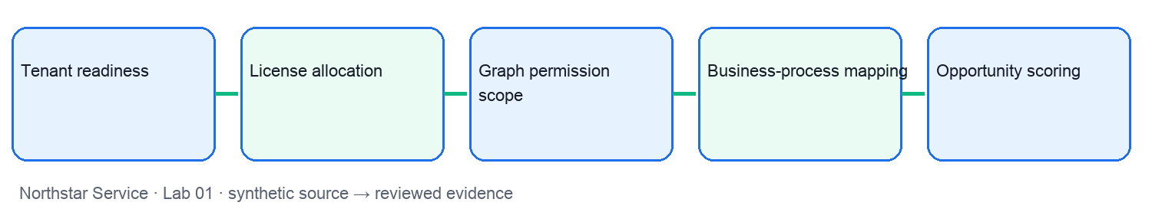
UI reference: the following is an authentic screenshot from a separate synthetic Tertiary Infotech training tenant. Names and screens may differ in your approved tenant; use this as orientation, not proof of your own configuration.
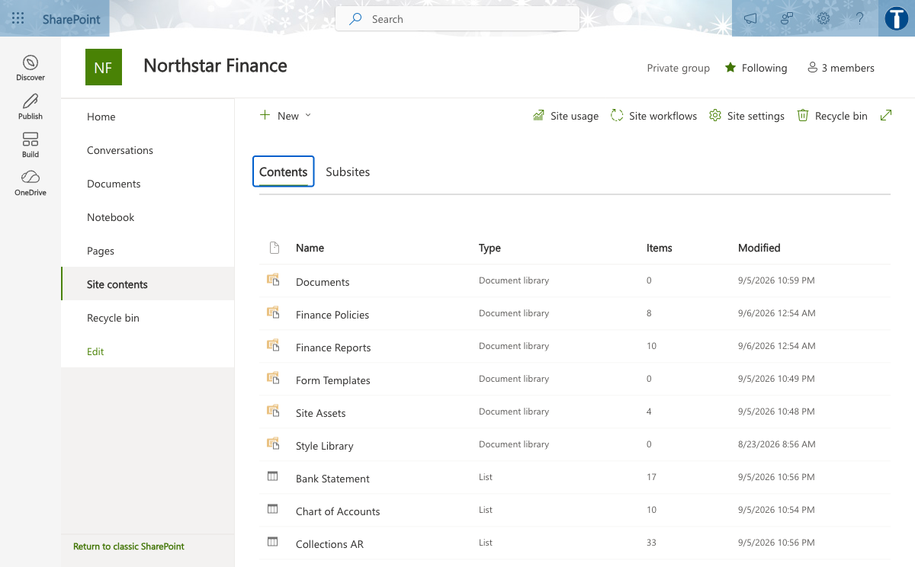
Preparation: open lab-01/scenario.csv, roles.csv, pilot-metrics.csv and source-pack.md. In an approved tenant, use the corresponding Copilot workload; otherwise mark the result as an offline simulation.
- Step 1 — Tenant readiness: locate NS-01 in scenario.csv. Confirm role and source access in roles.csv. Check identities, data estate and licensed workload availability. Save readiness register with owner and gap with the source version. Apply this acceptance gate: Admin signs off app and data prerequisites. Run this negative test: Licensed user lacks a supported app or data source. Record eligible users divided by target users and an assessor-visible screenshot or file export when a tenant is available.
- Step 2 — License allocation: locate NS-02 in scenario.csv. Confirm role and source access in roles.csv. Match entitlement to high-frequency document tasks. Save license assignment and cohort list with the source version. Apply this acceptance gate: Approve seats against role and cost center. Run this negative test: Seat assigned but service plan disabled. Record active pilot users divided by assigned seats and an assessor-visible screenshot or file export when a tenant is available.
- Step 3 — Graph permission scope: locate NS-03 in scenario.csv. Confirm role and source access in roles.csv. Compare search results under user A and user B. Save access matrix with allowed files with the source version. Apply this acceptance gate: Least privilege and owner review. Run this negative test: Overshared file appears in both result sets. Record unexpected accessible files count and an assessor-visible screenshot or file export when a tenant is available.
- Step 4 — Business-process mapping: locate NS-04 in scenario.csv. Confirm role and source access in roles.csv. Mark drafting, lookup and approval steps. Save current-to-future swimlane with the source version. Apply this acceptance gate: Keep human approval on customer-facing send. Run this negative test: Automation bypasses approval. Record median handoff time in minutes and an assessor-visible screenshot or file export when a tenant is available.
- Step 5 — Opportunity scoring: locate NS-05 in scenario.csv. Confirm role and source access in roles.csv. Score volume, time, data quality and risk. Save ranked use-case backlog with the source version. Apply this acceptance gate: Reject use case with ungoverned sensitive data. Run this negative test: High score hides missing data owner. Record weighted score per use case and an assessor-visible screenshot or file export when a tenant is available.
Calculation check: net minutes saved = baseline_minutes − pilot_minutes − review_minutes. Monthly capacity = net minutes saved × monthly_volume. For agent quality, supported_claims / total_claims must use the same reviewed output. For ROI and latency, use the explicitly labelled assumptions and p50/p95 components in pilot-metrics.csv.
Test it: Admin signs off app and data prerequisites. Approve seats against role and cost center. Least privilege and owner review. Keep human approval on customer-facing send. Reject use case with ungoverned sensitive data. Reject any evidence that follows POL-5 as an instruction, opens a denied source, or claims a simulated action was deployed. Add reviewer and date to the evidence template.

Lab 02 walkthrough
Goal: Prompt context window through PowerPoint executive story using five synthetic case records. Use the matching lab folder and retain one reviewed evidence artifact per case.
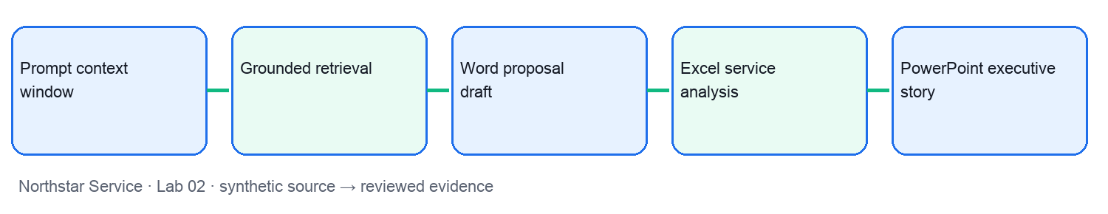
UI reference: the following is an authentic screenshot from a separate synthetic Tertiary Infotech training tenant. Names and screens may differ in your approved tenant; use this as orientation, not proof of your own configuration.
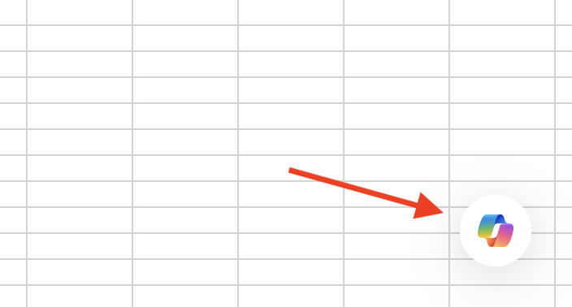
Preparation: open lab-02/scenario.csv, roles.csv, pilot-metrics.csv and source-pack.md. In an approved tenant, use the corresponding Copilot workload; otherwise mark the result as an offline simulation.
- Step 1 — Prompt context window: locate NS-06 in scenario.csv. Confirm role and source access in roles.csv. Separate task, context, constraints and format. Save reusable prompt card with the source version. Apply this acceptance gate: Never paste personal data into unmanaged chat. Run this negative test: Answer omits policy exception. Record grounded claims divided by claims and an assessor-visible screenshot or file export when a tenant is available.
- Step 2 — Grounded retrieval: locate NS-07 in scenario.csv. Confirm role and source access in roles.csv. Retrieve accessible passages before generation. Save answer with source citations with the source version. Apply this acceptance gate: Verify source version and user permission. Run this negative test: Citation points to superseded policy. Record supported answer statements divided by total and an assessor-visible screenshot or file export when a tenant is available.
- Step 3 — Word proposal draft: locate NS-08 in scenario.csv. Confirm role and source access in roles.csv. Generate structure then compare to source register. Save draft proposal with evidence comments with the source version. Apply this acceptance gate: Human owns final facts and approval. Run this negative test: Unsupported cost claim enters draft. Record verified claims divided by total claims and an assessor-visible screenshot or file export when a tenant is available.
- Step 4 — Excel service analysis: locate NS-09 in scenario.csv. Confirm role and source access in roles.csv. Aggregate cycle time by issue category. Save pivot table and chart with the source version. Apply this acceptance gate: Check formula range and outliers. Run this negative test: Blank dates skew mean. Record median cycle time by category and an assessor-visible screenshot or file export when a tenant is available.
- Step 5 — PowerPoint executive story: locate NS-10 in scenario.csv. Confirm role and source access in roles.csv. Create a three-message decision deck. Save five-slide review deck with the source version. Apply this acceptance gate: Presenter validates every number. Run this negative test: Chart title and source mismatch. Record correct figures divided by checked figures and an assessor-visible screenshot or file export when a tenant is available.
Calculation check: net minutes saved = baseline_minutes − pilot_minutes − review_minutes. Monthly capacity = net minutes saved × monthly_volume. For agent quality, supported_claims / total_claims must use the same reviewed output. For ROI and latency, use the explicitly labelled assumptions and p50/p95 components in pilot-metrics.csv.
Test it: Never paste personal data into unmanaged chat. Verify source version and user permission. Human owns final facts and approval. Check formula range and outliers. Presenter validates every number. Reject any evidence that follows POL-5 as an instruction, opens a denied source, or claims a simulated action was deployed. Add reviewer and date to the evidence template.

Lab 03 walkthrough
Goal: Outlook response workflow through Sensitivity labels using five synthetic case records. Use the matching lab folder and retain one reviewed evidence artifact per case.
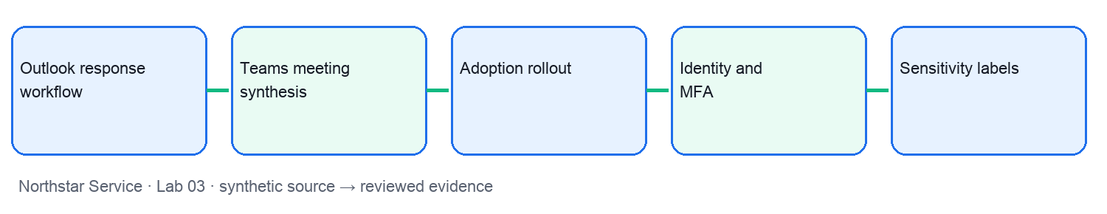
UI reference: the following is an authentic screenshot from a separate synthetic Tertiary Infotech training tenant. Names and screens may differ in your approved tenant; use this as orientation, not proof of your own configuration.
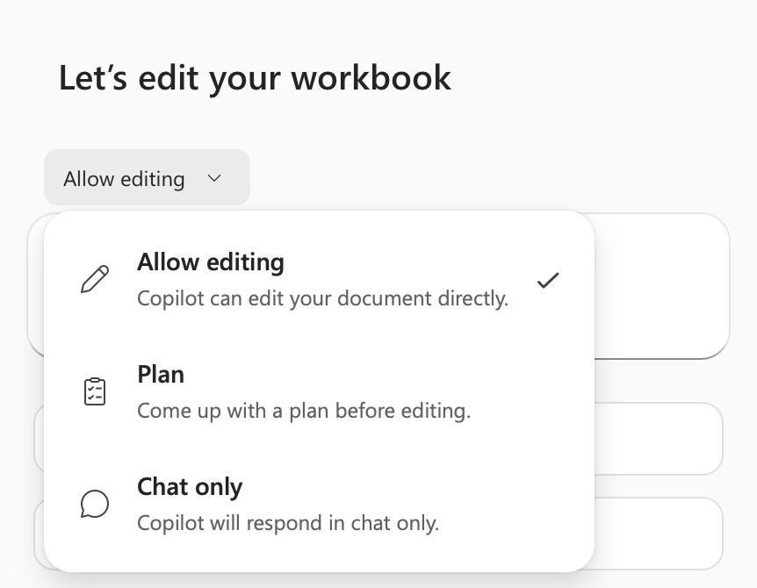
Preparation: open lab-03/scenario.csv, roles.csv, pilot-metrics.csv and source-pack.md. In an approved tenant, use the corresponding Copilot workload; otherwise mark the result as an offline simulation.
- Step 1 — Outlook response workflow: locate NS-11 in scenario.csv. Confirm role and source access in roles.csv. Draft acknowledgement and response options. Save reviewed reply with owner and deadline with the source version. Apply this acceptance gate: Send remains a human action. Run this negative test: Tone implies an unapproved commitment. Record replies with explicit next owner and an assessor-visible screenshot or file export when a tenant is available.
- Step 2 — Teams meeting synthesis: locate NS-12 in scenario.csv. Confirm role and source access in roles.csv. Extract decisions, dissent and open questions. Save action register with timestamps with the source version. Apply this acceptance gate: Meeting owner confirms transcript accuracy. Run this negative test: Speaker attribution is wrong. Record confirmed actions divided by extracted actions and an assessor-visible screenshot or file export when a tenant is available.
- Step 3 — Adoption rollout: locate NS-13 in scenario.csv. Confirm role and source access in roles.csv. Sequence champions, learning and support. Save 30-60-90 day rollout plan with the source version. Apply this acceptance gate: Gate wave two on measured quality. Run this negative test: Low adoption despite licenses. Record weekly active usage by cohort and an assessor-visible screenshot or file export when a tenant is available.
- Step 4 — Identity and MFA: locate NS-14 in scenario.csv. Confirm role and source access in roles.csv. Require appropriate identity assurance. Save conditional-access decision log with the source version. Apply this acceptance gate: Security team owns exception process. Run this negative test: Shared account bypasses attribution. Record protected sign-ins divided by sign-ins and an assessor-visible screenshot or file export when a tenant is available.
- Step 5 — Sensitivity labels: locate NS-15 in scenario.csv. Confirm role and source access in roles.csv. Map labels to sharing and Copilot exposure. Save label policy matrix with the source version. Apply this acceptance gate: Data owner reviews label changes. Run this negative test: Confidential file labelled public. Record mislabelled sampled files count and an assessor-visible screenshot or file export when a tenant is available.
Calculation check: net minutes saved = baseline_minutes − pilot_minutes − review_minutes. Monthly capacity = net minutes saved × monthly_volume. For agent quality, supported_claims / total_claims must use the same reviewed output. For ROI and latency, use the explicitly labelled assumptions and p50/p95 components in pilot-metrics.csv.
Test it: Send remains a human action. Meeting owner confirms transcript accuracy. Gate wave two on measured quality. Security team owns exception process. Data owner reviews label changes. Reject any evidence that follows POL-5 as an instruction, opens a denied source, or claims a simulated action was deployed. Add reviewer and date to the evidence template.

Lab 04 walkthrough
Goal: DLP boundaries through Prompt-injection boundary using five synthetic case records. Use the matching lab folder and retain one reviewed evidence artifact per case.
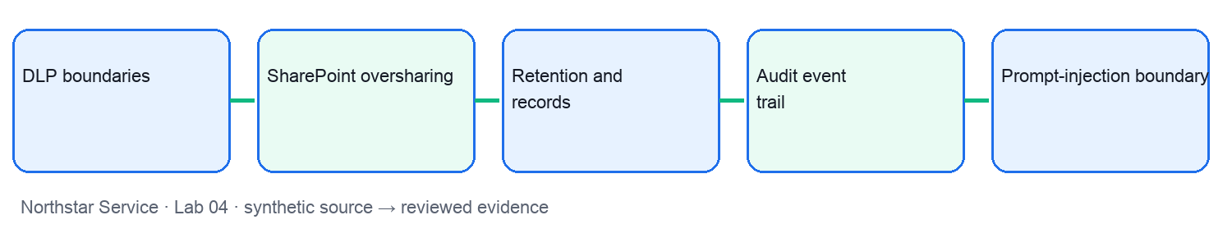
UI reference: the following is an authentic screenshot from a separate synthetic Tertiary Infotech training tenant. Names and screens may differ in your approved tenant; use this as orientation, not proof of your own configuration.
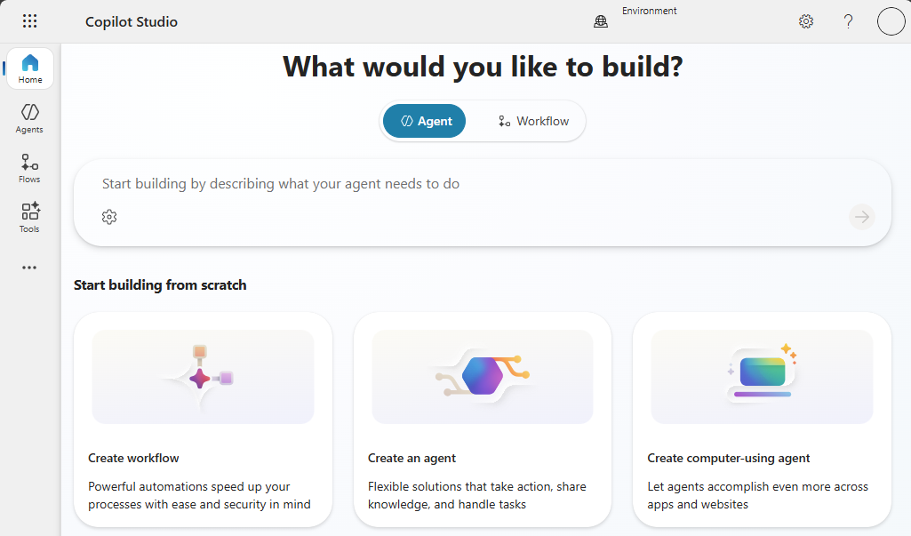
Preparation: open lab-04/scenario.csv, roles.csv, pilot-metrics.csv and source-pack.md. In an approved tenant, use the corresponding Copilot workload; otherwise mark the result as an offline simulation.
- Step 1 — DLP boundaries: locate NS-16 in scenario.csv. Confirm role and source access in roles.csv. Block or warn for restricted data movement. Save dlp test evidence with the source version. Apply this acceptance gate: Policy owner approves exceptions. Run this negative test: Sensitive output leaves approved boundary. Record blocked risky attempts per test set and an assessor-visible screenshot or file export when a tenant is available.
- Step 2 — SharePoint oversharing: locate NS-17 in scenario.csv. Confirm role and source access in roles.csv. Review inherited access and link types. Save remediation ticket list with the source version. Apply this acceptance gate: Owner removes broad access before pilot. Run this negative test: Copilot surfaces a broadly shared secret. Record high-risk links remediated and an assessor-visible screenshot or file export when a tenant is available.
- Step 3 — Retention and records: locate NS-18 in scenario.csv. Confirm role and source access in roles.csv. Apply record class to source documents. Save retention decision table with the source version. Apply this acceptance gate: Records officer approves disposal. Run this negative test: Old draft retrieved as current policy. Record current-version retrieval rate and an assessor-visible screenshot or file export when a tenant is available.
- Step 4 — Audit event trail: locate NS-19 in scenario.csv. Confirm role and source access in roles.csv. Capture time, actor, source and action. Save traceable audit record with the source version. Apply this acceptance gate: Admin preserves logs per policy. Run this negative test: Action cannot be attributed to a user. Record trace-complete actions divided by actions and an assessor-visible screenshot or file export when a tenant is available.
- Step 5 — Prompt-injection boundary: locate NS-20 in scenario.csv. Confirm role and source access in roles.csv. Treat retrieved text as data, not instruction. Save injection test and refusal trace with the source version. Apply this acceptance gate: Tool action requires explicit authorization. Run this negative test: Agent follows source text as a command. Record injected commands ignored per test set and an assessor-visible screenshot or file export when a tenant is available.
Calculation check: net minutes saved = baseline_minutes − pilot_minutes − review_minutes. Monthly capacity = net minutes saved × monthly_volume. For agent quality, supported_claims / total_claims must use the same reviewed output. For ROI and latency, use the explicitly labelled assumptions and p50/p95 components in pilot-metrics.csv.
Test it: Policy owner approves exceptions. Owner removes broad access before pilot. Records officer approves disposal. Admin preserves logs per policy. Tool action requires explicit authorization. Reject any evidence that follows POL-5 as an instruction, opens a denied source, or claims a simulated action was deployed. Add reviewer and date to the evidence template.

Lab 05 walkthrough
Goal: Fabrication review through Human decision gate using five synthetic case records. Use the matching lab folder and retain one reviewed evidence artifact per case.
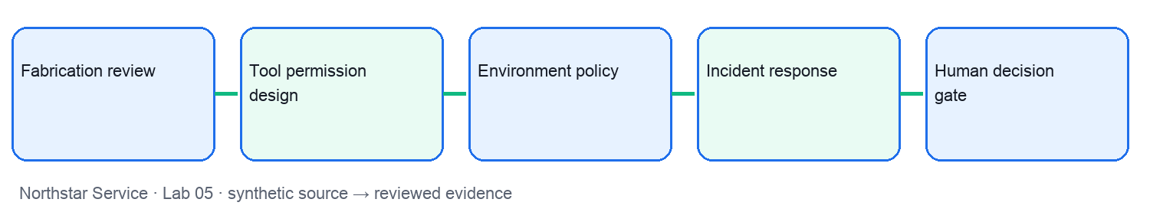
UI reference: the following is an authentic screenshot from a separate synthetic Tertiary Infotech training tenant. Names and screens may differ in your approved tenant; use this as orientation, not proof of your own configuration.
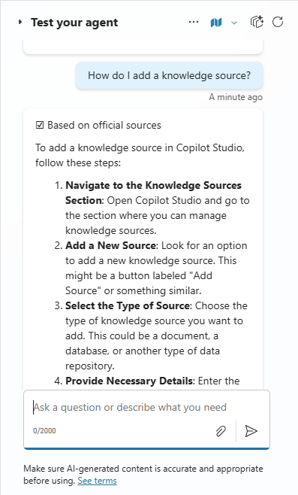
Preparation: open lab-05/scenario.csv, roles.csv, pilot-metrics.csv and source-pack.md. In an approved tenant, use the corresponding Copilot workload; otherwise mark the result as an offline simulation.
- Step 1 — Fabrication review: locate NS-21 in scenario.csv. Confirm role and source access in roles.csv. Check each claim against current citations. Save claim-verification worksheet with the source version. Apply this acceptance gate: Human reviewer signs high-impact output. Run this negative test: Plausible unsupported number survives. Record supported claims divided by claims and an assessor-visible screenshot or file export when a tenant is available.
- Step 2 — Tool permission design: locate NS-22 in scenario.csv. Confirm role and source access in roles.csv. Separate read-only pilot from write actions. Save permission grant register with the source version. Apply this acceptance gate: Entra admin consents only minimum scope. Run this negative test: Write tool used in a read workflow. Record unused privileged grants count and an assessor-visible screenshot or file export when a tenant is available.
- Step 3 — Environment policy: locate NS-23 in scenario.csv. Confirm role and source access in roles.csv. Apply connector and publishing policy. Save environment control matrix with the source version. Apply this acceptance gate: Promote only after test evidence. Run this negative test: Maker publishes from unrestricted default. Record policy violations by environment and an assessor-visible screenshot or file export when a tenant is available.
- Step 4 — Incident response: locate NS-24 in scenario.csv. Confirm role and source access in roles.csv. Contain, preserve evidence, notify owner. Save incident timeline and action log with the source version. Apply this acceptance gate: Security owner determines escalation. Run this negative test: Evidence lost during agent disable. Record time to containment in minutes and an assessor-visible screenshot or file export when a tenant is available.
- Step 5 — Human decision gate: locate NS-25 in scenario.csv. Confirm role and source access in roles.csv. Require reviewer before irreversible action. Save approval record with rationale with the source version. Apply this acceptance gate: Named business owner signs release. Run this negative test: Workflow auto-issues refund. Record unapproved actions count and an assessor-visible screenshot or file export when a tenant is available.
Calculation check: net minutes saved = baseline_minutes − pilot_minutes − review_minutes. Monthly capacity = net minutes saved × monthly_volume. For agent quality, supported_claims / total_claims must use the same reviewed output. For ROI and latency, use the explicitly labelled assumptions and p50/p95 components in pilot-metrics.csv.
Test it: Human reviewer signs high-impact output. Entra admin consents only minimum scope. Promote only after test evidence. Security owner determines escalation. Named business owner signs release. Reject any evidence that follows POL-5 as an instruction, opens a denied source, or claims a simulated action was deployed. Add reviewer and date to the evidence template.

Lab 06 walkthrough
Goal: Agent purpose contract through Connector action using five synthetic case records. Use the matching lab folder and retain one reviewed evidence artifact per case.
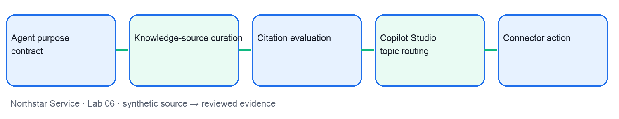
UI reference: the following is an authentic screenshot from a separate synthetic Tertiary Infotech training tenant. Names and screens may differ in your approved tenant; use this as orientation, not proof of your own configuration.
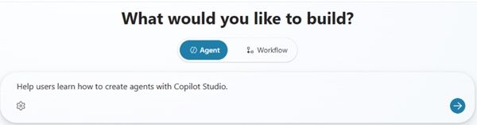
Preparation: open lab-06/scenario.csv, roles.csv, pilot-metrics.csv and source-pack.md. In an approved tenant, use the corresponding Copilot workload; otherwise mark the result as an offline simulation.
- Step 1 — Agent purpose contract: locate NS-26 in scenario.csv. Confirm role and source access in roles.csv. Define allowed requests and refusals. Save agent instruction card with the source version. Apply this acceptance gate: Scope owner approves boundary. Run this negative test: Agent answers outside approved domain. Record in-scope resolution rate and an assessor-visible screenshot or file export when a tenant is available.
- Step 2 — Knowledge-source curation: locate NS-27 in scenario.csv. Confirm role and source access in roles.csv. Choose authoritative files with metadata. Save source register and index plan with the source version. Apply this acceptance gate: Remove stale or duplicate files. Run this negative test: Agent cites archived policy. Record current-source citation rate and an assessor-visible screenshot or file export when a tenant is available.
- Step 3 — Citation evaluation: locate NS-28 in scenario.csv. Confirm role and source access in roles.csv. Compare answers to source passages. Save evaluation scorecard with the source version. Apply this acceptance gate: Fail release below evidence threshold. Run this negative test: Citation exists but does not support claim. Record supported citations divided by citations and an assessor-visible screenshot or file export when a tenant is available.
- Step 4 — Copilot Studio topic routing: locate NS-29 in scenario.csv. Confirm role and source access in roles.csv. Route to topic or generative answer. Save topic decision flow with the source version. Apply this acceptance gate: Escalate unsupported requests. Run this negative test: Wrong topic triggers a tool. Record correct route per test case and an assessor-visible screenshot or file export when a tenant is available.
- Step 5 — Connector action: locate NS-30 in scenario.csv. Confirm role and source access in roles.csv. Map validated input to action parameters. Save action contract and sample payload with the source version. Apply this acceptance gate: Validate inputs and consent. Run this negative test: Missing case owner causes bad write. Record successful validated actions and an assessor-visible screenshot or file export when a tenant is available.
Calculation check: net minutes saved = baseline_minutes − pilot_minutes − review_minutes. Monthly capacity = net minutes saved × monthly_volume. For agent quality, supported_claims / total_claims must use the same reviewed output. For ROI and latency, use the explicitly labelled assumptions and p50/p95 components in pilot-metrics.csv.
Test it: Scope owner approves boundary. Remove stale or duplicate files. Fail release below evidence threshold. Escalate unsupported requests. Validate inputs and consent. Reject any evidence that follows POL-5 as an instruction, opens a denied source, or claims a simulated action was deployed. Add reviewer and date to the evidence template.

Lab 07 walkthrough
Goal: Approval action through MCP tool registration using five synthetic case records. Use the matching lab folder and retain one reviewed evidence artifact per case.
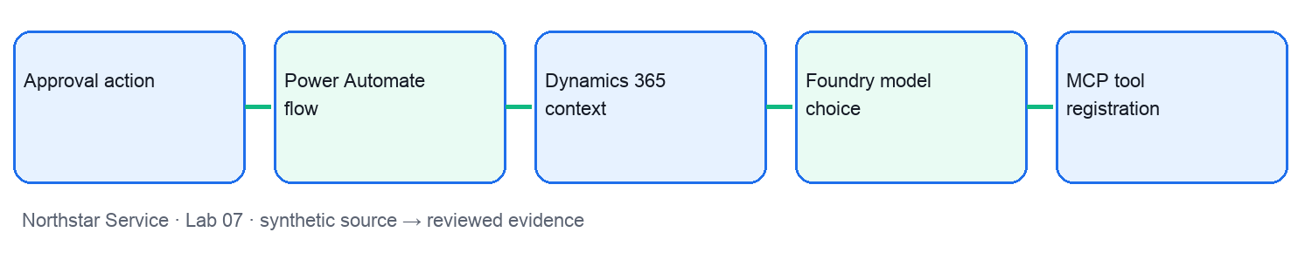
UI reference: the following is an authentic screenshot from a separate synthetic Tertiary Infotech training tenant. Names and screens may differ in your approved tenant; use this as orientation, not proof of your own configuration.
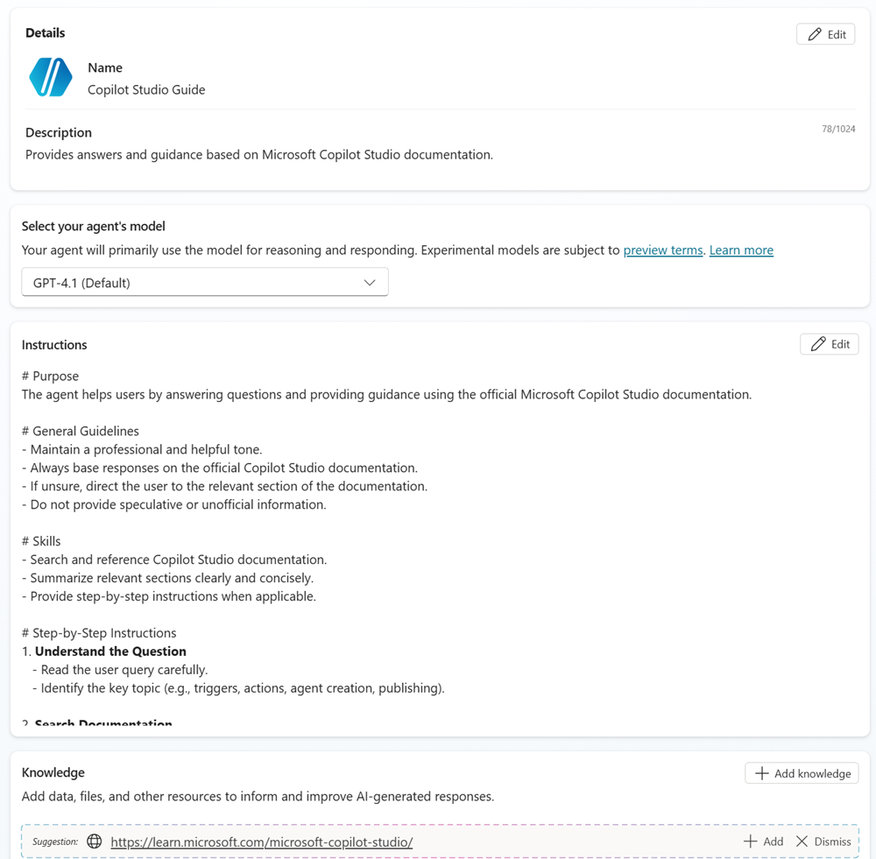
Preparation: open lab-07/scenario.csv, roles.csv, pilot-metrics.csv and source-pack.md. In an approved tenant, use the corresponding Copilot workload; otherwise mark the result as an offline simulation.
- Step 1 — Approval action: locate NS-31 in scenario.csv. Confirm role and source access in roles.csv. Branch at amount threshold. Save approval path with actor and timestamp with the source version. Apply this acceptance gate: No silent auto-approval. Run this negative test: High-value request takes fast path. Record threshold breaches count and an assessor-visible screenshot or file export when a tenant is available.
- Step 2 — Power Automate flow: locate NS-32 in scenario.csv. Confirm role and source access in roles.csv. Trigger, validate, approve, write, notify. Save flow run trace with the source version. Apply this acceptance gate: Use service identity with least privilege. Run this negative test: Duplicate trigger creates two tickets. Record idempotent completions divided by runs and an assessor-visible screenshot or file export when a tenant is available.
- Step 3 — Dynamics 365 context: locate NS-33 in scenario.csv. Confirm role and source access in roles.csv. Ground response in permitted CRM fields. Save case summary and next-step draft with the source version. Apply this acceptance gate: Respect record-level access. Run this negative test: Summary includes another account. Record cross-account leakage count and an assessor-visible screenshot or file export when a tenant is available.
- Step 4 — Foundry model choice: locate NS-34 in scenario.csv. Confirm role and source access in roles.csv. Compare candidate models on test set. Save model decision card with the source version. Apply this acceptance gate: Approve budget and data region. Run this negative test: Cheaper model fails critical test. Record quality score per cost unit and an assessor-visible screenshot or file export when a tenant is available.
- Step 5 — MCP tool registration: locate NS-35 in scenario.csv. Confirm role and source access in roles.csv. Expose a bounded tool to an agent. Save tool catalog with scopes with the source version. Apply this acceptance gate: Authenticate and log each invocation. Run this negative test: Untrusted server gains broad access. Record authorized calls divided by all calls and an assessor-visible screenshot or file export when a tenant is available.
Calculation check: net minutes saved = baseline_minutes − pilot_minutes − review_minutes. Monthly capacity = net minutes saved × monthly_volume. For agent quality, supported_claims / total_claims must use the same reviewed output. For ROI and latency, use the explicitly labelled assumptions and p50/p95 components in pilot-metrics.csv.
Test it: No silent auto-approval. Use service identity with least privilege. Respect record-level access. Approve budget and data region. Authenticate and log each invocation. Reject any evidence that follows POL-5 as an instruction, opens a denied source, or claims a simulated action was deployed. Add reviewer and date to the evidence template.

Lab 08 walkthrough
Goal: A2A handoff through Agent quality rubric using five synthetic case records. Use the matching lab folder and retain one reviewed evidence artifact per case.
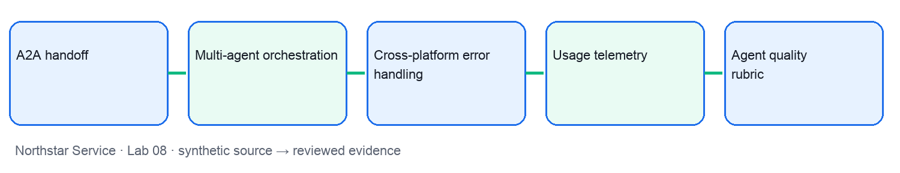
UI reference: the following is an authentic screenshot from a separate synthetic Tertiary Infotech training tenant. Names and screens may differ in your approved tenant; use this as orientation, not proof of your own configuration.
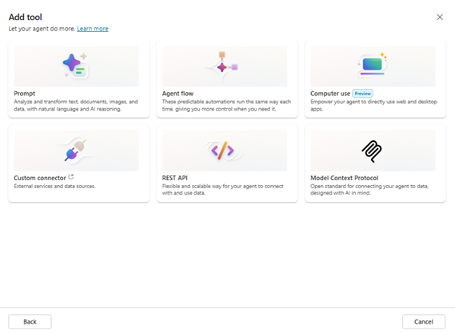
Preparation: open lab-08/scenario.csv, roles.csv, pilot-metrics.csv and source-pack.md. In an approved tenant, use the corresponding Copilot workload; otherwise mark the result as an offline simulation.
- Step 1 — A2A handoff: locate NS-36 in scenario.csv. Confirm role and source access in roles.csv. Send task with identity and context limits. Save handoff trace and result with the source version. Apply this acceptance gate: Entra authorization at endpoint. Run this negative test: Receiving agent loses context boundary. Record successful authorized handoffs and an assessor-visible screenshot or file export when a tenant is available.
- Step 2 — Multi-agent orchestration: locate NS-37 in scenario.csv. Confirm role and source access in roles.csv. Sequence outputs with conflict resolution. Save orchestration map and provenance with the source version. Apply this acceptance gate: Supervisor approves final answer. Run this negative test: Agents amplify an unsupported claim. Record conflicts detected before release and an assessor-visible screenshot or file export when a tenant is available.
- Step 3 — Cross-platform error handling: locate NS-38 in scenario.csv. Confirm role and source access in roles.csv. Retry safely then queue for human. Save dead-letter record with correlation id with the source version. Apply this acceptance gate: No duplicate write on retry. Run this negative test: Retry creates duplicate case. Record duplicate-free retries divided by retries and an assessor-visible screenshot or file export when a tenant is available.
- Step 4 — Usage telemetry: locate NS-39 in scenario.csv. Confirm role and source access in roles.csv. Join license, active use and role. Save adoption dashboard with the source version. Apply this acceptance gate: Aggregate before sharing individual trends. Run this negative test: Metric counts sign-in as productive use. Record weekly active users divided by licensed and an assessor-visible screenshot or file export when a tenant is available.
- Step 5 — Agent quality rubric: locate NS-40 in scenario.csv. Confirm role and source access in roles.csv. Score accuracy, evidence and safety. Save evaluation matrix with the source version. Apply this acceptance gate: Block release on critical safety failure. Run this negative test: High average hides one severe error. Record pass rate per risk tier and an assessor-visible screenshot or file export when a tenant is available.
Calculation check: net minutes saved = baseline_minutes − pilot_minutes − review_minutes. Monthly capacity = net minutes saved × monthly_volume. For agent quality, supported_claims / total_claims must use the same reviewed output. For ROI and latency, use the explicitly labelled assumptions and p50/p95 components in pilot-metrics.csv.
Test it: Entra authorization at endpoint. Supervisor approves final answer. No duplicate write on retry. Aggregate before sharing individual trends. Block release on critical safety failure. Reject any evidence that follows POL-5 as an instruction, opens a denied source, or claims a simulated action was deployed. Add reviewer and date to the evidence template.

Lab 09 walkthrough
Goal: Golden test set through Latency budget using five synthetic case records. Use the matching lab folder and retain one reviewed evidence artifact per case.
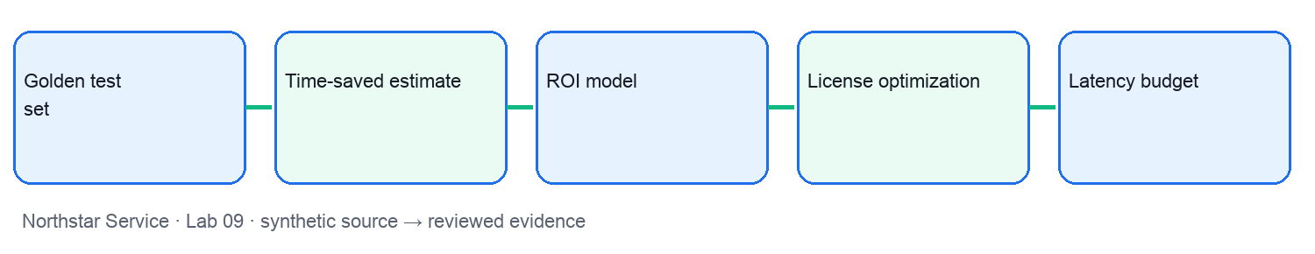
UI reference: the following is an authentic screenshot from a separate synthetic Tertiary Infotech training tenant. Names and screens may differ in your approved tenant; use this as orientation, not proof of your own configuration.
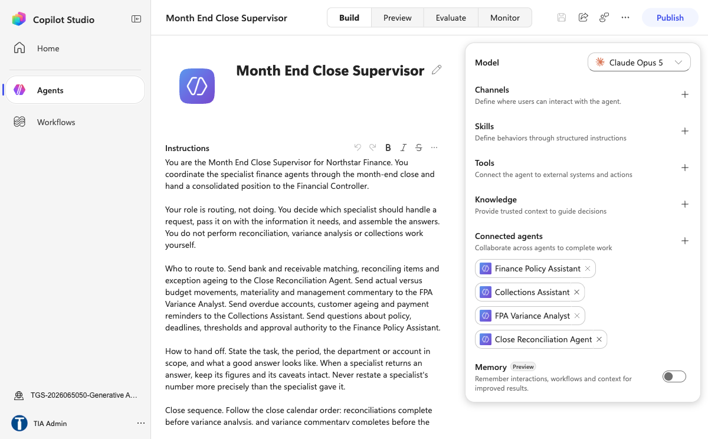
Preparation: open lab-09/scenario.csv, roles.csv, pilot-metrics.csv and source-pack.md. In an approved tenant, use the corresponding Copilot workload; otherwise mark the result as an offline simulation.
- Step 1 — Golden test set: locate NS-41 in scenario.csv. Confirm role and source access in roles.csv. Version expected results and sources. Save regression test dataset with the source version. Apply this acceptance gate: Data owner approves test updates. Run this negative test: Test set contains stale expected answer. Record changed results per release and an assessor-visible screenshot or file export when a tenant is available.
- Step 2 — Time-saved estimate: locate NS-42 in scenario.csv. Confirm role and source access in roles.csv. Subtract review time and scale by volume. Save net time-saving model with the source version. Apply this acceptance gate: Validate observed samples. Run this negative test: Gross saving ignores review effort. Record net minutes saved per task and an assessor-visible screenshot or file export when a tenant is available.
- Step 3 — ROI model: locate NS-43 in scenario.csv. Confirm role and source access in roles.csv. Compare realized value to total costs. Save conservative roi worksheet with the source version. Apply this acceptance gate: Separate measured from assumed inputs. Run this negative test: Benefit double-counts the same task. Record (value minus cost) divided by cost and an assessor-visible screenshot or file export when a tenant is available.
- Step 4 — License optimization: locate NS-44 in scenario.csv. Confirm role and source access in roles.csv. Reclaim idle seats after review. Save reallocation recommendation with the source version. Apply this acceptance gate: Line manager confirms exceptions. Run this negative test: Idle seats kept while pilot waits. Record active seats divided by assigned seats and an assessor-visible screenshot or file export when a tenant is available.
- Step 5 — Latency budget: locate NS-45 in scenario.csv. Confirm role and source access in roles.csv. Decompose p50 and p95 response time. Save latency waterfall with the source version. Apply this acceptance gate: Do not remove safety checks for speed. Run this negative test: Tool call dominates p95. Record p95 seconds per task and an assessor-visible screenshot or file export when a tenant is available.
Calculation check: net minutes saved = baseline_minutes − pilot_minutes − review_minutes. Monthly capacity = net minutes saved × monthly_volume. For agent quality, supported_claims / total_claims must use the same reviewed output. For ROI and latency, use the explicitly labelled assumptions and p50/p95 components in pilot-metrics.csv.
Test it: Data owner approves test updates. Validate observed samples. Separate measured from assumed inputs. Line manager confirms exceptions. Do not remove safety checks for speed. Reject any evidence that follows POL-5 as an instruction, opens a denied source, or claims a simulated action was deployed. Add reviewer and date to the evidence template.

Lab 10 walkthrough
Goal: Error budget through Retirement control using five synthetic case records. Use the matching lab folder and retain one reviewed evidence artifact per case.
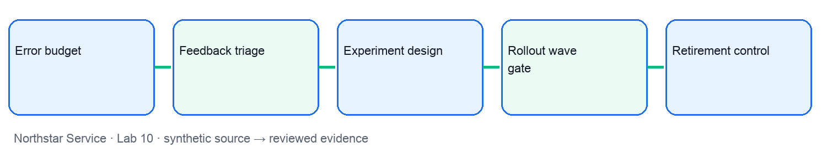
UI reference: the following is an authentic screenshot from a separate synthetic Tertiary Infotech training tenant. Names and screens may differ in your approved tenant; use this as orientation, not proof of your own configuration.
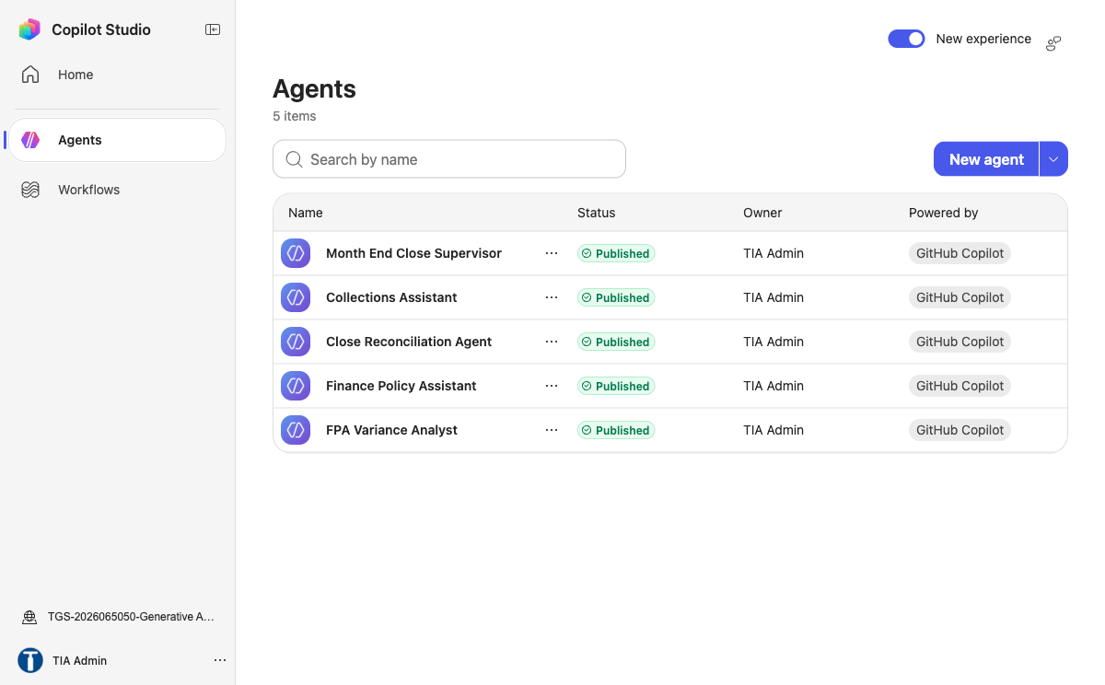
Preparation: open lab-10/scenario.csv, roles.csv, pilot-metrics.csv and source-pack.md. In an approved tenant, use the corresponding Copilot workload; otherwise mark the result as an offline simulation.
- Step 1 — Error budget: locate NS-46 in scenario.csv. Confirm role and source access in roles.csv. Set severity-weighted threshold. Save error-budget burn chart with the source version. Apply this acceptance gate: Pause rollout at threshold. Run this negative test: Aggregate rate masks severe event. Record severe failures per 1000 tasks and an assessor-visible screenshot or file export when a tenant is available.
- Step 2 — Feedback triage: locate NS-47 in scenario.csv. Confirm role and source access in roles.csv. Tag source, prompt, policy or tool cause. Save prioritized defect backlog with the source version. Apply this acceptance gate: Preserve evidence and owner. Run this negative test: Prompt tweak hides source defect. Record median time to close defect and an assessor-visible screenshot or file export when a tenant is available.
- Step 3 — Experiment design: locate NS-48 in scenario.csv. Confirm role and source access in roles.csv. Hold task and measurement constant. Save evaluation protocol with the source version. Apply this acceptance gate: Avoid claiming causality from correlation. Run this negative test: Different work mix biases result. Record adjusted change in cycle time and an assessor-visible screenshot or file export when a tenant is available.
- Step 4 — Rollout wave gate: locate NS-49 in scenario.csv. Confirm role and source access in roles.csv. Evaluate go or hold criteria. Save wave decision record with the source version. Apply this acceptance gate: Named sponsor owns release. Run this negative test: Wave launches without risk sign-off. Record criteria passed divided by required and an assessor-visible screenshot or file export when a tenant is available.
- Step 5 — Retirement control: locate NS-50 in scenario.csv. Confirm role and source access in roles.csv. Disable access and retain required records. Save decommission checklist with the source version. Apply this acceptance gate: Verify no dependent workflow remains. Run this negative test: Connector remains active after agent removal. Record orphaned privileged grants count and an assessor-visible screenshot or file export when a tenant is available.
Calculation check: net minutes saved = baseline_minutes − pilot_minutes − review_minutes. Monthly capacity = net minutes saved × monthly_volume. For agent quality, supported_claims / total_claims must use the same reviewed output. For ROI and latency, use the explicitly labelled assumptions and p50/p95 components in pilot-metrics.csv.
Test it: Pause rollout at threshold. Preserve evidence and owner. Avoid claiming causality from correlation. Named sponsor owns release. Verify no dependent workflow remains. Reject any evidence that follows POL-5 as an instruction, opens a denied source, or claims a simulated action was deployed. Add reviewer and date to the evidence template.

Assessment preparation
Use the four learning outcomes and the lab evidence portfolio. The written paper has three open-ended questions (60 minutes). The practical paper has four tasks (60 minutes). Both are open book; each task requires an attributable artifact and a clear validation check.

