
Tertiary Infotech Academy Pte Ltd
UEN: 201200696W
LESSON PLAN
For
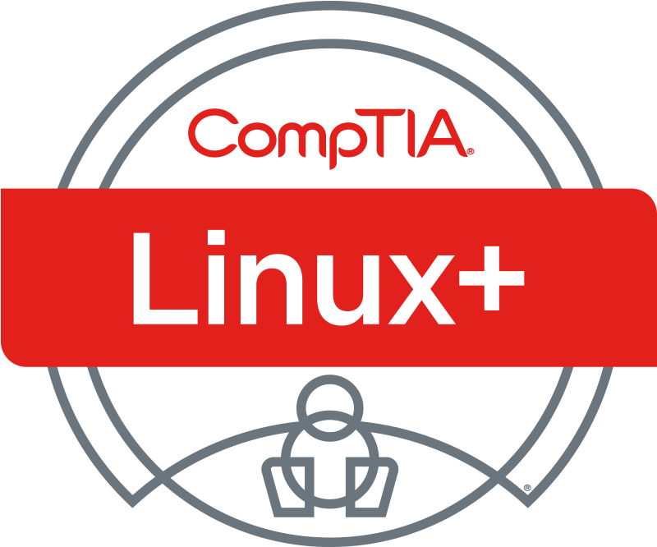
CompTIA Certified Linux+ Training (XK0-006)
TGS Ref No: TGS-2024048316
Conducted by
Tertiary Infotech Academy Pte Ltd
UEN: 201200696W
Version 1.0

DOCUMENT VERSION CONTROL RECORD
Version Number | Effective Date of Release | Summary of Included Changes | Author
1.0 | 2 Jul 2026 | Initial release — CompTIA Linux+ XK0-006 V8 2-day lesson plan aligned to the 30 labs, the five exam domains and the slide deck (slide numbers cited). | Dr. Alfred Ang

TABLE OF CONTENTS
Right-click and choose “Update Field”, or press F9, to build the table of contents.

Course Information
Course Title | CompTIA Certified Linux+ Training (XK0-006)
WSQ Course Reference | TGS-2024048316
Certification Exam | CompTIA Linux+ XK0-006 V8
Training Provider | Tertiary Infotech Academy Pte Ltd (UEN 201200696W)
Duration | 2 days · 8 training hours per day (16 hours)
Daily Timing | 9:00 am – 6:00 pm (1-hour lunch; tea breaks within training time)
Mode | Instructor-led, hands-on labs on the free Killercoda Ubuntu Playground
Trainer | Dr. Alfred Ang

Learning Outcomes
On completion of this course, learners will be able to:
- Explain core Linux concepts — the boot process, the Filesystem Hierarchy Standard, device management and virtualization — and manage storage, networking and shell operations.
- Manage files, local user and group accounts, processes and jobs, software packages, systemd services and containerized applications on a Linux server.
- Apply Linux security: authentication/authorization (sudo, PAM), firewalls, OS and account hardening, cryptography and compliance/audit procedures.
- Automate administration with Ansible, Bash and Python, apply Git version control, and use AI assistants responsibly and securely.
- Monitor a Linux system and analyze and troubleshoot hardware, storage, network, security and performance issues using the right diagnostic tools.

Assessment
- Written Assessment (WA) — Short-Answer Questions (SAQ), 1 hour, open book — aligned to the course slides.
- Practical Performance (PP) — hands-on Linux tasks, 1 hour, open book — aligned to the course labs.
- Format: Open Book — course slides, Learner Guide and approved materials only.
- The final assessment is conducted on Day 2 from 4:00 pm (WA 4:00–5:00, PP 5:00–6:00).
- A minimum of 75% attendance is required to be eligible for assessment and funding.
- Courseware and the assessment are on the LMS — https://lms-tms.tertiaryinfotech.com/.

Exam Domain Coverage
The course maps 1:1 to the CompTIA Linux+ XK0-006 exam blueprint. Each domain, its exam weighting, the labs that cover it, and the deck slides:
Domain | Exam Weight | Labs | Deck Slides
1. System Management | 23% | 1–7 | 21–89
2. Services and User Management | 20% | 8–13 | 87–148
3. Security | 18% | 14–19 | 146–207
4. Automation, Orchestration, and Scripting | 17% | 20–24 | 205–256
5. Troubleshooting | 22% | 25–30 | 254–319

Daily Schedule
Each training day runs 9:00 am – 6:00 pm and delivers 8 instructional hours (1-hour lunch; tea breaks counted within training time). The Slides column cites the deck page range the trainer runs for each teaching session.

Day 1 — System Management & Services / User Management
Time | Duration | Topic / Activity | Method | Slides
9:00–9:15 | 15 min | Welcome, mandatory digital attendance (AM), trainer & learner introduction | Admin | —
9:15–9:30 | 15 min | Course overview, learning outcomes and ground rules | Admin | —
9:30–11:45 | 135 min | Domain 1 — System Management (23%): boot & FHS, kernel modules, LVM storage, networking, shell operations. Hands-on Labs 1–5 | Lecture + Hands-on Lab | 21–66
11:45–12:45 | 60 min | Lunch break | Break | —
12:45–14:15 | 90 min | Domain 1 (cont.): backup & restore, virtualization. Hands-on Labs 6–7 | Lecture + Hands-on Lab | 67–89
14:15–14:25 | 10 min | Digital attendance (PM) | Admin | —
14:25–17:15 | 170 min | Domain 2 — Services and User Management (20%): files, accounts, processes, packages, systemd, containers. Hands-on Labs 8–13 | Lecture + Hands-on Lab | 87–148
17:15–17:45 | 30 min | Domain 1–2 recap, Q&A and consolidation | Discussion | —
17:45–18:00 | 15 min | Day 1 review, preview of Day 2 and PM digital attendance | Discussion | —
Total training time: 480 minutes (8 hours).

Day 2 — Security, Automation, Troubleshooting & Final Assessment
Time | Duration | Topic / Activity | Method | Slides
9:00–9:10 | 10 min | Mandatory digital attendance (AM) and Day 1 recap | Admin | —
9:10–11:45 | 155 min | Domain 3 — Security (18%): AAA/sudo/PAM, firewalls, OS & account hardening, cryptography, compliance & audit. Hands-on Labs 14–19 | Lecture + Hands-on Lab | 146–207
11:45–12:45 | 60 min | Lunch break | Break | —
12:45–14:35 | 110 min | Domain 4 — Automation, Orchestration & Scripting (17%): Ansible, Bash, Python, Git, responsible AI. Hands-on Labs 20–24 | Lecture + Hands-on Lab | 205–256
14:35–14:45 | 10 min | Digital attendance (PM) | Admin | —
14:45–15:35 | 50 min | Domain 5 — Troubleshooting (22%): monitoring, storage, network, security, performance. Hands-on Labs 25–29 | Lecture + Hands-on Lab | 254–301
15:35–15:55 | 20 min | Capstone — end-to-end server build & triage. Hands-on Lab 30 | Lecture + Hands-on Lab | 302–319
15:55–16:00 | 5 min | Revision · Briefing for Assessment · Course feedback & TRAQOM survey | Assessment | —
16:00–17:00 | 60 min | Written Assessment (WA) — Short-Answer Questions (SAQ), 1 hour, open book | Assessment | —
17:00–18:00 | 60 min | Practical Performance (PP) — hands-on Linux tasks, 1 hour, open book. PM digital attendance; submit answers on the LMS | Assessment | —
Total training time: 480 minutes (8 hours).

Topic-by-Topic Breakdown
Each lab below cites the deck slide of its overview so the trainer can jump straight to it.

Domain 1 — System Management (23%) · Slides 21–89
Lab 1 — Boot Process & Filesystem Hierarchy [Obj 1.1] · Slide 24
Inspect a running Linux system's boot configuration, kernel command line, initramfs, and the standard Filesystem Hierarchy to understand how GRUB hands off to the kernel and where FHS directories live.
Lab 2 — Kernel Modules & Device Management [Obj 1.2] · Slide 32
List, inspect, load, and unload kernel modules and use the standard hardware-enumeration tools to understand modprobe vs insmod, module dependencies, and reading dmesg.
Lab 3 — Storage with LVM, Partitions & Filesystems [Obj 1.3] · Slide 41
Build a complete LVM stack on loopback-backed disks, format with ext4/xfs/btrfs, mount with hardening options, persist in fstab, and grow a filesystem online.
Lab 4 — Network Configuration [Obj 1.4] · Slide 49
Inspect interfaces, addresses, and routes with ip; walk the name-resolution stack; validate a netplan YAML; and use the standard diagnostic toolbox to read a Linux network stack top-to-bottom.
Lab 5 — Shell Operations & Text Processing [Obj 1.5] · Slide 58
Work with shell environment variables, login vs interactive startup files, every common redirection form, and the classic text-processing pipeline to assemble non-trivial one-liners.
Lab 6 — Backup & Restore [Obj 1.6] · Slide 67
Create tar/cpio/dd archives with gzip/bzip2/xz compression, image and recover disks with dd and ddrescue, mirror trees with rsync, and verify integrity with sha256sum.
Lab 7 — Virtualization with QEMU/KVM & libvirt [Obj 1.7] · Slide 76
Install QEMU and libvirt, manipulate virtual disk images with qemu-img, list libvirt domains/networks with virsh, and boot a tiny guest under QEMU to discuss hypervisors, image formats, snapshots, and network modes.

Domain 2 — Services and User Management (20%) · Slides 87–148
Lab 8 — File & Directory Management [Obj 2.1] · Slide 90
Practice core file and directory operations: navigating, creating, copying, searching, linking, and inspecting special device files with standard Linux utilities.
Lab 9 — Local Account & Group Management [Obj 2.2] · Slide 99
Create and manage local users and groups, set passwords and aging policies, change shells, and distinguish user, system, and service accounts.
Lab 10 — Processes, Jobs & Scheduling [Obj 2.3] · Slide 108
Inspect processes, manipulate shell jobs, adjust priorities, send signals, and schedule tasks with at, cron, and anacron.
Lab 11 — Software & Package Management [Obj 2.4] · Slide 117
Manage Debian packages with apt/dpkg, add a signed third-party repo, run dnf/rpm in a container, and use language and sandboxed package managers.
Lab 12 — Service Management with systemd [Obj 2.5] · Slide 126
Inspect and control systemd units, author custom service/timer/mount units, analyze boot performance, and configure host/time/DNS via systemd helpers.
Lab 13 — Containers with Docker & Podman [Obj 2.6] · Slide 135
Install Docker and Podman, pull/run images, manage volumes and networks, build an image from a Dockerfile, and contrast rootful vs rootless engines.

Domain 3 — Security (18%) · Slides 146–207
Lab 14 — AAA: sudo, PAM, and Polkit [Obj 3.1] · Slide 149
Configure sudo authorization, inspect PAM authentication stacks, and enable auditd accounting to record security events. Finish with a conceptual look at centralized identity via LDAP, Kerberos, and SSSD.
Lab 15 — Firewalls: ufw, firewalld, iptables, nftables, ipset [Obj 3.2] · Slide 158
Configure firewalls at every layer of the Linux netfilter stack, from the ufw wrapper down to iptables and nftables, and understand stateful inspection. Explore zones, rich rules, ipset, and SNAT/DNAT.
Lab 16 — OS Hardening: Permissions, SELinux, SSH, Fail2ban [Obj 3.3] · Slide 167
Apply layered OS hardening from file permissions and immutability through SELinux labeling, then harden OpenSSH and add brute-force protection. Inventory SUID binaries and legacy cleartext services.
Lab 17 — Account Hardening [Obj 3.4] · Slide 176
Harden user accounts through password quality and aging policies, brute-force lockouts, and restricted or non-interactive shells. Explore TOTP MFA and Have I Been Pwned k-anonymity lookups.
Lab 18 — Cryptography: GPG, LUKS, OpenSSL, WireGuard [Obj 3.5] · Slide 185
Practice core Linux cryptography: GPG key generation and signing, LUKS2 disk encryption, OpenSSL certificates, hashing and HMAC, and WireGuard keys. Learn to identify weak TLS versions and ciphers.
Lab 19 — Compliance, Auditing, and File Integrity [Obj 3.6] · Slide 194
Establish file-integrity monitoring and run compliance and audit tooling to detect tampering, rootkits, and misconfigurations. Cover secure deletion, login banners, and OpenSCAP/CIS benchmarks.

Domain 4 — Automation, Orchestration, and Scripting (17%) · Slides 205–256
Lab 20 — Infrastructure as Code with Ansible [Obj 4.1] · Slide 208
Learn Infrastructure as Code using Ansible as the primary agentless configuration management tool, and recognize the wider IaC ecosystem (Puppet, OpenTofu, cloud-init, Kubernetes ConfigMaps). Build an idempotent playbook that deploys and configures nginx.
Lab 21 — Bash Scripting [Obj 4.2] · Slide 216
Practice core Bash scripting constructs (variables, conditionals, loops, functions, option parsing, regex, file tests) and assemble a defensive backup script, then audit it with shellcheck.
Lab 22 — Python for System Administration [Obj 4.3] · Slide 225
Use Python for common Linux admin tasks: create a virtual environment, exercise core data types, walk the filesystem, parse JSON, call a REST API with requests, and enforce PEP 8 with black and flake8.
Lab 23 — Git Version Control [Obj 4.4] · Slide 234
Work through Git end to end: init, commit, branch, merge, resolve conflicts, stash, tag, rewrite history with reset and rebase, and push/pull against a local bare remote.
Lab 24 — Responsible AI Use for Linux Administrators [Obj 4.5] · Slide 243
Adopt a verify-before-paste workflow for AI-generated Linux commands: redact secrets before sending prompts to hosted models, lint and sandbox suggestions, weigh local vs hosted models, and draft a corporate AI usage policy.

Domain 5 — Troubleshooting (22%) · Slides 254–319
Lab 25 — Monitoring Concepts and Tools [Obj 5.1] · Slide 257
Learn the monitoring vocabulary (SLA/SLO/SLI) and stand up a working monitoring stack to produce metrics, alerts, webhooks, health checks, and aggregated logs.
Lab 26 — Troubleshooting Hardware, Storage, and OS Issues [Obj 5.2] · Slide 266
Deliberately inject common OS and storage failures then diagnose and repair each, keeping every breakage contained to loopback devices, throwaway units, or subshells.
Lab 27 — Troubleshooting Network Connectivity [Obj 5.3] · Slide 275
Break and repair the common network faults (DNS, routing, firewall, MTU, IP, link, dual-stack) while practicing the standard L3/L4 triage toolkit.
Lab 28 — Troubleshooting Security Issues [Obj 5.4] · Slide 284
Diagnose and repair security faults spanning SELinux contexts, POSIX ACLs, certificate trust, account lockout, broken repos, and weak TLS, using a Rocky container for the SELinux portion.
Lab 29 — Troubleshooting Performance Issues [Obj 5.5] · Slide 293
Stress CPU, memory, disk I/O, and network in turn, then walk the universal performance loop: baseline, spike, identify the bottleneck with the right counter, and resolve it.
Lab 30 — Capstone: End-to-End Server Build and Triage [Obj Capstone] · Slide 302
Integrate Objectives 1-5 into one coherent build: a hardened admin account, LVM storage, nginx with a systemd override, a locked firewall, a health-check timer, and git-versioned config, then inject a fault and triage it end-to-end.

Resources Required
- A laptop with a modern web browser and reliable internet access.
- Free Killercoda Ubuntu Playground — https://killercoda.com/playgrounds/scenario/ubuntu (no local install required).
- Course slide deck and Learner Guide (downloaded from the LMS).
- Tertiary Infotech LMS account — https://lms-tms.tertiaryinfotech.com/ (courseware download and assessment).
- CompTIA Linux+ XK0-006 V8 Exam Objectives (reference blueprint).

