
Tertiary Infotech Academy Pte Ltd
UEN: 201200696W
LESSON PLAN
For
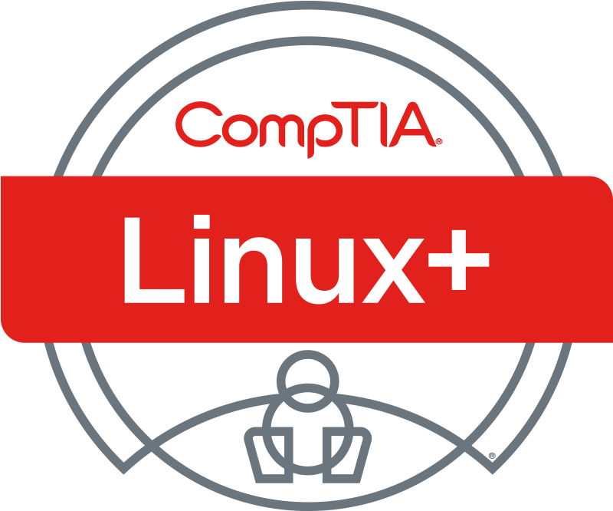
CompTIA Certified Linux+ Training (XK0-006)
TGS Ref No: TGS-2024048316
Conducted by
Tertiary Infotech Academy Pte Ltd
UEN: 201200696W
Version 1.0

DOCUMENT VERSION CONTROL RECORD
Version Number | Effective Date of Release | Summary of Included Changes | Author
1.0 | 1 Jul 2026 | Initial release — aligned to CompTIA Linux+ XK0-006 V8 exam domains and the 30 hands-on labs. | Dr. Alfred Ang

TABLE OF CONTENTS
Right-click and choose “Update Field”, or press F9, to build the table of contents.

Course Overview
CompTIA Certified Linux+ Training (XK0-006) (TGS-2024048316) is a 2-day, hands-on WSQ course that prepares learners to configure, manage, operate and troubleshoot Linux server environments while applying security best practices, scripting, containerization, virtualization and automation. The course is fully aligned to the five CompTIA Linux+ XK0-006 V8 exam domains and is delivered through 30 practical labs on the free Killercoda Ubuntu Playground.

Learning Outcomes
By the end of this course, participants will be able to:
- Explain core Linux concepts — the boot process, the Filesystem Hierarchy Standard, device management and virtualization — and manage storage, networking and shell operations.
- Manage files, local user and group accounts, processes and jobs, software packages, systemd services and containerized applications on a Linux server.
- Apply Linux security: authentication/authorization (sudo, PAM), firewalls, OS and account hardening, cryptography and compliance/audit procedures.
- Automate administration with Ansible, Bash and Python, apply Git version control, and use AI assistants responsibly and securely.
- Monitor a Linux system and analyze and troubleshoot hardware, storage, network, security and performance issues using the right diagnostic tools.

Exam Domain Coverage
The course maps 1:1 to the CompTIA Linux+ XK0-006 V8 exam blueprint. Each domain's weighting and the labs that cover it:
Domain | Exam Weight | Labs | Sub-objectives
1. System Management | 23% | 1–7 | 1.1, 1.2, 1.3, 1.4, 1.5, 1.6, 1.7
2. Services and User Management | 20% | 8–13 | 2.1, 2.2, 2.3, 2.4, 2.5, 2.6
3. Security | 18% | 14–19 | 3.1, 3.2, 3.3, 3.4, 3.5, 3.6
4. Automation, Orchestration, and Scripting | 17% | 20–24 | 4.1, 4.2, 4.3, 4.4, 4.5
5. Troubleshooting | 22% | 25–30 | 5.1, 5.2, 5.3, 5.4, 5.5

Daily Schedule
Each training day runs 9:00 AM – 6:00 PM and delivers 8 instructional hours (1-hour lunch; tea breaks counted within teaching time).

Day 1 — System Management & Services / User Management
Time | Duration | Topic / Activity | Method
9:00 AM | 15 min | Digital Attendance (AM) via TRAQOM/LMS · Trainer & Learner Introduction | Admin
9:15 AM | 15 min | Course Overview, Learning Outcomes & Ground Rules | Lecture
9:30 AM | 2 hr 15 min | Domain 1 — System Management (23%): boot & FHS, kernel modules, LVM storage, networking, shell operations (Labs 1–5) | Lecture + Hands-on Labs
11:45 AM | 45 min | Lunch Break
12:30 PM | 1 hr 30 min | Domain 1 (cont.) — backup & restore, virtualization (Labs 6–7) | Lecture + Hands-on Labs
2:00 PM | 10 min | Digital Attendance (PM) | Admin
2:10 PM | 2 hr 50 min | Domain 2 — Services and User Management (20%): files, accounts, processes, packages, systemd, containers (Labs 8–13) | Lecture + Hands-on Labs
5:00 PM | 50 min | Domain 2 wrap-up, Q&A and Day 1 recap | Discussion
5:50 PM | 10 min | Day 1 review & preview of Day 2 | Discussion
6:00 PM |  | End of Day 1

Day 2 — Security, Automation, Troubleshooting & Final Assessment
Time | Duration | Topic / Activity | Method
9:00 AM | 10 min | Digital Attendance (AM) via TRAQOM/LMS | Admin
9:10 AM | 2 hr 35 min | Domain 3 — Security (18%): AAA/sudo/PAM, firewalls, OS hardening, account hardening, cryptography, compliance & audit (Labs 14–19) | Lecture + Hands-on Labs
11:45 AM | 45 min | Lunch Break
12:30 PM | 2 hr 10 min | Domain 4 — Automation, Orchestration & Scripting (17%): Ansible, Bash, Python, Git, responsible AI (Labs 20–24) | Lecture + Hands-on Labs
2:40 PM | 10 min | Digital Attendance (PM) | Admin
2:50 PM | 50 min | Domain 5 — Troubleshooting (22%): monitoring, storage, network, security, performance (Labs 25–29) | Lecture + Hands-on Labs
3:40 PM | 20 min | Capstone — end-to-end server build & triage (Lab 30) | Hands-on Lab
4:00 PM | 0 min | Revision · Briefing for Assessment · Course Feedback & TRAQOM Survey | Admin
4:00 PM | 1 hr | Final Written Assessment (SAQ) — Open Book | Written Assessment (WA)
5:00 PM | 1 hr | Final Practical Performance (PP) — Open Book | Practical Performance (PP)
6:00 PM |  | Submit answers on LMS · Sign Assessment Summary Record · End of Class

Topic-by-Topic Breakdown

Domain 1 — System Management (23%)
Lab 1 — Boot Process & Filesystem Hierarchy [Obj 1.1]
Inspect a running Linux system's boot configuration, kernel command line, initramfs, and the standard Filesystem Hierarchy to understand how GRUB hands off to the kernel and where FHS directories live.
Lab 2 — Kernel Modules & Device Management [Obj 1.2]
List, inspect, load, and unload kernel modules and use the standard hardware-enumeration tools to understand modprobe vs insmod, module dependencies, and reading dmesg.
Lab 3 — Storage with LVM, Partitions & Filesystems [Obj 1.3]
Build a complete LVM stack on loopback-backed disks, format with ext4/xfs/btrfs, mount with hardening options, persist in fstab, and grow a filesystem online.
Lab 4 — Network Configuration [Obj 1.4]
Inspect interfaces, addresses, and routes with ip; walk the name-resolution stack; validate a netplan YAML; and use the standard diagnostic toolbox to read a Linux network stack top-to-bottom.
Lab 5 — Shell Operations & Text Processing [Obj 1.5]
Work with shell environment variables, login vs interactive startup files, every common redirection form, and the classic text-processing pipeline to assemble non-trivial one-liners.
Lab 6 — Backup & Restore [Obj 1.6]
Create tar/cpio/dd archives with gzip/bzip2/xz compression, image and recover disks with dd and ddrescue, mirror trees with rsync, and verify integrity with sha256sum.
Lab 7 — Virtualization with QEMU/KVM & libvirt [Obj 1.7]
Install QEMU and libvirt, manipulate virtual disk images with qemu-img, list libvirt domains/networks with virsh, and boot a tiny guest under QEMU to discuss hypervisors, image formats, snapshots, and network modes.

Domain 2 — Services and User Management (20%)
Lab 8 — File & Directory Management [Obj 2.1]
Practice core file and directory operations: navigating, creating, copying, searching, linking, and inspecting special device files with standard Linux utilities.
Lab 9 — Local Account & Group Management [Obj 2.2]
Create and manage local users and groups, set passwords and aging policies, change shells, and distinguish user, system, and service accounts.
Lab 10 — Processes, Jobs & Scheduling [Obj 2.3]
Inspect processes, manipulate shell jobs, adjust priorities, send signals, and schedule tasks with at, cron, and anacron.
Lab 11 — Software & Package Management [Obj 2.4]
Manage Debian packages with apt/dpkg, add a signed third-party repo, run dnf/rpm in a container, and use language and sandboxed package managers.
Lab 12 — Service Management with systemd [Obj 2.5]
Inspect and control systemd units, author custom service/timer/mount units, analyze boot performance, and configure host/time/DNS via systemd helpers.
Lab 13 — Containers with Docker & Podman [Obj 2.6]
Install Docker and Podman, pull/run images, manage volumes and networks, build an image from a Dockerfile, and contrast rootful vs rootless engines.

Domain 3 — Security (18%)
Lab 14 — AAA: sudo, PAM, and Polkit [Obj 3.1]
Configure sudo authorization, inspect PAM authentication stacks, and enable auditd accounting to record security events. Finish with a conceptual look at centralized identity via LDAP, Kerberos, and SSSD.
Lab 15 — Firewalls: ufw, firewalld, iptables, nftables, ipset [Obj 3.2]
Configure firewalls at every layer of the Linux netfilter stack, from the ufw wrapper down to iptables and nftables, and understand stateful inspection. Explore zones, rich rules, ipset, and SNAT/DNAT.
Lab 16 — OS Hardening: Permissions, SELinux, SSH, Fail2ban [Obj 3.3]
Apply layered OS hardening from file permissions and immutability through SELinux labeling, then harden OpenSSH and add brute-force protection. Inventory SUID binaries and legacy cleartext services.
Lab 17 — Account Hardening [Obj 3.4]
Harden user accounts through password quality and aging policies, brute-force lockouts, and restricted or non-interactive shells. Explore TOTP MFA and Have I Been Pwned k-anonymity lookups.
Lab 18 — Cryptography: GPG, LUKS, OpenSSL, WireGuard [Obj 3.5]
Practice core Linux cryptography: GPG key generation and signing, LUKS2 disk encryption, OpenSSL certificates, hashing and HMAC, and WireGuard keys. Learn to identify weak TLS versions and ciphers.
Lab 19 — Compliance, Auditing, and File Integrity [Obj 3.6]
Establish file-integrity monitoring and run compliance and audit tooling to detect tampering, rootkits, and misconfigurations. Cover secure deletion, login banners, and OpenSCAP/CIS benchmarks.

Domain 4 — Automation, Orchestration, and Scripting (17%)
Lab 20 — Infrastructure as Code with Ansible [Obj 4.1]
Learn Infrastructure as Code using Ansible as the primary agentless configuration management tool, and recognize the wider IaC ecosystem (Puppet, OpenTofu, cloud-init, Kubernetes ConfigMaps). Build an idempotent playbook that deploys and configures nginx.
Lab 21 — Bash Scripting [Obj 4.2]
Practice core Bash scripting constructs (variables, conditionals, loops, functions, option parsing, regex, file tests) and assemble a defensive backup script, then audit it with shellcheck.
Lab 22 — Python for System Administration [Obj 4.3]
Use Python for common Linux admin tasks: create a virtual environment, exercise core data types, walk the filesystem, parse JSON, call a REST API with requests, and enforce PEP 8 with black and flake8.
Lab 23 — Git Version Control [Obj 4.4]
Work through Git end to end: init, commit, branch, merge, resolve conflicts, stash, tag, rewrite history with reset and rebase, and push/pull against a local bare remote.
Lab 24 — Responsible AI Use for Linux Administrators [Obj 4.5]
Adopt a verify-before-paste workflow for AI-generated Linux commands: redact secrets before sending prompts to hosted models, lint and sandbox suggestions, weigh local vs hosted models, and draft a corporate AI usage policy.

Domain 5 — Troubleshooting (22%)
Lab 25 — Monitoring Concepts and Tools [Obj 5.1]
Learn the monitoring vocabulary (SLA/SLO/SLI) and stand up a working monitoring stack to produce metrics, alerts, webhooks, health checks, and aggregated logs.
Lab 26 — Troubleshooting Hardware, Storage, and OS Issues [Obj 5.2]
Deliberately inject common OS and storage failures then diagnose and repair each, keeping every breakage contained to loopback devices, throwaway units, or subshells.
Lab 27 — Troubleshooting Network Connectivity [Obj 5.3]
Break and repair the common network faults (DNS, routing, firewall, MTU, IP, link, dual-stack) while practicing the standard L3/L4 triage toolkit.
Lab 28 — Troubleshooting Security Issues [Obj 5.4]
Diagnose and repair security faults spanning SELinux contexts, POSIX ACLs, certificate trust, account lockout, broken repos, and weak TLS, using a Rocky container for the SELinux portion.
Lab 29 — Troubleshooting Performance Issues [Obj 5.5]
Stress CPU, memory, disk I/O, and network in turn, then walk the universal performance loop: baseline, spike, identify the bottleneck with the right counter, and resolve it.
Lab 30 — Capstone: End-to-End Server Build and Triage [Obj Capstone]
Integrate Objectives 1-5 into one coherent build: a hardened admin account, LVM storage, nginx with a systemd override, a locked firewall, a health-check timer, and git-versioned config, then inject a fault and triage it end-to-end.

Resources Required
- A laptop with a modern web browser and reliable internet access.
- Free Killercoda Ubuntu Playground — https://killercoda.com/playgrounds/scenario/ubuntu (no local install required).
- Course slide deck and Learner Guide (downloaded from the LMS).
- Tertiary Infotech LMS account — https://lms-tms.tertiaryinfotech.com/ (courseware download and assessment).
- CompTIA Linux+ XK0-006 V8 Exam Objectives (reference blueprint).

Assessment
The course is assessed on the final afternoon of Day 2 (4:00 PM – 6:00 PM):
- Written Assessment (WA) — Short-Answer Questions (SAQ), 1 hour (4:00–5:00 PM), open book.
- Practical Performance (PP) — hands-on lab tasks, 1 hour (5:00–6:00 PM), open book.
- Open book means learners may refer to the slides, Learner Guide and any approved materials.
- Assessment flow: TRAQOM survey (scan the QR code on the LMS) → Assessment Digital Attendance → Assessment (WA + PP) → Submit answers on the LMS → Sign the Assessment Summary Record.
- Courseware and the assessment are hosted on the LMS — https://lms-tms.tertiaryinfotech.com/.
Funding criteria: learners must attend at least 75% of the course and be assessed as Competent (C) in both the Written Assessment and the Practical Performance to be eligible for course funding and certification.

