MARKETING PERFORMANCE ANALYSIS
Sunset Bay Resort Singapore
Google Ads and Facebook Ads | January–June 2026
Executive report based on MOCK-MARKETING-DATA.xlsx
SIMULATION DATA — All figures are fictional and provided for training use only. They do not describe a real business.
Prepared by Tertiary Infotech Academy | 2026

Executive Summary
The portfolio generated S$625,170 in simulated revenue from S$72,700 in advertising spend, producing an 8.60x return on ad spend (ROAS) and 759.9% return after advertising cost. Across both channels, the campaign delivered 1,848 conversions at an average cost per conversion of S$39.34.

Headline findings
- Google Ads is the growth and efficiency engine: 10.36x ROAS, S$34.36 cost per conversion, and 1,266 conversions.
- Facebook Ads remains profitable but is deteriorating: ROAS fell from 6.83x in January to 5.00x in June, while cost per conversion rose from S$43.96 to S$60.00.
- Portfolio revenue grew 44.9% from January to June, almost exactly matching spend growth of 45.0%; overall ROAS was therefore essentially flat (8.61x to 8.60x).
- The channel mix hides a strong divergence: Google efficiency improved as it scaled, while Facebook's post-click conversion rate weakened despite stable click-through and cost per click.
- A controlled reallocation of 20% of Facebook spend (S$5,840) to Google would have produced approximately S$25,570 more revenue and 54 more conversions if historical efficiency had held. This is a scenario, not a forecast.

Recommended decision
Scale Google Ads gradually, pause further Facebook budget increases, and use a four-week Facebook recovery test focused on landing-page conversion, audience quality, and creative fatigue. Reallocate budget only after confirming marginal performance and saturation limits.

Portfolio KPI Scorecard
Metric | Jan–Jun 2026 result | Interpretation
Advertising spend | S$72,700 | Total investment across both channels
Revenue | S$625,170 | Simulated revenue attributed to campaigns
ROAS | 8.60x | S$8.60 revenue per S$1 of spend
ROI after ad cost | 759.9% | (Revenue − spend) / spend
Conversions | 1,848 | Total recorded conversions
Cost per conversion | S$39.34 | Blended acquisition cost
Click-through rate | 1.8% | Clicks / impressions
Click-to-conversion rate | 1.8% | Conversions / clicks
Metric note: the workbook defines “ROI (return on spend)” as Revenue / Spend. This report labels that measure ROAS and separately reports percentage ROI as (Revenue − Spend) / Spend.

Performance Trend
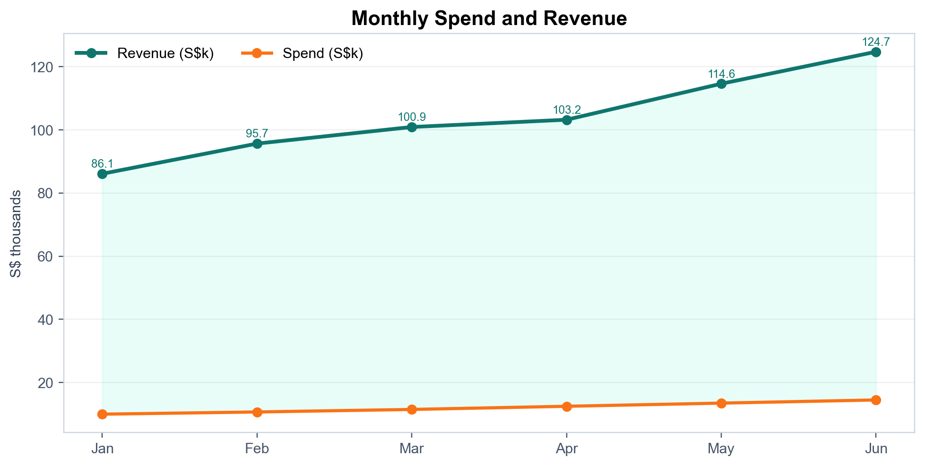
Monthly revenue increased from S$86,100 in January to S$124,720 in June (44.9%), while spend increased from S$10,000 to S$14,500 (45.0%). The portfolio's best monthly ROAS was 8.94x in Feb; the lowest was 8.26x in Apr.

Interpretation
- Top-line growth was driven mainly by increased investment rather than a broad improvement in blended efficiency.
- Conversions rose 37.5% from January to June, slower than spend and revenue, while revenue per conversion improved from S$332.43 to S$350.34.
- The April ROAS dip was followed by recovery in May and June, led by stronger Google Ads performance.
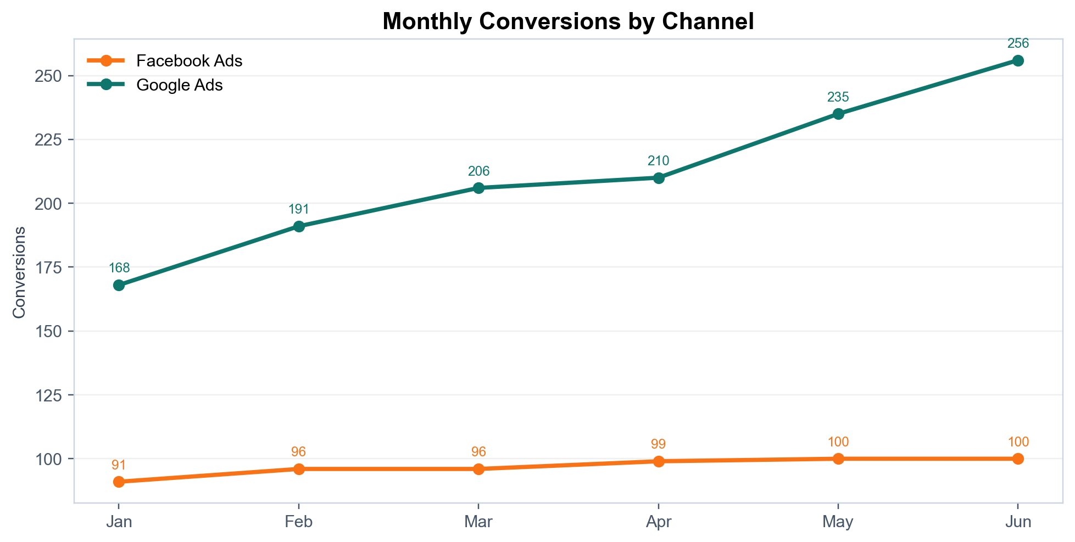
Google Ads produced the majority of incremental conversions. Facebook conversions plateaued at 100 in May and June even as monthly Facebook spend increased to S$5,500 and S$6,000 respectively.

Channel Comparison
Metric | Google Ads | Facebook Ads | Google advantage
Spend | S$43,500 | S$29,200 | —
Revenue | S$450,570 | S$174,600 | —
Conversions | 1,266 | 582 | 2.18× volume
ROAS | 10.36x | 5.98x | 73% higher
Cost per conversion | S$34.36 | S$50.17 | 32% lower
CTR | 2.0% | 1.6% | 25% higher
Click-to-conversion rate | 2.1% | 1.3% | 59% higher
Revenue per conversion | S$355.90 | S$300.00 | 19% higher
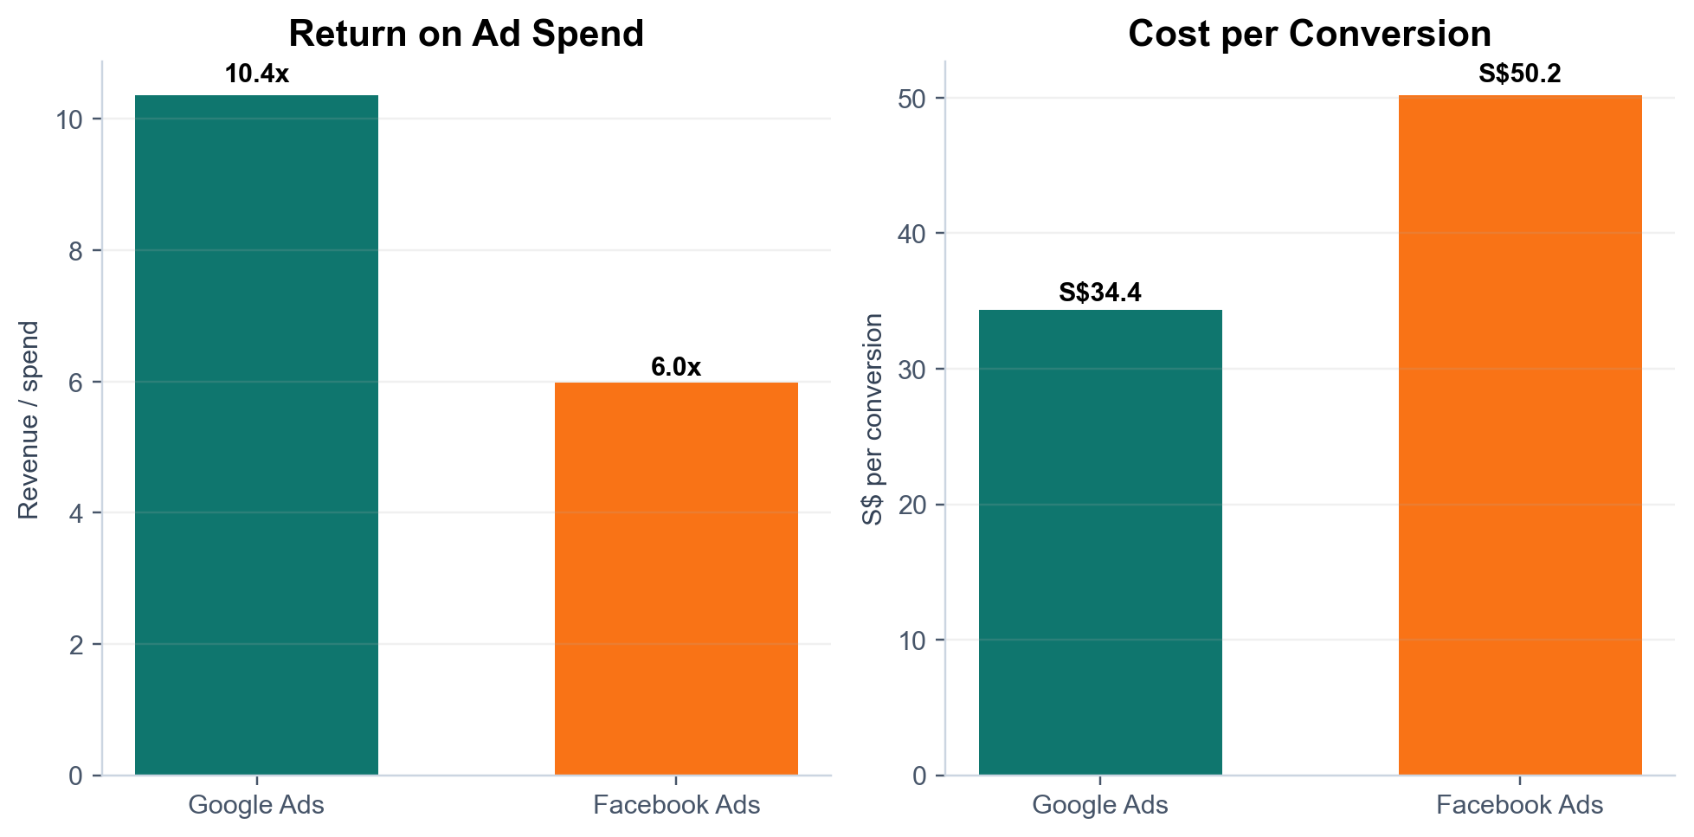

Why Google leads
- Google generated 72.1% of revenue from 59.8% of spend.
- Google's higher CPC (S$0.71 versus S$0.66) is more than offset by its stronger conversion rate (2.1% versus 1.3%).
- From January to June, Google revenue increased 61.1%, ROAS improved 13.7%, and CPA declined 7.0%.

Funnel Diagnosis
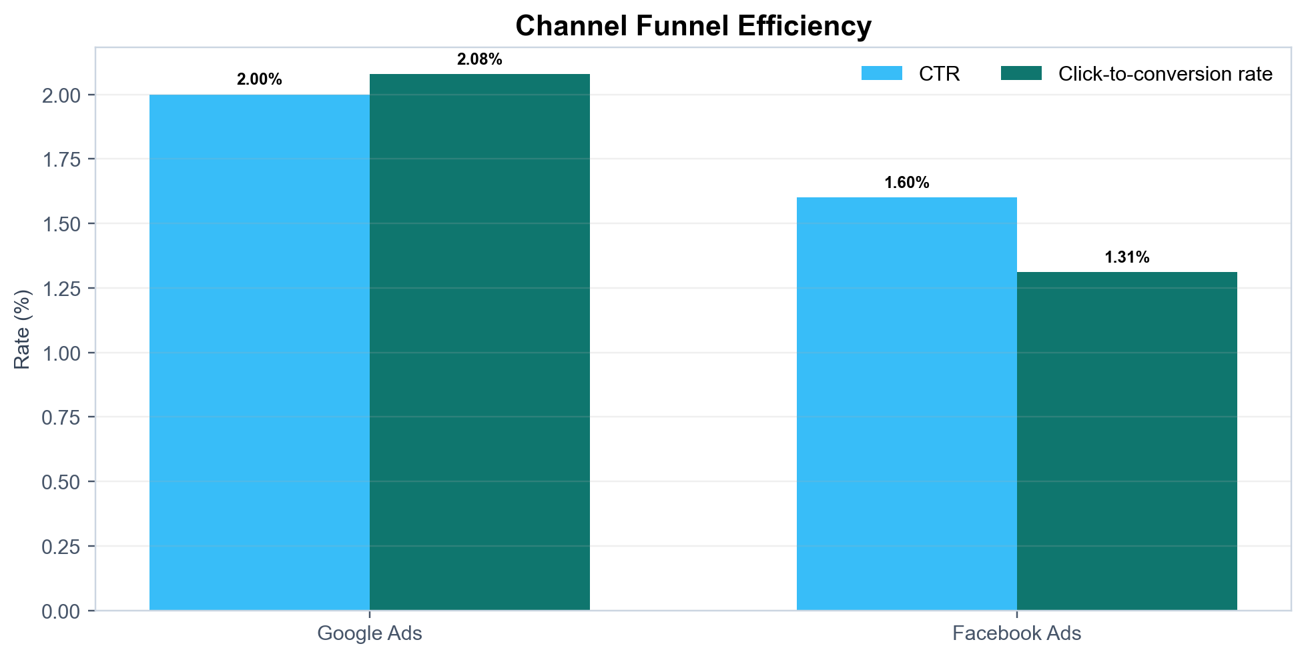

Facebook issue is primarily post-click
Facebook's click-through rate stayed fixed at 1.60% and CPC remained approximately S$0.66, but its click-to-conversion rate fell from 1.50% in January to 1.10% in June. Over the same period, spend rose 50.0% while revenue and conversions grew only 9.9%. This pattern points more strongly to audience quality, offer/landing-page mismatch, conversion friction, or attribution quality than to rising traffic costs.

Google shows healthy scaling
Google's CTR remained at 2.00% while click-to-conversion rate improved from 2.00% to 2.15%. Revenue per conversion increased from S$350 to S$370 in June. The channel absorbed 41.7% more spend while revenue rose 61.1%, indicating improved average efficiency over the observed range.

Data caveats
- The dataset contains only 12 rows, six months, and two channels; no campaign, audience, creative, device, geography, or landing-page detail is available.
- Revenue attribution method, conversion window, cancellations, refunds, and customer lifetime value are not provided.
- The dataset is explicitly fictional; recommendations demonstrate analytical method rather than real-world business advice.

Prioritized Recommendations

1. Reallocate budget through a controlled test
Move up to 20% of aggregate Facebook spend (S$5,840) to Google in two 10% steps. At historical average efficiency, the full shift implies approximately S$25,570 incremental revenue and 54 incremental conversions. Treat these as scenario outputs; marginal efficiency may decline as Google scales.

2. Stop scaling Facebook until conversion quality recovers
- Hold Facebook budget at or below the current level during diagnosis; do not increase spend solely to maintain impression growth.
- Set recovery gates of CPA ≤ S$45 and click-to-conversion rate ≥ 1.40% before resuming scale.
- Audit conversion tracking, landing-page speed and form friction, audience expansion, placement mix, frequency, and creative fatigue.

3. Scale Google incrementally and watch marginal returns
- Increase Google budget in 10–15% steps, separated by enough time to observe conversion quality.
- Use operating guardrails of ROAS ≥ 9.5x and CPA ≤ S$37; review search terms, match types, brand/non-brand mix, and device performance.
- Measure marginal ROAS on each added budget tranche rather than relying only on the strong six-month average.

4. Build a structured experimentation cadence
- Run one clear Facebook test per week: audience, creative, landing page, then retargeting sequence.
- Pre-register the primary KPI, minimum sample threshold, and stop rule; avoid changing multiple variables at once.
- Record test cost, incremental conversions, CPA, conversion quality, and downstream booking value.

5. Improve measurement and decision reporting
- Add campaign/ad-set, device, audience, creative, landing-page, and booking-quality dimensions.
- Report attributed revenue alongside cancellations, refunds, gross margin, and customer lifetime value.
- Use a weekly dashboard with spend, marginal ROAS, CPA, CTR, conversion rate, and budget pacing by channel.

30-Day Action Plan
Timing | Action | Owner / output | Success measure
Days 1–3 | Verify conversion tracking, attribution window, and revenue reconciliation | Marketing + analytics audit | No unexplained conversion or revenue gaps
Days 4–7 | Freeze Facebook increases; segment by audience, placement, device, and landing page | Diagnostic cut of Facebook performance | Root-cause shortlist
Week 2 | Shift first 10% budget tranche to Google; launch Facebook landing-page test | Controlled budget test | Google marginal ROAS ≥ 9.5x
Week 3 | Evaluate first tranche; run Facebook creative/audience test | Test readout | Facebook CPA trends toward ≤ S$45
Week 4 | Apply or reverse second 10% shift; publish operating dashboard | Budget decision and dashboard | Portfolio CPA ≤ S$39.34 with stable quality

Decision rules
- Scale a channel only when marginal—not average—ROAS and CPA remain within guardrails.
- Reverse budget changes if conversion quality or downstream revenue declines.
- Do not declare a Facebook recovery from CTR alone; require improvement in click-to-conversion rate and CPA.

Expected outcome
The recommended approach protects current profitability while creating evidence for a more efficient channel mix. It prioritizes reversible tests over a one-time permanent budget move.

Methodology and Definitions
Source: MOCK-MARKETING-DATA.xlsx, “Marketing Data” and “Read Me” sheets. Coverage: January–June 2026. Channels: Google Ads and Facebook Ads. Evidence status: SIM (fictional training data).
Metric | Formula
ROAS | Revenue / Spend
ROI percentage | (Revenue − Spend) / Spend
CTR | Clicks / Impressions
Click-to-conversion rate | Conversions / Clicks
CPC | Spend / Clicks
Cost per conversion | Spend / Conversions
Revenue per conversion | Revenue / Conversions
Data quality checks: 12 marketing rows; no missing cells, duplicate rows, or negative numeric values. Metrics were aggregated with ratio-of-totals calculations rather than averaging row-level ratios. Scenario estimates assume historical average efficiency remains constant and therefore exclude saturation, incrementality, attribution changes, and seasonality.
© 2026 Tertiary Infotech Pte Ltd — Training use only

