BCI433 Lab 3A (updated Fall 2020)

**Writing an interactive RPGLE screen program**

**Lab objectives:**

* **Create a display file (screen)**
* **Code an interactive RPGLE program using the display file**

**Lab Requirements:**

* **Show the compile listing for ELECBILL.RPGLE (as a pdf in ACS)**
* **Successfully run ElecBill similar to instructor program ElecBillA.**

Start an RDi session

Start a ‘Green Screen’ (emulator) Session.

**Using** **Rational Developer for i (RDi):**

Lab 3AB Overview

Lab 3 has been separated into two related labs. Lab 3A involves screen design with RDi and the related RPGLE code to display screens. Validation with a display file and with an RPGLE program is also covered.

The program generates a residential electricity bill based on kilowatt hours consumption. When you consume electricity your provider looks at the times. If it is a high consumption time, the charge is higher. If it is a low consumption time (OFFPEAK) then the charge is less.

A kilowatt hour (kWh) is a way to measure the amount of electricity used in an hour. It would take approximately 1000 watts to run a microwave for 1 hour and that equals 1 kilowatt hour.

Some business rules are introduced in Lab3A. Most of the computational information and additional rules are supplied in Lab3B.

**Part A**

**Objectives:**

* **Use RDi Screen Designer to Create a Display File**

Display File screens in IBM i are very similar to forms you see on Web pages. Entering and compiling DDS code can produce these interactive screens. One option that may be used for entering DDS code is to use a GUI tool that allows you to visually select and enter what appears on the screen. Your selections are converted to DDS program code that is compiled to produce interactive screen records in a display file object. Those interactive screens are available to various program languages.

We will create a display file object called ELECDSP that uses two overlapping screen records. RPGLE, CLLE and COBOL programs can interact with the screens in the ELECDSP object. We will code an RPGLE program called ELECBILL to view and interact with the screen records. The following shows a run of the RPGLE program.

==>CALL ELECBILL

first screen called GETDATA is displayed

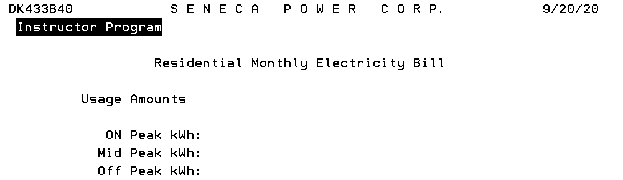

Data is entered for all the fields and the ENTER key is pressed

A second screen called ShowResult overlays the first screen and the input fields are protected. This screen is from LAB3B. You will not be doing any calculations for LAB3A and the screen will be different.

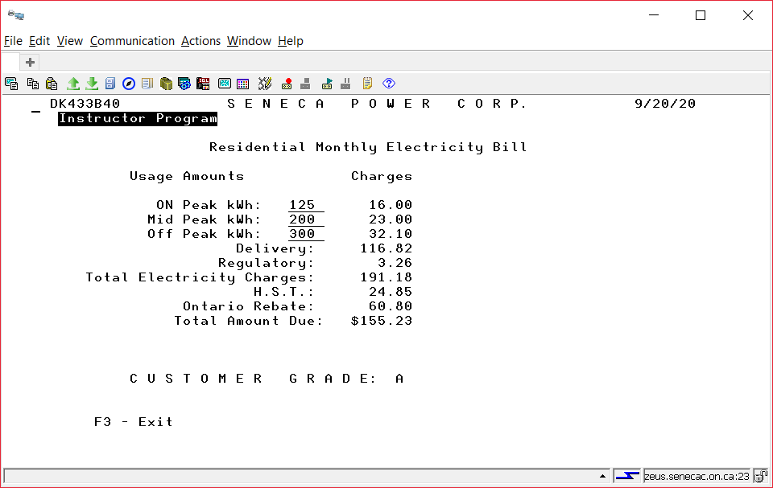

## Using Screen Designer to Produce a Display File

Source code for a Display File may be stored in a source file called QDDSSRC. You have already created this file in Lab 2 to store DDS code in the STUDENTS member that produced a physical file called STUDENTS.

DDS Stands for Data Description Specifications. The native IBM i language used to describe *FILE objects.

Create a new member inside of QDDSSRC. The member name should be specified as ELECDSP and the member type should be DSPF. If you are not immediately put in the GUI and are just in the editor after creating the member, close the ELECDSP tab.   
  
Right click on your ELECDSP member, click on Open With and select SCREEN DESIGNER.

You should still see a Remote Systems view on your upper right. The following should appear:

An outline view on the right.

A tab in the centre that has your member name (ELECDSP) with two boxes below the tab. One box has a title of Screens and the other box includes a Screen and Records tab

Below this a work area should appear with a ruler that counts from column 1 to column 100

A palette is available to the right of this work area and this will be used to select and place fields and constants on our screen record.

Immediately below this work area will be tabs that allow us to work with the GUI or to work with actual DDS code

Further down is a Source Prompter tab. We have already used a source prompter in lab 2 to enter RPGLE code and to enter DDS code for a physical file program.

A properties box on the lower left which can be used to enter useful information about records and fields.

|  |  |
| --- | --- |
|  | .  Left click on Standard Record in the Palette area and drag this over to the left work area.  Record1 should show up in several spots. In a right top window and in a Properties box on the lower left. This name can be changed to something else here. We will change it to GETDATA |

Create a date constant ( MM/DD/YY ) by clicking on Date Constant which is found in the palette underneath the Constants folder. Move your cursor over to the top left of your black grid screen and click once to place the date constant. As you move your cursor with the mouse, you should see the row and column numbers changing.

After you have placed this date, go back to the constants folder in the palette and use the arrows to scroll through other constant selections. We are also using the user constant. Refer to the finished first screen on a previous page to determine the placement of these constants and then add them to your work area.

A text constant shows below the user constant on the demo screen above as “Instructor Program”. Put your actual name here to identify this screen as your screen for the professor marking the interactive program.

There are several text constants to include on the first screen record to be named GETDATA: “Monthly Electricity Bill”, “Usage Amounts”, “On Peak kWh” etc. (check the screen shot for these text constants)

Click on Text Constant in the palette and then click to place this centred at the top of your screen.

You can change the default text of “Text constant” to “S E N E C A P O W E R C O R P.” in one of two ways. Type directly in the box provided. If this is awkward click on the word “Text Constant” in the properties box in the lower left corner.

Put in all the Text constants using the finished product screenshot.

We need to put in fields beside the some of the text constant prompts.

Click on Named Field below the Fields folder in the palette. Place the named field beside the “On Peak kWh:” constant.

This shows up as BBBBBBBBB on your work screen. Double click on the Properties box to specify information about this field. Change the provided field name to ONPEAK.

The default properties for this field are set as 9 character Input/Output field. The usage reflects this in Properties with a setting of “Both”.

Make this a 3 digits field by typing over the “9” that appears under Length on the right side of the properties view. This field will not include decimal positions.

The usage for the field should remain as Both. This means it is input capable (the user can enter something into the field when it is presented on the screen record and it is output capable, the program or user can set the field contents and it will show up to the user the next time the screen is displayed. The type of field should be Zoned and Shift should be “S” – Signed.

The display attributes for this field will use an indicator. When this indicator is on, we want the cursor positioned to this field and we want this field to show in reverse image.

First select Reverse image and Position cursor and click on the Add button.

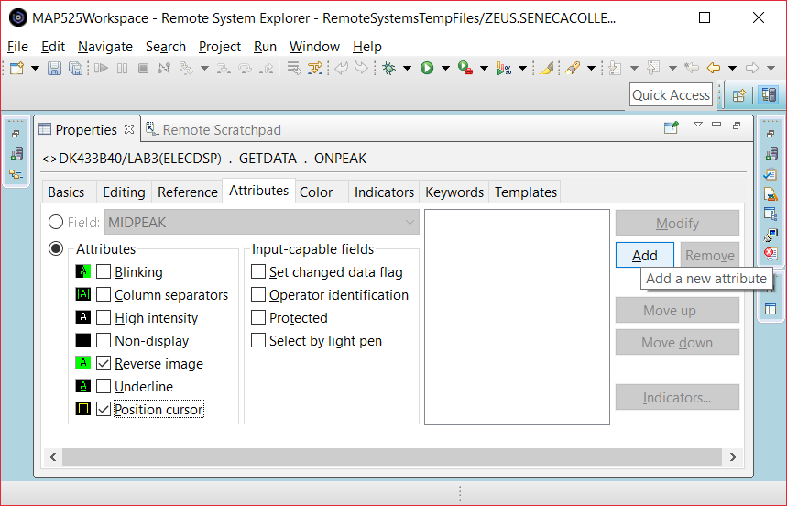

Then click on the Indicators button and use indicator 98

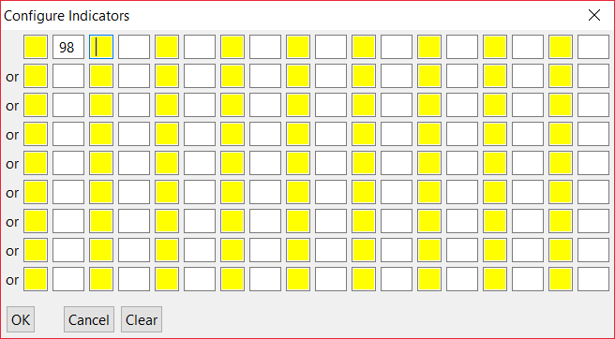

This means indicator has to be on in order for reverse image and position cursor to occur.

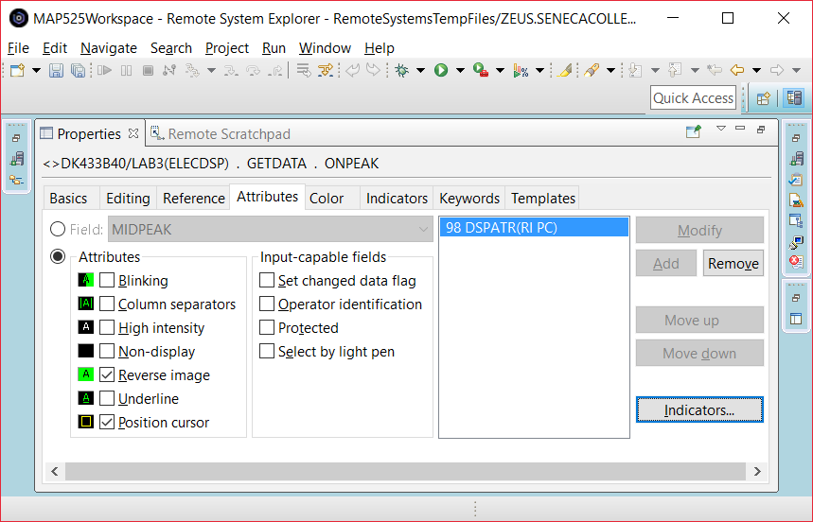

Indicators are either on or off, true or false, “1” or “0”. You have 99 of them available to use and their default setting when your program starts is off.

We are going to include some data validation with the display file rather than have the program handle it. Use the Keywords tab and select the RANGE keyword.

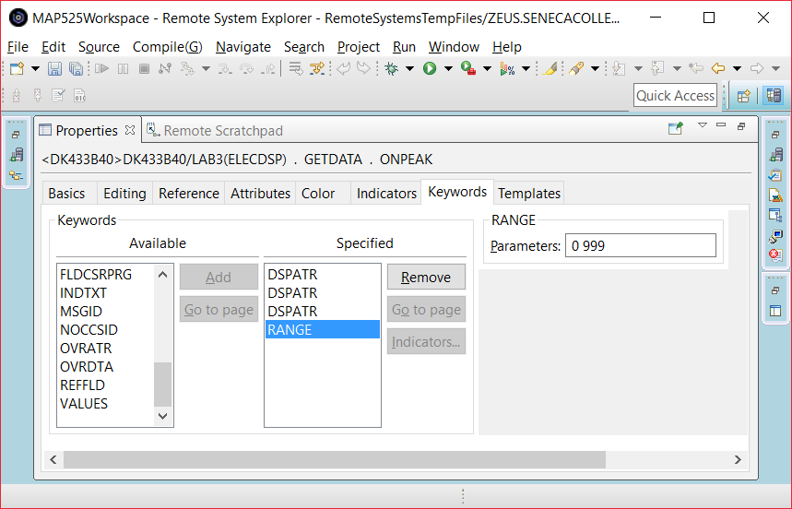

This will prevent the user from entering a negative value and is handled before the program checks the field. We will have the program handle an upper limit check for this field and it will be less than 999.

Our program will check to see if the entry made in ONPEAK is greater than 500 kWh. You should put a text constant on the same line as that field. This warning should only show if a value between 501 and 999 is entered in the ONPEAK field. You can use indicator 98 as a conditioning indicator so the text will only show when indicator 98 is on. Our program will determine if indicator 98 needs to be turned on.

Between the ONPEAK field and the warning text, include a 5 digit 2 decimal output only field that is used to show the charges based on ONPEAK usage.

The next fields will be similar - MIDPEAK and OFFPEAK. Use indicator 97 for the MidPeak field and there is no upper limit for OFFPEAK, so we will not use an indicator.

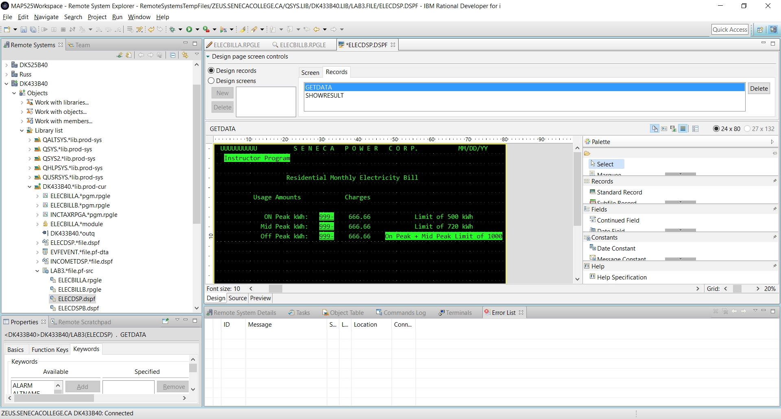

On the line with the OFFPEAK field, include a text warning conditioned with indicator 95 that shows in reverse image if the total of the ONPEAK and MIDPEAK fields is greater than 1000.

In the screen shot showing above at the bottom of the screen record being designed with the GUI, there is an option to look at the actual code that is being generated. We are currently on the Design tab. You can click on the Source tab and view the actual code. You can make changes to the code as well, but this should be done carefully when you are a beginner. You can’t introduce syntax errors when working in design mode, but you could inadvertently touch a key and modify the code and not be able to recover.

One thing you can safely do when viewing the source code is to use a compile option that appears near the top of your screen: File, Edit, Source, **Compile**, Navigate …

When you compile the code a new object is placed in your library. In this case ELECDSP This display file object can be used by CLLE, RPGLE, and COBOL programs.

Object Type Attribute

QDDSSRC *FILE PF-SRC

ELECDSP *FILE DSPF

QDDSSRC holds the member that contains the display file code for ELECDSP and ELECDSP is the object available to be used by programs.

Click on the Source tab.

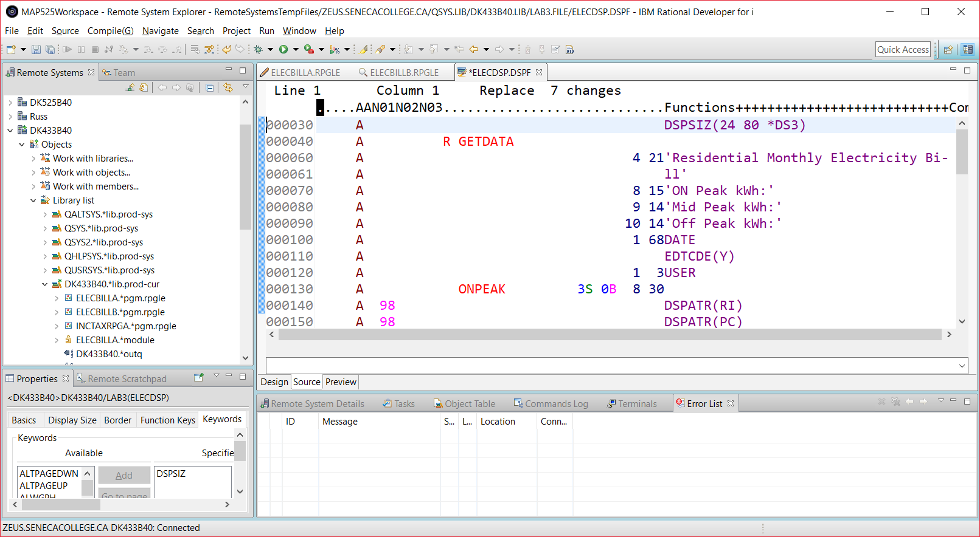

Compile what you have so far. Remember to click on the Design tab to get back to the GUI interface.

Here is source code for the first screen record. It is missing the control of when the calculated fields ONPEAKA, MIDPEAKA and OFFPEAKA should be displayed along with the ‘Charges’ literal.

Note a DSPATR(PR) is included in the code, but was not discussed.

A DSPSIZ(24 80 *DS3)

A R GETDATA

A 1 3USER

A 1 23'S E N E C A P O W E R C O R-

A P.'

A 1 68DATE

A EDTCDE(Y)

A 2 4'Instructor Program'

A DSPATR(RI)

A 4 21'Residential Monthly Electricity-

A Bill’

A 6 12'Usage Amounts'

A 8 15'ON Peak kWh:'

A ONPEAK 3S 0B 8 30

A 98 DSPATR(RI)

A 98 DSPATR(PC)

A 99 DSPATR(PR)

A RANGE(0 999)

A 98 8 56'Limit of 500 kWh'

A 9 14'Mid Peak kWh:'

A MIDPEAK 3S 0B 9 30

A 97 DSPATR(RI)

A 97 DSPATR(PC)

A 99 DSPATR(PR)

A RANGE(0 999)

A 97 9 56'Limit of 720 kWh'

A 10 14'Off Peak kWh:'

A OFFPEAK 3S 0B 10 30

A 99 DSPATR(PR)

A RANGE(0 999)

A 95 10 48'On Peak + Mid Peak Limit of 1000'

A 95 DSPATR(RI)

A ONPEAKA 5Y 2O 8 38EDTCDE(1)

A MIDPEAKA 5Y 2O 9 38EDTCDE(1)

A OFFPEAKA 5Y 2O 10 38EDTCDE(1)

A 6 37'Charges'

You are ready to provide the second screen record that will overlay the first screen record.

Click on Standard Record in the palette and drop it onto your work area. You should get a RECORD1 with a blank work area. You can toggle between GETDATA and RECORD1 by clicking on the appropriate name at the top box in the screen. Try it. Change RECORD1 to the record name SHOWRESULT

Make sure all your entries are below the area for GETDATA (in order for OVERLAY to work properly)

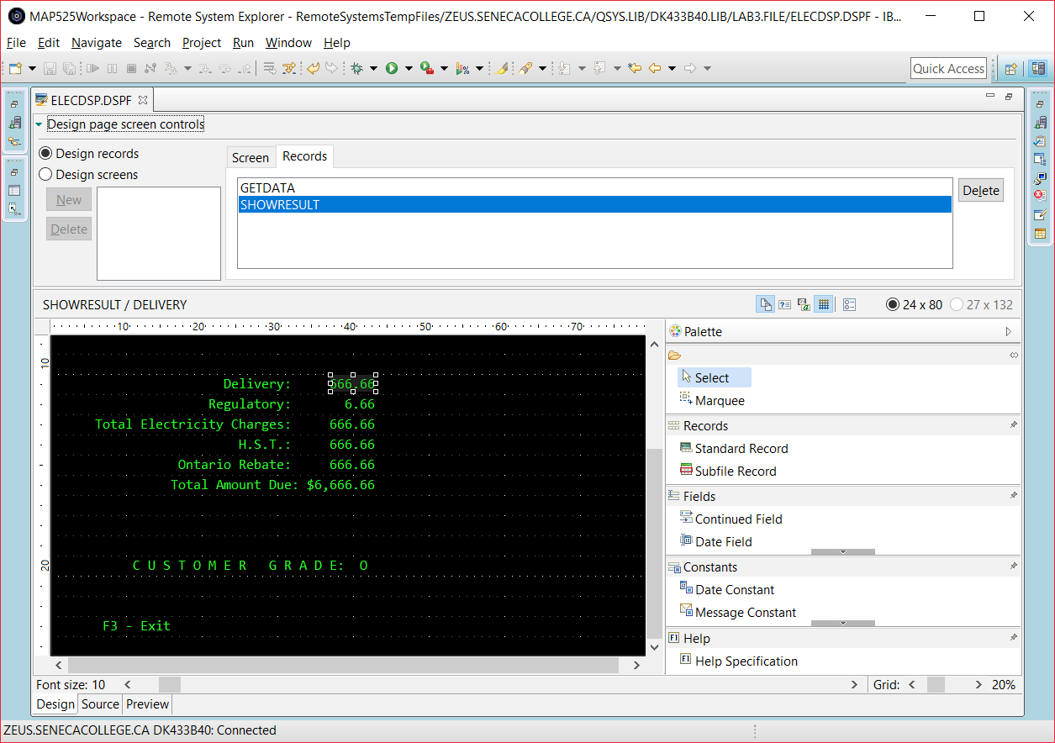

The fieldnames used for the above screen are: DELIVERY, REGULATORY, TOTALCHG, REBATE, HST, TOTALDUE and CUSTGRADE.

**Specifying Function Keys**

We specified a constant which told the user to use F3 to exit the program. Constants are only text, they do not do anything! We need to make the F3 function key available to the user.

Making sure your focus is not on a constant or a field in the SHOWRESULT work area, double click on the properties view tab at the lower left of your screen and then select the Function Keys tab.

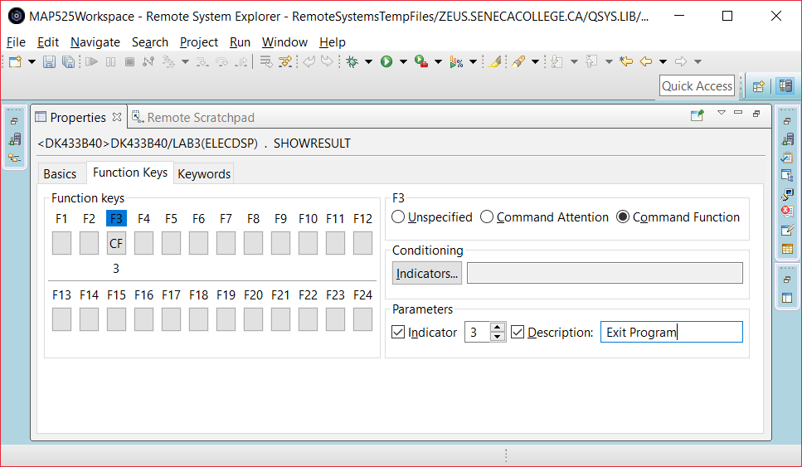

Click on F3 and on the right hand side select the Command Function radio button.

Under Parameters click on Indicator and beside that change the number to show as a three.

Click on Description and type in **Exit Program**.

Let’s review what you have done:

By clicking on F3 you have enabled the F3 key for SHOWRESULT. That means when the user is looking at SHOWRESULT they can press F3. They can not press F4 or F5 because those keys have not been enabled.

The Enter key is by default enabled for the screen records. Now, the user can press F3 or Enter. Our program will exit when F3 is pressed and reshow GETDATA if Enter is pressed.

Command Attention means that no data is passed back to the program. If you entered data into an input capable field, that data would not be available to the program. Command Function allows the data entered on the screen to be passed back to the program. Our application could have used either the CA or CF setting because when F3 is pressed our program does not do anything with the input data entered on that final screen.

The program needs to know if F3 or Enter was pressed. You have enabled a response indicator by checking of Indicator 3 under Parameters. There are 99 indicators available to you. They are like switches with an “On” or an “Off” setting. This logical field either has a ‘1’ or a ‘0’ in it.

The EXIT Description is a comment that is placed in your code.

What was the actual DDS code for all of this? _____________________________________________________

(You already know how to look this up)

Does this function key setting apply to GETDATA and SHOWRESULT or just one of those records? ___________

Add the OVERLAY keyword for SHOWRESULT by using the KEYWORDS tab when setting SHOWRESULT properties.

This will allow SHOWRESULT to display without wiping out GETDATA. If any of SHOWRESULT’s fields or constants are on the same line as a GETDATA field or constant, GETDATA will still be wiped out.

Check your source code for the second screen record with this code.

A R SHOWRESULT CF03(03)

A OVERLAY

A 11 24'Delivery:'

A DELIVERY 5 2O 11 38EDTCDE(1)

A 12 22'Regulatory:'

A REGULATORY 3 2O 12 40EDTCDE(1)

A 13 7'Total Electricity Charges:'

A TOTALCHG 5 2O 13 38EDTCDE(1)

A 15 18'Ontario Rebate:'

A REBATE 5 2O 15 38EDTCDE(1)

A 14 26'H.S.T.:'

A HST 5 2O 14 38EDTCDE(1)

A 16 17'Total Amount Due:'

A TOTALDUE 6 2O 16 35EDTCDE(1 $)

A 23 8'F3 - Exit'

A 20 12'C U S T O M E R G R A D E:'

A CUSTGRADE 1 O 20 42

Close your ELECDSP tab and save your work.

Right click on you closed Display file member (in the Remote Systems View) and compile it.

What is the command used to compile a display file DDS member? _________________________________

You should see feedback that the “Events file contains no messages” under the Error List Tab.

Click on the Commands Log Tab. You should see dialogue similar to the following:

SBMJOB CMD(CRTDSPF SRCFILE(DK433A40/LAB3) SRCMBR(ELECDSP) REPLACE(*YES) OPTION(*EVENTF) FILE(DJ433A40/ELECDSP)) JOBD(*USRPRF)

Job 262777/DK433A40/QDFTJOBD submitted to job queue QBATCH in library QGPL.

CRTDSPF SRCFILE(DK433A40/LAB3) SRCMBR(ELECDSP) REPLACE(*YES) OPTION(*EVENTF) FILE(DJ433A40/ELECDSP)

**File ELECDSP created in library DJ433A40.**

If you don’t get this there may be an error introduced into the code when you were working with the Source tab.

There also may be trouble with your connection. If the **File ELECDSP created in library** dialogue does not appear and no syntax errors show, then close up RDi, reopen it and then try the compile.

You can also compile this code using the green screen. Sign on to a Client Access session.

Type WRKMBRPDM QDDSSRC at the command line.

(This won’t work properly if you didn’t call your source physical file QDDSSRC)

Use option 14 beside the ELECDSP member name.

Instead of typing WRKSPLF at the command line to view your listing, type in SP where you had typed in “14”.

Use option 5 and scroll up and down your listing or just type in “B” at the top to get to the bottom of your listing and look for the **File ELECDSP created in library** message.

We are ready to code our program. Here is some help with entering the code.

Although a lot of help is provided, this help assumes that you made it to class and saw your instructor enter the code. If you missed that class, you should be able to get help from a lab aid or an instructor if you are stuck on any step. If you missed both the class and the lab, you should see a BCI433 tutor.

Add a new member called ELECBILL with an RPGLE member type to your QRPGLESRC source physical file. It will contain your program code for an RPGLE program that uses the display file records you have just created.

We are going to code a free format RPGLE program. In the past students have coded fixed format file and definition specs and then coded free format statements to indicate the processing logic and order. This was acceptable to the editor we worked with in lab 1 (PDM - SEU – Program Development Manager – Source Entry Utility). It was possible to work with the code in that environment and only code errors would be flagged.

This semester we are going to code the file and definition information using free format code. If you look at this code using the source entry utility, syntactically correct free format file lines will be flagged as errors.

They are not flagged as errors when using RDi. So lets be aware of that problem and use RDi.

What file name are we processing? ___________________________ . We are using a workstation device file.

Make sure you start your code anywhere after column 7.

**dcl-f filename workstn;**

This is the fixed format way to do the same thing that shows above with a workstation file called TICKETDSP. With a prompter 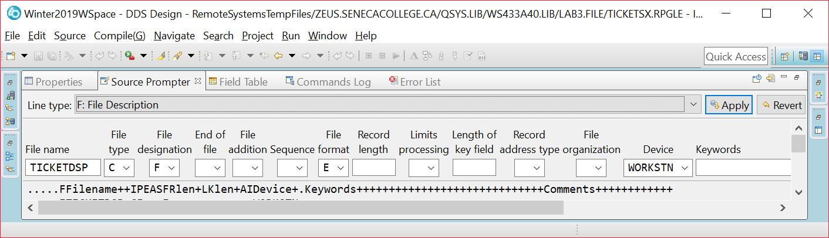

and how it appears in code.

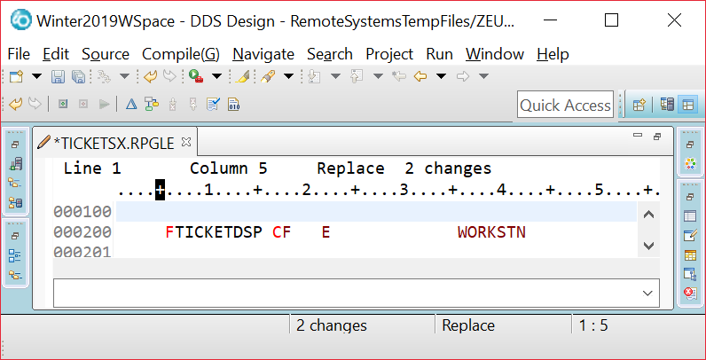

**Enter your file declaration using the easier free format technique.**

______________________________________________________________________

If we had started with a fixed format file spec would have had to type /FREE on the next line to indicate we were going to free format RPG. The slash would have gone in column 7.

As you move your cursor, feedback should be provided about which column number you are in.

The code you need to enter for the main routine will be supplied for you. This version will not be perfect and may require a few adjustments in a later lab.

It is important to remember that each program statement needs to end with a semicolon. If you don’t do this, a syntax error may pop up when you go to the next line. The compiler will also reject an RPGLE statement that does not end with a ” ; ”

If a syntax error pops up it may not always appear immediately below the line that is missing the semicolon. Figure out where you need to make the adjustment and then press CTRL + F5 to get rid of the message that shows up in the LPEX editor.

Common PDM and LPEX editor commands:

A line can be deleted by typing a D in the first position of the line number and pressing enter.

A line can also be copied by typing a C at the line and a B or A at the line it is to be copied before or after

Multiple lines can be deleted by typing DD at the start of the block and DD at the end of the block

CC and MM also work with a block of lines. There are more modern ways of editing available with the LPEX editor.

Here is the code you need to enter.

**;**

**;**

**IF OnPeak > 500;**

**\*IN98 = *ON ;**

**EXFMT GetData;**

**\*in98 = *OFF;**

**ITER;**

**ElseIf MidPeak > ?;**

**?**

**ElseIf ?;**

**?**

**ELSE;**

**______________ ;**

**ENDIF;**

**// PROTECT FIRST SCREEN RECORD FIELDS**

**// REDISPLAY FIRST SCREEN RECORD AND THEN OVERLAY SECOND RECORD**

**_________________________________;**

**_________________________________;**

**_________________________________;**

**_________________________________;**

**IF *IN03=*OFF;**

**EXSR CLEAR;**

**EXFMT GETDATA;**

**ENDIF;**

**ENDDO;**

**\*INLR = *ON;**

**RETURN;**

EXFMT is a Read/Write operation

A write of the screen record to the display station and a pause while the user reads it. The user may fill in some fields if there are input capable fields on the screen. At minimum the user will press the return key. A read back to the program occurs and the next program statement is executed.

DOW / ENDDO is for looping. The test is done at the start of the loop and if the test is not passed, none of the loop statements are executed.

NOT(*IN03) is a test of the response indicator 03 which was specified when developing ELECDSP.

Where was that specified? _____________________________________________________________

You could have also said DOW (*IN03 = ‘0’) or DOW (*IN03 = *OFF)

EXSR CalculateBill is sending control down to a subroutine called CalculateBill. This subroutine needs to appear after the RETURN statement and will determine the contents of SHOWRESULT output only fields.

Here is some sample code to use for this subroutine:

BEGSR CalculateBill;

OnPeakA = .16.55; // this is a stub coded amount. We will worry about getting the right amount in lab 3B

ENDSR;

Notice that all those fields have not been determined properly in the code above. You can demonstrate your program with this stub code for this lab and the next lab will include the information on how to determine the amounts..

We will use these stub coded values for your fields. In Lab 3B we will look at solving for these fields.

When the overlayed second screen shows, the user will not be allowed to change the kWh entries. They can press return to redisplay the first screen or press F3 to exit the program.

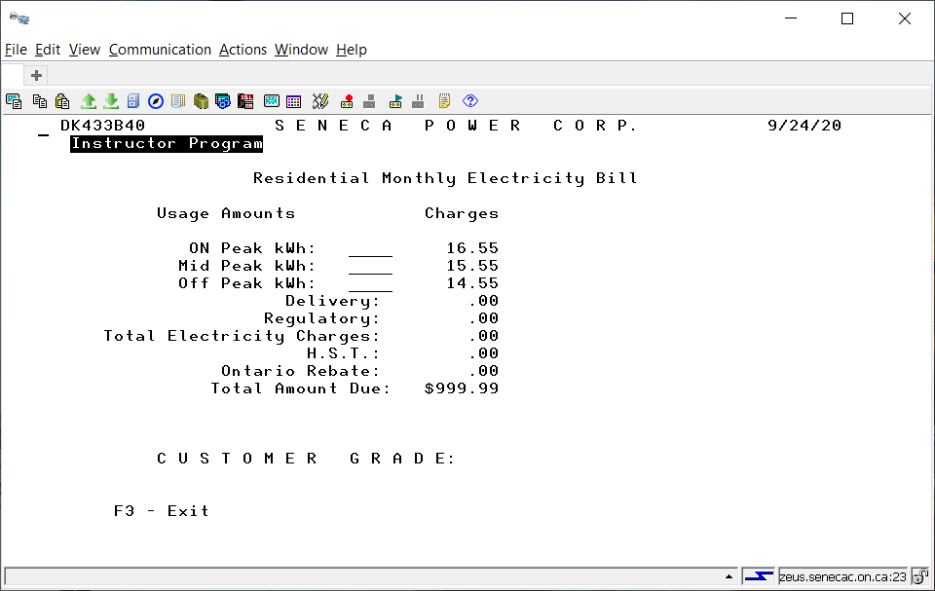

Compile ElecBill.

Fix any errors

Switch to your Access Client session and run ELECBILL. This is done by typing

______________________________________ at the command line.

Enter values for all the input fields and press enter.

When your results screen shows, can you still type data into the top screen fields? ___________

Make sure you can exit your program by pressing the F3 key. A previous lab showed what do to if you can’t stop your program.

What do you need to do to stop this program if it won’t end?

__________________________________________________________________________________________

__________________________________________________________________________________________

Instructor sample programs are available to check yours against. They have reverse image text to self identify as an instructor program. There is ElecBillA allowing you to check how your ELECBILL program should behave after doing LAB3A (showing screens and doing validation). Next week you will compare your ELECBILL RPGLE program to the instructor program ELECBILLB which correctly calculates the electricity bill.

To run the first sample program, change your current library to BCI433LIB and then invoke the program:

CHGCURLIB BCI433LIB

CALL ELECBILLA

After you have finished, you should reset your current library back to your own library.

What happens if you do not change the current library when running the instructor’s version of this program?

It will depend on the existence of ELECDSP in your library.

Try running this program with your library as the current library after you have successfully created your version of ELECDSP.

What happened?

______________________________________________________________________________________

Lab 3 Summary

A display file is coded with DDS code in a member that has a DSPF type.

Once this DDS code has been successfully compiled a Display File object is produced that can be used by different programming languages that want to take advantage of the interactive screens allowing data entry and data display.

The easiest way to define how the display file screens or records will look is to use the Screen Designer GUI in RDi.

The GUI allows you to define field names, types, usage, editing, validations and optional indicators that allow viewing of the field.

You would use the GUI to provide this information and the appropriate line is entered as DDS code.

Here is a sample line with explanations

This is how it actually appears



Some separation is shown here to better highlight concepts – the line would not be entered this way.

Field Field Data Decimal Line Column

Indicator Name Length Type Positions Use Number Position Functions

A 90 TEST1 3 S 0 B 5 32 RANGE(0 100)

Indicator 90 has to be on in order to view this field called TEST1 on the screen. If indicator 90 is off, the TEST1 field will not be visible when the screen record is displayed. For our application it would not be a good idea to use an indicator with the TEST1 field.

L shows a field length of three. So at this point XXX could be entered

T or Type shows a field type of zoned decimal and D or Decimal shows 0 decimal positions. So now we cannot put X’s in the field. 999 would work.

U or Usage indicates if this field is for input only (I) , output only (O) or both input and output (B).

P or position on the screen shows that this field would reside on line 5 at column 32.

The RANGE function allows us to validate the field before it is passed to a program. The user can enter 0 to 100. They cannot enter a negative number or 101.

Here is some more partial DDS code with explanations

A R RECORD2

A CA03(03 'EXIT')

A OVERLAY

A 11 18'Tests:'

A 13 18'Final Mark:'

A 15 18'Final Grade:'

A 22 3'F3=Exit'

A TESTOVRALL 3Y 0O 11 32EDTCDE(1)

A NUMGRADE 3Y 0O 13 32EDTCDE(1)

A LETGRADE 2A O 15 33

This screen record is called RECORD2 and has some text and fields that are displayed.

At the record level we see CA03 – that enables the pressing of function key F3 when the screen record is displayed. CA is command attention and no data from the screen gets passed back to the program. Using CF will allow data entered on the screen record to be passed back to the program.

(03 ‘Exit’) indicates when F3 is pressed indicator 03 will be turned on and the comment is ‘Exit’

OVERLAY is used to allow RECORD2 to overlay a screen record that is already being displayed. This only works of the first screen record does not use lines 11 – 25. You can see RECORD2 is using lines 11 to 22.

EDTCDE(1) can be used to make a numeric field show with commas, a decimal point and suppressed leading zeros

So 090 would show as 90. If the field was larger 0293334^33 would show as 293,334.33. The decimal point is not stored in the field but can be shown with proper editing. We used the “^” symbol to show where the placeholder for a decimal point is.

RPGLE

A Display file is declared in an RPGLE program with a DCL-f statement

Dcl-F HWYTOLLDSP Workstn;

EXFMT – write a screen record from a display file, pause and when the user presses enter read back what has been inputted into the screen record fields. Sometimes there are no fields and the read back just acknowledges that the screen has been viewed and the user is letting the rest of the program proceed.

DOW - a loop where the test on entering the loop or repeating the loop is done at the start of the loop.

ENDDO

DOU – the loop code is executed at least once and the test on repeating the loop is done at the bottom.

WRITE – can be used to have a screen record display. There is no pause and the program continues. This is useful when showing a screen record and then overlaying a second record and then pausing to let the user look at both screen records.

EXSR GETGRADE – control goes from here to a subroutine at the bottom of the program. The named subroutine has a BEGSR and ENDSR to indicate what code is executed and then control goes back up and executes the next line after the EXSR line.

*IN01 - *IN99 – in RPGLE indicators are referred to by an asterisk and a number. There are 99 indicators available for use and their default setting is *OFF or ‘0’ . They can be turned on during the program run and then checked to see if they are on or off to determine a course of action.

*INLR = *ON – these two statements are how you should end all your RPGLE programs.

RETURN The last record indicator is turned *ON and RETURN is used to return control to the operating system.