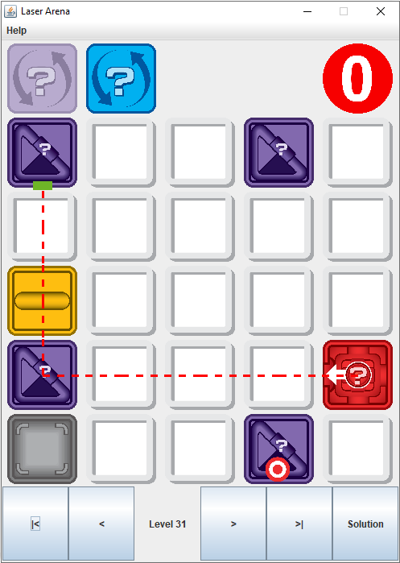

**BUTTONS and LABELS:**

**|<** Goes to first level

**<** Goes to previous level if it exists

**Level X** Indicates current level and user can RIGHT CLICK to skip to another level or LEFT CLICK to refresh the game into its initial state

**>** Goes to next level if it exists and it is unlocked. Displays FIN if game is finished.

**>|** Goes to last unlocked level

**Solution/Game** Moves between the solution and the game. This button is enabled if the solution of the level is unlocked before.