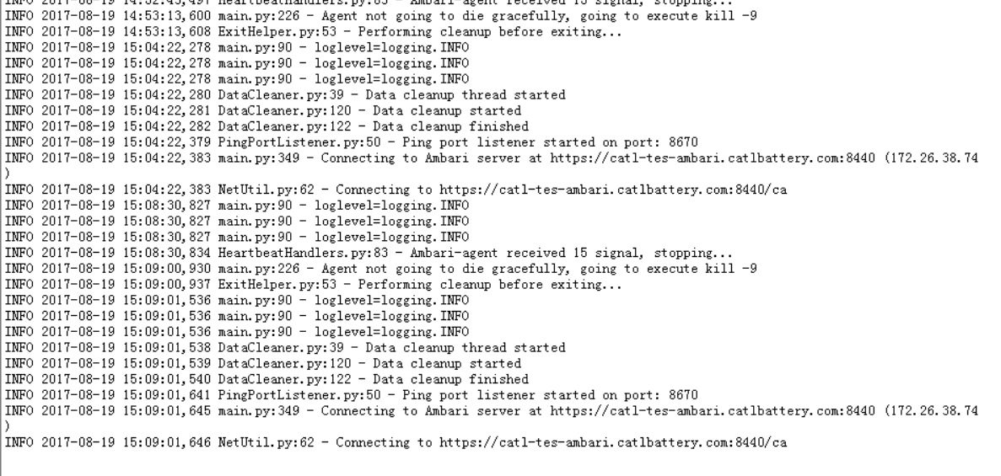

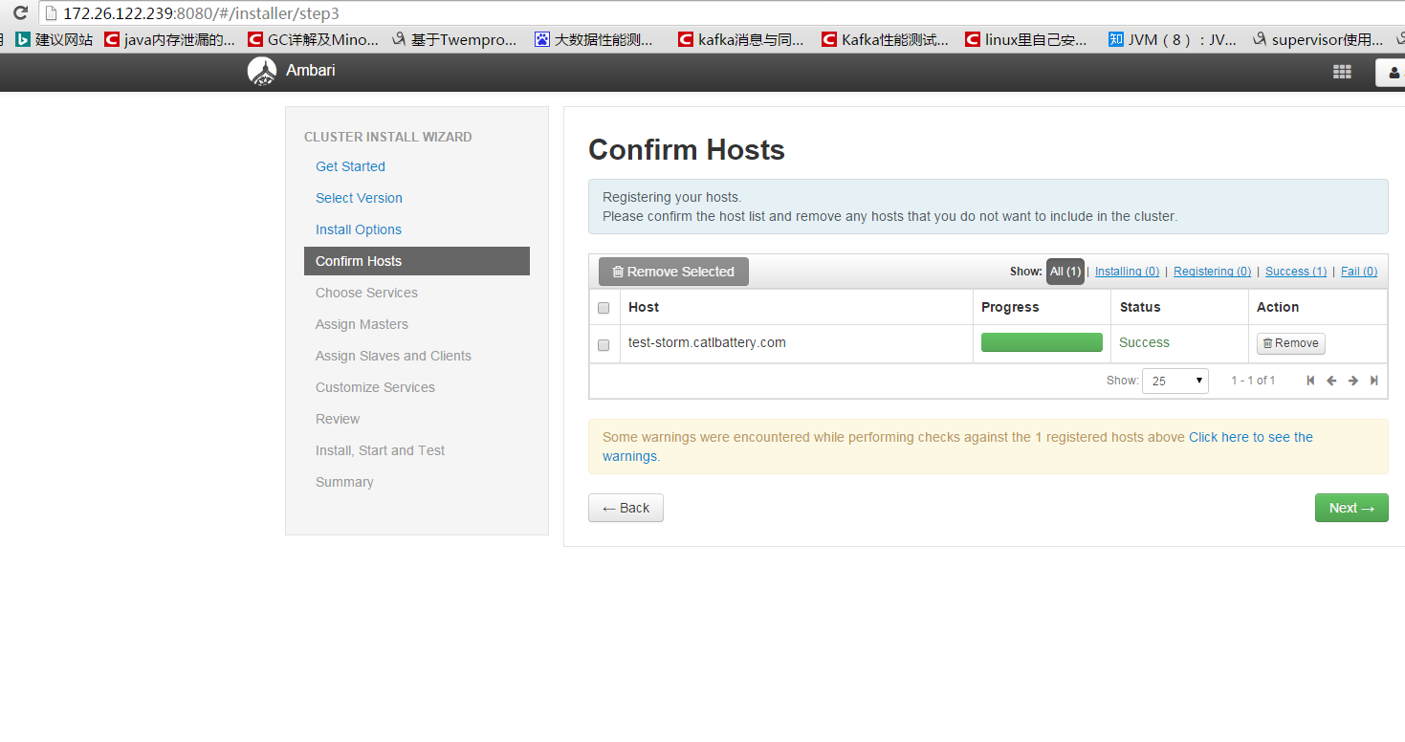

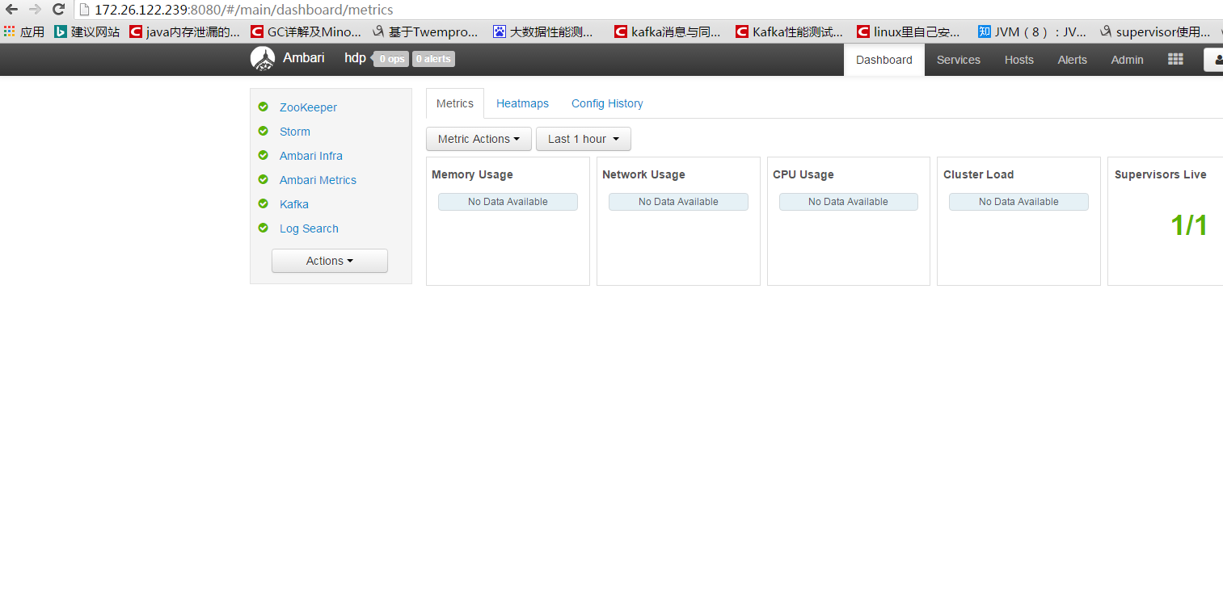

系统参数

1.内核参数，等待时间

Vim /etc/sysctl.conf

net.ipv4.tcp_syncookies = 1

net.ipv4.tcp_tw_reuse = 1

net.ipv4.tcp_tw_recycle = 1

net.ipv4.tcp_fin_timeout = 30

再加关闭ipv6

2.系统资源限制

vim /etc/security/limits.d/90-nproc.conf

* soft nproc 65536

root soft nproc unlimited

vim /etc/security/limits.conf

* soft nofile 128000

* hard nofile 128000

关闭窗口生效

可通过ulimit –a查看

3.storm参数

/hadoop/storm

topology.executor.send.buffer.size

16384

topology.executor.receive.buffer.size

16384

topology.max.spout.pending

2000

worker.childopts

-Xmx4096m -Xss256k -XX:PermSize=256m -XX:ReservedCodeCacheSize=64M -XX:MaxPermSize=1024m _JAAS_PLACEHOLDER -Dcom.sun.management.jmxremote -Dcom.sun.management.jmxremote.ssl=false -Dcom.sun.management.jmxremote.authenticate=false -Dcom.sun.management.jmxremote.port=1%ID% -javaagent:/usr/hdp/current/storm-client/contrib/storm-jmxetric/lib/jmxetric-1.0.4.jar=host=localhost,port=8650,wireformat31x=true,mode=multicast,config=/usr/hdp/current/storm-client/contrib/storm-jmxetric/conf/jmxetric-conf.xml,process=Worker_%ID%_JVM

=========================

Kafka

=========================

log.dirs *

/kafka-logs

num.io.threads * (CPU Core size)

16

=========================

Zookeeper

=========================

maxClientCnxns

2000

=========================

Ambari Infra Solr

=========================

Infra Solr Minimum Heap Size *

2G

Infra Solr Maximum Heap Size *

4G

Infra Solr data dir *

/opt/ambari_infra_solr/data