Software Requirements Specification

for

Car Rental Management System

Version 1.0

Prepared by Group 4:

*Anene Bekuma Terefe 610773*

*Joe Sleiman 610721*

*Namuun Sainbayar 610745*

*Tesfai Gebrekidan 110464*

**Table of Contents**

**1.** **Introduction** 3

**1.1.** **Purpose** 3

**2.** **Use Case Model** 3

**2.1.** **Use Case Diagram** 3

**2.2.** **Use Case Description** 4

**3.** **Glossary** 9

**4.** **Sequence Diagrams** 10

**5.** **Collaboration Diagrams** 12

**6.** **VOPC Diagrams** 13

# **Introduction**

## **Purpose**

*This is the Software Requirements Specification (SRS) document for the Car Rental Management System.*

# **Use Case Model**

## **Use Case Diagram**

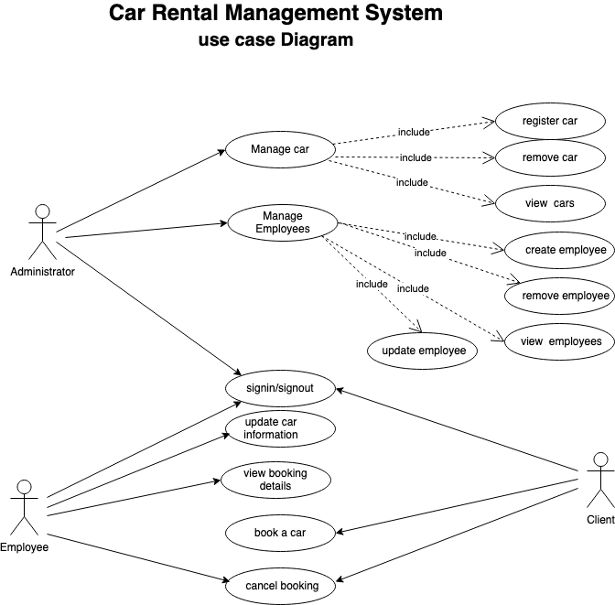

## **Use Case Description**

|  |  |  |  |  |
| --- | --- | --- | --- | --- |
| **Use Case Number: 1** | | | | |
| **Name** | | | Manage Cars | |
| **Brief description** | | | This use case allows the Administrator to manage car profile | |
| **Actors** | | | Administrator | |
| **Preconditions** | | | | |
| The admin must log in to the system | | | | |
| **Flows of Events** | | | | | |
| **1. Basic Flows** | | | | | |
| **1.1.0 Register a car** | | | | | |
| **Step** | **User Actions** | | | **System Actions** | |
| 1 | The Administrator selects the ‘Register Car’ command | | | The system displays the register car form with the required fields. | |
| 2 | The Administrator fills out the form and requests the system to save the details. | | | The system verifies all fields are filled as required and saves the car and returns the success message on success or a fail message in case of failure. | |
| **Postconditions** | | | | | |
| The car details is persisted in the system | | | | | |
|  | | | | | |
| **Business Rules** | | | | | |
| No duplicate car details. A unique car is identified by vin number. | | | | | |
|  | | | | | |
| **1.1.1 Remove Car** | | | | | |
| **Step** | **User Actions** | | | **System Actions** | |
| 1 | The Administrator select the show list command. | | | The system displays the list of cars in the system | |
| 2 | The Administrator selects the delete command associated with the car to be deleted | | | The system removes the car from the list and returns the success message on success or a fail message in case of failure. | |
| **Postconditions** | | | | | |
| The car details are removed from the system | | | | | |
| **1.1.2 View Cars** | | | | | |
| **Step** | | **User Actions** | | **System Actions** | |
| 1 | | The Administrator select the show list command. | | The system displays the list of cars in the system | |
| **Postconditions** | | | | | |
| The car details are displayed | | | | | |

|  |  |  |  |
| --- | --- | --- | --- |
| **Use Case Number: 2** | | | |
| **Name** | | Manage Employees | |
| **Brief description** | | This use case allows the admin to create profile for employee | |
| **Actors** | | Admin | |
| **Preconditions** | | | |
| The admin must log in to the system | | | |
| **Flows of Events** | | | | | |
| **2. Basic Flows** | | | | | |
| **2.1.0 Create Employee Profile** | | | | | |
| **Step** | **User Actions** | | **System Actions** | | |
| 1 | The admin calls the create employee profile command | | The system displays the create employee profile form with the fields for firstname, lastname email, password. | | |
| 2 | The Admin fills out the form and requests the system to save the details | | The system verifies that there’s no other profile in  the database with the same email address and  saves the employee and returns the success message on success or a fail message in case of failure. In case another profile exists with the email address, the system returns the message indicating a duplicate entry exists. | | |
| **Postconditions** | | | | | |
| The employee profile is persisted in the system | | | | | |
|  | | | | | |
| **Business Rules** | | | | | |
| No duplicate employee profiles. A unique profile is identified by email address. | | | | | |
|  | | | | | |
| **2.1.1 Read/view Employee Profile** | | | | |
| **Step** | **User Actions** | | **System Actions** | |
| 1 | The admin selects to view a list of employee profiles | | The system returns a list of all employee profiles. | |
| 2 | The admin selects to view a profile of one of the employees from the list of profiles | | The system returns the profile of the employee as a string with the names (firstname and lastname), email. | |
|  | | | | |
| **2.1.2 Update/Edit Employee Profile** | | | | |
| **Step** | **User Actions** | | **System Actions** | |
| 1 | The admin selects to view a list of employee profiles | | The system returns a list of all employee profiles. | |
| 2 | The admin selects the profile of the employee they want to update | | The system displays an editable employee profile from pre-populated with the employee profile details | |
| 3 | The admin updates the fields they want to update and requests system to save the new details | | The system updates the record and returns the  success message or a fail message on exception. | |
| **Postconditions** | | | | |
| The employee profile will be updated | | | | |
| **Business Rules** | | | | |
| The email field should be unwritable. | | | | |
|  | | | | |
| **2.1.3 Delete Employee Profile** | | | | |
| **Step** | **User Actions** | | **System Actions** | |
| 1 | The admin selects to view a list of employee profiles | | The system returns a list of all employee profiles. | |
| 2 | The admin selects to delete an employee profile from a list of employee profiles | | The system displays a confirmation dialogue window | |
| 3 | The admin selects OK on the confirmation dialog window to confirm deleting the profile | | The system deletes the profile. The system returns message a success message on success or failure message. | |
| **Postconditions** | | | | |
| The employee profile will be deleted | | | | |
| **Business Rules** | | | | |
|  | | | | |

|  |  |  |  |
| --- | --- | --- | --- |
| **Use Case Number: 3** | | | |
| **Name** | | Book a car | |
| **Brief description** | | This use case allows the customer to book a car | |
| **Actors** | | Customer | |
| **Preconditions** | | | |
| The customer has only to browse the system | | | |
| **Flows of Events** | | | |
| **3. Basic Flows** | | | |
| **3.1.0 Book a car** | | | |
| **Step** | **User Actions** | | **System Actions** |
| 1 | The customer enters the system or browse it. | | The system displays the form that the customer has to fill the requested information. |
| 2 | The Customer fills out the form like the date he need to book the car from which date to which date. | | The system replies by showing the customer the available cars to book on the selected dates. |
| 3 | The customer chooses a convenient car, by clicking on book button | | The system has to redirect the customer to the payment form |
| 4 | The customer fills the payment form like the credit card number, the expiration date of the card, the name of the customer…. | | The system has to verify the information inserted, if everything works fine, the customer will receive a message of confirmation, included all the details from the amount paid to the car information and date booked. |
| **Postconditions** | | | |
| The booking record is persisted in the system | | | |
|  | | | |
| **Business Rules** | | | |
| If the customer that already booked a car, if he delayed returning it back, he has to pay fees determined by the admin or employee.  The system will ask the user in the form payment about his birthday, to check if he’s older than 18 years old.  When the customer book a car, we will save the history, and send one to the customer so he can provide it when he come to take the car personally.  The system has to validate the forms, like at least if the customer fills the right required information in any form. | | | |

|  |  |  |  |
| --- | --- | --- | --- |
| **Use Case Number: 4** | | | |
| **Name** | | View Booking Detail | |
| **Brief description** | | This use case allows the employees to view the booking detail when renting a car to a customer. | |
| **Actors** | | Employee | |
| **Preconditions** | | | |
| The employee must logged in to the system | | | |
| **Flows of Events** | | | | |
| **4. Basic Flows** | | | | |
| **4.1.0 View Booking Detail** | | | | |
| **Step** | **User Actions** | | **System Actions** | |
| 1 | The Employee selects the ‘Search Booking’ Command | | The system displays a search form for Bookings with the field of Booking ID. | |
| 2 | The Employee fills out the search form for Bookings and requests the system to search | | The system verifies that there is a booking record in the database with the same booking ID and displays the booking information of that booking ID. | |
| **Postconditions** | | | | |
| The employee receives a detail information of a customer booking | | | | |
|  | | | | |
| **Business Rules** | | | | |
| There must be one search result of the booking ID | | | | |
|  | | | | |

|  |  |  |  |
| --- | --- | --- | --- |
| **Use Case Number: 5** | | | |
| **Name** | | Cancel Booking | |
| **Brief description** | | This use case allows the employees to cancel customer booking | |
| **Actors** | | Employee, Customer | |
| **Preconditions** | | | |
| The employee must logged in to the system | | | |
| **Flows of Events** | | | | |
| **5. Basic Flows** | | | | |
| **5.1.0 Cancel Bookings** | | | | |
| **Step** | **User Actions** | | **System Actions** | |
| 1 | The Employee or Customer selects the ‘Search Booking’ Command | | The system displays a search form for Bookings with the field of Booking ID. | |
| 2 | The Employee fills out the search form for Bookings and requests the system to search | | The system verifies that there is a booking record in the database with the same booking ID and displays the booking information of that booking ID. | |
| 3 | The Employee selects ‘Cancel Booking’ command | | The system deletes the booking information and make a refund depending on conditions. | |
| **Postconditions** | | | | |
| A customer booking is canceled | | | | |

|  |  |  |  |
| --- | --- | --- | --- |
| **Use Case Number: 6** | | | |
| **Name** | | Update Car Information | |
| **Brief description** | | This use case allows the employees to update the status information a rental car. | |
| **Actors** | | Employee | |
| **Preconditions** | | | |
| The employee must logged in to the system | | | |
| **Flows of Events** | | | | |
| **6. Basic Flows** | | | | |
| **6.1.0 Update Car Information** | | | | |
| **Step** | **User Actions** | | **System Actions** | |
| 1 | The Employee selects the ‘Update Car Information’ Command | | The system displays a search form for Bookings with the field of Vin number. | |
| 2 | The Employee fills out the search form and requests the system to search | | The system verifies that there is a car record in the database with the same Vin number and displays the car information of that Vin number. | |
| 3 | The Employee then updates the car information accordingly and selects the update command | | The system updates the car information and displays a confirmation message. | |
| **Postconditions** | | | | |
| The car information will be updated | | | | |
|  | | | | |
| **Business Rules** | | | | |
| The employee is not allowed to modify the Vin number. | | | | |

# **Glossary**

|  |  |
| --- | --- |
| **Customer** | A person who Is renting a car |
| **Employee** | A person who works at car rental office and who is responsible for handing the rental car to customers. |
| **Administrator** | A person who manages Employees and Rental cars |
| **Vin** | Is vehicle identification number that uniquely identifies a car. |
| **Booking** | Booking is a reservation detail of a rental car. |
| **Rental Car** | Is a car that is rented to the customers |

# **Sequence Diagrams**

**Booking a Car Sequence Diagram**

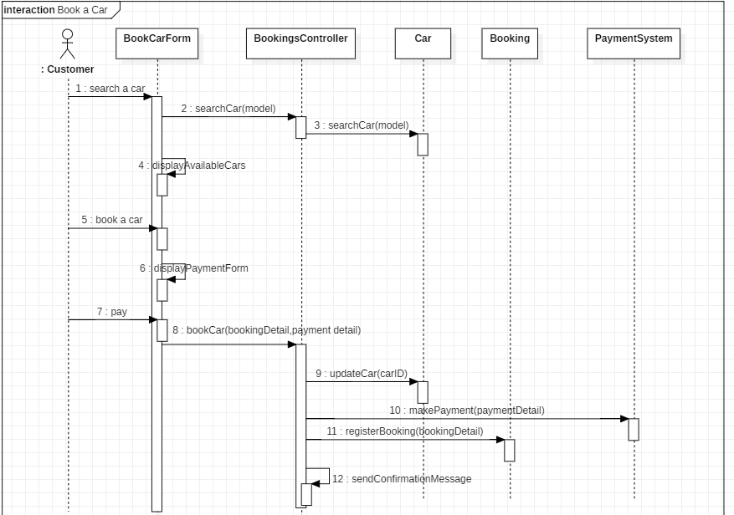

**Cancel Booking Sequence Diagram**

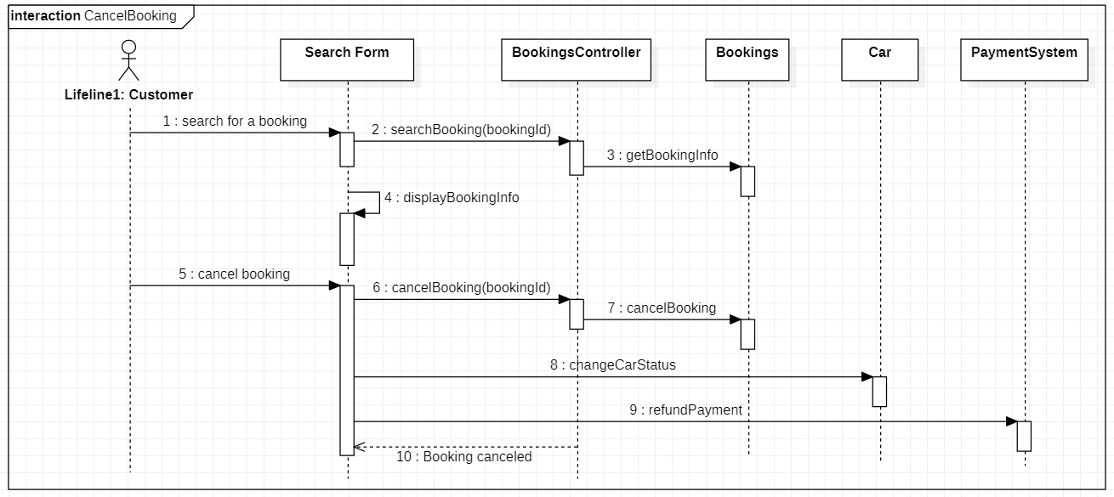

# **Collaboration Diagrams**

**Booking a Car Collaboration Diagram**

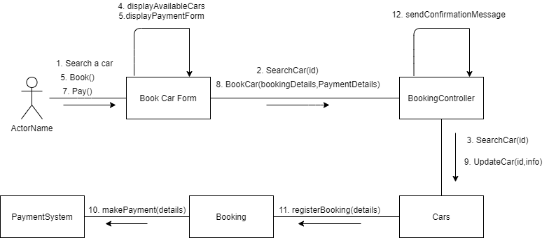

# **VOPC Diagrams**

**Booking a Car VOPC Diagram**

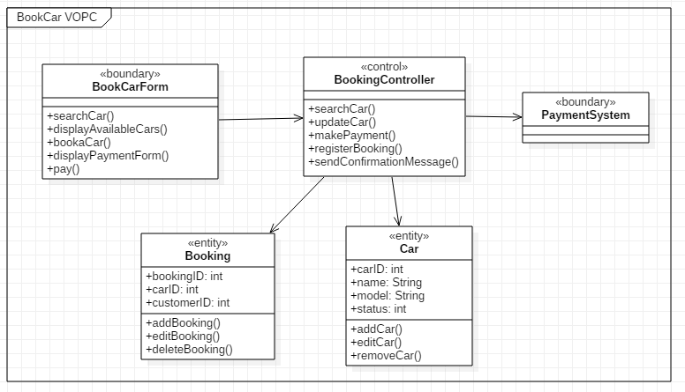

**Cancel Booking VOPC Diagram**

