

**SCHOOL OF INFORMATION TECHNOLOGY AND ENGINEERING**

**M.C.A – Cloud Computing ITA6009**

**Topic: Deploying a AI Chatbot using Python on Amazon AWS EC2 (PaaS)**

**Group members’ details:**

**Dipangshu Mandal (21MCA0016)**

**Sourav Kumar Das (21MCA0198)**

**Dandupati Srinivas Kumar (21MCA0201)**

**Guided by**

**Dr. Siva Rama Krishnan**

**Abstract:**

A Chabot is an intelligent piece of software that is capable of communicating and performing actions similar to a human. Chatbots are used a lot in customer interaction, marketing on social network sites and instantly messaging the client. In this project we are going to implement a Chabot concerning college related queries with the help of Python and cloud computing. We will achieve the functionalities of the chat bot via the NLTK (Natural Language Processing) library in python. Natural Language Processing allows computers and algorithms to understand human interactions via various languages. The code will be executed in the cloud and run on the college’s server.

**Introduction:**

In this project we are going to build a chatbot with the help of Python and implement the software on the cloud. The chatbot will be able to answer all the common queries related to college like fees, courses and other frequently asked questions. The chatbot will be powered by AI so it will learn from the user interactions. Natural Language Processing will be used to predict the answers of the user's questions.

**Literature Survey:**

1. **Implementation of Cloud computing Service Delivery Models (IAAS, PAAS) by AWS and Microsoft Azure: A Survey**.

Tanmay R. Toraskar- M. Tech IT (IS) K. J. Somaiya College of Engineering, Mumbai, India , Yogita Borse - Professor Department of Information Technology, K. J. Somaiya College of Engineering, Mumbai, India

Platform-as-a-Service (PaaS): It provides the platform for computational requirements, and the solution stack required by the customers to build their own applications and host their own data. Example: Google Apps, AWS Elastic Beanstalk.

The AWS Cloud infrastructure is built around Regions and Availability Zones (AZs) [5]. It consists of many cloud services that you can use in combinations fitted to your business or organizational needs. Some of the IAAS by AWS are Amazon EC2, Amazon Elastic Block Store, Autoscaling, Elastic Load Balancing. Amazon EC2 is used for Virtual Machine hosting to provide compute capacity in the cloud. Amazon EC2 provides you Linux and Windows based servers with cores in the range of 1 to 60+ and RAM in the range of 1.7 GB to 244 GB. Amazon EBS is used to provide storage to EC2 instances. With the help of Autoscaling feature you can scale up or down an automatically. Amazon ELB is used to redirect traffic to healthy instance in order to handle incoming traffic [6]

1. **An Introduction to AWS – EC2 (Elastic Compute Cloud)** Rahul Saini, Rachna Behl

Amazon Elastic Compute Cloud (Amazon EC2) gives an adaptable processing limit in the Amazon Web Services (AWS) cloud. Utilizing Amazon EC2 takes out your need to put resources into equipment in advance so that you can create and convey applications quicker. You can utilize Amazon EC2 to dispatch the same number of or as not many virtual servers as you need, design security and organizing, and oversee capacity. Amazon EC2 empowers you to scale up or down to deal with changes in necessities or spikes in prominence, lessening your need to gauge traffic.

1. **Programming challenges of Chatbot: Current and Future Prospective**

Authors: AM Rahman, Abdullah Al Mamun , Alma Islam

In the modern Era of technology, Chatbots is the next big thing in the era of conversational services. Chatbots is a virtual person who can effectively talk to any human being using interactive textual skills. Currently, there are many cloud base Chatbots services which are available for the development and improvement of the chatbot sector such as IBM Watson, Microsoft bot, AWS Lambda, Heroku and many others.

**CHATBOT PROGRAMMING CHALLENGES**

There are a lot of challenges which are associated with chatbots. Some of them are as follows.

1. **Natural language processing** The first and foremost challenge [7] of the chatbot is to handle NLP issue by mastering their syntax. If we ask them that " what's the weather?". You will get an answer but what if we ask "Could you check the weather?" you might not get the proper answer. Such type of programming issues falls in natural language processing category which is a key focus for the companies like Facebook, Google with Deep Text and Syntax Net respectively.
2. **Machine learning**

Getting NLP is one aspect of designing and development of Chatbots while Machine Learning is another aspect of the Chatbot design and development. Our computer systems should able to learn the correct response should be which can be achieved with efficient programming with AI concepts

***LIMITATION AND FUTURE OF NLP AND MACHINE LEARNING***

It is quite clear that chatbot needs to provide vast logic and linguistic resources which are input, output and entities phrases. Chatbot with complex queries handling need high attention in using singular and plural forms, need to take care of synonyms, hyponyms, and finally, the sentimental analysis should be done carefully.

**4. AI Based Student Bot for Academic Information System using Machine Learning**

Authors: Vijayakumar R, Bhuvaneshwari B, Adith S, Deepika M

Chatbot programs are often designed to convincing simulate how a human would behave as a conversational partner, thereby passing the Turing test. Chat bots are usually used in dialogue systems for various practical reasons, for example, automated online assistants, giving them the ability to engage the customer. STUDENT BOT is a native Chabot that will analyze and understand user’s queries and reply appropriately. A native Chabot is a Chat bot technology which interacts with users in the website browser or any application. This system is a web service which will provide answers to the queries of the system user.

Artificial intelligence (AI) is the simulation of human intelligence processes by machines, especially computer systems. AIML is a one of the most commonly using algorithm for the artificial intelligence in NLP processing.

Natural Language Processing or NLP is a part of artificial intelligence that will be used to analyze the user’s queries. Users won’t have to go to the college office to make the inquiry. The user just has to register himself to the system. Then the user can ask college-related information such as timetables, notes, etc. This system also helps the user to get the updated information’s about the college activities. The query will be answered on the basis of the knowledge base.

The keywords will be fetched from the natural language processing algorithms and a relevant answer will be provided to the user. In case the answer is not available in the knowledge base or the question is irrelevant then the default message will be displayed.

***Artificial Intelligence Markup Language (AIML)*** is a set of possible queries and their respective responses. AIML consists of elements such as: categories, pattern and template. Every category consists of a pattern and a template. Patterns are the possible queries that the bot-user may type in and template is the response to the respective pattern.

***Natural language Processing***

Natural Language Processing (NLP) is the area of research and application that investigates and analyse how the computational techniques can be used to perceive and alter the user’s human language text or speech inputs. Natural Language Processing (NLP)techniques can be used in various applications such

as machine translations, natural language processing,

multilingual and cross language information retrieval

(CLIR), speech recognition and Artificial intelligence system [3]. For this chatbot natural language

processing of text inputs are done by dialogflow.

**Implementation:**

**Step 1:** At first we have to create an instance in Amazon EC2.

We chose Ubuntu Server for Amazon Machine Image.

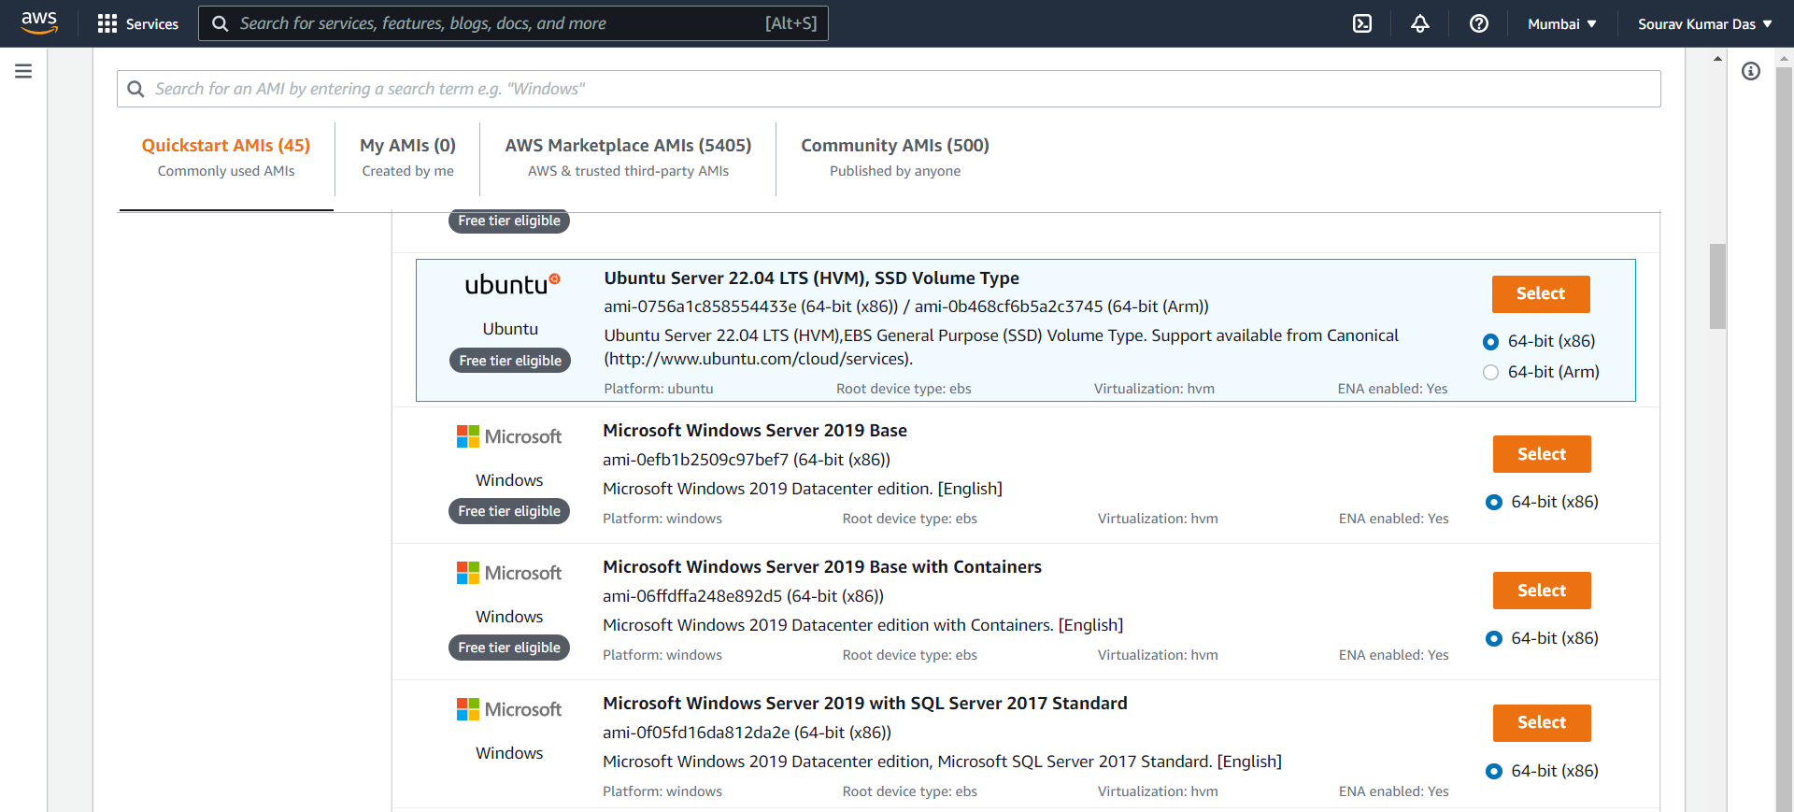

**Step 2:** Selected t2.micro instance type (free tier eligible)

Generate a new key pair and store it in your storage.

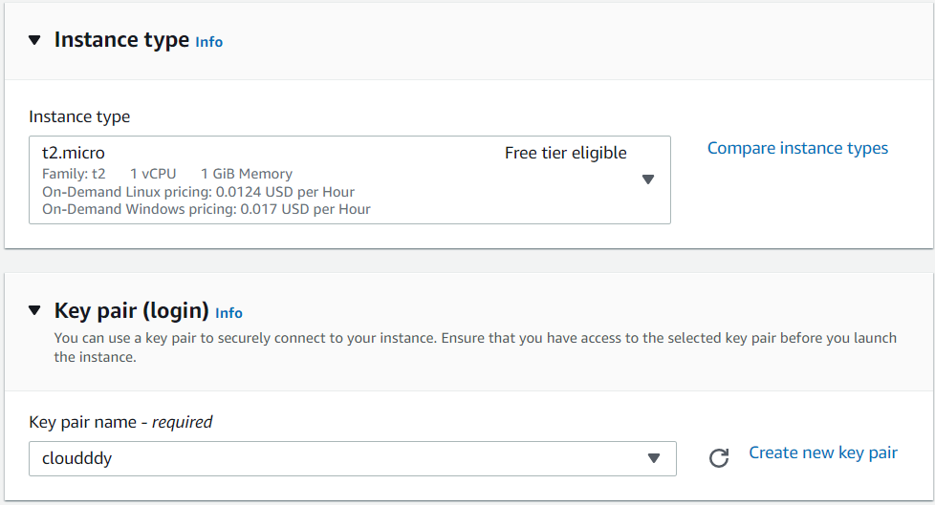

**Step 3:**

This is our required settings….and after that we launched the instance.

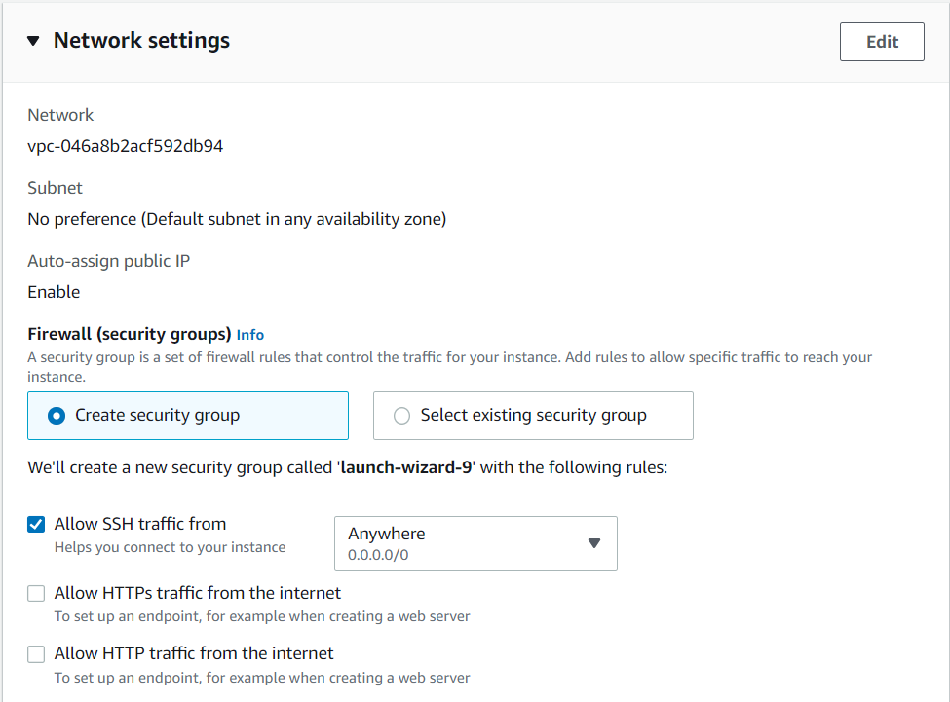

**Linux OS instance created in instance name cloud_final:**

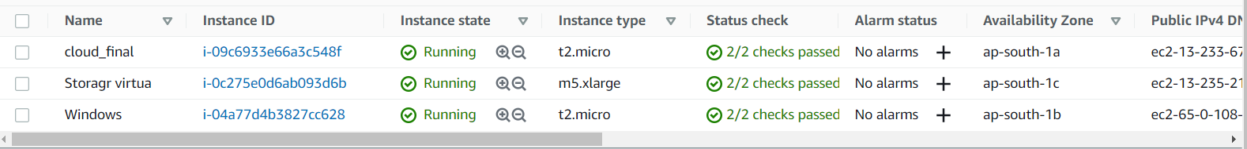

**Step 4:** Copy the public IPV4 address for the Instance:

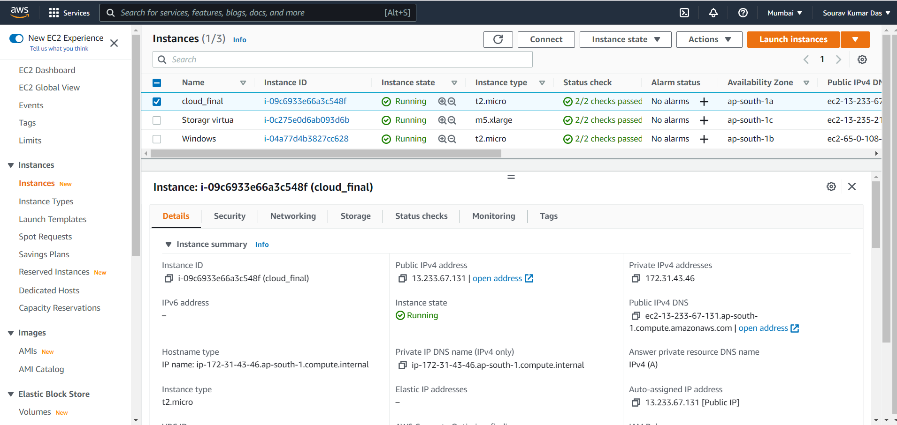

**Step 5: Project files uploaded through Filezilla:**

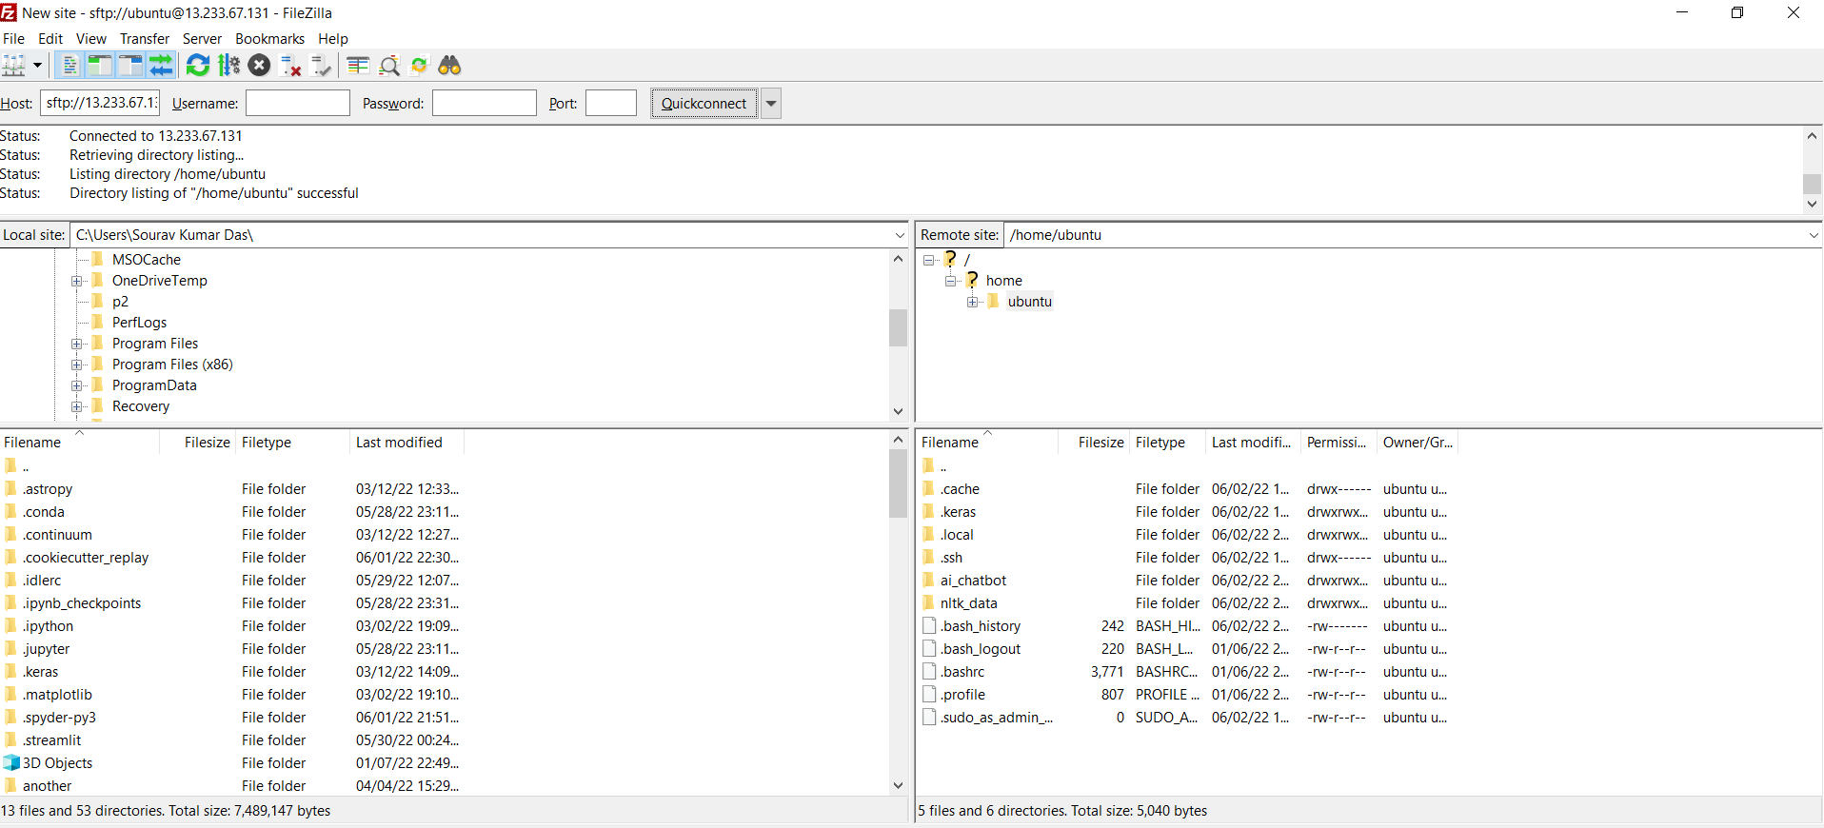

**Project running via putty:**

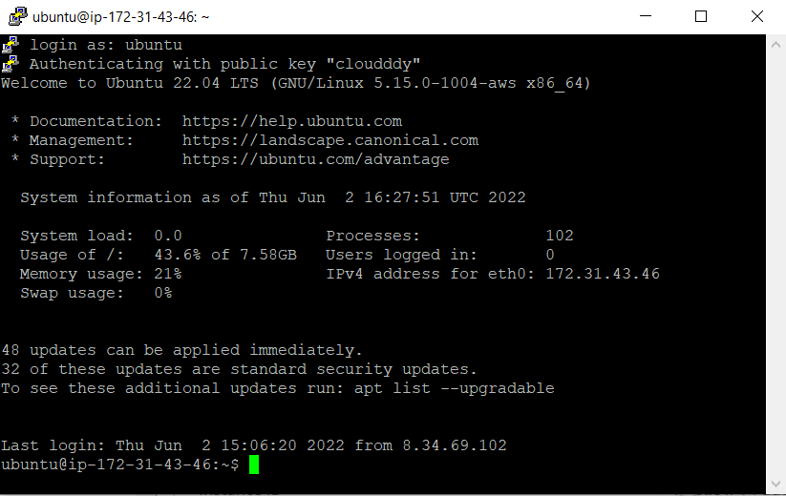

**Program running successfully via the deployed instance:**

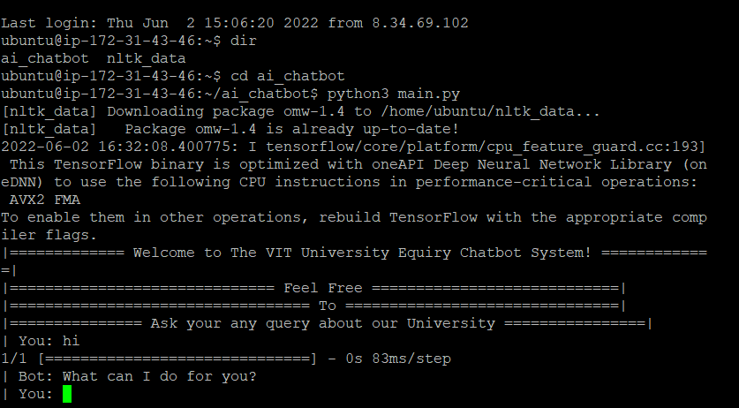

**References:**

<https://data-flair.training/blogs/python-chatbot-project/amp/>

<https://www.analyticsvidhya.com/blog/2021/12/creating-chatbot-building-using-python/>

<https://pypi.org/>

<https://www.youtube.com/watch?v=qUHQuZjTOFA>

<https://towardsaws.com/python-on-aws-ec2-instance-ca55ef531b95>