RE: A summary of the ins and outs of my client and server programs

First I divided the programs into 2 folders; client and server and placed the client.py

and some files to upload in client folder and I placed the server.py in another folder to see

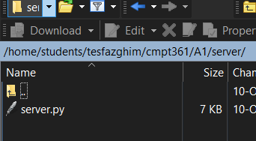the effects.

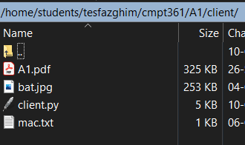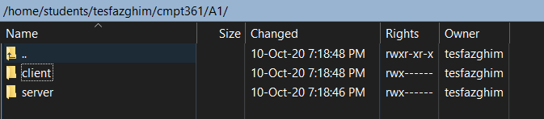

Then logged to lab machine 10 for server and lab machine 11 for client.

1. I checked if the user is a valid user and if it wasn’t “user1” it would terminate connection

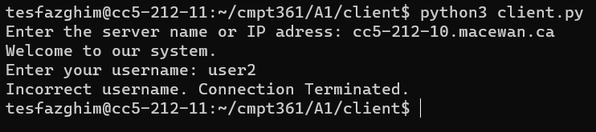I tried a wrong one as below first:

And then a correct one, and I got the menu as it should be:

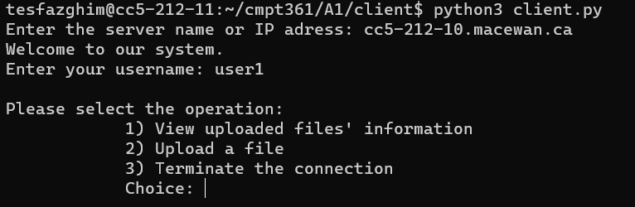

1. 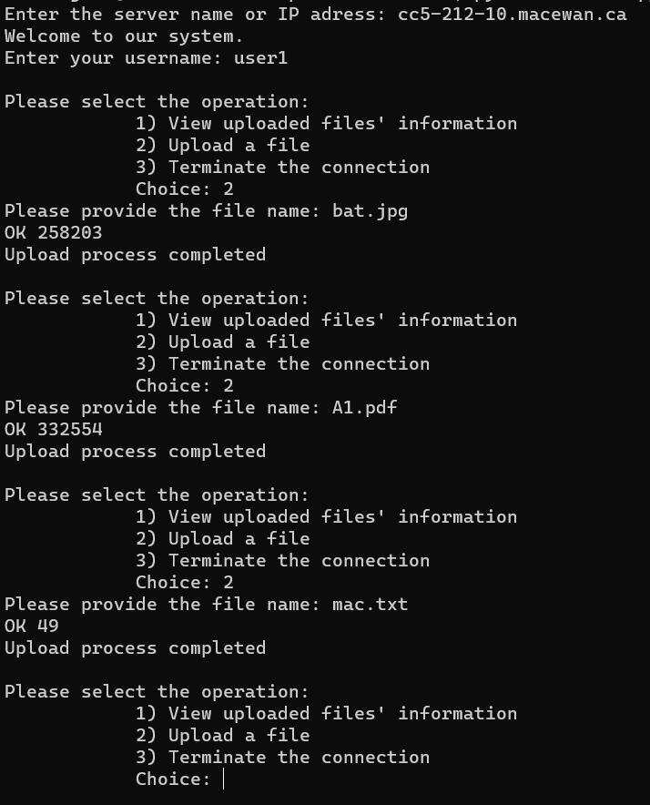Then I tried to upload 3 files (A1.pdf, bat.jpg, and mac.txt). As per my uploads, I did not get any errors and I do not think it is missing anything.
2. At this point I wanted to see the metadata of the files I uploaded. I had as issue converting the string to a dictionary in the client so I could parse it. I was getting this error: “[Expecting property name enclosed in double quotes](https://stackoverflow.com/questions/39491420/python-jsonexpecting-property-name-enclosed-in-double-quotes)”. A little googling, and I found out that the double quotes in the dictionary had somehow been converted to single quotes and json.load was having an issue reading single quotes so I replaced every single quote with a double quote and found a valid dictionary to parse and print accordingly.

The results of this run should confirm whether the upload worked or not so here goes:

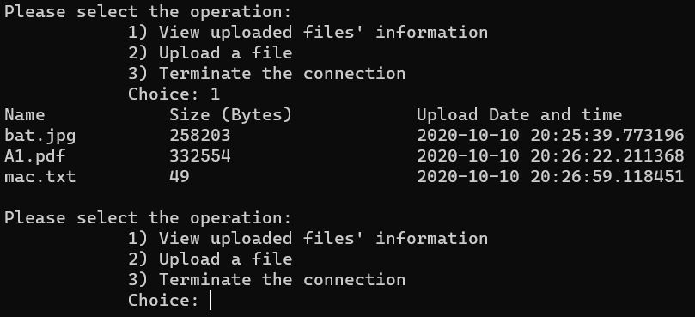

1. To confirm if the files have been transferred, I checked server folder and I found that the files have been successfully transferred from the client lab machine to the server lab machine

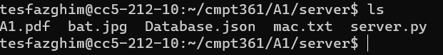

This shows both the transferred files and the json file that contains the metadata:

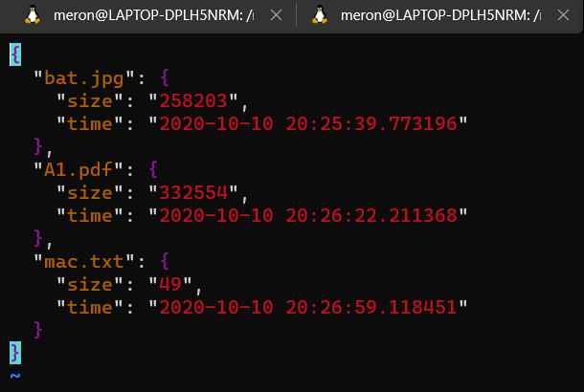

1. And then terminated the client-server connection

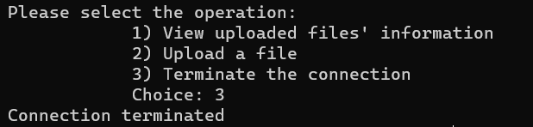

What I found peculiar was that the files had been successfully transferred between the lab machines; however, the original server folder still only had server.py. By original server folder, I mean the folder I created on the student server stayed the same; but the folder in the lab machine had the new files. Maybe this is how it is supposed to work; but I found that interesting is all.

The above test prove that the programs run as they should and work as they should assuming the input is valid otherwise, it crashes or hangs. This means that there is some error checking but not enough which goes to show the programmer is just lazy and procrastinated until the 11th hour.